# BD-9766_TC-11022

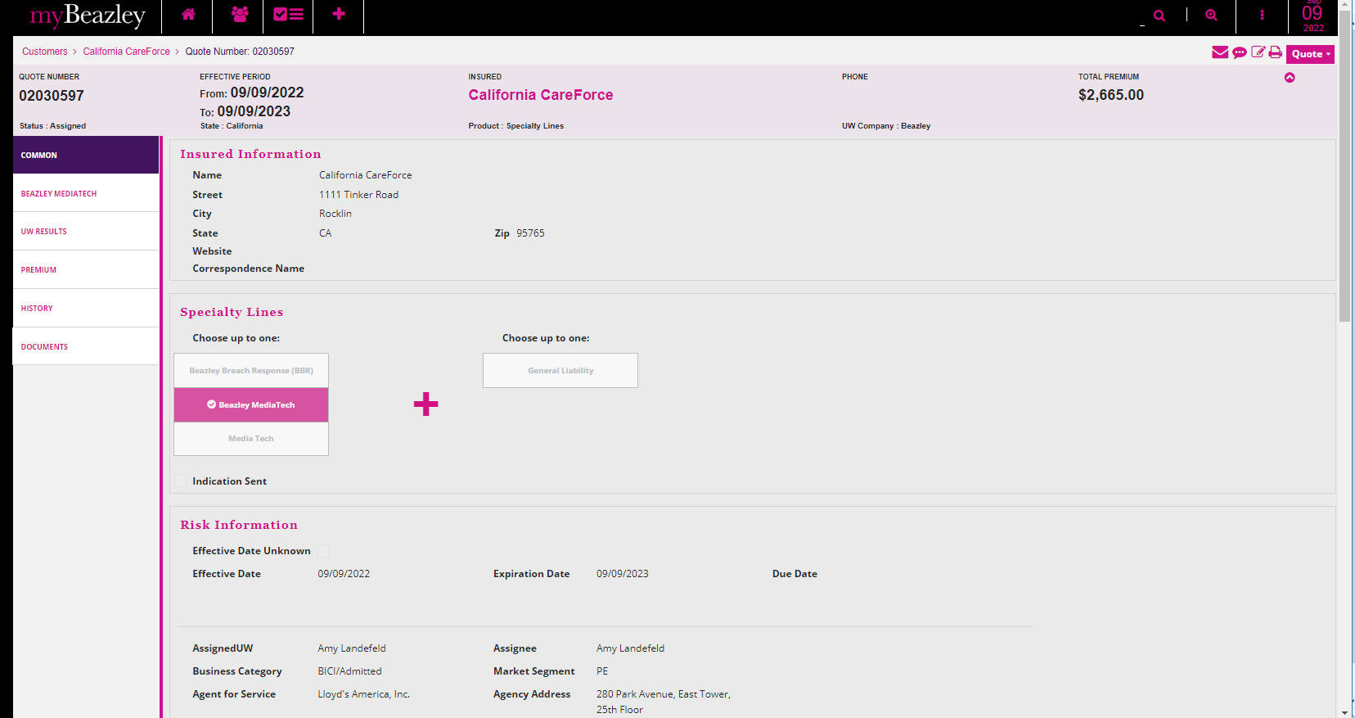

The “Amend Definition of professional services” E12984 052019 ed. Is not available, which is ok.

