# BD-9766_TC-11023

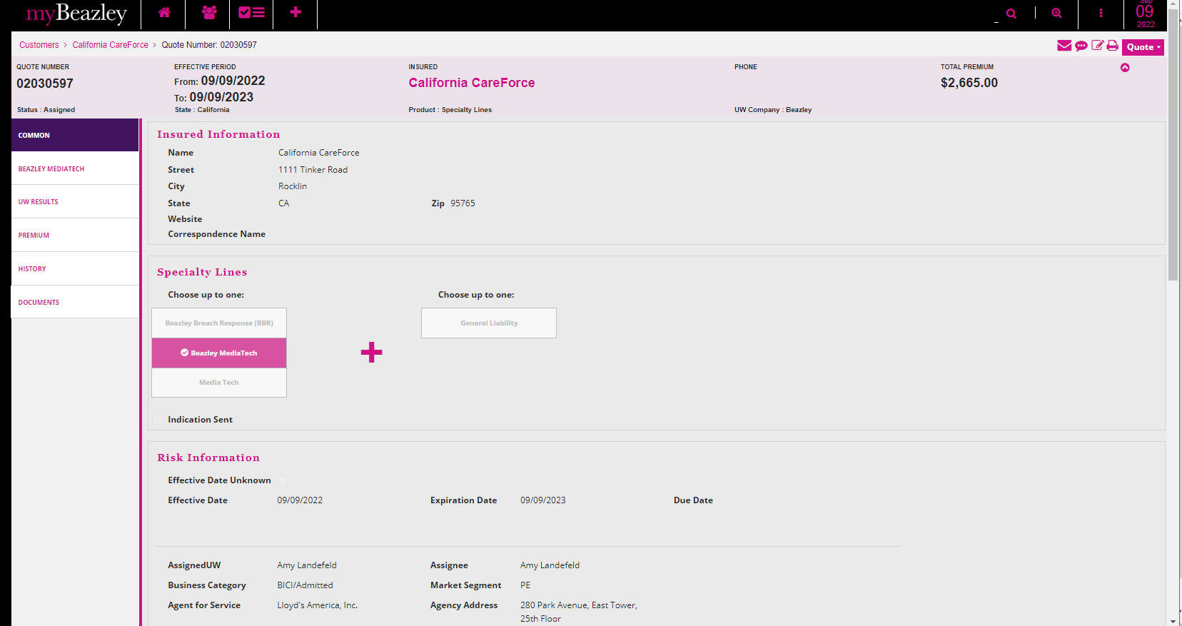

The “Amend Definition of professional services” E12984 052019 ed. Is not available, which is ok.

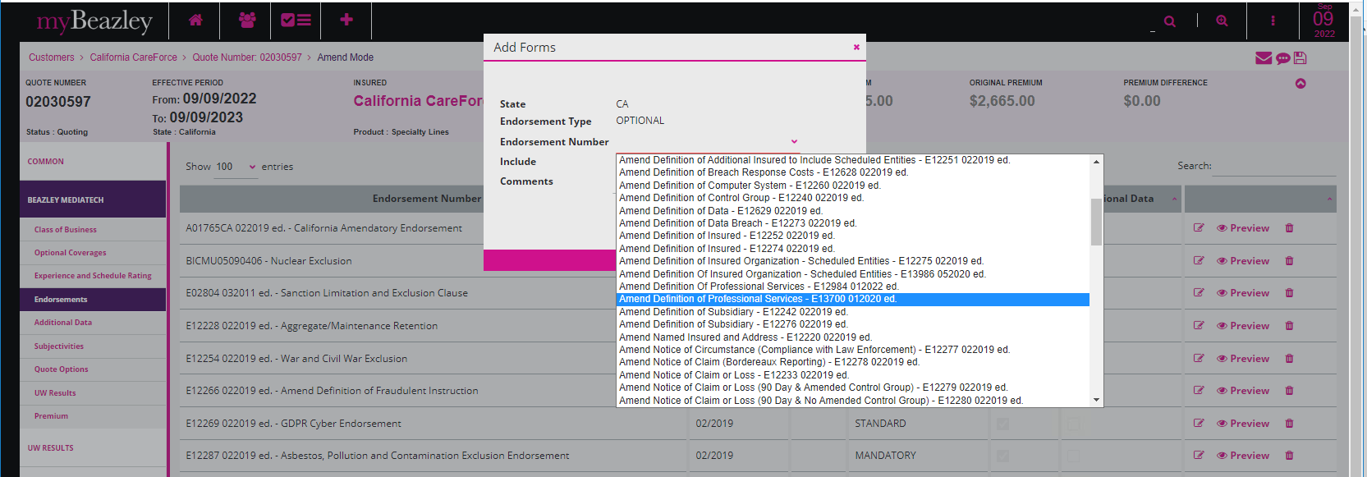

Quote letter

Binder Letter

Policy DEC

