# BD-9766_TC-11024

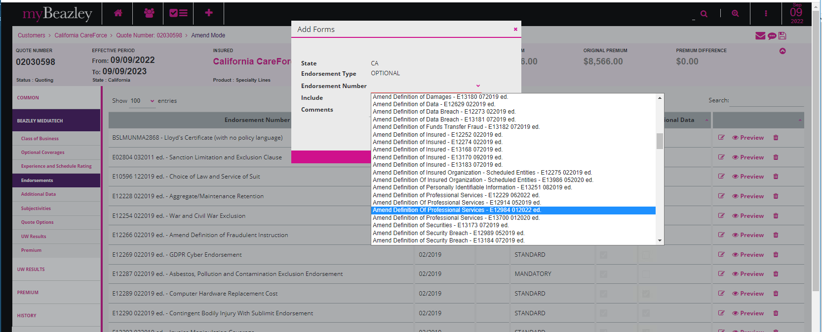

Quote Letter

Binder Letter

Policy DEC

