# BD-9927_TC-11029

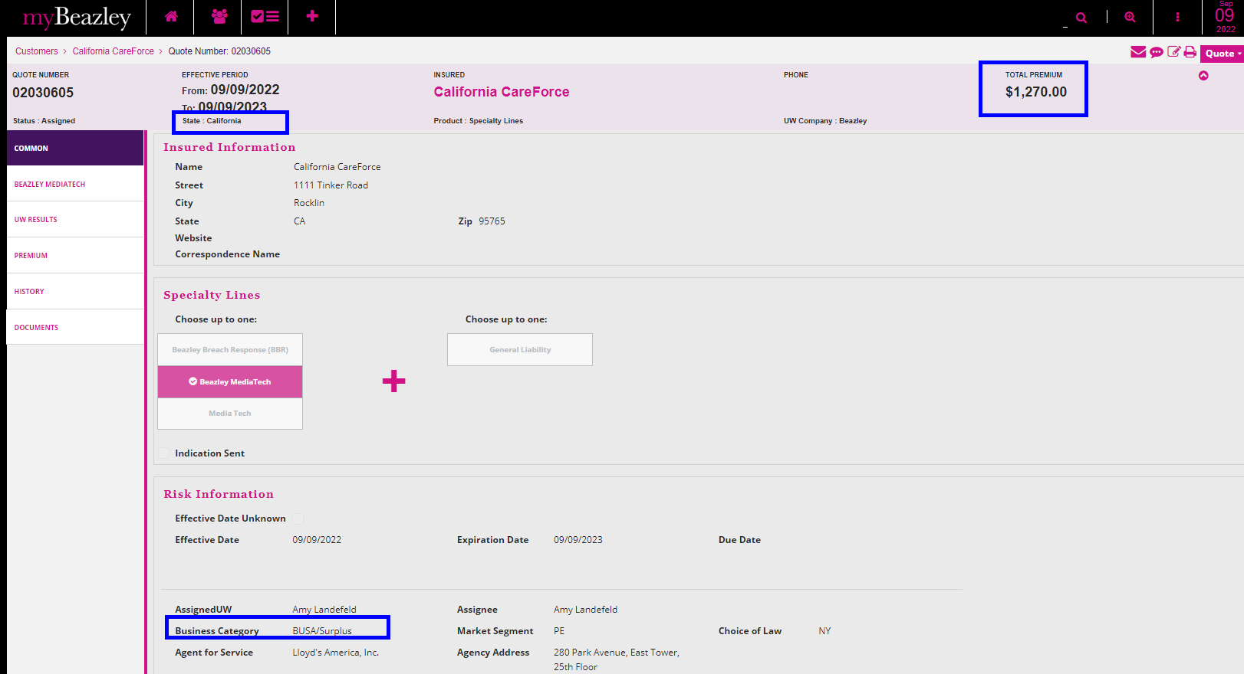

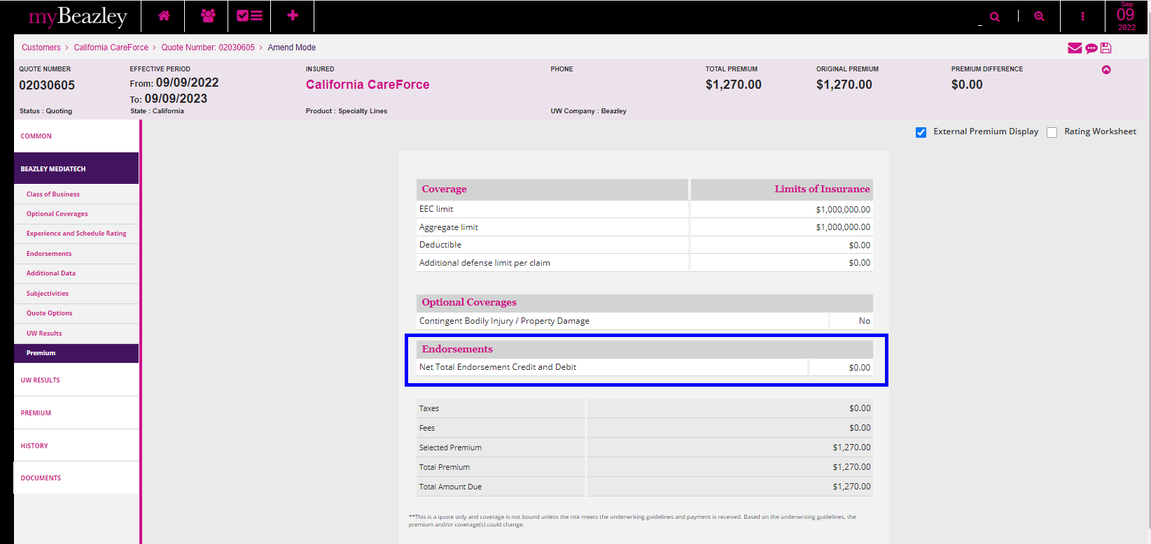

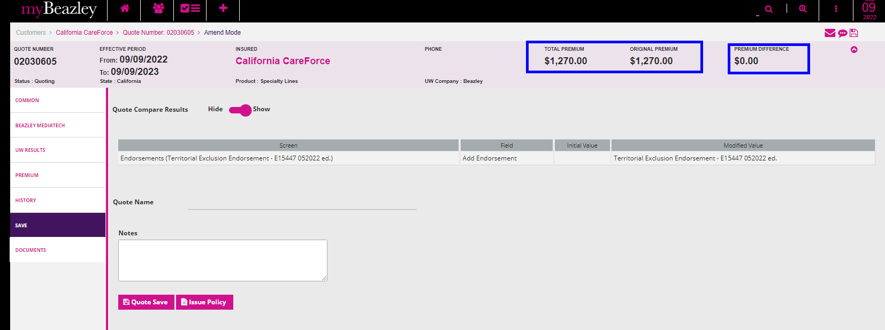

Quote Letter

Binder Letter

Policy DEC

