# BD-9725

This test was done on Sept/13/2022 before the change takes place. This change will take place on Sept-16-2022

11 = NO

Now, 12 = No

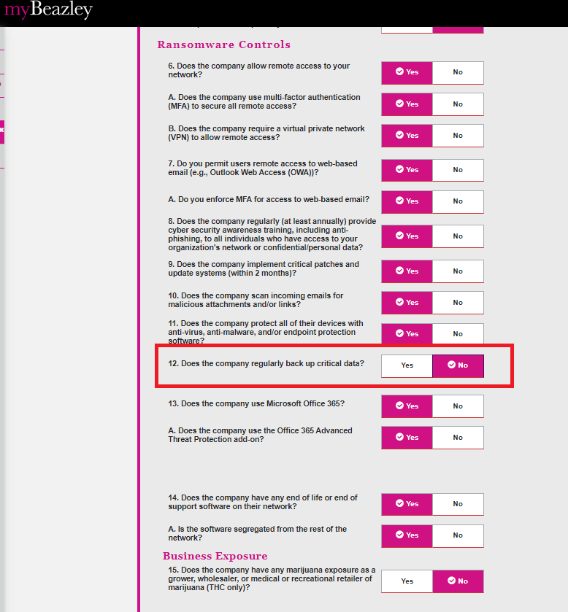

We got the orange banner

12A = No

