# BD-9725_TC-11344 BBR 2030703

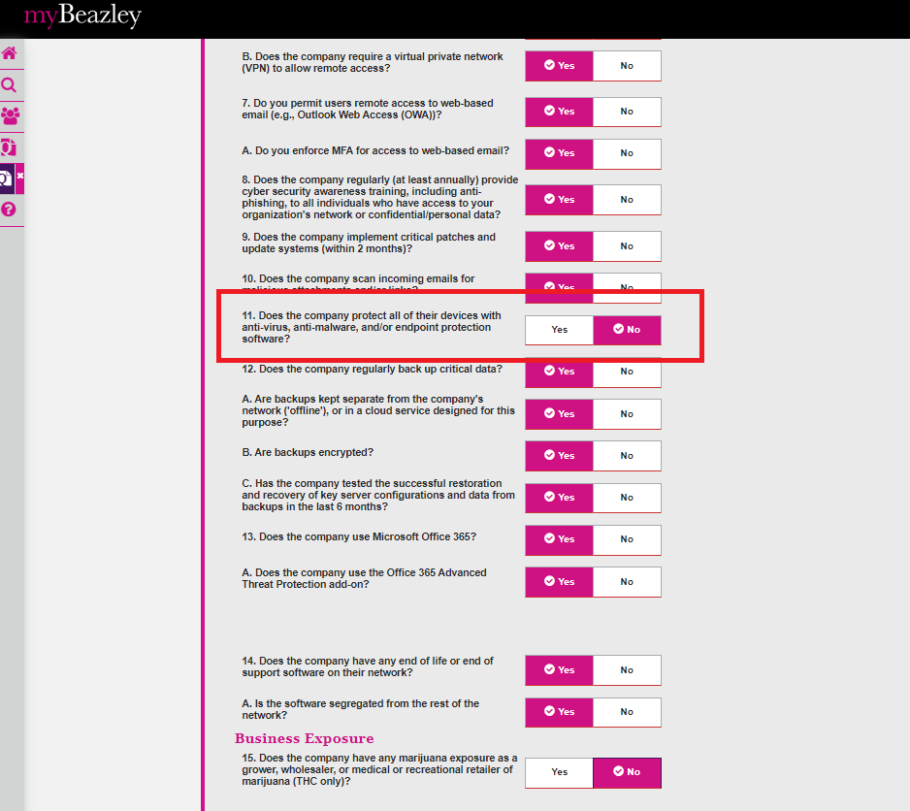

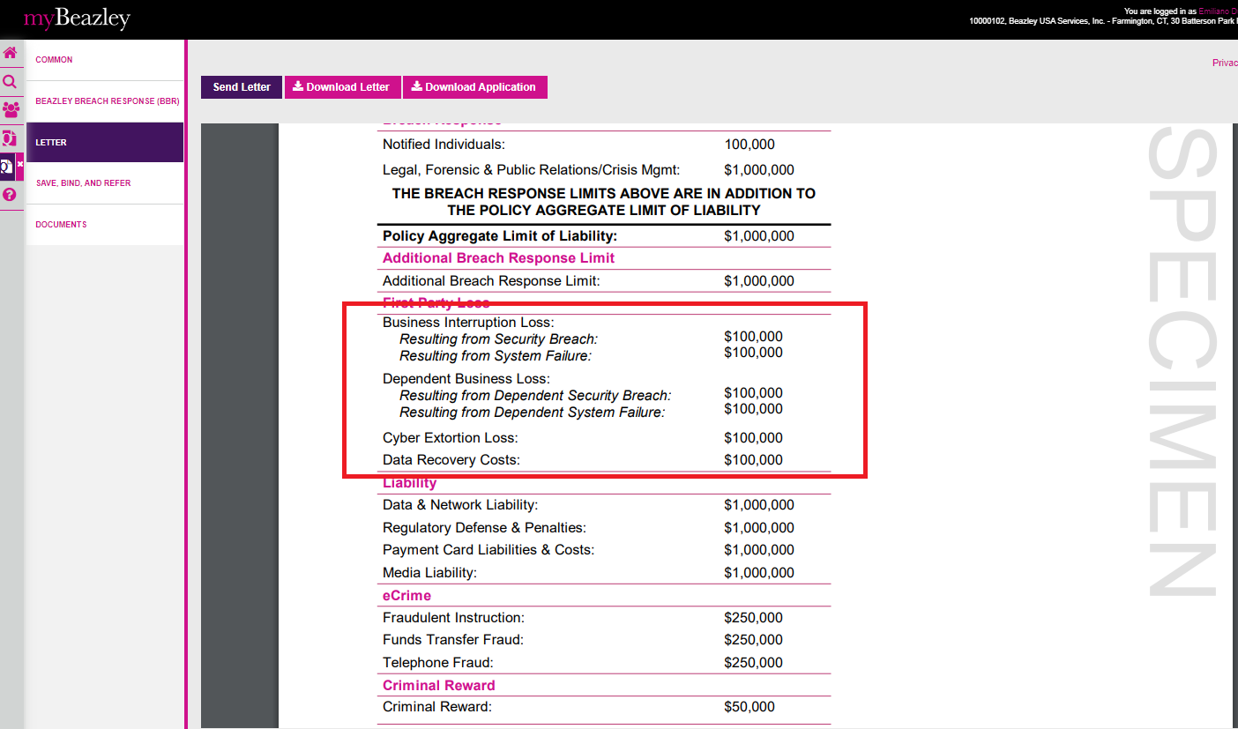

Open the quote in UWP

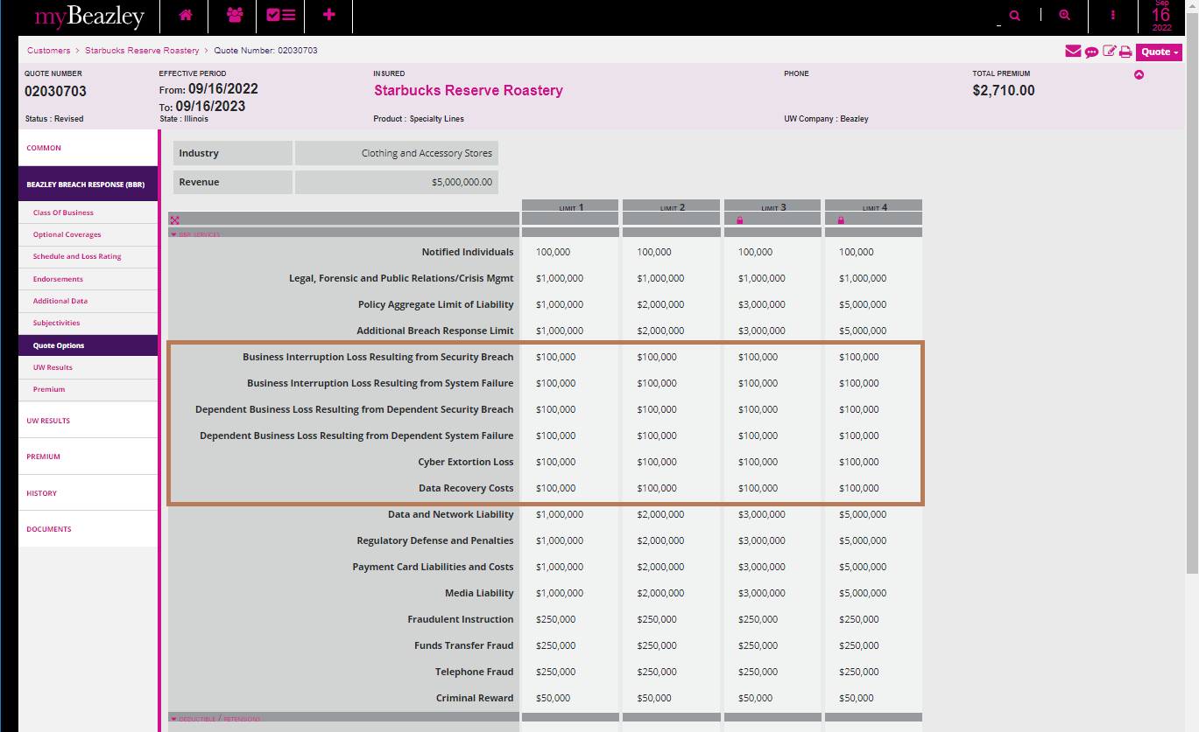

Application Letter

