# BD-9725_TC-11345 BBR Q#2030703

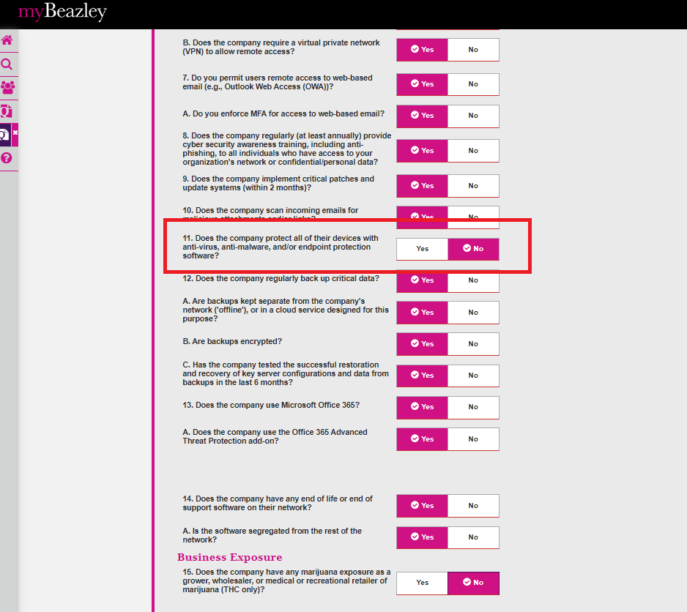

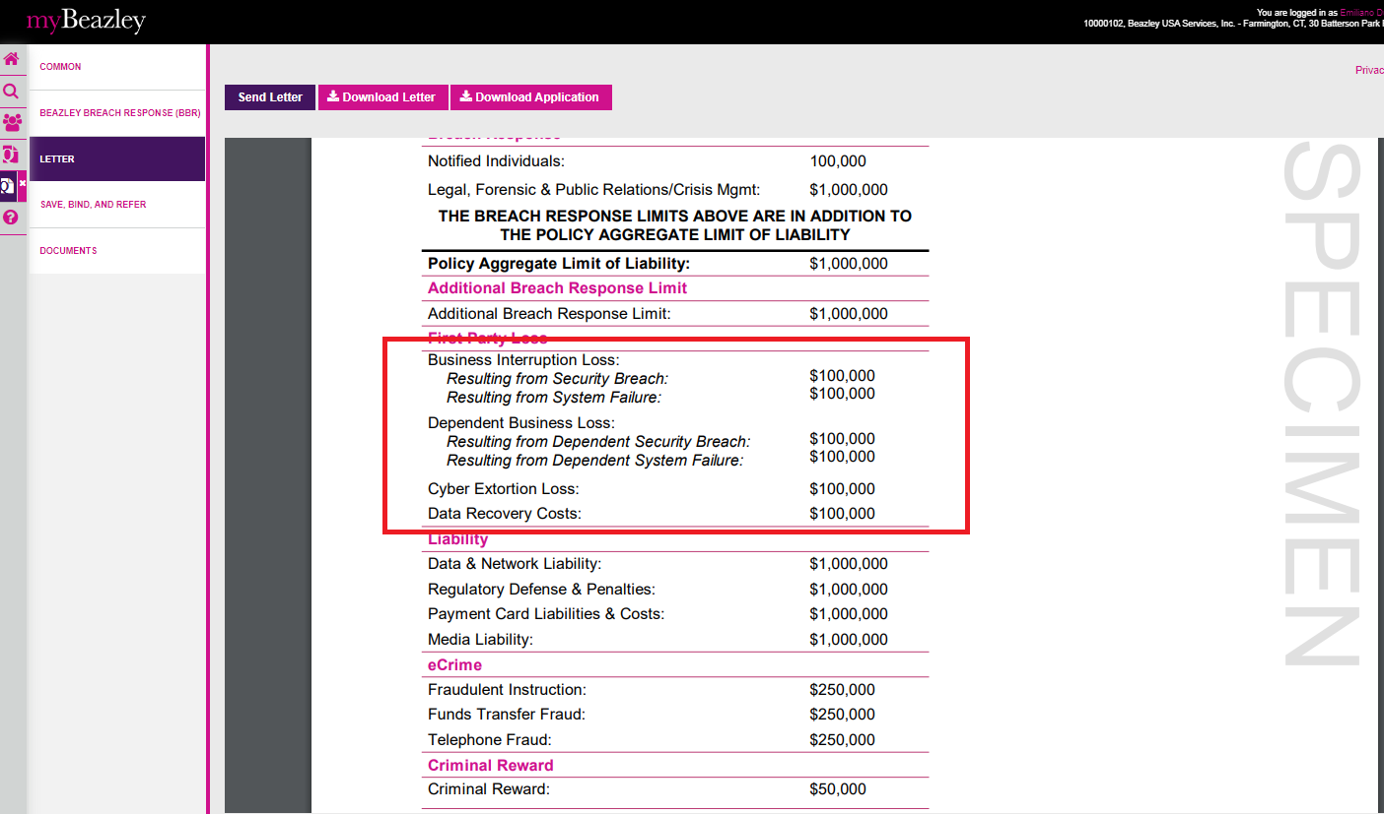

Open the quote in UWP

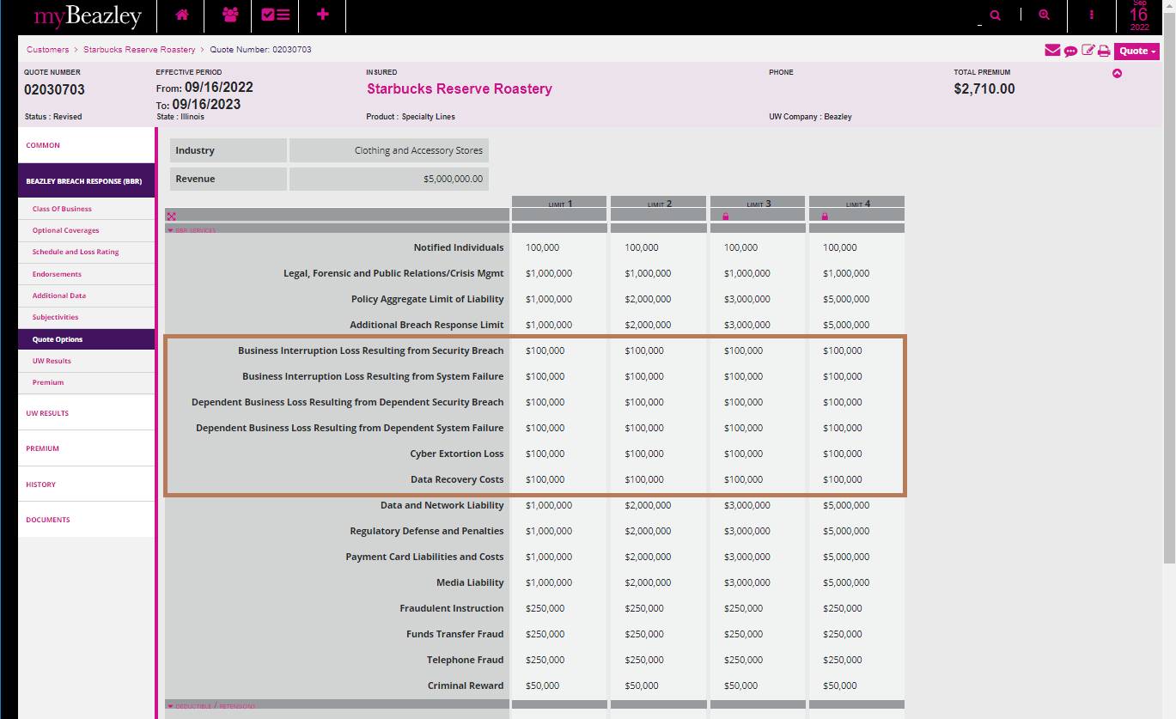

Application Letter

