# BD-10302

This are the parts of the AP that are affected by the changes.

This are mainly in the main page in AP.

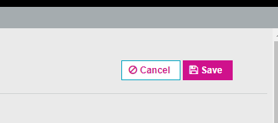

The Reload button has the turquoise border.

The information icons will show with a white background and turquoise border

The new quote button has the turquoise border color.

The submit for clearance button will have the white background and the turquoise border color.

In the quote options tab, when the user hovers over the premium the tooltip will pop up with white background and turquoise border

In the Letter tab

Recent Customers should have no change!

The drop down menus are blue when selected.

The arrow at the bottom should be gray. No change

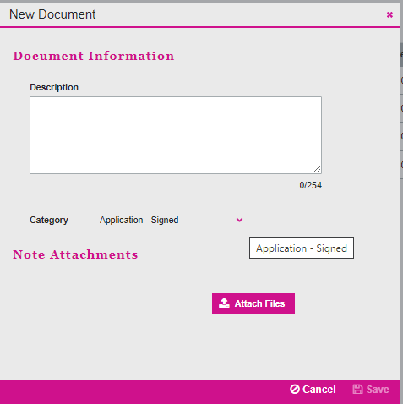

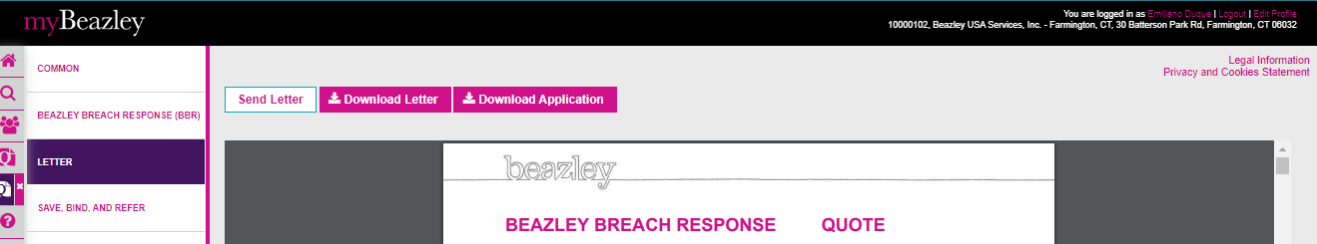

These are the changes done in UWP

