# BD-10382

Test date Sep 01/2022

State: MA

Industry Class: Car Wash

Business Line: Surplus

BBR Q# 2030794

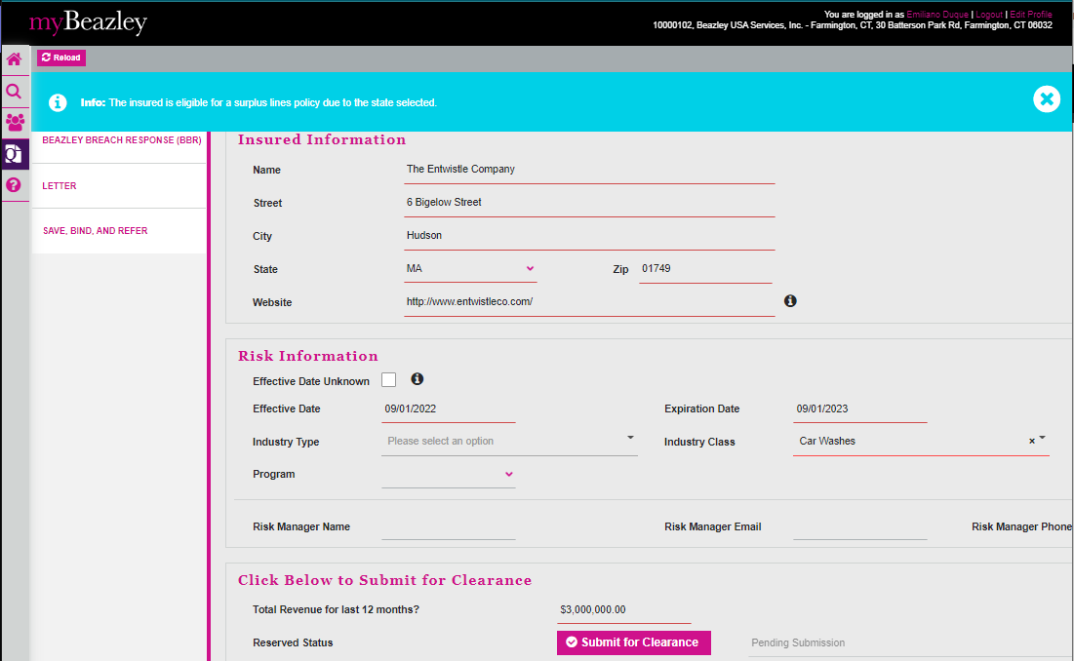

State: MA

Industry Class: Boat Dealers

Business Line: Surplus

BBR Q# 2030795

State: MA

Industry Class: Electronics and Appliance Stores

Business Line: Surplus

BBR Q# 2030796

State: MT

Industry Class: Home and Garden Equipment Repair …

Business Line: Surplus

BBR Q# 2030798

State: MT

Industry Class: Industrial Launderers

Business Line: Surplus

BBR Q# 2030799

State: MT

Industry Class: Liquor Stores

Business Line: Surplus

BBR Q# 2030800

State: MT

Industry Class: Liquor Stores

Business Line: Surplus

BBR Q# 2030806

