# BD-10382

This data was taken on 9/26/2022 before the change goes live.

BBR Q# 2030762

State MT – Montana

Surplus

BBR Q# 2030764

State MT – Montana

Surplus

BBR Q# 2030765

State MT – Montana

Surplus

BBR Q# 2030766

State MA - Massachusetts

Surplus

BBR Q# 2030767

State MA - Massachusetts

Surplus

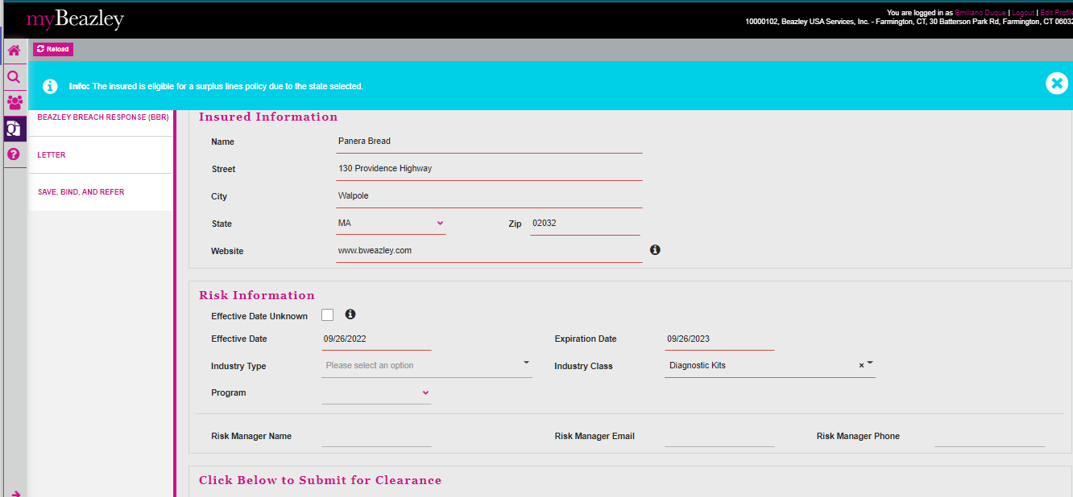

BBR Q# 2030769

State MA - Massachusetts

Surplus

