# BD-10832-Tested

BBR Q# 2030829

State: MA

Industry Class: Churches

Line: Admitted

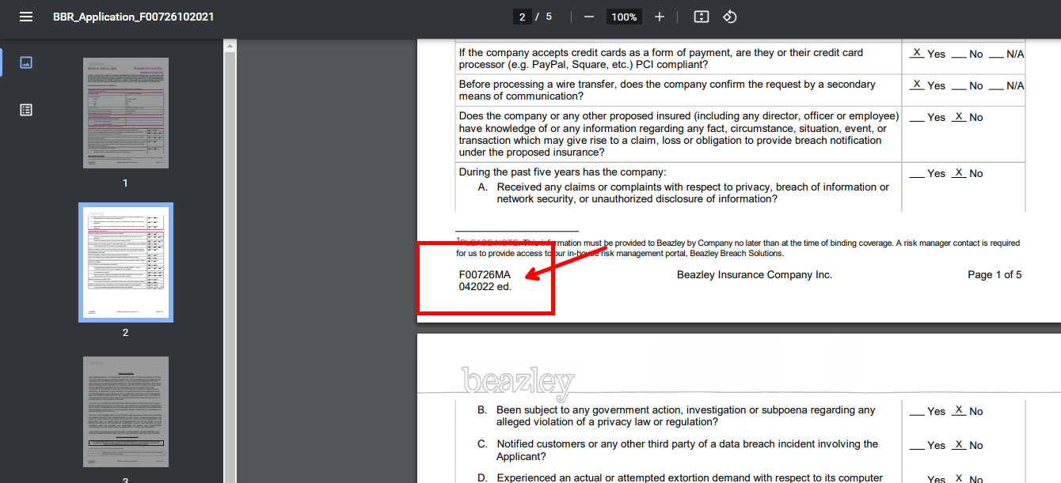

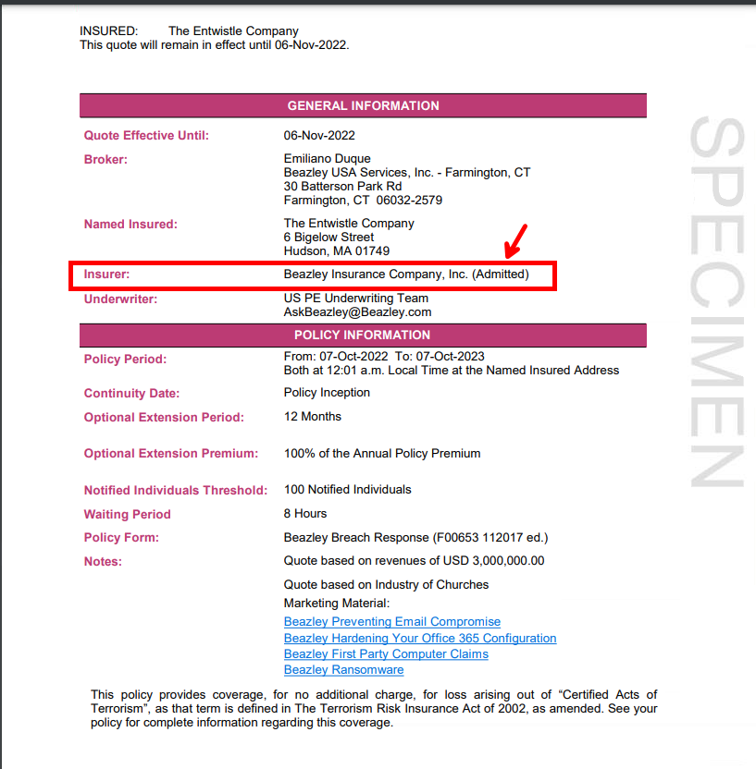

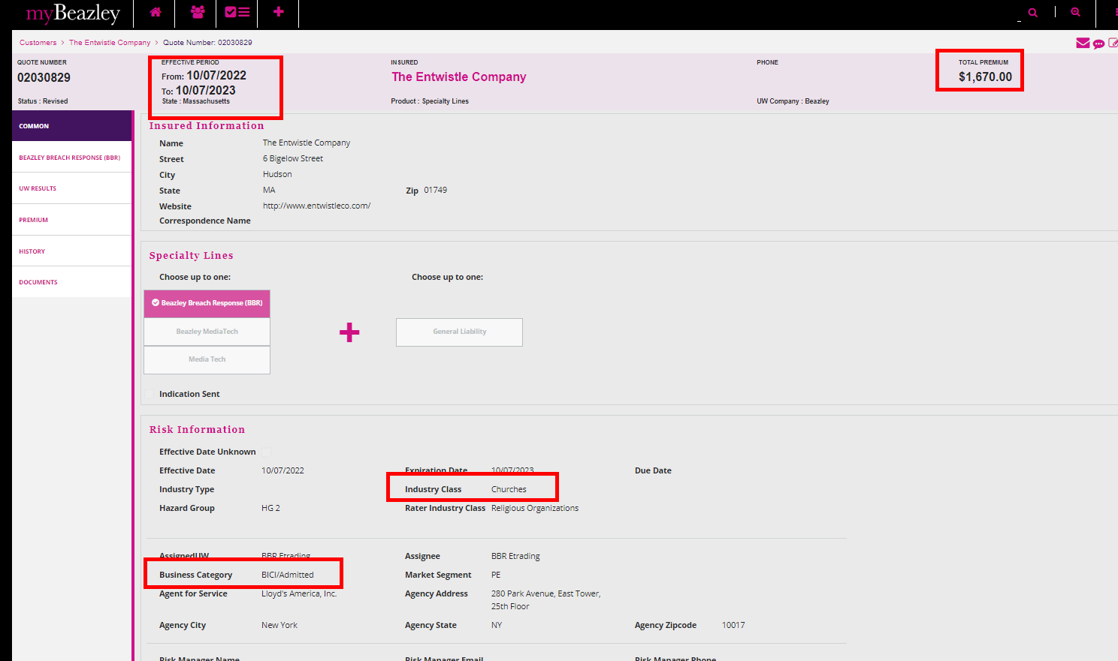

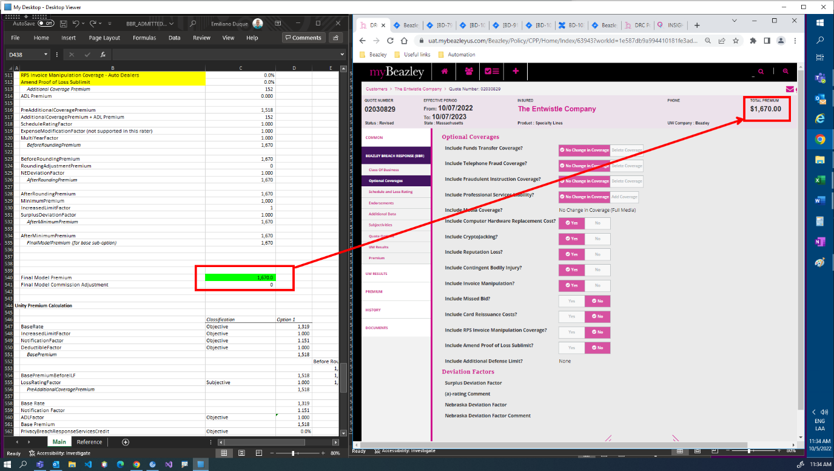

Creating other BBR Q# 2030891

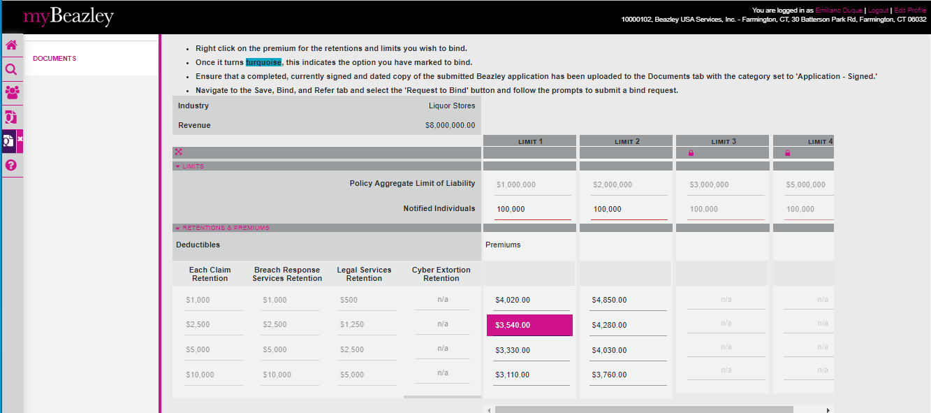

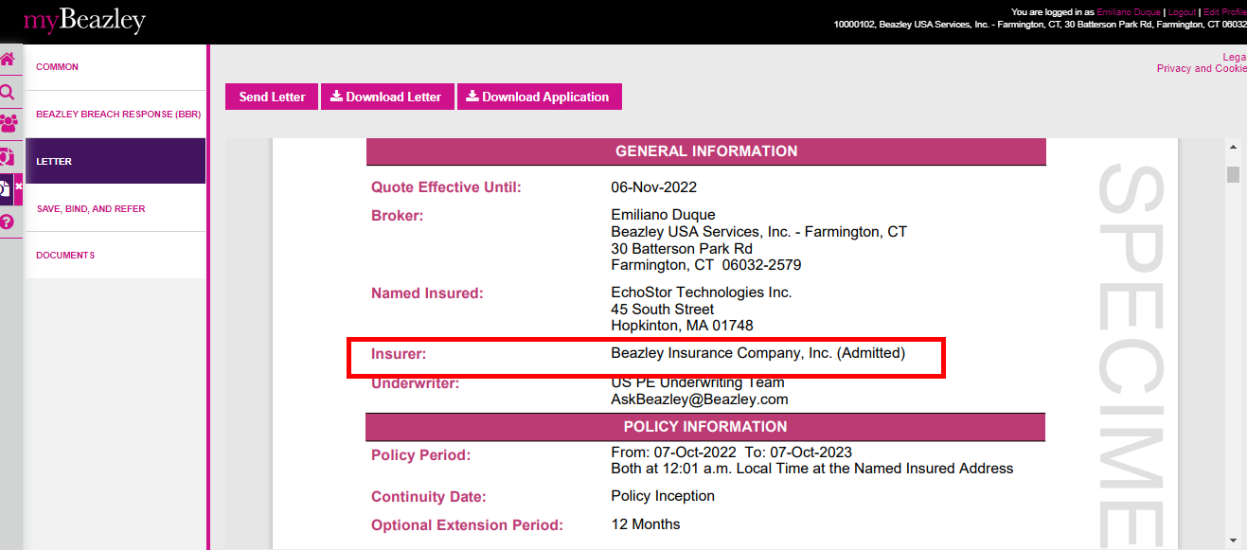

Opening it in GC



