# BD-10382-TC-12326

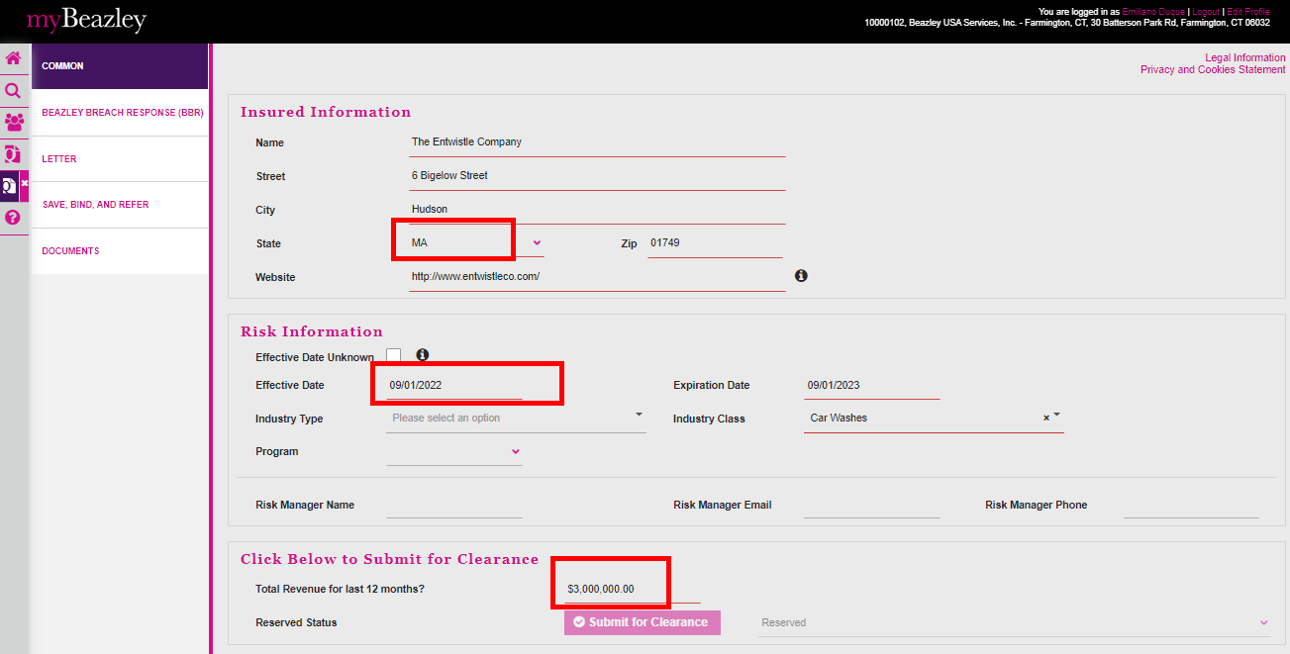

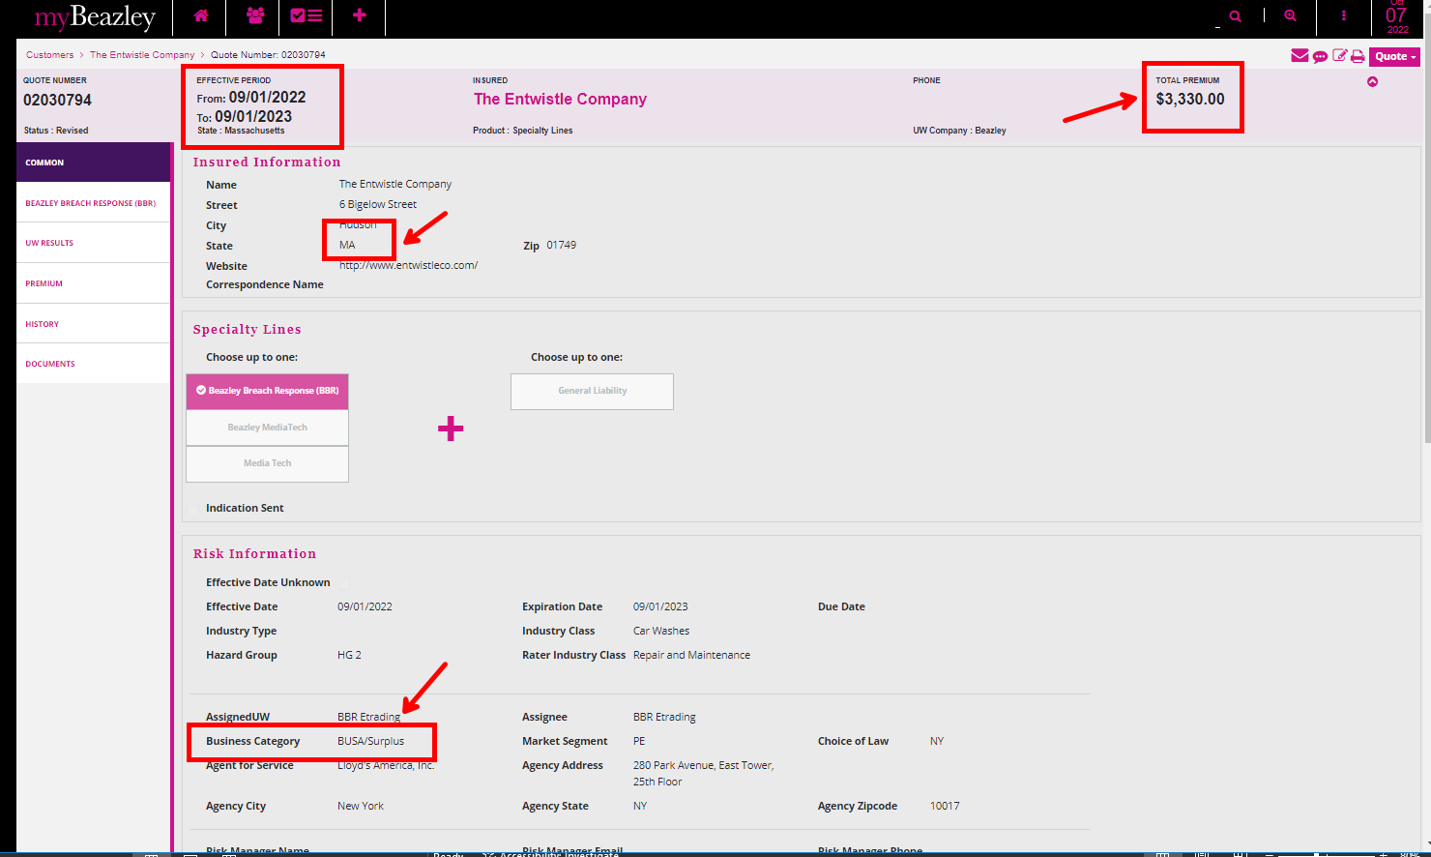

After amending the quote options showed empty, so I reselected the same premium in the quote options and saved the quote.

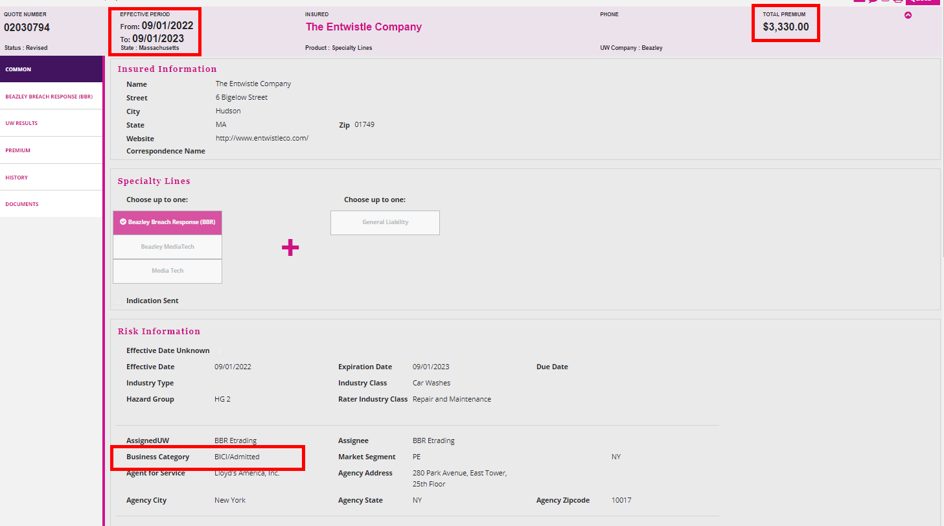

Then I changed the questions 2 and 3 = NO

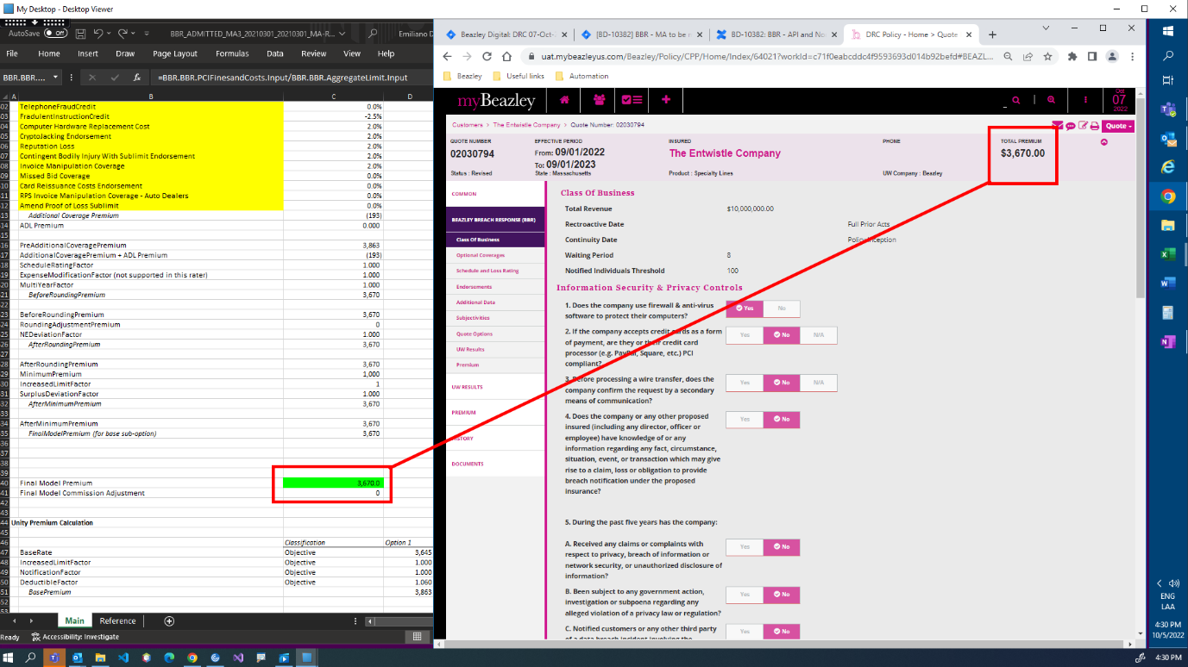

Honoring (within 30 days): Now if open a quote created within 30 days

BBR Q# 2030766



