# MA- 09/01/2022

State: MA

Industry Class: Automotive Repair

Surplus

BBR Q# 2030856

State: MA

Industry Class: Beauty Salons

Surplus

BBR Q# 2030857

State: MA

Industry Class: Churches

Surplus

BBR Q# 2030858

State: MA

Industry Class: Funeral Homes

Surplus

BBR Q# 2030859

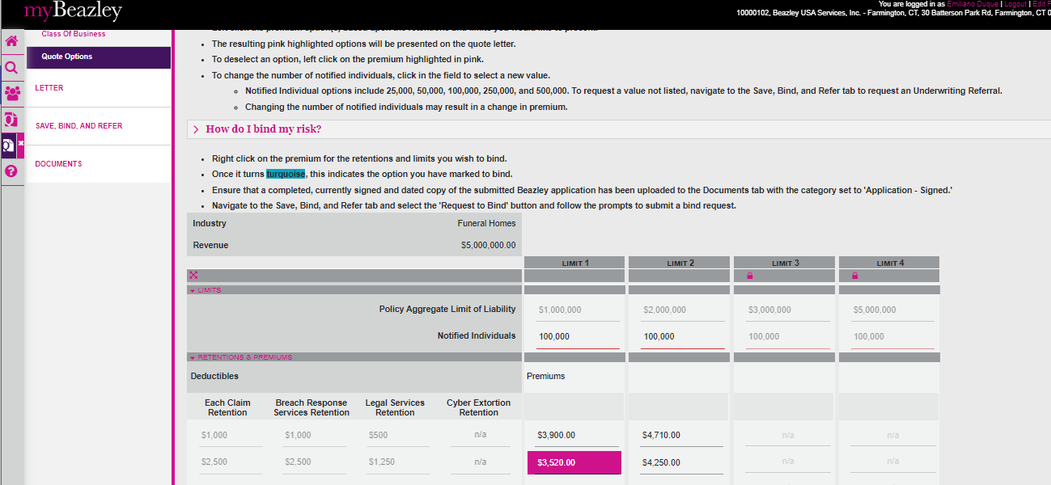

State: MA

Industry Class: Gasoline Stations

Surplus

BBR Q# 2030861

State: MA

Industry Class: Boat Dealers

Surplus

BBR Q# 2030862

State: MA

Industry Class: Hotel/Motel

Surplus

BBR Q# 2030863

State: MA

Industry Class: Grocery Stores

Surplus

BBR Q# 2030860

