# MA-TestData-09/25/2022

State: MA

Industry Class: Churches

Surplus

BBR Q# 2030870

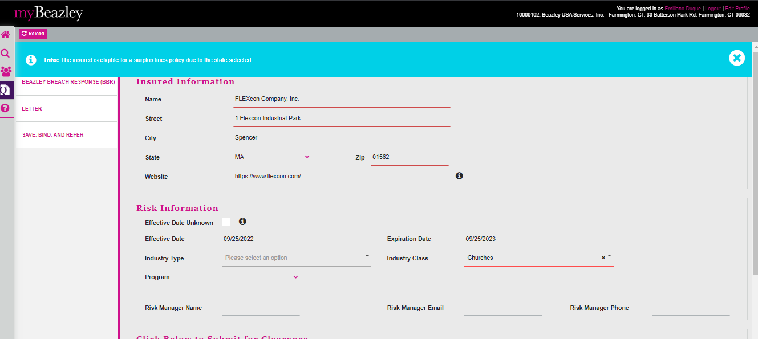

State: MA

Industry Class: Liquor Stores

Surplus

BBR Q# 2030871

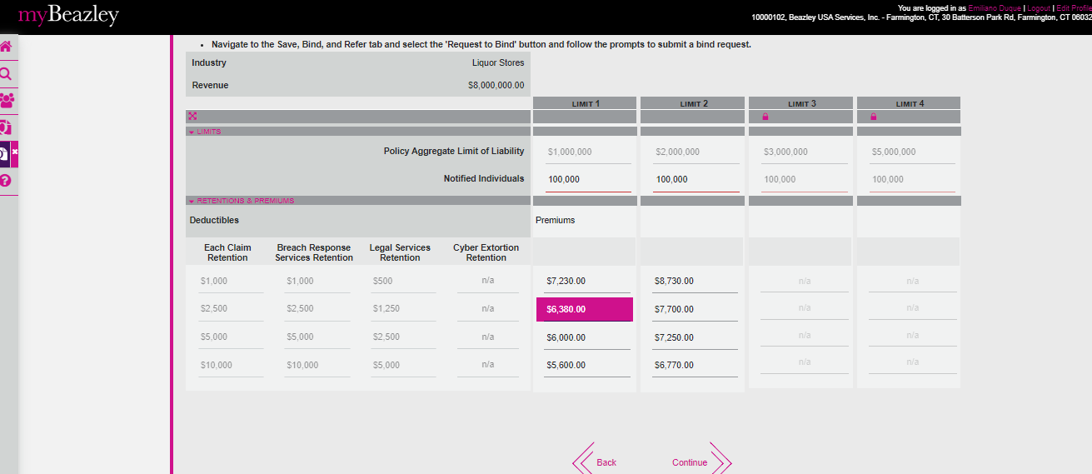

State: MA

Industry Class: Book Publishing

Surplus

BBR Q# 2030872

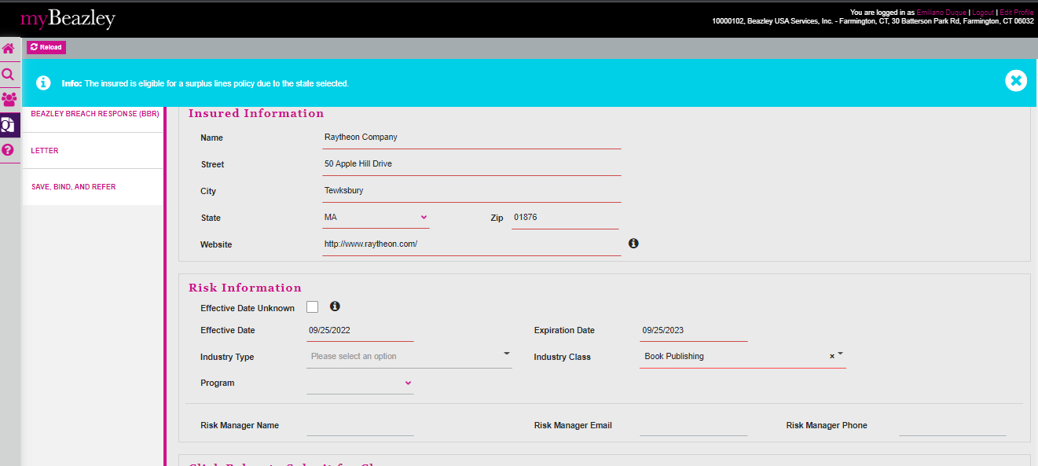

State: MA

Industry Class: Nail Salons

Surplus

BBR Q# 2030873

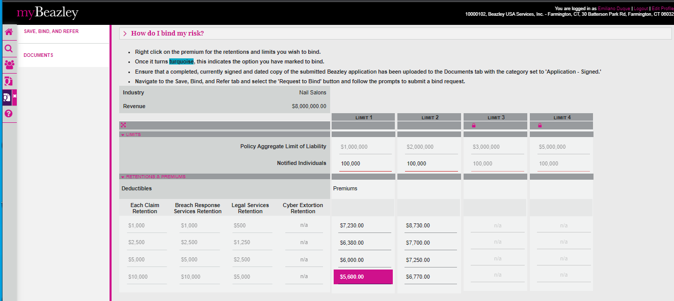

State: MA

Industry Class: Individual Launderers

Surplus

BBR Q# 2030874

State: MA

Industry Class: Parking Lots and Garages

Surplus

BBR Q# 2030875

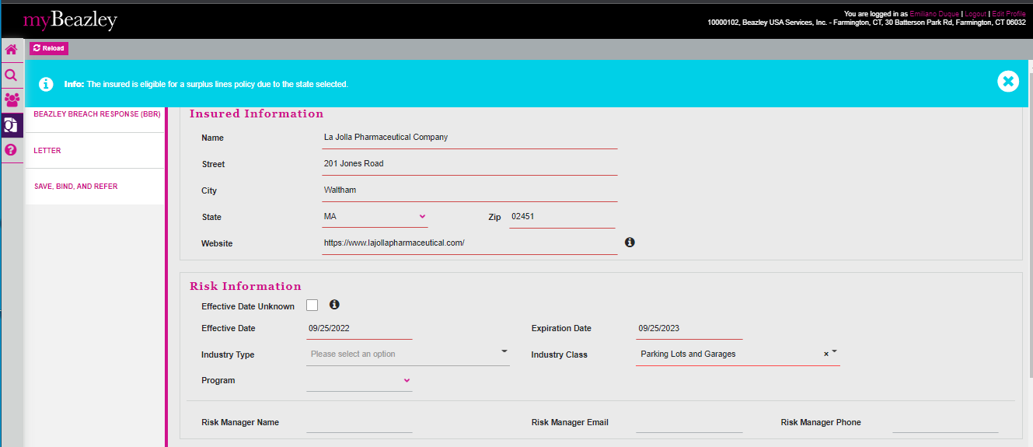

State: MA

Industry Class: Motor Vehicle and Parts Dealers

Surplus

BBR Q# 2030876

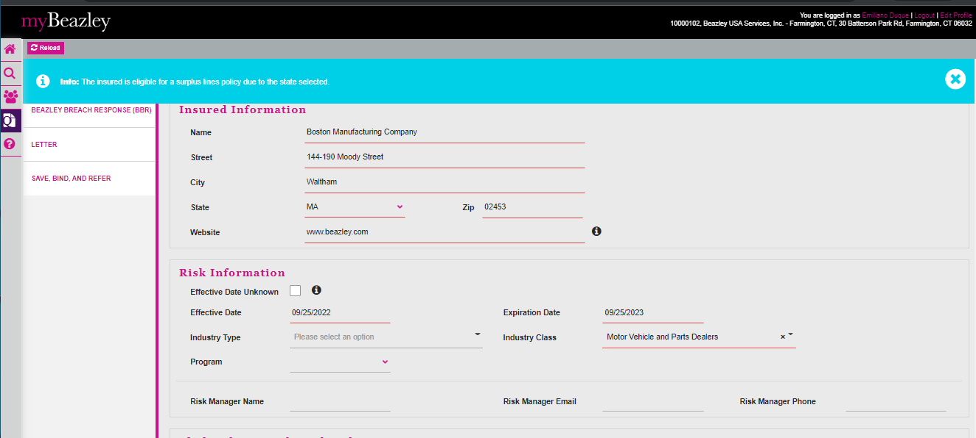

State: MA

Industry Class: Personal Care Services

Surplus

BBR Q# 2030877

State: MA

Industry Class: Tire Dealers

Surplus

BBR Q# 2030878



