# BD-10902

BBR Q# 2030898

State: MT

Admitted

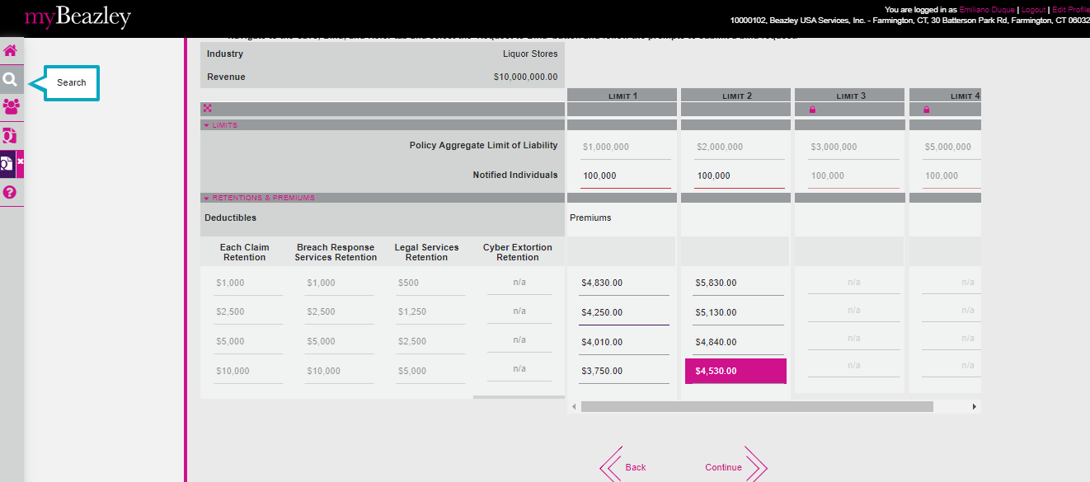

Verified the rater for MT and it is rating pretty well.

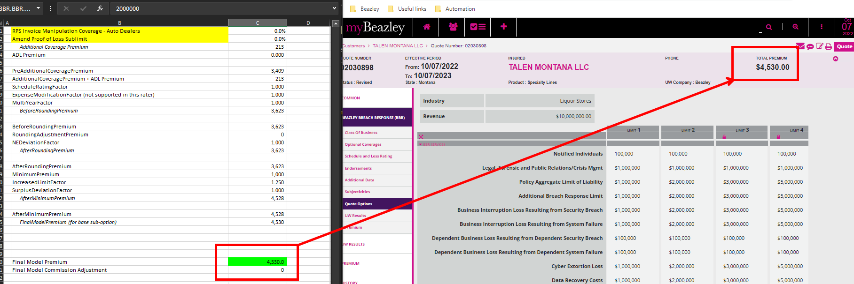

Changed the answer of questions 2 and 3 = NO

