# BD-10902-TC-12329

Recall the BBR Q# 2030864 that was Creates more than 30 days (created 09/01/2022).

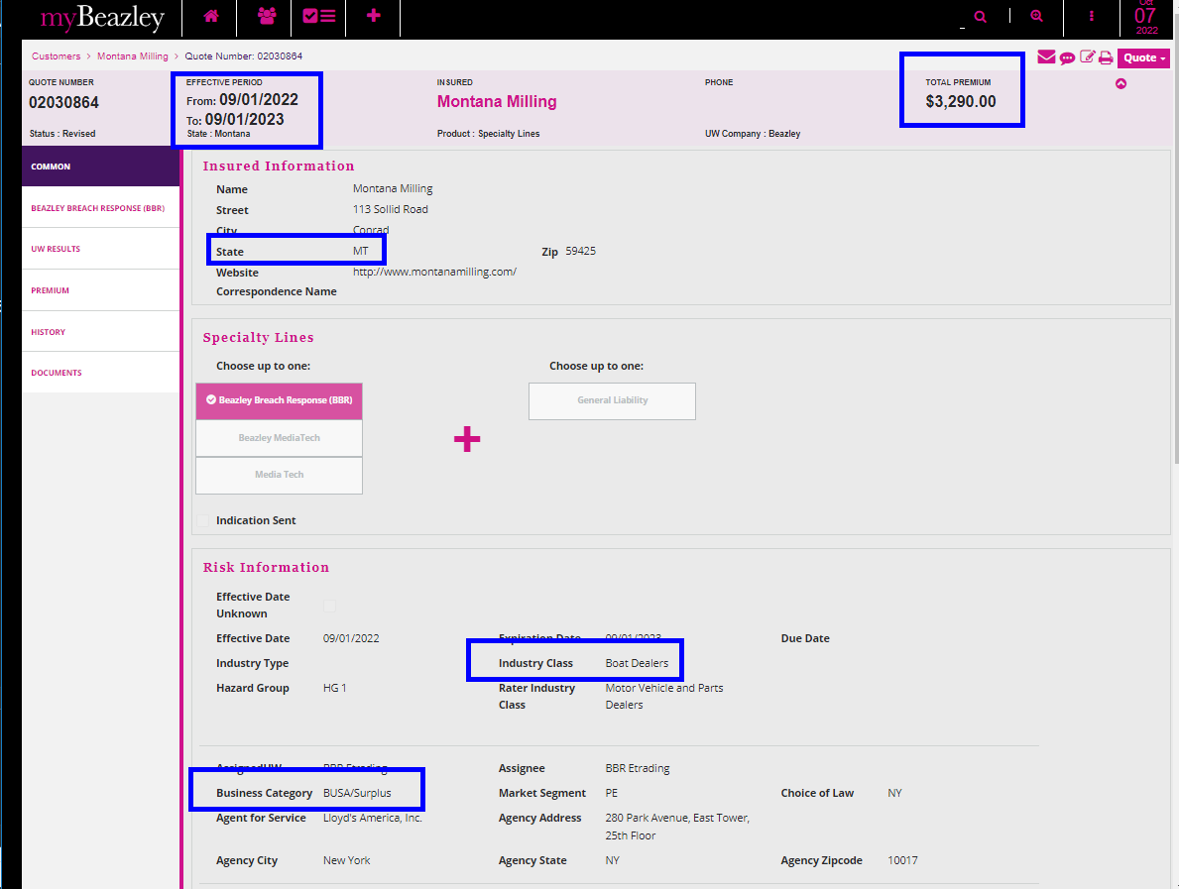

Amend and change answers 2 and 3 = NO

Change the premium

Save and Exit

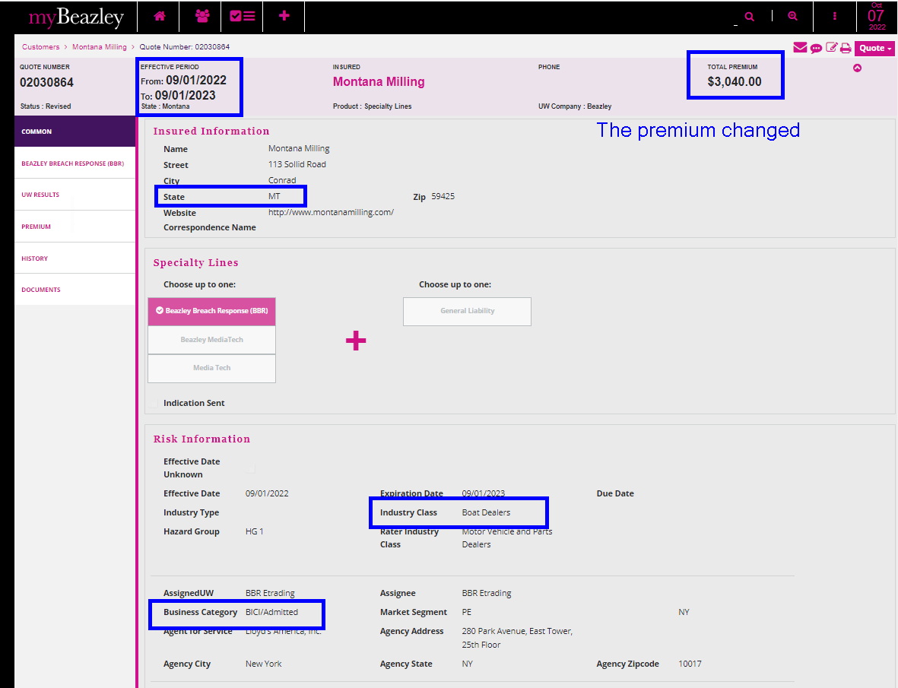

Let’s compare with the Admitted rater for MT.

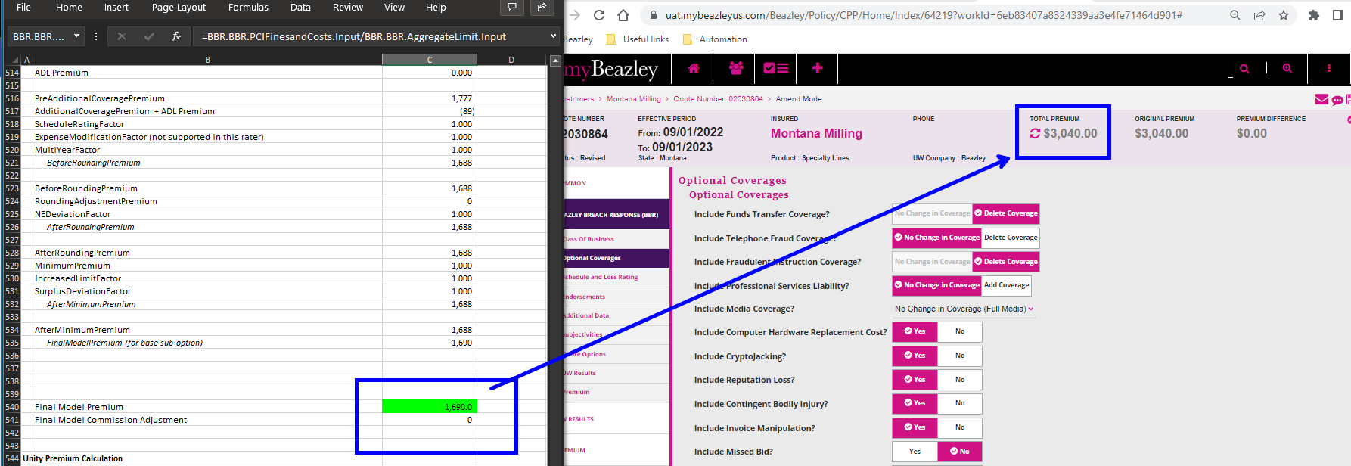

Then, in UWP toggle the surplus and Amitted

Moved to other tab and went back to change to Admitted

Moved to quote options

Now, it has the values for retention 2500 and aggregate limit 1000

Which matches with the rater.

Let’s try a quote within 30 days.

