# BD-10902_TC-12330

BBR Q# 2030930

BBR Q# 2030931

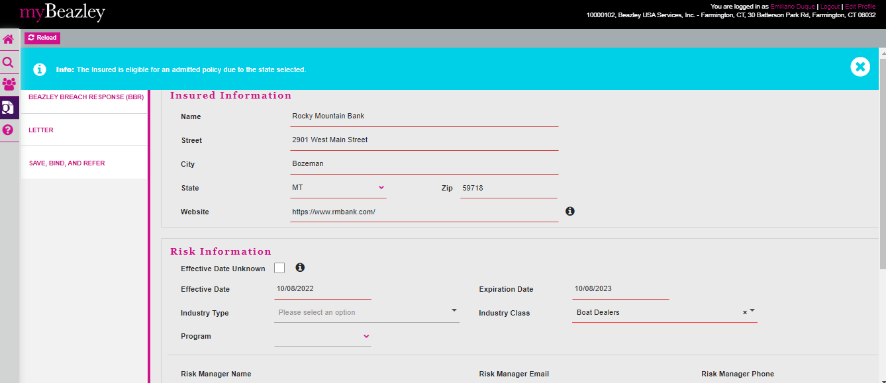

BBR Q#

MA

