# Within 30 days

State: MT

Industry Class: Churches

Surplus

BBR Q# 2030880

As can be seen in the pic, originally it opens as a surplus quote in UWP.

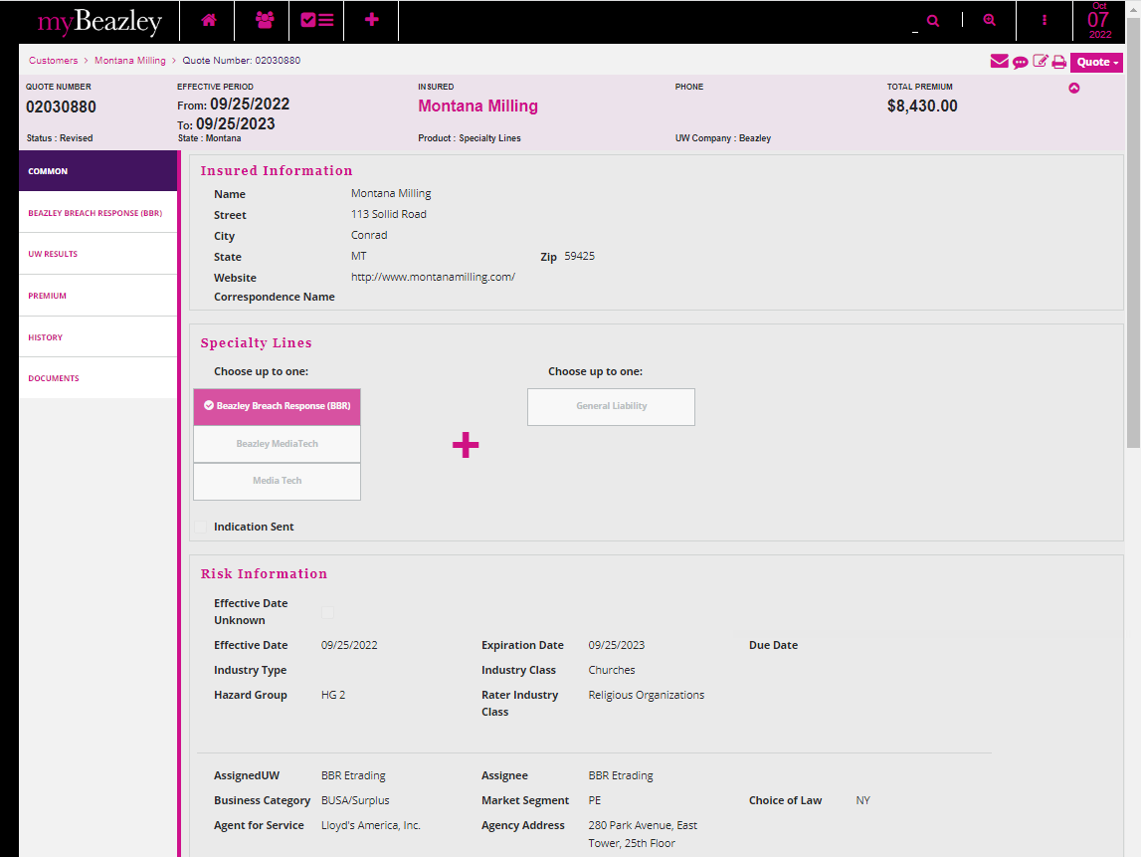

Then amended the policy and changed the answer to question Q#2 = NO

This clears out the quote options and one has to be selected.

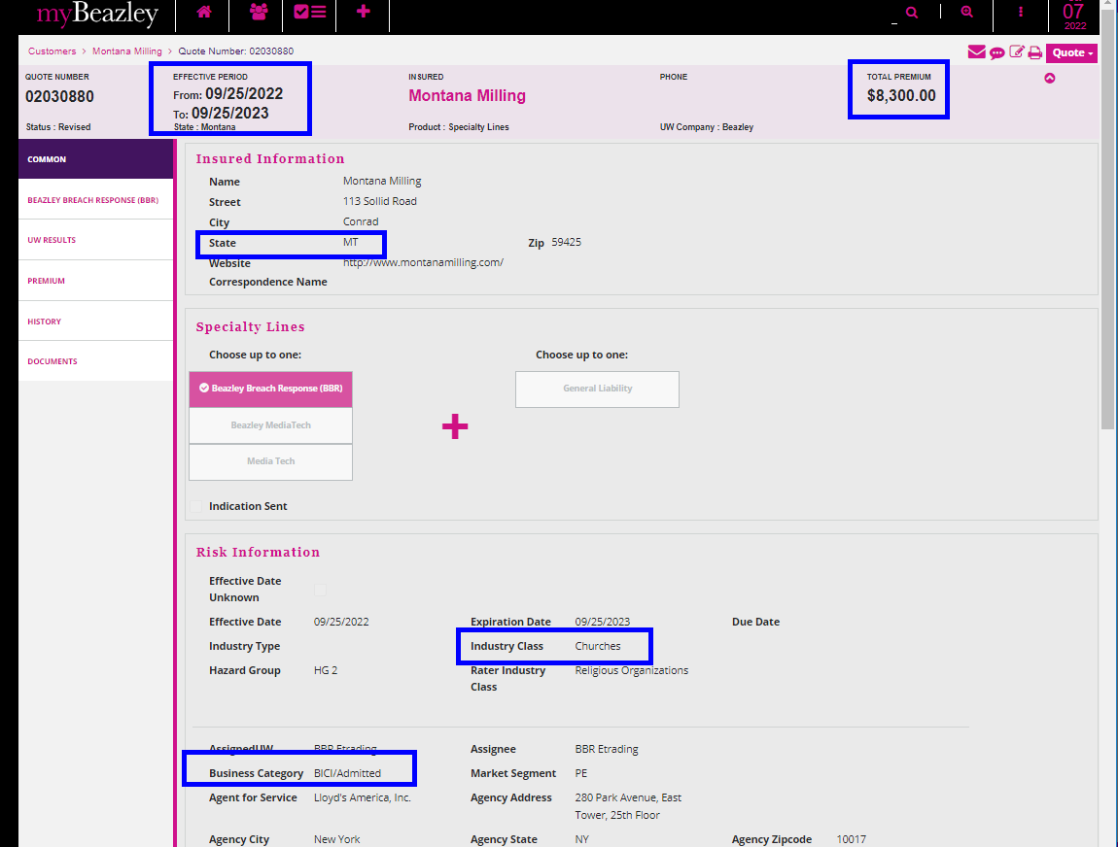

Let’s compare with the rater.

Changed the Industry class to other within the same Hazard Group, move to other tab, then went back and changed to admitted and the original industry class.

Re-rates to the good rate. Select the retention and aggregate limit

This is the value that matches with the rater.

State: MT

Industry Class: Children’s and Infant’s Clothing Stores

Surplus

BBR Q# 2030881

**This time this quote will be changed the question 2 but from AP.**

The quote options get cleared out.

I opened the quote in UWP and it kept the same premium as in AP ($4570). Compared with the rater, but it calculated ($2900).

Amended the quote in UWP, changed the industry class for other that had the same hazard group. It re-rated ok. Went to change back to the original industry class and selected the correct premium for the correct aggregation limit and the correct claim retention.

