# MT- 09/01/2022

State: MT

Industry Class: Boat Dealers

Surplus

BBR Q# 2030864

State: MT

Industry Class: Liquor Store

Surplus

BBR Q# 2030865

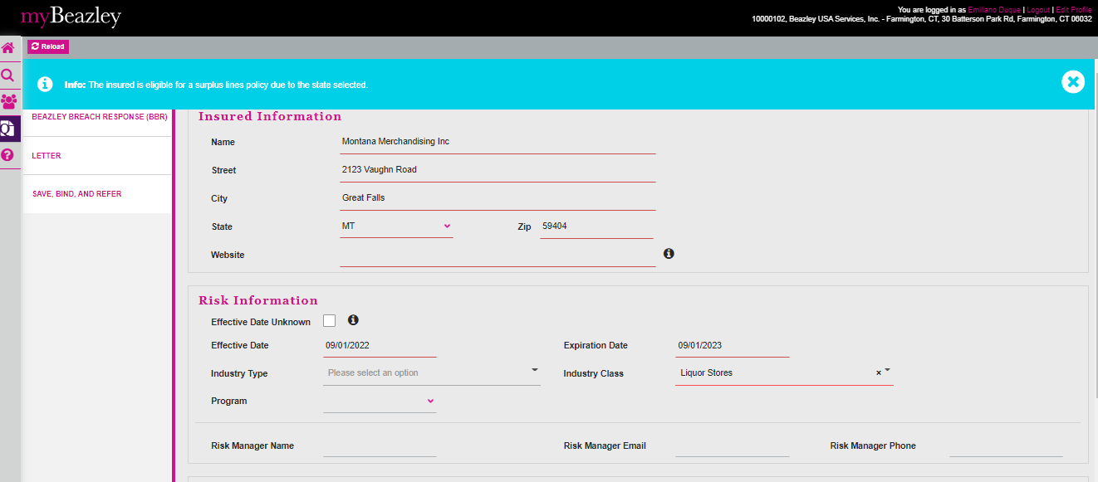

State: MT

Industry Class: Mosques

Surplus

BBR Q# 2030866

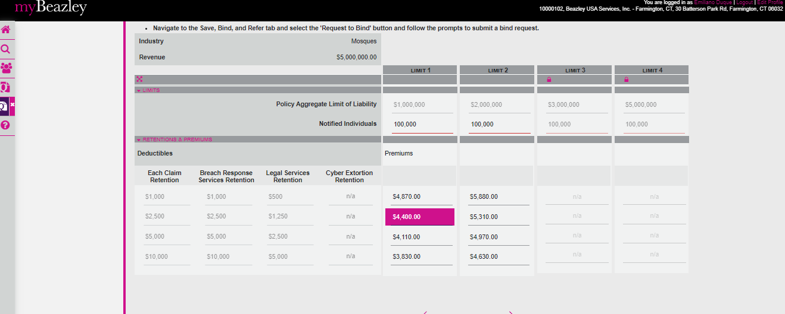

State: MT

Industry Class: Nutraceutics

Surplus

BBR Q# 20308

State: MT

Industry Class: Nail Salons

Surplus

BBR Q# 2030867

State: MT

Industry Class: Nail Salons

Surplus

BBR Q# 2030869

