# MT-TestData-09/25/2022

State: MT

Industry Class: Boat Dealers

Surplus

BBR Q# 2030879

State: MT

Industry Class: Churches

Surplus

BBR Q# 2030880

State: MT

Industry Class: Children’s and Infant’s Clothing Stores

Surplus

BBR Q# 2030881

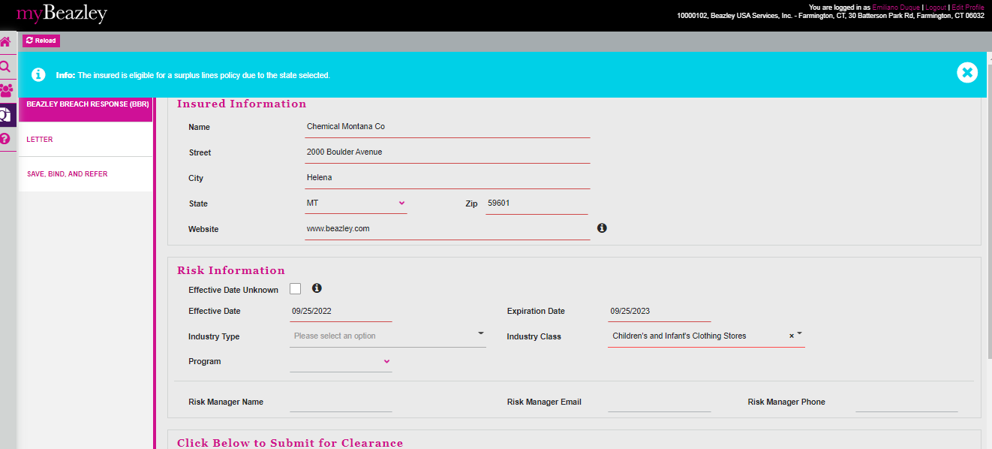

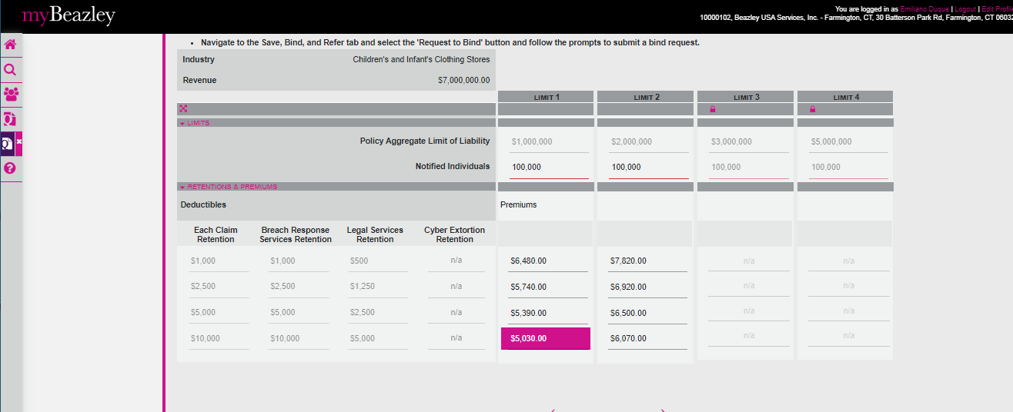

State: MT

Industry Class: Dating Service

Surplus

BBR Q# 2030882

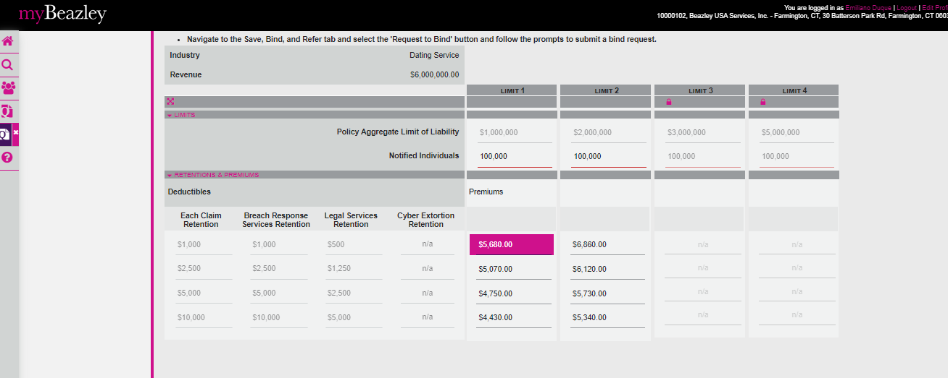

State: MT

Industry Class: Diagnostic kits

Surplus

BBR Q# 2030883

State: MT

Industry Class: Electronics and Appliance Stores

Surplus

BBR Q# 2030884

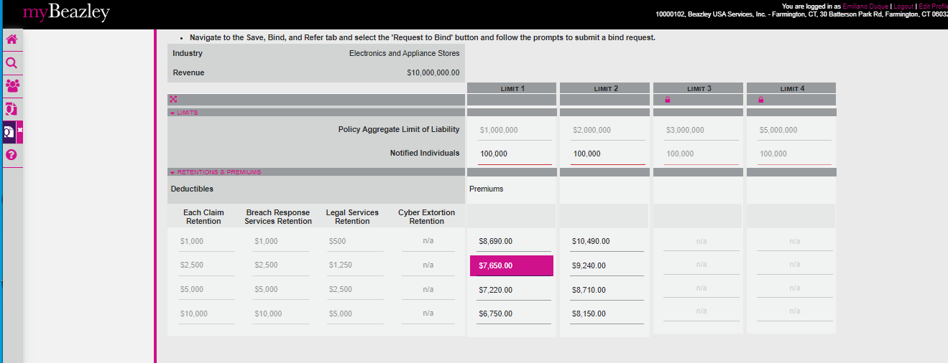

State: MT

Industry Class: Diet and Weight Reduction Centers

Surplus

BBR Q# 2030885

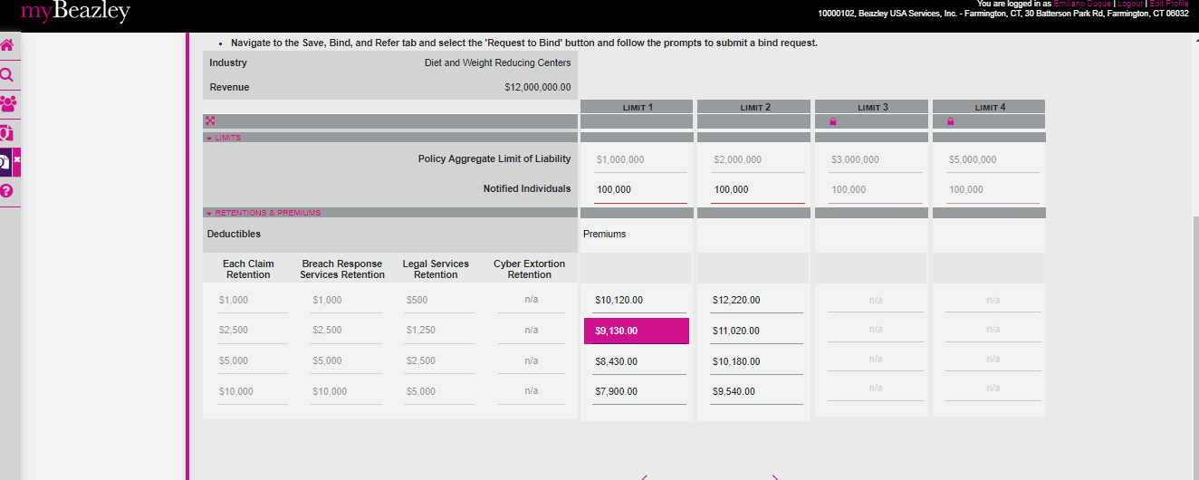

State: MT

Industry Class: Gasoline Stations

Surplus

BBR Q# 2030886

