# BD-7967

Creating other BBR Q# 2030891

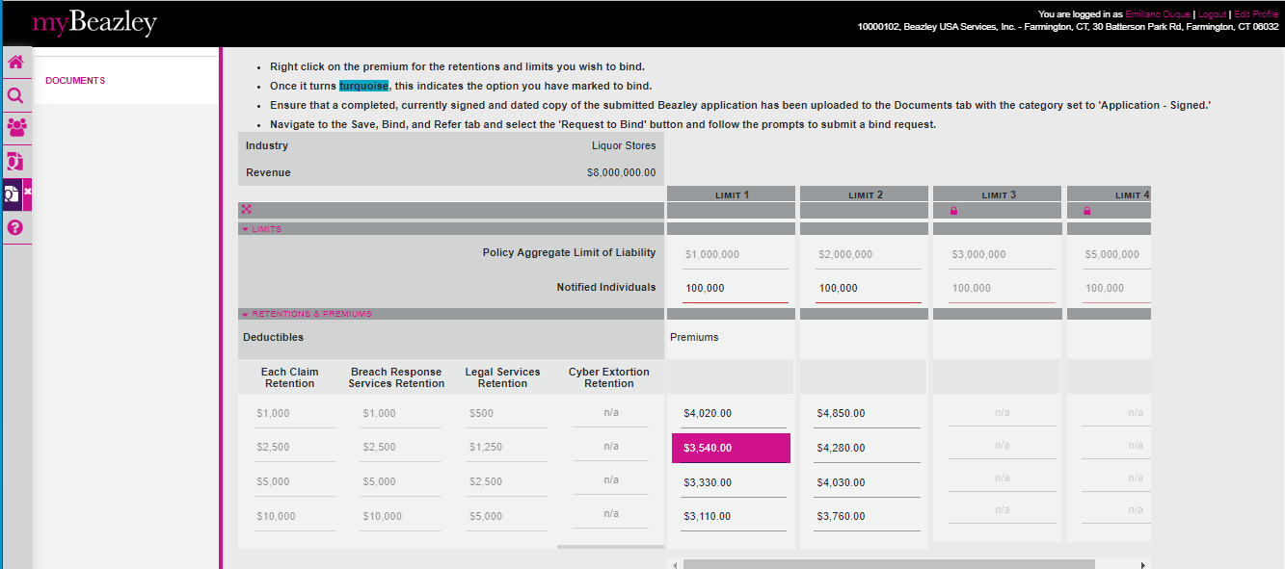

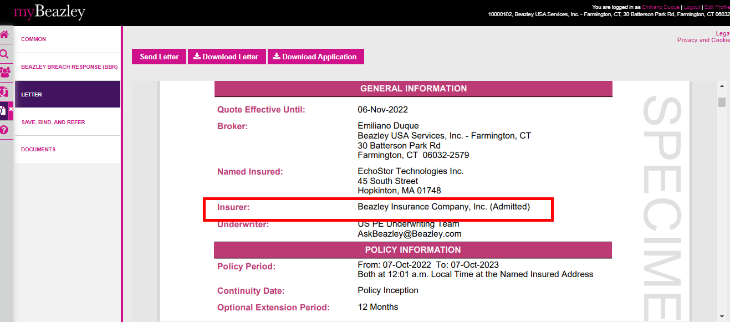

Opening it in GC



