# BD-11989-Tested

This were the values before this ticket, when you selected the question 7=NO and you had a revenue less than 35M. All first party sublimit were set to $100,000.

Now, let’s test that this rule does not apply with the new ticket. The first party sublimits should not be all equal to $100,000.

BBR Q# 2030980

Revenue: $10.000.000

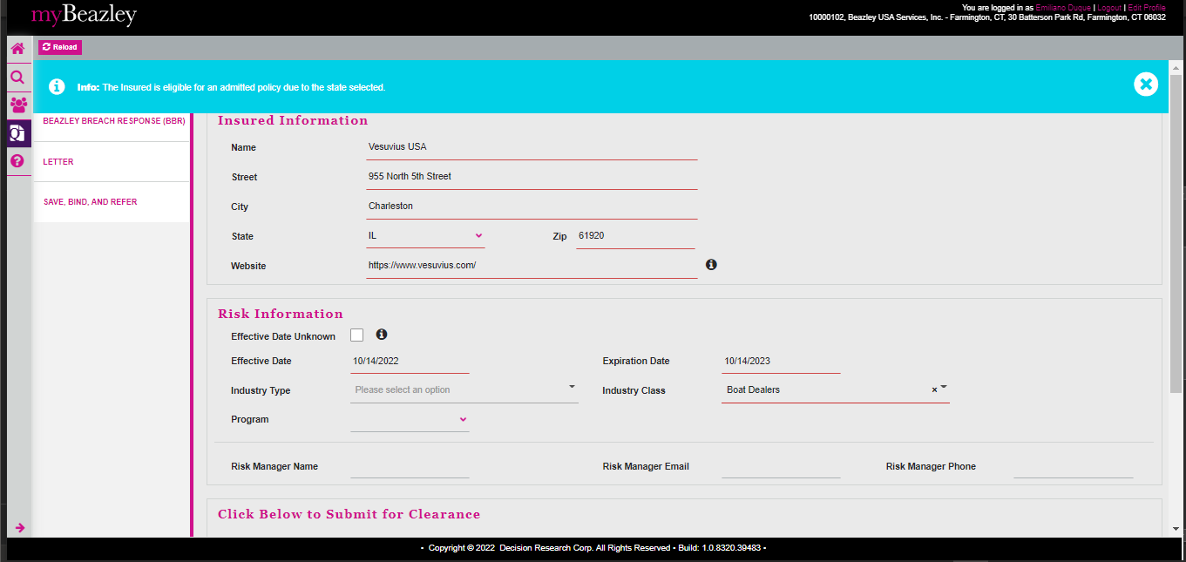

Selected happy path Q7 = YES

Open the quote in UWP and verify the First Party Sublimits

Now, answering Q7 = NO

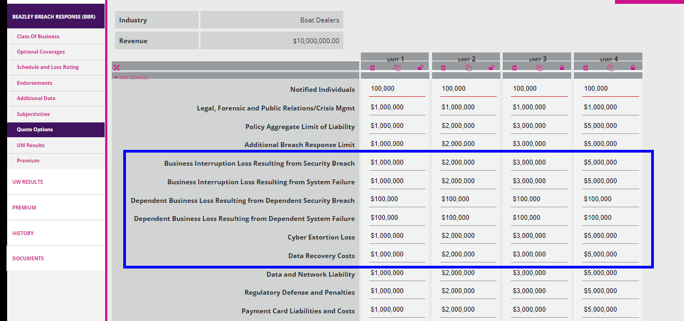

Now, let’s create a new quote with Auto Dealership and Revenue: $247.000.000

BBR Q#2030981

Changed the status to Reserved and went back to AP

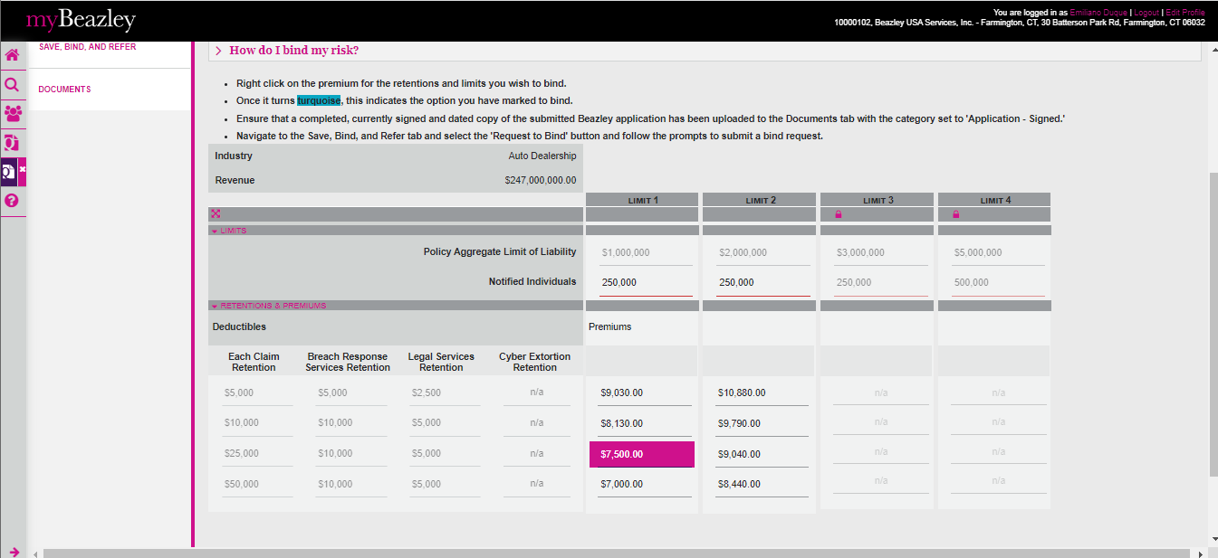

Opening the quote in UWP

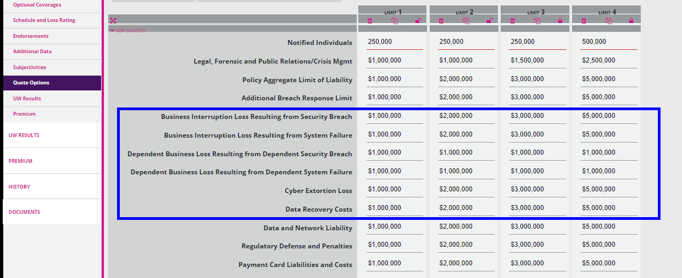

Now, let’s change the answer to Q7 = NO

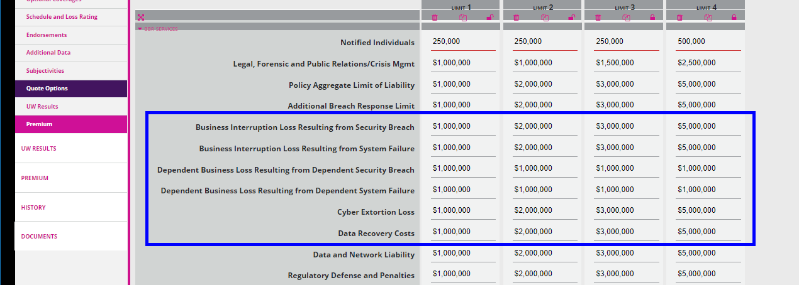

As we can see, after answering Q7 = No, the first party sublimits are not affecte by the rule that was before.