# BD-11648_TC-AllBands

BBR Q#2031172

Revenue $1M

All questions answered favourably.

Let’s toggle to one negative answer… 11=NO

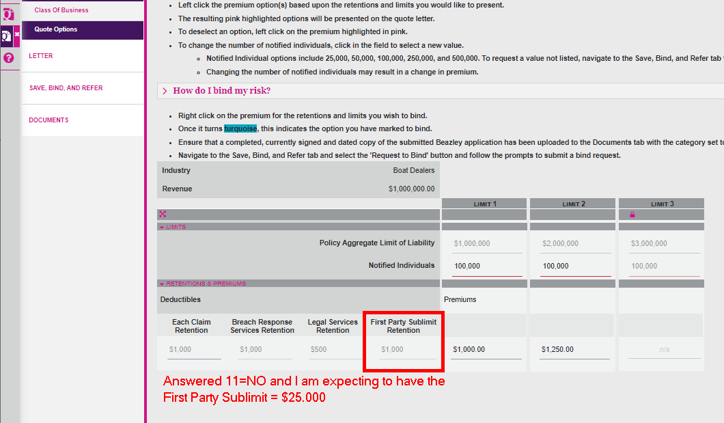

BBR Q#2031177

Revenue $2M

All questions answered favourably.

Revenue $2M

One question answered unfavourably. 12=NO

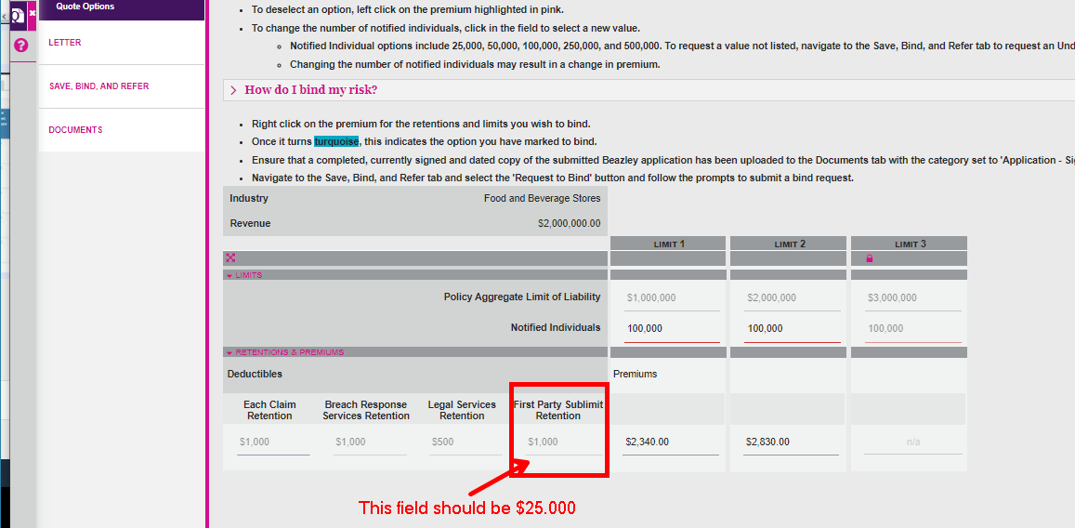

BBR Q#2031181

Using Revenue=4M

All questions answered favourably

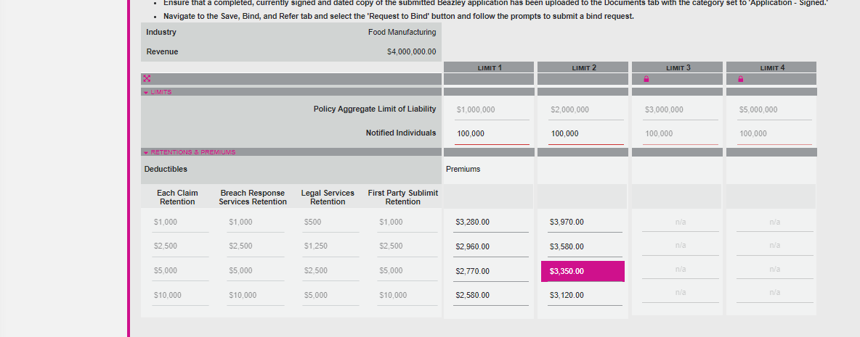

12A=NO

BBR Q#2031175

Using Revenue=20M

All questions answered favourably

Question 11 = NO

BBR Q#2031183

Using Revenue=35M

All questions answered favourably

Answer 6a=NO

BBR Q#2031186

Using Revenue=249M

All questions answered favourably

6A=NO

