# BD-11648_TC-allPositive

BBR Q#2031172

Let’s toggle to one negative answer… 11=NO

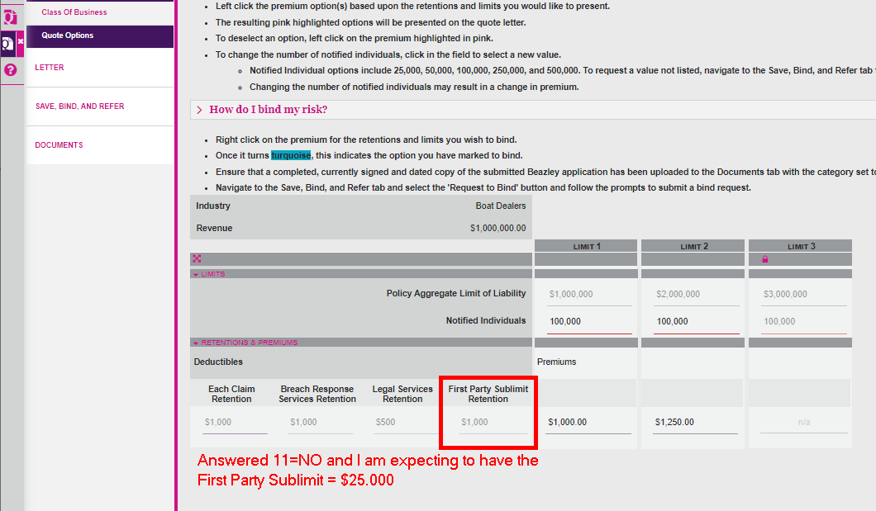

Using Revenue=20M

All questions answered favorably

Question 11 = NO

