# BD-11922 TC-14184

BBR Q# 2031287

State: AK

Surplus

Answered all in the happy path

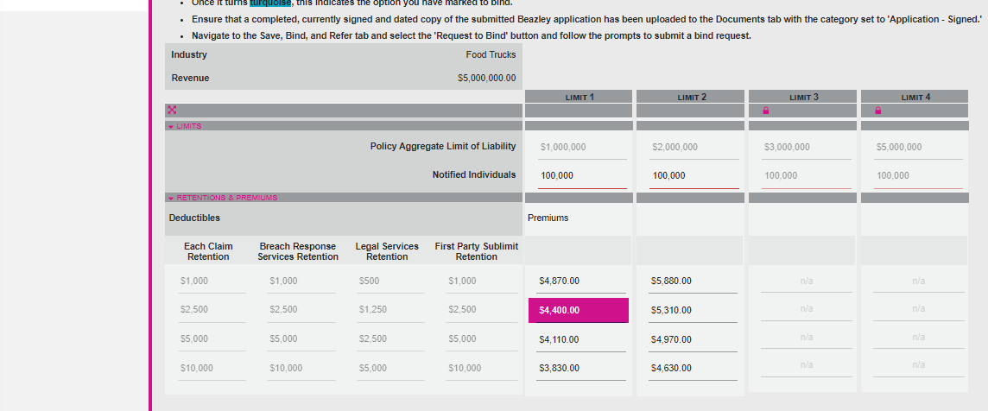

Document letter

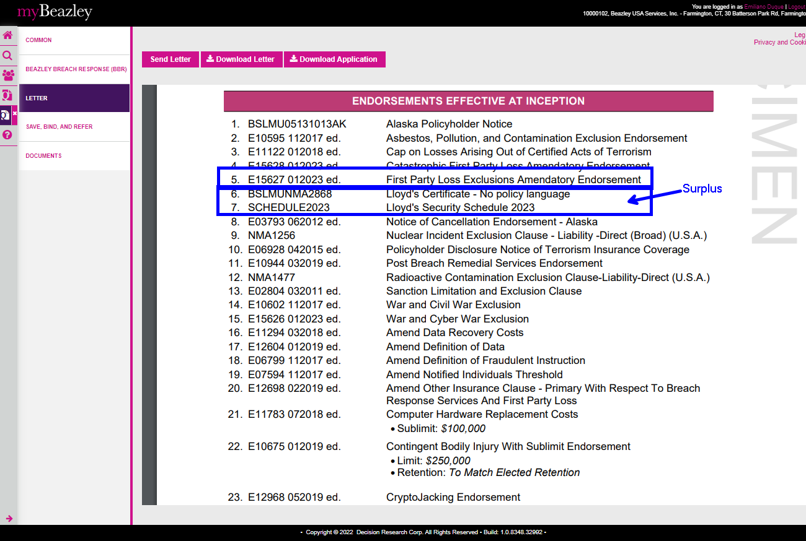

BBR Q# 2031294

State: FL

Surplus

All answers favorably

