# BD-11922 TC-14185

BBR Q#2031297

State: AZ

Admitted

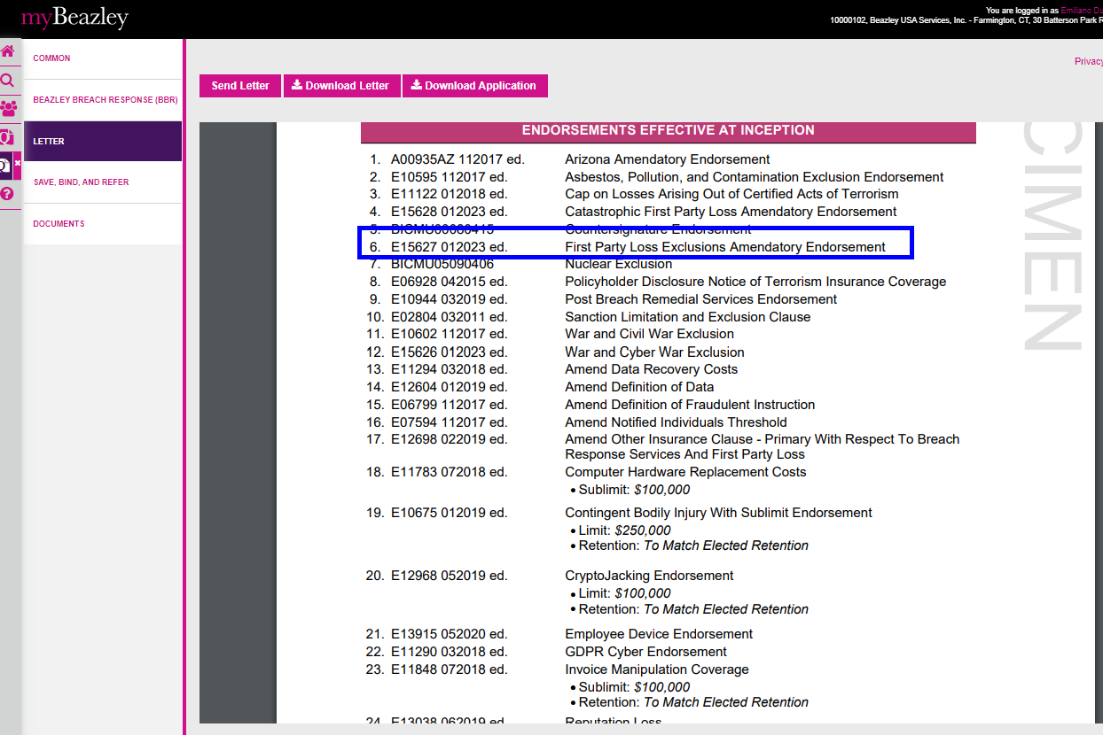

BBR Q#2031302

State: MI

Admitted

Happy path

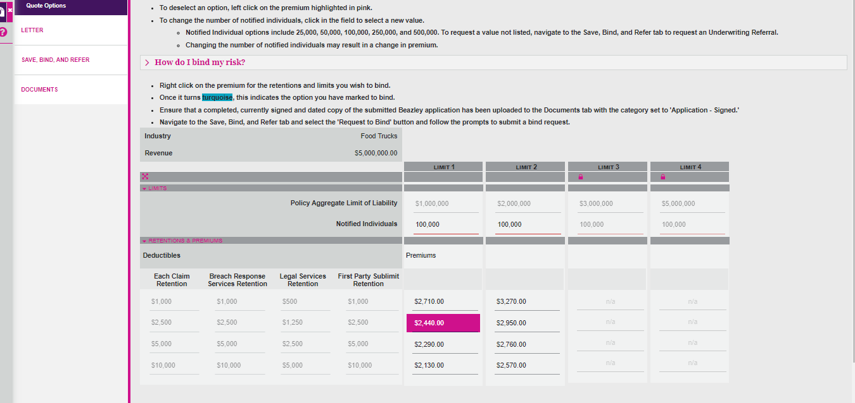

BBR Q#2031308

State: MN

Admitted

Happy Path

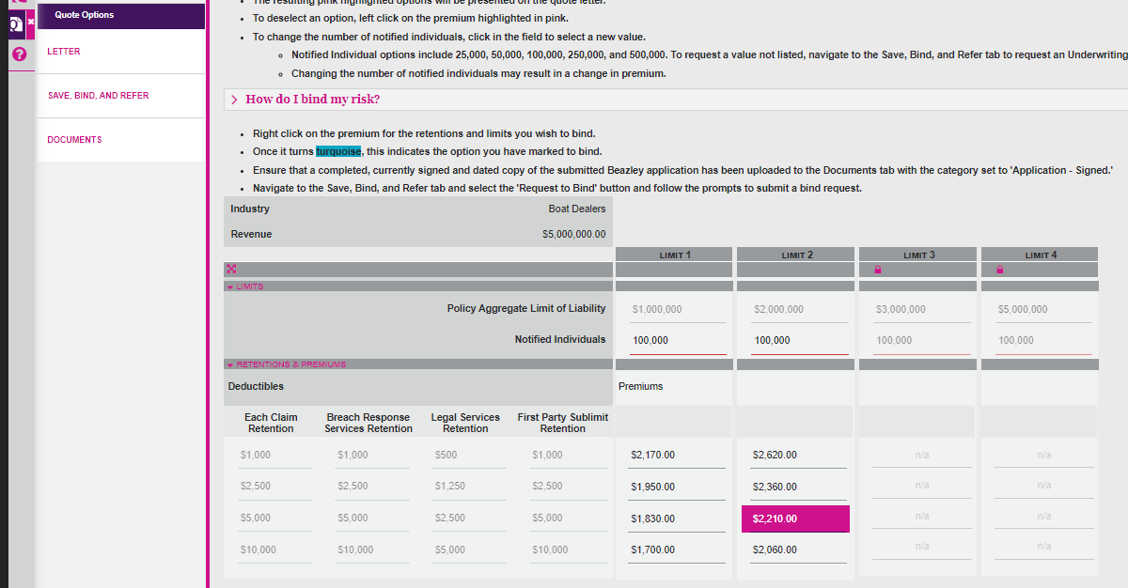

BBR Q#2031309

State: NJ

Admitted

Happy Path

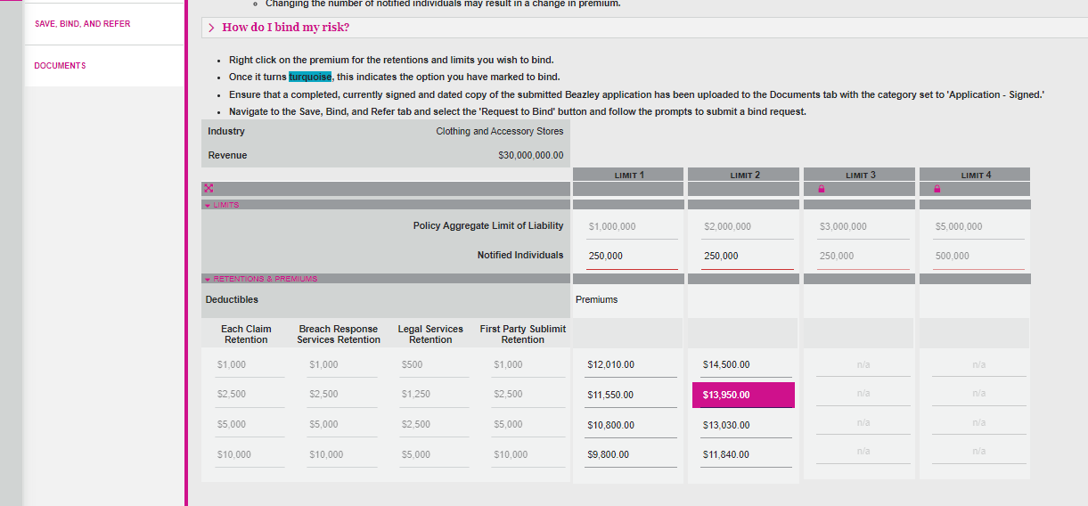

BBR Q#2031310

State: TX

Admitted

Happy Path

BBR Q#2031314

State: NY

Admitted

Happy Path

