# BD12873

BMT: WG00004478AA

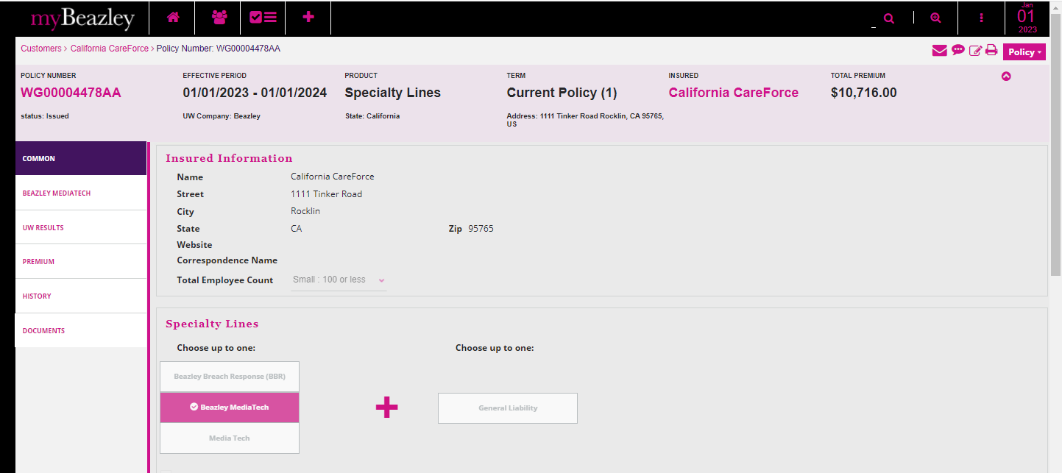

BMT + GL: WG00004477AA

Quote Letter:

Binder Letter:

Policy Declaration:

