# BD-12879_Tested

BBR Q# 2031541

Industry Class: Apparel Manufacturing

SLDF Base: 2.9

HG: 1

State: CA

Line: Surplus

Now, if we have 1 question = No, and we override it in UWP

SLDF all favourably

Question 6B = No

6B and 10 = No

With the Question 6B=No we are going to override the Surplus Deviation Factor and verify before ana after.

In this case due to the 6B=No the SLDF base = 2.9+0.1=3.0

Now, let’s override the value in the Optional Coverage tab and see how the Quote Option Premium gets affected.

The Quote Options change and we can compare the value against the rater using SLDF base = 2.9

Changing to 3.4 (it means we are assuming we answered 5 negative questions) 2.9 + 0.5 = 3.4

Note that we are overriding the original value, since the user only selected one negative question 6B=No

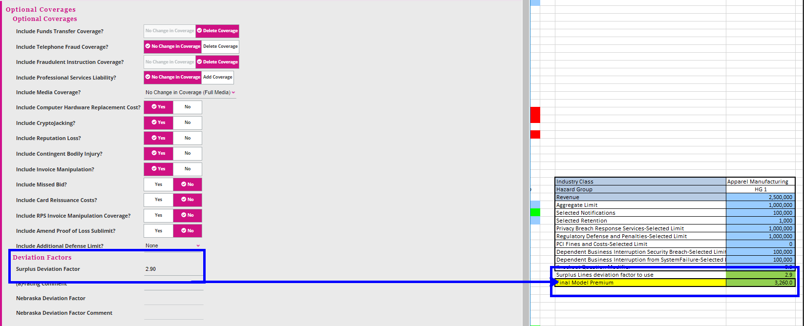

BBR Q# 2031553

Industry Class: Charitable Organizations

SLDF Base: 1.4

HG: 2

State: IL NOTE: this is an Admitted state This produces errors

Line: Surplus

Now, let’s change the questions 2 and 3 = Yes

Now, let’s answer questions 9, 10, 12B = NO

Now, let’s override this value in the UWP and use 2.5 = Base SLDF and expect to have a premium = $2500

Let’s change the revenue to $1.550.000



