# BD-12879_TestData_11/23/22

BBR Q# 2031531

HG1

Industry Class: Tire Dealers

Surplus

11/29/2022

Q2=Q3=NO, RSA 12B=12C=NO

BBR Q# 2031532

HG1

Industry Class: Used Car Dealers

Surplus

Now, will change one RSA on 11/29/2022 and see if it rerates with the new ratter.

Changed the Industry Class: Book Publishing

Revenue: $3.000.000

BBR Q# 2031533

HG2

State: CA

Industry Class: Florists

Surplus

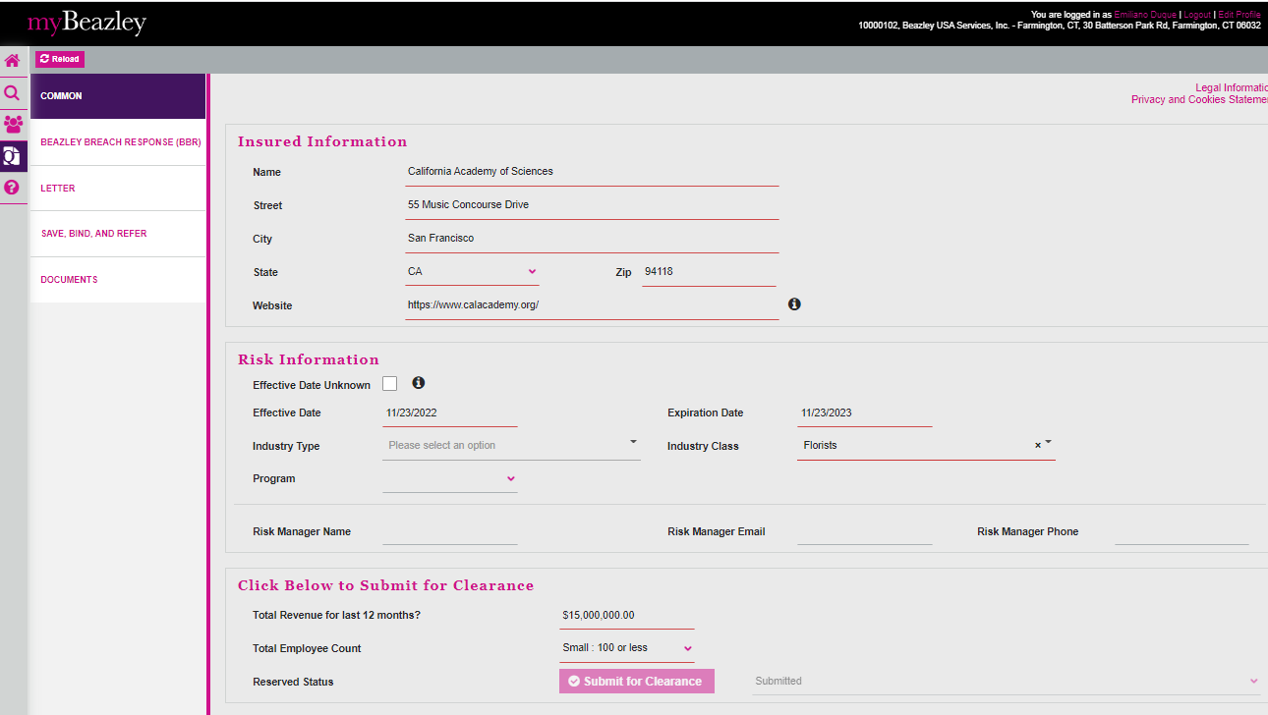

11/29/2022 Open and change a non-premium-bearing change

Then opened in AP and changed the industry class: Furniture and Home Furnishings Stores and the Revenue: $10.000.000

Changed the Q2=Q3=NO

And RSA 9=10=NO

BBR Q# 2031535

HG3

State: AK

Industry Class: Other Financial Vehicles

Surplus

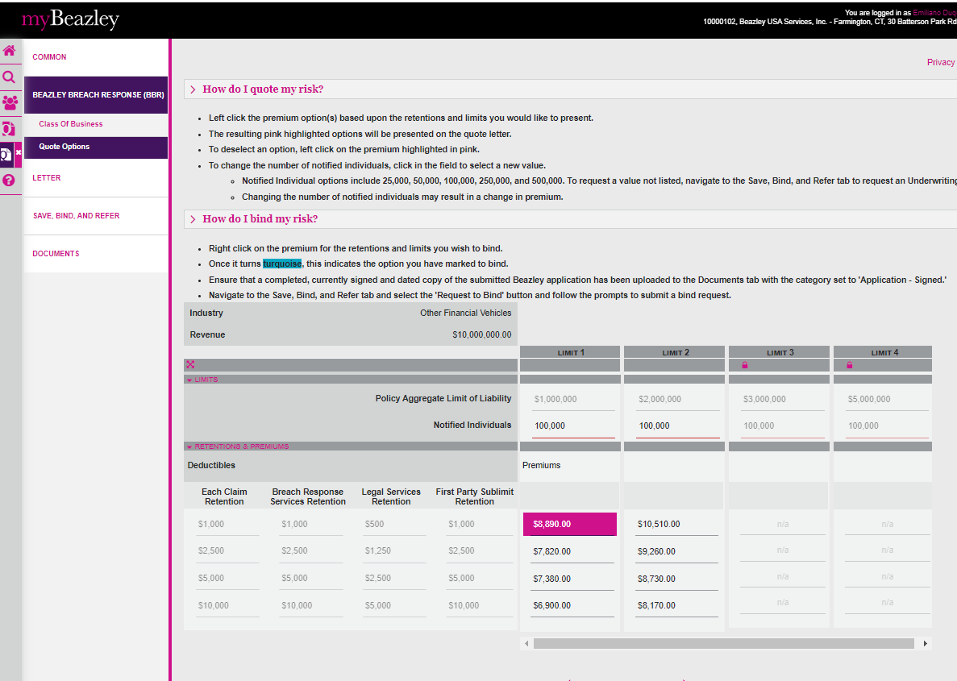

11/29/2022

Q2=Q3=NO, 5 RSA negative questions

BBR Q# 2031536

HG4

State: AK

Industry Class: Nursing Care Facilities

Surplus

11/29/2022

Q2=Q3=NO, 4RSA negative

BBR Q# 2031537

HG5

State: WY

Industry Class: Dentist

Surplus 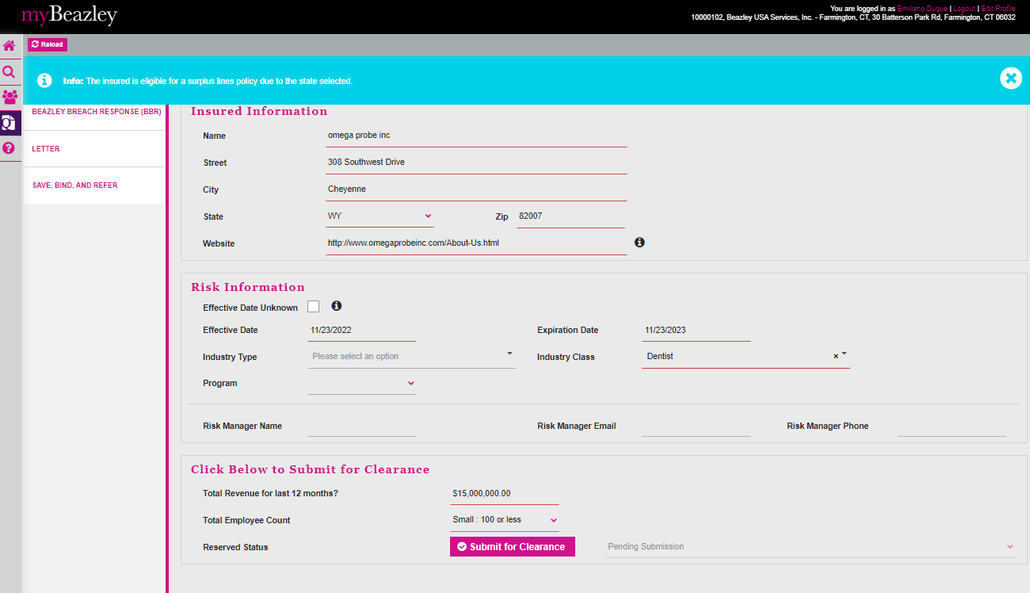

11/29/2022

Revenue$10.000.000

Q2=Q3=NO

BBR Q# 2031538

HG6

State: CA

Industry Class: Sales Financing

Surplus

