# BD-9147

**Description:**

The user says that every time she makes a renewal with effective date after **10/1/2022**, the Rapid Renewal Questionnaire document does not appear in the documents tab.

These screen shots show that there was only one situation in which it actually happened in UAT environment (WB00004053AB). Also, it was tested in efix to see the behavior in that environment, too.

There is a recap at the end of this document.

You will see different scenarios.

**Scenario 1:**

These are renewals manually generated in UAT.

**Steps to reproduce:**

To be able to see the differences, we are going to create policies with two renewals with different effective dates, one before and other after **10/1/2022**.

Before the date (10/1/2022):

* Create or copy a quote with Effective Period **9/10/2021 – 9/10/2022** and convert it to a policy (?GxxxxxxxAA).
* Create a renewal of this policy to create a ?Gxxxx xxxAB and this will have an effective period **9/10/2022 – 9/10/2023** which is what the user has in prod.
* Verify documents tab and email and verify if the Rapid Renewal Questionnaire is present.

After the date (10/1/2022):

* Create or copy a quote with Effective Period **10/15/2021 – 10/15/2022** and convert it to a policy (?GxxxxxxxAA).
* Create a renewal of this policy to create a ?GxxxxxxxxAB and this will have an effective period **10/15/2022 – 10/15/2023** which is what the user has in prod.
* Verify documents tab and email and verify if the Rapid Renewal Questionnaire is present.

Testing different dates after 10/01/2022

**Scenario 2:**

Testing in **efix** when the renewal was **automatically** generated by the system, provided by the user.

I am using the policy numbers that did not work in Production (provided by the user).

Other from Production tested in **efix** when the renewal was automatically generated by the system (provided by the user).

Other from Production worked in efix when the renewal was automatically generated by the system.

**Scenario 3:**

Now let’s copy a quote for the effective period **10/18/2019 – 10/18/2021** in **efix** environment. This will be a renewal **MANUALLY** created.

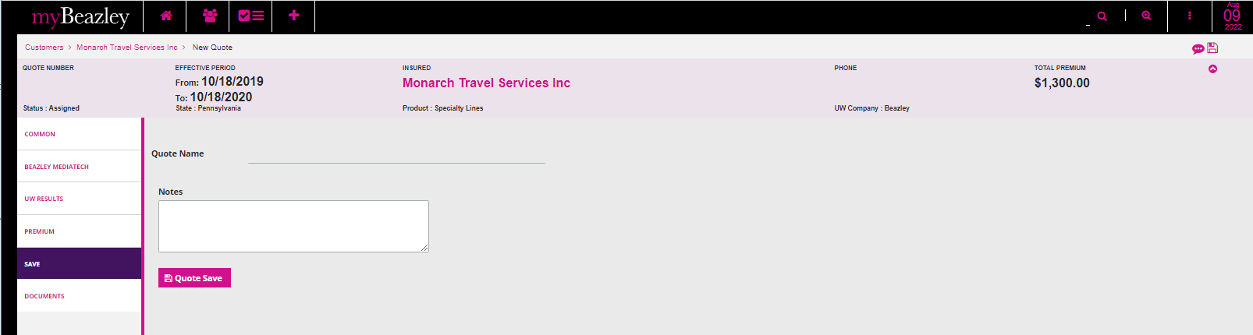

New quote

After this I issued the new policy

Now let’s copy a quote for the effective period **10/18/2021 – 10/18/2022** in **efix** environment. This will be a renewal **MANUALLY** created.

**Recap:**

In UAT were tested some renewals **manually** created with dates before and after the 10/1/2022 effective date.

There was only one renewal in UAT which did not get the questionnaire document. All the others tested ok when the renewals were done **manually.**

Tested in Efix environment the policies the user provided which were **automatically** generated by the system in production. All these renewals did not get the questionnaire document.

Copied some quotes in Efix and created **manually** renewals wit effective dates after 10/1/2022, and these renewals came with the Questionnaire document.