# BD-8692

Previous to step 1, I copied a quote and created a new one.

Step 1: Is the creation of the issued policy

Then, bond the quote.

Let’s issue the policy

The step 1 does not create an additional LES entry.

Step 2: Perform a Revised Policy… Effective Date 5/25/2022

New history entry is generated

New documents generated after the Revised policy

Now you should have 3 entries in LES

From bottom up, you will see the new business which was created once we bound the policy.

Then the **Error correction** is created once you perform the Revised Policy and changed the Effective Date (from 5/27/2022 to 5/25/2022), and it creates the **New business** in the middle with the new Effective Date (5/25/2022).

Step 3: Make a Rollback

No changes in LES

Step 4: Perform a Revised Policy… Effective Date 5/25/2022

No changes in LES

Step 5: Perform an MTA…

This is the history after save changes

No changes in LES after the MTA eventhough the Premium changed from $1000 to $973

Step 6: Make a rollback to 01-04

No changes in LES after the Rollback in step 6.

Step 7: Perform an MTA with effective date 05/27/2022 and change the expiration date to 05/15/2023

This step makes a change in the Premium

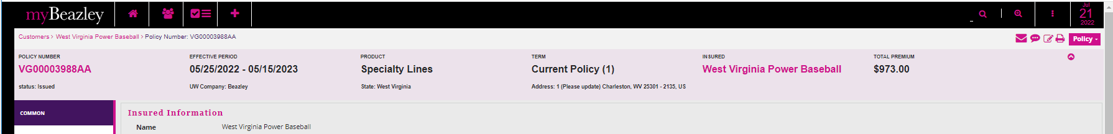

New history after step 6 is done

But LES does not reflect the changes.

