Market Intelligence Hub — User Manual
  - Prysmian × EY · AI-powered always-on intelligence platform
EY for Prysmian Group
May 2026
Table of Contents

1. Introduction
The Market Intelligence Hub is an AI-powered platform that aggregates, curates and distributes reliable market intelligence to Prysmian’s business units. It transforms scattered Excel files, news feeds and CRM/ERP data into a single source of truth, with audit-grade traceability and always-on AI agents that monitor the market on your behalf.
What it does, in one sentence: six AI agents continuously scan public sources (news, mining projects, KPI signals, competitor moves, customer events) and write back evidence-backed insights into a central Hub, where the MI team can validate them before they reach the wider organization.
Who it’s for: - MI team — review and validate AI drafts before publishing - Country managers / BU leads — daily intelligence on their geography and product line - Sales — Share-of-Wallet insight on key customers - Executives — high-level dashboards and alerts
This manual covers every screen and every function in the demo build.

2. Accessing the platform
The platform is web-based — open it in any modern browser (Chrome, Edge, Firefox, Safari).
Demo URL: https://mi-hub-web.onrender.com

2.1 Login
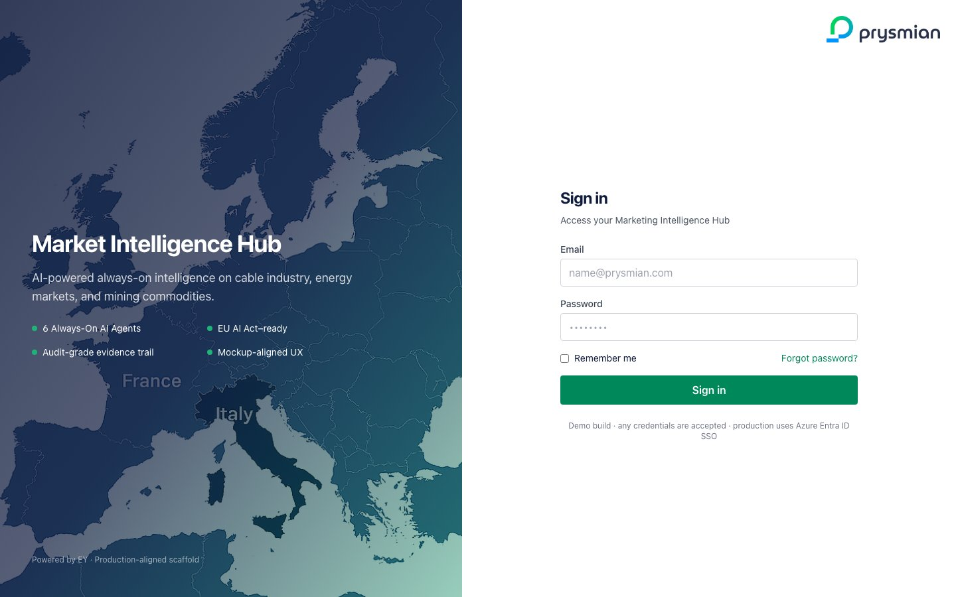
Login screen
The split-screen login shows:
- Left panel — branded hero with the Market Intelligence Hub value proposition: 6 always-on AI agents, EU AI Act ready, audit-grade evidence trail.
- Right panel — sign-in form: email + password, “Remember me” checkbox, “Forgot password?” link.
In production this will use Azure Entra ID (SSO). In the demo build any non-empty email + password is accepted.
To sign in: 1. Enter your corporate email 2. Enter your password 3. Click Sign in
💡 The demo banner under the button reminds you that demo credentials are not validated. Production uses SSO with role-based access control (RBAC).

3. The Dashboard
After login you land on the Dashboard — your daily briefing screen.
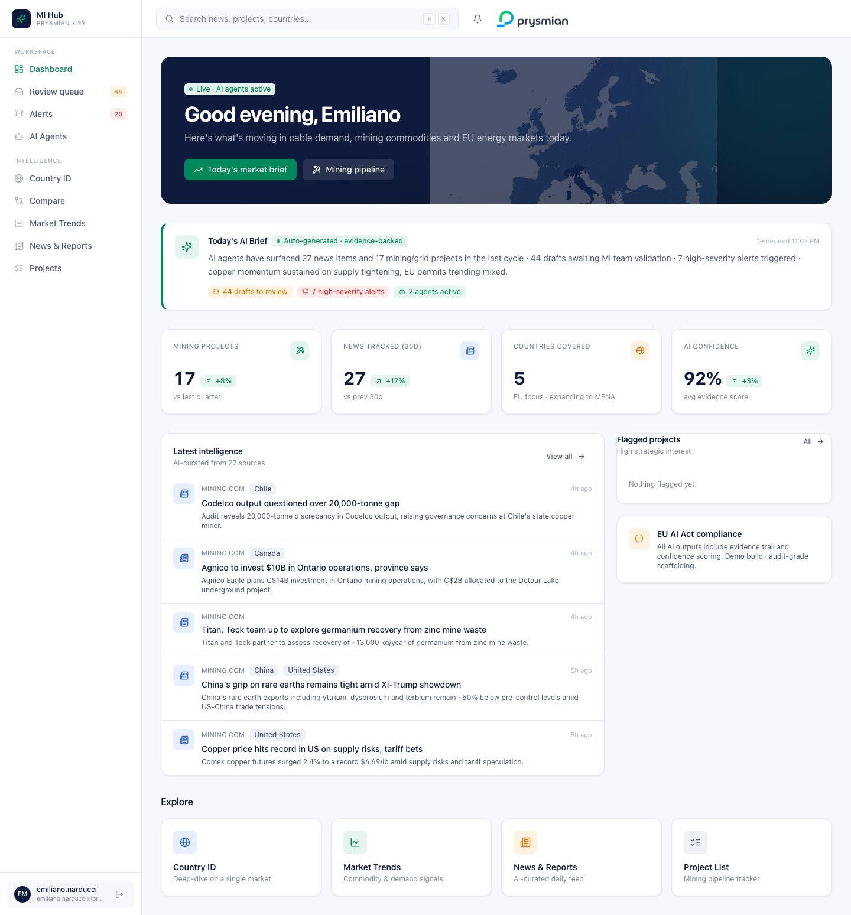
Dashboard

3.1 Page anatomy

3.1.1 Left sidebar — navigation
The sidebar is split into two groups:
- Workspace (operational tasks)
  - Dashboard — this screen, the daily briefing
  - Review queue — AI drafts awaiting your validation, with a badge counter
  - Alerts — triggered alerts (KPI deviations, competitor moves), with unread counter
  - AI Agents — control center for the 6 monitoring agents
- Intelligence (data exploration)
  - Country ID — per-country deep-dive
  - Compare — side-by-side country comparison
  - Market Trends — commodities, GDP, construction indicators
  - News & Reports — full news feed
  - Projects — mining/grid project pipeline
The active page is highlighted in Prysmian green. The user pod at the bottom shows your initials and email with a one-click Logout button.

3.1.2 Top bar — search and notifications
- Search bar — click or press ⌘K (Mac) / Ctrl+K (Windows) to open the global search palette
- Bell icon — quick notifications shortcut
- Prysmian logo — top right

3.1.3 Hero greeting
The header welcomes you by name with the current time-of-day greeting (“Good morning / afternoon / evening, Your Name”). The “Live · AI agents active” badge confirms the AI is running in the background. Two quick-action buttons take you to today’s market brief and the mining pipeline.

3.1.4 Today’s AI Brief
A green-bordered card auto-generates a one-paragraph executive summary using live numbers from the database. It cites:
- Number of news items and projects surfaced by agents
- Drafts awaiting MI team validation
- High-severity alerts triggered
- Headline market signal (e.g., copper momentum)
Three chip-links jump directly to the Review queue, Alerts inbox, and Agents page — these are your one-click entry points to take action.
The brief regenerates every page load and is timestamped (top right). The evidence-backed badge indicates every claim is traceable to a source.

3.1.5 KPI strip
Four headline metrics:
KPI | What it shows
Mining projects | Total in the database, with quarterly delta
News tracked (30d) | News items in the last 30 days
Countries covered | EU footprint (expanding to MENA in Phase 2)
AI confidence | Average evidence score across AI outputs
Each KPI shows an arrow (▲ / ▼) and percentage delta when applicable.

3.1.6 Latest intelligence feed
The two-column workspace block:
- Left (large) — AI-curated news with source, country tags, age, headline and 2-line summary. Click any item to open the source URL.
- Right (small) — “Flagged projects” mini-list (strategic interest only), plus the EU AI Act compliance info card reminding you that all AI outputs are evidence-backed.

3.1.7 Explore cards
Four shortcut cards (Country ID · Market Trends · News & Reports · Project List) for quick navigation. Each shows a color-coded icon and one-line description.

4. Global Search (⌘K)
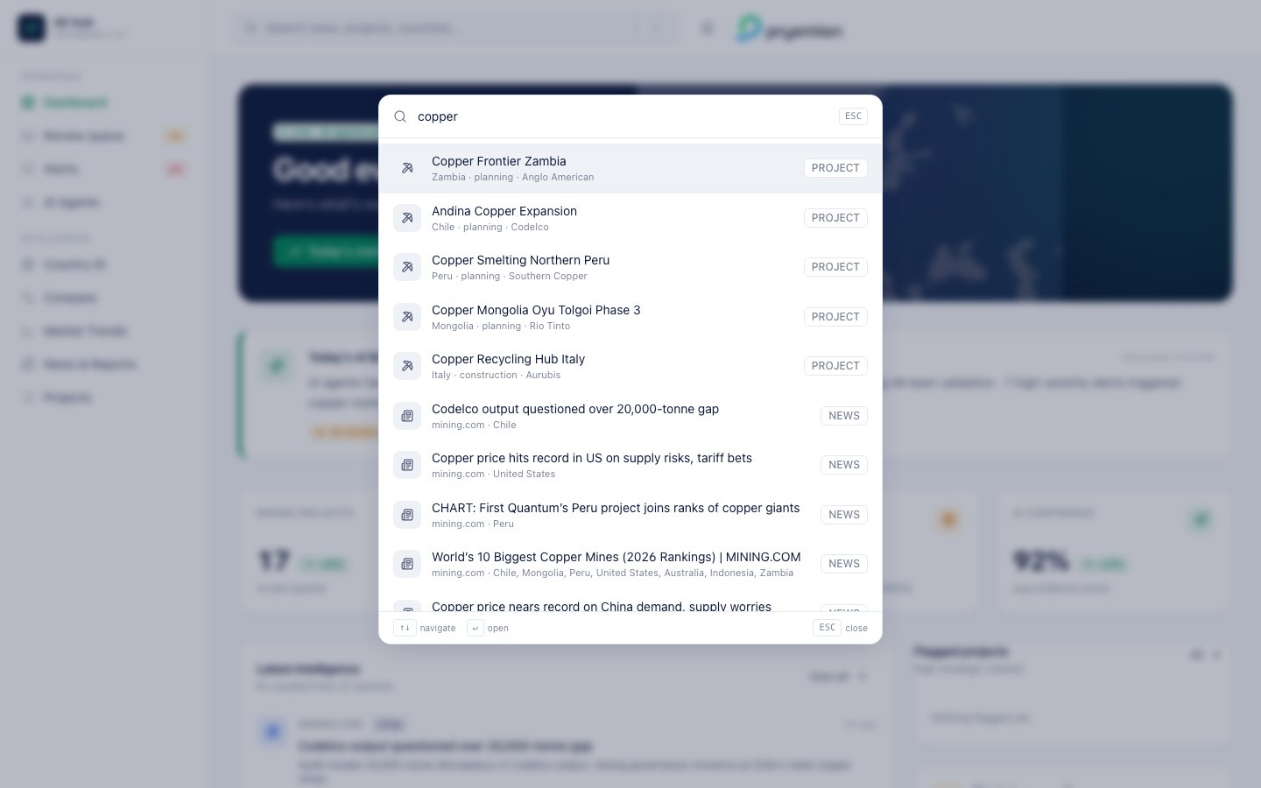
Search palette
The global search is available on every screen via the search bar in the header or the keyboard shortcut ⌘K.

4.1 How it works
- Start typing (minimum 2 characters) — results stream as you type with a 180ms debounce
- Results are grouped by type: Country · Project · News
- Each row shows a type icon, the item title, a sub-line (source/country/status), and a colored type chip

4.2 Keyboard navigation
Key | Action
↑ / ↓ | Move selection
Enter | Open selected
ESC | Close the palette
Hovering with the mouse also moves the selection. Click a row to navigate directly to that page or open the source URL.

4.3 Suggested queries
Try copper, Italy, EV, a competitor name, a project name, or an owner. The backend full-text search runs across news titles, summaries, project names, owners and countries.

5. Review Queue (Human-in-the-Loop)
This is the operational heart of the platform — where AI drafts become published intelligence after your validation. It implements the workflow the briefing document calls for: draft → validated → published, with feedback captured to improve the agents over time.
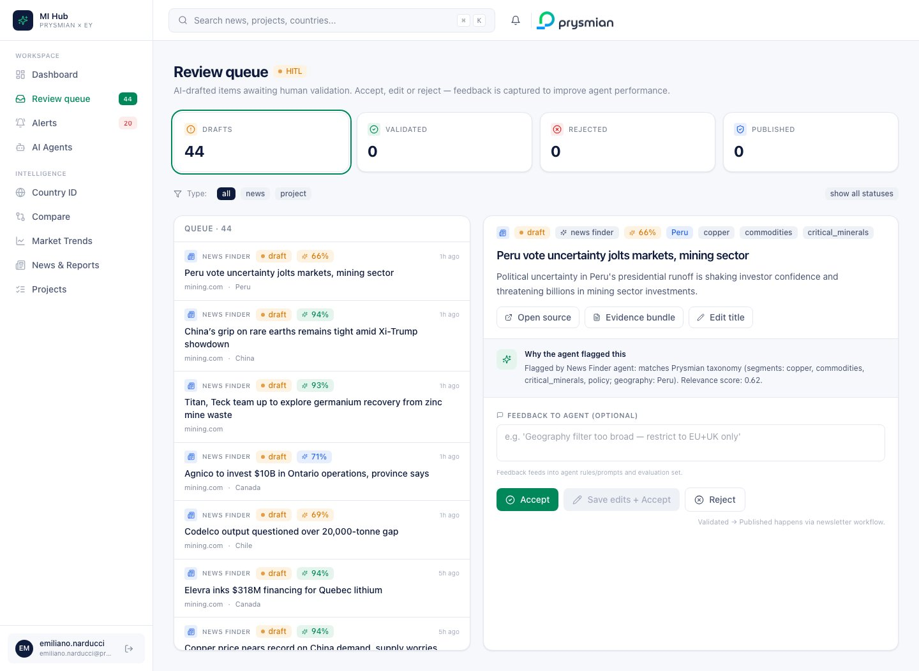
Review Queue

5.1 Top stat pills
Four big tiles at the top show counts by status and act as filters:
- Drafts (amber) — AI-produced items not yet reviewed
- Validated (green) — accepted by the MI team, awaiting publish
- Rejected (red) — discarded; agent learns from these
- Published (blue) — live in the Hub and visible to consumers
Click any pill to filter the queue by that status. The active filter shows a green ring.

5.2 Type filter
Below the pills:
- all · news · project — narrow by item type
- show all statuses — bypass the status filter

5.3 Master-detail layout

5.3.1 Left pane — the queue list
Each row shows:
- Type icon — newspaper (news) or pickaxe (project)
- Agent label — which agent flagged this item
- Status chip — current state
- Confidence chip — AI confidence score (green ≥ 85%, blue 70–84%, amber < 70%)
- Title (2 lines max)
- Source and country
- Age — “4h ago”, “2d ago”
Click an item to inspect it in the right pane.

5.3.2 Right pane — the detail view
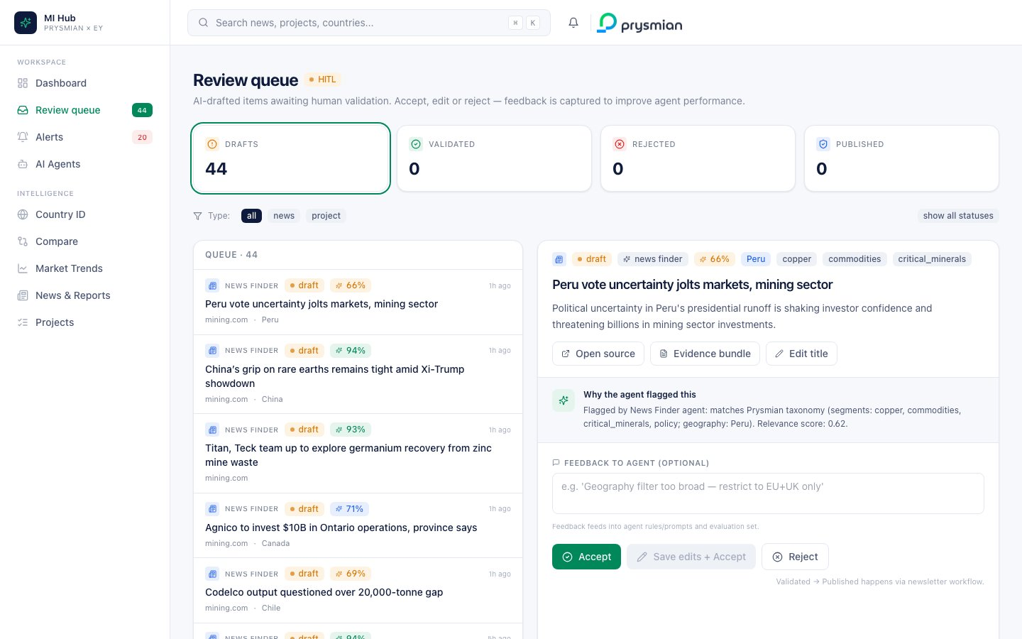
Review detail
Header section shows:
- Type icon, status, agent, confidence, country, segments
- The item title (editable inline — click Edit title)
- The AI-extracted summary
- Three action buttons: Open source · Evidence bundle · Edit title
“Why the agent flagged this” — a callout that quotes the AI reasoning, e.g.
Flagged by News Finder agent: matches Prysmian taxonomy (segments: copper, commodities; geography: Peru). Relevance score: 0.62.
This is the evidence trail the brief explicitly requires.
Feedback to agent — a textarea where you write why you accept/edit/reject:
e.g. “Geography filter too broad — restrict to EU+UK only”
The text feeds back into the agent’s rules and evaluation set.
Three decision buttons:
Button | Effect
Accept (green) | Status → validated. Item moves to publish queue.
Save edits + Accept | Saves your edited title and validates the item.
Reject (white) | Status → rejected. Feedback feeds agent improvement loop.

5.3.3 Decision history strip
Once an item has been decided, the detail panel shows:
Decided 3m ago by emiliano.narducci@prysmian.com “Geography too broad, restrict to Italy.”
This is the audit trail — who/when/feedback for every state transition.

5.4 The validated → published step
When an item is in validated state, the right panel offers a single button “Publish now” that transitions it to published. In production this is wired to the newsletter / editorial workflow.
Rejected items get a “Restore to queue” button so a wrongly-rejected item can be brought back.

5.5 Live counter
The sidebar Review queue badge updates every 20 seconds with the current draft count — so you always know how much work is queued.

6. AI Agents Control Center
The brief specifies six always-on AI agents. This page is mission control: status, configuration, manual runs, performance feedback.
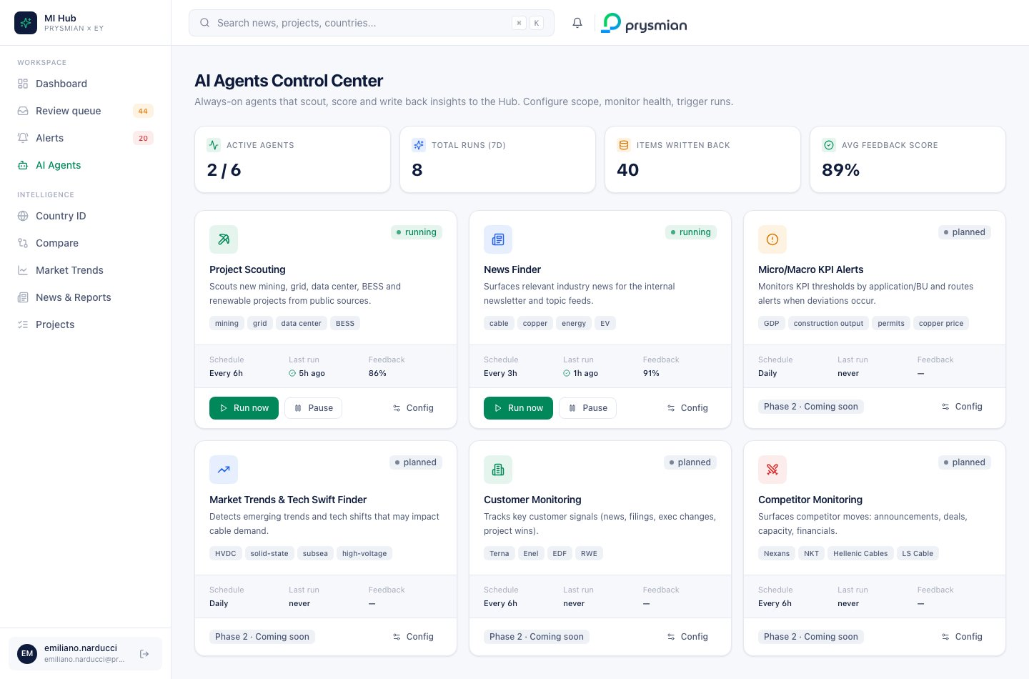
Agents

6.1 Top stat strip
Tile | Meaning
Active agents | Implemented + enabled / total catalog
Total runs (7d) | Number of execution runs in the last week
Items written back | Items the agents have produced and written to the Hub
Avg feedback score | Average MI team approval rate across runs

6.2 The six agents
Each agent is shown as a card:

Agent card anatomy
- Color-coded icon matching the agent category
- Status badge — running (green) · paused (amber) · planned (Phase 2)
- Name + one-line description
- Keyword chips showing the agent’s taxonomy (e.g., for News Finder: cable, copper, EV, grid)
- 3-column metadata strip — Schedule · Last run · Feedback %
- Action row — Run now · Pause/Resume · Config

The six agents (Prysmian brief mapping)
ID | Name | Status | Purpose
project_scouting | Project Scouting | running ✅ | New mining/grid/data center/BESS/renewable projects
news_finder | News Finder | running ✅ | Industry news for the newsletter and topic feeds
kpi_alerts | Micro/Macro KPI Alerts | planned (P2) | KPI thresholds per application/BU
swift_finder | Market Trends Swift Finder | planned (P2) | Emerging trends and tech shifts
customer_monitor | Customer Monitoring | planned (P2) | Signals on Terna, Enel, EDF, RWE, TenneT, etc.
competitor_monitor | Competitor Monitoring | planned (P2) | Nexans, NKT, Hellenic Cables, LS Cable moves

6.3 Running an agent on demand
For an implemented agent, click Run now — the agent fires in the background (bounded run: max 3 items, 30s timeout). The status badge animates and the “Last run” updates when the run completes.

6.4 Pause / Resume
Click Pause to disable scheduled runs without losing config. The button toggles to Resume.

6.5 Agent configuration
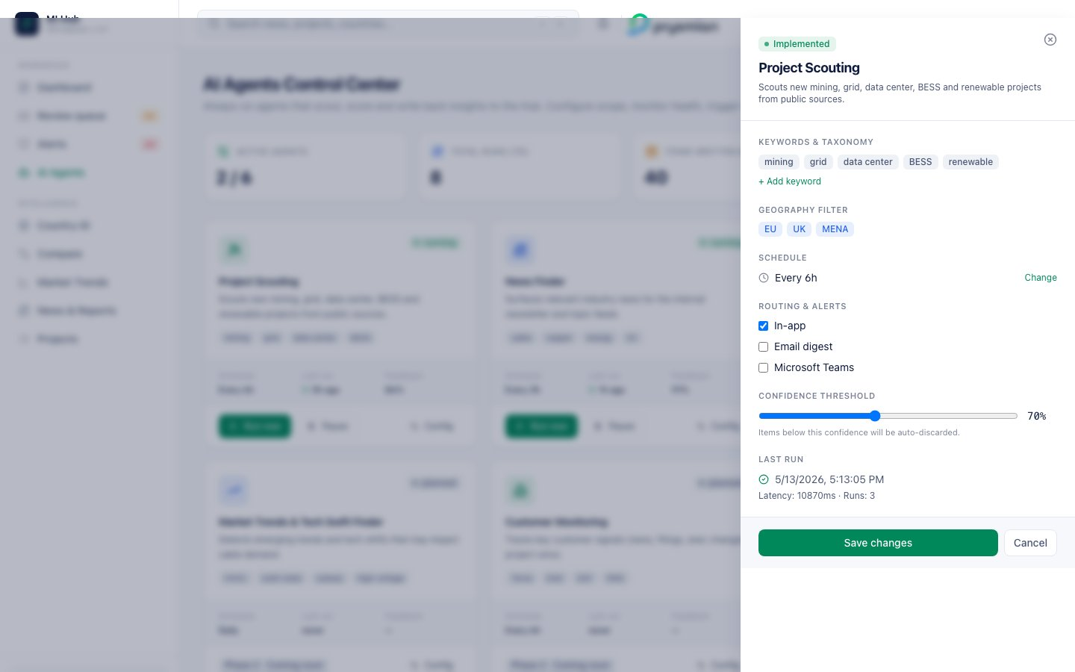
Agent config drawer
Clicking Config opens a right-side drawer with:
- Keywords & taxonomy — chip list of the agent’s filter words. Click + Add keyword to extend.
- Geography filter — which regions the agent monitors
- Schedule — current cadence (“Every 6h”). Click Change to modify.
- Routing & alerts — toggle channels: In-app · Email digest · Microsoft Teams
- Confidence threshold — slider 50–95% (default 70%). Items below this score are auto-discarded.
- Last run — timestamp, success/failure, latency, total runs
A Save changes / Cancel footer commits the config.
In Phase 1 this maps to the agent’s rule file and prompt template. Changes here re-deploy the agent with the new parameters.

7. Alerts & Subscriptions
Where you receive triggered signals — KPI deviations, project flags, news spikes, competitor moves.
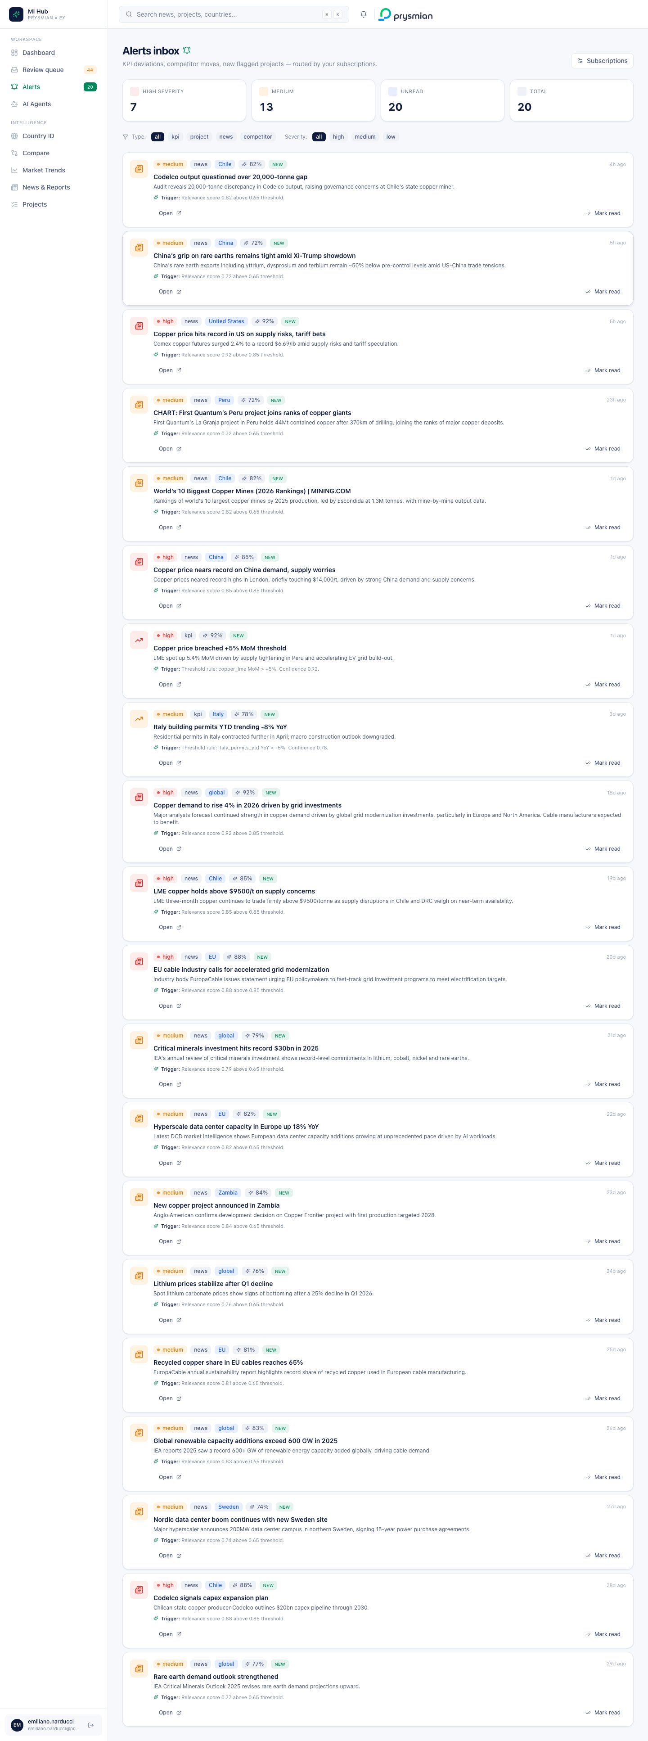
Alerts inbox

7.1 Stat strip
Four cards summarize the current state:
- High severity (red)
- Medium (amber)
- Unread (blue)
- Total (neutral)

7.2 Filter bar
Two filter rows:
- Type: all · kpi · project · news · competitor
- Severity: all · high · medium · low

7.3 Alert card
Each alert shows:
- Type icon — color-coded by severity (red/amber/blue)
- Badges row — severity, type, country, AI confidence %, optional NEW chip if unread
- Age — top right
- Title (bold)
- Body — 2-line summary
- “Trigger” callout — the rule that fired the alert (e.g., “Threshold rule: copper_lme MoM > +5%. Confidence 0.92.”)
- Action row — Open (link to source) · Mark read (toggle)
Read items are dimmed at 60% opacity so unread items stand out.

7.4 Subscriptions
Click Subscriptions (top right) to open the preferences drawer.
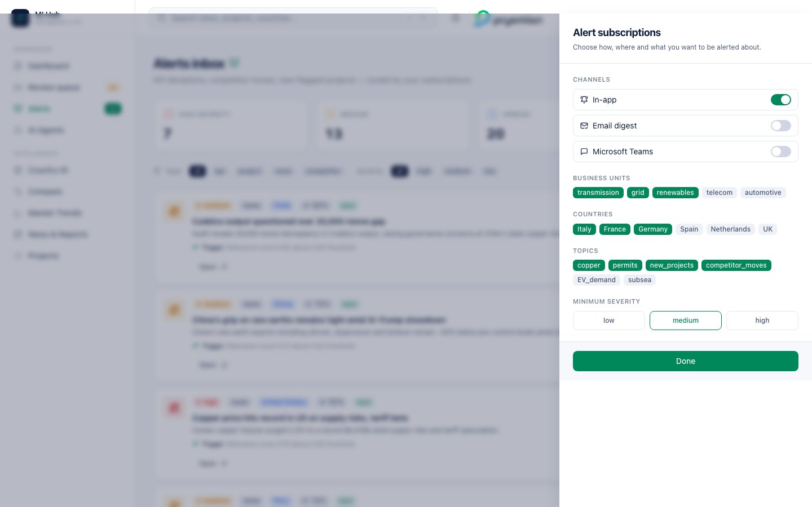
Subscriptions drawer

7.4.1 Channels
Toggle switches per channel:
- In-app — show in this inbox (always on by default)
- Email digest — daily roll-up email
- Microsoft Teams — direct message via Teams app

7.4.2 Business units
Chip-group selection: transmission · grid · renewables · telecom · automotive. Selected BUs show in Prysmian green.

7.4.3 Countries
Same UI for: Italy · France · Germany · Spain · Netherlands · UK

7.4.4 Topics
copper · permits · new_projects · competitor_moves · EV_demand · subsea

7.4.5 Minimum severity
Three-segment selector: alerts below this threshold are suppressed across all channels.
All preferences save instantly — no Save button needed. They drive both the inbox filter and the channel routing in Phase 1.

8. Country ID
The Country Identity Card — a per-country deep-dive that mirrors the structure of the Prysmian briefing document (4 quadrants) but enriches each one with AI insights.
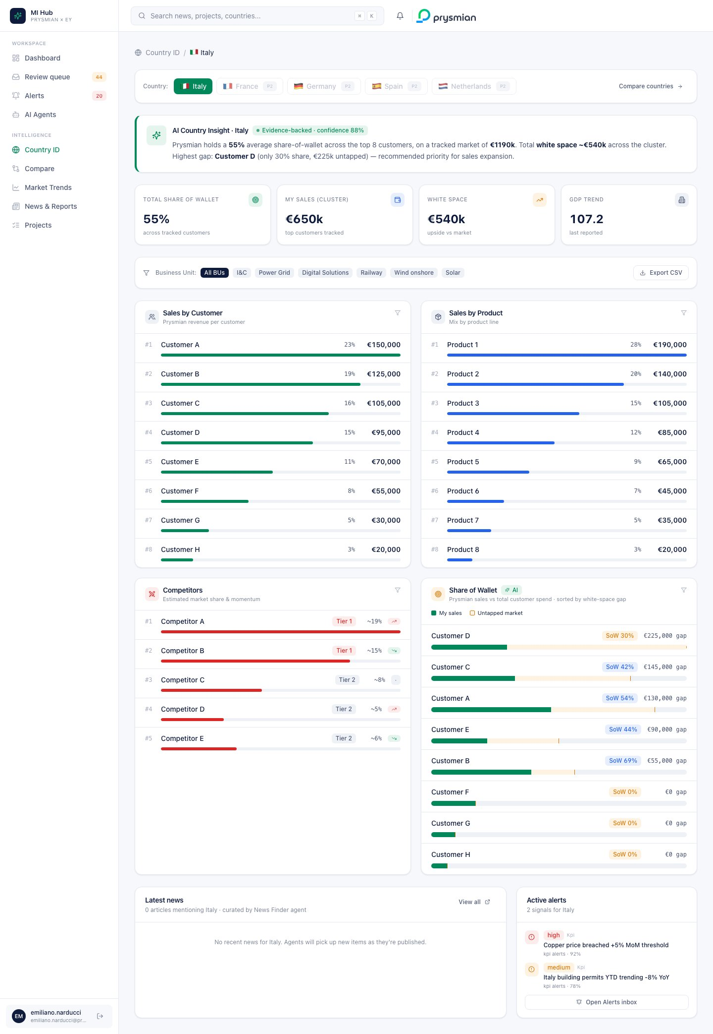
Country ID Italy

8.1 Breadcrumb and country switcher
A top breadcrumb (Country ID › 🇮🇹 Italy) plus a country switcher card with flag emojis. Italy has live demo data; other countries (France, Germany, Spain, Netherlands) are marked P2 and show a Phase 2 placeholder.

8.2 AI Country Insight banner
A green-bordered card that auto-narrates the strategic story in natural language:
Prysmian holds a 58% share-of-wallet across the top 8 customers, on a tracked market of €1,810k. Total white space ~€1,005k across the cluster. Highest gap: Customer D (only 30% share, €225k untapped) — recommended priority for sales expansion.
The narrative pulls real numbers from the database; it’s not pre-written.

8.3 Macro snapshot tiles
Four KPI tiles:
Tile | Meaning
Total share of wallet | Sum of Prysmian sales / sum of market value, all customers
My sales (cluster) | Total Prysmian revenue tracked in this country
White space | Total upside vs market (market value − sales)
GDP trend | Latest GDP indicator value

8.4 Filter bar
- Business Unit chips — I&C · Power Grid · Digital Solutions · Railway · Wind onshore · Solar
- Export CSV — top right. Downloads all 4 quadrants as a single CSV file (transition path from Excel).

8.5 The four quadrants
The platform preserves the Prysmian Excel mental model but transforms each quadrant into an insight-rich component.

8.5.1 Sales by Customer
- Rank number (#1, #2, …)
- Customer name (+ owner)
- Share % of total country sales
- Value in €
- Proportional green bar showing relative magnitude
- Click any row → drill-down modal (see §8.6)

8.5.2 Sales by Product
Same pattern as Customer, but blue bars.

8.5.3 Competitors
- Tier badge — Tier 1 (red) or Tier 2 (neutral)
- Estimated market share %
- Momentum chip — 📈 in salita (threat) · 📉 cala (favourable) · ⏸ flat
- Red bar showing relative share

8.5.4 Share of Wallet (AI insight) ⭐
The killer view. Each customer row shows:
- Customer name
- SoW % badge (red < 40%, blue 40–69%, green ≥ 70%)
- € gap — untapped market for that customer
- Stacked bar — Prysmian green (your sales) + amber (gap) — visually shows the white-space opportunity
The list is sorted by gap descending — the biggest untapped customers float to the top.

8.6 Drill-down on a customer
Click any row in Sales by Customer or Share of Wallet to open a 2-tab modal.

8.6.1 Tab: MI Hub overview
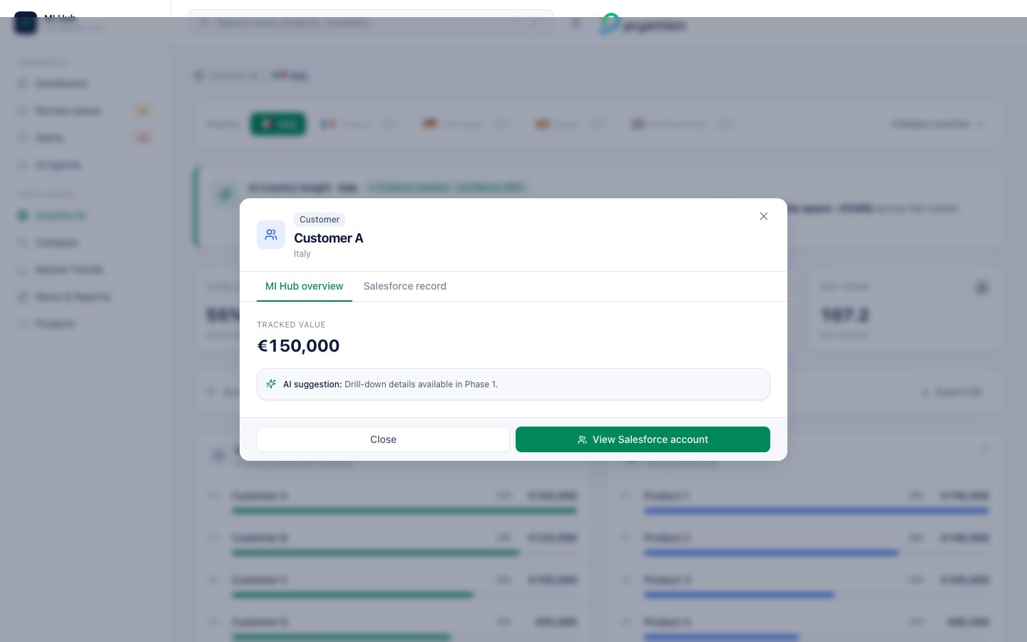
Drill-down overview
- Tracked value (€)
- Share of wallet bar
- Detail context
- AI suggestion card — adaptive recommendation:
  - SoW < 40% → “Low share. Investigate competitor lock-in and propose share-shift initiative for Q3.”
  - SoW 40–69% → “Stable mid-share. Cross-sell adjacent product lines (HV, accessories) to lift wallet.”
  - SoW ≥ 70% → “Strong incumbent. Defend with multi-year framework and protect margin.”
- Footer hint at Phase 1 unlocks: order history, contract list, pipeline, evidence trail.

8.6.2 Tab: Salesforce record
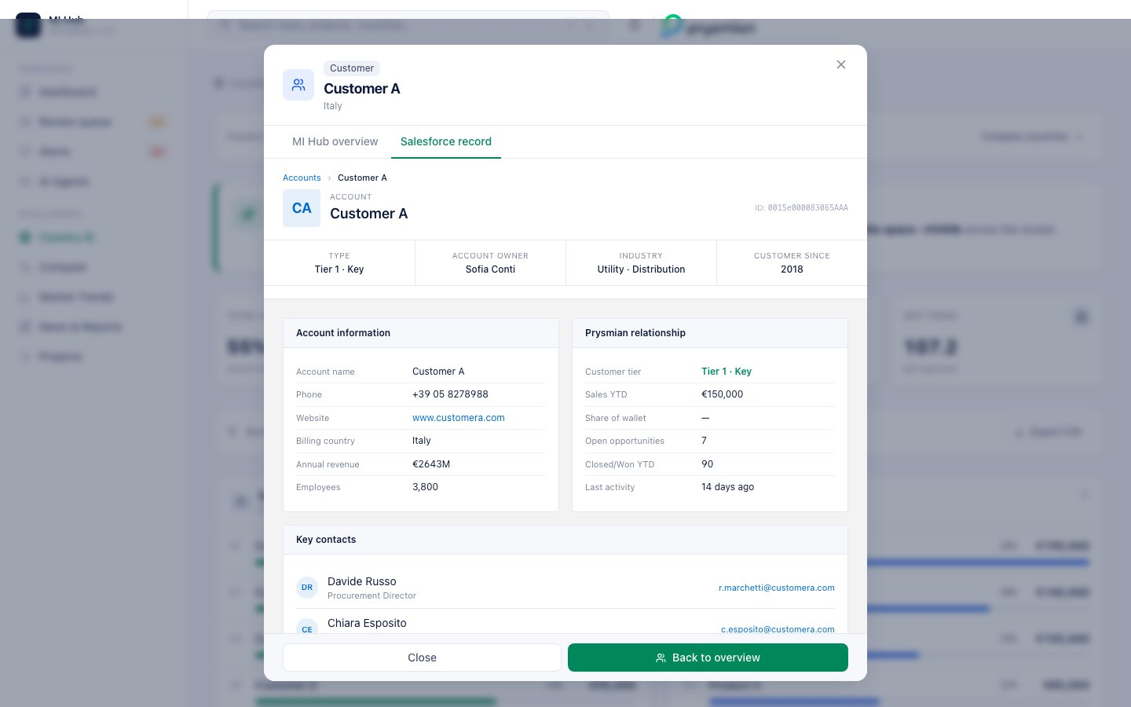
Salesforce record
A realistic Salesforce account page rendering using deterministic synthetic data:
- Breadcrumb Accounts › Customer A
- Account avatar with initials, Account ID (e.g., 0015e000083065AAA)
- 4-column highlight strip — Type (Tier 1 · Key) · Account Owner (Sofia Conti) · Industry (Utility · Distribution) · Customer since (2018)
Then 4 panels:
- Account information — name, phone, website (clickable, blue), billing country, annual revenue (€), employees
- Prysmian relationship — customer tier, sales YTD, SoW %, open opps count, closed/won YTD, last activity
- Key contacts — 2 contacts with initials avatars, role and clickable email
- Open opportunities — table with stage badge (Qualification/Proposal/Negotiation), amount, close date
Footer notes that in Phase 1 the button links to the live <customer>.my.salesforce.com record.

8.7 Drill-down on a product
Click a row in Sales by Product to open the same modal but for products.

8.7.1 Tab: SAP material master
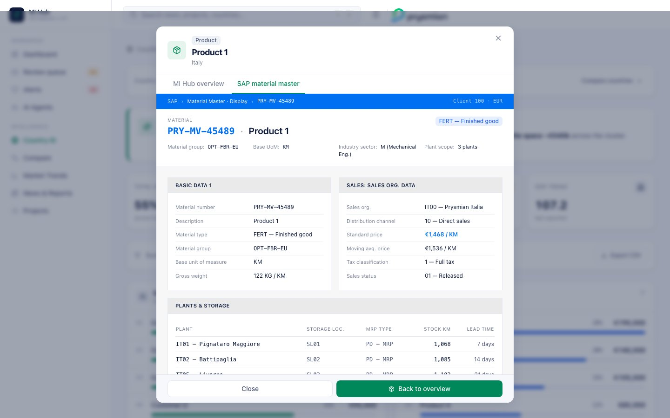
SAP material master
Renders a SAP-Fiori-style material master:
- Top blue bar (#0070F2 SAP blue) with breadcrumb SAP › Material Master · Display › PRY-MV-45489 · Client 100 · EUR
- Material header — mono-coded PRY-MV/HV/LV-XXXXX, material type badge (FERT — Finished good / HALB / ROH)
- 4 metadata cells — material group, base UoM (KM/M/KG), industry sector, plant scope
Four panels:
- Basic data 1 — material number, description, type, group, base UoM, gross weight
- Sales: sales org. data — sales org (IT00 — Prysmian Italia), distribution channel, standard price, moving avg price, tax classification, sales status
- Plants & storage — table with plant codes (IT01 — Pignataro Maggiore, IT02 — Battipaglia, IT05 — Livorno), storage location, MRP type, stock, lead time
- MI Hub link — sales YTD, volume YTD, top customer
Footer notes that in Phase 1 the integration calls SAP RFC BAPI_MATERIAL_GET_DETAIL.

8.8 Country news + Active alerts
Below the quadrants:
- Latest news (wide) — articles mentioning this country, with source · time · “High” relevance chip if score ≥ 0.7. Click an item to open the source.
- Active alerts (narrow) — live alerts filtered by this country, with severity badge, agent label, confidence %. “Open Alerts inbox” button at the bottom.

9. Compare (multi-country)
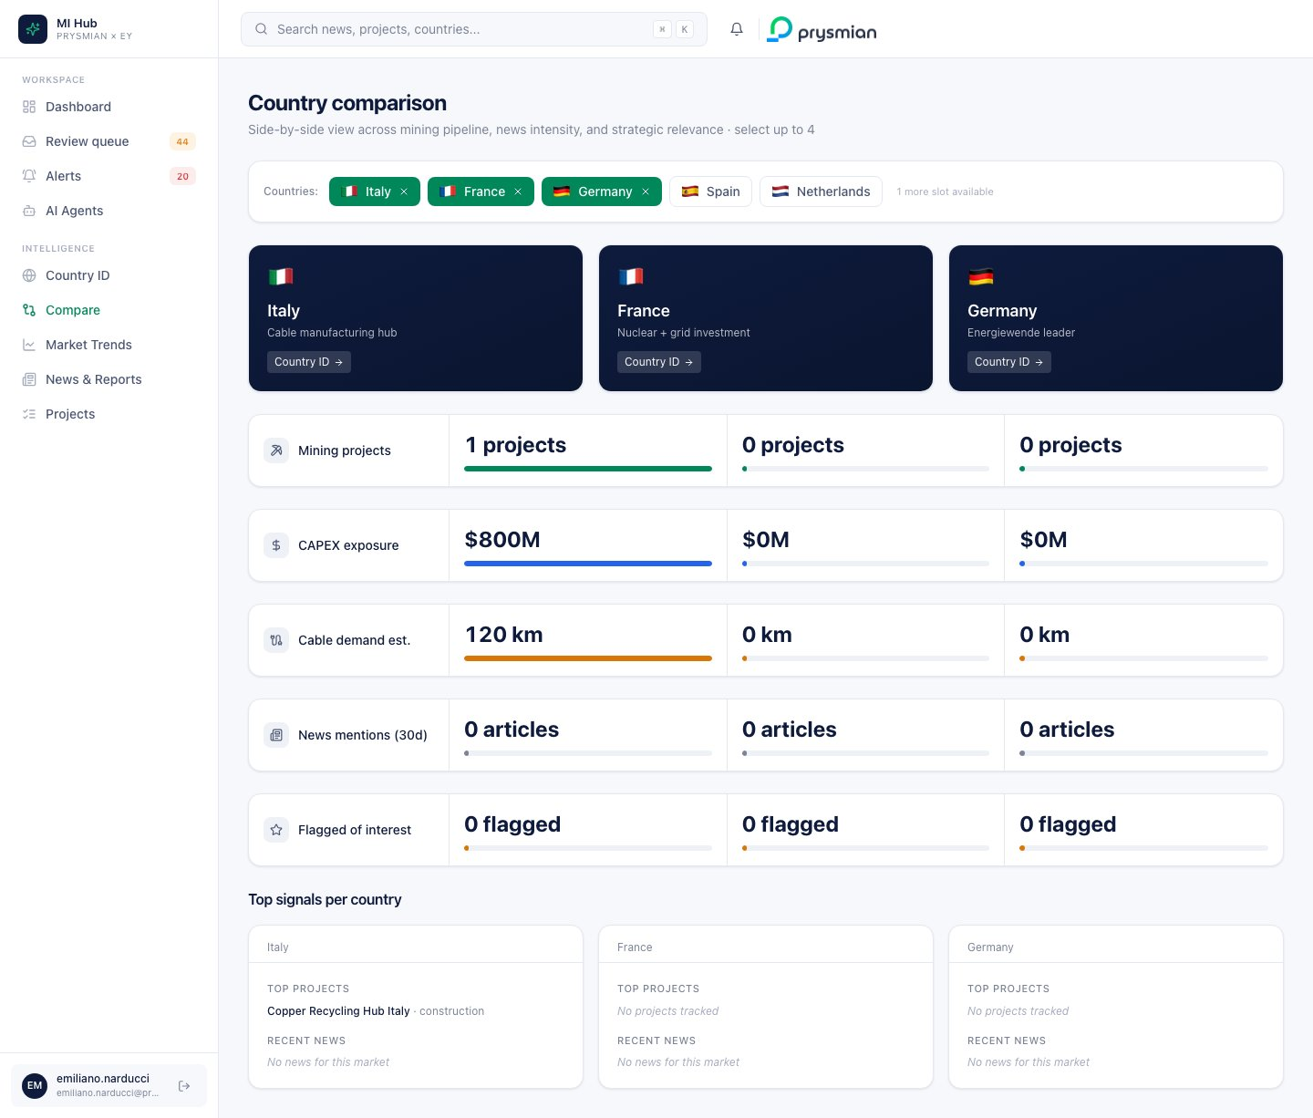
Compare view
Side-by-side comparison of up to 4 countries.

9.1 Country selector
5 countries available, each with flag emoji and one-line focus blurb (e.g., Germany — “Energiewende leader”). Click to select/deselect. Active countries show in green; when 4 are selected, others are disabled.

9.2 Header tiles
For each selected country: a navy gradient card with flag, country name, focus tagline, and a Country ID → deep-link.

9.3 Comparable metric rows
Five rows, each showing the metric label on the left and the value per country with a proportional bar scaled across the cohort:
Metric | Source
Mining projects | count of projects in country
CAPEX exposure | sum of project CAPEX (€)
Cable demand est. | km estimate
News mentions (30d) | news articles
Flagged of interest | strategic flags

9.4 Top signals row
Below the metric rows, a per-country panel with:
- Top projects (up to 3)
- Recent news (up to 3) — clickable to the source

10. Market Trends
Macroeconomic and commodity charts driving cable demand.
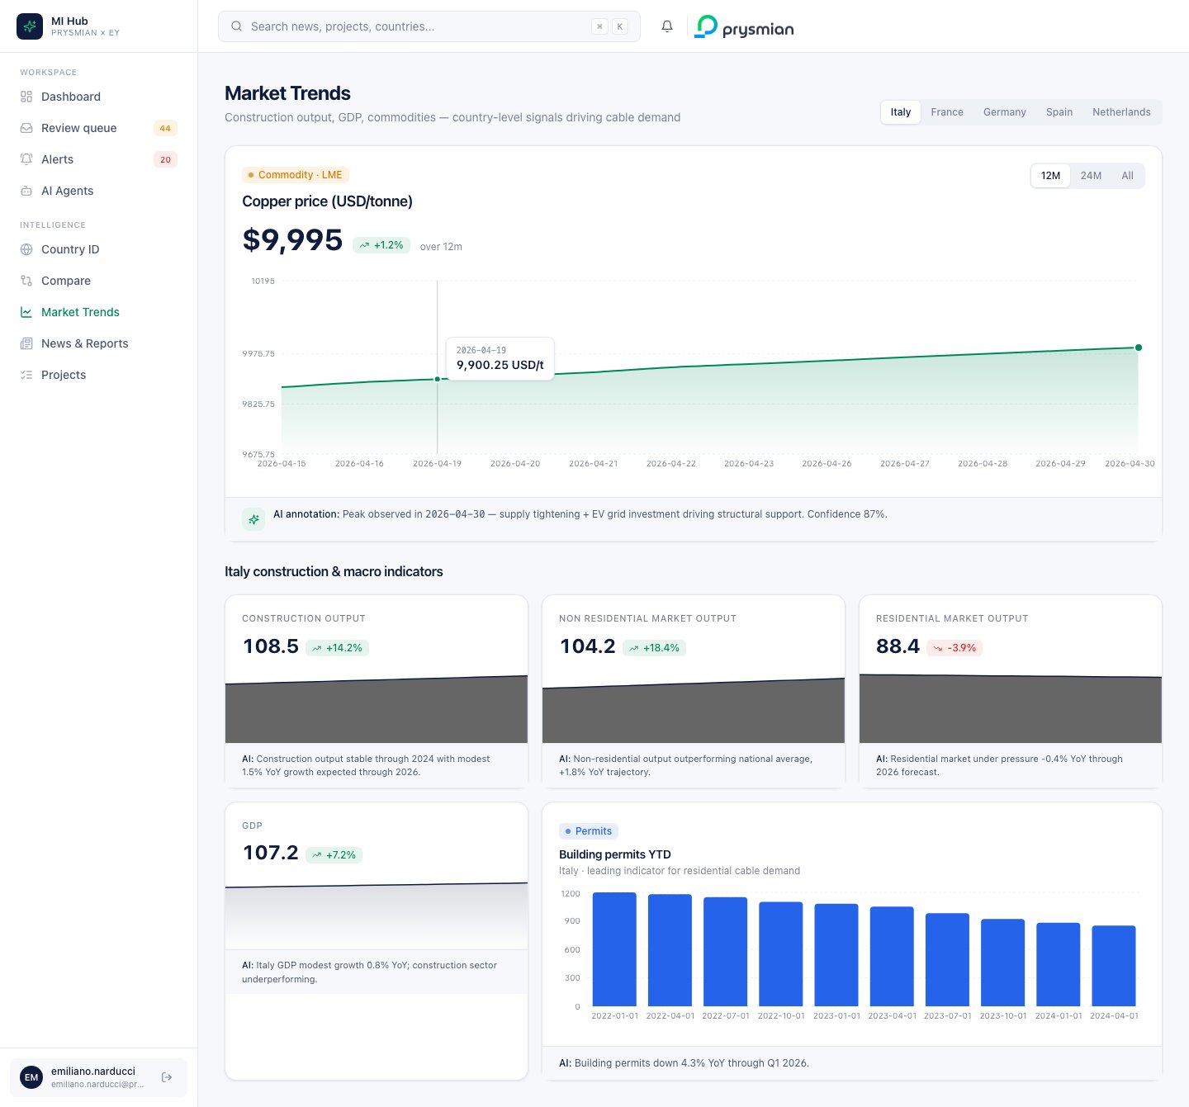
Trends

10.1 Top controls
- Country switcher — segmented control for the 5 EU countries
- Time range segmented control — 12M · 24M · All

10.2 Copper price hero card
The headline chart:
- Latest price + delta chip (% change over the selected range)
- Area chart with green gradient and a red dot marking the peak
- AI annotation strip under the chart explaining the move:
- AI annotation: Peak observed in 2026-04 — supply tightening + EV grid investment driving structural support. Confidence 87%.

10.3 Indicator grid
For the selected country, mini-cards for the macro indicators:
- Construction output
- Non-residential market output
- Residential market output
- GDP
Each card shows: label, latest value, delta % chip, sparkline area chart, AI insight footer (one-line narrative from the agent).

10.4 Building permits YTD bar chart
A wider bar chart for building permits — a leading indicator for residential cable demand — with custom tooltips and AI insight footer.

11. Projects (pipeline tracker)
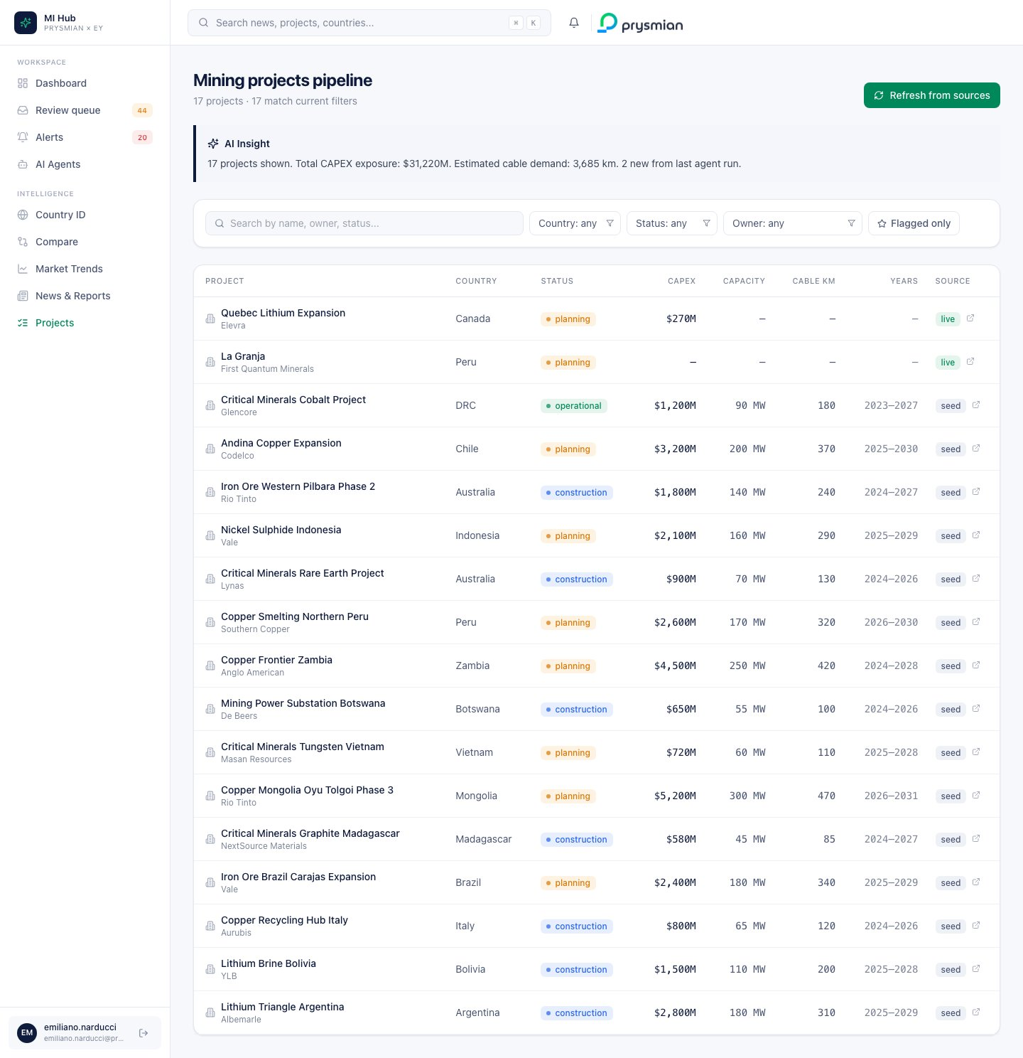
Projects
The mining/grid/renewable project pipeline.

11.1 Top bar
- Title with total count and filtered match count
- Refresh from sources — triggers the Project Scouting agent on-demand

11.2 AI Insight callout
One-sentence narrative summing up the filtered cohort:
17 projects shown. Total CAPEX exposure: $4,500M. Estimated cable demand: 420 km. 17 new from last agent run.

11.3 Filter bar
- Search — name, owner, country, status (text input with clear button)
- Country select
- Status select
- Owner select
- Flagged only toggle (star icon)
- Clear filters — appears when active

11.4 Project table
Columns:
Column | Notes
Project | Name (clickable to detail) + owner + ⭐ if flagged
Country
Status | Colored badge (planning/under construction/operational)
CAPEX | $XXXM
Capacity | MW
Cable km | Estimated km of cable demand
Years | Start–End
Source | live (from agent) or seed, with ↗ external-link icon
Click any row → Project detail page.

11.5 Project detail page
A drill-down screen with:
- Breadcrumb · Hero with badges, owner, country, status · Evidence + Source buttons
- 4 KPI tiles — CAPEX · Capacity · Cable demand · Lifecycle
- Project timeline — auto-built milestones with colored status dots (Project announced · Permitting · Construction · Operational · End-of-life)
- AI Insight card — auto-narrated paragraph with confidence
- Evidence trail entry point
- Related news — articles mentioning the same country

12. News & Reports
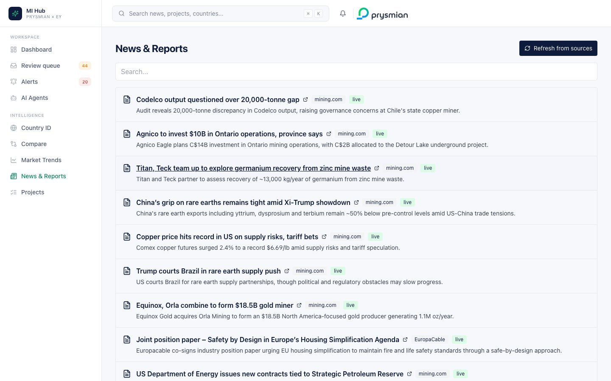
News & Reports
Full news feed (the News Finder agent’s output). Filterable, searchable, with relevance scoring.

12.1 List view
For each article:
- Source · publication date
- Title (link to source)
- 2-line summary
- Country tags · segment tags
- Relevance score chip
Click the title to open the source in a new tab.

13. Evidence Bundle
Across the platform, anywhere you see an Evidence bundle button (Review queue detail, Project detail, AI Insight cards), clicking it opens a modal showing:
- The source URL(s) the AI used
- The retrieval log (timestamp, query, agent name)
- The confidence breakdown by sub-factor
- The prompt template version used
This is the audit trail the EU AI Act requires — every AI output is traceable to its sources and reasoning.

14. Logout
Click the Logout icon in the user pod at the bottom of the sidebar. You’ll be redirected to the login screen and your session is cleared.

15. Roadmap
The demo build covers everything in the MVP scope of the Prysmian brief. The next two phases unlock:

Phase 1 (post-MVP)
- Azure Entra ID SSO + RBAC
- Live SAP transactional ingestion (replacing demo seeds)
- Live Salesforce market-interaction ingestion
- Newsletter editorial workflow (validated → published → digest)
- 4 additional AI agents implemented (KPI Alerts, Swift Finder, Customer Monitor, Competitor Monitor)
- Real-time alerts via Email digest + Teams routing
- Versioning + diff view per Hub item

Phase 2 (scale-out)
- API integrations for external databases and reports
- 75 users (consultation)
- Multi-country commercial seeds (France, Germany, Spain, Netherlands, UK)
- Manual structured “value data” input forms

16. Support
For demo issues: emiliano.narducci@ey.com For platform questions: refer to this manual or the deploy doc (docs/DEPLOY_RENDER.md).
The demo is hosted on Render.com — free-plan services sleep after 15 min of inactivity (≈ 30s cold start on first wake).

EY for Prysmian Group — Market Intelligence Hub user manual · May 2026

