Market Intelligence Hub — Functional Analysis
  - Calculation logic, output production rules, data flow, API surface
EY for Prysmian Group
May 2026
Table of Contents

1. Document purpose & audience
This document is the functional analysis companion to the user manual. Where the user manual answers “what do I do here?”, this document answers:
- How is this number calculated?
- Where does this output come from?
- What logic produces this insight?
- What rules drive this state transition?
- What data flows where, and why?
- What is the API contract behind each screen?
- What are the acceptance criteria, performance characteristics, failure modes?
Target audience:
- MI team / business analysts validating logic
- Solution architects sizing Phase 1
- EY consultants reviewing design choices
- Audit/compliance reviewing AI traceability (EU AI Act)
- Phase 1 implementers needing the exact specs
- Procurement / vendor evaluators
Every formula, ranking rule, taxonomy, state machine, confidence formula, API endpoint and acceptance criterion is documented here. Each section pairs the functional logic with a UI screenshot of the affected screen, so the analyst can map what the user sees to what the system does.

2. Architectural foundation

2.1 The medallion data flow
The Hub uses a medallion architecture (Bronze → Silver → Gold) inspired by Databricks lakehouse patterns, plus a dedicated audit schema for AI traceability and a runtime layer for HITL state.
┌─────────┐ ┌──────────┐ ┌──────┐ ┌──────────┐
│ Bronze │──▶ │ Silver │──▶ │ Gold │──▶ │ MI Hub │
│ raw │ │ cleaned │ │ ready│ │ outputs │
└─────────┘ └──────────┘ └──────┘ └──────────┘
▲
┌─────────┐ │
│ Audit │ ◀────────────────┘
│ trail │ every AI write logs here
└─────────┘
┌─────────┐
│ Runtime │ review decisions,
│ state │ alert read-flags, subscriptions
└─────────┘
Schema | Purpose | Update cadence
bronze | Raw ingestion — CSV seeds, HTTP fetches, API pulls, SAP/Salesforce exports | continuous (agent runs)
silver | Normalized, deduplicated, schema-validated, embeddings computed | derived from bronze
gold | UI-ready aggregates with derived fields (relevance score, flagged, country tags) | derived from silver
audit | Every agent run, every AI prompt+response, every decision, every confidence | append-only, immutable
runtime | Mutable per-user state (review decisions, alert read flags, subscriptions) | per-user actions
In the demo all schemas live in a single Postgres 16 instance with pgvector. In Phase 1 this maps to Databricks / Snowflake equivalents with the same boundary semantics.

2.2 The end-to-end loop (from the brief)
Ingestion → Normalize/Enrich -- AI → Hub Storage
↑ ↓
│ Search / UI / API
│ ↓
│ Outputs & Dashboards -- AI
│ ↓
└───── Feedback loop (HITL early phases) ◀
Every box is reflected in the platform:
Stage | Implementation in this build
Ingestion | seed CSVs (bronze) + News Finder agent (HTTP) + Project Scouting
Normalize/Enrich | AI extraction → silver (relevance score, country tags, segments)
Hub Storage | Postgres gold tables + Review Queue state
Search/UI/API | FastAPI + Vite SPA + /api/search global endpoint
Outputs/Dashboards | Country ID, Trends, Compare, Project detail, AI insight cards
Feedback loop | Review Queue accept/edit/reject + feedback textarea

2.3 Process-level architecture
┌──────────────┐ ┌──────────────┐ ┌──────────────┐
│ Frontend │ │ Backend │ │ Workers │
│ (Vite SPA) │──▶│ (FastAPI) │──▶│ (Agents) │
│ served by │ │ uvicorn 2× │ │ Anthropic SDK │
│ nginx │ │ │ │ │
└──────────────┘ └──────────────┘ └──────────────┘
│ │
▼ ▼
┌─────────────────────────────┐
│ Postgres 16 + │
│ pgvector │
└─────────────────────────────┘
In Phase 1 the worker process splits into a scheduled job runner (Airflow / Prefect / Render cron) and an event-driven stream consumer (Kafka / Kinesis / Pub/Sub).

3. Authentication & session model
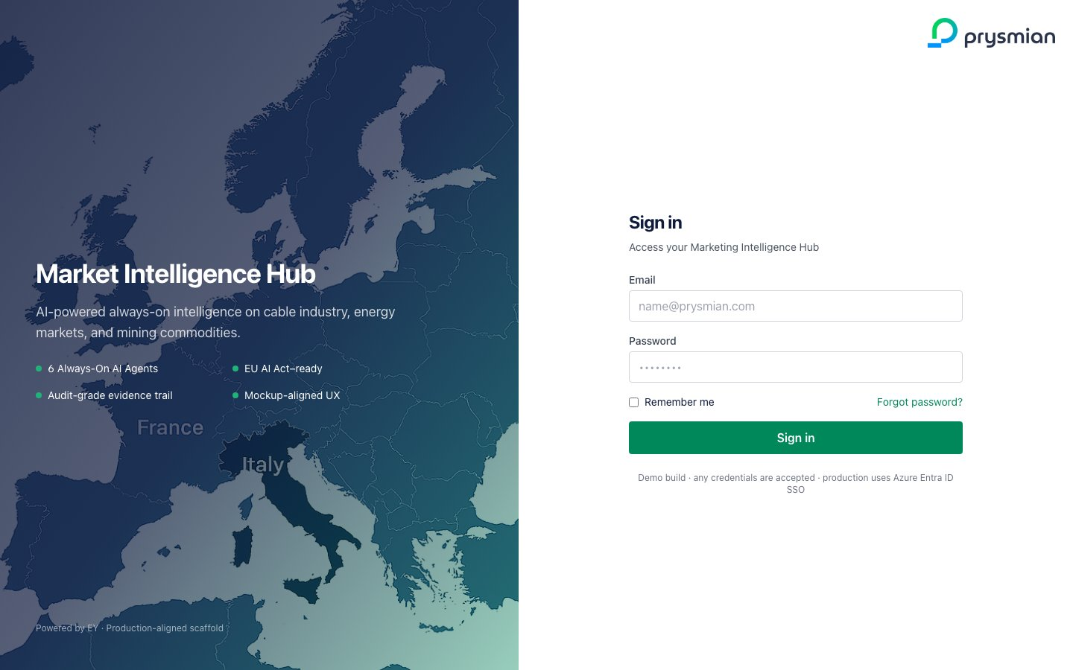
Login screen

3.1 Demo auth (current build)
- Login uses sessionStorage to persist the user email after submit
- Any non-empty email + password is accepted
- The RequireAuth React component reads sessionStorage.mi_hub_user and redirects to /login if absent
- Session ends on browser tab close (sessionStorage behavior)
This is demo-only scaffolding. No password validation, no token rotation, no rate limiting. The login screen explicitly states this.

3.2 Phase 1 auth model
Property | Phase 1 spec
Identity provider | Azure Entra ID (Microsoft Entra)
Protocol | OpenID Connect (OIDC) authorization code flow with PKCE
Session storage | Encrypted HTTP-only cookies (SameSite=Lax)
Token lifetime | Access token 1h, refresh token 24h
MFA | Required by Prysmian IT policy (managed at IdP)
User attributes | email, name, BU, country, role (claims propagated from Entra)
Logout | Local cookie clear + Entra end_session_endpoint redirect
User → role mapping comes from Entra group membership (group:mi-team-lead → role MI lead, etc).

3.3 RBAC matrix
Role | Hub read | Review queue | Agent config | Subscriptions own/others | RBAC mgmt
Viewer | ✅ | — | — | own ✅ / others — | —
Country viewer | ✅ (scoped) | — | — | own ✅ / others — | —
MI analyst | ✅ | ✅ act | run agents | own ✅ / others — | —
MI lead | ✅ | ✅ act | config + taxonomy | own ✅ / team ✅ | —
Admin | ✅ | ✅ | ✅ | ✅ | ✅

3.4 Acceptance criteria — auth
AC-ID | Criterion
AUTH-1 | Demo: any non-empty email@x + non-empty password lands on /
AUTH-2 | Demo: unauthenticated access to /, /review, etc. redirects to /login
AUTH-3 | Demo: closing tab clears session
AUTH-4 | Phase 1: invalid Entra token → 401 with WWW-Authenticate: Bearer header
AUTH-5 | Phase 1: user without mi_team role accessing /api/review/{id}/decide → 403

4. Dashboard — every block, mapped to its logic
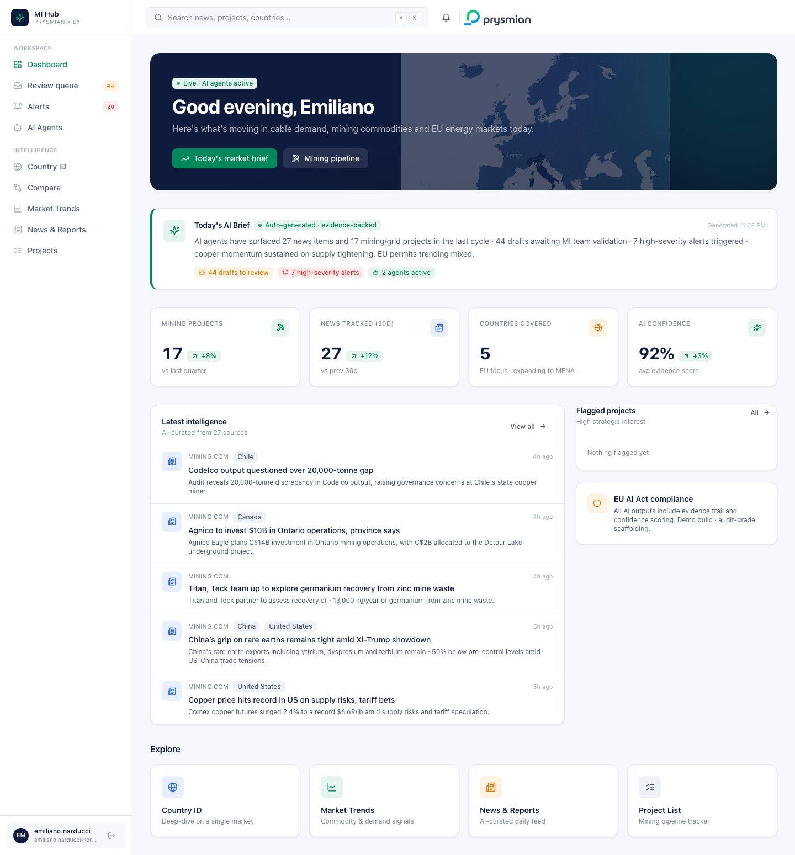
Dashboard
The Dashboard is a read-only aggregator — no writes happen here. Each block has a precise data source and rendering rule.

4.1 Hero greeting (top card)
Element | Logic
Greeting text | f"Good {tod}, {firstName}" where tod ∈ {morning|afternoon|evening|night} by hour
“Live · AI agents active” badge | Static visual signal (no real ping in demo, would be live in Phase 1)
“Today’s market brief” CTA | Links to /trends
“Mining pipeline” CTA | Links to /projects
Background image | /mockup-reference/image1.jpg, opacity 25%, screen blend

4.2 Today’s AI Brief
A templated natural-language paragraph generated from live aggregates:
def generate_brief(projectsTotal, newsCount, draftsCount, highAlerts, flaggedCount):
parts = [
f"AI agents have surfaced {newsCount} news items and "
f"{projectsTotal} mining/grid projects in the last cycle"
]
if flaggedCount > 0: parts.append(f"{flaggedCount} flagged of strategic interest")
if draftsCount > 0: parts.append(f"{draftsCount} drafts awaiting MI team validation")
if highAlerts > 0: parts.append(f"{highAlerts} high-severity alerts triggered")
parts.append("copper momentum sustained on supply tightening, EU permits trending mixed")
return " · ".join(parts) + "."
Aggregate | Source endpoint
projectsTotal | /api/projects → total
newsCount | /api/news → length
draftsCount | /api/review/stats → by_status.draft
highAlerts | /api/alerts/stats → by_severity.high
flaggedCount | computed client-side from projects with flagged_of_interest=true
Why templated, not LLM-generated? Determinism and audit safety. The numbers are provably the same as those shown elsewhere on the page (same query, same render). In Phase 1, an LLM can wrap stylistic variety around this skeleton, but the numbers stay deterministic.
The three chip-links are quick navigation:
- {draftsCount} drafts to review → /review
- {highAlerts} high-severity alerts → /alerts
- 2 agents active → /agents (count is currently static — Phase 1 reads it from /api/agents/catalog)

4.3 KPI strip (4 tiles)
Tile | Formula | Delta logic
Mining projects | count(gold.mining_projects) | demo: hardcoded +8%; Phase 1: vs same period prior quarter
News tracked (30d) | count(gold.news_curated WHERE curated_at >= now - 30d) | demo: hardcoded +12%; Phase 1: vs prior 30d
Countries covered | count(distinct country) | static “5”
AI confidence | avg(audit.evidence_metadata.confidence_score) | demo: 92%; Phase 1: rolling 7d avg
Delta arrow + color is purely a function of sign:
trend = delta > 0 ? "up" : delta < 0 ? "down" : "flat"
chipClass = trend == "up" ? green : trend == "down" ? red : neutral

4.4 Latest intelligence feed (left)
SELECT * FROM gold.news_curated
ORDER BY published_at DESC NULLS LAST, curated_at DESC
LIMIT 5;
Per-row rendering:
Element | Source
Source label | n.source
Country chips | n.countries.slice(0, 2)
Relative time | relTime(n.published_at) — see §22.1
Title (2 lines) | n.title
Summary (2 lines) | n.summary
Click behavior | window.open(n.url, '_blank')

4.5 Flagged projects (right)
SELECT * FROM gold.mining_projects
WHERE flagged_of_interest = true
ORDER BY capex_estimate_musd DESC NULLS LAST
LIMIT 4;
Per-row: building icon + name + {country} · {status} + CAPEX in $XXXM format.

4.6 EU AI Act compliance card
Static info card. Reminds the user that every output carries evidence trail + confidence. Click-through to the Evidence bundle viewer is not linked here directly (intentional — this is a strategic message, not a function).

4.7 Explore cards
4 navigation cards to /country/italy, /trends, /news, /projects. Each has:
- Color-coded icon (green / blue / amber / neutral)
- Label
- One-line description
- Hover effect: arrow icon slides in + label turns green

4.8 Acceptance criteria — Dashboard
AC-ID | Criterion
DASH-1 | Greeting changes by hour-of-day
DASH-2 | If draftsCount == 0, the corresponding clause is omitted from AI Brief
DASH-3 | KPI strip values match what the destination pages show (no double counting)
DASH-4 | If news.data is null, “Latest intelligence” shows “No news available yet.”
DASH-5 | Clicking a news row opens n.url in a new tab; analytics event news.open_external fires (Phase 1)

5. Global search (⌘K) — ranking & dispatch
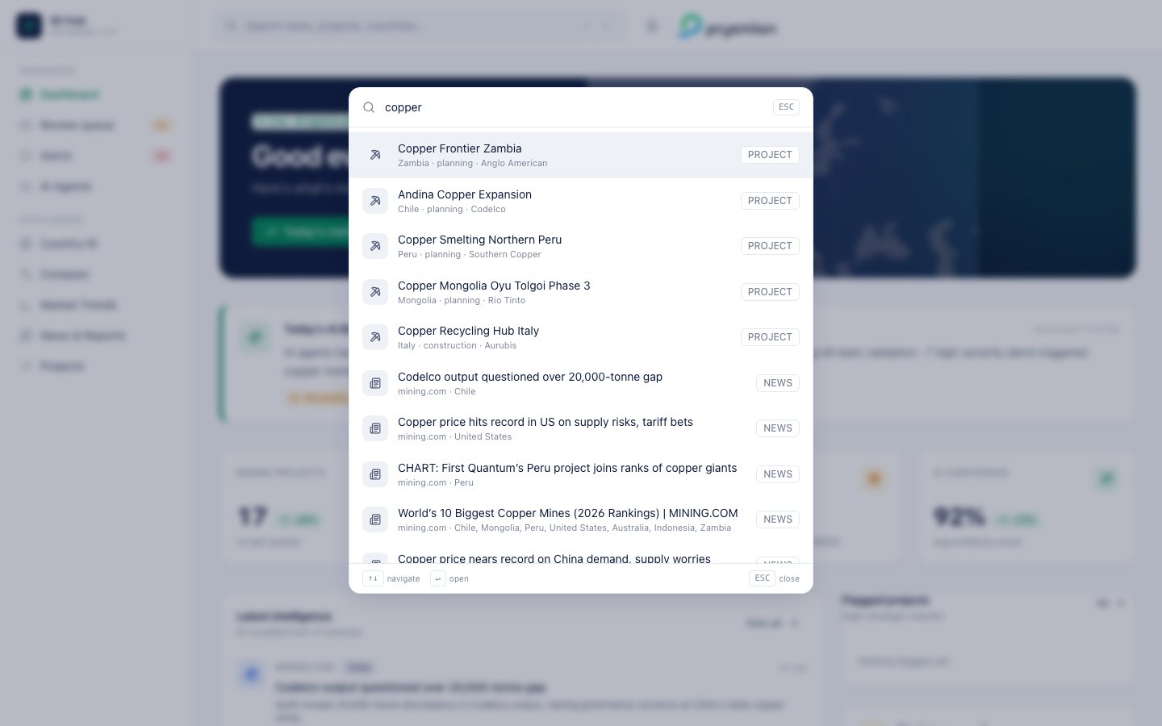
Search palette

5.1 Triggering
- Click search bar in header
- Press ⌘K (Mac) / Ctrl+K (Windows/Linux)
- ESC to close
- Background click closes (modal pattern)

5.2 Debounce
180ms after the last keystroke before the search query fires. This prevents request spam while typing fast.
useEffect(() => {
const t = setTimeout(() => setDebounced(q), 180);
return () => clearTimeout(t);
}, [q]);

5.3 Backend query (current build)
-- /api/search?q=copper
SELECT * FROM gold.news_curated
WHERE title ILIKE '%copper%' OR summary ILIKE '%copper%'
ORDER BY published_at DESC
LIMIT 8;
SELECT * FROM gold.mining_projects
WHERE name ILIKE '%copper%' OR owner ILIKE '%copper%' OR country ILIKE '%copper%'
LIMIT 8;
-- in-memory match against known countries list
filter KNOWN_COUNTRIES WHERE name.lower() CONTAINS 'copper'
OR id CONTAINS 'copper'
Returns shape:
{
"query": "copper",
"news": [...],
"projects": [...],
"countries": [],
"totals": { "news": 5, "projects": 1, "countries": 0 }
}

5.4 Result ordering in the palette
In SearchPalette.tsx:
1. Countries (most specific, smallest cohort)
2. Projects
3. News
This is intentional: when a user searches “Italy”, they probably want to navigate to the Italy country page, not see articles about Italy.

5.5 Keyboard navigation
Key | Action
↑ / ↓ | Move activeIdx within bounds
Enter | Call items[activeIdx].onSelect()
ESC | Close palette
Type | Updates q, resets activeIdx to 0 on debounce
Mouse hover also updates activeIdx. Click executes onSelect.

5.6 Dispatch per type
Result type | onSelect action
country | navigate('/country/' + c.id) + close palette
project | navigate('/projects/' + p.id) + close palette
news | window.open(n.url, '_blank') + close palette

5.7 Phase 1 — semantic search upgrade
The current ILIKE approach is a lexical “starts/contains” matcher. Phase 1 makes it hybrid:
- BM25 lexical match on title + summary → top 100 candidates
- Vector cosine (Voyage-3-large, 1024-dim) on full content → top 100 candidates
- Re-rank with Reciprocal Rank Fusion (RRF, k=60)
- Render with lexical highlights + similarity score
PostgreSQL with tsvector + pgvector handles both in one database below ~10M documents.

5.8 Acceptance criteria — search
AC-ID | Criterion
SEARCH-1 | Below 2 chars, palette shows “Type at least 2 characters” hint
SEARCH-2 | Search latency p95 < 400ms (single-region, 10K rows)
SEARCH-3 | Result groups appear in country → project → news order
SEARCH-4 | Enter on selected row navigates or opens, palette closes
SEARCH-5 | ESC closes even with an in-flight query
SEARCH-6 | No results message: No results for "{q}" after the in-flight finishes

6. Review Queue (HITL) — complete workflow spec
This is the operational core of the platform. The brief specifies a human-in-the-loop validation step on every AI output before it propagates downstream. This section documents the state machine, transitions, audit log, and feedback loop in full.
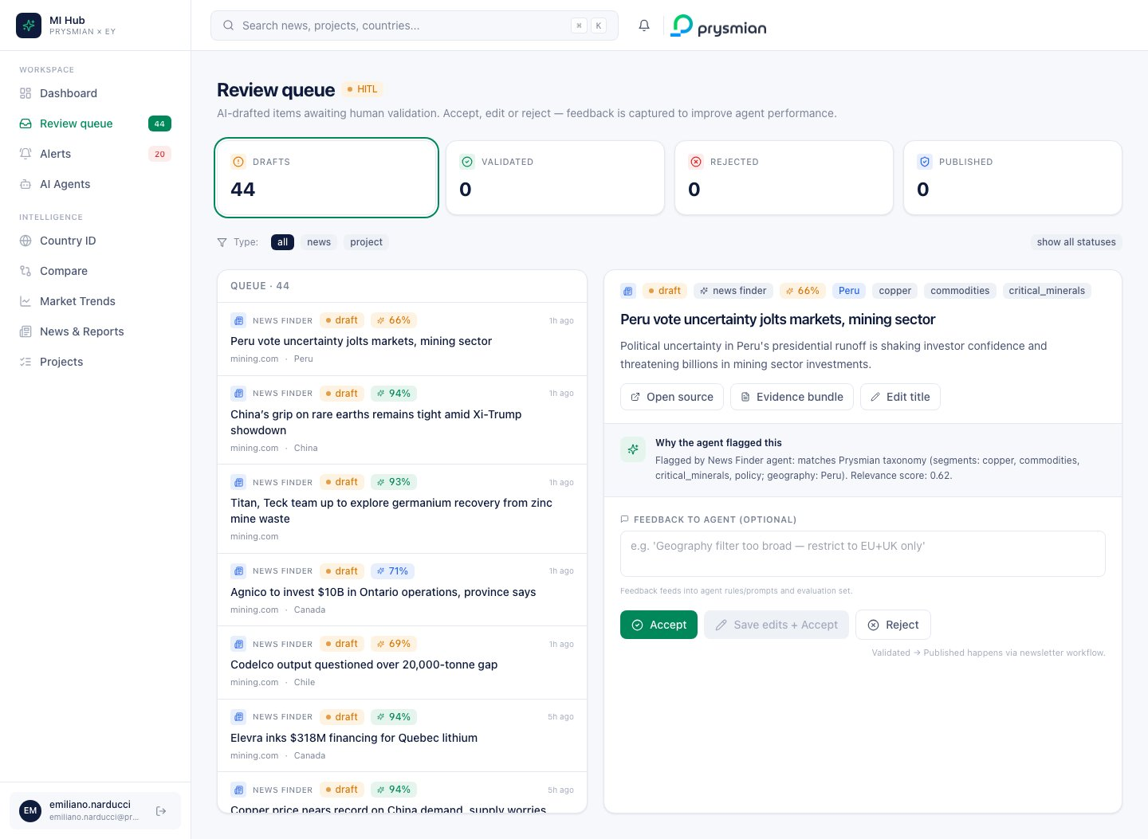
Review Queue main

6.1 State machine
┌─────────────────────────────────┐
▼ │
┌─────────┐ accept ┌────────────┴───┐ publish ┌─────────────┐
│ draft │ ─────────────▶│ validated │ ─────────────▶│ published │
└─────────┘ save-edit-acc.└────────────────┘ └─────────────┘
│ │
│ reject │
▼ │
┌──────────┐ │
│ rejected │ ◀───── restore ──────┘
└──────────┘
Transition | Trigger | Side effects
(new)→draft | Agent writes item, surfacing rule passes | Item appears in Review Queue list
draft→validated | MI clicks Accept | decided_by, decided_at, optional feedback stored
draft→validated | MI clicks Save edits + Accept | edited_title saved, decided_by/at/feedback stored
draft→rejected | MI clicks Reject | feedback stored, item dimmed in UI
validated→published | MI clicks Publish now | item becomes visible in public Hub views (newsletter)
rejected→draft | MI clicks Restore to queue | item re-enters draft pool
In Phase 1 the validated → published transition is automated through an editorial workflow (daily digest) instead of one-click. But the manual override stays available.

6.2 Surfacing rule (what enters the queue?)
A new agent-produced item enters Review Queue draft state iff:
confidence >= agent.surfacing_threshold (default 0.65)
AND relevance_score >= agent.relevance_threshold (default 0.65)
AND NOT exists duplicate(item.url, last 48h)
Items below either threshold are written to gold (still searchable) but not queued for review. This prevents alert fatigue.

6.3 List rendering rules
The list (left pane) is queried via /api/review/queue?status_filter=draft&limit=80.
Each row shows (top to bottom):
Row element | Source
Type icon | newspaper for news, pickaxe for project
Agent label | agent.replace('_', ' ') ALL CAPS
Status chip | tone map: draft=amber, validated=green, rejected=red, published=blue
Confidence chip | tone band by score (see §6.5)
Relative time | relTime(curated_at)
Title (2 lines) | title (or edited_title if present)
Source + country | source and country (when present)
Click selects the item, populating the right detail pane. Active row gets bg-prysmian-green/8 highlight.

6.4 Detail pane
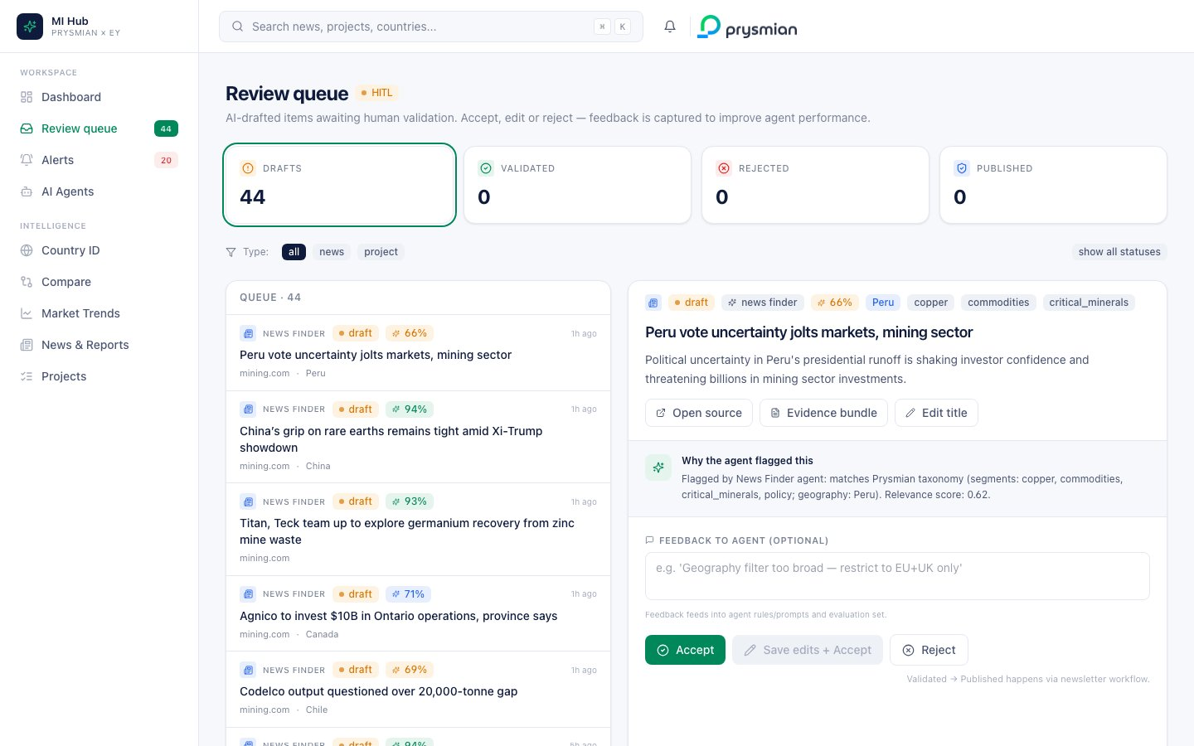
Review detail
The right pane has 4 sections:

6.4.1 Header
- Type icon · status badge · agent badge · confidence chip · country chip · segment chips
- Title (editable inline — click Edit title button)
- Sub: edited_title diff line if title !== original_title
- Summary (item.summary)
- Action row: Open source · Evidence bundle · Edit title

6.4.2 AI reasoning callout
Flagged by News Finder agent: matches Prysmian taxonomy (segments: copper, commodities; geography: Peru). Relevance score: 0.62.
Generated server-side in backend/api/review.py:
def _ai_reason(item_type, item):
if item_type == "news":
return (
f"Flagged by News Finder agent: matches Prysmian taxonomy "
f"(segments: {', '.join(item.segments or []) or 'general'}; "
f"geography: {', '.join(item.countries or []) or 'global'}). "
f"Relevance score: {float(item.relevance_score):.2f}."
)
return (
f"Flagged by Project Scouting agent: {item.project_type or 'mining'} "
f"project in {item.country or 'unspecified region'} with estimated "
f"${float(item.capex_estimate_musd or 0):,.0f}M CAPEX. "
f"Cable demand exposure: ~{float(item.cable_demand_estimate_km or 0):,.0f} km."
)

6.4.3 Decision history strip (only when decided)
Decided 3m ago by user@prysmian.com “Geography too broad, restrict to Italy.”

6.4.4 Feedback + actions (only when status = draft)
- Textarea: optional feedback, placeholder example shown
- Buttons: Accept (green) · Save edits + Accept (Prysmian green, only enabled when editing == true) · Reject (white)
For validated state: replaced with a Publish now button. For rejected state: replaced with a Restore to queue button.

6.5 Confidence display rules
Score range | Chip color | Recommended MI action
≥ 85% | green | Likely accept; spot-check
70–84% | blue | Read fully before accepting
50–69% | amber | Scrutinize; likely needs edit or reject
< 50% | (not surfaced) | Not queued (auto-discarded)

6.6 Feedback loop (“AI evaluation reinforcement”)
When MI submits a decision with feedback text, the demo logs it to in-memory state. In Phase 1:
- Each feedback row joins the agent evaluation set (audit.review_decisions)
- Weekly cron replays the evaluation set against the current agent prompts/rules
- Items where the new agent output disagrees with the historical MI decision are flagged as “regression risks”
- Prompt tuning / rule changes that improve the alignment % are promoted to production
This is the reinforcement-via-evaluation pattern the brief asks for. Note: no online RLHF — the loop is deliberate, MI-curated, and auditable.

6.7 Audit trail
Every item in any non-draft state shows on the detail panel:
Decided 3m ago by user@prysmian.com “Geography too broad, restrict to Italy.”
This satisfies the brief’s “versioning + audit trail” requirement. In Phase 1 the audit trail is append-only and immutable (write to audit.review_decisions with no UPDATE allowed at DB level — Postgres role with INSERT/SELECT only).

6.8 API surface — Review Queue
Endpoint | Method | Body / Query | Returns
/api/review/queue | GET | item_type (news|project|null), status_filter, limit | {items[], total}
/api/review/stats | GET | — | {by_status, total_items, decisions_logged}
/api/review/{item_id}/decide | POST | {status, feedback?, edited_title?, decided_by?} | {ok, item_id, ...}

6.9 Live counter refresh
Sidebar Review queue badge polls /api/review/stats every 20 seconds via React Query. UI updates when by_status.draft changes.
useQuery({
queryKey: ["review-stats-nav"],
queryFn: ...,
refetchInterval: 20000,
});

6.10 Acceptance criteria — Review Queue
AC-ID | Criterion
REV-1 | Drafts list updates within 20s of an agent run completing
REV-2 | Accept transitions item to validated, removes from status_filter=draft list
REV-3 | Feedback text persists across page reloads (Phase 1: stored in DB)
REV-4 | Edit title diff line shows in detail panel when titles differ
REV-5 | Rejected items can be restored to draft
REV-6 | All transitions log decided_by + decided_at + feedback in audit.review_decisions
REV-7 | UPDATE/DELETE on audit.review_decisions rejected by DB role permissions

7. AI Agents — per-agent specs
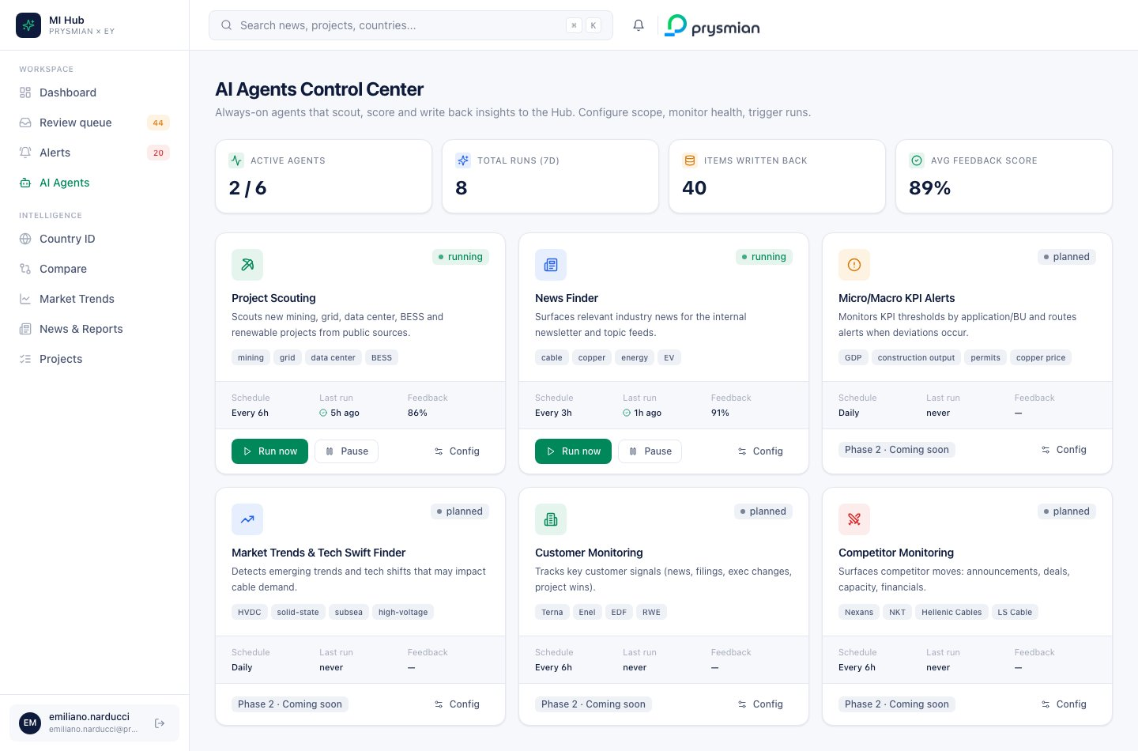
Agents Control Center
The brief specifies six always-on AI agents. This section is the complete spec for each one: inputs, processing, outputs, schedule, confidence, routing, failure modes, acceptance criteria.

7.1 Agent design patterns (shared)
All agents share the same BaseAgent abstraction (mimicking Databricks Agent Bricks):
class BaseAgent:
name: str
version: str
keywords: list[str]
geography: list[str]
confidence_threshold: float
def run(self, bounded: bool = False, max_items: int = None, timeout_seconds: int = None):
run_id = self._start_audit_run()
try:
sources = self._fetch_sources()
for source in sources:
items = self._extract(source)
for item in items:
if not self._dedupe(item): continue
confidence = self._score(item)
if confidence < self.confidence_threshold: continue
evidence_id = self._write_evidence(item, confidence)
self._write_to_gold(item, evidence_id)
if bounded and self.items_produced >= max_items: break
if bounded and timeout_seconds and self._elapsed() > timeout_seconds: break
self._end_audit_run(run_id, status="success")
except Exception as e:
self._end_audit_run(run_id, status="error", error=str(e))
raise
Common patterns:
- Bounded runs for on-demand triggers (max items, max seconds) to prevent runaway costs
- Dedup at URL/content level over a sliding window
- Evidence-first: write evidence record before gold record (so even partial writes are traceable)
- Audit: every run logged with timing, tokens, status, error

7.2 Project Scouting Agent
Status: implemented (mining_cable_specialist)

Input
- Sources: mining.com, S&P Global, Reuters mining feed, BNEF press releases, BloombergNEF
- Configurable keywords: mining, grid, data center, BESS, renewable
- Geography filter (default: EU, UK, MENA)

Processing
- Retrieve — fetch RSS / API feeds since last successful run
- Filter — keyword match on title + first 500 chars
- Extract — LLM (Claude Sonnet 4.6) extracts structured entities:
  - Project name, owner, country
  - Project type (copper / lithium / data_center / wind / grid / BESS)
  - CAPEX in MUSD (with currency conversion from raw publication currency via published FX)
  - Capacity MW where applicable
  - Start/end years
  - Status (mapping vendor terms → planning|construction|operational|cancelled)
- Derive cable demand (see §15.2)
- Score confidence (see §15.4)
- Score flagged_of_interest (see §15.3)
- Write back — single transaction:
  - INSERT into gold.mining_projects
  - INSERT into audit.evidence_metadata with source URLs and confidence breakdown
  - Surfaces to Review Queue as draft if confidence ≥ surfacing threshold

Prompt template (Phase 1, sketch)
You are an industrial market intelligence analyst.
From the following article excerpt, extract a single mining/grid/datacenter/renewable
project record as STRICT JSON:
{ "name": str, "owner": str, "country": str, "project_type": one_of(
"copper","lithium","nickel","cobalt","REE","data_center","wind","solar",
"BESS","grid","other"),
"capex_estimate_musd": float|null, "capacity_mw": float|null,
"start_year": int|null, "end_year": int|null,
"status": one_of("planning","construction","operational","cancelled"),
"currency_raw": str|null, "extraction_confidence": float in [0,1] }
If the article does not describe ONE project, return: { "skip": true, "reason": str }.
Cite the spans you used. Output JSON only, no commentary.
ARTICLE:
"""
{article_text}
"""

Output schema → see §13.1.2

Schedule
- Default: every 6 hours (cron 0 */6 * * *)
- Bounded runs (max 3 items, 30s timeout) when triggered via /api/agents/.../run

Failure modes
Failure | Behavior
Source unreachable | log error in audit.agent_runs, retry next cycle, alert ops after 3 fails
LLM rate-limit | fallback to Claude Haiku 4.5 with explicit agent_version: haiku-fallback tag
Extraction confidence < threshold | item still written but flagged low_confidence, surfaced in Review Queue with amber chip
JSON parse error | log raw output to audit.agent_runs.error_message, skip item
Currency conversion missing FX | flag item, leave CAPEX null, MI sees red chip

Performance SLAs
Metric | Target
Run latency p95 (3 items) | < 30s
Cost per item | < $0.03 (Sonnet) / $0.005 (Haiku)
Daily runs | 4× scheduled + on-demand

7.3 News Finder Agent
Status: implemented (news_finder)

Input
- Sources: 8+ industry publications + Google News RSS for keyword sets
- Configurable keywords: cable, copper, energy, EV, grid (extensible)
- Geography filter: EU + Global

Processing
- Fetch RSS / scrape with rate-limit (1 req/sec per source)
- Deduplicate — URL canonicalization + 24h sliding window
- LLM extracts:
  - 2-3 sentence summary (system prompt: “Summarize for a senior MI analyst, neutral tone, max 3 sentences.”)
  - segments (taxonomy match)
  - countries (NER + ISO normalization)
  - relevance_score ∈ [0,1] (see §15.1)
- Write to gold.news_curated + audit.evidence_metadata
- Items with relevance_score ≥ 0.65 enter Review Queue as draft
- Items with relevance_score < 0.65 are written but not surfaced to Review Queue (still searchable, but stay quiet)

Schedule
- Default: every 3 hours
- Cost: ~$0.02 per article extracted (Sonnet) — budget ~$10/day at ~500 articles/day

7.4 Micro/Macro KPI Alerts Agent
Status: planned (Phase 2)

Input
- KPI feeds: GDP, construction output, building permits, copper LME, interest rates, FX rates
- Configurable per-BU thresholds (e.g., “alert when Italy construction output MoM < −3%”)
- Geography: EU + Global commodity

Processing
- Daily scheduled run pulls fresh KPI values from official sources (Eurostat, Istat, LME)
- For each (kpi, country, bu) triple, compute:
  - MoM delta = (value_t − value_{t−1}) / value_{t−1}
  - YoY delta = (value_t − value_{t−12}) / value_{t−12}
  - z-score over 24-month history
- Rule engine matches against subscribed thresholds (stored in runtime.alert_rules)
- When matched, emit Alert with severity:
  - high if |delta| > 2× threshold OR z-score > 2.5
  - medium if |delta| > threshold OR z-score > 1.5
  - low otherwise
- Confidence ≥ 0.7 always (data is structured, low uncertainty)
- Routing: see §8.4

7.5 Market Trends & Tech Swift Finder
Status: planned (Phase 2)

Input
- Tech blogs, ArXiv abstracts (cable/EE category), patent filings (USPTO, EPO), conference papers
- Keywords: HVDC, solid-state, subsea, high-voltage, smart grid, …

Processing
- Compute embeddings on each candidate (Voyage-3-large)
- Cosine similarity against Prysmian’s tech-radar topic vectors (curated by R&D team)
- Top-K with similarity > 0.7 → Review Queue as swift_finder drafts
- LLM summarizes “what’s new” and “why it matters for Prysmian”

7.6 Customer Monitoring
Status: planned (Phase 2)

Input
- Subscribed customer list (Terna, Enel, EDF, RWE, TenneT) — synced from Salesforce nightly
- Salesforce account list

Processing
- Per-customer: news + filings (SEC/CONSOB) + LinkedIn execs feed
- Event extraction: project wins, leadership changes, capacity expansion, capex announcements
- Each event becomes a customer_event row + alert if subscribed
- Severity: events that change the customer’s procurement profile → high

7.7 Competitor Monitoring
Status: planned (Phase 2)

Input
- Competitor list: Nexans, NKT, Hellenic Cables, LS Cable, …

Processing
- Same pipeline as Customer Monitoring but classified by competitor keyword
- Events: pricing moves, M&A, capacity, financials
- All competitor news routes to competitor alert type with severity computed from event class

7.8 Agent control endpoints
Endpoint | Method | Returns
/api/agents/catalog | GET | All 6 agents enriched with last-run, runs_count
/api/agents/{id}/toggle | POST | Flip enabled flag
/api/agents/{name}/run | POST | Trigger background bounded run
/api/agents/runs | GET | Last 50 runs from audit.agent_runs

7.9 Agent card UI logic
Field shown | Source
Status badge | enabled && implemented → running, !enabled && implemented → paused, !implemented → planned
Schedule | static config string (“Every 6h”, “Daily”, etc)
Last run | relTime(last_run) from latest audit.agent_runs row
Last run status icon | green check / red X / nothing
Feedback % | round(feedback_score * 100)

7.10 Agent config drawer
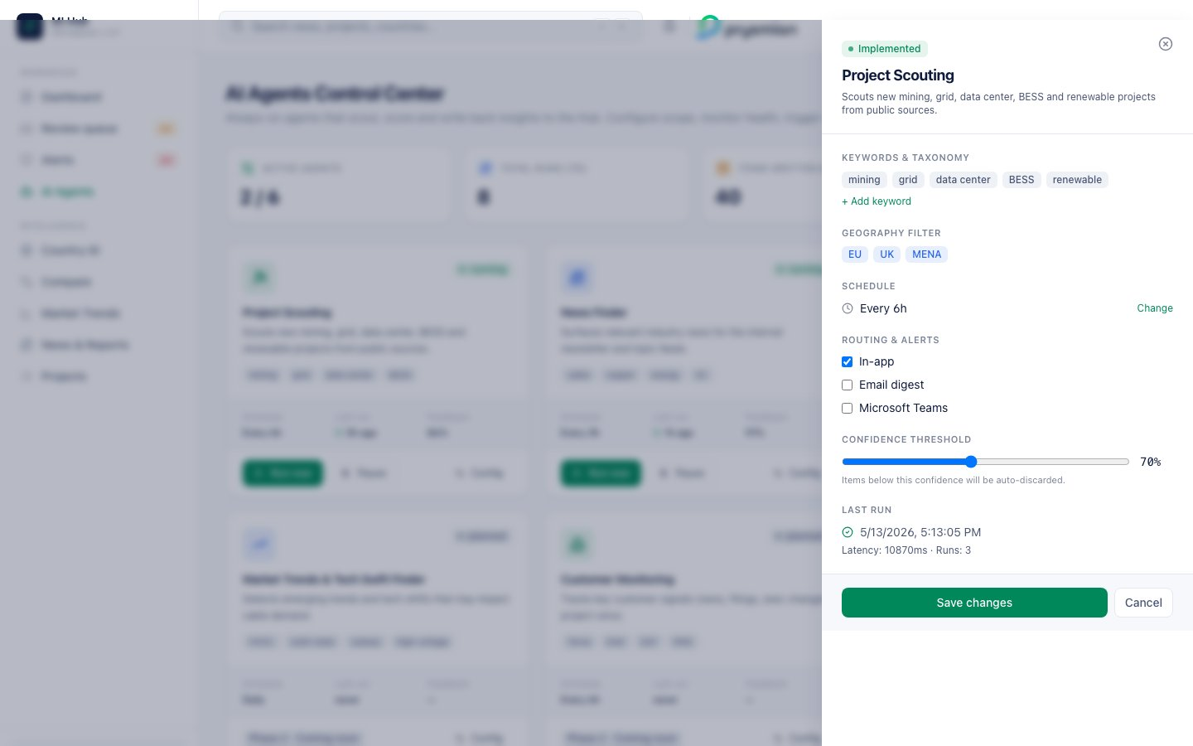
Agent config drawer
Configurable fields (Phase 1, persisted to runtime.agent_config):
Field | Type | Example
Keywords | chip list | mining, grid, data center, …
Geography filter | chip list | EU, UK, MENA
Schedule | cron string | 0 */6 * * *
Routing channels | bool×3 | in_app, email, teams
Confidence threshold | slider 50–95 | default 70
Changes here re-deploy the agent’s runtime config without code change (taxonomy as data, not code).

7.11 Acceptance criteria — Agents
AC-ID | Criterion
AGT-1 | Catalog lists exactly 6 agents
AGT-2 | Implemented agents show “running” or “paused”; planned agents show “Phase 2 · Coming soon”
AGT-3 | “Run now” triggers a bounded run; status visible within 30s in Last run
AGT-4 | Pause sets enabled=false, scheduled runs do not fire
AGT-5 | Config save persists across page reloads (Phase 1: DB)
AGT-6 | Audit trail entry created for every run, success or failure

8. Alerts engine — triggering, severity, routing
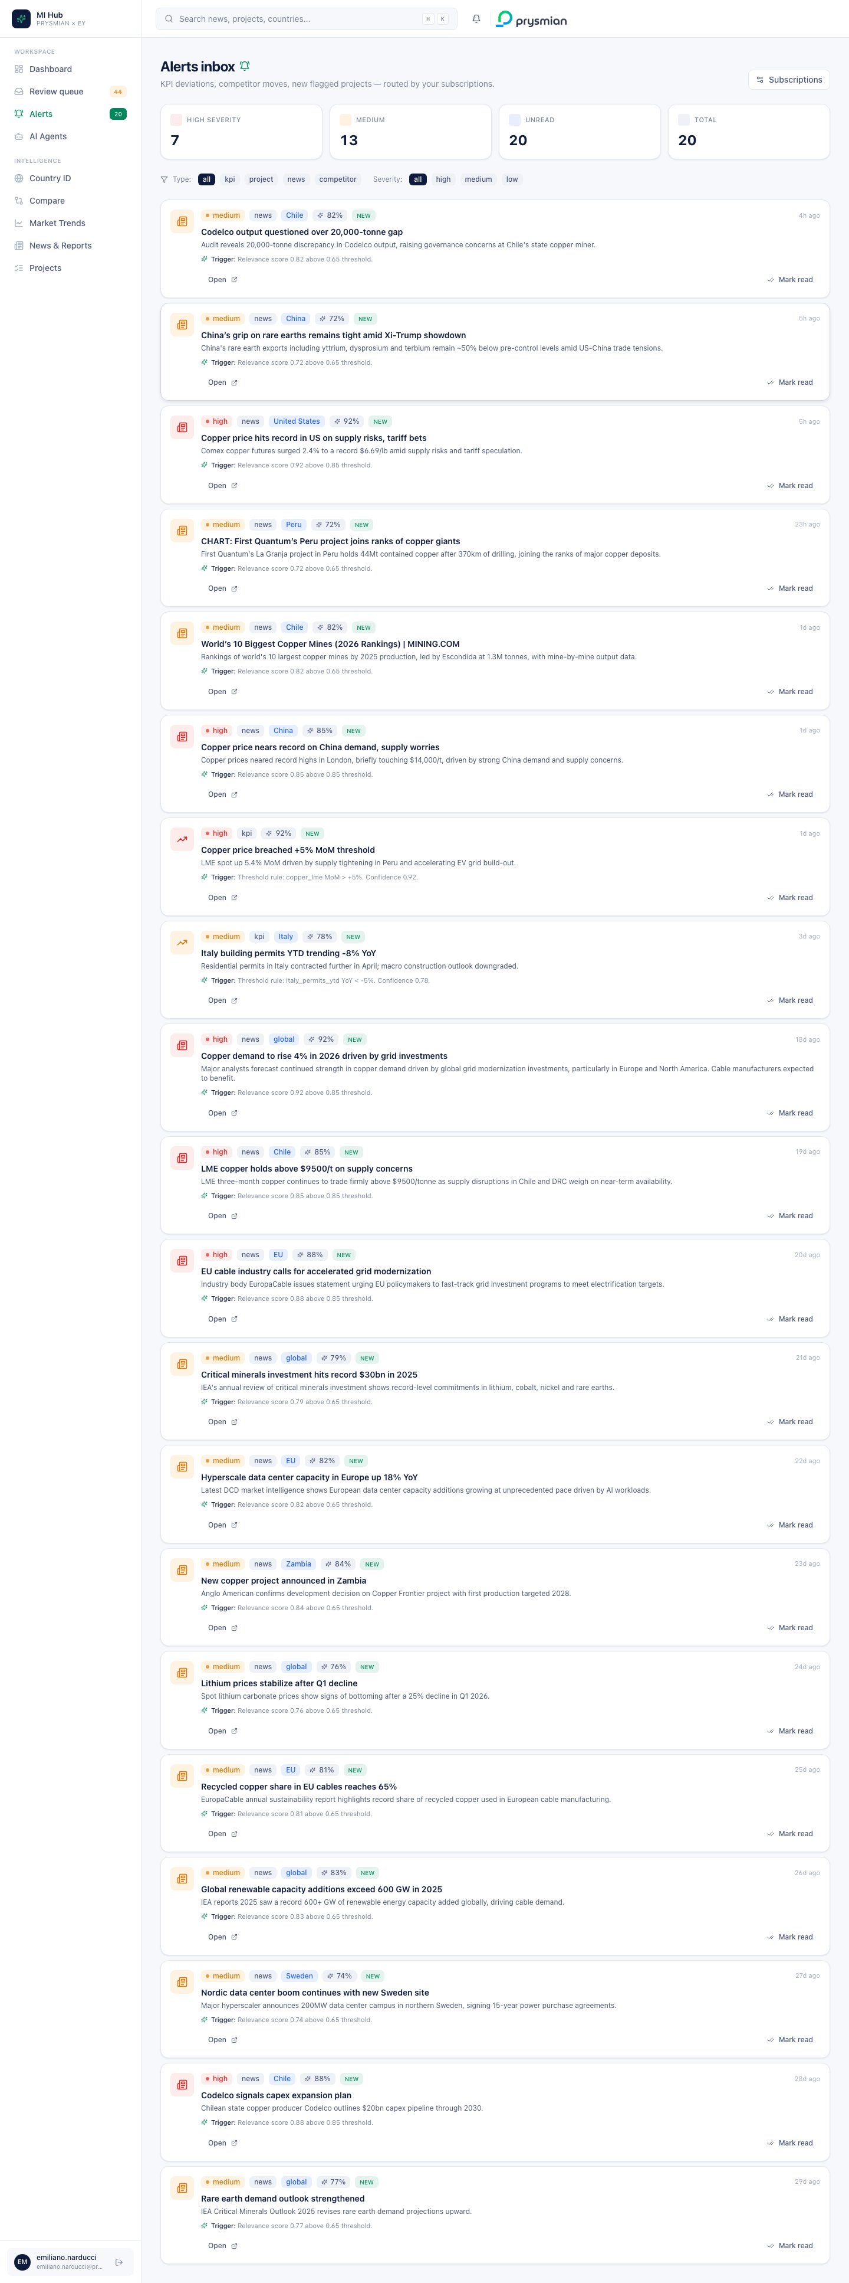
Alerts inbox

8.1 Alert sources
Alerts are synthesized from existing data (demo) or emitted by KPI agent (Phase 1):
Alert type | Source data | Trigger condition
project | gold.mining_projects | flagged_of_interest = true AND created in last N days
news | gold.news_curated | relevance_score >= 0.65
competitor | gold.news_curated (sub-classified) | news title matches competitor keyword regex
kpi | gold.commodity_indicators, gold.market_trends | threshold rule matched

8.2 Severity classification
def _classify_severity(score: float) -> str:
if score >= 0.85: return "high"
if score >= 0.65: return "medium"
return "low"
Per type-specific scoring:
- news/competitor: relevance_score
- project: derived → high if CAPEX > $500M, medium otherwise (currently fixed; Phase 1 adds BU exposure factor)
- KPI: derived → high if |delta| > 2× threshold else medium

8.3 Trigger reason (transparency)
Every alert exposes a structured trigger_reason string:
- News/competitor: “Relevance score 0.78 above 0.65 threshold.”
- Project: “Strategic flag triggered — high CAPEX and Prysmian BU exposure.”
- KPI: “Threshold rule: copper_lme MoM > +5%. Confidence 0.92.”
Intentionally machine-readable (agent name + rule that fired) so MI can identify and tune the rule directly.

8.4 Subscriptions & routing
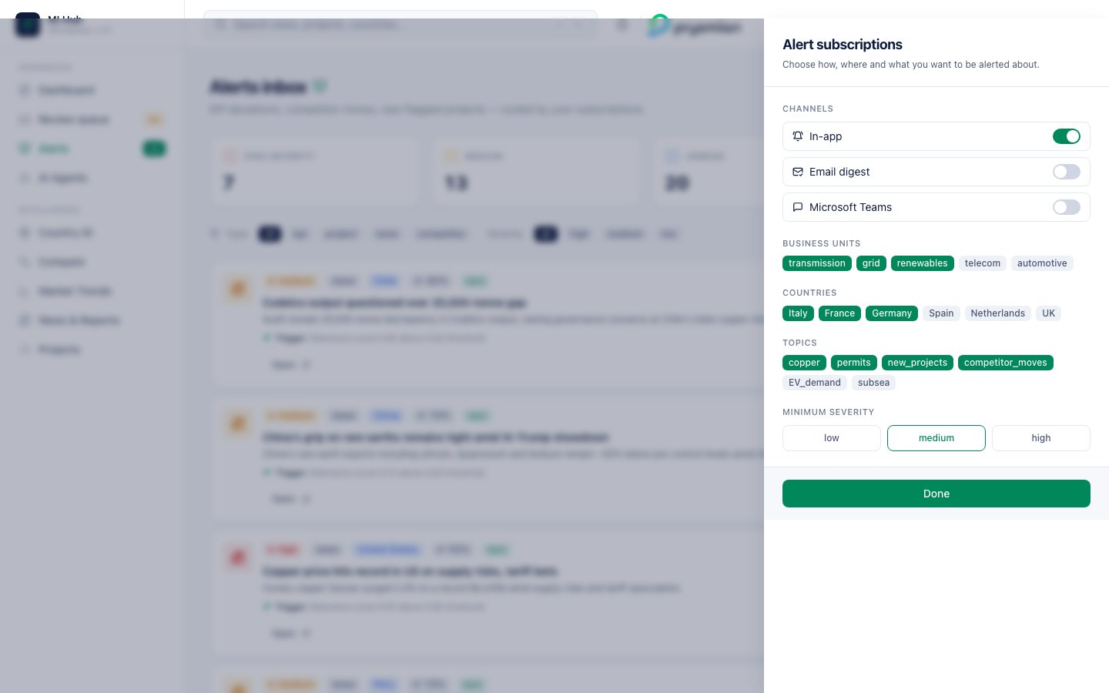
Subscriptions drawer
The user’s subscription preferences gate which alerts land where:
alert_visible_to_user = (
severity_rank(alert.severity) >= severity_rank(user.min_severity)
AND (
alert.country in user.subscribed_countries
OR (alert.type == 'kpi' AND alert.bu in user.subscribed_bus)
OR (alert.type in {'news','competitor'} AND alert.topic in user.subscribed_topics)
)
AND user.channels.in_app == True # at minimum
)
Where severity_rank('low')=1, 'medium'=2, 'high'=3.
Same rule applies per channel (email, teams): if user has email disabled, the alert lands in-app only.

8.5 Subscription persistence
Demo: in-memory single user (_SUBSCRIPTIONS dict in backend/api/alerts.py).
Phase 1: per-user JSON in users.preferences:
{
"channels": { "in_app": true, "email": false, "teams": false },
"bu": ["transmission", "grid", "renewables"],
"countries": ["Italy", "France", "Germany"],
"topics": ["copper", "permits", "competitor_moves", "new_projects"],
"min_severity": "medium"
}
PUT to /api/alerts/subscriptions with partial body updates only the provided fields.

8.6 Read-state
An alert’s read flag is per-user. Demo: in-memory set; Phase 1: join table (user_id, alert_id, read_at).
POST /api/alerts/{alert_id}/read with body { "read": true|false }.

8.7 Default subscription policy
New users get a sensible default:
channels: { in_app: true, email: false, teams: false }
bu: ["transmission", "grid", "renewables"]
countries: [user's country from HR feed]
topics: ["copper", "permits", "new_projects", "competitor_moves"]
min_severity: "medium"
MI lead role onboarding sets this from Entra/HR attributes; user can override.

8.8 Card rendering
Per alert in the inbox:
Element | Source
Type icon | type-based: TrendingUp (kpi), Building2 (project), Newspaper (news), Swords (competitor)
Severity badge | tone map
Type chip | static text
Country chip | if present
Confidence chip | sparkle icon + {confidence}%
NEW chip | if !read
Title (bold) | title
Body (2 lines) | body
Trigger callout | sparkle icon + Trigger: {trigger_reason}
Open link | internal route (startsWith('/')) or external URL
Mark read/unread | toggle button
Read items get 60% opacity (opacity-60) so unread items stand out.

8.9 API surface — Alerts
Endpoint | Method | Body / Query | Returns
/api/alerts | GET | severity?, type_filter? | { alerts[], total }
/api/alerts/stats | GET | — | { total, unread, by_type, by_severity }
/api/alerts/{id}/read | POST | { read: bool } | { id, read }
/api/alerts/subscriptions | GET | — | { channels, bu, countries, topics, min_severity }
/api/alerts/subscriptions | PUT | partial Subscriptions | merged Subscriptions

8.10 Acceptance criteria — Alerts
AC-ID | Criterion
ALT-1 | Stats counters match alerts list under same filters
ALT-2 | Marking read decreases unread count; refresh interval ≤ 30s for header badge
ALT-3 | Filter chips combine (AND between type and severity, OR within each)
ALT-4 | Subscriptions PUT with partial body only updates provided fields
ALT-5 | Open button routes to internal page for /... links, opens new tab for http* URLs
ALT-6 | Phase 1: alerts below min_severity are filtered out at the API layer, not just UI

9. Country ID — full calculation reference
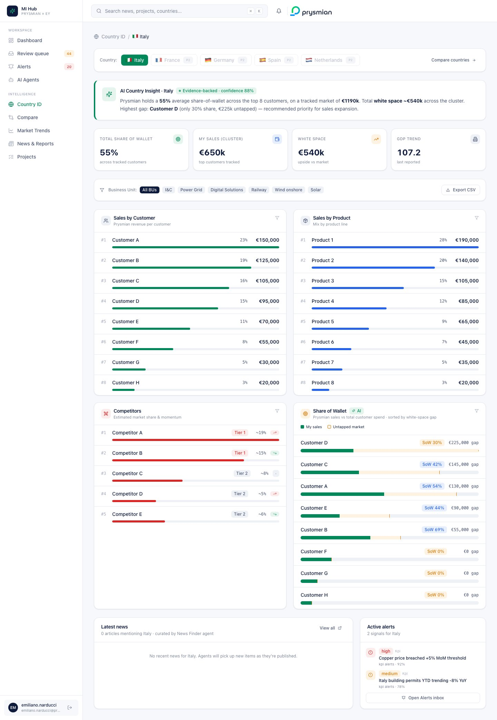
Country ID Italy
The Country Identity Card is the most metric-dense screen. Every number is documented here.

9.1 Country switcher
- 5 countries: Italy (live), France, Germany, Spain, Netherlands (Phase 2 placeholder)
- Active country: green pill
- Phase 2 countries: outline pill + P2 chip + opacity 70%
- Right-aligned: link to /compare
When user clicks a Phase 2 country, the page renders a placeholder card with two CTAs: - “Country news” → /news - “Country projects” → /projects?country={name} (filter pre-applied)

9.2 AI Country Insight banner
Templated paragraph. Inputs (Italy example, live numbers):
Variable | Source
total_sow | total_mySales / total_marketValue
n | len(sales_by_customer)
total_market_value | Σ market_value_by_customer.value
total_white_space | total_market_value - total_mySales
top_gap.name | first row of sow[] sorted by gap desc
top_gap.share | top_gap.mySales / top_gap.market
top_gap.gap | top_gap.market - top_gap.mySales
Template:
Prysmian holds a {total_sow:.0%} average share-of-wallet across the top {n} customers,
on a tracked market of €{total_market_value/1000:.0f}k.
Total white space ~€{total_white_space/1000:.0f}k across the cluster.
Highest gap: {top_gap.name} (only {top_gap.share:.0%} share, €{top_gap.gap/1000:.0f}k untapped)
— recommended priority for sales expansion.
Why templated, not LLM-generated? Determinism + audit safety. The numbers are always provably correct because they come from the same data the user sees. In Phase 1 an LLM can wrap stylistic variety around the same template, but the underlying calculation stays auditable.

9.3 Macro snapshot tiles
Tile | Formula
Total share of wallet | total_mySales / total_marketValue (% formatted)
My sales (cluster) | Σ sales_by_customer.value (€XXXk formatted)
White space | Σ max(0, market_value - my_sales) per customer
GDP trend | trends.indicators['gdp'].series[-1].value

9.4 Filter bar
- Business Unit chips — I&C, Power Grid, Digital Solutions, Railway, Wind onshore, Solar
  - Demo: filter applied but values unchanged; UI shows italic helper text “Filter applied (demo: values unchanged, Phase 1 wires real BU split)”
  - Phase 1: queries filter by bu_filter parameter; values recompute per BU split stored in silver
- Export CSV — client-side blob download with all 4 quadrants flattened to CSV (quadrant, name, value_eur, detail)

9.5 Quadrant 1 — Sales by Customer
Source: gold.country_summary.sales_by_customer (CSV seed in demo).
Per row:
Column | Logic
Rank | #{i+1} from sorted order (input order = pre-sorted by value desc)
Name | r.name
Share % | (r.value / total_mySales) * 100
Value | €{r.value:,}
Bar width | max(2, (r.value / max(*values)) * 100)%
Bar color | green (Prysmian)
Click → drill modal (§10).

9.6 Quadrant 2 — Sales by Product
Identical structure to Quadrant 1, except:
Column | Logic
Bar color | blue
Drill modal | SAP material master tab instead of Salesforce account

9.7 Quadrant 3 — Competitors
Source: gold.country_summary.competitors (only name + tier in seed).
Synthesized fields (demo only, see §11):
Field | Logic
Tier | parse from detail field: contains “1” → 1 else 2
Market share % | max(2, base_share + perturbation) where base_share = (18 - i*2) for Tier 1, (9 - i) for Tier 2
Trend | i%3 == 0 → up (threat), == 1 → down (favourable), == 2 → flat
Bar color | red (Prysmian competitor)

9.8 Quadrant 4 — Share of Wallet (AI insight)
The killer view. Computed client-side from quadrants 1 and 4 of the original brief:
const mvbcMap = new Map(market_value_by_customer.map(r => [r.name, r.value]));
sow = sales_by_customer.map(s => {
const mySales = s.value;
const market = mvbcMap.get(s.name) ?? 0;
const share = market > 0 ? mySales / market : 0;
const gap = max(0, market - mySales);
return { name: s.name, mySales, market, share, gap };
}).sort((a,b) => b.gap - a.gap); // biggest gap on top
Per row:
Element | Logic
Name | r.name
SoW chip | < 40% amber, 40–69% blue, ≥ 70% green
Gap label | €{r.gap:,} gap
Stacked bar | green portion = mySales/maxMarket, amber portion = gap/maxMarket
The bar visually communicates both current footprint and untapped opportunity in a single horizontal element.

9.9 SoW band classification
Band | Interpretation | Strategy
< 40% | Low penetration | Share-shift initiative
40–69% | Mid-share | Cross-sell room
≥ 70% | Incumbent | Defend & protect margin

9.10 Country news + Active alerts (bottom panels)
Latest news — useNews() filtered client-side:
news.filter(n => n.countries?.some(c => c.toLowerCase() == country.toLowerCase()))
.slice(0, 4);
Per row: source, time, “High” relevance chip if score ≥ 0.7, title, summary.
Active alerts — /api/alerts filtered client-side by country (or null country = global):
alerts.filter(a => !a.country || a.country.toLowerCase() == country.toLowerCase())
.slice(0, 4);
Per row: severity icon + badge, type, title, agent label, confidence %.

9.11 API surface — Country ID
Endpoint | Method | Returns
/api/countries | GET | List of country IDs available
/api/countries/{id}/summary | GET | { country, sales_by_customer[], sales_by_product[], competitors[], market_value_by_customer[] }
/api/trends/{country} | GET | macro indicators (used for GDP tile)
/api/news | GET | news list (filtered client-side)
/api/alerts | GET | alerts list (filtered client-side)

9.12 Acceptance criteria — Country ID
AC-ID | Criterion
CTY-1 | AI banner uses live numbers matching the macro tiles
CTY-2 | SoW quadrant rows sorted by gap desc
CTY-3 | Customer drill-down opens SF tab; product drill-down opens SAP tab
CTY-4 | Export CSV produces valid CSV with all 4 quadrants
CTY-5 | Phase 2 country page does NOT 404 — shows informative placeholder
CTY-6 | News + Alerts panels show count=0 message when empty

10. Drill-down modals — Salesforce + SAP

10.1 Modal layout
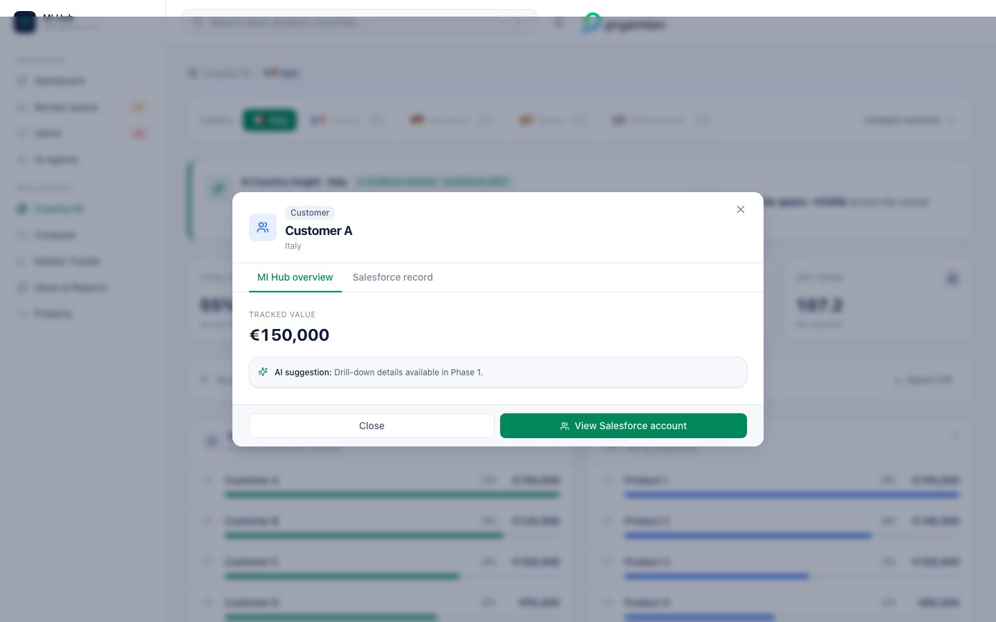
MI Hub overview tab
Two tabs:
- MI Hub overview — Prysmian-internal view (value, SoW, AI suggestion)
- Salesforce record OR SAP material master — system-of-record view
Header: type icon, kind chip, name (bold), country sub-line, close X. Footer: Close + dynamic primary CTA (Salesforce / SAP / Competitor dossier).

10.2 MI Hub overview tab
Element | Logic
Tracked value | €{item.value:,} if not null
SoW bar | only if item.sow != null
Detail line | passed string
AI suggestion | from drillSuggestion(item) (see §10.5)
Footer hint | static “Phase 1 unlocks: order history, contract list, pipeline, evidence trail.”

10.3 Salesforce record tab
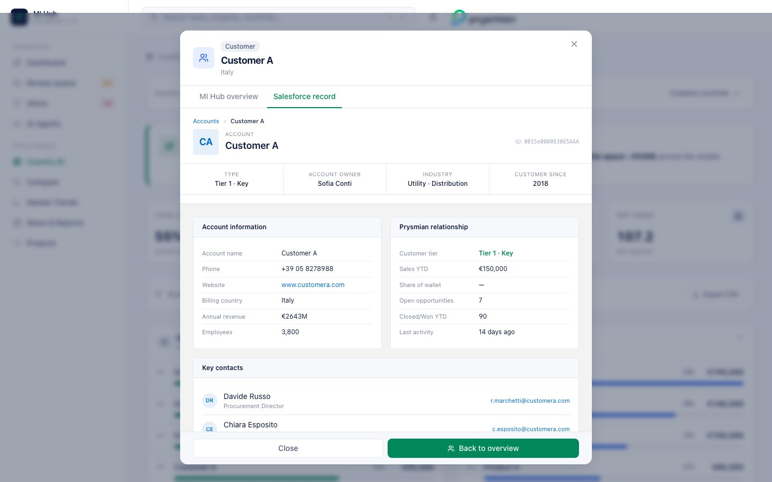
Salesforce record
Salesforce-style account page. Deterministic synthetic based on hashCode(name) (see §11.1).
Section | Content
Breadcrumb | Accounts › {name} in SF blue (#006DCC)
Avatar | initials of name words (max 2), blue background
Account ID | 0015e0000{hash%99999:05}AAA mimicking SF ID format
Highlight strip (4 cols) | Type, Account Owner (Italian names list), Industry, Customer since
Account information panel | name, phone, website, billing country, annual revenue, employees
Prysmian relationship panel | tier, sales YTD, SoW %, open opps, closed/won YTD, last activity
Key contacts (full row) | 2 contacts with initials avatars, role, clickable email
Open opportunities table | 3 mock opps with stage (Qualification/Proposal/Negotiation), amount, close date
Footer hint | “Demo view · in Phase 1 this opens the live record at {name}.my.salesforce.com”

Phase 1 integration
GET https://prysmian.my.salesforce.com/services/data/v59.0/sobjects/Account/{salesforce_id}
Authorization: Bearer {oauth_token}
Cached for 15 minutes. Editable fields write back through the same API with full audit.

10.4 SAP material master tab
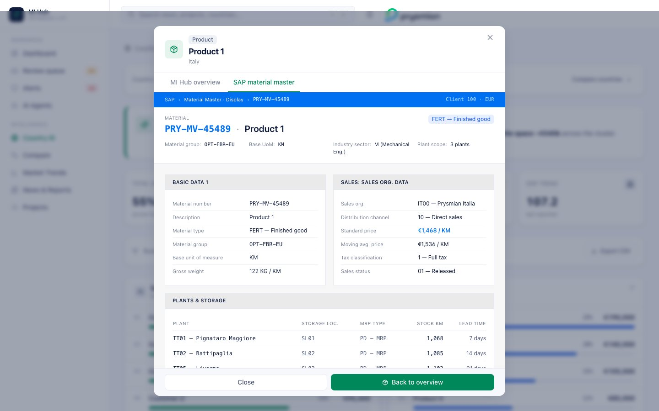
SAP material master
SAP-Fiori-style material master. Deterministic synthetic.
Section | Content
Top bar (SAP blue) | SAP › Material Master · Display › {matNo} · Client 100 · EUR
Material header | mono PRY-{type}-{hash%99999:05}, material type badge
4 metadata cells | material group, base UoM (KM/M/KG), industry sector, plant scope
Basic data 1 panel | material #, description, type, group, base UoM, gross weight
Sales: sales org panel | sales org (IT00 — Prysmian Italia / EU00 — Prysmian Europe), distribution channel, standard price, moving avg price, tax classification, sales status
Plants & storage table | plant codes (IT01 — Pignataro Maggiore, IT02 — Battipaglia, IT05 — Livorno for Italy; DE01/FR01 for others), storage location, MRP type, stock, lead time
MI Hub link tile | sales YTD, volume YTD, top customer
Footer hint | “Demo view · in Phase 1 this calls SAP RFC BAPI_MATERIAL_GET_DETAIL for live data”

Phase 1 integration
RFC: BAPI_MATERIAL_GET_DETAIL
Input: MATERIAL = PRY-MV-45489
PLANT = IT01
Returns full material master record + plants + storage locations
Cached for 1 hour. Standard price reads are common; full master data refresh nightly.

10.5 AI suggestion rules (deterministic)
def suggestion(kind, sow):
if kind == "Customer":
if sow < 0.40: return "Low share … propose share-shift initiative for Q3."
if sow < 0.70: return "Stable mid-share. Cross-sell adjacent product lines (HV, accessories) to lift wallet."
return "Strong incumbent. Defend with multi-year framework and protect margin."
if kind == "Competitor":
return "Monitor for pricing moves and capacity changes — flagged in Competitor Monitoring agent."
if kind == "Product":
return "Watch demand signals tied to this product — link to Trends for macro context."
In Phase 1 these become LLM-generated with grounded prompting (RAG over CRM + history). The deterministic rules remain as a fallback when LLM is unavailable.

10.6 Acceptance criteria — Drill modals
AC-ID | Criterion
DRL-1 | Same customer name always produces the same SF record (deterministic hash)
DRL-2 | Same product name always produces the same SAP master record
DRL-3 | Tab switch preserves modal context (no reset of which item)
DRL-4 | SoW bar only renders for customers, not products
DRL-5 | All field labels match the system-of-record conventions (Account, Material, etc)

11. Synthetic data engineering
The demo uses deterministic synthetic data wherever live integrations are not yet in place (Salesforce, SAP, competitor share, etc).

11.1 The hash function
function hashCode(s: string): number {
let h = 0;
for (let i = 0; i < s.length; i++) {
h = ((h << 5) - h) + s.charCodeAt(i);
h |= 0;
}
return h;
}
function pick<T>(seed: number, arr: T[]): T {
return arr[Math.abs(seed) % arr.length];
}
This is a 32-bit FNV-like hash. Deterministic (same input → same hash → same synthetic data across all renders and all sessions). Critical for demo coherence.

11.2 Salesforce account synthesis
Field | Derivation
Account ID | 0015e0000{(|hash| % 99999):05}AAA — mimics Salesforce ID format
Industry | pick(seed, ["Utility · Transmission", "Utility · Distribution", "Renewable energy", "Industrial · OEM", "Data center operator", "Infrastructure contractor"])
Tier | pick(seed, ["Tier 1 · Strategic", "Tier 1 · Key", "Tier 2 · Growth"])
Account Owner | pick(seed, ["Marco Bianchi", "Giulia Romano", "Luca Ferrari", "Sofia Conti"]) (Italian names list)
Customer since | 2005 + (|hash| % 18)
Employees | (5 + (|hash| % 95)) * 100
Annual revenue | (|hash| % 4500) + 200 (in MEUR)
Open opps | (|hash| % 7) + 1
Closed/Won YTD | round((customer.value / 1000) * 0.6)
Last activity | (|hash| % 14) + 1 days ago
Phone | +39 0{(|hash|%9)+1} {1M + (|hash| % 8.999M)}

11.3 SAP material master synthesis
Field | Derivation
Material number | PRY-{pick(["MV","HV","LV","OPT"])}-{(|hash| % 99999):05}
Material type | pick(["FERT — Finished good", "HALB — Semi-finished", "ROH — Raw material"])
Material group | pick(["CBL-MV-EU", "CBL-HV-EU", "CBL-LV-EU", "OPT-FBR-EU", "ACC-MV-EU"])
Base UoM | pick(["KM", "M", "KG"])
Standard price | (|hash| % 5000) + 500 (€ / UoM)
Moving avg price | std_price + (hash%200 - 100)
Plants | Country-specific (Italy → IT01 Pignataro Maggiore, IT02 Battipaglia, IT05 Livorno)
Stock per plant | ((|hash| + i*17) % 5000) + 100
Lead time | (i+1) * 7 days
Volume YTD | ((|hash| % 1500) + 100) * 10

11.4 Competitor share synthesis
tier = 1 if "1" in detail else 2
base_share = 18 - i*2 if tier == 1 else 9 - i # i = rank index in seed list
share = max(2, base_share + (1 if i%2==0 else -1))
trend = "up" if i%3==0 else "down" if i%3==1 else "flat"
In Phase 1, market share is sourced from external syndicated reports (e.g. CRU, S&P Platts) and momentum from rolling 90-day deal volume.

11.5 The labeling contract
The platform’s contract is that any synthetic value is clearly labeled in the UI:
- “Demo view” footer in drill modals
- “Phase 1 unlocks…” hints
- “P2” chips on placeholder countries
- “demo: values unchanged, Phase 1 wires real BU split” helper text on filters
No fake number is rendered as if it were real. This is a deliberate design constraint to preserve trust during demos.

12. Compare page
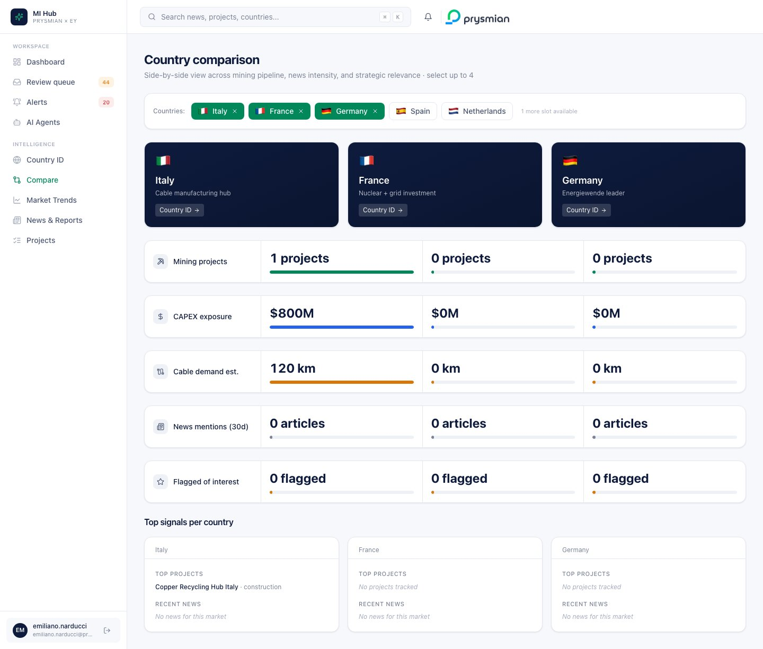
Compare view
Side-by-side comparison of up to 4 countries.

12.1 Country selector
5 countries with flag emojis. Click toggles in/out of the selected list (max 4). When at 4, others are disabled with opacity-50 cursor-not-allowed.

12.2 Per-country aggregates
For each country in selected:
projectsCount(c) = | gold.mining_projects WHERE country == c |
capex(c) = Σ projects.capex_estimate_musd WHERE country == c
cable(c) = Σ projects.cable_demand_estimate_km WHERE country == c
flagged(c) = | projects WHERE country == c AND flagged_of_interest |
newsCount(c) = | gold.news_curated WHERE c in countries |
topProjects(c) = first 3 projects for c
recentNews(c) = first 3 news for c

12.3 Header tiles
Navy gradient card per country: flag, name, focus tagline, “Country ID →” link to /country/{id}.
Country | Focus tagline
Italy | Cable manufacturing hub
France | Nuclear + grid investment
Germany | Energiewende leader
Spain | Renewable boom
Netherlands | Offshore wind

12.4 Comparable metric rows (5 rows)
Each row: 220px label column + N equal-width value columns (where N = selected count).
Metric | Bar color | Format
Mining projects | green | XX projects
CAPEX exposure | blue | $XXM or $X.Xk M compact when ≥ 1000
Cable demand est. | amber | XX km or compact
News mentions (30d) | neutral | XX articles
Flagged of interest | amber | XX flagged
Bar width in the comparison rows is proportional to the max across selected countries:
bar_width_pct(c, metric) = max(2, (metric(c) / max(metric(*selected))) * 100)
The max(2, …) ensures even zero values show a visible nub.

12.5 “Top signals per country” row
Per country, a card with:
- “Top projects” — first 3 from gold.mining_projects filtered by country
- “Recent news” — first 3 from gold.news_curated filtered by country
Both fall back to italic “No projects/news tracked” if empty.

12.6 Acceptance criteria — Compare
AC-ID | Criterion
CMP-1 | Selecting 5th country is blocked
CMP-2 | Deselecting all shows empty-state card
CMP-3 | Bar widths are relative to the max of selected (not global)
CMP-4 | Grid columns equal selected count (no empty columns when 1-2 selected)

13. Market Trends — chart logic
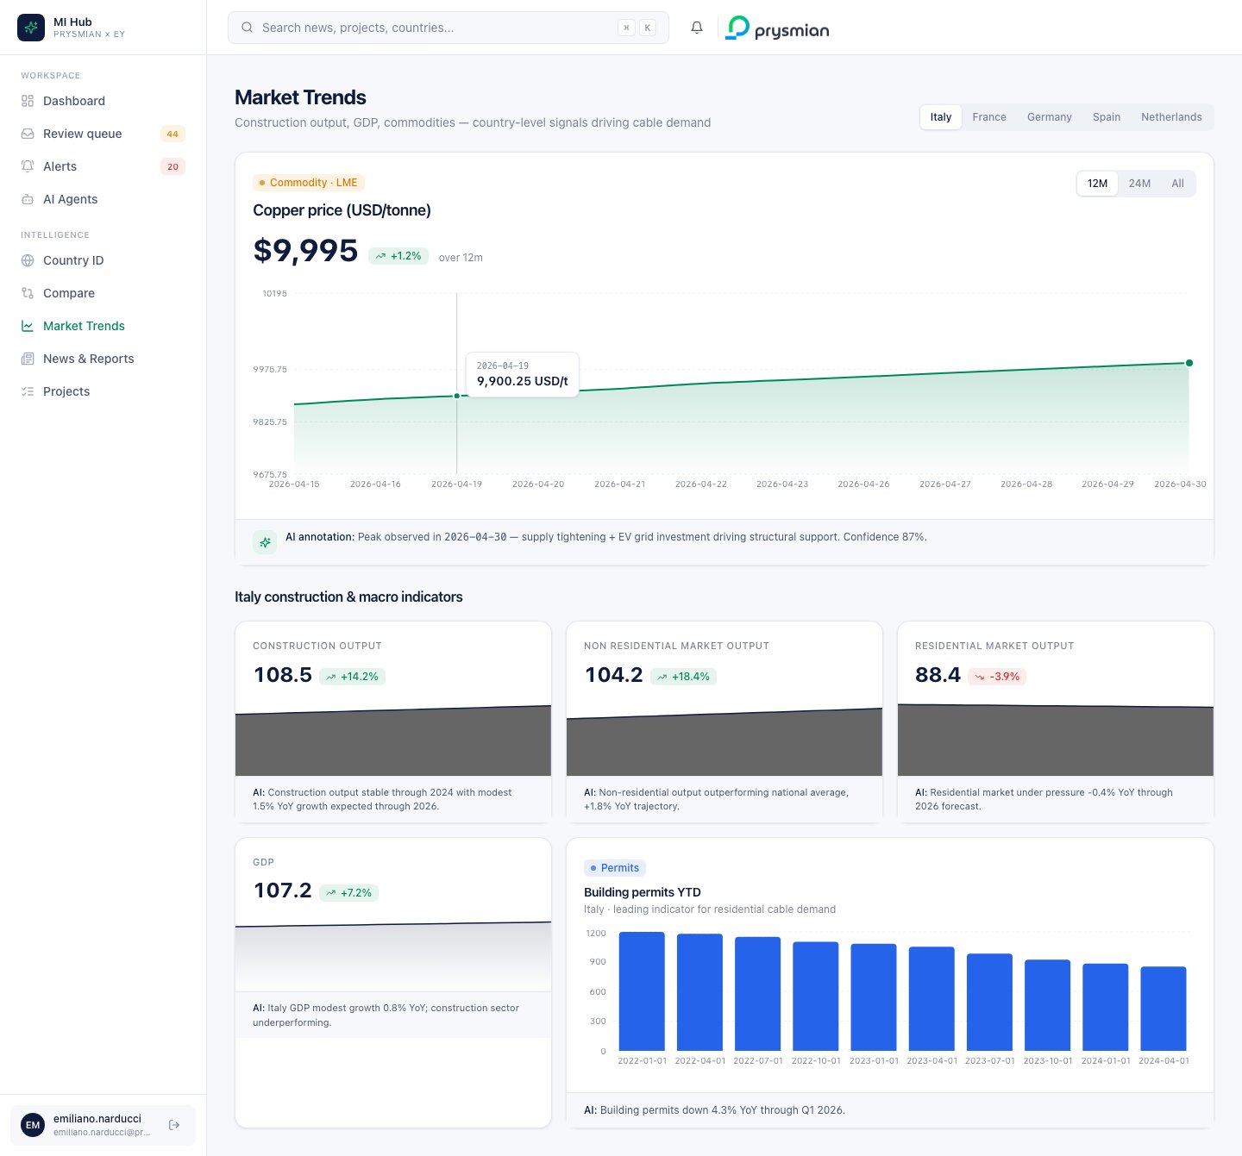
Trends

13.1 Top controls
- Country switcher — segmented control for 5 EU countries; default Italy
- Time range — 12M / 24M / All → clips series to last N points (12, 24, 999)

13.2 Time range clipping
const points = RANGES.find(r => r.id == range).points;
const clipped = series.slice(Math.max(0, series.length - points));

13.3 Copper hero card
Element | Logic
Latest value | series[-1].value formatted as $X,XXX
Delta chip | ((last - first) / first) * 100 % over the range
Area chart | Recharts AreaChart, green gradient (Prysmian green @ 35% → 2%)
Peak indicator | red ReferenceDot at (maxPeriod, max)
AI annotation strip | template with maxPeriod interpolated
const max = Math.max(...series.map(p => p.value));
const maxIdx = series.findIndex(p => p.value === max);
// ReferenceDot at series[maxIdx]

13.4 Indicator cards (4 macro indicators)
Per indicator (construction_output, non_residential_market_output, residential_market_output, gdp):
Element | Logic
Label | prettify(indicator_key) — replaces _ with space, title case
Latest value | series[-1].value with thousand separator
Delta chip | (last - first) / first * 100 over range
Sparkline | 90px AreaChart, navy color
AI footer | indicator.ai_insight_narrative from gold (one-line)

13.5 Building permits bar chart
SELECT * FROM gold.market_trends
WHERE country = :country AND indicator = 'building_permits_ytd'
ORDER BY period;
Recharts BarChart, blue bars (#2563EB), rounded top corners. AI footer with the indicator’s narrative.

13.6 Custom tooltip component
function ChartTooltip({active, payload, label, suffix, mini}) {
return active && payload?.length ? (
<div className="bg-white border rounded-lg shadow-card px-3 py-2">
<div className="text-[10px] text-ink-subtle font-mono">{label}</div>
<div className="text-sm font-semibold tabular-nums">
{payload[0].value.toLocaleString()}{suffix}
</div>
</div>
) : null;
}
Mini variant for sparklines (smaller padding).

13.7 Acceptance criteria — Trends
AC-ID | Criterion
TRD-1 | Switching country reloads all charts under that country’s data
TRD-2 | Switching range clips series and updates delta chip without full page refresh
TRD-3 | Copper card peak dot matches the highest series value
TRD-4 | Indicator cards each show their AI insight narrative when present

14. Projects pipeline + detail
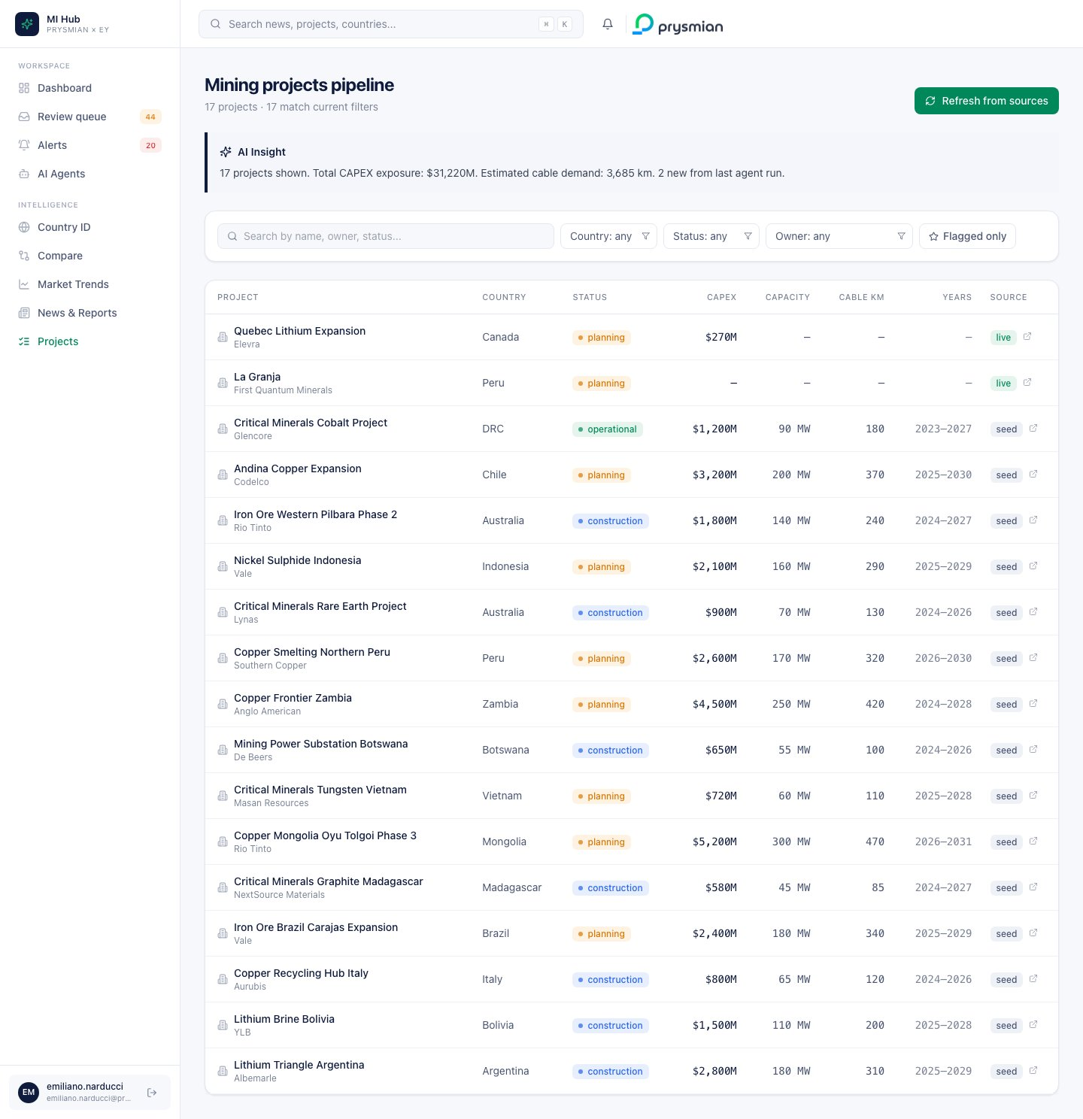
Projects list

14.1 Top bar
- Page title with total and filtered.length counts
- Refresh from sources — triggers POST /api/agents/mining_cable_specialist/run (bounded: 3 items, 30s) and polls list every 8s

14.2 AI Insight callout
"{filtered.length} projects shown.
Total CAPEX exposure: ${totalCapex:,}M.
Estimated cable demand: {totalCable:,} km.
{liveCount} new from last agent run."

14.3 Filter bar
Filter | Type | Source
Search | text | client-side filter on name/owner/country/status containing q
Country | select | unique(items.country) sorted alpha
Status | select | unique(items.status) sorted alpha
Owner | select | unique(items.owner) sorted alpha
Flagged only | toggle (star) | filter flagged_of_interest == true
Clear filters | shows when activeCount > 0
The search and flagged filter are client-side (already-fetched data). Country/Status/Owner are passed as /api/projects?country=X query params (server-side) so the result set narrows.

14.4 Table
Columns:
Column | Source / format
Project | name (link to /projects/{id}) + owner sub + ⭐ if flagged
Country | country
Status | colored badge per StatusBadge mapping
CAPEX | $XXXM if capex_estimate_musd present
Capacity | XXX MW if capacity_mw present
Cable km | XXX (no unit, header shows “Cable km”)
Years | start_year–end_year
Source | live (green) or seed (neutral) badge + external link icon if source_url present

Status badge mapping
const s = status.toLowerCase();
tone = s.includes("oper") ? "green" :
s.includes("constr") || s.includes("build") ? "blue" :
s.includes("plan") || s.includes("explor") ? "amber" : "neutral";

14.5 Project detail page
A drill-down screen at /projects/{id}:
Block | Content
Breadcrumb | Projects › {name}
Hero | Flagged badge, data source badge, project type badge; name (H1); owner/country/status sub-row; Evidence + Source action buttons
4 KPI tiles | CAPEX, Capacity, Cable demand, Lifecycle
Project timeline | inferred milestones with colored dots (see §14.6)
AI Insight card | templated narrative (see §14.7)
Evidence trail entry | opens EvidenceMetadataViewer modal
Related news section | news filtered by project country

14.6 Auto-built timeline
Rules in buildTimeline(project):
- “Project announced” at start_year − 1 (always shown)
- “Permitting & construction start” at start_year (if defined)
- Current state milestone:
  - status contains “oper” or “prod” → “Operational” at start_year + 2
  - status contains “constr” or “build” → “Under construction”
  - else → “Future milestone”
- “Planned end of life” at end_year (if defined)
Each milestone has a colored dot: - announced → blue - start → green or amber (depending on current status) - operational → green - under construction → blue - future → faint - end of life → faint

14.7 Project AI Insight
def aiInsight(p):
cap = f"${p.capex:,}M CAPEX" if p.capex else "undisclosed CAPEX"
cable = f"~{p.cable:,} km of cable demand" if p.cable else "moderate cable exposure"
flag = " Strategic relevance confirmed by domain expert review." if p.flagged else ""
return (
f"{p.name} represents {cap} in {p.country or 'the region'}, "
f"with {cable} over its lifecycle. "
f"{f'Current status — {p.status.lower()}.' if p.status else ''}"
f"{flag} Cross-reference with related news indicates ongoing market momentum."
)

14.8 Related news (project detail)
SELECT * FROM gold.news_curated
WHERE LOWER(:project_country) = ANY(LOWER(countries))
ORDER BY published_at DESC
LIMIT 5;
Simple country-match. Phase 1 will use entity-level matching (owner mentions, project name in title) for higher precision.

14.9 API surface — Projects
Endpoint | Method | Query / Body | Returns
/api/projects | GET | country?, status?, owner?, capex_min?, capacity_min?, start_year_min?, page, page_size | { items[], total, page, page_size }
/api/projects/{id} | GET | — | MiningProject
/api/agents/mining_cable_specialist/run | POST | { bounded, max_items, timeout_seconds } | { agent, status }

14.10 Acceptance criteria — Projects
AC-ID | Criterion
PRJ-1 | Filters compound (AND across all active filters)
PRJ-2 | “Refresh from sources” triggers an agent run; loading state visible
PRJ-3 | Click row → navigate to project detail (no modal hijack)
PRJ-4 | Detail page renders without project_type/start_year/end_year/capex (graceful nulls)
PRJ-5 | Timeline shows at least 2 milestones for every project

15. Derived fields & confidence

15.1 News relevance score
Composite [0,1] computed by the News Finder agent:
relevance_score = 0.30 * taxonomy_match + # keyword overlap with config
0.25 * geo_relevance + # country match with subscribed regions
0.20 * source_authority + # weighted by source rank
0.15 * recency + # exponential decay over 30d
0.10 * embedding_proximity # cosine with Prysmian topic vectors
The weights are configurable per BU (a country team may weight geo higher; the technology team may weight embedding higher).

Sub-scores
Sub-score | Computation
taxonomy_match | |matched_keywords ∩ taxonomy| / |taxonomy|
geo_relevance | 1.0 if country in subscribed_regions, 0.5 if neighbor, 0.0 else
source_authority | predefined per-source: mining.com = 0.9, Reuters = 1.0, blog = 0.5
recency | exp(-days_since_published / 14)
embedding_proximity | cosine(article_embedding, prysmian_topic_centroid)

15.2 Cable demand estimate (mining projects)
Derived field — production target × cable intensity ratio per project type:
INTENSITY = { # km of cable per MW or per kt/year of production
"copper": {"per_year_kt": 0.08}, # 80m per kt/yr
"lithium": {"per_year_kt": 0.06},
"nickel": {"per_year_kt": 0.07},
"data_center": {"per_mw": 0.40}, # 400m per MW
"wind": {"per_mw": 1.20},
"solar": {"per_mw": 0.50},
"BESS": {"per_mw": 0.30},
"grid": {"per_mw": 2.00},
}
Applied at silver → gold:
if project_type == "data_center":
cable_km = capacity_mw * INTENSITY["data_center"]["per_mw"]
elif project_type in ("copper", "lithium", "nickel"):
cable_km = production_kt_per_yr * INTENSITY[project_type]["per_year_kt"]
elif project_type in ("wind", "solar", "BESS", "grid"):
cable_km = capacity_mw * INTENSITY[project_type]["per_mw"]
# etc.
These ratios come from Prysmian’s existing internal heuristics (Phase 0 input). They’re tracked as data, not code, so MI team can adjust them without a deploy.

15.3 flagged_of_interest rule
A project is flagged iff:
flagged_of_interest = (
cable_demand_estimate_km >= 100 # material exposure
AND country in PRYSMIAN_PRIORITY_COUNTRIES
AND status in {"planning", "construction"} # actionable lifecycle
)
OR
LLM_judgment(name+owner+description) == "strategic" # AI-suggested
The LLM judgment is invoked only if the rule-based check fails — so it’s a secondary signal.
PRYSMIAN_PRIORITY_COUNTRIES is configurable per quarter (currently: EU + UK + MENA core).

15.4 Composite confidence score (any AI output)
confidence = 0.4 * source_reliability + # publisher rank or system trust
0.3 * extraction_certainty + # LLM self-reported (with calibration)
0.2 * consistency_check + # cross-source agreement
0.1 * recency
Sub-scores are stored in audit.evidence_metadata.confidence_breakdown so the Evidence bundle modal can show why a confidence is high or low — not just the number.

Calibration
LLM self-reported confidence is notoriously poorly calibrated. The pipeline applies a calibration curve learned from MI decisions:
calibrated_confidence = isotonic_regression(raw_confidence)
Curve refit weekly from audit.review_decisions (accept = label 1, reject = label 0).

15.5 Demo vs Phase 1 confidence
In the demo build, confidence is computed by:
def _confidence(item_id: str) -> int:
h = sum(ord(c) for c in str(item_id))
return 65 + (h % 31) # 65..95
Deterministic hash → integer in [65,95]. The composite formula above is the Phase 1 implementation target.

16. News & Reports page
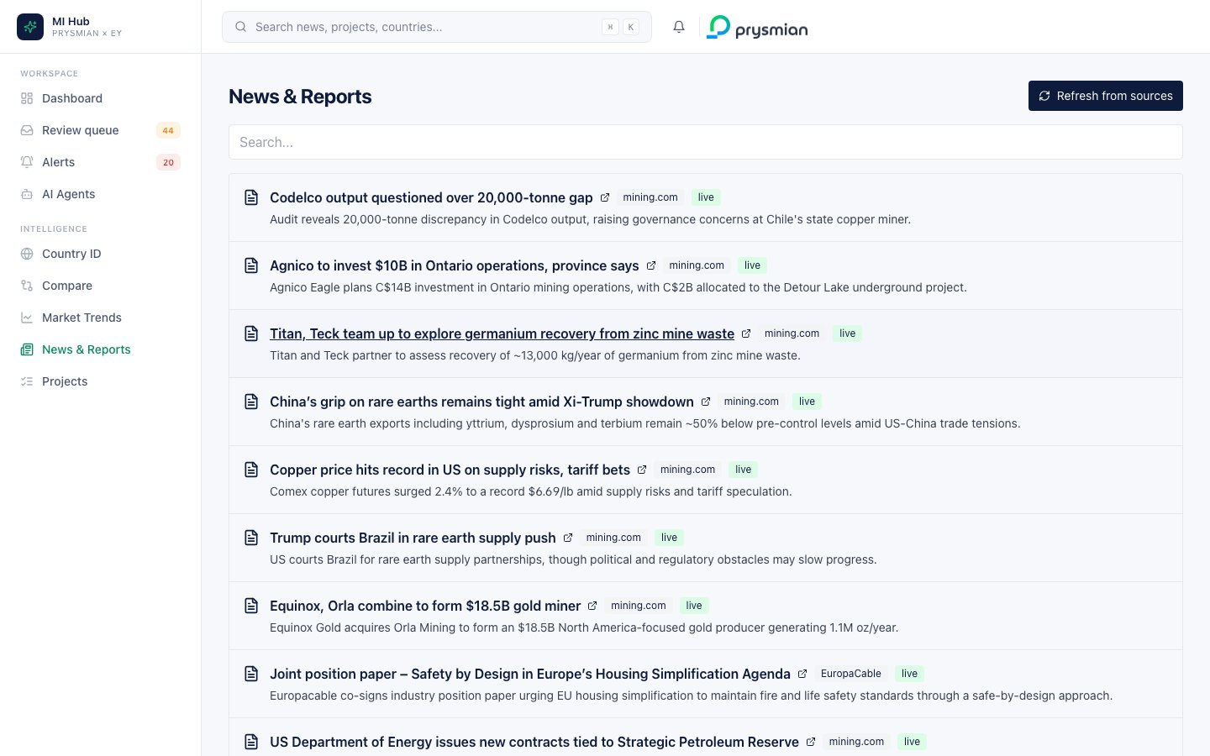
News

16.1 List rendering
SELECT * FROM gold.news_curated
ORDER BY published_at DESC NULLS LAST
LIMIT :page_size OFFSET :offset;
With optional ?q=<text>:
... WHERE title ILIKE '%q%' OR summary ILIKE '%q%' ...
Per article shown:
- Source · publication date (relative or absolute on hover)
- Title (link to source, opens in new tab)
- Summary (2 lines, line-clamp)
- Country chips · segment chips
- Relevance score chip (color band per §6.5)

16.2 API surface — News
Endpoint | Method | Query | Returns
/api/news | GET | q?, page, page_size | NewsItem[]

16.3 Acceptance criteria — News
AC-ID | Criterion
NWS-1 | Articles sorted newest first
NWS-2 | ?q=copper returns subset of unfiltered list
NWS-3 | Link click opens source in new tab

17. Evidence bundle
Across the platform, anywhere you see an Evidence bundle button (Review queue detail, Project detail, AI Insight cards), clicking it opens a modal showing:
- The source URL(s) the AI used
- The retrieval log (timestamp, query, agent name)
- The confidence breakdown by sub-factor
- The prompt template version used
- The model used (Sonnet / Haiku / etc) and agent version
This is the audit trail the EU AI Act requires — every AI output is traceable to its sources and reasoning.

17.1 Schema
{
"id": "uuid",
"agent_name": "news_finder",
"agent_version": "1.2.0",
"prompt_template_id": "news_finder_v3",
"model": "claude-sonnet-4-6",
"source_urls": [
"https://www.mining.com/copper-price-record-tariff/"
],
"retrieval_log": [
{"ts": "2026-05-13T14:32:01Z", "query": "RSS fetch", "status_code": 200, "bytes": 8421},
{"ts": "2026-05-13T14:32:02Z", "action": "llm_extract", "tokens_in": 1240, "tokens_out": 320}
],
"confidence_score": 0.87,
"confidence_breakdown": {
"source_reliability": 0.9,
"extraction_certainty": 0.85,
"consistency_check": 0.8,
"recency": 0.95
},
"created_at": "2026-05-13T14:32:03Z"
}

17.2 What’s intentionally NOT stored
- Raw chain-of-thought reasoning
- LLM internal tokens or embeddings
- User prompts that contain confidential queries (PII / classified data)
This is the safer audit pattern: provable but not regurgitating model internals.

18. API endpoint catalog (complete)
Endpoint | Method | Purpose
/api/health | GET | Liveness probe
/api/projects | GET | List projects with filters
/api/projects/{id} | GET | Project detail
/api/news | GET | News list with optional search
/api/trends/{country} | GET | Macro indicators + copper history
/api/countries | GET | List of countries available
/api/countries/{id}/summary | GET | 4-quadrant country data
/api/agents/catalog | GET | All 6 agents with live status
/api/agents/{name}/run | POST | Trigger bounded run
/api/agents/{id}/toggle | POST | Pause/resume agent
/api/agents/runs | GET | Last 50 audit runs
/api/evidence/{id} | GET | Evidence bundle for an item
/api/search?q= | GET | Global search (news + projects + countries)
/api/review/queue | GET | Review queue items by status
/api/review/stats | GET | Counts by status
/api/review/{id}/decide | POST | Submit decision
/api/alerts | GET | Alerts list with filters
/api/alerts/stats | GET | Counts by type/severity, unread
/api/alerts/{id}/read | POST | Mark read/unread
/api/alerts/subscriptions | GET | Get user preferences
/api/alerts/subscriptions | PUT | Update preferences (partial)

18.1 Auth header (Phase 1)
All non-/health endpoints require:
Authorization: Bearer {jwt_from_entra}
Demo build does not enforce this.

18.2 Rate limits (Phase 1)
Endpoint group | Per user limit
Read-only (GET) | 600 req/min
Search | 60 req/min
Decisions (POST) | 120 req/min
Agent runs (POST) | 10 req/min
Enforced via Redis token bucket. Exceeding returns 429 Too Many Requests with Retry-After header.

19. Data quality rules

19.1 Required fields per entity
Entity | Required to enter gold
NewsCurated | source, url, title, relevance_score, evidence_id
MiningProject | name, country, project_type, status, evidence_id
CountrySummary | (computed from CSV — always 4 quadrants present)
Items missing required fields stay in silver and are flagged for MI review with validation_status = 'incomplete'.

19.2 Normalizations applied at silver
- Country → ISO-3166 long name (e.g., “Italy” not “IT” not “Italia”)
- URL → canonicalized (strip UTM, sort query params, lowercase domain)
- Currency → USD millions for CAPEX (FX as-of published_at)
- Capacity → MW (not GW, not kW)
- Dates → ISO 8601 UTC

19.3 Deduplication
Entity | Dedupe key
News | canonical URL
Project | (name lowercased, owner lowercased, country)
Evidence | (agent_name, prompt_template_id, source_urls hashed)
Window: 48 hours for news (allow re-fetch with updated content), 30 days for projects (in case of restatements).

19.4 Schema validation
Pydantic v2 models on every API ingress + JSON Schema on every agent output. Invalid payloads logged to audit.validation_errors with full original payload (in case of debugging) — retained 30 days.

20. Security model

20.1 Data classification
Every row in gold tables carries data_classification:
Level | Examples | Access
public | News from public publishers | All authenticated users
internal | Mining projects, country summaries | All MI Hub users
confidential | Salesforce account details, SAP material master | RBAC-scoped
restricted | Pricing details, contract specifics | Need-to-know, audit logged

20.2 PII handling
- News and projects do not contain PII (extraction strips personal names from summaries unless they are public-figure executives)
- Salesforce contacts (Phase 1) contain PII → routed through PII-aware processing (no LLM see PII unless explicitly invoked)
- Feedback text typed by MI is internal-only; not used as input to public-facing dashboards

20.3 Audit retention
Audit table | Retention
audit.agent_runs | 24 months online
audit.evidence_metadata | 24 months online + 5 years archive
audit.review_decisions | 5 years online (compliance)
audit.validation_errors | 30 days (debug)
WORM (write-once read-many) via DB role permissions: agent service role has INSERT only, no UPDATE/DELETE.

20.4 LLM safety
- No customer PII sent to LLM provider (unless internally-hosted model)
- Prompt injection defenses: structured output schemas, allow-list filters on JSON
- Rate limiting per agent to bound cost (max tokens/run, max runs/day)
- Cost alerting when daily spend > 1.5× rolling 7-day average

21. Performance characteristics

21.1 SLAs (Phase 1)
Operation | Target p95
Login → Dashboard render | < 1.5s
Search palette response | < 400ms
Country ID page render | < 2s
Project list (50 items) | < 600ms
Review queue accept submit | < 300ms
Agent run trigger ACK | < 200ms (background runs separately)

21.2 Capacity targets
Resource | Initial (Phase 1) | 12 months
Users (concurrent) | 25 | 75
News rows | 50K | 500K
Project rows | 1K | 5K
Daily agent runs | 50 | 250
LLM tokens/day | 2M | 10M

21.3 Cold start (free Render tier — demo only)
Services sleep after 15 min idle. First request after sleep → ≈30s warm-up. Once warm, normal latencies apply.
In Phase 1, services are always-on (Starter+ Render plans or containerized in Prysmian’s cloud).

22. Utility & helper logic

22.1 Relative time formatter
function relTime(iso) {
if (!iso) return "—";
const diff = (Date.now() - new Date(iso).getTime()) / 1000;
if (diff < 60) return "just now";
if (diff < 3600) return `${Math.floor(diff/60)}m ago`;
if (diff < 86400) return `${Math.floor(diff/3600)}h ago`;
return `${Math.floor(diff/86400)}d ago`;
}
Used everywhere that shows article ages, last run, decided_at, etc.

22.2 Greeting by hour
function greeting() {
const h = new Date().getHours();
if (h < 6) return "Good night";
if (h < 12) return "Good morning";
if (h < 18) return "Good afternoon";
return "Good evening";
}

22.3 Initials extractor
function initials(name) {
return name.split(" ").map(w => w[0]).slice(0, 2).join("").toUpperCase();
}
Used for SF account avatar and contact avatars.

22.4 Currency formatting
Format | Example | When used
$XXXM | $4,500M | Project CAPEX
€XXX,XXX | €150,000 | Country summary values
€X.Xk | €1.8k | Compact, large aggregates
€X.XM | €2,643M | Annual revenue (SF panel)
Locale-aware via toLocaleString().

23. Demo build vs Phase 1 production — full gap matrix
Area | Demo build | Phase 1 production
Auth | sessionStorage, any email | Azure Entra ID SSO + RBAC
DB | Postgres 16 + pgvector single instance | Managed Postgres + replicas + pgvector / external vector
SAP ingestion | None (synthetic in modal) | Live RFC calls (BAPI_MATERIAL_GET_DETAIL) cached
Salesforce ingestion | None (synthetic in modal) | Live REST /sobjects/Account/{id} cached
Agents | 2 implemented, 4 catalog-only | All 6 implemented + scheduling cron / Airflow
Agent runtime | Single-process background tasks | Container-based, autoscaled queue consumers
Review state | In-memory | audit.review_decisions append-only table
Alerts | Synthesized from data | KPI agent computes deltas live, alerts in stream
Subscriptions | In-memory single demo user | Per-user JSON in users.preferences + Teams/email routing
Newsletter | “Publish now” button | Editorial workflow + scheduled send via SendGrid/Mailchimp
Audit trail | Decisions only | Full WORM log of all agent runs + decisions
Confidence | Hash-based [65,95] | Composite formula §15.4 + isotonic calibration
Embedding model | Voyage-3-large (optional) | Voyage-3-large or org-internal model
LLM model | Claude Sonnet 4.6 + Haiku 4.5 fallback | Same, with caching + batch API where appropriate
Cost controls | Bounded runs (max 3 items, 30s timeout) | Token budget per agent run, daily cap
Search | ILIKE substring | Hybrid BM25 + vector + RRF rerank
Rate limits | None | Redis token bucket per user
Monitoring | Render dashboard | Datadog / New Relic + Sentry
Backup | Render auto | PITR + nightly snapshot + cross-region replica
Compliance reports | — | EU AI Act self-assessment quarterly

24. Open questions for Phase 1
Topic | Decision needed
Vector store | pgvector in Postgres or external (Qdrant, Pinecone)?
Agent scheduling | Airflow / Prefect / Render cron / Databricks Jobs?
Newsletter delivery | Mailchimp / SendGrid / internal SMTP?
Teams integration | Microsoft Graph API or Power Automate?
Audit retention | 12 months online / 5 years archive policy?
LLM provider | Anthropic only or multi-provider (OpenAI fallback)?
Embedding model | Voyage cloud or org-hosted?
Confidence calibration | Quarterly re-tune or continuous online learning?
RBAC granularity | Per-BU, per-country, per-document, per-row?
Data classification | Confidential / Internal / Public on every row?
Newsletter content rights | Can extracted summaries be re-published as Prysmian content?
Cable intensity ratios | Source authority — who signs them off, how often updated?
Customer/Competitor lists | Manual curation or auto-discovery via news?
HITL escalation | What happens to items waiting > 48h?

25. Glossary
Term | Meaning
BU | Business Unit (I&C, Power Grid, …)
HITL | Human in the Loop
MI | Market Intelligence (team and function)
SoW | Share of Wallet — Prysmian sales / total customer spend
White space | Untapped market = market value − current sales
Evidence bundle | The audit-trail record produced for every AI output
Gold table | UI-ready data table after normalization and enrichment
Surfacing rule | Threshold that decides whether an item enters Review Queue
Cable intensity | km of cable estimated per MW or per kt/yr of production
Tier 1 / Tier 2 | Customer/competitor strategic importance band
Sonnet / Haiku | Claude model sizes (Sonnet = primary, Haiku = fast fallback)
BAPI | SAP function module (Business Application Programming Interface)
RBAC | Role-Based Access Control
WORM | Write-Once Read-Many (immutable storage)
RRF | Reciprocal Rank Fusion (search rerank technique)

EY for Prysmian Group — Functional Analysis · May 2026

