# <http://had.co.nz/ggplot2>

### This HTML page was created using knitr by taking a simple R script by Hadley Wickham and adding some R markdown.

library(ggplot2)

## qplot examples

qplot(diamonds$cut, diamonds$carat)

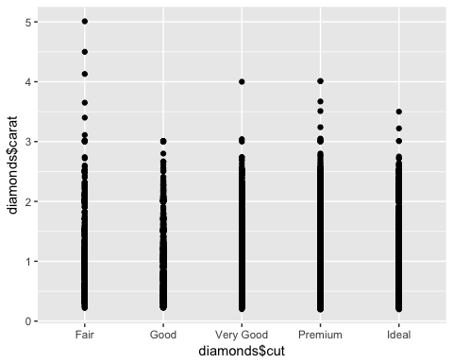

qplot(carat, price, data = diamonds)

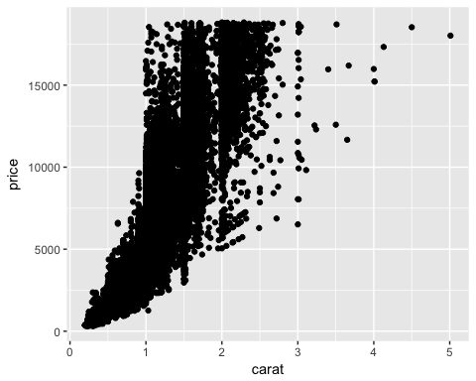

qplot(carat, price, data = diamonds, colour=clarity)

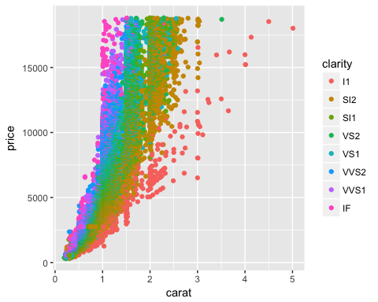

qplot(carat, price, data = diamonds, geom=c("point", "smooth"), method=lm)

## Warning: Ignoring unknown parameters: method

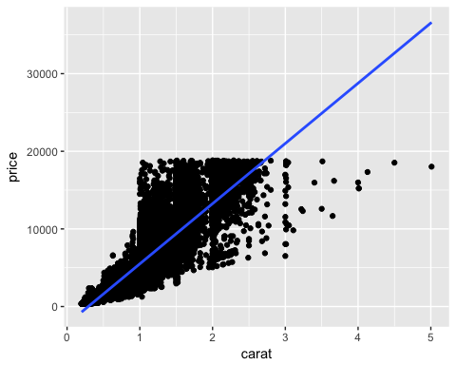

qplot(carat, data = diamonds, geom="histogram")

## `stat_bin()` using `bins = 30`. Pick better value with `binwidth`.

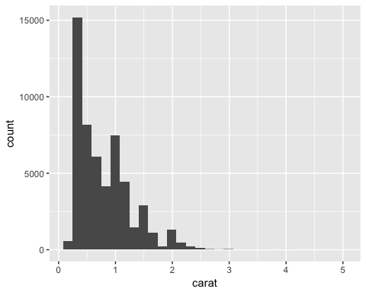

qplot(carat, data = diamonds, geom="histogram", binwidth = 1)

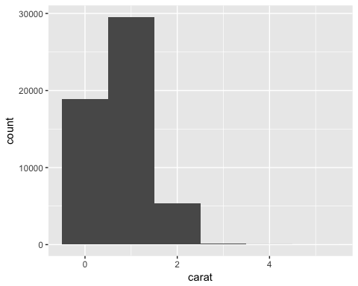

qplot(carat, data = diamonds, geom="histogram", binwidth = 0.1)

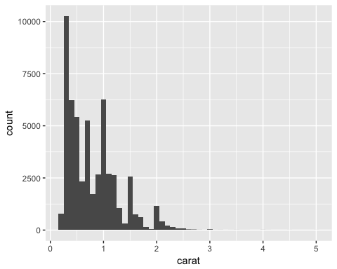

qplot(carat, data = diamonds, geom="histogram", binwidth = 0.01)

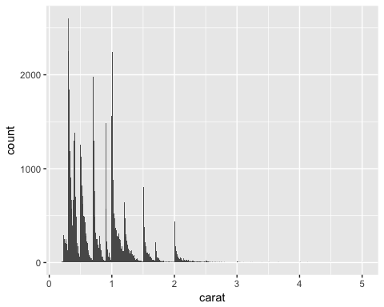

## using ggplot()

d <- ggplot(diamonds, aes(x=carat, y=price))

d + geom_point()



d + geom_point(aes(colour = carat))

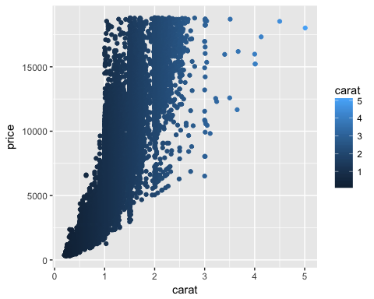

ggplot(diamonds) + geom_histogram(aes(x=price))

## `stat_bin()` using `bins = 30`. Pick better value with `binwidth`.

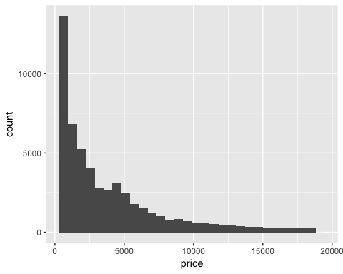

## Separation of statistcs and geometric elements

p <- ggplot(diamonds, aes(x=price))

p + geom_histogram()

## `stat_bin()` using `bins = 30`. Pick better value with `binwidth`.



p + stat_bin(geom="area")

## `stat_bin()` using `bins = 30`. Pick better value with `binwidth`.

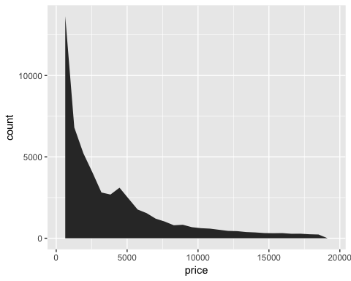

p + stat_bin(geom="point")

## `stat_bin()` using `bins = 30`. Pick better value with `binwidth`.

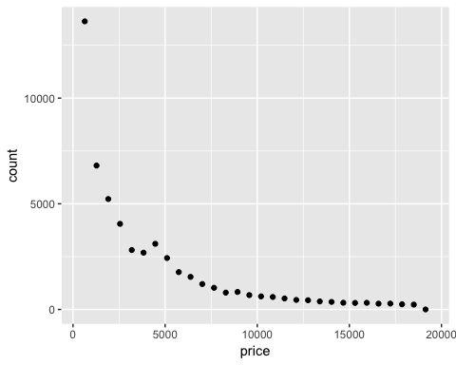

p + stat_bin(geom="line")

## `stat_bin()` using `bins = 30`. Pick better value with `binwidth`.

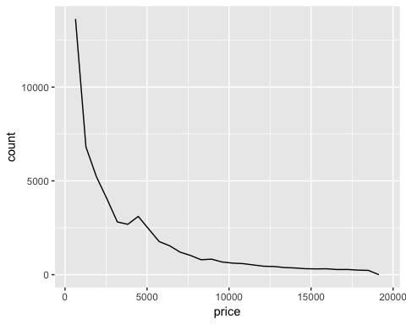

p + geom_histogram(aes(fill = clarity))

## `stat_bin()` using `bins = 30`. Pick better value with `binwidth`.

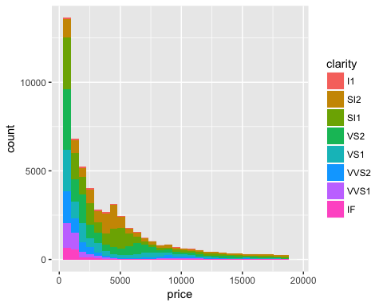

p + geom_histogram(aes(y = ..density..))

## `stat_bin()` using `bins = 30`. Pick better value with `binwidth`.

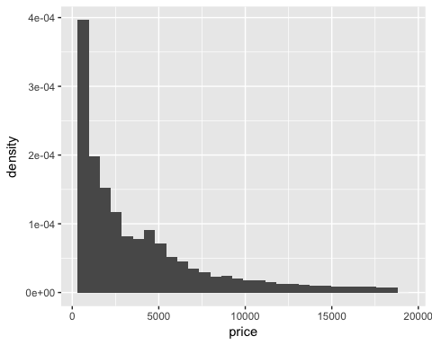

## Setting vs mapping

p <- ggplot(diamonds, aes(x=carat,y=price))

## What will this do?

p + geom_point(aes(colour = "green"))

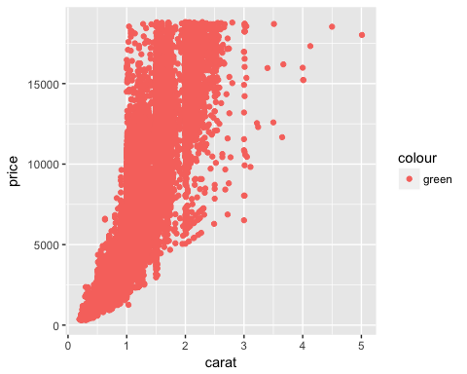

p + geom_point(colour = "green")

