Thursday Setup Instructions

(Estimated time 1-2 hours)

1. Install Java 8

a. <https://www.java.com/en/download/>

Download from the above link and follow the instructions

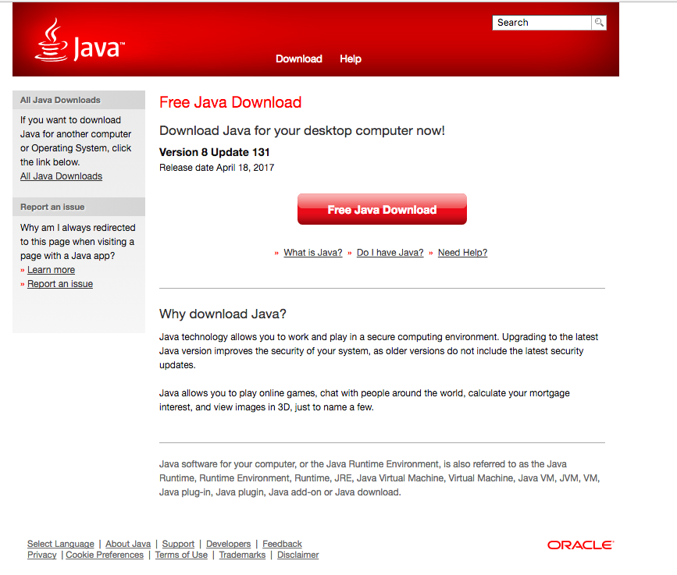

1. Install NetBeans IDE 8.2

a. <https://netbeans.org/downloads/index.html>

Choose the operation system from the drop down (Mac or Windows),

Click the download button to the far right.

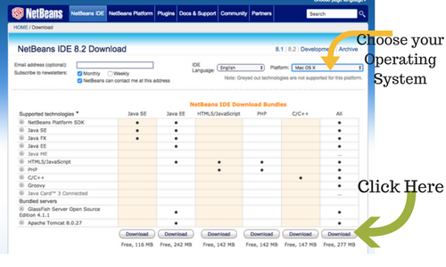

1. Download sample project from GitHub:

<https://github.com/lizarodewald/MadSkills.git>

Click Download ZIP 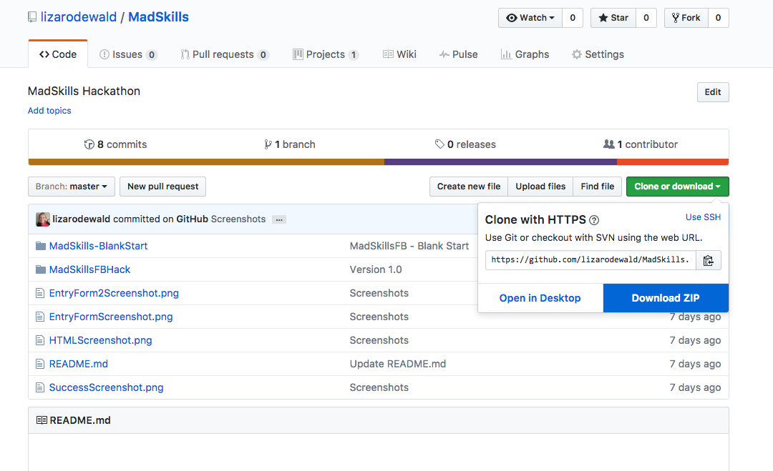

1. Open your file explorer and find the zip file you just download from github. Double click the zip file to unzip it.

Now we are going to open our starter application for the Saturday hackathon.

1. Open the NetBeans 8.2 application we installed in step 2.

You should see a screen like this:

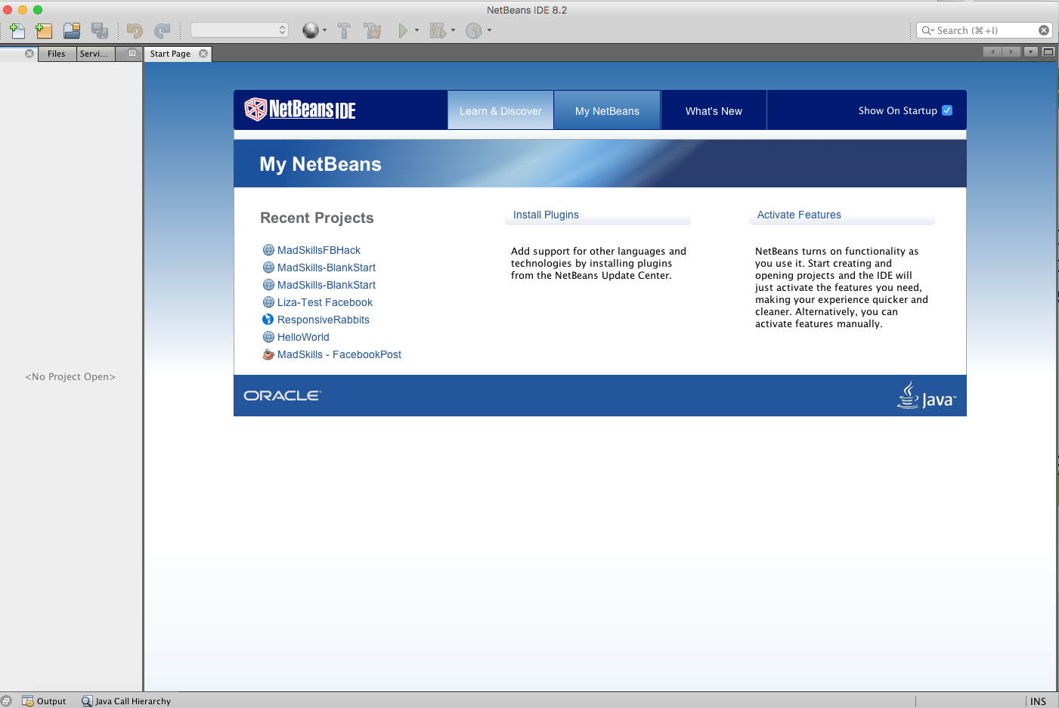

1. In the file menu click “Open Project”
2. Browse to your where you downloaded and unzipped your files from github.
3. Click on the “MadSkills – BlankStart”
4. Click “Open Project”

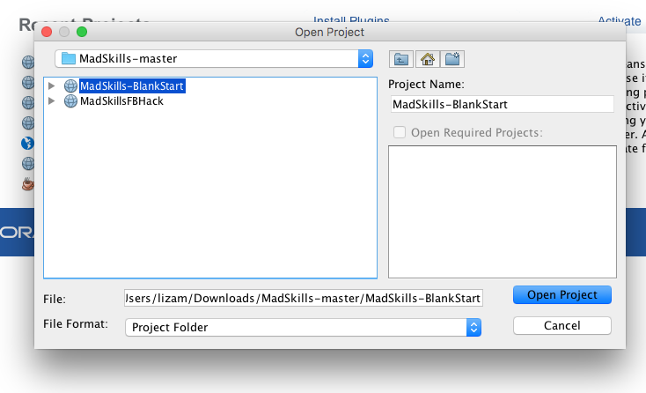

Now we will need to connect our Facebook API to our project. When the project opens you will see a screen like this:

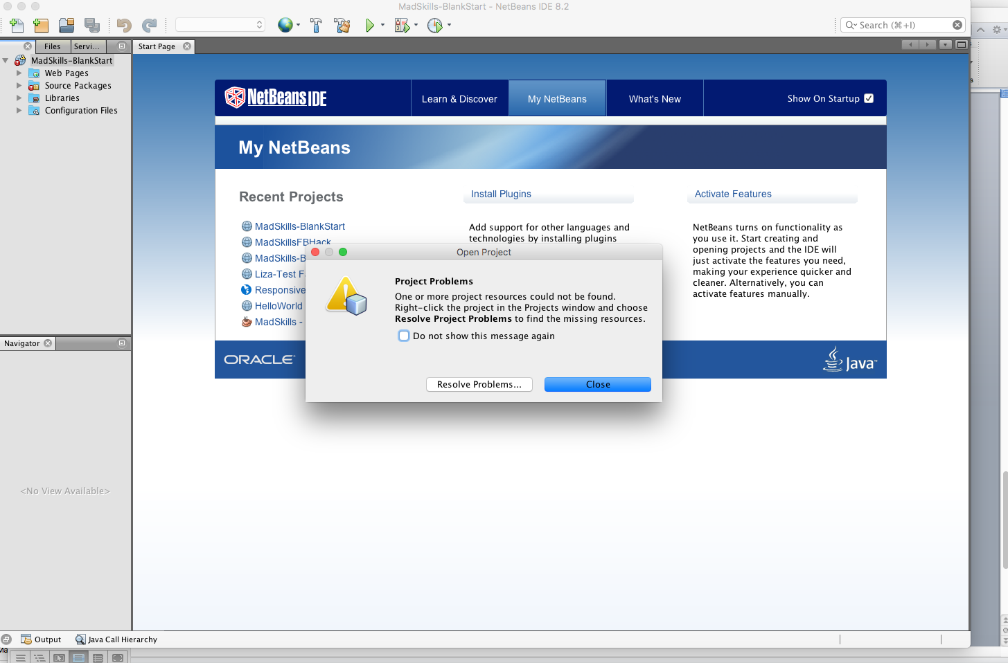

1. Click “Resolve Problems”

The following screen displays:

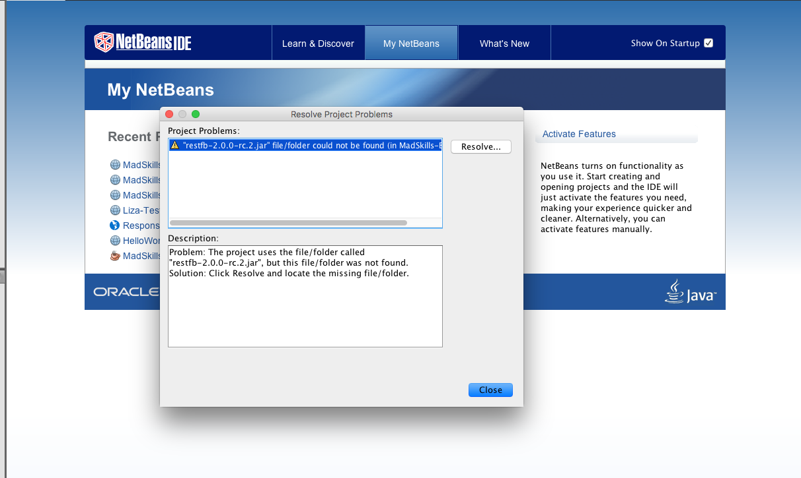

1. Click the “Resolve” button.

Now browse to the folder you downloaded the project from github and highlight this file:

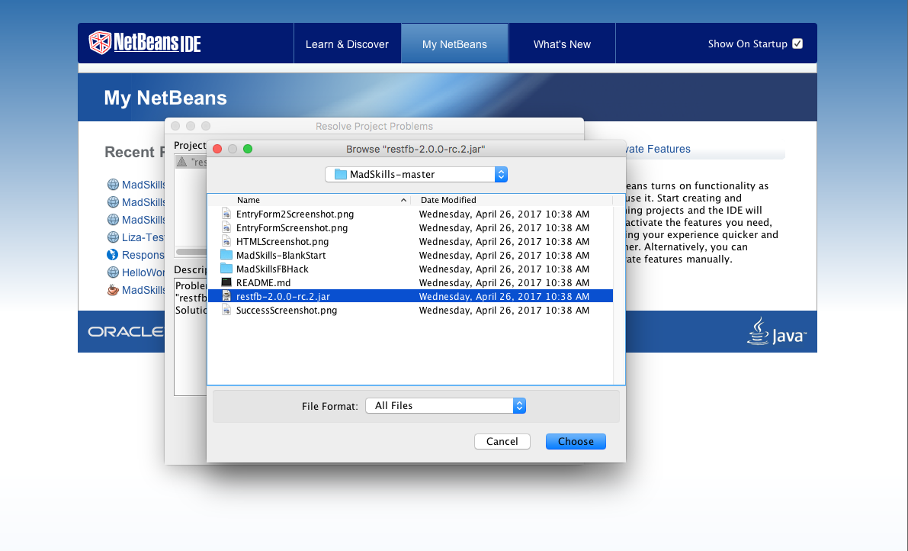

1. Then click the “Choose” button.

You should now see this screen:

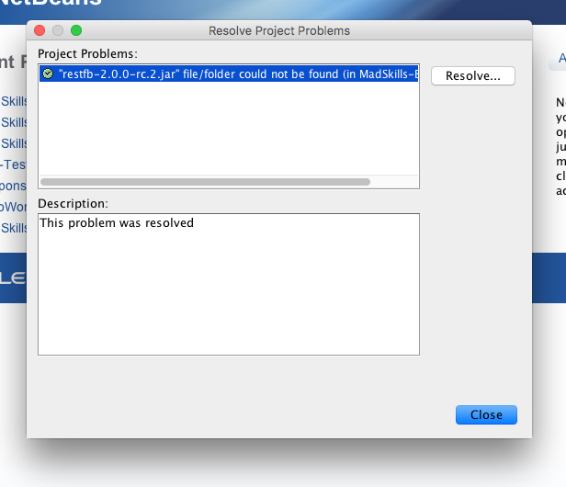

1. Click “Close”.

Let’s make sure everything is working properly now.

1. Click the green arrow in the tool bar.

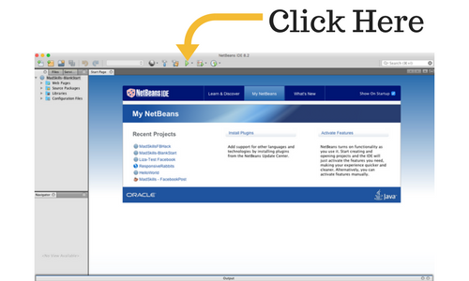

If you see a blank browser window open then you are all ready for Saturday. If it’s not working please email me so I can help you before the big day: [liza@hiremadskills.com](mailto:liza@hiremadskills.com)