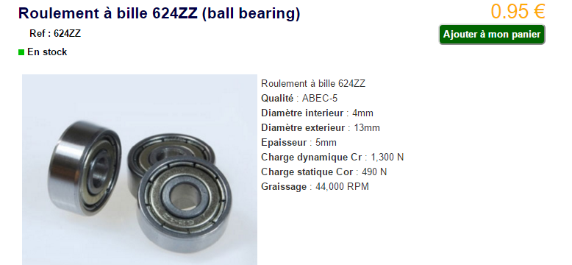

[http://www.tracepartsonline.net/(S(vcfmpowha2qu3ljrdrnhdf1j))/PartDetails.aspx?DetailLevels=0&CFSUB=1&CF=7&ExportCADModel=1&VwAutoRefresh=1&Vw3DManualRefreshDone=0&VwMode=3DWebGL&3DVwMode=3DWebGL&WebSite=GLOBALV3&Lang=fr&Class=SKF&ClsID=%2FF_SKF%2FSKF.01%2FSKF.01.01%2F&ManId=SKF&sid=1&PartId=10-13122001-061255&PartTab=0&pageScrollTopPosition=&ProdCfgPageMode=1&ProdCfgPreviousViewMode=2&ProdCfgCurrentViewMode=2&ProdCfgSelectionPath=1%7C1%7C1%7C1%7C1%7C1%7C1%7C1%7C&ProdCfgVersion=1.5.1&ProdCfgTargetParametersGroup=1&ProdCfgTargetParameter=*&ProdCfgTargetParameterSelectorOrValue=5&ProdCfgPageViewStatesId=2E04F9547D204440ACB73E4E558D7899&nbItemsReturned=81&SendComment=0&CommentWriter](http://www.tracepartsonline.net/(S(vcfmpowha2qu3ljrdrnhdf1j))/PartDetails.aspx?DetailLevels=0&CFSUB=1&CF=7&ExportCADModel=1&VwAutoRefresh=1&Vw3DManualRefreshDone=0&VwMode=3DWebGL&3DVwMode=3DWebGL&WebSite=GLOBALV3&Lang=fr&Class=SKF&ClsID=%2FF_SKF%2FSKF.01%2FSKF.01.01%2F&ManId=SKF&sid=1&PartId=10-13122001-061255&PartTab=0&pageScrollTopPosition=&ProdCfgPageMode=1&ProdCfgPreviousViewMode=2&ProdCfgCurrentViewMode=2&ProdCfgSelectionPath=1%7C1%7C1%7C1%7C1%7C1%7C1%7C1%7C&ProdCfgVersion=1.5.1&ProdCfgTargetParametersGroup=1&ProdCfgTargetParameter=*&ProdCfgTargetParameterSelectorOrValue=5&ProdCfgPageViewStatesId=2E04F9547D204440ACB73E4E558D7899&nbItemsReturned=81&SendComment=0&CommentWriter)=

