Scientific Report
as part of the application for the position “Junior Research Scientist in ecology - Vulnerability and resilience of ecosystem services in Mediterranean context” (Profile number: CR-2024-ECODIV-2)
Emilio Berti, February 2024

emilio.berti@idiv.de

Table of Contents
Summary 1
T1 – From community assembly to ecosystem functions and services 2
T1.1 – Climate variability impacts the suitability and distribution of species 2
T1.2 – Community assembly is determined by abiotic drivers and limiting similarity 2
T1.3 – Limiting similarity enhances biodiversity-ecosystem functioning (BEF) 3
T1.4 – From food webs to ecosystem functions: mapping ecosystem services 3
T1.5 – Energy landscapes determine animal movement strategies 4
Relevance of T1 for the planned research and synergies with the working groups 4
T2 – Anthropogenic disturbances, people’s perception, and restoration opportunities 5
T2.1 – People’s interest is biased towards large animals 5
T2.2 – Identifying sustainable coexistence potential for megafauna in Kenya 6
T2.3 – Declines of biotic connectivity due to human-driven extinctions 6
T2.4 – Dispersal corridors for tigers in Nepal: how effective are they? 6
T2.5 – Global patterns and drivers of lead concentration in inland waters 7
Relevance of T2 for the planned research and synergies with the working groups 7
T3 – Theory and models for ecology and biodiversity conservation 7
T3.1 – The R package enerscape for quantifying energy costs of movement 8
T3.2 – The R package ATNr for modelling biomass dynamics of food webs 8
T3.3 – Taxonomic harmonization for data synthesis 8
T3.4 – Sustained speed of animals is limited by heat dissipation capacity 8
T3.5 – XSDM: a novel SDM to quantify the effects of climate variability 9
Relevance of T3 for the planned research and synergies with the working groups 9
Experience with lab and field work and database management 10
Conclusion 10
References 11
Figures 14

Summary
My previous and current research can be divided into three broad themes (T), discussed in detail in the sections below. Taken together, these themes aim at understand of how ecosystems and their functions and services emerge from local processes and how anthropogenic disturbances have impacted them, providing also novel tools and ideas for theoretical and practical application. As a general overview, these themes are:
- To understand how biotic and abiotic factors influence species’ distribution and community structure, and how this upscale to ecosystem functions and services. This, in order to advance our fundamental understanding of how community are organized and ecosystems function, which provide societies of their services.
- To investigate how biodiversity and humans interact and how ecosystems have been impacted by anthropogenic global changes. This, in order to identify potential solutions to promote human-wildlife coexistence and reduce the negative effects that human societies have on ecosystems.
- To conceptualise and formalise basic ecological theory and develop novel methodologies and software for ecological research. This, in order to advance ecological theory and to improve how we model ecological processes, needed for testing hypotheses about ecosystems.
These themes strongly align with the planned research and overlap with the interests of the RECOVER research unit and of the EMR team. In particular:
- Ecosystem services emerge from ecological processes that shape species composition and community assembly and how these upscale to the ecosystem and landscape level (Burkhard & Maes, 2017). Therefore, T1 is necessary for a deeper understanding of how ecosystems provide their services and how to quantify and map their indicators. My previous experience with how environmental, biotic, and climatic factors influence species’ suitability, community assembly, ecosystem functions, and the delivery of ecosystem services aligns with the planned research and the goals of the EMR team.
- Ecosystem services are essential for societies, but societies often have negative impacts on ecosystems and we urgently need a sustainable solution for coexistence. T2 is needed to understand how human societies have affected ecosystems and their services and for proposing sustainable solutions for coexistence. My experience with assessing the impacts of anthropogenic disturbances on ecosystems and with including societal aspects in socio-ecological theory and modelling aligns with the planned research and the objectives of the EMR team and, more generally, of the RECOVER unit and INRAE.
- Ecosystem services are emerging properties of complex ecosystems. Therefore, T3 is required to develop the technical apparatus for modelling ecological processes and services. My experience in mathematical and statistical modelling and software development will allow a steady and proficient progress in the development of the theory and models for quantifying and mapping ecosystem services.
An overview of how the themes and sub-projects fit into ecosystem services assessments is illustrated in Figure 1 and Table 2. This scientific report consists of 10 pages of text plus 17 figures, 2 tables, and 3 pages for references. To make it easier to follow the report, I organized the figures within the body of the text. For the personal pronouns, I adopted the following convention: I used “I” when I was the person in charge of the task or I was the leading author of the study. I used “we” when my role in the study was a supporting one; for these cases, I specified my contribution.

T1 – From community assembly to ecosystem functions and services
Ecosystem services emerge from local ecological processes that upscale to generate and regulate ecosystem functions at the landscape level. Therefore, to understand and assess ecosystem services and how they are influenced by environmental and biotic processes, we need to investigate what shapes such local processes and how these generate ecosystem functions. Yet, we have only a limited understanding on how communities are organized and of their impacts on ecosystem functions and services. To fill this gaps, my previous research investigated the drivers shaping species distribution, community organization, its effects on ecosystem functioning, and quantified indicators for assessing ecosystem services. T1 is divided into four sub-projects, showing a progression from understanding how climate variability affects species suitability (T1.1), the role of environmental and biotic factors in determining community assembly (T1.2), how this affects ecosystem processes and functions, such as primary productivity (T1.3), and how we can use these to quantify and map ecosystem services (T1.4).

T1.1 – Climate variability impacts the suitability and distribution of species
Species suitability to climatic conditions is usually evaluated based on long-term climatological normals, i.e. climatic values averaged over multiple decades (e.g. 1970-2000). However, this ignores climate variability, i.e. climate fluctuations that occur across the years, which we know is important for determining the long-term viability of populations (Caswell & Caswell, 2006). This likely generates biases in predicted distributional ranges of species. Importantly, as global change will also affect climate variability in addition to its average values, we need to incorporate inter-annual climatic fluctuations when predicting species’ ranges and their change. In this ongoing project, in collaboration with Prof. Daniel Reuman at Kansas University (KS, USA), I expand the concept of the fundamental niche of species to accommodate for inter-annual climatic variability and develop a novel SDM framework that can account for it. This is achieved by integrating the two fields of species distribution models and stochastic demography (see also T3.5). This allows, using a Bayesian framework, to estimate the fundamental niche and distributional range of species while accounting for climate variability and using widely available occurrence data (e.g. GBIF). Analyses so far showed promising results for XSDM. I applied this framework to the yellow-bellied kingsnake (Lampropeltis calligaster) and found that inter-annual climate variability strongly affects its distributional range, explaining the genetic divergence among its sub-populations (Figure 2).

T1.2 – Community assembly is determined by abiotic drivers and limiting similarity
Community assembly, i.e. how species organize themselves to form a community, has been extensively studied, yet it still remains unsolved. In particular, there is a long-standing debate on the relative importance of abiotic factors, e.g. environmental conditions, and biotic interactions in shaping community assembly (Chase & Myers, 2011). Niche theory predicts that biotic interactions are a fundamental driver of community assembly and that species that are too similar should not coexist. This is the limiting similarity principle first proposed by MacArthur (Macarthur & Levins, 1967). Testing this theory, however, is a challenging task and often hindered by practical limitations. To shed light into community assembly, I assessed the relative importance of abiotic and biotic factors in determining the community composition and emerging food web properties of two ecosystems (Figure 3A), the Adirondack lakes in USA and the forest soil communities in Germany (Bauer et al., 2022). In particular, I investigated if the community composition in local patches for the lake food webs (n = 50) and the forest soil food webs (n = 48) was determined by the limiting similarity principle and, thus, by biotic interactions. Additionally, I quantified the influence of spatial distance, environmental distance, and community dissimilarity on food web properties. I found that for both ecosystems biotic filtering played a major role in shaping community composition and that this influenced the structural properties of the food webs (Figure 3BC). This suggests that community composition is structured by competition among species with similar traits or functional roles. In addition, environmental filters and spatial processes of species distribution affected the communities and food web properties in both ecosystems.

T1.3 – Limiting similarity enhances biodiversity-ecosystem functioning (BEF)
It is well known that biodiversity has a positive effect on the delivery and resilience of ecosystem functions. For instance, primary productivity increases with species richness (Hooper et al., 2005), suggesting potential facilitation effects among plant species. However, how community assembly, especially niche complementarity among plants, affects BEF relationships was not well understood. In (Amyntas et al., 2023), we built on ^{(Bauer et al., 2022)} and complemented it with a theoretical model of trophic interactions (Gauzens et al., 2023) in order to understand how community assembly influences BEF relationships. In particular, we investigated if selection of species that have complementary trophic niches during community assembly affects the primary productivity of the ecosystem. We found that BEF relationships became stronger when plants had more complementary niches, i.e. communities that assemble according to limiting similarity were more productive (Figure 4). My contribution in this study was to advice on theory and methodology of community assembly and species’ biomass dynamics and how to upscale these to calculate primary productivity at the ecosystem scale. I also contributed R code for the simulations.

T1.4 – From food webs to ecosystem functions: mapping ecosystem services
There is still a lack of consensus on how to quantify and map some of the proposed ecosystem services and their indicators (Burkhard & Maes, 2017), preventing us from assessing and mapping their delivery. In (Antunes et al., 2024), by taking a food web perspective, we tackled this problem and showed how to quantify ecosystem functions that rely on energy fluxes between species and mapped the ecosystem services that depend on such functions. We proposed a conceptual and practical framework that can be used to map several ecosystem services that rely on energy fluxes and on biomass production. A summary of the proposed ecosystem services that this approach can quantify is provided in Table 1. My contribution was to develop the conceptual and analytical framework and programmatic pipeline to synthesize databases of abundance, distribution, trophic interactions, and climate in order to predict energy fluxes and quantify the regulating ecosystem service “pest control” of the studied species Microtus arvalis in Europe (Figure 5). I also contributed in defining the links between energy fluxes and ecosystem services (Table 1).
The focus of T1.3 was on animal communities across Europe, but it can be tailored to Mediterranean ecosystems, including plants. The workflow is easily scalable to other spatial and temporal scales and account for how climate influences primary productivity and how human land-use impacts species’ distribution. Therefore, this framework can be applied to quantify the current delivery of ecosystem services and also how this will be affected by climate change and socio-ecological transformations. For example, it could be applied to forecast how the capability of Mediterranean ecosystems to deliver ecosystem services will change due to increasing temperature and altered precipitation patterns under several future climate scenarios.
Table 1: Ecosystem services that can be quantified using the workflow described in T1.3
Ecosystem service | Ecosystem function | Indicator
Regulation of population dynamics | pollination and seed dispersal | fluxes between plant and pollinator
Climate regulation | carbon sequestration | fluxes to primary producers
Nutrient regulation | soil formation, decomposition, regulation of forest succession | non-assimilated ﬂuxes to decomposers
Wood production | primary production | fluxes to primary producers
Control of erosion risk | primary production | fluxes to primary producers
Food and feed | primary production | fluxes to primary producers
Food and feed | livestock production | fluxes to livestock species
Regulation of pests species | regulation of population dynamics | fluxes between pest and its consumers
Adapted from (Antunes et al., 2024).

T1.5 – Energy landscapes determine animal movement strategies
During my PostDoc period, I have investigated the influence of energy costs of travelling on animal behaviour, particularly how terrestrial animals’ strategies are shaped by energy landscapes, i.e. the energy costs of moving mapped to a geographic area (Shepard et al., 2013). Despite the recognition that energy landscapes should play a crucial role for animal movement, its application in movement ecology have been limited due to the lack of a scalable framework. To fill this gap, I developed a framework and R package that integrates a locomotory model for terrestrial animals (Pontzer, 2016) with GIS tools to quantify energy landscapes (Berti et al., 2022) (see also T3.1). This allows theory and concepts of energy landscapes to be applied to terrestrial mammals, scaling its application to a broader taxonomic range and spatial and temporal scales. I applied this framework to an extensive dataset of 155 GPS collared elephants in Northern Kenya and showed that individuals optimize their movement strategies by minimizing the energy costs of moving (Berti et al., 2023) (Figure 6). I also found that NDVI, a proxy for primary productivity obtained through remote sensing, affects landscape use of elephants, which tend to favour, as expected, highly-productive habitats. This study, in collaboration with Prof. Fritz Vollrath at Oxford University (UK), has important implications for conservation, especially for corridor and protected area planning, as energy costs can be used to map species-specific landscape connectivity. I have collaborated on a project where I applied this framework to assess dispersal corridors for tigers in Nepal (see T2.4).

Relevance of T1 for the planned research and synergies with the working groups
T1 establishes a basis for a deeper understanding of the fundamental processes that generate ecosystem services, namely how to link species-level processes, e.g. environmental suitability, to community structure and functioning. Specifically, T1 shows that communities with species having complementary functional niches, as observed empirically, have higher primary productivity, indicating that functional diversity promotes several provisioning and regulating ecosystem services. Moreover, T1 establishes, for the first time, a clear link between species suitability and climate variability, which is needed to better understand and predict the impacts of future global changes. Therefore, T1 is highly relevant for the planned research and constitutes a core of conceptual and practical knowledge that can be used to:
- Develop concepts, theory, and methodologies to quantify how species- and community-level processes upscale to ecosystem functions and the delivery of ecosystem services.
- Progress from expert based opinions to indicators of ecosystem services that rely on testable models. In particular, to identify, quantify, and map selected ecosystem services related to fluxes of energy and matter.
- Set up a scalable and reproducible pipeline to map and monitor ecosystem services.
- Understand and predict the impacts of global changes on ecosystem services.
- Add a temporal component in ecosystem services assessments, e.g. expanding the workflow of T1.3 to accommodate for climate variability. This will allow us to understand how ecosystem services change throughout the year and on longer time scales. Specifically, T1.5 is based on integrating climate time series with a Bayesian framework for inferring species distribution. Although different in scope, this has several methodological and conceptual similarities with temporally-explicit modelling of ecosystem services.
- Include animal movement for assessing the delivery of ecosystem services that depend on biotic connectivity and the functions it supports, such as nutrient and seed dispersal. This can be relevant for later stages of the planned research, e.g. once several ecosystem services have been assessed and mapped and the workflow is mature and stable.

T2 – Anthropogenic disturbances, people’s perception, and restoration opportunities
In addition to advancing theory and understanding of community processes and how these upscales to ecosystem functions and services, my research is also focused on understanding how people perceive biodiversity and have impacted ecosystems, their functions, and the delivery of their services. This has tremendous importance in today’s world, because only by understanding what has been lost can we set objective baselines for restoration (Papworth et al., 2009). Moreover, to protect and restore ecosystems effectively and sustainably, we need to take into account the role human societies play in them. During my PhD under the supervision of Prof. Jens-Christian Svenning at Aarhus University (Denmark), I was exposed to novel ideas on how this can be achieved, e.g. by restoring ecosystems to a feasible natural state and minimizing subsequent human interventions (Svenning et al., 2016). To accomplish this or any other sort of sustainable nature conservation plan, we need to understand how people perceive biodiversity and how this can influence conservation and management outcomes. Integrating people’s perception in existing frameworks will improve our understanding of how societies react to potential biodiversity changes and to propose solutions to mitigate the risks of biodiversity losses and decline of ecosystem services associated with such socio-ecological transformations.
T2 is divided into five sub-projects that focus on understanding the biases of people’s opinion towards wildlife, accounting for it in socio-ecological assessments, and quantifying the impacts that human activities have had on ecosystems. Specifically, these sub-projects aim at: Assessing biases of people’s perception towards biodiversity (T2.1). Integrating such biases into habitat suitability models to identify opportunities for sustainable coexistence (T2.2). Quantifying the losses of biotic connectivity due to human-driven species’ extinctions (T2.3). Assessing the effectiveness of designated connectivity corridors in relation to human activities, which interfere with optimal dispersal strategies of species (T2.4). And quantifying the global patterns and drivers of lead concentration in inland waters (T2.5).

T2.1 – People’s interest is biased towards large animals
Any visit at a zoo will suggest that some animals attract more attention than others. Species that are more charismatic, i.e. more popular among people, attract more visitors. This is not limited to zoos, but affects all interactions between animals and people and determines how much we are willing to invest in seeing, studying, and protecting them. In turn, this has important repercussions for biodiversity conservation, as more funds are allocated towards charismatic species, irrespective of conservation priorities (Colléony et al., 2017; Martín-López et al., 2007). Previous studies quantified animal charisma by means of complex statistical models (Macdonald et al., 2015), which were however specific for few mammals and that could not be used for broader assessments. I hypothesized that a simple relationship existed between animal charisma and their body size, e.g. due to their sublime aesthetic (impressing the mind with a sense of grandeur or power; inspiring awe, veneration, etc.). I synthesized nine studies that assessed people’s perception of animals in one large database that I used to test this hypothesis(Berti et al., 2020).
I found that not only large animals are more charismatic, but that there is a linear relationship between animals’ body size and their perceived charisma (Figure 7). This relationship has good explanatory power (R²=0.69) and holds for mammals, birds, reptiles, and amphibians and can be used to quantify the charisma of species. This is important not only for conservation, but also for basic research, as scientists are also biased towards large, charismatic megafauna, as confirmed by a later analysis(Tam et al., 2022). Animal charisma determines how much people, including scientists, are willing to put effort and allocate money for their conservation. Notably, my findings also highlight that species that should be particularly prioritized by conservation efforts are not necessarily more charismatic, highlighting a mismatch between where conservation funds are potentially being allocated and where they would be more useful to protect biodiversity.

T2.2 – Identifying sustainable coexistence potential for megafauna in Kenya
Understanding how people perceive biodiversity and how much they are willing to tolerate it is crucial for planning and management of sustainable conservation and restoration projects. However, one major limitation of ecosystem assessments is that they often lack a societal component, specifically how tolerance towards wildlife affects biodiversity conservation (Frank, 2016). In (Vogel et al., 2023), we developed a holistic approach that integrates people’s willingness to coexist with ecological factors. We assessed the socio-ecological coexistence potential for elephants (Loxodonta africana) and black rhinoceros (Diceros bicornis) in Kenya. In particular, we show that perceived threats to human life and activities determine the willingness to coexist in human-wildlife ecosystems (Figure 10). Importantly, this highlights the importance of using a holistic perspective in order to identify areas where targeted conservation actions can improve a sustainable coexistence between people and wildlife. In this project, I advised and performed preliminary analyses on how to integrate the willingness to coexist metric, obtained from field surveys of people’s opinions, with ecological suitability models.

T2.3 – Declines of biotic connectivity due to human-driven extinctions
Today’s biodiversity decline has been compared in magnitude to previous mass extinction events (Dirzo et al., 2014). This extinction event started several millennia ago, following the spread of modern humans worldwide and has particularly affected megafauna (Lemoine et al., 2023; Martin & Klein, 1989). This caused substantial changes in the composition and functional structure of communities. When I started my PhD, however, it was not clear how this affected biotic connectivity, which is essential for ecosystem functioning and stability, including ecological functions that promote several ecosystem services necessary for societies (Brudvig et al., 2009; Gravel et al., 2016; Lundberg & Moberg, 2003). Because large animals use disproportionally more area to fulfil their energy demands (Jetz, 2004), I hypothesized that megafauna extinctions have severely reduced biotic connectivity worldwide. I tested this hypothesis by integrating a scaling model for animal home range (Kelt & Van Vuren, 2015; Figure 8) with a GIS approach to quantify how much connectivity has been lost due to human-driven extinctions. In addition, I assessed how much of the potential declines could be restored by means of species reintroduction into their native ranges.
I found that 74% of biotic connectivity has potentially been lost worldwide due to human-driven species’ extinctions and extirpations (Berti & Svenning, 2020; Figure 9A). These declines were particularly severe in Europe and the Americas (Figure 9B), consistent with where megafauna extinctions have been more severe. Importantly, biotic connectivity can be partly restored to twice its current value if species would be allowed to reoccupy their native ranges. This is important for ecosystem functioning and resilience, as many ecological processes, such as nutrient and energy dispersal, depend on biotic connectivity. More broadly, these results highlight that ecosystem functions and services depending on biotic connectivity are today drastically downgraded and that, even if these losses can be partly reverted, it will require great and sustained efforts to achieve partial restoration.

T2.4 – Dispersal corridors for tigers in Nepal: how effective are they?
The population of tigers has been growing steadily in Nepal during the last decade. Tiger individuals have started to disperse Northward, partly to avoid conflicts with people in the human-dominated landscapes further South. In [REF], I quantified landscape connectivity for tigers based on the energy costs of travel (Berti et al., 2022). Moreover, using remote sensing approaches, I assessed how human activities and land-cover use affected high-connectivity areas at the national level and within the network of protected areas. I found that most of the areas with high connectivity are currently used by people and that tigers would need to adjust their movement strategies in order to avoid conflicts, at the cost, however, of increased energy costs (Figure 11A). Importantly, this also happens within designated corridor areas (Figure 11B), where most of the high-connectivity regions are used by human activities.

T2.5 – Global patterns and drivers of lead concentration in inland waters
Chemical pollution of rivers is one the main anthropogenic stressors of freshwater ecosystems [REF]. In particular, lead (Pb) has received considerable attention as one of the main pollutants in rivers. Yet, we did not have a quantitative assessment of the patterns and drivers of lead concentration in inland waters at the global scale. I was invited to participate in a study in collaboration with Prof. Kai Yue at Fujian University (China) that aimed at assessing lead concentration patterns and drivers globally by using an extensive dataset compiled from published literature (Wei et al., 2023). In particular, I performed the mixed modelling approach used in the meta-analysis, which revealed that lead concentration was positively driven by potential evapotranspiration, elevation, and road density (Figure 12). Additionally, lead pollution was particularly high in rivers near industrial areas, where most of the water for drinking and agriculture is collected.

Relevance of T2 for the planned research and synergies with the working groups
T2 explores how human societies and biodiversity interact. This is needed to identify potential sources of conflicts and to mitigate the risks of biodiversity declines and losses of ecosystem services. Specifically, T2 highlights biases in people’s perception of wildlife and how these can influence biodiversity patterns. Moreover, it identifies past losses and potential restoration opportunities for extirpated mammals, which play a key role in maintaining several ecosystem functions needed for regulating ecosystem services. The themes and sub-projects of T2 are relevant for the planned research as they identify:
- Potential biases in the people’s perception of biodiversity that affect biodiversity. It may be relevant for the planned research to assess similar biases in the perception and opinion of local stakeholders and the general public towards species and habitats in Mediterranean ecosystems. This will allow to identify potential biases that may hinder the effective delivery of ecosystem services.
- Potential ways to promote human-wildlife coexistence. This is highly relevant to achieve sustainable policies for managing ecosystem services and for the well-being of ecosystems and societies.
- Anthropogenic losses of biotic connectivity, with consequent downgrading of several ecosystem services. Moreover, T2 identifies potential issues with design of dispersal corridors. Such assessments may be relevant in later stages of the planned research in order to assess the delivery of services that depend on animal movement and biotic connectivity (see also T1.5 and T3.1).
- T1.5 Is unrelated to the planned research, but it highlights my capability to adapt to new topics and work well in a diverse network of collaborators.

T3 – Theory and models for ecology and biodiversity conservation
Ecology is a relatively new discipline which still lacks a unified fundamental theory. Incredible advances have been made in the last century, yet theory and methodologies are still partly inadequate for achieving a coherent integration. This is particularly relevant for ecosystem services assessment. Because they emerge from complex relationships among ecological actors at different scales, we need to advance the theory and develop the tools needed to quantify and assess ecosystem services. During my career, I have conceptualised and formalised several novel ideas, advanced basic ecological theory, and developed methods and software for its application. T3 brings together these achievements into five sub-projects: Developing of a GIS framework to quantify the energy costs of moving for terrestrial animals (T3.1). Developing a standardized framework for simulating biomass dynamics in food webs (T3.2). Proposing a practical approach for taxonomic harmonization (T3.3). Advancing current theory on animal locomotion and movement ecology (T3.4). And developing a novel approach for ecological niche and distribution modelling (T3.5).

T3.1 – The R package enerscape for quantifying energy costs of movement
Despite the recognition that energy landscapes, i.e. the energy cost of travelling mapped on a geographic landscape, should play a crucial role for animal movement (Shepard et al., 2013), its application in movement ecology have been limited due to the lack of a scalable framework. To fill this gap I published an R package hosted on CRAN (Berti, 2021) that integrates a biomechanical model of terrestrial animal locomotion (Pontzer, 2016) with a GIS framework (Berti et al., 2022). This allows to broaden the investigation of energy landscapes for terrestrial mammals using widely available data, namely a digital elevation model and the body mass of the individuals. The output of enerscape is a raster map of energy costs of moving in the landscape (Figure 13). Enerscape back-end runs in C++ integrated with a frontend in R, making it particularly efficient and suitable for large-scale analyses.

T3.2 – The R package ATNr for modelling biomass dynamics of food webs
Allometric trophic network models (ATNs) are a theoretical framework capable of modelling the biomass dynamics of a community by quantifying interaction strengths in food webs (Martinez, 2020). Although ATNs have been extensively used, we lacked a standardized framework to model them, with different studies using different underlying models and parametrizations. Moreover, ATNs were accessible only to advanced programmers, as coding in C++ was required, a skill that most ecologists do not have. To fill these gaps, we developed an R package hosted on CRAN that provides ready-to-use implementation for the three most commonly used ATNs (Gauzens et al., 2023) (Figure 14). Importantly, ATNr comes with default parametrizations (customizable by users) extracted from literature and allows to model biomass dynamics in communities while assuring high reproducibility. My contribution to this sub-project was to review code developed by Dr. Benoit Gauzens (iDiv), to help with the development of the package, e.g. optimizing the interface between R and C++, and to run the analyses and write text for the case examples for the publication (Gauzens et al., 2023).

T3.3 – Taxonomic harmonization for data synthesis
A common problem of synthesis studies is to join data that comes from several different sources with contrasting standards. For instance, joining biodiversity data at the species level requires that species names have been harmonized against a common taxonomic backbone. However, it was unclear how to practically achieve this and we did not have a good overview of the available tools and resources to facilitate it. In (Grenié et al., 2023), we reviewed existing literature, data sources, and software to harmonize taxonomic names and proposed guidelines and four practical approaches that fit different goals (Figure 15). In this study, I contributed in conceptualizing the problem and solutions, I proposed the complementary Shiny App as a tool to guide users, and designed and carried out the examples for the four approached used to achieve taxonomic harmonization.

T3.4 – Sustained speed of animals is limited by heat dissipation capacity
In addition to topography (see T3.1 and T1.5), energy costs of travel depend on animal speed, with total costs being smaller at higher speeds (Taylor & Heglund, 1982). Moreover, heat produced by muscle contraction can be difficult to dissipate, imposing an additional limit to animal speed during sustained locomotion. Despite its potential importance, however, it was unknown how heat dissipation influenced sustained travel speed of animals. To fill this gap, we synthesized a large dataset of sustained travel speed for 532 species and developed a mathematical and statistical model to assess if heat dissipation limited sustained speed of animals (Dyer et al., 2023). We found that sustained speed showed a hump-shaped relationship with body mass, highlighting that the highest travel speeds are achieved by animals of intermediate body mass. Importantly, we found that heat dissipation capacity is negatively related to body mass and that large animals need more time to dissipate heat produced during locomotion, limiting their sustained locomotion speed (Figure 16). This provides a mechanistic understanding of sustained travel speed that will facilitate more realistic predictions of biodiversity dynamics in fragmented landscapes. My contribution in this study was to help develop the mathematical model describing how speed relates with body mass and is influenced by heat dissipation capacity. We are currently expanding this model to account for environmental temperature, as this will influence the rate of heat dissipation. This will be particularly relevant to investigate the effects of climate change on the movement patterns of large animals in warm habitats, e.g. tropical and Mediterranean ecosystems.

T3.5 – XSDM: a novel SDM to quantify the effects of climate variability
The novel XSDM framework introduced in T1.4 is part of an ongoing project to include inter-annual climatic variability in species distribution modelling (Figure 17). This is achieved by integrating two established fields that have not been previously connected: stochastic demography and species distribution modelling (SDM). XSDM, currently in its pre-release stage, is based on a Bayesian framework implemented in Stan and callable from R that estimates how inter-annual climate variability influences the distributional range of species. Notably, XSDM is computationally efficient and requires only widely available data (e.g. GBIF). Analyses so far showed promising results for XSDM. Importantly, this framework can be expanded to include the demographic structure of populations and to assess the influence of climate variability at different time scales, e.g. months or seasons, when relevant for the studied species. We received high praise and strong encouragement from Prof. Peterson and Prof. Soberón, leading experts in the field of SDMs. I did not release a pre-print of this study, but I can provide a copy of the current manuscript for confidential use.

Relevance of T3 for the planned research and synergies with the working groups
T3 aims at developing new or expand current basic ecological theory and at providing software and tools to facilitate testing ecological hypotheses and forecasting biodiversity patterns at large spatial scales. The themes and sub-projects of T3 are relevant for the planned research as they highlight my experience with software development, conceptualization and formalization of new theory, and development of novel approaches and methods for assessing several aspects of biodiversity and ecosystem functioning. Specifically, T3 highlights:
- My previous experience in developing stable and optimized packages in R. Additionally, some of these packages (e.g., T3.2) can be used to assess biomass dynamics and related ecosystem functions (primary productivity, energy fluxes) that determine ecosystem services (wood production, climate mitigation, pest control) and can provide a starting point for quantifying ecosystem services in Mediterranean ecosystems and how they change through time.
- My skills in data science for ecological synthesis, which can have synergies with the ECOSCOPE project (EMR team), aimed at standardizing environmental data.
- My experience and skills in conceptualizing new theory and formalizing it mathematically. This is a highly transferable skill that will be useful in advancing theory and knowledge on ecosystem services.
- Potential avenues for ecosystem services assessment, for example modelling species distribution under climate change, which is altering, in addition to average climatic conditions, also the intensity and frequency of extreme events, such as droughts and heat waves. This has several potential applications for the planned research, with many synergies with other projects conducted at the RECOVER unit and the EMR team. For instance, XSDM can be used for better understanding how changing climate variability will affect the suitability and distribution of Mediterranean species, which are already facing extreme inter-annual variability in climate.

Experience with lab and field work and database management
My research during my PhD and PostDoc periods has been mostly theoretical and oriented towards the synthesis and analysis of large amounts of data. In addition to this main line of research, I have been part of several field expeditions during my MSc, I have carried out experimental work for both my BSc and MSc theses, I have helped with field work during my PhD, and I led the planning and coordination of a camera trapping experiment in Italy during my PostDoc. Specifically:
- I extracted and prepared muscle fibres for analysis using the “striation follower”(Simmons, 2018) (BSc thesis).
- I joined an expedition to survey the distribution of an invasive ant in the Casentino forests (MSc).
- I joined an expedition to survey the species composition and distribution of Mediterranean plant species on Capraia Island (MSc).
- I sampled ants from two colonies of different species and recorded their movement behaviour and the dynamics of their aggressive interactions (MSc thesis).
- I helped setting up exclusion plots for assessing the effects of grazing on plant and insect biodiversity and assisted with the deployment of 4 GPS collars attached to four animals (PhD)
- I planned, coordinated, and performed field work for a camera trap experiment in the Central Apennines (Italy) that aimed at surveying animal composition and investigating how species interact (PostDoc). I also collected and organized spatial data (Earth Engine app) for assisting two MSc students involved in the project.
- I am managing the food web database GATEWAy. In particular, I am developing a new harmonized and standardized version that can be hosted on a website (PostDoc).
This is relevant for the planned research as it highlights my previous experience with field and lab work, database management, and spatial data. It will be particularly promising to integrate models for indicators of ecosystem services with long-term field surveys and experiments. This will allow to continuously test models’ output with ground truth, similarly to what currently done for climate simulations, and to set-up a continuous integration between models and field measurements.

Conclusion
Additionally to a strong scientific interest, I have a deep personal connection with Mediterranean ecosystems. I grew up in Tuscany, Italy, surrounded by Mediterranean forests. These forests are frequently perturbed by fires caused by humans, e.g. hikers or olive farmers burning branches after pruning. I witnessed three large fires during the period 2000-2014. After the fires, I frequently surveyed the burnt areas to assess the regrowth of vegetation. In recent years, extreme droughts and heat waves have severely impacted these forests. For instance, trees have been shedding their leaves early during the year; I recorded one of such episode in late August. Human benefits have also been compromised: olive, wine, and chestnut production has steadily declined. Therefore, understanding how Mediterranean ecosystems deliver their services and how to mitigate the impacts of global changes is very important to me for helping the community I was born and raised in. Because of this deep personal connection with Mediterranean forests and ecosystems, I am extremely motivated and committed to the missions and goals of the planned research and shared by the RECOVER unit and the EMR team.

References
Amyntas, A., Berti, E., Gauzens, B., Albert, G., Yu, W., Werner, A. S., Eisenhauer, N., & Brose, U. (2023). Niche complementarity among plants and animals can alter the biodiversity–ecosystem functioning relationship. Functional Ecology, 37(10), 2652–2665. https://doi.org/10.1111/1365-2435.14419
Antunes, A. C., Berti, E., Brose, U., Hirt, M. R., Karger, D. N., O’Connor, L. M. J., Pollock, L. J., Thuiller, W., & Gauzens, B. (2024). Linking biodiversity, ecosystem function, and Nature’s contributions to people: A macroecological energy flux perspective. Trends in Ecology & Evolution, 0(0). https://doi.org/10.1016/j.tree.2024.01.004
Bauer, B., Berti, E., Ryser, R., Gauzens, B., Hirt, M. R., Rosenbaum, B., Digel, C., Ott, D., Scheu, S., & Brose, U. (2022). Biotic filtering by species’ interactions constrains food-web variability across spatial and abiotic gradients. Ecology Letters, 25(5), 1225–1236. https://doi.org/10.1111/ele.13995
Berti, E. (2021). Enerscape: Compute Energy Landscapes. R package version 0.1.0 [Computer software]. https://cran.r-project.org/package=enerscape
Berti, E., Davoli, M., Buitenwerf, R., Dyer, A., Hansen, O. L. P., Hirt, M., Svenning, J.-C., Terlau, J. F., Brose, U., & Vollrath, F. (2022). The r package enerscape: A general energy landscape framework for terrestrial movement ecology. Methods in Ecology and Evolution, 13(1), 60–67. https://doi.org/10.1111/2041-210X.13734
Berti, E., Monsarrat, S., Munk, M., Jarvie, S., & Svenning, J.-C. (2020). Body size is a good proxy for vertebrate charisma. Biological Conservation, 251, 108790. https://doi.org/10.1016/j.biocon.2020.108790
Berti, E., Rosenbaum, B., Brose, U., & Vollrath, F. (2023). Energy landscapes direct the movement preferences of elephants [Preprint]. Preprints. https://doi.org/10.22541/au.168373276.62196439/v1
Berti, E., & Svenning, J.-C. (2020). Megafauna extinctions have reduced biotic connectivity worldwide. Global Ecology and Biogeography, 29(12), 2131–2142. https://doi.org/10.1111/geb.13182
Brudvig, L. A., Damschen, E. I., Tewksbury, J. J., Haddad, N. M., & Levey, D. J. (2009). Landscape connectivity promotes plant biodiversity spillover into non-target habitats. Proceedings of the National Academy of Sciences, 106(23), 9328–9332. https://doi.org/10.1073/pnas.0809658106
Burkhard, B., & Maes, J. (2017). Mapping ecosystem services (Vol. 1).
Caswell, H., & Caswell, H. (2006). Matrix Population Models: Construction, Analysis, and Interpretation (Second Edition, Matrix Population Models, Second Edition, is a comprehensive treatment of matrix population models and their applications in ecology and ..., Second Edition, Matrix Population Models, Second Edition, a comprehensive treatment of matrix population models and their applications in ecology and ...). Oxford University Press.
Chase, J. M., & Myers, J. A. (2011). Disentangling the importance of ecological niches from stochastic processes across scales. Philosophical Transactions of the Royal Society B: Biological Sciences, 366(1576), 2351–2363. https://doi.org/10.1098/rstb.2011.0063
Colléony, A., Clayton, S., Couvet, D., Saint Jalme, M., & Prévot, A.-C. (2017). Human preferences for species conservation: Animal charisma trumps endangered status. Biological Conservation, 206, 263–269. https://doi.org/10.1016/j.biocon.2016.11.035
Dirzo, R., Young, H. S., Galetti, M., Ceballos, G., Isaac, N. J. B., & Collen, B. (2014). Defaunation in the Anthropocene. Science, 345(6195), 401–406. https://doi.org/10.1126/science.1251817
Dyer, A., Brose, U., Berti, E., Rosenbaum, B., & Hirt, M. R. (2023). The travel speeds of large animals are limited by their heat-dissipation capacities. PLOS Biology, 21(4), e3001820. https://doi.org/10.1371/journal.pbio.3001820
Frank, B. (2016). Human–Wildlife Conflicts and the Need to Include Tolerance and Coexistence: An Introductory Comment. Society & Natural Resources, 29(6), 738–743. https://doi.org/10.1080/08941920.2015.1103388
Gauzens, B., Brose, U., Delmas, E., & Berti, E. (2023). ATNr: Allometric Trophic Network models in R. Methods in Ecology and Evolution, 14(11), 2766–2773. https://doi.org/10.1111/2041-210X.14212
Gravel, D., Massol, F., & Leibold, M. A. (2016). Stability and complexity in model meta-ecosystems. Nature Communications, 7(1), Article 1. https://doi.org/10.1038/ncomms12457
Grenié, M., Berti, E., Carvajal-Quintero, J., Dädlow, G. M. L., Sagouis, A., & Winter, M. (2023). Harmonizing taxon names in biodiversity data: A review of tools, databases and best practices. Methods in Ecology and Evolution, 14(1), 12–25. https://doi.org/10.1111/2041-210X.13802
Hooper, D. U., Chapin III, F. S., Ewel, J. J., Hector, A., Inchausti, P., Lavorel, S., Lawton, J. H., Lodge, D. M., Loreau, M., Naeem, S., Schmid, B., Setälä, H., Symstad, A. J., Vandermeer, J., & Wardle, D. A. (2005). Effects of Biodiversity on Ecosystem Functioning: A Consensus of Current Knowledge. Ecological Monographs, 75(1), 3–35. https://doi.org/10.1890/04-0922
Jetz, W. (2004). The Scaling of Animal Space Use. Science, 306(5694), Article 5694. https://doi.org/10.1126/science.1102138
Kelt, D. A., & Van Vuren, D. H. (2015). Home ranges of Recent mammals. Ecology, 96(6), 1733–1733. https://doi.org/10.1890/14-2264.1
Lemoine, R. T., Buitenwerf, R., & Svenning, J.-C. (2023). Megafauna extinctions in the late-Quaternary are linked to human range expansion, not climate change. Anthropocene, 44, 100403. https://doi.org/10.1016/j.ancene.2023.100403
Lundberg, J., & Moberg, F. (2003). Mobile Link Organisms and Ecosystem Functioning: Implications for Ecosystem Resilience and Management. Ecosystems, 6(1), 0087–0098. https://doi.org/10.1007/s10021-002-0150-4
Macarthur, R., & Levins, R. (1967). The Limiting Similarity, Convergence, and Divergence of Coexisting Species. The American Naturalist, 101(921), 377–385. https://doi.org/10.1086/282505
Macdonald, E. A., Burnham, D., Hinks, A. E., Dickman, A. J., Malhi, Y., & Macdonald, D. W. (2015). Conservation inequality and the charismatic cat: Felis felicis. Global Ecology and Conservation, 3, 851–866. https://doi.org/10.1016/j.gecco.2015.04.006
Martin, P. S., & Klein, R. G. (1989). Quaternary Extinctions: A Prehistoric Revolution. University of Arizona Press.
Martinez, N. D. (2020). Allometric Trophic Networks From Individuals to Socio-Ecosystems: Consumer–Resource Theory of the Ecological Elephant in the Room. Frontiers in Ecology and Evolution, 8, 92. https://doi.org/10.3389/fevo.2020.00092
Martín-López, B., Montes, C., & Benayas, J. (2007). The non-economic motives behind the willingness to pay for biodiversity conservation. Biological Conservation, 139(1), 67–82. https://doi.org/10.1016/j.biocon.2007.06.005
Papworth, S. k., Rist, J., Coad, L., & Milner-Gulland, E. j. (2009). Evidence for shifting baseline syndrome in conservation. Conservation Letters, 2(2), 93–100. https://doi.org/10.1111/j.1755-263X.2009.00049.x
Pontzer, H. (2016). A unified theory for the energy cost of legged locomotion. Biology Letters, 12(2), 20150935. https://doi.org/10.1098/rsbl.2015.0935
Shepard, E. L. C., Wilson, R. P., Rees, W. G., Grundy, E., Lambertucci, S. A., & Vosper, S. B. (2013). Energy Landscapes Shape Animal Movement Ecology. The American Naturalist, 182(3), 298–312. https://doi.org/10.1086/671257
Simmons, R. M. (2018). Sir Andrew Fielding Huxley OM. 22 November 1917—30 May 2012. Biographical Memoirs of Fellows of the Royal Society, 65, 179–215. https://doi.org/10.1098/rsbm.2018.0012
Svenning, J.-C., Pedersen, P. B. M., Donlan, C. J., Ejrnæs, R., Faurby, S., Galetti, M., Hansen, D. M., Sandel, B., Sandom, C. J., Terborgh, J. W., & Vera, F. W. M. (2016). Science for a wilder Anthropocene: Synthesis and future directions for trophic rewilding research. Proceedings of the National Academy of Sciences, 113(4), 898–906. https://doi.org/10.1073/pnas.1502556112
Tam, J., Lagisz, M., Cornwell, W., & Nakagawa, S. (2022). Quantifying research interests in 7,521 mammalian species with h-index: A case study. GigaScience, 11, giac074. https://doi.org/10.1093/gigascience/giac074
Taylor, C. R., & Heglund, N. C. (1982). Energetics and Mechanics of Terrestrial Locomotion. Annual Review of Physiology, 44(1), 97–107. https://doi.org/10.1146/annurev.ph.44.030182.000525
Vogel, S. M., Vasudev, D., Ogutu, J. O., Taek, P., Berti, E., Goswami, V. R., Kaelo, M., Buitenwerf, R., Munk, M., Li, W., Wall, J., Chala, D., Amoke, I., Odingo, A., & Svenning, J.-C. (2023). Identifying sustainable coexistence potential by integrating willingness-to-coexist with habitat suitability assessments. Biological Conservation, 279, 109935. https://doi.org/10.1016/j.biocon.2023.109935
Wei, S., Berti, E., Ma, D., Wu, Q., Peng, Y., Yuan, C., Zhao, Z., Jin, X., Ni, X., Wu, F., & Yue, K. (2023). Global patterns and drivers of lead concentration in inland waters. Journal of Hazardous Materials, 460, 132455. https://doi.org/10.1016/j.jhazmat.2023.132455

Figures

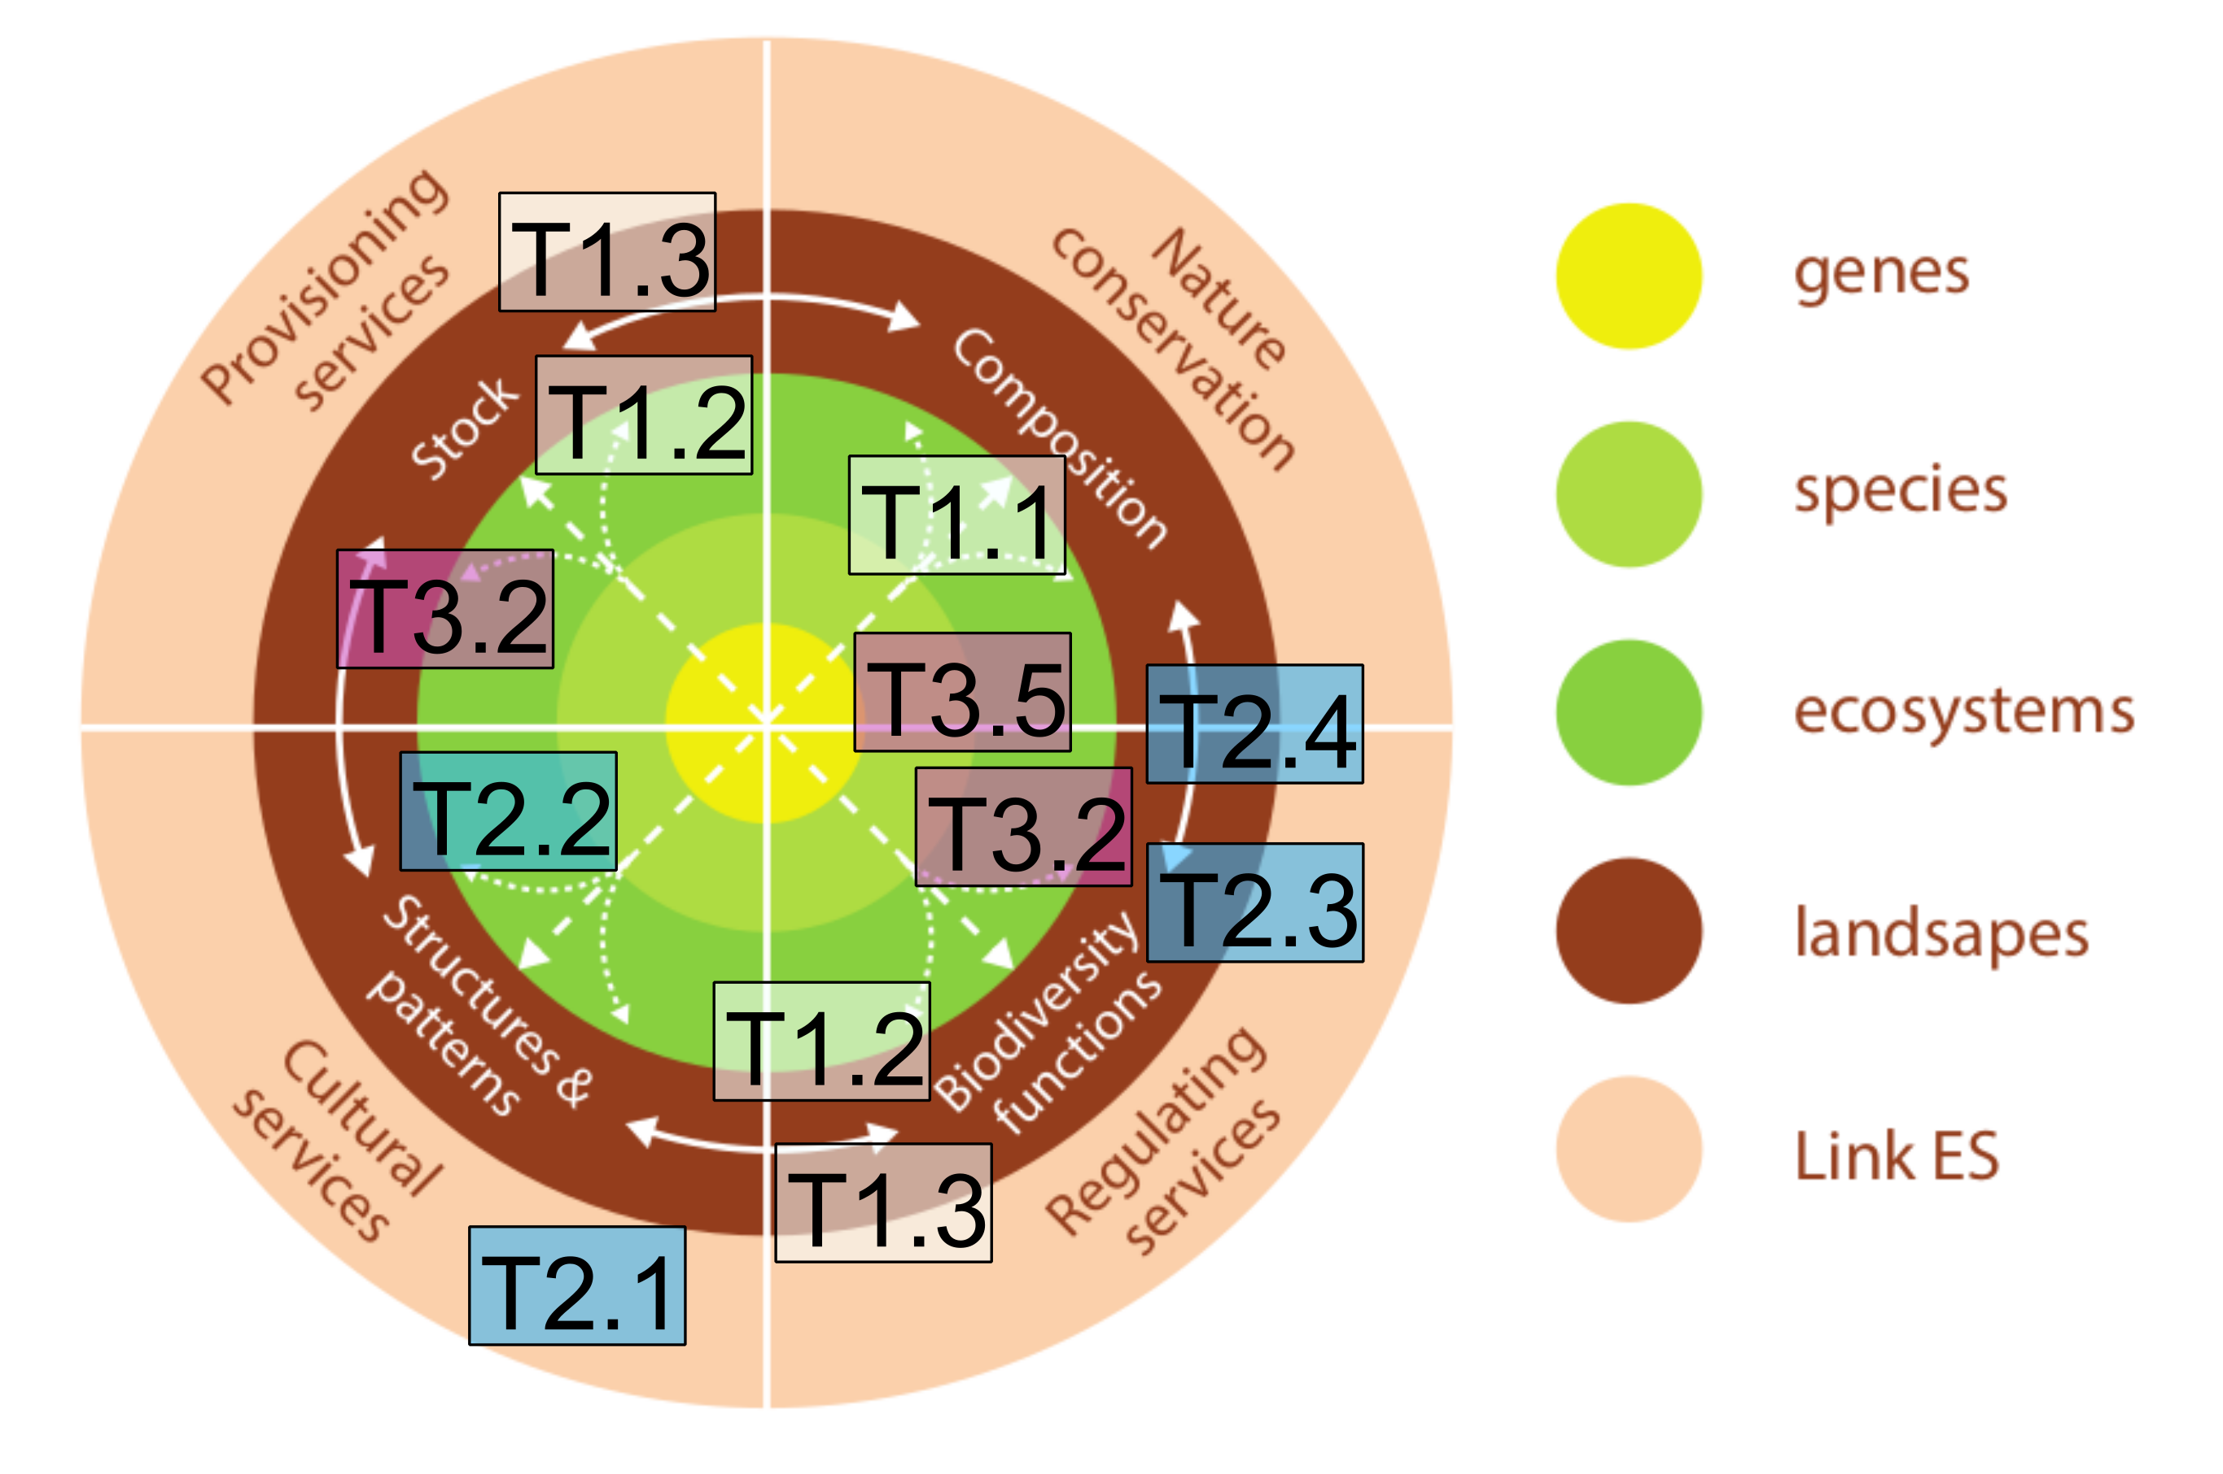Figure 1: Relevance of the themes and sub-projects for assessing ecosystem services. Only the most relevant sub-projects are shown, with colours referring to their overall theme: T1 (From community assembly to ecosystem functions and services) is shown in white, T2 (Anthropogenic disturbances, people’s perception, and restoration opportunities) in blue, and T3 (Theory and models for fundamental ecological theory and biodiversity conservation) in pink. Adapted from [1].
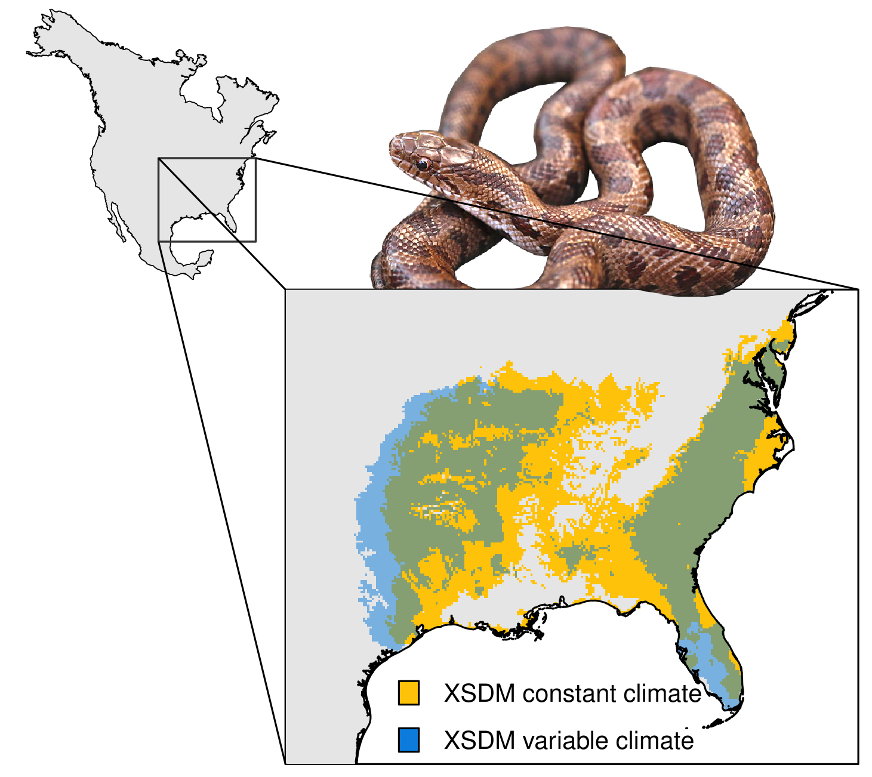Figure 2: Potential distribution of the yellow-bellied kingsnake (Lampropeltis calligaster) using the XSDM framework. Blue shade shows the potential distribution when accounting for climate and its inter-annual variability and yellow shade shows the potential distributions assuming constant climate. The two distributions differ markedly. Notably, the distribution accounting for climate variability (blue) can explain observed patterns of genetic divergence among L. calligaster populations.

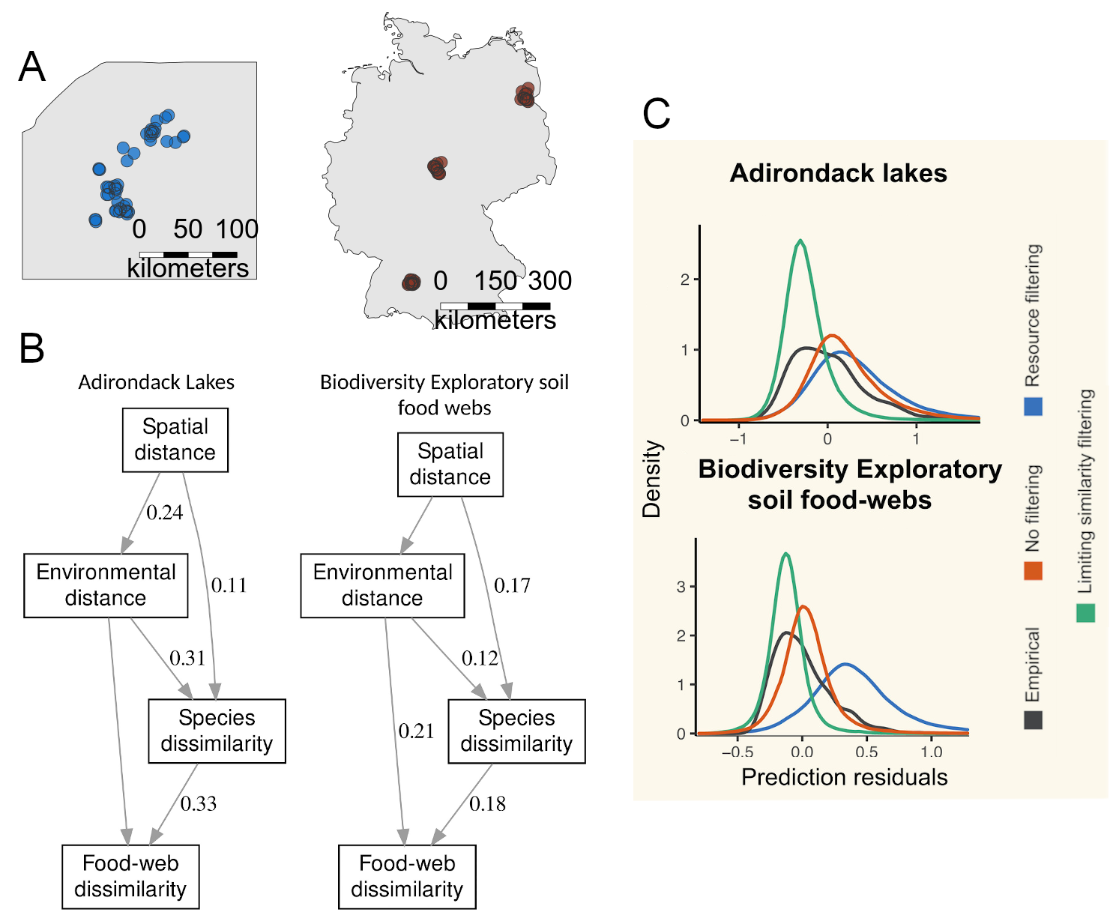Figure 3: Limiting similarity determines community assembly and food web properties in two ecosystem types. A) The communities studied for the two ecosystems, the Adirondack Lakes (blue) and forest soil food webs (Biodiversity Exploratory soil food webs; brown). B) Results from the structural equation modelling, showing that spatial distance and environmental dissimilarity affect community composition, which then influences food web structure. C) Results from simulation models showing that limiting similarity (green lines) has the highest agreement with empirical patterns (black lines) compared to a scenario where species composition is random (orange lines) or affected only by resource availability (blue lines). Adapted from [5].

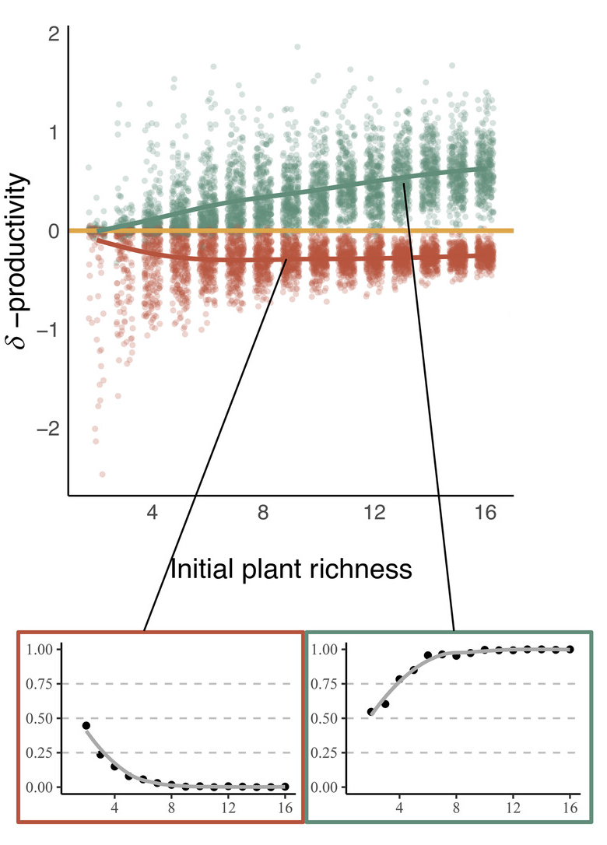Figure 4: Community assembly influences the relationship between plant richness and primary productivity. The difference (δ) in primary productivity when plant complementarity increases through niche packing (red points) or divergent adaptation (green points) relative to the control (yellow line). The red and green inset figures show the proportion of positive changes for each scenario. Primary productivity is higher in communities shaped by limiting similarity, which reduces niche overlap and increases functional diversity of species, strengthening the BEF relationship. Adapted from [7].

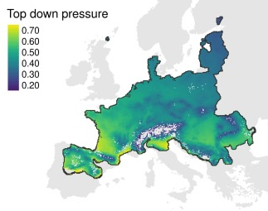Figure 5: Pest control of the common vole (Microtus arvalis) in Europe. Top-down pressure represents the sum of energy fluxes between M. arvalis and its predators. The lighter the colour, the greater the top-down pressure. This example shows how the framework from [9] can be applied to quantify ecosystem services that depend on flux of energy and nutrients.

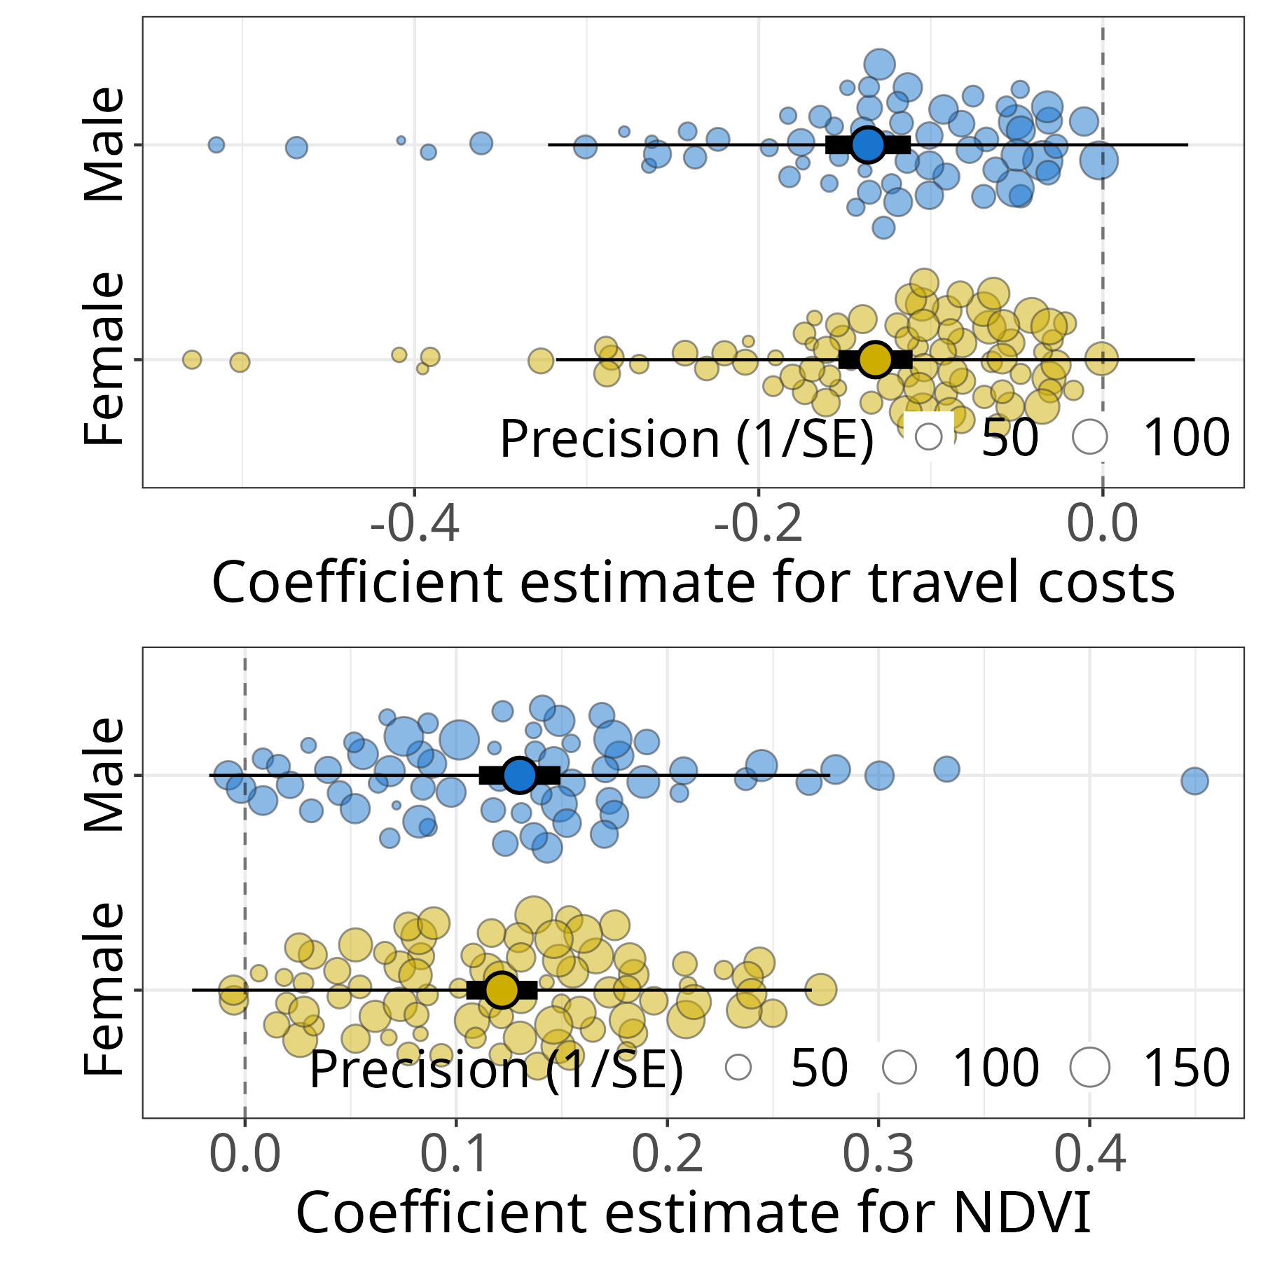Figure 6: Preferences for habitat features of 155 elephants in Northern Kenya. Circles show the coefficient estimates of the preference model, with colours showing the sex of individuals and size proportional to estimate uncertainty. Elephants tend to avoid areas with high cost of travel and prefer habitats with high primary productivity, highlighting the importance of movement strategies to optimize energy trade-offs. Adapted from [28].

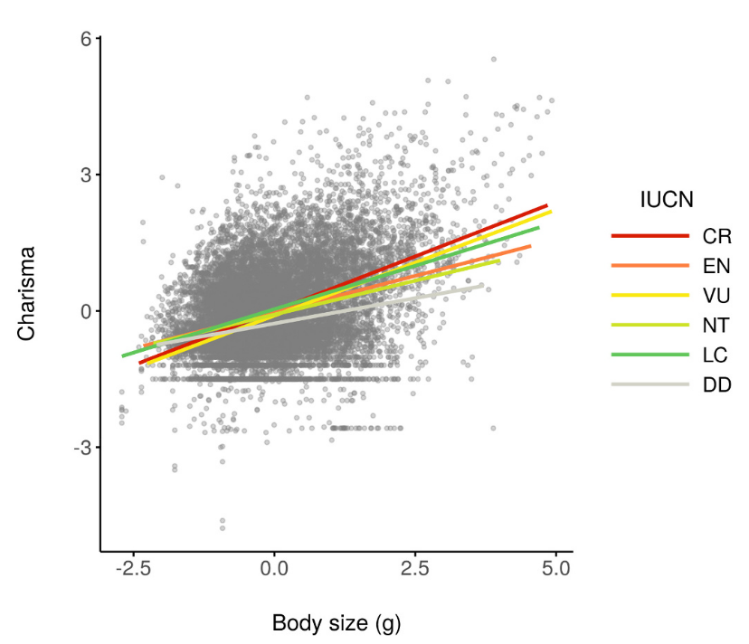Figure 7: Relationship between animal charisma and body size. Data was obtained from nine datasets for amphibians, birds, mammals, and reptiles. Circles show species data points, with charisma being normalized relatively to each dataset. Lines show the relationship between charisma and body size, with colors indicating the IUCN threat category.

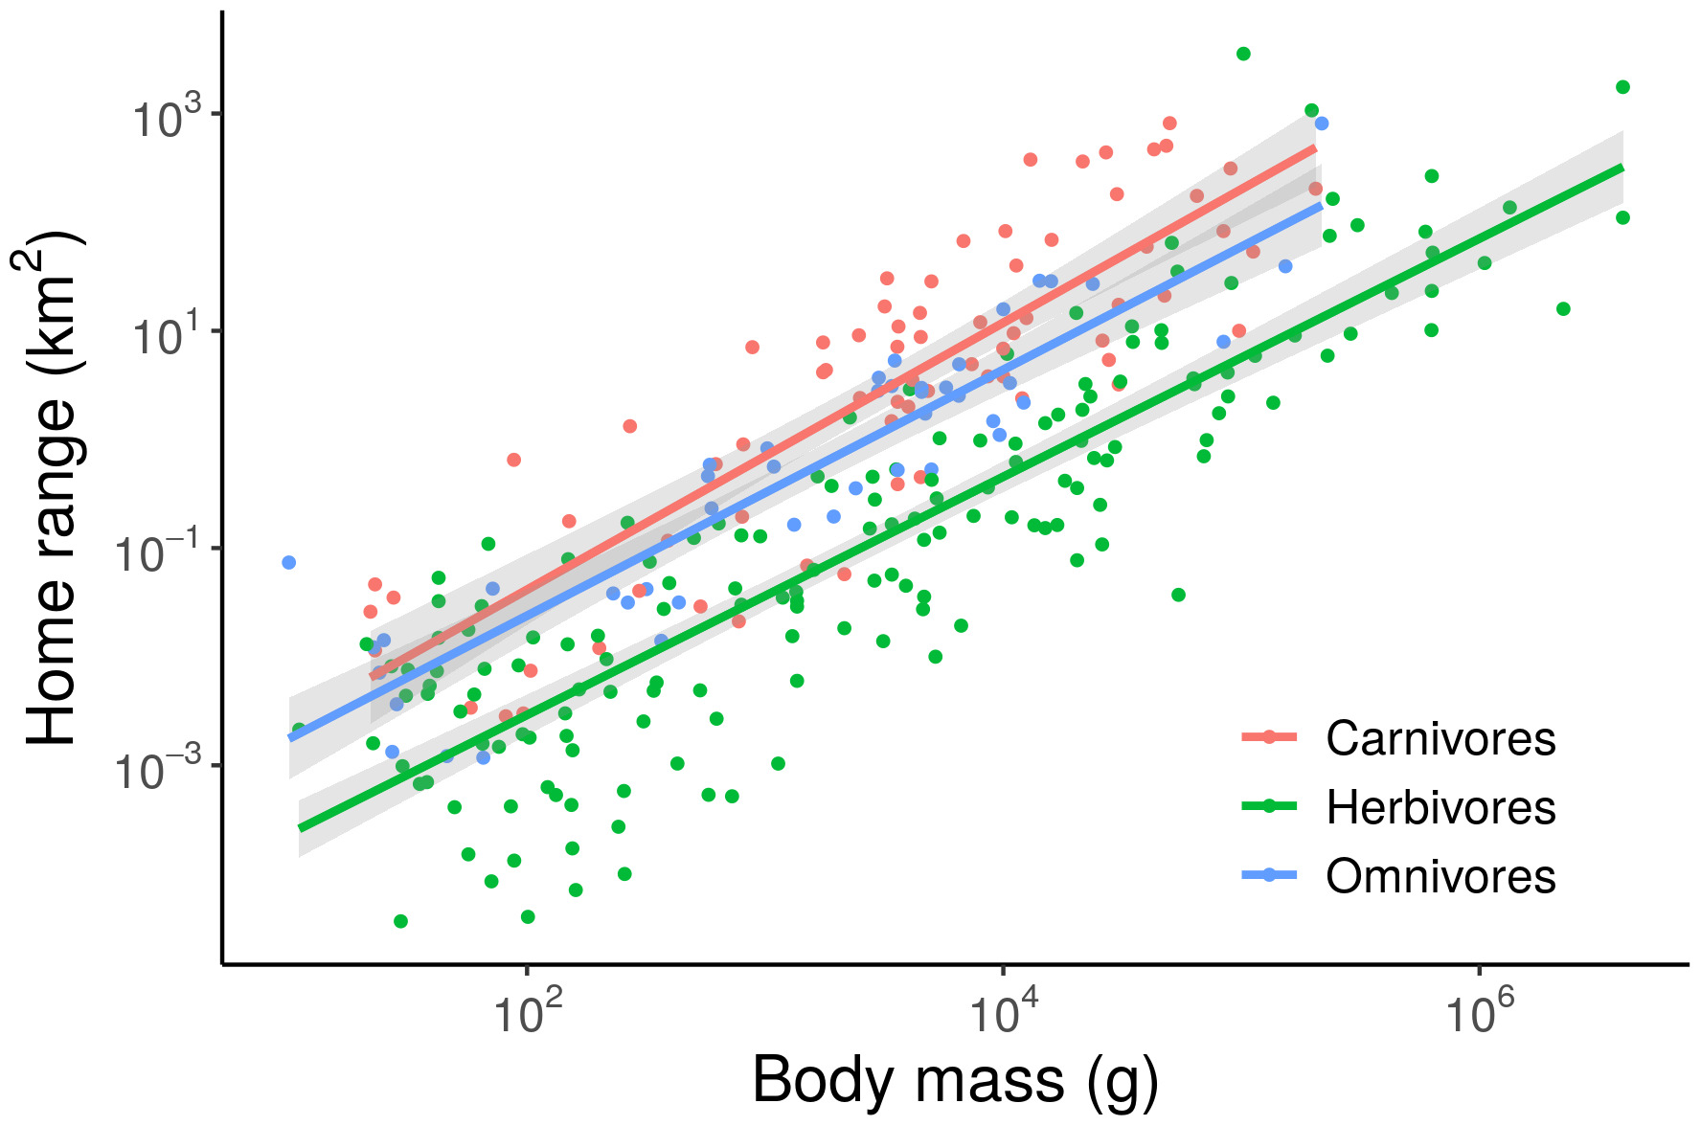Figure 8: Allometric scaling of home range (km²) with species body mass (g) in mammals. Circles show the species-level data points from [43] and lines the scaling relationship between body mass and home range, obtained by means of linear regression. Colours show the trophic level of the species. Both axes are log₁₀-scaled.
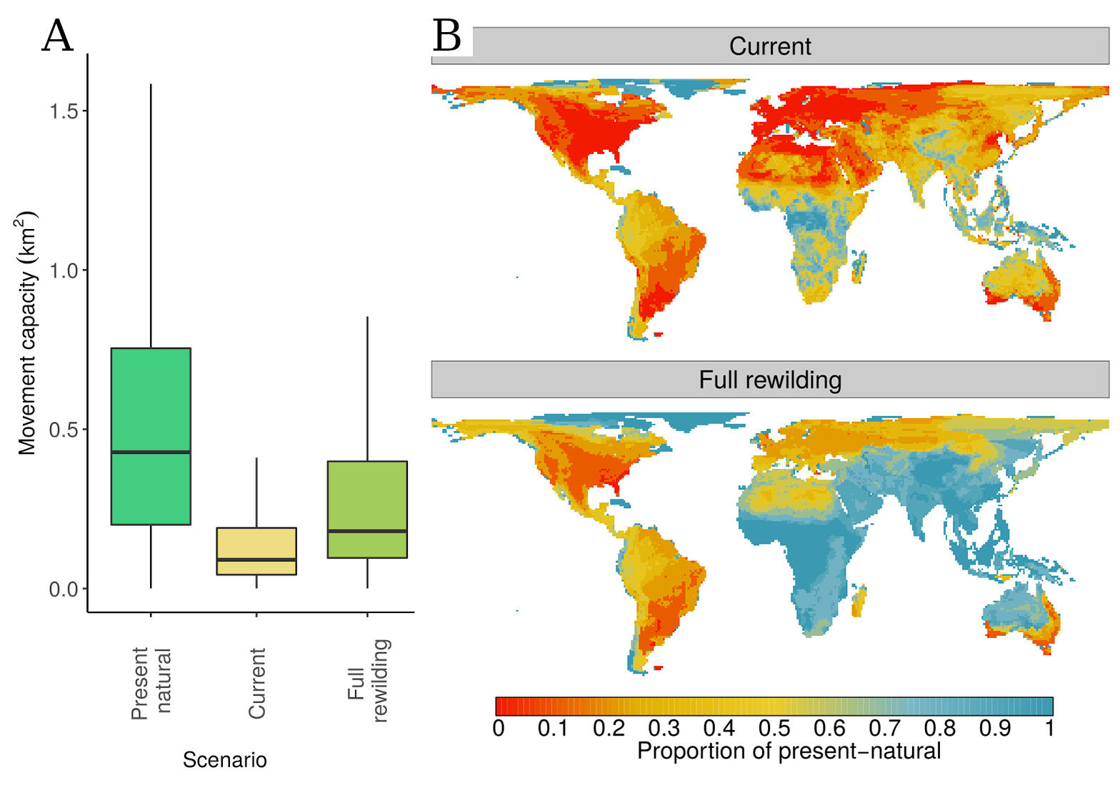Figure 9: Declines of biotic connectivity caused by human-driven extinctions and restoration opportunities. A) Global movement capacity, a proxy for biotic connectivity, of terrestrial mammal assemblages under three scenarios: present natural (assuming no extinction and range contraction occurred); current; and full rewilding, showing the maximum connectivity that can be restored if all existing animals are allowed to occupy their native ranges. Boxplots show the median, upper and lower quantiles (box limits), and 1.5 interquartile range (whiskers); outliers were removed for clarity. B) Geographic distribution of the loss of biotic connectivity. Colours show the proportion of connectivity that we would have today if humans did not affect mammal assemblages (present natural) compared to what we have today (current) and to what can be restored (full rewilding scenario). Red indicates low, yellow intermediate, and blue high connectivity.

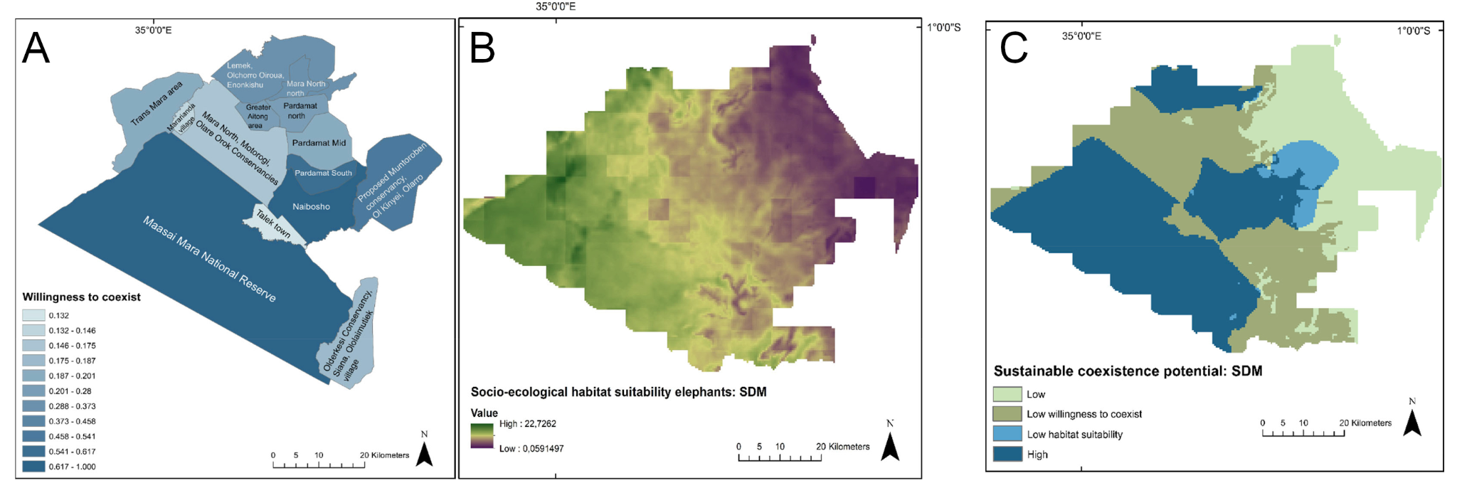Figure 10: People’s tolerance determines the potential for sustainable coexistence between societies and megafauna in Kenya. A) Willingness to coexist measure, quantified using field surveys of people’s opinions. Darker shades of blue show higher tolerance of people towards wildlife. B) Socio-ecological potential habitat suitability for elephants. Violet shows are with low suitability and green areas with high suitability. C) Potential for sustainable coexistence between human societies and elephants in Kenya, obtained integrating A and B. Green shades show low coexistence potential and blue shades high coexistence potential. Adapted from [36].

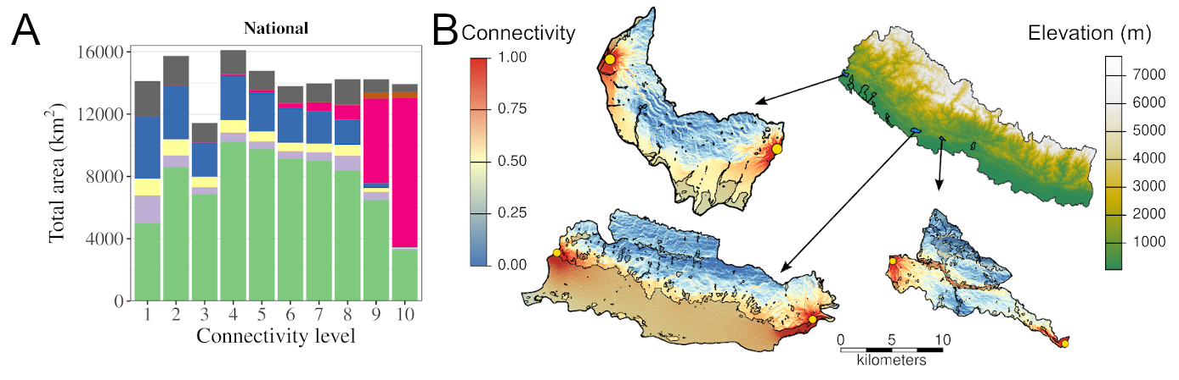Figure 11: Landscape connectivity for adult male tigers in Nepal. A) Land-cover zonal statistics grouped by connectivity levels. Stacked bars show the area covered by land-cover types for each connectivity level, with 1 indicating lowest and 10 highest connectivity. B) Landscape connectivity for a tiger travelling through three designated areas of the Terai-Arc dispersal corridors. Connectivity was calculated using as resistance matrix the energy costs of travelling across the landscape. Gray shades show areas of human land-use, such as croplands and settlements. Adapted from an ongoing study in collaboration with Prof. Niel Carter [NEPAL].

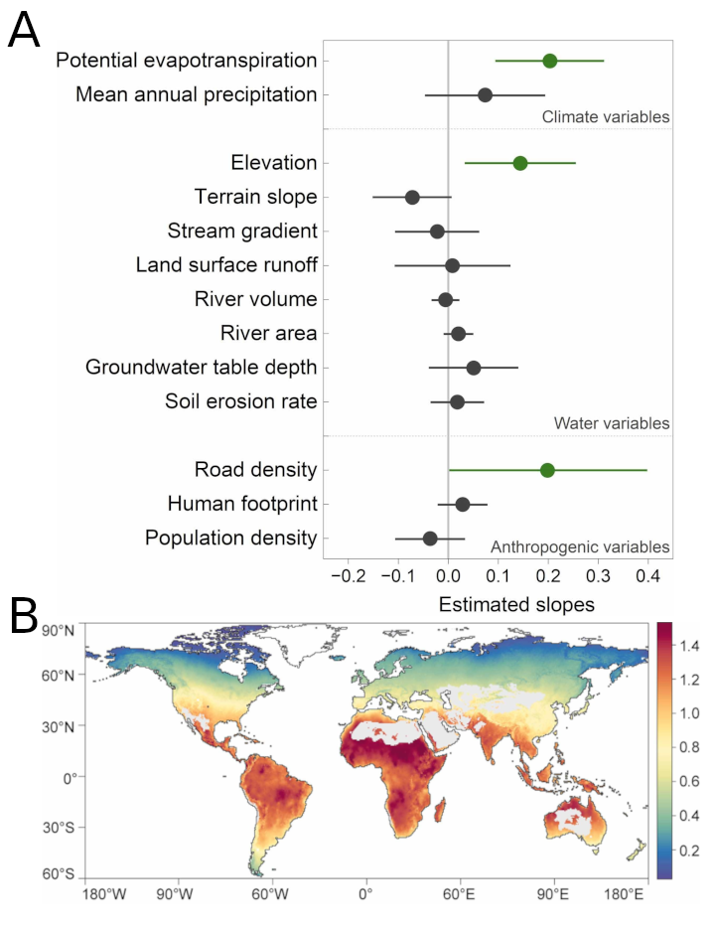Figure 12: Results from the meta-analysis on patterns and drivers of lead concentration. A) Overall effects of the 13 predictors used for estimating lead concentration in global inland waters. Circles show mean estimated effects (± 95% confidence intervals), obtained using mixed linear models. Gray colour indicates a statistically non-significant effects on lead concentration (p ≥ 0.05) and green colour a significant positive effects on (p < 0.05). B) Predicted global pattern of Pb concentration in inland waters (μg L−1) obtained from using linear mixed models. Colours indicate the lead concentration, with blue showing low levels and red high levels of lead concentration. Gray cells indicate areas without inland waters. Adapted from 37.

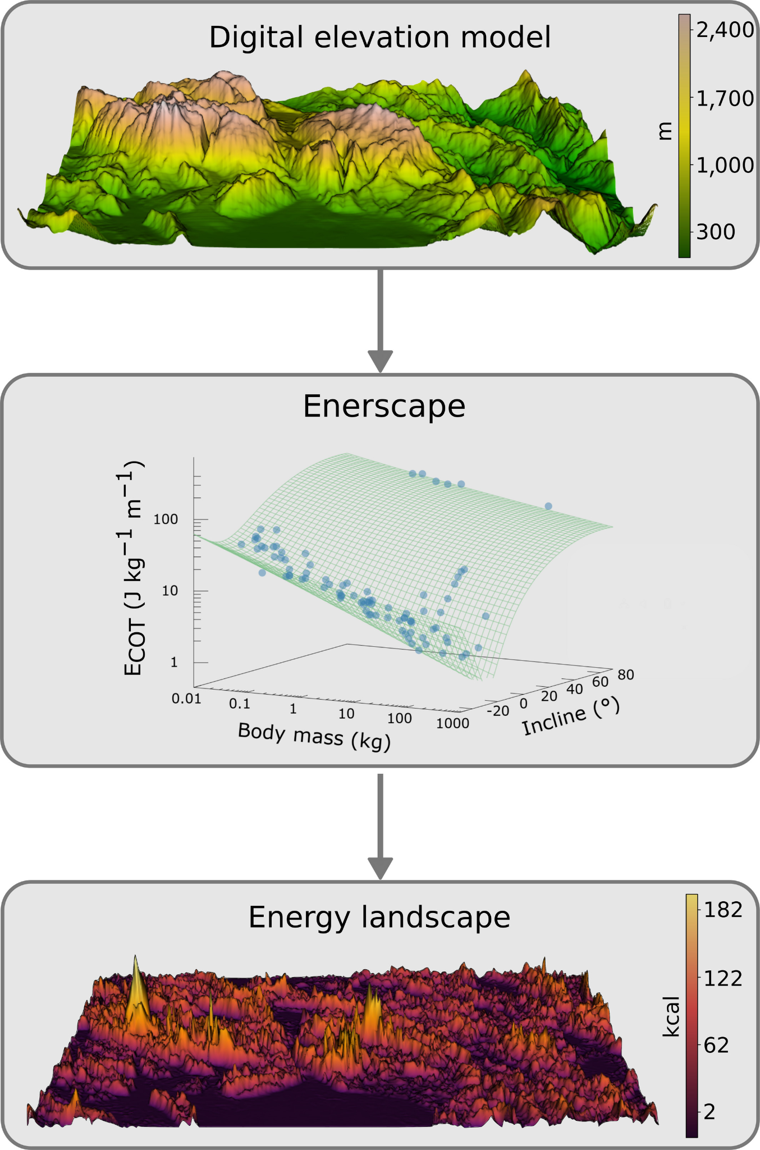Figure 13: Illustration of the workflow of the R package enerscape. The energy landscape is computed starting from a raster of the digital elevation model (top) and animal body mass using a locomotory model to calculate the energy costs of transport (ECOT). Green lines show the ARC model 24 for legged, terrestrial animals (middle), with blue circles showing the empirical data used for validation. The output of enerscape is the raster of energy landscapes (bottom). From 25.

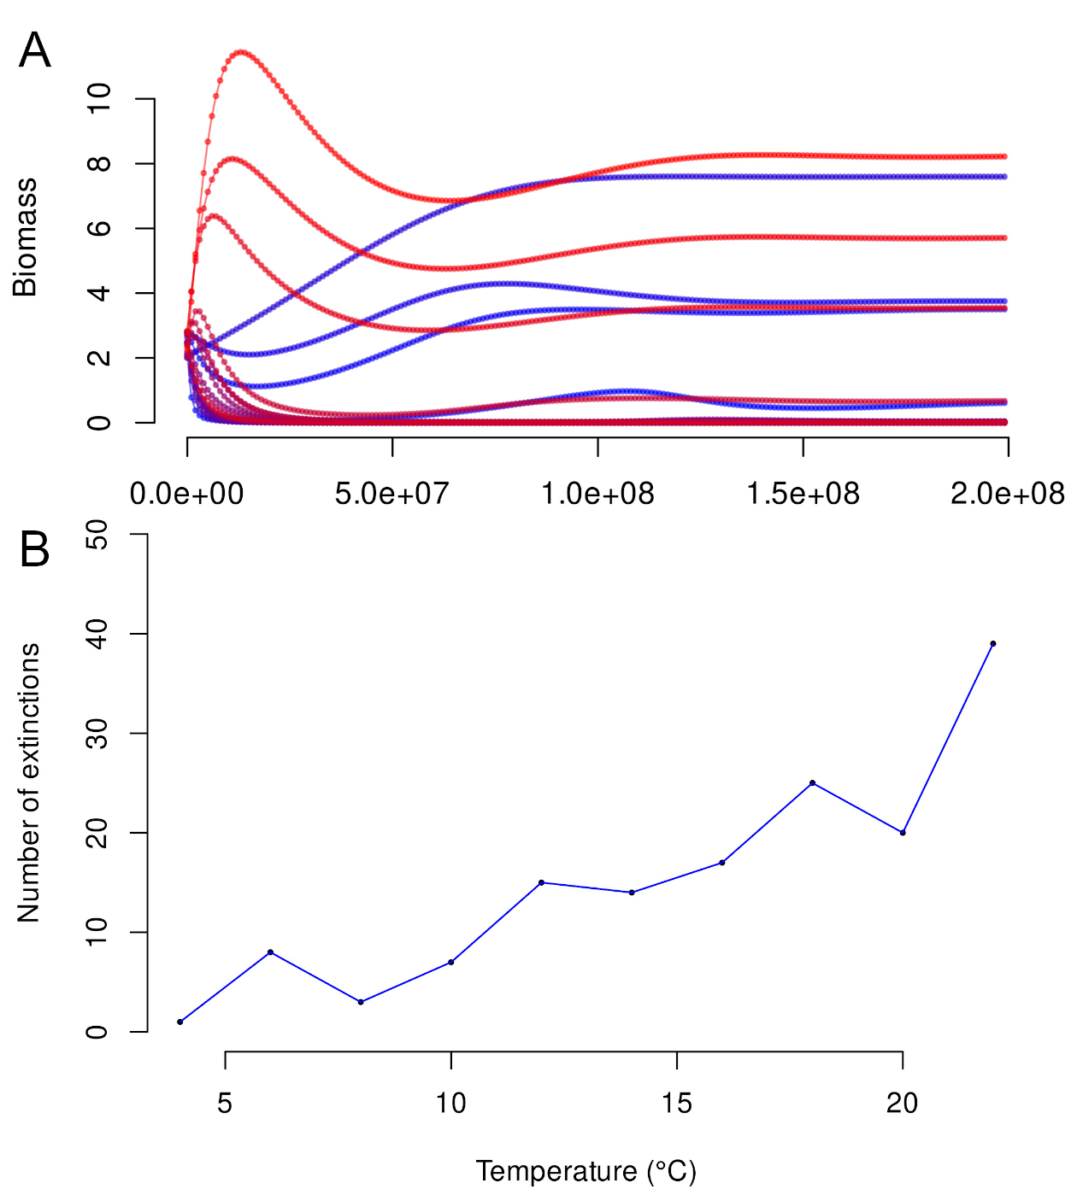Figure 14: Examples of the output of ATNr and its applications. A) ATNr simulates biomass dynamics through time using fast C++ code. Colours show different species, using a gradient from blue to red based on species' ranks in the food web matrix. B) Effect of temperature on species persistence using the unscaled ATN model with nutrients as implemented in ATNr. For increasing temperatures, more species go extinct (total species richness = 50). Adapted from [8].

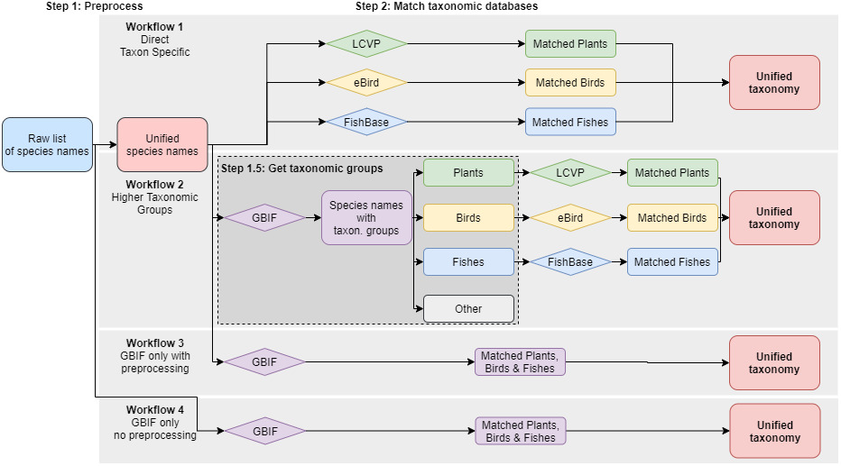Figure 15: Diagram of the four taxonomic harmonization workflows explored. The workflows differ in the number of steps they consider and the taxonomic backbone they use. Rounded rectangles represent lists of taxon names and diamonds the taxonomic databases used.. The different colours used at step 2 represent different taxonomic groups. From [39].

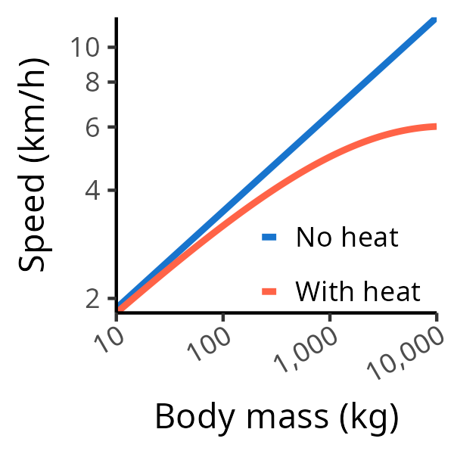Figure 16: Predictions of optimal sustained travel speed for terrestrial animals. The two curves show the model commonly used in previous studies that does not include heat dissipation processes (blue) and the new model developed in 41, which includes heat (red) and best explains the empirical data. The sustained travel speed of large animals is strongly influenced by heat dissipation processes. The coefficients of the were curves extracted from [41].

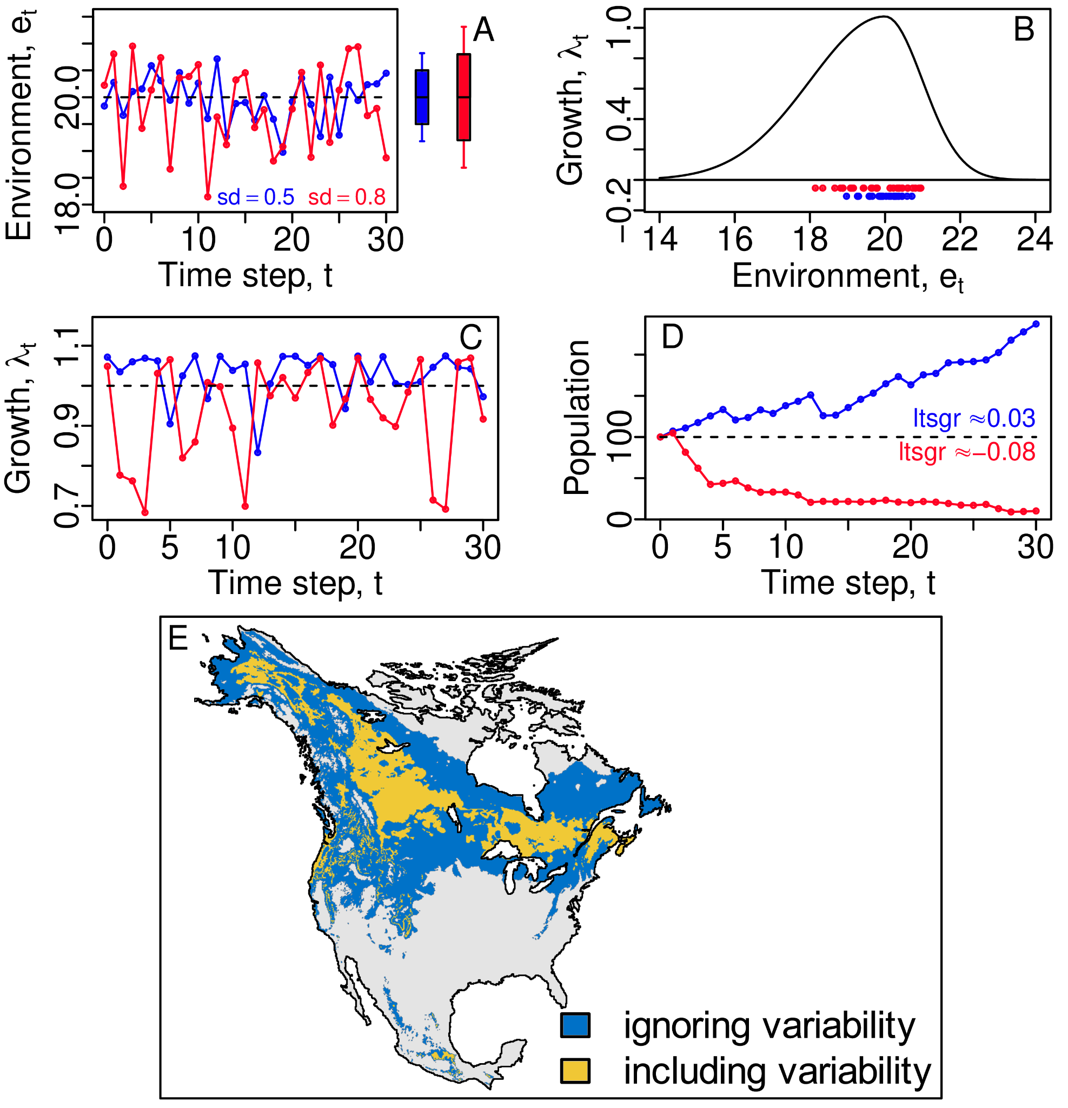Figure 17: Illustration of how inter-annual environmental variability can alter population viability and how stochastic demography can account for this effect. A) Two distinct locations (red and blue points/lines in all panels) have identical average environmental conditions, but different degrees of inter-annual variability (sd = standard deviation). If the annual net growth rate (λ_{t}) is a function of the environment as in panel B, then differences in environmental variance can produce large differences in the time series of growth rates (C), which lead to dramatic differences in survival outcomes of the population (D). The long-term stochastic growth rate (ltsgr), a concept borrowed from stochastic demography, accurately captures population viability in these two scenarios. E) The projected environmental suitability can drastically differ when accounting or not for inter-annual variability.

Table 2: Relevance of the themes for ecosystem services assessment. Relevance is shown only for themes that directly link ecosystem functions to services.
Essential functions or structures for the supply of a service | Food | Wood production | Production energy crops | Venison | Pollination | Pest control | Global climate regulation | Nutrient regulation | Green space outdoor activities | Natura 2000 | Green infrastructre
 | Provisioning ES |  |  |  | Regulating ES |  |  |  | Cultural ES | Nature conservation
Primary production | 1.2, 1.3, 3.2 | 1.2, 1.3, 3.2 | 1.2, 1.3, 3.2 |  |  |  | 1.2, 1.3, 3.2 | 1.2, 1.3, 3.2
Animal production | 1.3, 3.2 |  |  | 1.3, 3.2 |  |  |  | 1.3, 1.5, 2.3, 3.1, 3.2
Soil formation & Nutrient availability / -cycling |  |  |  |  |  |  |  | 1.3, 1.5, 2.3, 3.1, 3.2
Decomposition of organic material |  |  |  |  |  |  |  | 1.3, 3.2
Carbon storage & carbon stock |  |  |  |  |  |  | 1.2, 1.3, 3.2 | 1.2, 1.3, 3.2
Pollination |  |  |  |  | 1.1, 1.4
Pest control |  |  |  |  |  | 1.1, 1.3, 3.2
Regulate population dynamics |  |  |  | 1.1, 1.3, 3.2 | 1.1, 1.4 | 1.1, 1.3, 3.2
Regulating ecosystem dynamics, succession |  | 1.2, 1.3, 3.2 |  |  |  |  |  |  | 2.1, 2.2 | 2.4, 3.1
Stability ecosystem processes & Ecosystem resilience |  |  |  |  |  |  |  |  |  | 1.1, 1.4, 2.4, 3.2
Development of complex ecological networks |  |  |  |  |  |  |  |  | 2.1, 2.2 | 2.2, 2.4 | 1.5, 2.4, 3.1
Develop ecosystem diversity / habitat quality |  |  |  |  |  |  |  |  |  | 1.4, 2.3 | 2.4
Adapted from ¹.
Colors are comparable with Figure 1.

