Rewiring food webs via trophic rewilding

Emilio Berti1, 2, *, Scott Jarvie1, 2, and Jens-Christian Svenning1, 2

1 Section for Ecoinformatics and Biodiversity, Department of Bioscience, Aarhus University, Ny Munkegade 114, DK-8000 Aarhus C, Denmark.

2 Center for Biodiversity Dynamics in a Changing World (BIOCHANGE), Department of Bioscience, Aarhus University, Ny Munkegade 114, DK-8000 Aarhus C, Denmark.

* Corresponding author: emilio.berti@bios.au.dk

Keywords: Food webs – Human-driven extinctions – Mammals – Megafauna – Rewilding – Trophic interactions.

# Abstract

During the late-Quaternary, humans triggered mass extinctions of vertebrates, with a selective size-bias towards large mammals, causing losses of top-down trophic processes in ecosystems. Trophic rewilding, the (re)introduction of species to promote self-sustaining biodiverse ecosystems, has been proposed as a restoration strategy to reinstate ecosystems’ trophic complexity. Yet, the extent of restoration possible via trophic rewilding is poorly understood. Here, we combined current ranges of terrestrial mammals, present-natural distributions (counter-factual range estimates where human influence through time is considered negligible), and rewilding ranges together with food web inference to examine the effects of late-Quaternary extinctions on ecosystems’ trophic structure and potential recoveries through rewilding. Our results show that trophic complexity and top-down control in terrestrial ecosystems have been severely degraded by human activities. We also found that trophic rewilding can rewire food webs, restoring a large proportion of the lost predator-prey interactions and, reinstating ecosystems’ trophic structure. Under the rewilding scenario examined, however, ecosystems remained depleted of higher trophic levels and of top-down trophic interactions with small to large differences compared to natural conditions.

# Introduction

Humans have degraded ecosystems worldwide, removing from the environment species, their interactions, and the ecological processes associated with them (Ceballos et al., 2015; Dirzo et al., 2014; C. Sandom, Faurby, Sandel, & Svenning, 2014; Valiente-Banuet et al., 2015). Human-driven extirpations of mammals date back to at least the Late Pleistocene, with a large bodied size-selectivity causing extinctions of over half of megafauna genera (121 out of 196 genera >= 44 kg have gone extinct (Barnosky, 2008; Martin, 1984; C. Sandom et al., 2014; F. A. Smith, Smith, Lyons, & Payne, 2018)). As Late Pleistocene mammal extinctions acutely affected large body-sized species, interactions previously maintained by pre-human biodiverse megafauna communities have been removed from ecological networks, modifying ecosystem processes and functions (Faurby & Svenning, 2015; Gill, 2014; Malhi et al., 2016). For example, extirpations of apex predators have reduced control of prey densities and generated trophic cascades altering ecosystems structure and dynamics (Atkins et al., 2019; Estes et al., 2011; A. T. Ford et al., 2014; Ripple et al., 2014).

Trophic rewilding, the (re)introduction of species to promote self-sustaining biodiverse ecosystems (Svenning et al., 2016), has been proposed to re-establish lost ecological interactions (Perino et al., 2019). Reintroduction of wolves in the Yellowstone National Park, for example, has restored landscape of fear and top-down control effects promoted by large carnivores, re-establishing trophic cascades (Beschta & Ripple, 2016). Rewilding is not universally accepted, however, with criticism on both its conceptual and ecological validity (Hayward et al., 2019; Nogués-Bravo, Simberloff, Rahbek, & Sanders, 2016). Data on rewilding are scarce, limited in time, and geographically biased (Tanentzap & Smith, 2018), and community responses to rewilding can be contradictory and inconclusive, arising the issue of when and how to rewild (Alston et al., 2019). Despite increasing evidence for the restoration potential of rewilding (Perino et al., 2019), there is limited knowledge of the potential of rewilding to rewire ecological networks to pre-human conditions at global scale.

Macroecological approaches provide an appropriate framework to assess the potential of rewilding to rewire ecological networks at large scales and deep-time perspectives (Mendoza & Araújo, 2019; Zhang et al., 2018). These approaches can highlight similarities between extinct and extant species and suggest suitable ecological replacements for rewilding (M. M. Pires, 2017). Moreover, inference of biotic interactions and reconstruction of prehistoric ecological networks can be used to examine the consequences of human-driven extinctions and extirpations of large mammals (Marjakangas et al., 2018; Pires et al., 2015; Yeakel et al., 2014). By combining a rewilding scenario supported by paleoecological data with macroecologically-grounded reconstructions of interaction networks it is possible to infer rewilding communities and interactions and examine the potential of rewilding to rewire ecological networks to pre-human conditions (M. M. Pires, 2017).

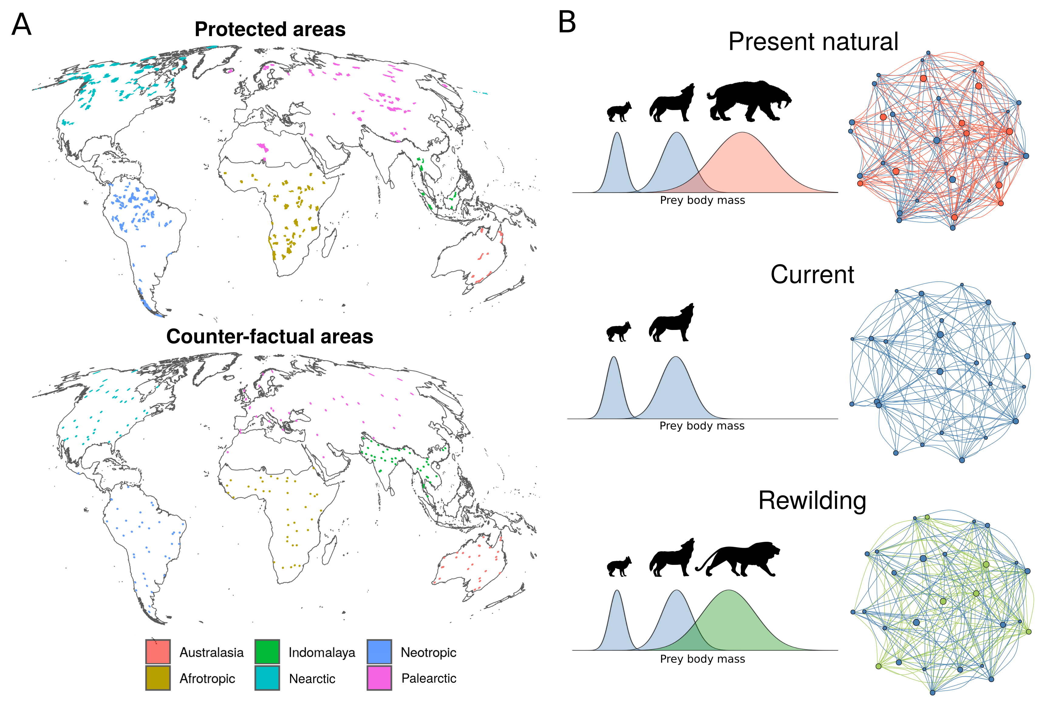

Figure 1. Conceptual representation of rewiring food webs via trophic rewilding. A) protected areas and counter-factual areas >= 5,000 km^2 included in the study. Colours in A show the six realms considered in the study (Antarctica and Oceania were excluded). B) Network representation of food webs. In the network, species are nodes and predator-prey interactions are edges. Late Pleistocene human-driven extinctions have removed species and trophic interactions (red nodes and edges). Trophic rewilding aims to restore lost interactions by replacing extinct species with suitable ecological analogues (green nodes) that can rewire food webs establishing functionally analogue links (green edges).

In this study, we investigate the potential of rewilding to rewire terrestrial mammal food webs in large (>=5,000 km^2) areas worldwide (Fig. 1). We infer food webs for three scenarios: 1) present-natural, i.e. a counter-factual scenario where mammals have not been influenced by human activities through time (Faurby & Svenning, 2015; Faurby et al., 2018); 2) current conditions; and 3) a rewilding scenario where extant species can re-expand to present-natural ranges and extinct species can be replaced by closely related, similarly sized functional analogues that tolerate similar climates. We then compare the food webs for the three scenarios to investigate how much current food webs are depleted of predator-prey interactions and whether rewilding can rewire food webs to pre-human states.

# Materials and methods

## Overview

Building on the terminology of Genes, Cid, Fernandez, & Pires (2017), we quantified: a) current debt,how many species and interactions have been lost because of past extinctions; b) rewilding credit, how many lost species and interactions can be reintroduced or replaced under the rewilding scenario; and c) rewilding deficit, how much past losses cannot be restored via rewilding. By comparing debt, credit, and deficit, we assessed if rewilding credit can balance current debt.

We quantified current extinction debt and rewilding credit and deficit in large (>= 5,000 km^2) protected areas (n = 209) with strict International Union for Conservation of Nature (IUCN) management category (Ia, Ib, and II). Rewilding is more feasible in large, strictly managed protected areas and human-wildlife coexistence less problematic. Because large protected areas are concentrated in areas with low biodiversity (Daru et al., 2019), we also examined rewilding restoration potential in counter-factual areas >= 5,000 km^2 (n = 206) randomly scattered worldwide to investigate a global rewilding scenario without geographic biases.

First, we ran correlative species distribution models (SDMs) to identify climatically suitable habitat for terrestrial mammals. Second, we selected for each extinct species a closely related, similarly sized functional analogue following conservative selection criteria. Third, we inferred food webs under present-natural, current, and rewilding scenarios. By contrasting food web for the three scenarios, we investigated whether rewilding can restore current defaunated food webs to natural conditions. We ran analyses for protected and counter-factual areas separately; in the following sections we describe in details the methods used for protected areas, implying that the same was done for the counter-factual areas where applicable.

## Species distribution models

Correlative SDMs are projections in geographic space of species' environmental suitability niches reconstructed through correlation of species' presence with abiotic environmental predictors (Elith & Leathwick, 2009). To overcome biases introduced by anthropogenic pressures on where terrestrial mammals live, we used current and present-natural range maps from the PHYLACINE database (Faurby et al., 2018). Following previous descriptions of PHYLACINE (Faurby & Svenning, 2015; Faurby et al., 2018), current ranges were generated from the IUCN range polygon maps for current, natural, and reintroduced ranges only (IUCN, 2016). Present-natural ranges are estimates of where species could be today in the complete absence of influence of modern humans (*Homo sapiens*) through time (Faurby & Svenning, 2015) and can be viewed as pre-human ranges adjusted for present-day climate. The present-natural ranges combine knowledge of species' current IUCN range with historic distributions, fossil co-occurrence data, and range modifications caused by humans (Faurby & Svenning, 2015; Faurby et al., 2018).

We generated presence locations within combined current and present-natural range maps with a 20 km separation distance, excluding locations reported above the highest elevation for each species in the IUCN Red List or, if not stated, 4,000 meters, which is roughly the 95 percentile for upper elevations of mammals (IUCN, 2016). Elevation was determined for presence locations using the EarthEnv-DEM90 digital elevation model (Robinson, Regetz, & Guralnick, 2014). In total, we identified 4,206 extant terrestrial mammal species with range maps.

As environmental predictors for the correlative SDMs, we used four climatic variables from the Worldclim database (Fick & Hijmans, 2017) : maximum temperature of the warmest month, minimum temperature of the coldest month, precipitation of wettest quarter, and precipitation of driest quarter. We selected these variables as they capture extreme conditions and, thus, likely represent factors limiting the distributions of terrestrial mammals. To model the climatic suitability of terrestrial mammals, we fitted maximum entropy (Maxent) models as implemented in the recently released *maxnet* R-package (S. J. Phillips, Anderson, Dudík, Schapire, & Blair, 2017). Maxent is a presence-background approach, in which environments occupied by a species are contrasted with the available environmental space (Elith et al., 2011; Merow, Smith, & Silander Jr, 2013). For the background areas, we calculated species-specific buffers around the combined current and present-natural ranges to reflect the dispersal abilities of each species, where the maximum distance from the range centroid to the range edge was used (Hof et al., 2018; Poo-Muñoz et al., 2014). When a species had a disjunct range, the buffer area was calculated from the largest continuous range following Hof et al. (2018) (see electronic supplementary material, figure S1).

We excluded 76 species with restricted ranges from modelling distributions as they had less than 10 presence points. In total, we modelled 4,130 of the 4,206 living terrestrial mammals. Predictive performance and model overfitting were assessed through five-fold cross validation and by comparing predicted suitable ranges with introduced range maps from IUCN (2016) and Lundgren, Ramp, Ripple, & Wallach (2018), which were not used to train Maxent models (Appendix).

## Rewilding selection criteria

We searched for rewilding candidates that were phylogenetically close and functionally similar to globally extinct species and that could tolerate climatic conditions of their ranges. Population restorations, i.e. reintroductions into present-natural ranges, were always prioritised over introductions of functional analogues, as moving species’ outside their indigenous range is inherently riskier than reintroductions due to unforeseeable uncertainties and ecological risks (**Fernández et al. 2017**). We assessed rewilding replacements separately for each biogeographic realm (Olson et al., 2001), which delimit areas within which ecological and evolutionary processes operate most strongly (Olson & Dinerstein, 2002). We excluded the Antarctica realm because no terrestrial mammal lives there and the Oceania realm because it did not contain strictly managed protected areas >= 5,000 km^2.

For each globally extinct species, we selected as rewilding replacements the species from the same family that had similar size (within the 50% range of extinct species' body mass) and that had the largest climatically suitable range within the present-natural of the extinct species in the focal biogeographic realm. Because several proboscidean families went globally extinct, megaherbivores (>= 1,000 kg; Malhi et al. (2016)) of the Proboscidea order were allowed to be replaced by the two extant elephants *Elephas maximus* and *Loxodonta africana*, often considered ecologically and functionally similar to extinct proboscideans (J. Donlan, 2005; Janzen & Martin, 1982; Josh Donlan et al., 2006). In addition, extant megacarnivores (>= 100 kg) within Felidae and Ursidae families were allowed to replace any extinct megacarnivore within the respective families, as they likely play similar ecological roles regulating the abundance and activity of large herbivores that are smaller than megaherbivores (Atkins et al., 2019; A. T. Ford et al., 2014; Laundré, Hernández, & Ripple, 2010; Ripple et al., 2014).

To avoid possible negative impacts of introducing functional analogues into the present-natural ranges of similarly-sized - within 50% of the body mass - extant species of the same taxonomic group, we excluded introductions of rewilding candidates if their proposed ranges overlapped with the ranges of reintroduced species. This was done to limit the risk of displacing extant native species through competition (Linnell & Strand, 2000). If we identified more than one rewilding candidate, we selected the species that had the largest climatically suitable range overlapping with the present-natural range of the extinct species in the focal biogeographic realm. We did not select species for rewilding that violated any of the above criteria. See electronic supplement material, figure S# for a schematic representation of the selection criteria.

## Reconstructing food webs

We reconstructed mammal assemblages within 209 large terrestrial protected areas (>= 5,000 km^2; Fig. 1), selected from the World Database of Protected Area (UNEP-WCMC & IUCN (2019), downloaded on June 2019). Following previous global studies (Jones et al., 2018; Runge et al., 2015), we excluded protected areas without detailed geographic information, proposed and designated sites not considered protected areas internationally, sites with an unknown status, UNESCO Biosphere Reserves, and marine-only sites as well as the marine portion of coastal sites. As large areas with limited human use facilitate the establishment of self-sustaining population of large mammals (Chundawat, Sharma, Gogate, Malik, & Vanak, 2016; Woodroffe & Ginsberg, 1998), we kept only protected areas with strict IUCN management category (Ia, Ib, and II) and total surface >= 5,000 km^2 after dissolving adjacent geometries together. Moreover, we investigated the effects of human activities and the restoration potential of rewilding outside the current network of protected areas, which poorly overlap with current biodiversity hotspots (Daru et al., 2019), by reconstructing food webs also for counter-factual areas randomly distributed within each biogeographic realm (figure 1). For each area, we obtained mammal assemblages under present-natural and current scenarios using the present-natural (including extinct species) and current range maps from the PHYLACINE database (Faurby et al., 2018). Rewilding assemblages were estimated from combined current, reintroduction (present-natural including only extant species), and rewilding ranges obtained using SDMs and selection of the best functional analogues for extinct species.

We inferred food webs for each area by combining phylogenetic inference with a trait-based approach (Pomeranz, Thompson, Poisot, & Harding, 2019). Phylogeny has been shown to be a good predictor of trophic interactions (Eklöf, Helmus, Moore, & Allesina, 2011), as closely related species share similar resources (Gray et al., 2015). We performed phylogenetic inference at the family level, a reasonable trade-off between accuracy of predictions and data availability (Gray et al., 2015). We gathered predator-prey interaction data from the ECOWeB database (J. E. Cohen, 2010), the Global Biotic Interactions (GLOBI) database (Poelen, Simons, & Mungall, 2014), and two published savannah food webs (Baskerville et al., 2011; Visser, Freymann, & Olff, 2011). Each observed interaction between a prey and a predator was assigned to all species of the respective families. We then used a trait-based approach to remove interactions inferred using phylogeny that were not supported by macroecological evidence (Pomeranz et al., 2019). This trait-based approach uses the relationship between the body mass of prey and predators, which structures trophic interactions in food webs (Owen-Smith & Mills, 2008; Segura, Farina, & Arim, 2016; Williams & Martinez, 2000). Following previous studies (Gravel, Poisot, Albouy, Velez, & Mouillot, 2013; Pomeranz et al., 2019), we used the 10% and 90% regression quantiles to obtain dietary niches of carnivores, i.e. the body mass range of their prey. Phylogenetically inferred predator-prey interactions that felt outside these dietary niches were then removed from the food web.

After food webs were inferred, we assigned species to trophic levels defined by diet and body mass, reflecting the trophic and ecological role of species in food webs (Malhi et al., 2016). For carnivores, we divided them into three functional groups: i) megacarnivores >= 100 kg, which are generally apex predators and dominate food webs; ii) large carnivores 21.5 - 99 kg, which can predate on large prey and are subjected to top-down control from megacarnivores; and iii) small carnivores < 21.5 kg, which can predate only on smaller prey (Carbone, Mace, Roberts, & Macdonald, 1999). For herbivores, we also divided them into three functional groups: i) megaherbivores >= 1,000 kg, which are mostly free from predation; ii) large herbivores 45 - 999 kg, which are predated only by large carnivores and megacarnivores; and iii) small herbivores < 45 kg, which are predated by all carnivores trophic levels (Hopcraft, Olff, & Sinclair, 2010).

## Statistical analyses

For each food web under present-natural, current, and rewilding scenarios, we calculated: 1) the number of species present at each trophic level, and 2) the number of predator-prey interactions connecting different trophic levels. We then compared the number of species in each trophic level between present-natural and current conditions to estimate current trophic richness debt and between current and rewilding scenarios to assess rewilding trophic richness credit. Similarly, we compared the number of trophic interactions across trophic levels between present-natural and current and between current and rewilding scenarios to obtain the current interaction debt and the rewilding interaction credit, respectively. Moreover, we investigated the difference in the number of species per trophic level and the number of interactions between trophic levels under present-natural and rewilding scenarios to quantify the amount of current debts that cannot be balanced by rewilding credit. We called this difference the "rewilding deficit".

To estimate significance and magnitude of differences among the scenarios, we used generalised linear mixed models (GLMMs). We selected the error distribution for the GLMMs based on the response data type and to remedy overdispersion (Zuur, Ieno, Walker, Saveliev, & Smith, 2009). We used a Poisson distribution to model the number of species at each trophic level with the fixed effects scenario, trophic level, and their interaction. A negative binomial distribution was used to model the predator-prey interactions across trophic levels with the fixed effects scenario, trophic levels involved in the link, and their interaction. For both GLMMs, we used the random effects area identity to account for pseudoreplication and biogeographic realms because of their different ecological histories. We assessed the significance among scenarios by performing multiple pair-wise contrasts with Bonferroni correction and estimated the magnitude of the differences using Cohen's *d* effect size (J. Cohen, 1988; Sawilowsky, 2009). Protected and counter-factual areas were analysed separately.

All data processing and analyses were performed in the R programming language version 3.6.1 (R Core Team, 2018) using packages tidyverse (Wickham, 2017), maxnet (S. Phillips, 2017), dismo (R. J. Hijmans, Phillips, Leathwick, & Elith, 2017), sf (Pebesma, 2018), raster (R. J. Hijmans, 2019), doParallel (Corporation & Weston, 2018), foreach (Microsoft & Weston, 2017), quantreg (Koenker, 2019), performance (Lüdecke, Makowski, & Waggoner, 2019), emmeans (Lenth, 2019), and estimate (Makowski & Lüdecke, 2019). All spatial analyses were conducted using the Behrmann cylindrical equal-area projection. Biogeographic realms were derived using the shapefile from the World Wildlife Foundation ([WWF](https://www.worldwildlife.org/publications/terrestrial-ecoregions-of-the-world), Olson & Dinerstein (2002)). Figures were made using packages ggplot2 (Wickham, 2016) with maps displayed in the Molleweide projection.

# Results

Predictive performance of SDMs was on average very high to excellent, while model overfitting was generally low (electronic supplementary material, Table S1 and figure S2). The projected climatic suitability ranges captured much of the known introduction ranges of species obtained from Lundgren et al. (2018) and IUCN (2016) (figure S2). These results indicate the SDMs give reliable projections of climatic suitability of terrestrial mammals.

Due to our conservative rewilding selection criteria, we found no replacements for the extinct families *Archaeolemuridae*, *Chaeropodidae*, *Diprotodontidae*, *Macrauchenidae*, *Megaladapidae*, *Megatheriidae*, *Mylodontidae*, *Nesophontidae*, *Nothrotheridae*, *Palaeopropithecidae*, *Prolagidae*, *Proterotheriidae*, *Thylacinidae*, *Thylacoleonidae*, and *Toxodontidae*. In total, we identified 94 living species that could be used as functional analogues for 127 of the 334 extinct terrestrial mammals (electronic supplementary material, Table S3).

In the protected areas >= 5,000 km^2, we found a lower number of species in trophic levels under current conditions than in the present-natural scenario except for small herbivores and small carnivores (Table 1, figure 1). The biggest decrease in numbers were for megacarnivores, megaherbivores, and large herbivores, with large (Cohen's *d* >= 0.80) or very large (*d* >= 1.20) differences. Under the rewilding scenario, the number of megacarnivores, megaherbivores, and large herbivores significantly increased from current conditions, with small or medium effect sizes. For large carnivores, however, the number of species did not increase significantly with rewilding. Also, the total number of species for trophic levels megacarnivores, megaherbivores, large carnivores, and large herbivores remained smaller than the present-natural. In the large counter-factual areas we observed similar but more pronounced patterns than in protected areas (figure 2).

*Table 1: Differences between regression coefficients estimates from generalised linear mixed models for the number of species per trophic level among scenarios: present-natural, current, and rewilding. The differences were obtained by performing multiple pair-wise contrasts accounting for variation across biogeographic realms and food webs. Superscripts show the p-value of the contrasts adjusted with Bonferroni correction and subscripts show the magnitude of the effect size of the change using Cohen's d. Change is: very small (d < 0.20), small (d = 0.20-0.49), medium (d = 0.50-0.79), large (d = 0.80-1.20), very large (d = 1.20-2.00), and huge (d >= 2.00).*

| Trophic level | Present natural - Current | Current - Rewilding | Present natural - Rewilding |
| --- | --- | --- | --- |
|  | **Protected areas** |  |  |
| Megacarnivores (≥100 kg) | 1.240.00very large | -0.600.00medium | 0.640.00medium |
| Megaherbivores (≥1,000 kg) | 1.790.00very large | -0.610.00medium | 1.180.00large |
| Large carnivores (21.5 - 99 kg) | 0.350.00small | -0.130.06very small | 0.220.00small |
| Large herbivores (45 - 999 kg) | 0.820.00large | -0.330.00small | 0.490.00small |
| Small carnivores (< 21.5 kg) | 0.060.01very small | -0.040.19very small | 0.020.79very small |
| Small herbivores (< 45 kg) | 0.030.40very small | -0.011.00very small | 0.021.00very small |
|  | **Counter-factual areas** |  |  |
| Megacarnivores (≥100 kg) | 1.890.00very large | -1.210.00very large | 0.670.00medium |
| Megaherbivores (≥1,000 kg) | 2.490.00huge | -1.310.00very large | 1.190.00large |
| Large carnivores (21.5 - 99 kg) | 0.680.00medium | -0.480.00small | 0.200.00small |
| Large herbivores (45 - 999 kg) | 1.100.00large | -0.590.00medium | 0.500.00medium |
| Small carnivores (< 21.5 kg) | 0.090.00very small | -0.070.01very small | 0.020.92very small |
| Small herbivores (< 45 kg) | 0.040.06very small | -0.020.57very small | 0.020.91very small |

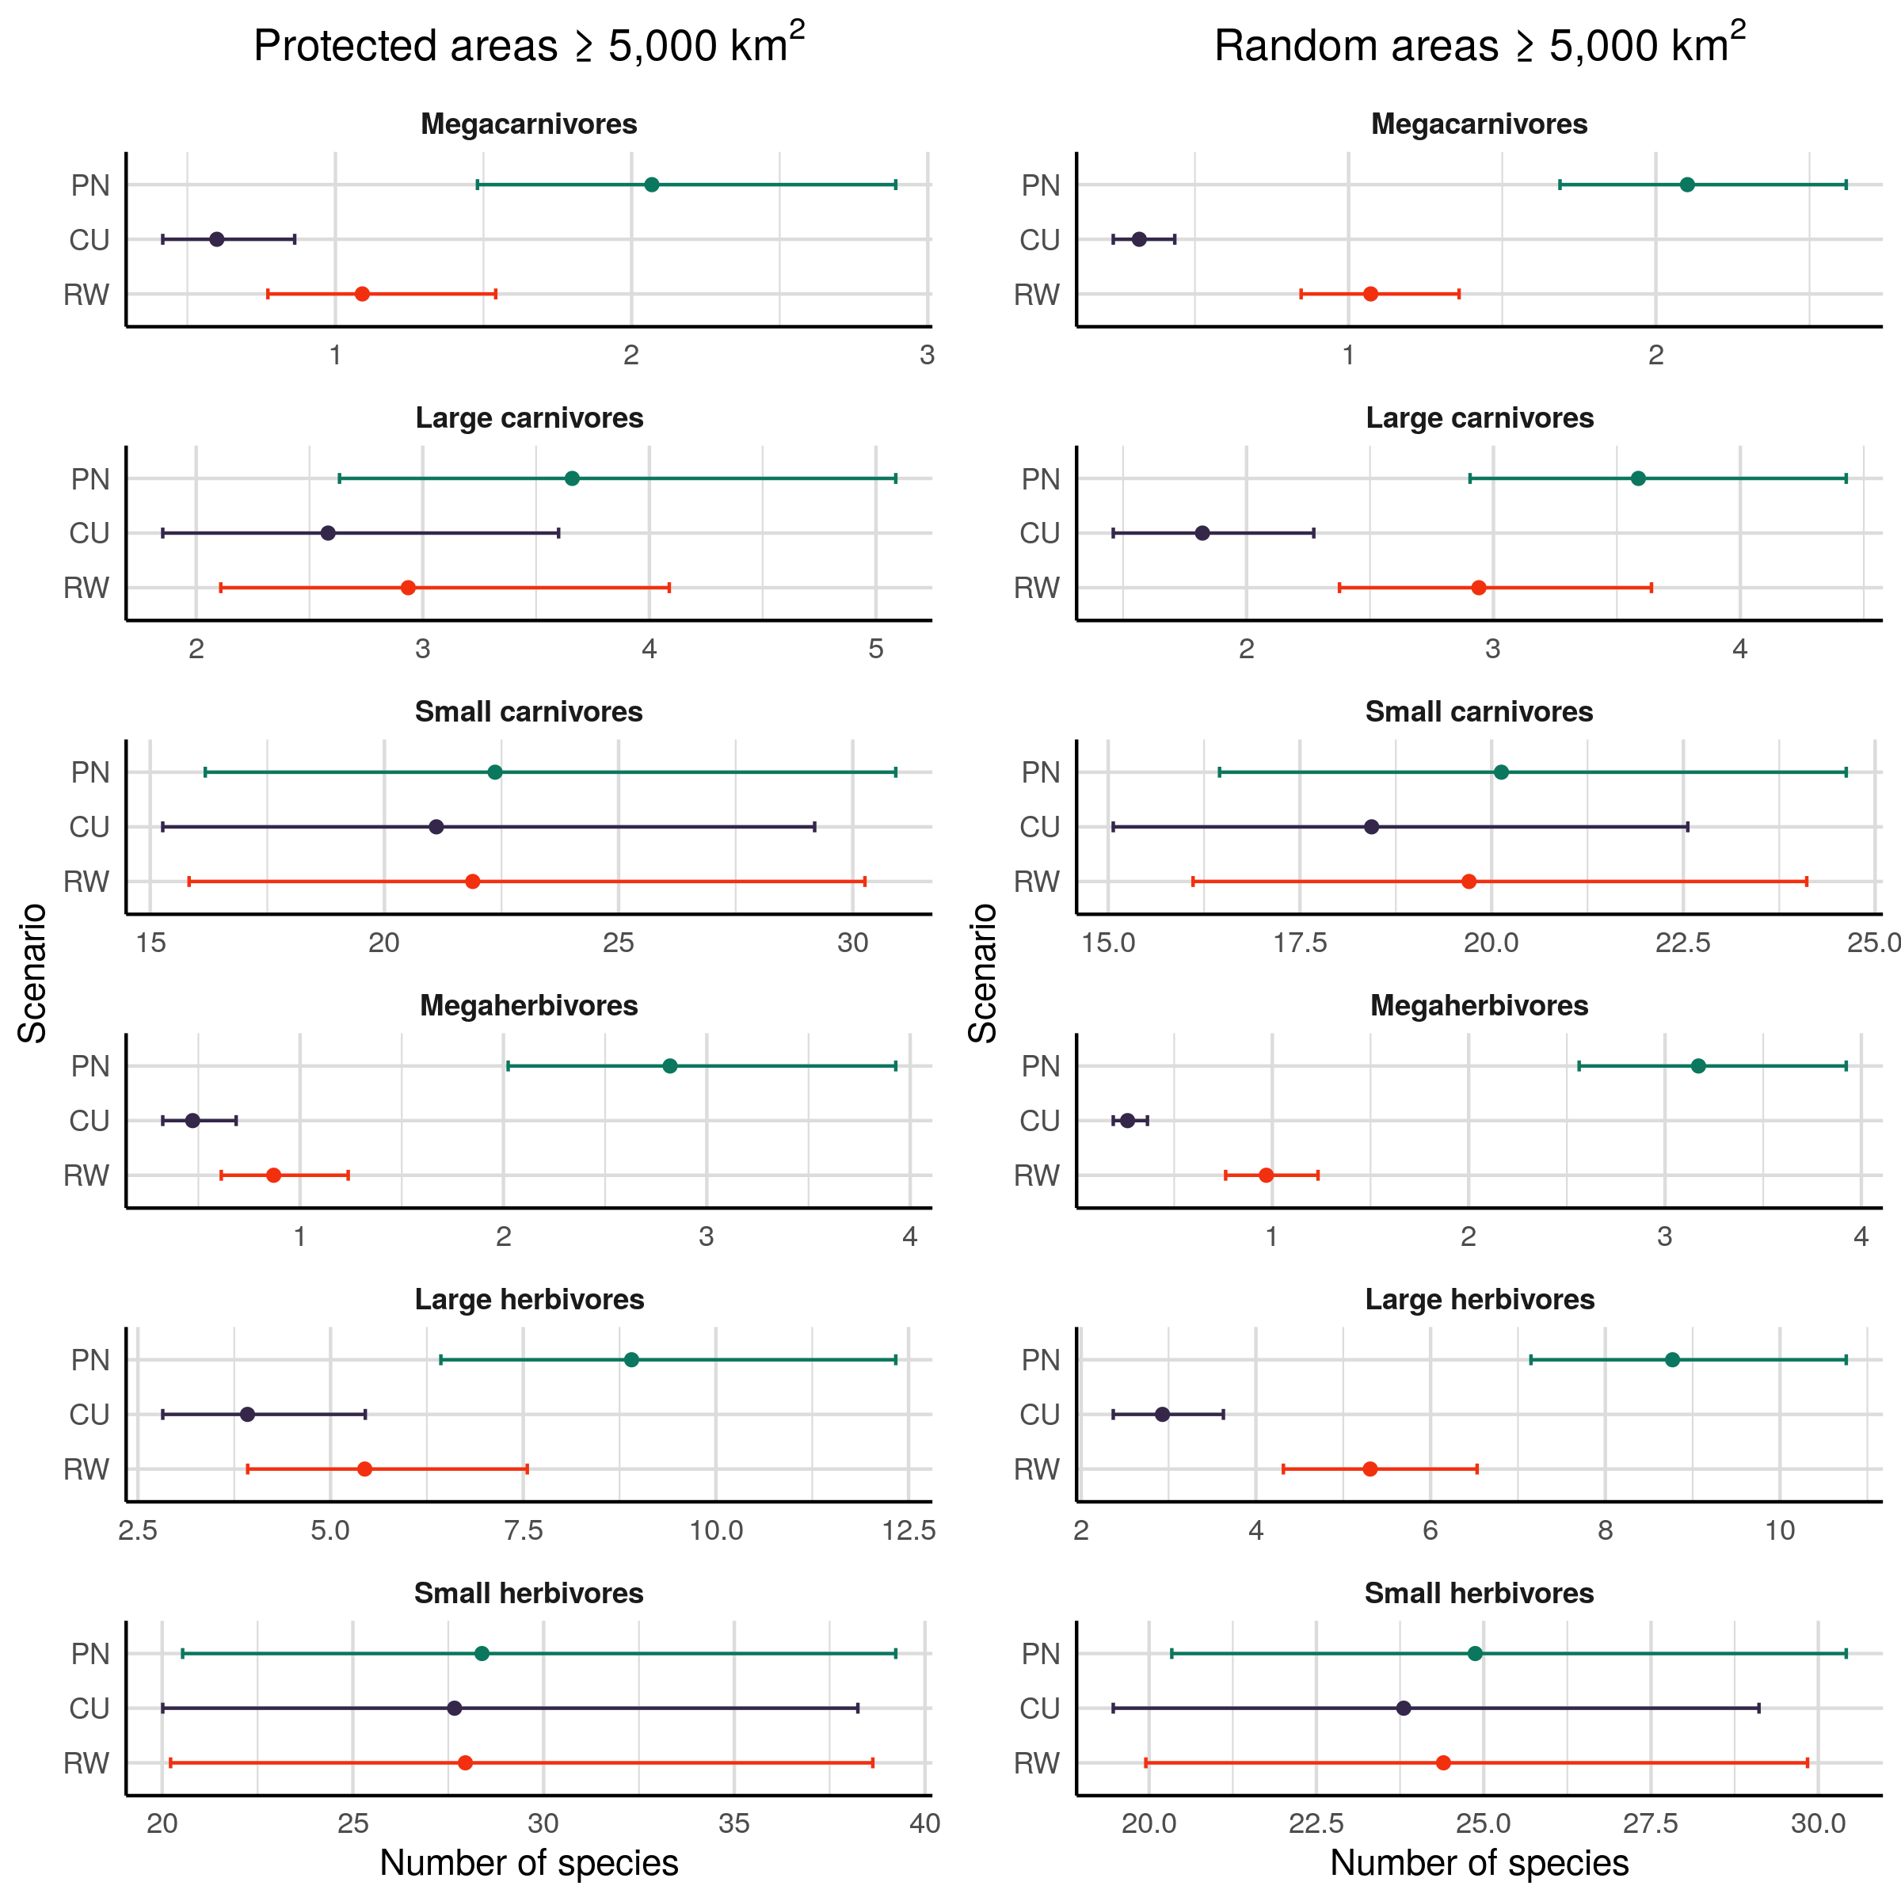

Number of species per trophic level for protected areas 5,000 km^2 (left) and for random areas (right) under the three scenario examined: PN, present-natural; CU, current; RW, rewilding. In all trophic levels except small carnivores (< 21.5 kg) and small herbivores (< 45 kg), human-driven extinctions and extirpations have significantly reduced the number of species. A conservative rewilding approach can partly replenish the species pool through reintroduction and introduction of mammals as ecological replacements for globally extinct species, but the number of species in each trophic level cannot be fully restored to natural levels, as many extinct species do not have today functional analogues that are also phylogenetically closely related. Notably, rewilding has higher restoration potential outside protected areas, where the impact of human pressure on trophic level species richness has been particularly severe. **add figurines; background grids**

The number of interactions among trophic levels decreased between present-natural and current conditions in both protected and counter-factual random areas (Fig. 3). All interactions that involved megacarnivores were severely reduced under current conditions compared to the present-natural, with very large effect sizes (Table 2). Predator-prey interactions maintained by large carnivores also decreased between present-natural and current conditions, with large declines in the number of predator-prey interactions between large herbivores and large carnivores and small reductions in the number of interactions between small mammals and large carnivores. Under the rewilding scenario, the number of interactions between trophic levels that have decreased between present-natural and current conditions increased with small to large effect sizes, with the only exception being for large herbivore-large carnivores interactions.

Rewilding credit did not balance current debt and trophic interactions were not completely restored to present-natural levels. The number of large herbivores-large carnivores interactions and all trophic links involving megacarnivores did not increased to present-natural levels, with medium to large magnitudes of the difference (Table 2). These patterns were qualitatively similar between protected and random areas, with higher extinctions debt and rewilding credit in random areas. Notably, rewilding deficit was comparable between protected and random areas, showing that food webs were rewired with similar relative extents.

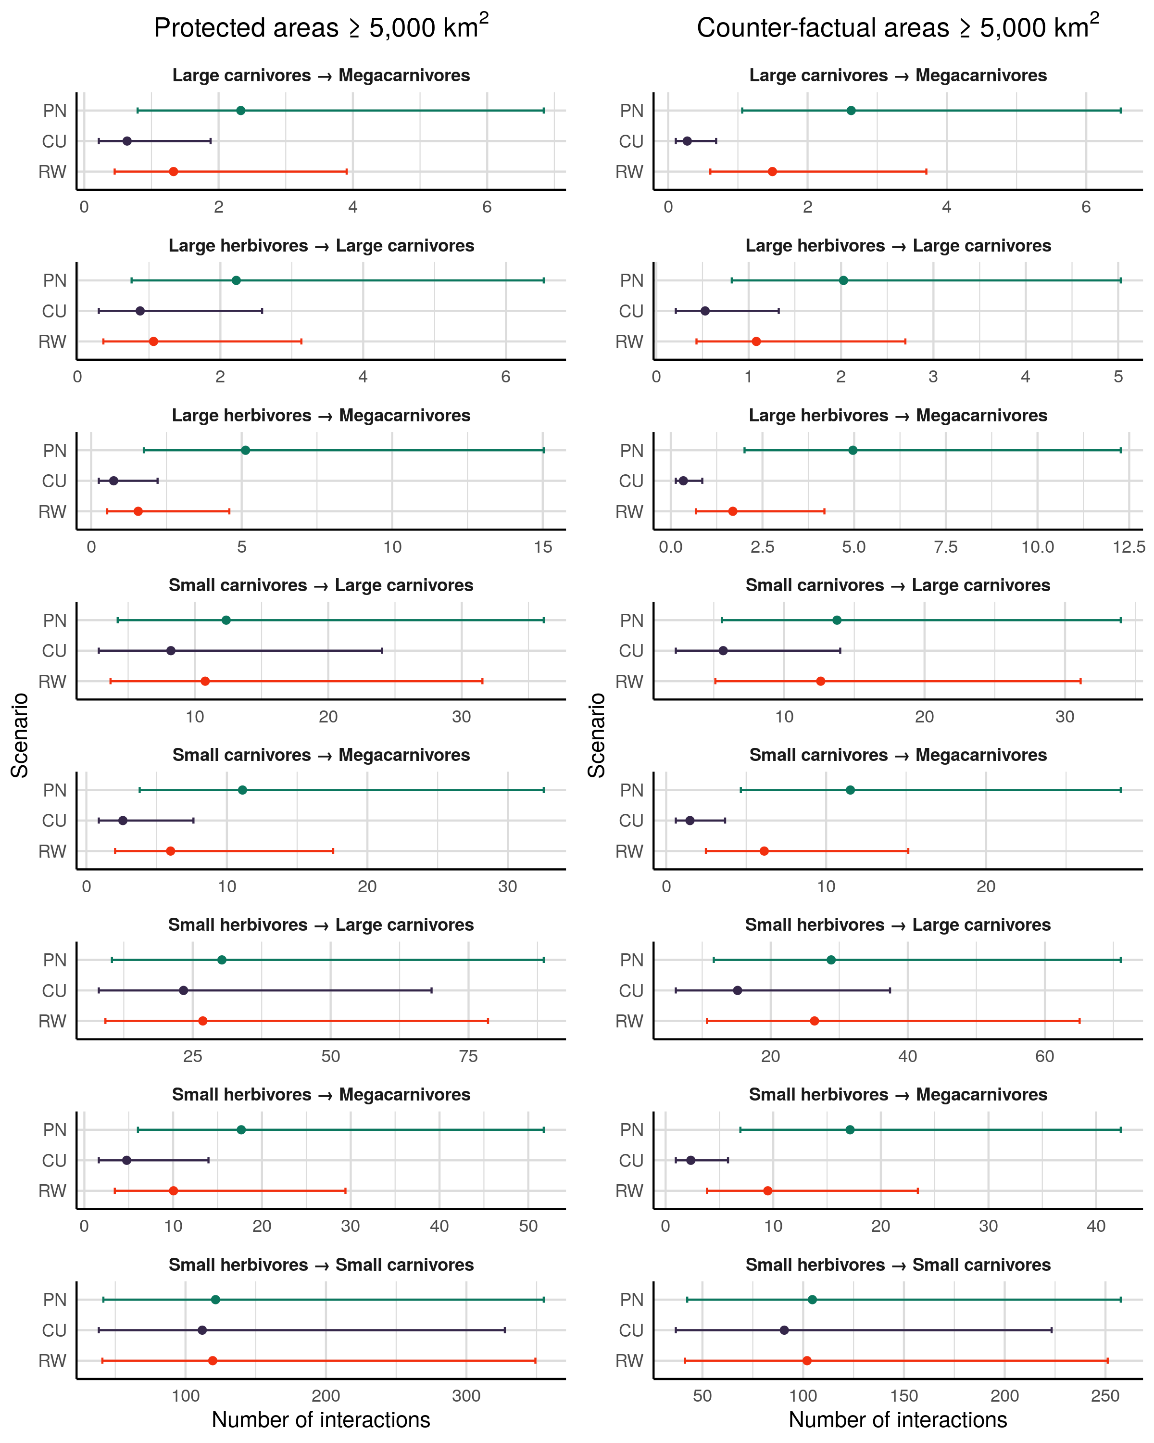

Figure 2. Number of predator-prey interactions across trophic levels under each scenarios for protected areas >=5,000 km^2 (left) and for random areas >=5,000 km^2 (right) under the three scenario examined. PN: present-natural; CU: current; RW: rewilding. Top-down interactions promoted by megacarnivores (>= 100 kg) and large carnivores (>= 21.5 kg) have been largely removed following Late Pleistocene and late-Quaternary extinctions. Trophic rewilding can restore trophic structure by rewiring food webs with lost or functionally analogue predator-prey interactions. However, a full recovery to pre-human conditions cannot be achieved under the conservative rewilding strategy examined.

Table 2: Differences between regression coefficients estimates from generalised linear mixed models for the number of predator-prey interactions between trophic levels among scenarios: PN, present-natural; CU, current; RW, rewilding. The differences were obtained by performing multiple pair-wise contrasts accounting for variation across biogeographic realms and food webs. Superscripts show the p-value of the contrasts adjusted with Bonferroni correction and subscripts show the magnitude of the effect size of the change using Cohen's *d*. Change is: very small (*d* < 0.20), small (*d* = 0.20-0.49), medium (*d* = 0.50-0.79), large (*d* = 0.80-1.20), very large (*d* = 1.20-2.00), and huge (*d* >= 2.00).

| Prey | Predator | Present natural - Current | Current - Rewilding | Present natural - Rewilding |
| --- | --- | --- | --- | --- |
|  |  | **Protected areas** |  |  |
| Large carnivores | Megacarnivores | 1.300.00very large | -0.730.00medium | 0.560.00medium |
| Large herbivores | Megacarnivores | 1.920.00very large | -0.740.00medium | 1.190.00large |
| Small carnivores | Megacarnivores | 1.450.00very large | -0.840.00large | 0.620.00medium |
| Small herbivores | Megacarnivores | 1.310.00very large | -0.740.00medium | 0.570.00medium |
| Large herbivores | Large carnivores | 0.930.00large | -0.190.17very small | 0.740.00medium |
| Small carnivores | Large carnivores | 0.410.00small | -0.270.00small | 0.140.07very small |
| Small herbivores | Large carnivores | 0.260.00small | -0.140.04very small | 0.120.09very small |
| Small herbivores | Small carnivores | 0.080.37very small | -0.060.67very small | 0.021.00very small |
|  |  | **Random areas** |  |  |
| Large carnivores | Megacarnivores | 2.260.00huge | -1.700.00very large | 0.560.00medium |
| Large herbivores | Megacarnivores | 2.670.00huge | -1.600.00very large | 1.080.00large |
| Small carnivores | Megacarnivores | 2.050.00huge | -1.420.00very large | 0.630.00medium |
| Small herbivores | Megacarnivores | 1.990.00very large | -1.400.00very large | 0.590.00medium |
| Large herbivores | Large carnivores | 1.340.00very large | -0.720.00medium | 0.630.00medium |
| Small carnivores | Large carnivores | 0.890.00large | -0.800.00large | 0.090.56very small |
| Small herbivores | Large carnivores | 0.640.00medium | -0.550.00medium | 0.090.51very small |
| Small herbivores | Small carnivores | 0.140.05very small | -0.120.15very small | 0.031.00very small |

# Discussion

During the last 50,000 years, the expansion of modern humans have been associated with species' extinctions and extirpations, especially of large-bodied species (Martin, 1984; F. A. Smith et al., 2018). These extinctions degraded ecological networks by removing predator-prey interactions that controlled ecosystems' trophic structure (Malhi et al., 2016). A recently proposed approach to restore ecosystems and rewire ecological networks is trophic rewilding, the (re)introduction of species to promote biodiverse, self-sustaining ecosystems (Svenning et al., 2016). Empirical studies at local scales suggest rewilding can be an effective strategy for biodiversity conservation and ecosystem restoration, e.g. by maintaining semi-open landscapes and re-establishing lost ecological interactions (Garrido et al., 2019; Genes et al., 2019; Riesch, Tonn, Meißner, Balkenhol, & Isselstein, 2019). However, the potential of rewilding to restore ecological networks to present-natural levels at global scale has not been investigated so far. Here, we took a deep-time large-scale perspective on trophic rewilding and we found that rewilding can rewire food webs globally, but not completely restore trophic complexity under a conservative approach that minimises ecological risks and human-wildlife conflict.

Our findings show that trophic levels of large body-size species were, not surprisingly (Malhi et al., 2016; F. A. Smith et al., 2018), the most affected by human pressure. The number of megacarnivores and megaherbivores significantly reduced due to extinctions, followed by large carnivores and large herbivores that also had significant but relatively smaller decreases in numbers. Trophic interactions maintained by higher trophic levels were consequently lost, degrading ecosystems' top-down control and trophic structure. Importantly, as trophic complexity is necessary for self-sustaining biodiverse ecosystems (Perino et al., 2019), the removal of large-bodied species and the degradation of food webs complexity and community trophic structure likely jeopardises the stability and resilience of ecosystems (Estes et al., 2011).

We found that trophic level richness and interactions debts due to past extinctions can partly be balanced by rewilding credit. The reintroduction of species into their present-natural ranges together with replacement of globally extinct species with functional analogues increased the number of species in affected trophic levels with medium to large effect sizes, showing intermediate to high potential for recovery. Although trophic level richness and complexity of trophic interactions increased with rewilding, these were still lower than the present-natural. Full restoration of food webs to pre-human conditions cannot be achieved under the conservative rewilding scenario examined, with medium to high levels of rewilding deficit. Importantly, as replacement of extinct species was phylogenetically constrained, a rewilding approach that focuses only on functional traits (e.g. mass, diet, and habitat) may restore food webs to present-natural conditions more effectively.

Our results also show that extinction debt and rewilding credit are higher in the large counter-factual areas than in the large protected areas with strict IUCN management (Ia, Ib, and II). Human land-use is concentrated in highly productive areas that potentially host higher biodiversity and species richness (Venter et al., 2018) and the network of protected areas has limited coverage for current mammalian biodiversity hotspots (Daru et al., 2019). Current extinction debt is thus lower in the protected areas than in the counter-factual areas, where human pressure caused larger losses of species and interactions and degraded ecosystems more severely. As more losses happened in the counter-factual areas, rewilding credit and restoration potential are also higher compared to protected areas. Notably though, rewilding deficit is comparable between protected and counter-factual areas, suggesting rewilding can rewire food webs to similar present-natural levels. Taken together, these results highlight the potential of rewilding to restore trophic interactions at global scale.

Here, we assessed the ecological consequences of adopting a conservative rewilding strategy. However, the outcome of such approach depends also on societal and political factors. Rewilding might increase human-wildlife conflicts in many areas, especially outside the network of protected areas, and society will play an important role in rewilding implementation and success (Perino et al., 2019). Rewilding can cause economic losses to local stakeholders via predation on livestock or damages to crops and pastures. People not directly damaged by wildlife can also negatively perceive rewilding projects depending on how they are implemented (Theunissen, 2019). Nevertheless, negative effects of rewilding can be mitigated by the adoption of compensation schemes by governmental agencies (Navarro & Pereira, 2015) and by aligning scientific, managers, and people's conception of nature with rewilding goals (Theunissen, 2019). In addition, identifying benefits and costs of wildlife in a socio-ecological framework can highlight possible actions to remedy unwanted outcomes of rewilding initiatives (Ceauşu, Graves, Killion, Svenning, & Carter, 2019). Importantly, new opportunities for implementing rewilding are occurring at local to regional scales, as recently shown by the return of wildlife in abandoned agricultural areas in Europe (Ceausu et al., 2015; Chapron et al., 2014). Because human intervention at these large scales will likely be unfeasible because of limited funding and resources, trophic rewilding provides an alternative, feasible approach to conserve and restore ecosystems to natural conditions. If and how rewilding is adopted will determine whether trophic complexity is restored or not in ecosystems.

In conclusion, our study shows that trophic complexity has been severely degraded worldwide due to human-driven extinctions and that a conservative rewilding strategy can partly, but not completely, restore trophic structure of ecosystems. To rewire food webs to pre-human conditions, rewilding needs to be taken with a bolder approach than the conservative scenario examined here. For instance, by selecting rewilding replacements based only on species' functional traits rather than phylogenetic relationships can increase the number of extinct species replaced and the restoration potential of rewilding to rewire food webs. Rewilding will probably be a controversial topic for long time and its implementation needs further improvements to secure the long-term restoration goals (Root-Bernstein, Gooden, & Boyes, 2018). This does not mean however that rewilding should be ostracised as a failing or unnecessary restoration strategy, but rather that policy makers, societal agencies, managers, and ecologists need to discuss and improve why and how rewilding is implemented. Overall, our findings show that a conservative rewilding strategy is a good starting point to restore ecosystems' trophic structure, but that rewilding cannot be so conservative and its restrictions need to be relaxed if the long-term goal is to achieve self-sustaining biodiverse ecosystems.

# Acknowledgment

We thank the Carlsberg Foundation for economic support of this work through the Semper Ardens project MegaPast2Future (grant CF16-0005 to JCS). JCS also considers this work a contribution to his VILLUM Investigator project 'Biodiversity Dynamics in a Changing World', funded by VILLUM FONDEN (grant 16549). We also thank members of the MegaPast2Future group for discussion that helped improve the manuscript.

# Data accessibility

All data used was open access. Predator-prey interactions were obtained from the ECOWeB and GLOBI databases (J. E. Cohen, 2010; Poelen et al., 2014), and from two published savanna food webs (Baskerville et al., 2011; Visser et al., 2011). Body mass and current and present-natural ranges were obtained from the PHYLACINE 1.2 database (Faurby et al., 2018). We used climate data from the Worldclim 2.0 database (Fick & Hijmans, 2017), elvenation data from the EarthEnv-DEM90 digital elevation model (Robinson et al., 2014), and the biogeographic realms shapefile from the WWF (Olson & Dinerstein, 2002).

# Author contribution

EB conceived and developed the study, performed analyses, and drafted the manuscript. SJ and JCS conceived and developed the study, interpreted the results, and helped revise the manuscript.

# Competing interests

We have no competing interests.

# References

Alston, J., Maitland, B., Brito, B., Esmaeili, S., Ford, A., Hays, B., … Goheen, J. (2019). Reciprocity in restoration ecology: When might large carnivore reintroduction restore ecosystems? *Biological Conservation*, *234*, 82–89.

Atkins, J. L., Long, R. A., Pansu, J., Daskin, J. H., Potter, A. B., Stalmans, M. E., … Pringle, R. M. (2019). Cascading impacts of large-carnivore extirpation in an african ecosystem. *Science*, eaau3561.

Barnosky, A. D. (2008). Megafauna biomass tradeoff as a driver of quaternary and future extinctions. *Proceedings of the National Academy of Sciences*, *105*(Supplement 1), 11543–11548.

Baskerville, E. B., Dobson, A. P., Bedford, T., Allesina, S., Anderson, T. M., & Pascual, M. (2011). Spatial guilds in the serengeti food web revealed by a bayesian group model. *PLoS Computational Biology*, *7*(12), e1002321.

Beschta, R. L., & Ripple, W. J. (2016). Riparian vegetation recovery in yellowstone: The first two decades after wolf reintroduction. *Biological Conservation*, *198*, 93–103.

Carbone, C., Mace, G. M., Roberts, S. C., & Macdonald, D. W. (1999). Energetic constraints on the diet of terrestrial carnivores. *Nature*, *402*(6759), 286.

Ceausu, S., Hofmann, M., Navarro, L. M., Carver, S., Verburg, P. H., & Pereira, H. M. (2015). Mapping opportunities and challenges for rewilding in europe. *Conservation Biology*, *29*(4), 1017–1027.

Ceauşu, S., Graves, R. A., Killion, A. K., Svenning, J.-C., & Carter, N. H. (2019). Governing trade-offs in ecosystem services and disservices to achieve human–wildlife coexistence. *Conservation Biology*, *33*(3), 543–553.

Ceballos, G., Ehrlich, P. R., Barnosky, A. D., García, A., Pringle, R. M., & Palmer, T. M. (2015). Accelerated modern human–induced species losses: Entering the sixth mass extinction. *Science Advances*, *1*(5), e1400253.

Chapron, G., Kaczensky, P., Linnell, J. D., Arx, M. von, Huber, D., Andrén, H., … others. (2014). Recovery of large carnivores in europe’s modern human-dominated landscapes. *Science*, *346*(6216), 1517–1519.

Chundawat, R. S., Sharma, K., Gogate, N., Malik, P. K., & Vanak, A. T. (2016). Size matters: Scale mismatch between space use patterns of tigers and protected area size in a tropical dry forest. *Biological Conservation*, *197*, 146–153.

Cohen, J. (1988). *Statistical power analysis for the behavioural sciences*. Hillsdale, NJ: erlbaum.

Cohen, J. E. (2010). *ECOWeB 1.1: Ecologists’ cooperative web bank*.

Corporation, M., & Weston, S. (2018). *DoParallel: Foreach parallel adaptor for the ’parallel’ package*. Retrieved from <https://CRAN.R-project.org/package=doParallel>

Daru, B. H., Roux, P. C. le, Gopalraj, J., Park, D. S., Holt, B. G., & Greve, M. (2019). Spatial overlaps between the global protected areas network and terrestrial hotspots of evolutionary diversity. *Global Ecology and Biogeography*, *28*(6), 757–766.

Dirzo, R., Young, H. S., Galetti, M., Ceballos, G., Isaac, N. J., & Collen, B. (2014). Defaunation in the anthropocene. *Science*, *345*(6195), 401–406.

Donlan, J. (2005). Re-wilding north america. *Nature*, *436*(7053), 913.

Eklöf, A., Helmus, M. R., Moore, M., & Allesina, S. (2011). Relevance of evolutionary history for food web structure. *Proceedings of the Royal Society B: Biological Sciences*, *279*(1733), 1588–1596.

Elith, J., & Leathwick, J. R. (2009). Species distribution models: Ecological explanation and prediction across space and time. *Annual Review of Ecology, Evolution, and Systematics*, *40*, 677–697.

Elith, J., Phillips, S. J., Hastie, T., Dudík, M., Chee, Y. E., & Yates, C. J. (2011). A statistical explanation of maxent for ecologists. *Diversity and Distributions*, *17*(1), 43–57.

Estes, J. A., Terborgh, J., Brashares, J. S., Power, M. E., Berger, J., Bond, W. J., … others. (2011). Trophic downgrading of planet earth. *Science*, *333*(6040), 301–306.

Faurby, S., & Svenning, J.-C. (2015). Historic and prehistoric human-driven extinctions have reshaped global mammal diversity patterns. *Diversity and Distributions*, *21*(10), 1155–1166.

Faurby, S., Davis, M., Pedersen, R. Ø., Schowanek, S. D., Antonelli, A., & Svenning, J.-C. (2018). PHYLACINE 1.2: The phylogenetic atlas of mammal macroecology. *Ecology*, *99*(11), 2626–2626. <https://doi.org/10.1002/ecy.2443>

Fick, S. E., & Hijmans, R. J. (2017). WorldClim 2: New 1-km spatial resolution climate surfaces for global land areas. *International Journal of Climatology*, *37*(12), 4302–4315.

Ford, A. T., Goheen, J. R., Otieno, T. O., Bidner, L., Isbell, L. A., Palmer, T. M., … Pringle, R. M. (2014). Large carnivores make savanna tree communities less thorny. *Science*, *346*(6207), 346–349.

Garrido, P., Mårell, A., Öckinger, E., Skarin, A., Jansson, A., & Thulin, C.-G. (2019). Experimental rewilding enhances grassland functional composition and pollinator habitat use. *Journal of Applied Ecology*, *56*(4), 946–955.

Genes, L., Cid, B., Fernandez, F. A., & Pires, A. S. (2017). Credit of ecological interactions: A new conceptual framework to support conservation in a defaunated world. *Ecology and Evolution*, *7*(6), 1892–1897.

Genes, L., Fernandez, F. A., Vaz-de-Mello, F. Z., Rosa, P. da, Fernandez, E., & Pires, A. S. (2019). Effects of howler monkey reintroduction on ecological interactions and processes. *Conservation Biology*, *33*(1), 88–98.

Gill, J. L. (2014). Ecological impacts of the late quaternary megaherbivore extinctions. *New Phytologist*, *201*(4), 1163–1169.

Gravel, D., Poisot, T., Albouy, C., Velez, L., & Mouillot, D. (2013). Inferring food web structure from predator–prey body size relationships. *Methods in Ecology and Evolution*, *4*(11), 1083–1090.

Gray, C., Figueroa, D. H., Hudson, L. N., Ma, A., Perkins, D., & Woodward, G. (2015). Joining the dots: An automated method for constructing food webs from compendia of published interactions. *Food Webs*, *5*, 11–20.

Hayward, M. W., Scanlon, R. J., Callen, A., Howell, L. G., Klop-Toker, K. L., Di Blanco, Y., … others. (2019). Reintroducing rewilding to restoration–Rejecting the search for novelty. *Biological Conservation*, *233*, 255–259.

Hijmans, R. J. (2019). *Raster: Geographic data analysis and modeling*. Retrieved from <https://CRAN.R-project.org/package=raster>

Hijmans, R. J., Phillips, S., Leathwick, J., & Elith, J. (2017). *Dismo: Species distribution modeling*. Retrieved from <https://CRAN.R-project.org/package=dismo>

Hof, C., Voskamp, A., Biber, M. F., Böhning-Gaese, K., Engelhardt, E. K., Niamir, A., … Hickler, T. (2018). Bioenergy cropland expansion may offset positive effects of climate change mitigation for global vertebrate diversity. *Proceedings of the National Academy of Sciences*, *115*(52), 13294–13299.

Hopcraft, J. G. C., Olff, H., & Sinclair, A. (2010). Herbivores, resources and risks: Alternating regulation along primary environmental gradients in savannas. *Trends in Ecology & Evolution*, *25*(2), 119–128.

IUCN. (2016). *The iucn red list of threatened species, version 2016-3*. International Union for Conservation of Nature; Natural Resources Cambridge.

Janzen, D. H., & Martin, P. S. (1982). Neotropical anachronisms: The fruits the gomphotheres ate. *Science*, *215*(4528), 19–27.

Jones, K. R., Venter, O., Fuller, R. A., Allan, J. R., Maxwell, S. L., Negret, P. J., & Watson, J. E. (2018). One-third of global protected land is under intense human pressure. *Science*, *360*(6390), 788–791.

Josh Donlan, C., Berger, J., Bock, C. E., Bock, J. H., Burney, D. A., Estes, J. A., … others. (2006). Pleistocene rewilding: An optimistic agenda for twenty-first century conservation. *The American Naturalist*, *168*(5), 660–681.

Koenker, R. (2019). *Quantreg: Quantile regression*. Retrieved from <https://CRAN.R-project.org/package=quantreg>

Laundré, J. W., Hernández, L., & Ripple, W. J. (2010). The landscape of fear: Ecological implications of being afraid. *Open Ecology Journal*, *3*, 1–7.

Lenth, R. (2019). *Emmeans: Estimated marginal means, aka least-squares means*. Retrieved from <https://CRAN.R-project.org/package=emmeans>

Linnell, J. D., & Strand, O. (2000). Interference interactions, co-existence and conservation of mammalian carnivores. *Diversity and Distributions*, *6*(4), 169–176.

Lundgren, E. J., Ramp, D., Ripple, W. J., & Wallach, A. D. (2018). Introduced megafauna are rewilding the anthropocene. *Ecography*, *41*(6), 857–866.

Lüdecke, D., Makowski, D., & Waggoner, P. (2019). *Performance: Assessment of regression models performance*. Retrieved from <https://CRAN.R-project.org/package=performance>

Makowski, D., & Lüdecke, D. (2019). *Estimate: Estimate effects, contrasts and means*. Retrieved from <https://github.com/easystats/estimate>

Malhi, Y., Doughty, C. E., Galetti, M., Smith, F. A., Svenning, J.-C., & Terborgh, J. W. (2016). Megafauna and ecosystem function from the pleistocene to the anthropocene. *Proceedings of the National Academy of Sciences*, *113*(4), 838–846.

Marjakangas, E.-L., Genes, L., Pires, M. M., Fernandez, F. A., Lima, R. A. de, Oliveira, A. A. de, … Galetti, M. (2018). Estimating interaction credit for trophic rewilding in tropical forests. *Philosophical Transactions of the Royal Society B: Biological Sciences*, *373*(1761), 20170435.

Martin, P. S. (1984). Prehistoric overkill: The global model. *Quaternary Extinctions: A Prehistoric Revolution*, 354–403.

Mendoza, M., & Araújo, M. B. (2019). Climate shapes mammal community trophic structures and humans simplify them. *Nature Communications*, *10*(1), 1–9.

Merow, C., Smith, M. J., & Silander Jr, J. A. (2013). A practical guide to maxent for modeling species’ distributions: What it does, and why inputs and settings matter. *Ecography*, *36*(10), 1058–1069.

Microsoft, & Weston, S. (2017). *Foreach: Provides foreach looping construct for r*. Retrieved from <https://CRAN.R-project.org/package=foreach>

Navarro, L. M., & Pereira, H. M. (2015). Rewilding abandoned landscapes in europe. In *Rewilding european landscapes* (pp. 3–23). Springer, Cham.

Nogués-Bravo, D., Simberloff, D., Rahbek, C., & Sanders, N. J. (2016). Rewilding is the new pandora’s box in conservation. *Current Biology*, *26*(3), R87–R91.

Olson, D. M., & Dinerstein, E. (2002). The global 200: Priority ecoregions for global conservation. *Annals of the Missouri Botanical Garden*, 199–224.

Olson, D. M., Dinerstein, E., Wikramanayake, E. D., Burgess, N. D., Powell, G. V., Underwood, E. C., … others. (2001). Terrestrial ecoregions of the world: A new map of life on eartha new global map of terrestrial ecoregions provides an innovative tool for conserving biodiversity. *BioScience*, *51*(11), 933–938.

Owen-Smith, N., & Mills, M. G. (2008). Predator–prey size relationships in an african large-mammal food web. *Journal of Animal Ecology*, *77*(1), 173–183.

Pebesma, E. (2018). Simple Features for R: Standardized Support for Spatial Vector Data. *The R Journal*, *10*(1), 439–446. <https://doi.org/10.32614/RJ-2018-009>

Perino, A., Pereira, H. M., Navarro, L. M., Fernández, N., Bullock, J. M., Ceaușu, S., … others. (2019). Rewilding complex ecosystems. *Science*, *364*(6438), eaav5570.

Phillips, S. (2017). *Maxnet: Fitting ’maxent’ species distribution models with ’glmnet’*. Retrieved from <https://CRAN.R-project.org/package=maxnet>

Phillips, S. J., Anderson, R. P., Dudík, M., Schapire, R. E., & Blair, M. E. (2017). Opening the black box: An open-source release of maxent. *Ecography*, *40*(7), 887–893.

Pires, M. M. (2017). Rewilding ecological communities and rewiring ecological networks. *Perspectives in Ecology and Conservation*, *15*(4), 257–265.

Pires, M. M., Koch, P. L., Farina, R. A., Aguiar, M. A. de, Reis, S. F. dos, & Guimarães Jr, P. R. (2015). Pleistocene megafaunal interaction networks became more vulnerable after human arrival. *Proceedings of the Royal Society B: Biological Sciences*, *282*(1814), 20151367.

Poelen, J. H., Simons, J. D., & Mungall, C. J. (2014). Global biotic interactions: An open infrastructure to share and analyze species-interaction datasets. *Ecological Informatics*, *24*, 148–159.

Pomeranz, J. P., Thompson, R. M., Poisot, T., & Harding, J. S. (2019). Inferring predator–prey interactions in food webs. *Methods in Ecology and Evolution*, *10*(3), 356–367.

Poo-Muñoz, D. A., Escobar, L. E., Peterson, A. T., Astorga, F., Organ, J. F., & Medina-Vogel, G. (2014). Galictis cuja (mammalia): An update of current knowledge and geographic distribution. *Iheringia. Série Zoologia*, *104*(3), 341–346.

R Core Team. (2018). *R: A language and environment for statistical computing*. Retrieved from <https://www.R-project.org/>

Riesch, F., Tonn, B., Meißner, M., Balkenhol, N., & Isselstein, J. (2019). Grazing by wild red deer: Management options for the conservation of semi-natural open habitats. *Journal of Applied Ecology*.

Ripple, W. J., Estes, J. A., Beschta, R. L., Wilmers, C. C., Ritchie, E. G., Hebblewhite, M., … others. (2014). Status and ecological effects of the world’s largest carnivores. *Science*, *343*(6167), 1241484.

Robinson, N., Regetz, J., & Guralnick, R. P. (2014). EarthEnv-dem90: A nearly-global, void-free, multi-scale smoothed, 90m digital elevation model from fused aster and srtm data. *ISPRS Journal of Photogrammetry and Remote Sensing*, *87*, 57–67.

Root-Bernstein, M., Gooden, J., & Boyes, A. (2018). Rewilding in practice: Projects and policy. *Geoforum*, *97*, 292–304.

Runge, C. A., Watson, J. E., Butchart, S. H., Hanson, J. O., Possingham, H. P., & Fuller, R. A. (2015). Protected areas and global conservation of migratory birds. *Science*, *350*(6265), 1255–1258.

Sandom, C., Faurby, S., Sandel, B., & Svenning, J.-C. (2014). Global late quaternary megafauna extinctions linked to humans, not climate change. *Proceedings of the Royal Society B: Biological Sciences*, *281*(1787), 20133254.

Sawilowsky, S. S. (2009). New effect size rules of thumb. *Journal of Modern Applied Statistical Methods*, *8*(2), 597–599.

Segura, A. M., Farina, R. A., & Arim, M. (2016). Exceptional body sizes but typical trophic structure in a pleistocene food web. *Biology Letters*, *12*(5), 20160228.

Smith, F. A., Smith, R. E. E., Lyons, S. K., & Payne, J. L. (2018). Body size downgrading of mammals over the late quaternary. *Science*, *360*(6386), 310–313.

Svenning, J.-C., Pedersen, P. B., Donlan, C. J., Ejrnæs, R., Faurby, S., Galetti, M., … others. (2016). Science for a wilder anthropocene: Synthesis and future directions for trophic rewilding research. *Proceedings of the National Academy of Sciences*, *113*(4), 898–906.

Tanentzap, A. J., & Smith, B. R. (2018). Unintentional rewilding: Lessons for trophic rewilding from other forms of species introductions. *Philosophical Transactions of the Royal Society B: Biological Sciences*, *373*(1761), 20170445.

Theunissen, B. (2019). The oostvaardersplassen fiasco. *Isis*, *110*(2), 341–345.

UNEP-WCMC, & IUCN. (2019). *Protected planet: The world database on protected areas (wdpa)*. Retrieved from www.protectedplanet.net

Valiente-Banuet, A., Aizen, M. A., Alcántara, J. M., Arroyo, J., Cocucci, A., Galetti, M., … others. (2015). Beyond species loss: The extinction of ecological interactions in a changing world. *Functional Ecology*, *29*(3), 299–307.

Venter, O., Magrach, A., Outram, N., Klein, C. J., Possingham, H. P., Di Marco, M., & Watson, J. E. (2018). Bias in protected-area location and its effects on long-term aspirations of biodiversity conventions. *Conservation Biology*, *32*(1), 127–134.

Visser, S. N. de, Freymann, B. P., & Olff, H. (2011). The serengeti food web: Empirical quantification and analysis of topological changes under increasing human impact. *Journal of Animal Ecology*, *80*(2), 484–494.

Wickham, H. (2016). *Ggplot2: Elegant graphics for data analysis*. Retrieved from [https://ggplot2.tidyverse.org](https://ggplot2.tidyverse.org/)

Wickham, H. (2017). The tidyverse. *R Package Ver. 1.1. 1*.

Williams, R. J., & Martinez, N. D. (2000). Simple rules yield complex food webs. *Nature*, *404*(6774), 180.

Woodroffe, R., & Ginsberg, J. R. (1998). Edge effects and the extinction of populations inside protected areas. *Science*, *280*(5372), 2126–2128.

Yeakel, J. D., Pires, M. M., Rudolf, L., Dominy, N. J., Koch, P. L., Guimarães, P. R., & Gross, T. (2014). Collapse of an ecological network in ancient egypt. *Proceedings of the National Academy of Sciences*, *111*(40), 14472–14477.

Zhang, J., Qian, H., Girardello, M., Pellissier, V., Nielsen, S. E., & Svenning, J.-C. (2018). Trophic interactions among vertebrate guilds and plants shape global patterns in species diversity. *Proceedings of the Royal Society B: Biological Sciences*, *285*(1883), 20180949.

Zuur, A., Ieno, E. N., Walker, N., Saveliev, A. A., & Smith, G. M. (2009). *Mixed effects models and extensions in ecology with r*. Springer Science & Business Media.