Appendix for *Rewiring food webs via trophic rewilding*

Emilio Berti $\begin{aligned}1,2,∗ \\ {}^{}\end{aligned}$, Scott Jarvie ${}^{1,2}$, and Jens-Christian Svenning ${}^{1,2}$

${}^{1}$ Section for Ecoinformatics and Biodiversity, Department of Bioscience, Aarhus University, Ny Munkegade 114, DK-8000 Aarhus C, Denmark. ${}^{2}$\ Center for Biodiversity Dynamics in a Changing World (BIOCHANGE), Department of Bioscience, Aarhus University, Ny Munkegade 114, DK-8000 Aarhus C, Denmark.\ corresponding author: emilio.berti@bios.au.dk

Keywords: defaunation, human-driven extinctions, food webs, rewilding, mammals, trophic interactions.

# Supporting information

## Changes to the PHYLACINE database

We modified the body mass of two extinct species in the PHYLACINE database before modelling and analyses: body mass of the extinct species *Sinomegaceros ordosianus* was set equal to the mass of *Sinomegaceros yabei* and body mass of the extinct *Dusicyon australis* to *Dusicyon avus*.

## Maxent species distribution models (SDMs)

Climatic suitability of terrestrial mammals was modelled using maximum entropy (Maxent) models using the *maxnet* R-package based on inhomogeneous Poisson processes (Phillips, Anderson, Dudík, Schapire, & Blair, 2017). Maxent is a presence-background approach, in which environments occupied by a species are contrasted with the available environmental space (Elith et al., 2011; Merow, Smith, & Silander Jr, 2013). We ran Maxent with the default settings of Maxent, besides disabling threshold features to avoid locally overfitted response curves (Merow et al., 2013, 2014). We used 100,000 randomly sampled background records – cf. 10,000 that is commonly used – to ensure greater representation of environmental variables available within background areas (Guevara, Gerstner, Kass, & Anderson, 2018). Background buffers were obtained for each species combining current and present-natural ranges and calculating the maximum distance between edge and centroid of the largest continuous range, ensuring buffer sizes reflected capabilities of the individuals species (Hof et al., 2018; Poo-Muñoz et al., 2014). An example is shown in figure S#. We only modelled species that had at least 10 presence locations, thus excluding 76 rare species with restricted geographic distribution. In total, we modeled 4,130 of the 4,206 living terrestrial mammals.

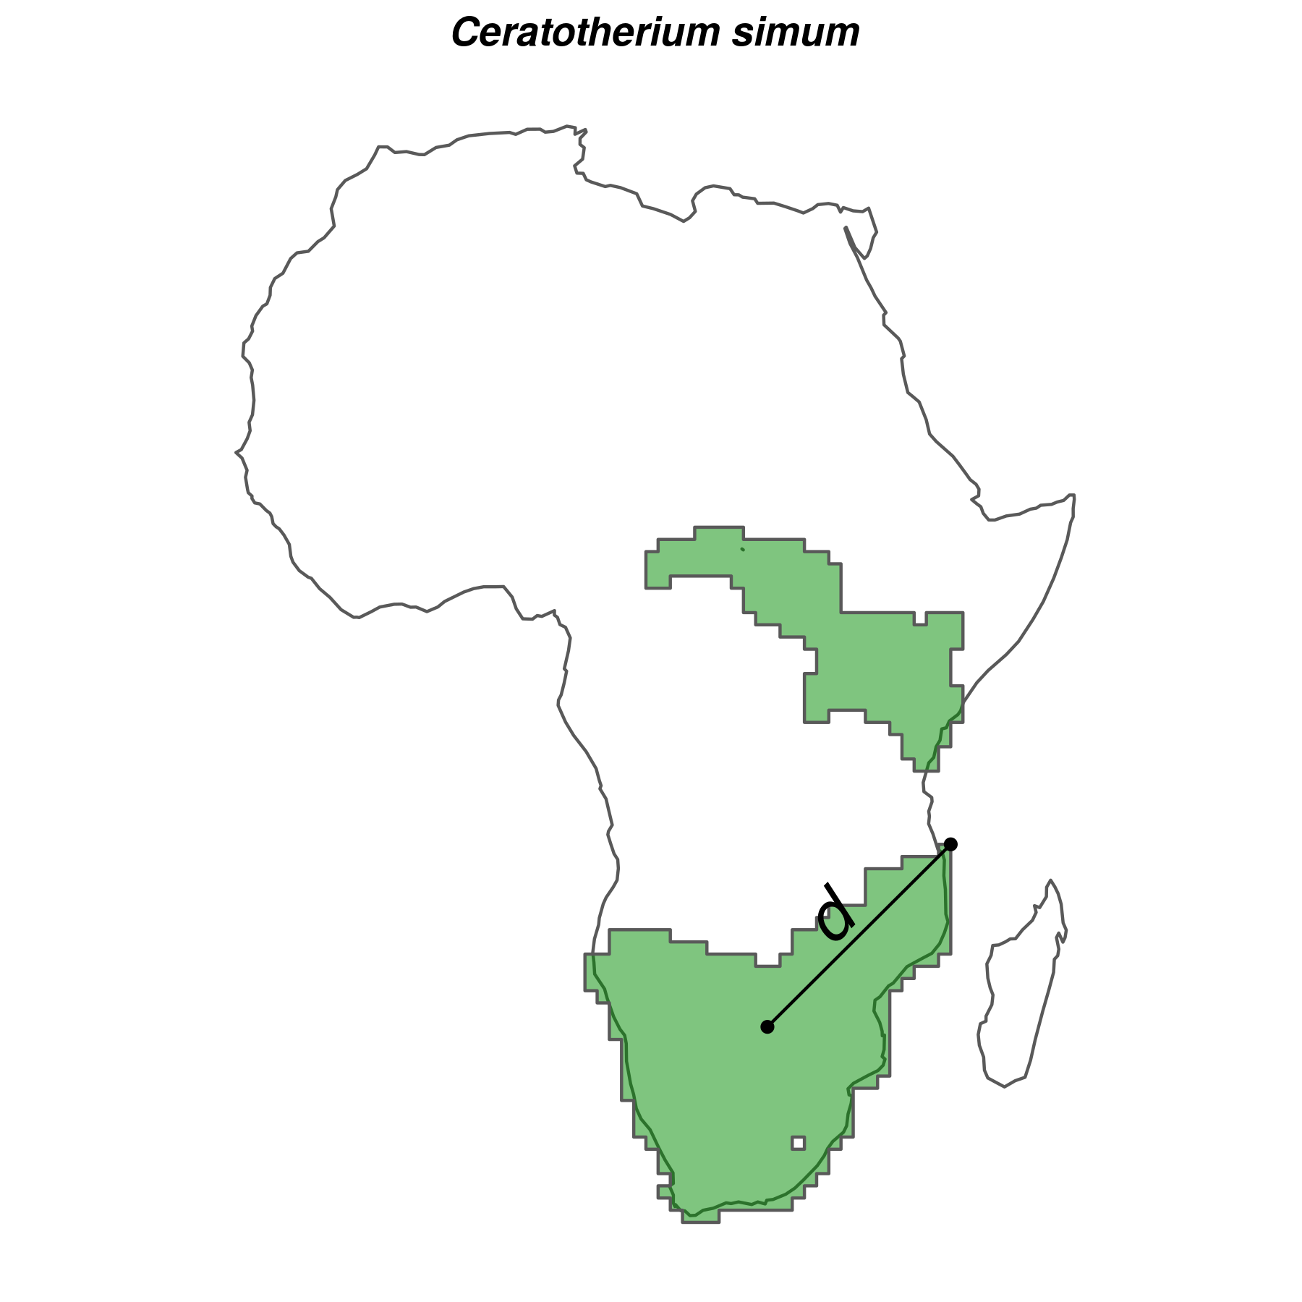

Figure S1: Example of how buffer sizes were calculated for the white rhyno (*Ceratotherium simum*). The buffer size was calculated as the maximum distance *d* (black line) between centroid and edge (black points) of the largest continuous range of the species (green). We estimated *d* following the same procedure for each species, resulting in species-specific buffer sizes that reflected the different dispersal capabilities of species.

We assessed the predictive performance of Maxent models through five-fold cross validation: we calculated the average continuous Boyce index (CBI; Hirzel, Le Lay, Helfer, Randin, & Guisan (2006)), which indicates how much models discriminate against random expectation, and the average Area Under the Receiver Operating Curve (AUC; Swets (1988)), which indicates how well models differentiate between presences and pseudo-absences regardless of the degree of difference between them. Model fit was inspected by the average omission rate based on the minimum training presence value (ORMTP). CBI values range between -1 and 1, where values > 0 indicate the model's output is positively correlated with the true probability of presence and values < 0 indicate it is negatively correlated with the true probability of presence; AUC values range from <= 0.5 for models with discrimination no better than random to 1 for models with perfect discrimination between occupied and unoccupied places (Fielding & Bell, 1997); and ORMTP values range from 0 for models that are not overfit to 1 for models that are overfit. To convert continuous suitability predictions to binary layers indicating suitable/unsuitable habitat, we used as threshold the suitability value that maximised sensitivity and specificity (MSS) as suggested by Liu, Newell, & White (2016). We further assessed the performance of Maxent models by comparing projections of climatic suitability with 136 introduced range maps from Lundgren, Ramp, Ripple, & Wallach (2018) (n = 22 species) and IUCN (IUCN (2016); n = 114 species). Introduced range maps were selected from Lundgren et al. (2018) over the IUCN (IUCN, 2016) for three species found in both datasets (*Cervus elaphus*, *Ovibos moschatus*, and *Rangifer tarandus*).

Evaluation statistics indicated in general very high to excellent quality of Maxent models. CBI index and AUC were on average very high (Table S#) and ORMTP was in low, indicating that models were in general not overfitted. Importantly, species chosen as rewilding replacement in downstream analyses had in general very high to excellent predictive performance: high CBI and AUC, and low ORMTP (Table S#). Also, much of the species' known introduction ranges were captured by Maxent models (Fig. S#): the median of the predicted introduction range was 0.84, with a median absolute deviation equal to 0.23.

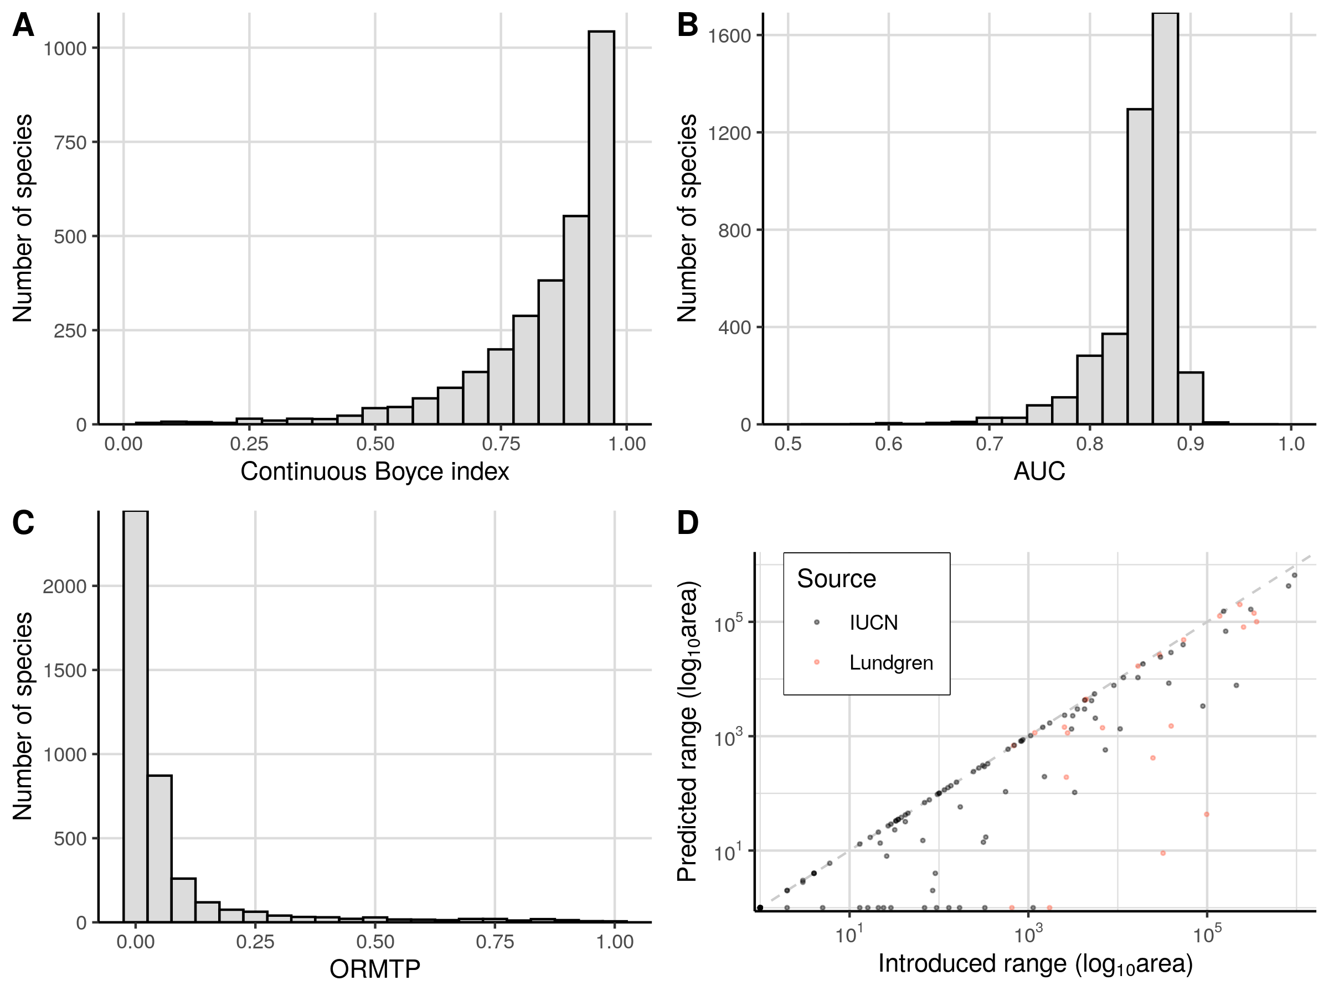

Figure S2: Evaluation statistics of Maxent species distribution models (SDMs). Continuous Boyce index (A) and the area under the receiving operating curve (AUC, B) were in general very good to excellent, showing SDMs had high performance on discriminating climatic suitable habitats from unsuitable ones. Omission rate of minimum training points (ORMTP, C) was generally low, indicating that models were not overfitting. SDMs predicted most of the ranges of introduced species not used for model calibration (D). Introduction area was obtained from the IUCN current introduction ranges (IUCN, 2016) and the ranges described in Lundgren et al. (2018), both of which were not included in the PHYLACINE present-natural and current ranges (Faurby et al., 2018).

## Supplementary figures and tables

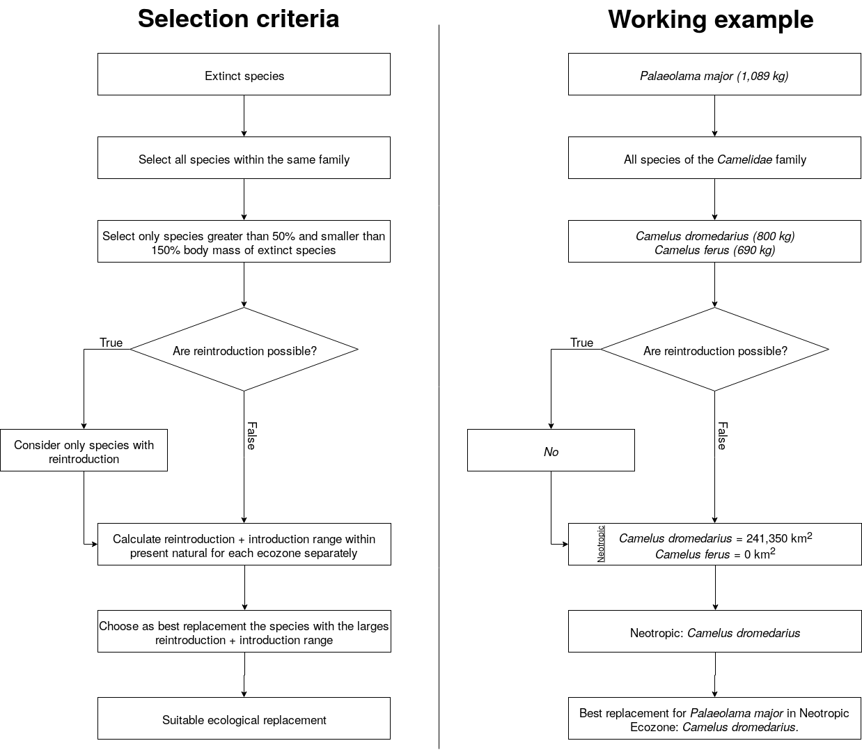

Figure S3: Diagram of selection criteria. Left, conceptual flowchart of the selection criteria used. Right, selection example of rewilding candidate for the extinct species Paleolama major.

Table S1: List of extinct species and their best functional analogue replacements for each biogeographic realm. We found a suitable replacement for 127 of the 334 extinct species during the Late Pleistocene. In total, 94 extant mammals were selected as best ecological replacements.

|  |  |  |
| --- | --- | --- |
| Extinct | Replacement | Biogeographic realm |
| Vombatus hacketti | Lasiorhinus latifrons | Australasia |
| Arctodus simus | Ursus arctos | Neartic |
| Arctodus simus | Ursus arctos | Neotropic |
| Arctotherium wingei | Ursus americanus | Neotropic |
| Tremarctos floridanus | Ursus americanus | Neartic |
| Tremarctos floridanus | Ursus americanus | Neotropic |
| Ursus spelaeus | Ursus arctos | Paleartic |
| Catagonus stenocephalus | Pecari tajacu | Neotropic |
| Muknalia minima | Pecari tajacu | Neartic |
| Muknalia minima | Pecari tajacu | Neotropic |
| Tapirus augustus | Tapirus indicus | Indomalaya |
| Tapirus augustus | Tapirus indicus | Paleartic |
| Tapirus merriami | Tapirus bairdii | Neartic |
| Tapirus rondoniensis | Tapirus terrestris | Neotropic |
| Tapirus veroensis | Tapirus bairdii | Neartic |
| Tapirus veroensis | Tapirus bairdii | Neotropic |
| Kolpochoerus majus | Hylochoerus meinertzhageni | Afrotropic |
| Metridiochoerus compactus | Phacochoerus africanus | Afrotropic |
| Sus bucculentus | Sus scrofa | Indomalaya |
| Stegodon orientalis | Elephas maximus | Indomalaya |
| Stegodon orientalis | Elephas maximus | Paleartic |
| Stegodon trigonocephalus | Elephas maximus | Indomalaya |
| Elasmotherium sibiricum | Ceratotherium simum | Paleartic |
| Stephanorhinus kirchbergensis | Ceratotherium simum | Indomalaya |
| Stephanorhinus kirchbergensis | Ceratotherium simum | Paleartic |
| Petauroides ayamaruensis | Pseudochirulus canescens | Australasia |
| Petauroides ayamaruensis | Pseudochirulus schlegeli | Australasia |
| Bettongia anhydra | Bettongia lesueur | Australasia |
| Bettongia pusilla | Bettongia lesueur | Australasia |
| Bettongia pusilla | Bettongia penicillata | Australasia |
| Potorous platyops | Potorous gilbertii | Australasia |
| Perameles eremiana | Perameles bougainville | Australasia |
| Ochotona whartoni | Ochotona alpina | Neartic |
| Neovison macrodon | Neovison vison | Neartic |
| Conilurus albipes | Conilurus penicillatus | Australasia |
| Conilurus capricornensis | Conilurus penicillatus | Australasia |
| Notomys amplus | Notomys mitchellii | Australasia |
| Notomys longicaudatus | Notomys mitchellii | Australasia |
| Notomys macrotis | Notomys mitchellii | Australasia |
| Notomys mordax | Notomys alexis | Australasia |
| Notomys mordax | Notomys aquilo | Australasia |
| Notomys mordax | Notomys fuscus | Australasia |
| Notomys robustus | Notomys fuscus | Australasia |
| Pseudomys glaucus | Pseudomys novaehollandiae | Australasia |
| Pseudomys gouldii | Pseudomys desertor | Australasia |
| Brachyprotoma obtusata | Conepatus leuconotus | Neartic |
| Manis paleojavanica | Smutsia gigantea | Indomalaya |
| Mammut americanum | Loxodonta africana | Neartic |
| Mammut americanum | Loxodonta africana | Neotropic |
| Lagorchestes asomatus | Lagorchestes hirsutus | Australasia |
| Macropus greyi | Thylogale billardierii | Australasia |
| Metasthenurus newtonae | Macropus rufus | Australasia |
| Onychogalea lunata | Petrogale lateralis | Australasia |
| Procoptodon browneorum | Macropus giganteus | Australasia |
| Procoptodon gilli | Macropus rufus | Australasia |
| Protemnodon hopei | Macropus antilopinus | Australasia |
| Protemnodon hopei | Macropus giganteus | Australasia |
| Protemnodon hopei | Macropus rufus | Australasia |
| Protemnodon nombe | Macropus giganteus | Australasia |
| Protemnodon tumbuna | Macropus giganteus | Australasia |
| Simosthenurus maddocki | Macropus giganteus | Australasia |
| Sthenurus andersoni | Macropus rufus | Australasia |
| Thylogale christenseni | Dorcopsulus vanheurni | Australasia |
| Troposodon minor | Macropus giganteus | Australasia |
| Wallabia kitcheneri | Macropus fuliginosus | Australasia |
| Aztlanolagus agilis | Lepus californicus | Neartic |
| Aztlanolagus agilis | Lepus californicus | Neotropic |
| Aztlanolagus agilis | Sylvilagus floridanus | Neotropic |
| Hystrix kiangsenensis | Hystrix brachyura | Indomalaya |
| Hystrix kiangsenensis | Hystrix brachyura | Paleartic |
| Hystrix refossa | Hystrix indica | Indomalaya |
| Hystrix refossa | Hystrix indica | Paleartic |
| Hexaprotodon sivalensis | Choeropsis liberiensis | Indomalaya |
| Cuvieronius hyodon | Elephas maximus | Neartic |
| Cuvieronius hyodon | Loxodonta africana | Neotropic |
| Notiomastodon platensis | Elephas maximus | Neotropic |
| Homotherium latidens | Panthera tigris | Paleartic |
| Homotherium serum | Panthera onca | Neartic |
| Homotherium serum | Panthera onca | Neotropic |
| Leopardus amnicola | Catopuma badia | Neartic |
| Leopardus amnicola | Leopardus wiedii | Neotropic |
| Miracinonyx trumani | Puma concolor | Neartic |
| Panthera atrox | Panthera tigris | Neartic |
| Panthera atrox | Panthera leo | Neotropic |
| Panthera spelaea | Panthera tigris | Neartic |
| Panthera spelaea | Panthera tigris | Paleartic |
| Smilodon fatalis | Panthera tigris | Neartic |
| Smilodon fatalis | Panthera leo | Neotropic |
| Smilodon populator | Panthera leo | Neartic |
| Smilodon populator | Panthera tigris | Neotropic |
| Equus francisci | Equus ferus | Neartic |
| Equus francisci | Equus ferus | Neotropic |
| Equus hydruntinus | Equus ferus | Paleartic |
| Equus ovodovi | Equus ferus | Paleartic |
| Hippidion devillei | Equus ferus | Neotropic |
| Hippidion principale | Equus quagga | Neotropic |
| Elephas iolensis | Loxodonta africana | Afrotropic |
| Elephas iolensis | Loxodonta africana | Paleartic |
| Elephas namadicus | Elephas maximus | Indomalaya |
| Elephas namadicus | Elephas maximus | Paleartic |
| Elephas naumanii | Elephas maximus | Indomalaya |
| Elephas naumanii | Elephas maximus | Paleartic |
| Mammuthus columbi | Elephas maximus | Neartic |
| Mammuthus columbi | Elephas maximus | Neotropic |
| Mammuthus primigenius | Elephas maximus | Indomalaya |
| Mammuthus primigenius | Elephas maximus | Neartic |
| Mammuthus primigenius | Elephas maximus | Paleartic |
| Cryptonanus ignitus | Thylamys venustus | Neotropic |
| Dasypus bellus | Dasypus kappleri | Neartic |
| Dasypus bellus | Dasypus kappleri | Neotropic |
| Lagostomus crassus | Lagostomus maximus | Neotropic |
| Agalmaceros blicki | Odocoileus virginianus | Neotropic |
| Cervalces scotti | Alces alces | Neartic |
| Haploidoceros mediterraneus | Cervus elaphus | Paleartic |
| Megaloceros giganteus | Alces alces | Paleartic |
| Morenelaphus brachyceros | Ozotoceros bezoarticus | Neotropic |
| Navahoceros fricki | Odocoileus virginianus | Neartic |
| Navahoceros fricki | Odocoileus virginianus | Neotropic |
| Paraceros fragilis | Ozotoceros bezoarticus | Neotropic |
| Rucervus schomburgki | Rucervus eldii | Indomalaya |
| Sangamona fugitiva | Cervus canadensis | Neartic |
| Sinomegaceros ordosianus | Alces alces | Paleartic |
| Sinomegaceros yabei | Alces alces | Indomalaya |
| Sinomegaceros yabei | Alces alces | Paleartic |
| Neochoerus aesopi | Hydrochoerus hydrochaeris | Neartic |
| Neochoerus aesopi | Hydrochoerus hydrochaeris | Neotropic |
| Canis dirus | Canis lupus | Neartic |
| Canis dirus | Canis lupus | Neotropic |
| Dusicyon avus | Lycalopex griseus | Neotropic |
| Protocyon troglodytes | Chrysocyon brachyurus | Neotropic |
| Theriodictis tarijensis | Chrysocyon brachyurus | Neotropic |
| Camelops hesternus | Camelus ferus | Neartic |
| Camelops hesternus | Camelus dromedarius | Neotropic |
| Hemiauchenia macrocephala | Lama guanicoe | Neartic |
| Hemiauchenia macrocephala | Lama guanicoe | Neotropic |
| Hemiauchenia paradoxa | Camelus dromedarius | Neotropic |
| Palaeolama major | Camelus dromedarius | Neotropic |
| Palaeolama mirifica | Lama guanicoe | Neartic |
| Palaeolama mirifica | Lama guanicoe | Neotropic |
| Palaeolama mirifica | Vicugna vicugna | Neotropic |
| Palaeolama weddeli | Camelus dromedarius | Neotropic |
| Antidorcas australis | Pelea capreolus | Afrotropic |
| Antidorcas bondi | Sylvicapra grimmia | Afrotropic |
| Bootherium bombifrons | Connochaetes taurinus | Neartic |
| Bubalus palaeokerabau | Bos javanicus | Indomalaya |
| CapriniGen spA | Tragelaphus scriptus | Afrotropic |
| Damaliscus hypsodon | Tragelaphus scriptus | Afrotropic |
| Damaliscus niro | Alcelaphus buselaphus | Afrotropic |
| Euceratherium collinum | Bison bison | Neartic |
| Euceratherium collinum | Bison bison | Neotropic |
| Gazella atlantica | Ammotragus lervia | Paleartic |
| Gazella bilkis | Capricornis crispus | Afrotropic |
| Gazella bilkis | Naemorhedus caudatus | Afrotropic |
| Gazella bilkis | Procapra gutturosa | Afrotropic |
| Gazella bilkis | Procapra przewalskii | Afrotropic |
| Gazella bilkis | Eudorcas albonotata | Paleartic |
| Gazella saudiya | Gazella gazella | Afrotropic |
| Gazella saudiya | Gazella gazella | Paleartic |
| Gazella tingitana | Gazella cuvieri | Paleartic |
| Hemitragus cedrensis | Capra pyrenaica | Paleartic |
| Hippotragus leucophaeus | Alcelaphus buselaphus | Afrotropic |
| Hippotragus leucophaeus | Damaliscus pygargus | Afrotropic |
| Megalotragus priscus | Alcelaphus buselaphus | Afrotropic |
| Megalovis guangxiensis | Pseudois nayaur | Indomalaya |
| Megalovis guangxiensis | Pseudois nayaur | Paleartic |
| Oreamnos harringtoni | Ovis canadensis | Neartic |
| Oreamnos harringtoni | Ovis canadensis | Neotropic |
| Pelorovis antiquus | Bos primigenius | Paleartic |
| Rusingoryx atopocranion | Kobus ellipsiprymnus | Afrotropic |
| Sivacobus sankaliai | Capricornis thar | Indomalaya |
| Sivacobus sankaliai | Capricornis thar | Paleartic |
| Soergelia minor | Capra sibirica | Paleartic |
| Spirocerus kiakhtensis | Bos primigenius | Paleartic |
| Caipora bambuiorum | Brachyteles arachnoides | Neotropic |
| Protopithecus brasiliensis | Brachyteles arachnoides | Neotropic |
| Stockoceros conklingi | Antilocapra americana | Neartic |
| Stockoceros conklingi | Antilocapra americana | Neotropic |
| Tetrameryx shuleri | Antilocapra americana | Neartic |
| Tetrameryx shuleri | Antilocapra americana | Neotropic |

# References

Elith, J., Phillips, S. J., Hastie, T., Dudík, M., Chee, Y. E., & Yates, C. J. (2011). A statistical explanation of maxent for ecologists. *Diversity and Distributions*, *17*(1), 43–57.

Faurby, S., Davis, M., Pedersen, R. Ø., Schowanek, S. D., Antonelli, A., & Svenning, J.-C. (2018). PHYLACINE 1.2: The phylogenetic atlas of mammal macroecology. *Ecology*, *99*(11), 2626–2626. <https://doi.org/10.1002/ecy.2443>

Fielding, A. H., & Bell, J. F. (1997). A review of methods for the assessment of prediction errors in conservation presence/absence models. *Environmental Conservation*, *24*(1), 38–49.

Guevara, L., Gerstner, B. E., Kass, J. M., & Anderson, R. P. (2018). Toward ecologically realistic predictions of species distributions: A cross-time example from tropical montane cloud forests. *Global Change Biology*, *24*(4), 1511–1522.

Hirzel, A. H., Le Lay, G., Helfer, V., Randin, C., & Guisan, A. (2006). Evaluating the ability of habitat suitability models to predict species presences. *Ecological Modelling*, *199*(2), 142–152.

Hof, C., Voskamp, A., Biber, M. F., Böhning-Gaese, K., Engelhardt, E. K., Niamir, A., … Hickler, T. (2018). Bioenergy cropland expansion may offset positive effects of climate change mitigation for global vertebrate diversity. *Proceedings of the National Academy of Sciences*, *115*(52), 13294–13299.

IUCN. (2016). *The iucn red list of threatened species, version 2016-3*. International Union for Conservation of Nature; Natural Resources Cambridge.

Liu, C., Newell, G., & White, M. (2016). On the selection of thresholds for predicting species occurrence with presence-only data. *Ecology and Evolution*, *6*(1), 337–348.

Lundgren, E. J., Ramp, D., Ripple, W. J., & Wallach, A. D. (2018). Introduced megafauna are rewilding the anthropocene. *Ecography*, *41*(6), 857–866.

Merow, C., Smith, M. J., & Silander Jr, J. A. (2013). A practical guide to maxent for modeling species’ distributions: What it does, and why inputs and settings matter. *Ecography*, *36*(10), 1058–1069.

Merow, C., Smith, M. J., Edwards Jr, T. C., Guisan, A., McMahon, S. M., Normand, S., … Elith, J. (2014). What do we gain from simplicity versus complexity in species distribution models? *Ecography*, *37*(12), 1267–1281.

Phillips, S. J., Anderson, R. P., Dudík, M., Schapire, R. E., & Blair, M. E. (2017). Opening the black box: An open-source release of maxent. *Ecography*, *40*(7), 887–893.

Poo-Muñoz, D. A., Escobar, L. E., Peterson, A. T., Astorga, F., Organ, J. F., & Medina-Vogel, G. (2014). Galictis cuja (mammalia): An update of current knowledge and geographic distribution. *Iheringia. Série Zoologia*, *104*(3), 341–346.

Swets, J. A. (1988). Measuring the accuracy of diagnostic systems. *Science*, *240*(4857), 1285–1293.