Rewiring food webs via trophic rewilding

Emilio Berti, Scott Jarvie, and Jens-Christian Svenning

Section for Ecoinformatics and Biodiversity, Department of Bioscience, Aarhus University, Ny Munkegade 114, DK-8000 Aarhus C, Denmark.

Center for Biodiversity Dynamics in a Changing World (BIOCHANGE), Department of Bioscience, Aarhus University, Ny Munkegade 114, DK-8000 Aarhus C, Denmark.

corresponding author: emilio.berti@bios.au.dk

Keywords: Food webs - Human-driven extinctions - Mammals - Megafauna - Rewilding - Trophic interactions.

# Abstract

During the late-Quaternary, humans triggered mass extinctions of vertebrates, with a selective size-bias towards large mammals, causing the loss of top-down trophic processes in many ecosystems. Trophic rewilding, the (re)introduction of species to promote self-sustaining biodiverse ecosystems, has been proposed as a strategy to restore ecosystem trophic complexity. Yet the extent of restoration possible via trophic rewilding is poorly understood. Here, we modelled a conservative rewilding scenario using species distribution models and selecting closely-related, similarly-sized rewilding candidates for extinct species. We then inferred food webs in protected and geographically-unbiased random areas and examined the effects of Late Pleistocene extinctions on ecosystems’ trophic structure and the potential recoveries through rewilding. Our results show that food webs have been degraded by human activities and that a conservative rewilding approach can partially, but not completely, restore predator-prey interactions. These findings highlight the potential of rewilding to rewire food webs at global scale and suggest that less conservative rewilding approaches are needed to completely restore ecosystems’ trophic complexity to natural conditions.

# Introduction

Humans have degraded ecosystems worldwide, removing from the environment species, their interactions, and the ecological processes associated with them (Dirzo et al., 2014; Valiente-Banuet et al., 2015). Human-driven extirpations of mammals date back to at least the Late Pleistocene, with a large bodied size-selectivity causing extinctions of over half of megafauna genera (121 out of 196 genera >= 44 kg have gone extinct; Barnosky et al., 2008; Smith et al., 2018). Alongside these extinctions, interactions previously maintained by pre-human biodiverse megafauna communities have been removed from ecological networks (Gill, 2014), modifying ecosystem processes and functions, reducing top-down control, and triggering trophic cascades (Estes et al. 2011).

Trophic rewilding, the (re)introduction of species to promote self-sustaining biodiverse ecosystems (Svenning et al., 2016), has been proposed to re-establish lost ecological interactions (Perino et al., 2019). For example, the reintroduction of wolves into Yellowstone National Park restored top-down control and the landscape of fear, thus re-establishing trophic cascades (Beschta & Ripple, 2016). Empirical data from rewilding projects are, however, scarce and geographically biased (Tanentzap & Smith, 2018), with the scientific literature on rewilding dominated by essays, perspectives and and opinion papers (Bakker & Svenning, 2018). Despite increasing evidence for the restoration potential of rewilding from local studies (Perino et al., 2019), there is still limited knowledge of the potential of rewilding to rewire ecological networks at a global scale. .

Macroecology provides a framework to assess the potential of rewilding to rewire ecological networks at large scales with deep-time perspectives (Mendoza & Araújo, 2019; Zhang et al., 2018). Using macroecological approaches, similarities between extinct and extant species can be highlighted, suggesting rewilding candidates to replace globally extinct species (M. M. Pires, 2017). Moreover, the inference of biotic interactions can be used to examine the effects of human-driven extinctions and of rewilding on ecological networks (Marjakangas et al., 2018; Pires et al., 2015; Yeakel et al., 2014). The consequences of past extinctions and the restoration potential of rewilding for trophic complexity can thus be evaluated by combining paleoecological data with macroecologically-grounded reconstructions of interaction networks, .

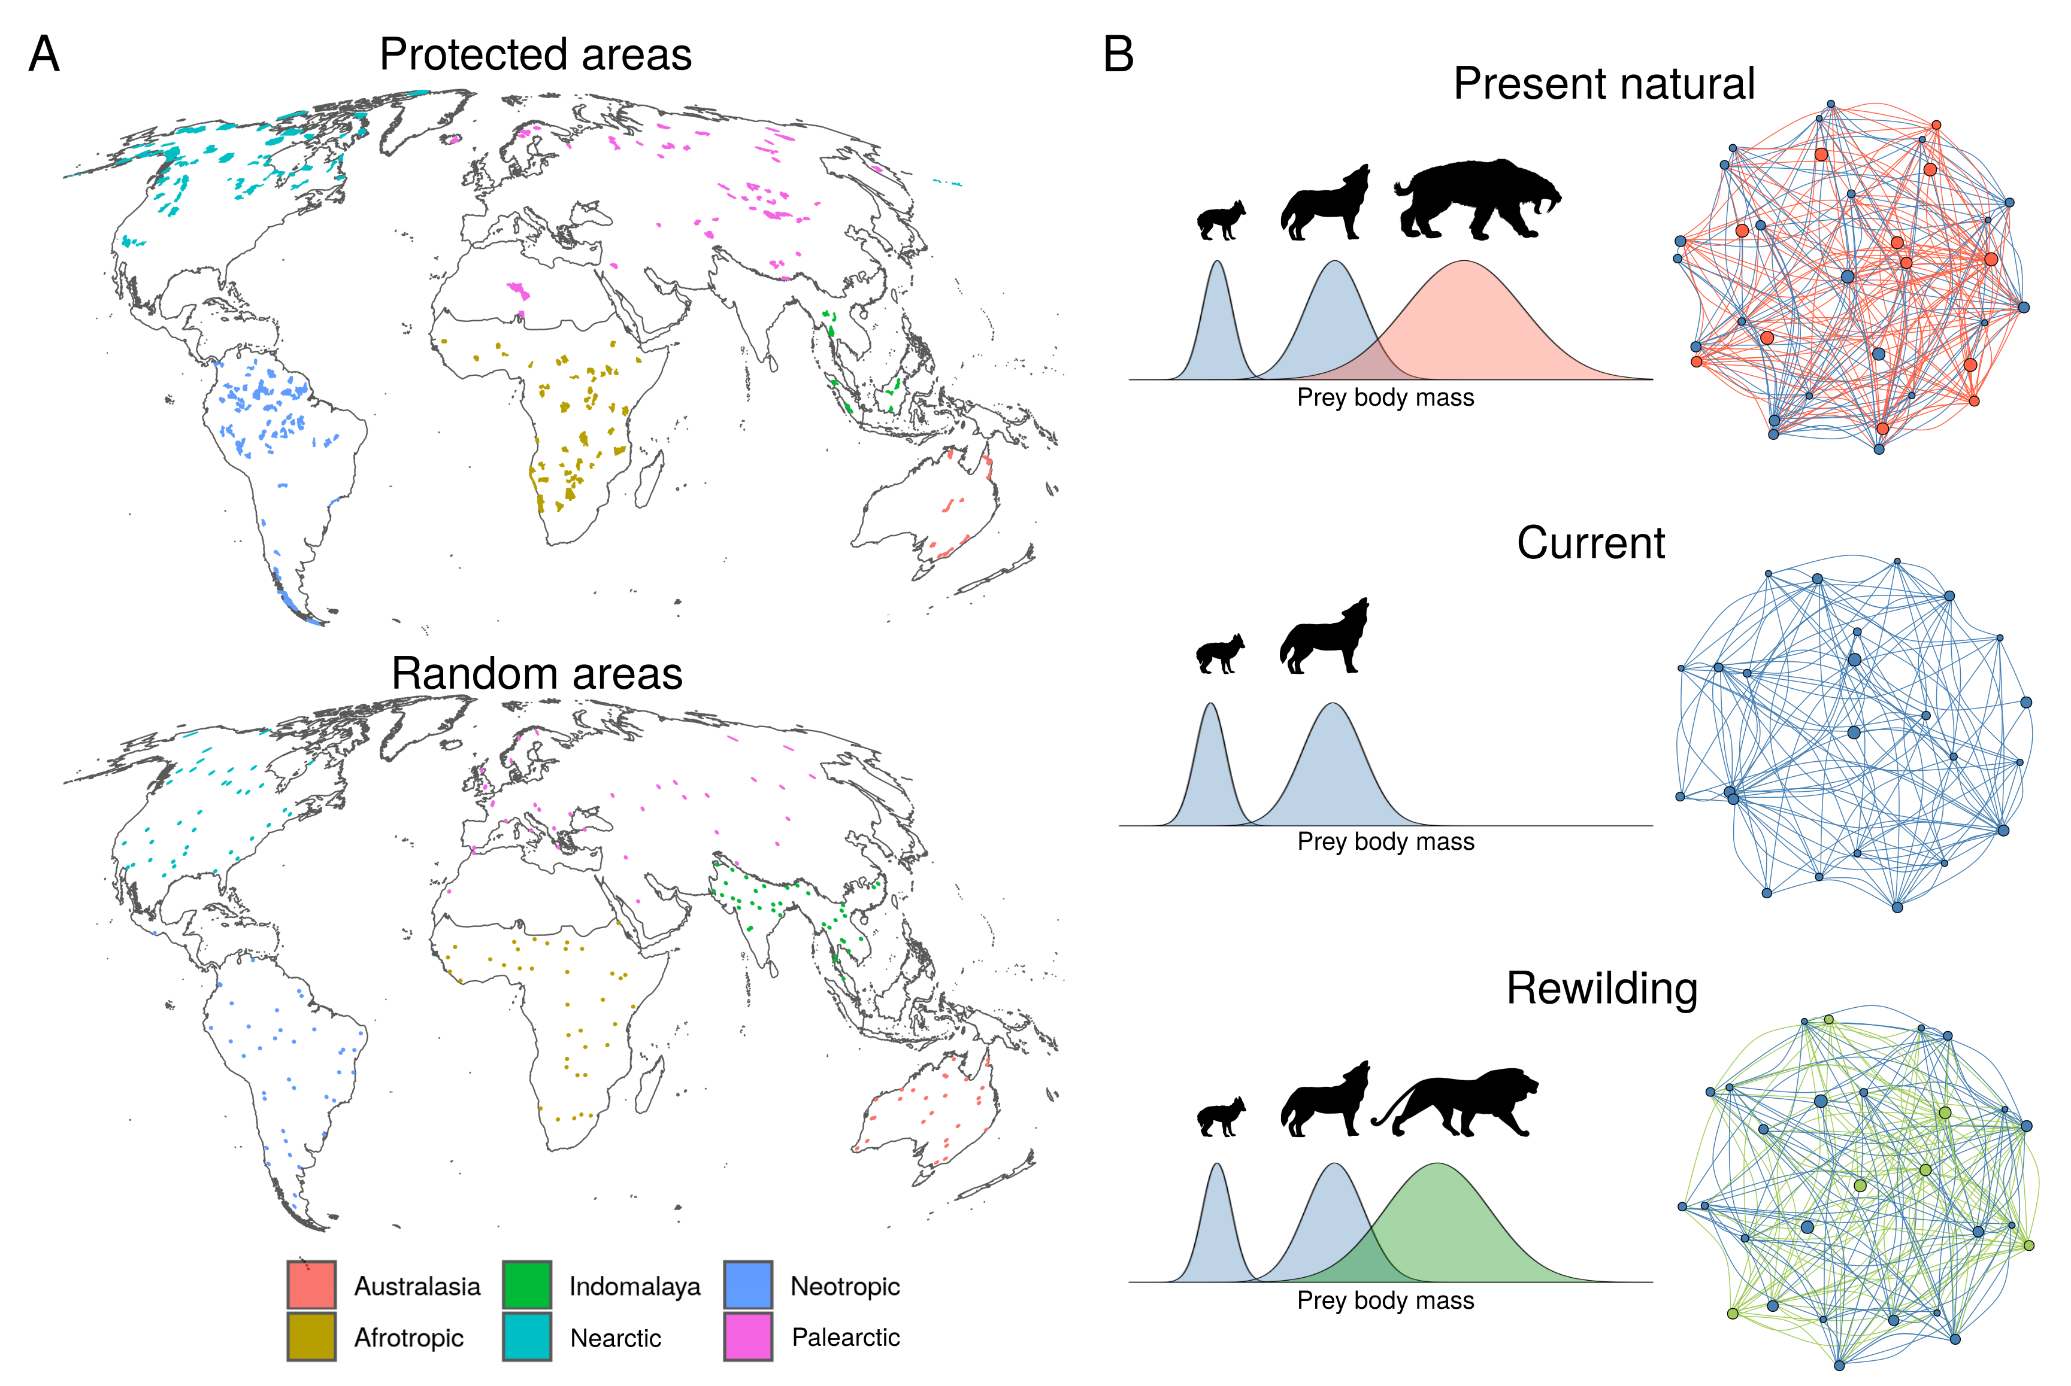

Figure 1. Conceptual representation of rewiring food webs via trophic rewilding. A) The protected areas and random areas >= 5,000 km^2 are coloured by the six biogeographic realms considered for trophic rewilding of terrestrial mammals . We excluded Antarctica because no terrestrial mammal lives there and Oceania because no protected area larger than >= 5,000 km^2 are found there. B)Network representation of food webs, where species are nodes (circles) and predator-prey interactions are edges (lines). The Late Pleistocene human-driven extinctions removed species and trophic interactions (red circles and lines), resulting in degraded current food webs (blue circles and lines). Rewilding aims to restore lost interactions by replacing extinct species with suitable ecological analogues (green circles) that can rewire food webs establishing functionally analogue links (green lines).

In this study, we investigate the potential of rewilding to rewire terrestrial mammal food webs in large (>=5,000 km^2) protected areas and geographically-unbiased random areas at a global scale (figure 1). We infer food webs for three scenarios: 1) present-natural, a counter-factual scenario where mammals have not been influenced by human activities through time (Faurby & Svenning, 2015; Faurby et al., 2018); 2) current; and 3) rewilding where extant species can be reintroduced to present-natural ranges and extinct species can be replaced by closely-related, similarly-sized functional analogues that have similar climatic niches. We then compare the food webs for the three scenarios to investigate the extent current food webs have reduced numbers of predator-prey interactions and whether rewilding can rewire food webs to present-natural states.

# Materials and methods

## Overview

Expanding upon the terminology of Genes, Cid, Fernandez, & Pires (2017), we quantified: a) current debt, the number of species and interactions lost because of the Late Pleistocene extinctions; b) rewilding credit, the number of species and interactions restored under the rewilding scenario; and c) rewilding deficit, the extent of past losses not restored by rewilding. By quantifying current debt, rewilding credit, and rewilding deficit, we could then assess whether rewilding credit can balance current debt and if a rewilding deficit remained.

We quantified current debt, rewilding credit, and rewilding deficit in large protected areas with strict International Union for Conservation of Nature (IUCN) management categories (Ia, Ib, and II; >= 5,000 km^2; n = 209). Rewilding is more feasible in large, protected areas where human-wildlife conflict is less likely. Moreover, because large protected areas are concentrated in areas with low biodiversity (Daru et al., 2019), we examined rewilding restoration potential in areas >= 5,000 km^2 randomly scattered within each biogeographic realm to investigate the potential of a global rewilding scenario without geographic biases (n = 206; Figure 1).

Our method includes three distinct steps: 1) fitting correlative species distribution models (SDMs) for extant terrestrial mammals to identify their climatically suitable habitat; 2) modelling reintroductions of extant terrestrial mammals to present-natural ranges and identifying extant mammals that could replace closely-related, similarly-sized extinct species; 3) reconstructing species present-natural, current, and rewilding food webs in both large protected and random areas under the three scenarios. These three steps are summarised below; more details are provided in the supplementary material. By contrasting food webs for each scenario, we investigated whether rewilding can rewire current food webs to present-natural conditions. .

### Species distribution models

Correlative SDMs are currently the main tools used to derive spatially explicit predictions of environmental suitability for species (Elith & Leathwick, 2009). They typically achieve this through identification of statistical relationships between species observations and environmental descriptors (Guisan & Thuiller, 2005). Following previous studies (Jarvie & Svenning 2018), we used current and present-natural range maps from the PHYLACINE database (Faurby et al., 2018) to overcome biases in the SDMs due to anthropogenic range contraction of species (Faurby & Aráujo, 2018). Current ranges were generated from the IUCN range polygon maps for current, natural, and reintroduced ranges only (IUCN, 2016). Present-natural ranges are estimates of where species could be today in the complete absence of influence of modern humans (*Homo sapiens*) through time (Faurby & Svenning, 2015).

As environmental predictors for the SDMs, we used four climatic variables from the WorldClim database at 2.5 arc-minute resolution (Fick & Hijmans, 2017): maximum temperature of the warmest month, minimum temperature of the coldest month, precipitation of wettest quarter, and precipitation of driest quarter. We selected these variables as they capture extreme conditions and, thus, likely represent factors limiting the distributions of terrestrial mammals (…). . To model the climatic suitability of terrestrial mammals, we fitted maximum entropy (Maxent) models, a presence-background approach that contrasts environments occupied by a species with the available environmental space (Elith et al., 2011; Merow, Smith, & Silander Jr, 2013), using the R package *maxnet* (S. J. Phillips, Anderson, Dudík, Schapire, & Blair, 2017). Full details on methods of Maxent SDMs (including model evaluation) are provided in the electronic supplementary material.. We did not model species with less than 10 presence points, thus excluding 76 species with restricted ranges. In total, we modelled 4,130 of the 4,206 living terrestrial mammals.

## Selection of rewilding candidates

We modelled a rewilding scenario where extant terrestrial mammals can be reintroduced to present-natural ranges and extinct species can be replaced by living mammals following conservative selection criteria. We searched for rewilding candidates that were closely-related and similarly-sized to extinct terrestrial mammals and that had similar climatic niches. We prioritized reintroductions into present-natural ranges over introductions of functional analogues, as moving species’ outside their indigenous range is inherently riskier than reintroductions due to unforeseeable uncertainties and ecological risks (**Fernández et al. 2017**). For assessing rewilding replacements, we examined each biogeographic realm separately (Olson et al., 2001), as these are areas where ecological and evolutionary processes operate most strongly (Olson & Dinerstein, 2002). We excluded Antarctica because no terrestrial mammal lives there and Oceania because no strictly managed IUCN protected areas >= 5,000 km^2 are found there (Figure 1).

For globally extinct species, we selected as functional analogues the species from the same family that had similar size (within the 50% range of extinct species' body mass) and the largest climatically suitable range within the present-natural of the extinct species in each biogeographic realm. We made two exceptions to the above criteria: 1) proboscidean megaherbivores (>=1,000kg; Malhi et al., 2016) were allowed to be replaced by the two extant elephants *Elephas maximus* and *Loxodonta africana,* as they promote ecosystem processes, e.g., nutrient cycles and vegetation clearing, similar to extinct megaherbivore Proboscidea(J. Donlan, 2005; Janzen & Martin, 1982; Josh Donlan et al., 2006); 2) extinct Felidae and Ursidae megacarnivores (>= 100 kg; Malhi et al., 2016) were allowed to be replaced by extant megacarnivores of the same family, as megacarnivores regulate abundance and activity of large herbivores (Laundré, Hernández, & Ripple, 2010; Ripple et al., 2014), necessary to restore trophic complexity in self-sustaining ecosystems (Perino et al., 2019), .

To avoid negative impacts from introductions of functional analogues into present-natural ranges of similarly-sized – i.e., within 50% of the body mass – extant species of the same taxonomic group, we excluded the functional analogue to prevent potential competition between two species (Linnell & Strand, 2000). For the remaining functional analogues, we selected the species that had the largest climatically suitable range overlapping within the present-natural range of the extinct species in each biogeographic realm. We did not select species for rewilding that violated any of the above criteria. See electronic supplement material, figure S3 for a schematic representation of the selection criteria.

## Reconstructing food webs

We reconstructed mammal communities within 209 large terrestrial protected areas (>= 5,000 km^2; figure 1), selected from the World Database of Protected Area (UNEP-WCMC & IUCN (2019), downloaded June 2019). Following previous global studies (Jones et al., 2018; Runge et al., 2015), we excluded protected areas without detailed geographic information, proposed and designated sites not considered protected areas internationally, sites with an unknown status, UNESCO Biosphere Reserves, and marine-only sites as well as the marine portion of coastal sites. As large areas with limited human use facilitate the establishment of self-sustaining population of large mammals (Chundawat, Sharma, Gogate, Malik, & Vanak, 2016; Woodroffe & Ginsberg, 1998), we kept only protected areas with strict IUCN management category (Ia, Ib, and II) and total surface >= 5,000 km^2 after dissolving adjacent geometries together. Because the protected area network poorly overlap with current biodiversity hotspots (Daru et al., 2019), we investigated the effects of human activities and the restoration potential of rewilding also in 209 geographycally-unbiased areas randomly distributed within each biogeographic realm (Figure 1). We obtained the mammal community for each area under present-natural scenario using the PHYLACINE present-natural range maps (including extinct species) and for current conditions using the current ranges. Three random areas that did not have terrestrial mammals in the present-natural were excluded. Rewilding assemblages were then estimated from combined current, reintroduction (present-natural including only extant species), and rewilding ranges obtained using SDMs and selecting the best functional analogues for extinct species.

To infer food webs for each area, we combined phylogenetic inference with a trait-based approach (Pomeranz, Thompson, Poisot, & Harding, 2019). Phylogeny has been shown to be a good predictor of trophic interactions (Eklöf, Helmus, Moore, & Allesina, 2011), as closely related species share similar resources (Gray et al., 2015). We performed phylogenetic inference at the family level, a reasonable trade-off between accuracy of predictions and data availability (Gray et al., 2015). We used predator-prey interaction data from the ECOWeB database (J. E. Cohen, 2010), the Global Biotic Interactions (GLOBI) database (Poelen, Simons, & Mungall, 2014), and two published food webs (Baskerville et al., 2011; Visser, Freymann, & Olff, 2011). Each observed interaction between a prey and a predator was assigned to all species of the respective families. We then used a trait-based approach to remove interactions inferred using phylogeny that were not supported by macroecological evidence (Pomeranz et al., 2019). This trait-based approach uses the relationship between the body mass of prey and predators, which structures trophic interactions in food webs (Owen-Smith & Mills, 2008; Segura, Farina, & Arim, 2016; Williams & Martinez, 2000). Following previous studies (Gravel, Poisot, Albouy, Velez, & Mouillot, 2013; Pomeranz et al., 2019), we used the range within the 10% and the 90% regression quantiles to obtain dietary niches of carnivores, i.e. the body mass range of their prey. Phylogenetically inferred predator-prey interactions outside the dietary niche were removed from the food web.

After food webs were inferred, we used the herbivore-carnivore definition of Malhi et al. (2016) to assign species to a trophic level according to their diet and body mass, as this reflects the trophic and ecological role of species. For carnivores, we divided them into three trophic levels: i) megacarnivores >= 100 kg, which are generally apex predators that dominate food webs; ii) large carnivores 21.5–99 kg, which can predate on large prey and are subjected to top-down control from megacarnivores; and iii) small carnivores < 21.5 kg, which can predate only on smaller prey (Carbone, Mace, Roberts, & Macdonald, 1999). For herbivores, we also used three trophic levels: i) megaherbivores >= 1,000 kg, which are mostly free from predation; ii) large herbivores 45–999 kg, which are predated only by large carnivores and megacarnivores; and iii) small herbivores < 45 kg, which are predated by all carnivore trophic levels (Hopcraft, Olff, & Sinclair, 2010).

## Statistical analyses

For the three food web scenarios, we calculated the number of species present in each trophic level and the number of predator-prey interactions connecting trophic levels. We then compared the number of species in each trophic level between present-natural and current conditions to estimate current trophic richness debt and between current and rewilding scenarios to assess rewilding trophic richness credit. We also compared the number of trophic interactions across trophic levels between present-natural and current scenarios to obtain the current interaction debt and between current and rewilding scenarios to quantify rewilding interaction credit. Moreover, we compared the difference in the number of species per trophic level and the number of interactions between trophic levels under present-natural and rewilding scenarios to quantify rewilding deficit.

To estimate significance among the scenarios, we used generalised linear mixed models (GLMMs). We selected the error distribution for the GLMMs based on the response data type and to remedy overdispersion (Zuur, Ieno, Walker, Saveliev, & Smith, 2009). We used a Poisson distribution to model the number of species at each trophic level with the fixed effects scenario, trophic level, and their interaction. A negative binomial distribution was used to model the predator-prey interactions across trophic levels with the fixed effects scenario, trophic levels involved in the link, and their interaction. For both GLMMs, we used the random effects food web ID and the biogeographic realm to account for pseudoreplicates. We assessed statistical significance among scenarios by performing pair-wise contrasts with Bonferroni correction, with results shown as mean and 95% confidence interval. To understand if statistical significant differences were ecologically meaningful, we quantified the magnitude of the change between scenarios as the difference between model estimates as their difference standardized by their pooled standard deviation (Cohen's *d* effect size; Cohen, 1988)*.* Increasing values of *d* are associated with differences that are ecologically more important. For instance, very small effect sizes indicate that the ecological relevance of the difference is negligible, whereas small effect sizes that there is a small but ecologically meaningful difference. Following Cohen (1988) and Sawilowsky (2009), we defined effect sizes as: very small (*d* = 0.00-0.20), small (*d* = 0.20-0.49), medium effect sizes (*d* = 0.50-0.79), large (*d* = 0.80–1.20 ), very large (*d* = 1.20-2.00), and huge (*d* >= 2.00) . Protected and random areas were analysed separately.

Data processing and analyses were performed in the R programming language version 3.6.1 (R Core Team, 2018) using packages tidyverse (Wickham, 2017), maxnet (S. Phillips, 2017), dismo (R. J. Hijmans, Phillips, Leathwick, & Elith, 2017), sf (Pebesma, 2018), raster (R. J. Hijmans, 2019), doParallel (Corporation & Weston, 2018), foreach (Microsoft & Weston, 2017), quantreg (Koenker, 2019), performance (Lüdecke, Makowski, & Waggoner, 2019), emmeans (Lenth, 2019), and estimate (Makowski & Lüdecke, 2019). All spatial analyses were conducted using the Behrmann cylindrical equal-area projection. Biogeographic realms were derived using the shapefile from the World Wildlife Foundation (WWF; Olson et al., 2001). Figures were made using packages ggplot2 (Wickham, 2016) with maps displayed in the Molleweide projection.

# Results

Predictive performance of SDMs was on average very high to excellent, while model overfitting was generally low (electronic supplementary material, Table S1 and figure S2). The projected climatic suitability ranges captured much of the known introduction ranges of species obtained from Lundgren et al. (2018) and IUCN (2016) (figure S2). These results indicate the SDMs give reliable projections of climatic suitability of terrestrial mammals.

In total, we identified 94 living species that could be used as functional analogues for 127 out of 334 extinct terrestrial mammals (electronic supplementary material, Table S2).

In protected areas >= 5,000 km^2, we found a significantly lower number of species in trophic levels under current conditions than in the present-natural scenario except for small herbivores and small carnivores (Table 1, figure 2). The largest decrease in the number of species was for megacarnivores (d = 1.24, very large effect size), megaherbivores (1.79, very large effect size) , and large herbivores (d = 0.82, large effect size). Large carnivores’ number was also significantly lower in the current than in the present-natural scenario, but with smaller magnitude of the difference (*d* = 0.35, small effect size). Small carnivores and small herbivores were not significantly affected by extinctions. Under the rewilding scenario, the number of megacarnivores (d = 0.60, medium effect size), megaherbivores (d = 0.61, medium effect size), and large herbivores (d = 0.33, small effect size) significantly increased from current conditions, whereas the number of large carnivores did not significantly increased (P =0.06). The number of species in the rewilding scenario was not completely restored to present-natural, but there were statistically significant differences for megacarnivores (d = 0.64, medium effect size), megaherbivores (d = 1.18, large effect size), large carnivores (d = 0.22, small effect size), and large herbivores (d = 0.49, small effect size). In the large random areas we observed similar patterns, but with higher effect sizes(Table1, figure 2).

Table 1: Standardized differences between coefficients estimates from generalised linear mixed models for the number of species per trophic level among the present-natural, current, and rewilding scenarios. The standardized differences (*d*) were obtained using multiple pair-wise contrasts accounting for variation across biogeographic realms and food webs. Significance of the contrast (*P*) was adjusted with Bonferroni correction. Effect sizes indicate the magnitude of the change.

|  |  |  |  |  |  |  |  |  |  |  |  |
| --- | --- | --- | --- | --- | --- | --- | --- | --- | --- | --- | --- |
| **Trophic level** | **Present-natural – current** | | |  | **Rewilding – current** | | |  | **Present-natural – rewilding** | | |
|  | ***d*** | ***P*** | ***Effect size*** |  | ***d*** | ***P*** | ***Effect size*** |  | ***d*** | ***P*** | ***Effect size*** |
| **Protected areas** | | | | | | | | | | |
| Megacarnivores (≥100 kg) | 1.24 | <0.01 | very large |  | 0.60 | <0.01 | medium |  | 0.64 | <0.01 | medium |
| Megaherbivores (≥1,000 kg) | 1.79 | <0.01 | very large |  | 0.61 | <0.01 | medium |  | 1.18 | <0.01 | large |
| Large carnivores (21.5–99 kg) | 0.35 | <0.01 | small |  | 0.13 | 0.06 | very small |  | 0.22 | <0.01 | small |
| Large herbivores (45–999 kg) | 0.82 | <0.01 | large |  | 0.33 | <0.01 | small |  | 0.49 | <0.01 | small |
| Small carnivores (< 21.5 kg) | 0.06 | 0.01 | very small |  | 0.04 | 0.19 | very small |  | 0.02 | 0.79 | very small |
| Small herbivores (< 45 kg) | 0.03 | 0.40 | very small |  | 0.01 | 1.00 | very small |  | 0.02 | <0.01 | very small |
|  | **Random areas** | | | | | | | | | | |
| Megacarnivores (≥100 kg) | 1.89 | <0.01 | very large |  | 1.21 | <0.01 | very large |  | 0.67 | <0.01 | medium |
| Megaherbivores (≥1,000 kg) | 2.49 | <0.01 | huge |  | 1.31 | <0.01 | very large |  | 1.19 | <0.01 | large |
| Large carnivores (21.5–99 kg) | 0.68 | <0.01 | medium |  | 0.48 | <0.01 | small |  | 0.20 | <0.01 | small |
| Large herbivores (45–999 kg) | 1.10 | <0.01 | large |  | 0.59 | <0.01 | medium |  | 0.50 | <0.01 | medium |
| Small carnivores (< 21.5 kg) | 0.09 | <0.01 | very small |  | 0.07 | 0.01 | very small |  | 0.02 | 0.92 | very small |
| Small herbivores (< 45 kg) | 0.04 | 0.06 | very small |  | 0.02 | 0.57 | very small |  | 0.02 | 0.91 | very small |

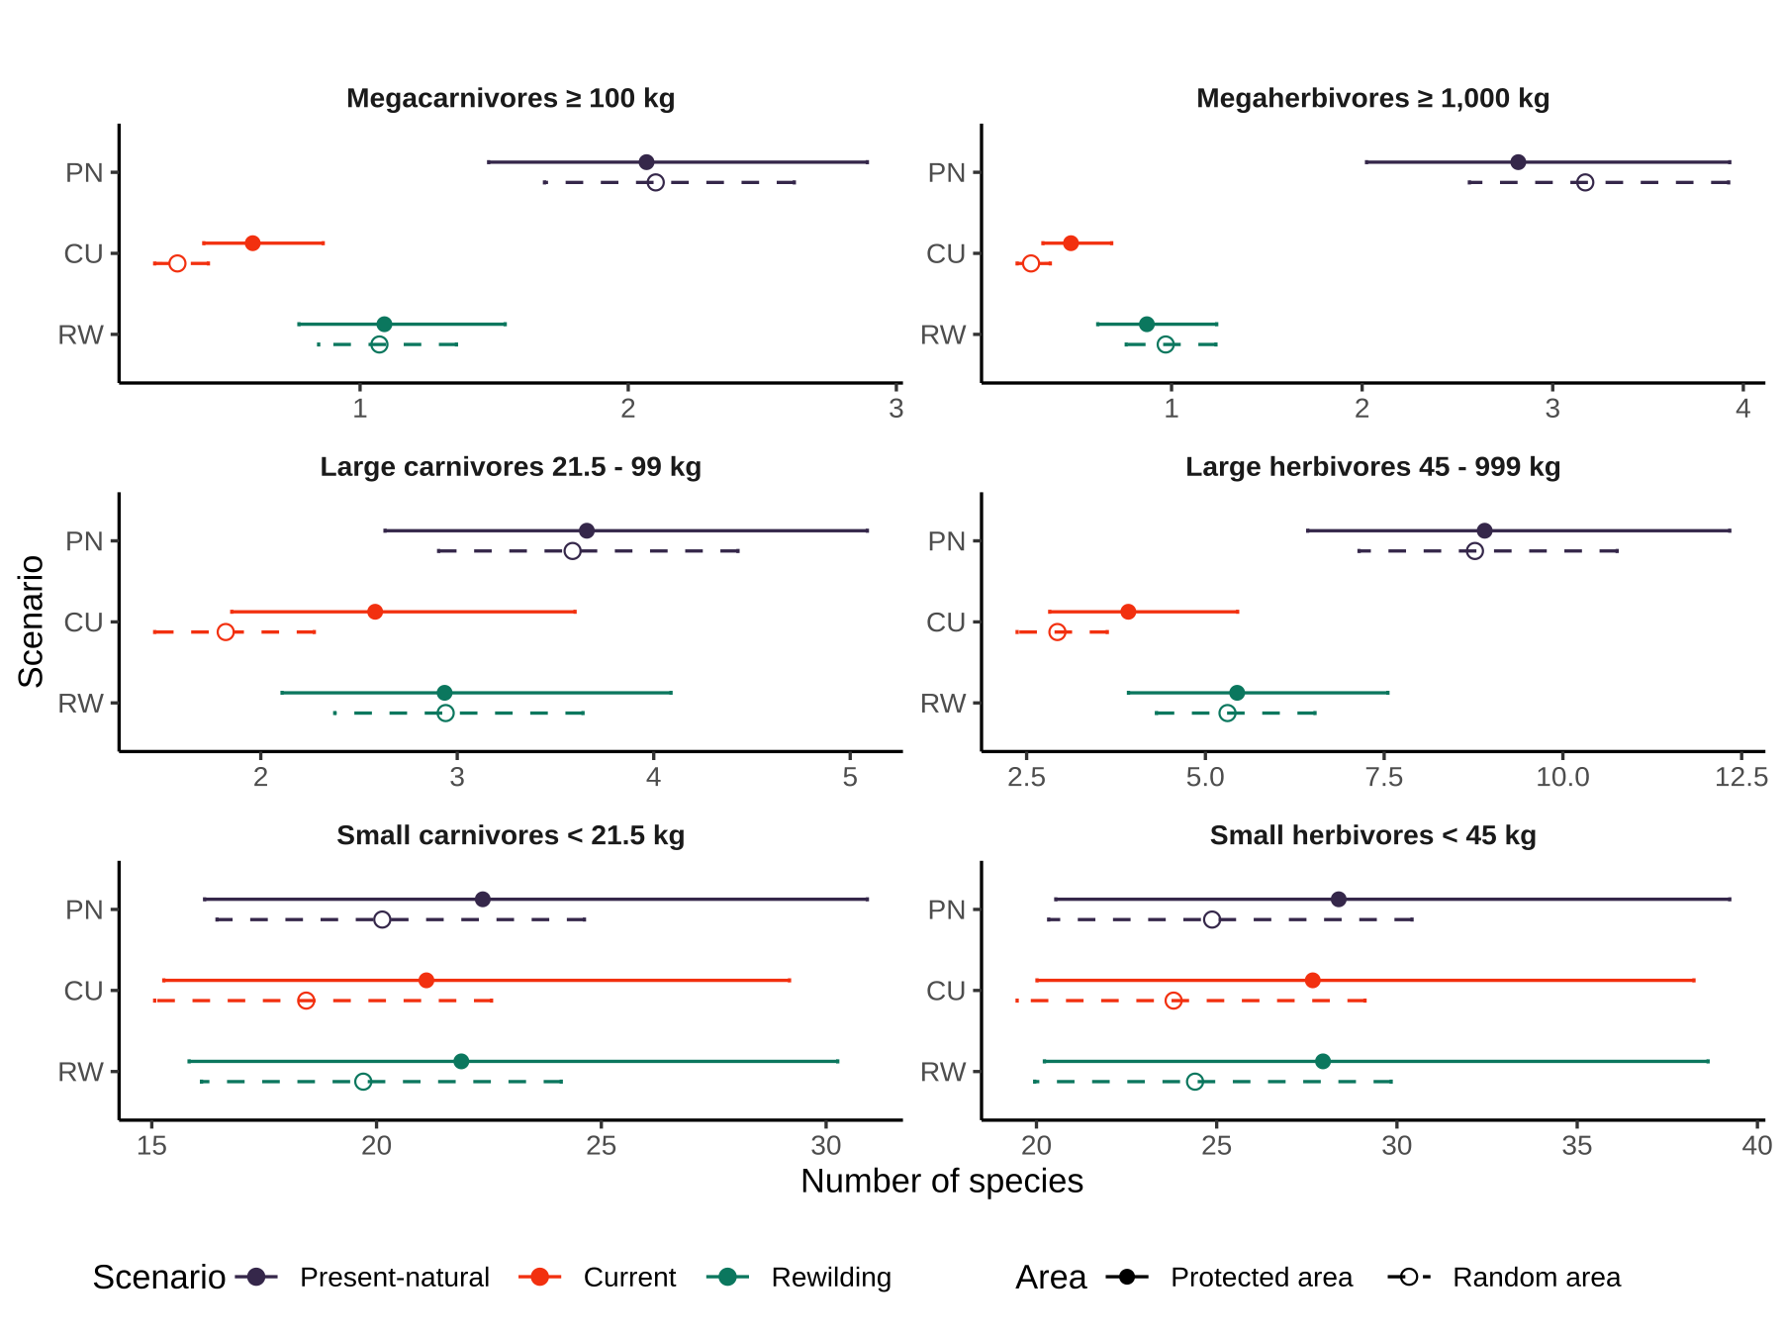

Figure 2: Model estimates of the number of species per trophic level from generalised linear mixed models (GLMMs) for three scenarios: PN, present-natural (blue); CU, current (red); and RW, rewilding (green). Circles show the model estimates and lines the 95% confidence intervals for protected areas (closed circle and solid lines) and for random areas (open circle and dashed lines). The GLMMs accounted for variation across biogeographic realms and food webs**.**

Among trophic levels, the numbers of predator-prey interactions decreased between present-natural and current conditions in protected areas (figure 3). All predator-prey interactions of megacarnivores decreased significantly from the present-natural to the current scenario, with very large effect sizes (Table 2). The predator-prey interactions of large carnivores also decreased significantly between present-natural and current conditions, with a large effect size between large carnivores and large herbivores and small effect sizes between large carnivores and small mammals. The number of interaction of small carnivores did not change (P = 0.37). Under the rewilding scenario, the number of interactions of megacarnivores significantly increased with medium to large effect sizes. Interactions between small mammals and large carnivores significantly increased, but only small carnivores-large carnivores interactions had an ecologically meaningful difference (small effect size). The number of interactions between large carnivores and large herbivores did not increased significantly (P = 0.17).. In the random areas >= 5,000 km^2 we observed similar but more pronounced patterns than in protected areas (figure 2).

From the current to the rewilding scenario, rewilding credit did not balance current debt and trophic interactions were not completely restored to present-natural levels. Megacarnivores’ predator-prey interactions were significantly lower under rewilding than present-natural, with medium to large effect sizes. (Table 2). Large herbivores-large carnivores interactions were also significantly lower (medium effect size). Small mammals-large carnivores interactions were however not different between rewilding and present-natural (P > 0.05). The random areas showed similar patterns to protected areas, although there was higher extinctions debt and rewilding credit. Rewilding deficit was comparable between protected and random areas.

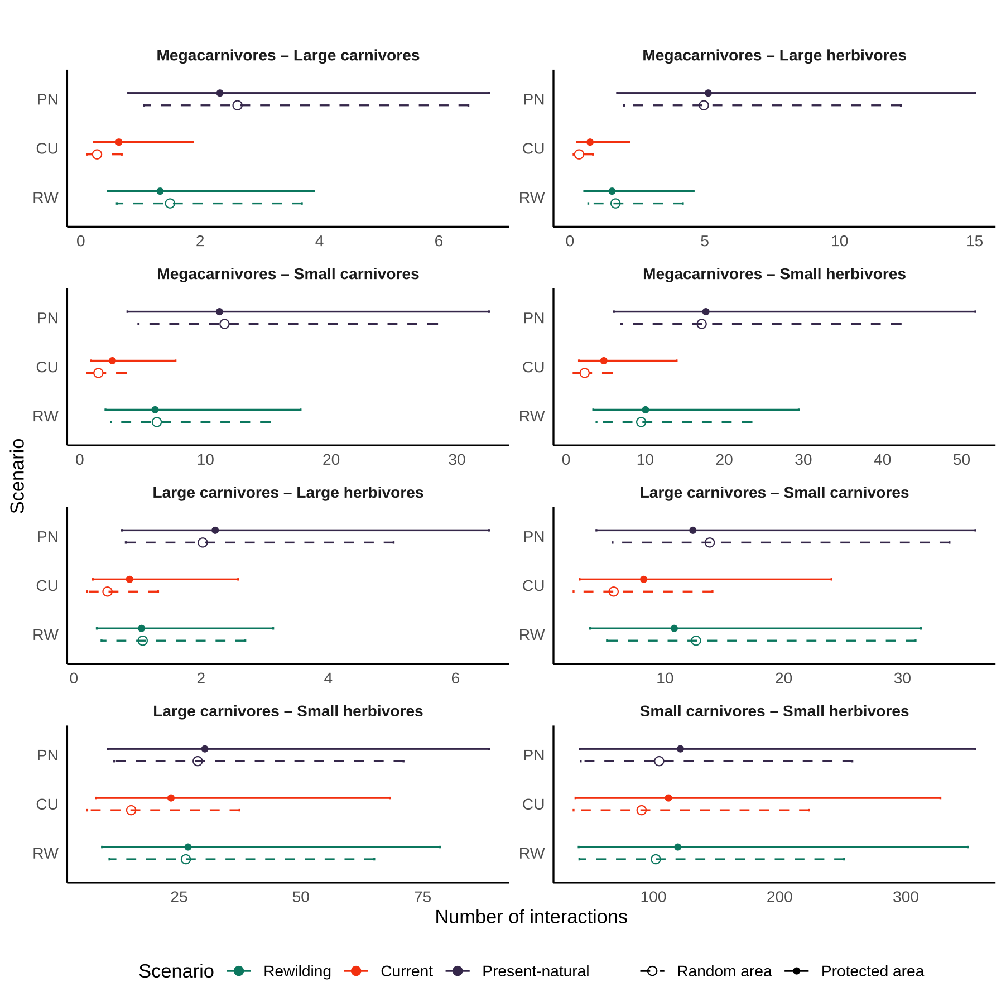Figure 3. Model estimates from generalised linear mixed models (GLMMs) of the number of predator-prey interactions between each trophic level for the three scenarios: PN, present-natural (green); CU, current (blue); RW, rewilding (red). Following Malhi et al. (2016), we defined trophic levels as: megacarnivores (>= 100 kg), large carnivores (21.5 – 99 kg), small carnivores (< 21.5 kg), megaherbivores (>= 1,000 kg), large herbivores (45 – 999 kg), and small herbivores (< 45 kg). Circles show the model estimates and lines the 95% confidence intervals for protected areas (closed circle and solid lines) and for random areas (open circle and dashed lines). The GLMMs accounted for variation across biogeographic realms and food webs.

Table 2: Standardized differences between coefficients estimates from generalised linear mixed models for the number of interactions between trophic levels among the present-natural, current, and rewilding scenarios. Following Malhi et al. (2016), we defined trophic levels as: megacarnivores (>= 100 kg), large carnivores (21.5 – 99 kg), small carnivores (< 21.5 kg), megaherbivores (>= 1,000 kg), large herbivores (45 – 999 kg), and small herbivores (< 45 kg). The standardized differences (*d*) were obtained using multiple pair-wise contrasts accounting for variation across biogeographic realms and food webs. Significance of the contrast (*P*) was adjusted with Bonferroni correction. Effect sizes indicate the magnitude of the change.

|  |  |  |  |  |  |  |  |  |  |  |  |  |
| --- | --- | --- | --- | --- | --- | --- | --- | --- | --- | --- | --- | --- |
| **Predator** | **Prey** | **Present-natural – current** | | |  | **Rewilding – current** | | |  | **Present-natural – rewilding** | | |
|  |  | ***d*** | ***P*** | ***Effect size*** |  | ***d*** | ***P*** | ***Effect size*** |  | ***d*** | ***P*** | ***Effect size*** |
| **Protected areas** | | | | | | | | | | |
| Megacarnivores | Large carnivores | 1.30 | < 0.01 | Very large |  | 0.73 | <0.01 | medium |  | 0.56 | <0.01 | medium |
| Large herbivores | 1.92 | <0.01 | Very large |  | 0.74 | <0.01 | Medium |  | 1.19 | <0.01 | large |
| Small carnivores | 1.45 | <0.01 | Very large |  | 0.84 | <0.01 | Large |  | 0.62 | <0.01 | medium |
| Small herbivores | 1.31 | <0.01 | Very large |  | 0.74 | <0.01 | Medium |  | 0.57 | <0.01 | medium |
| Large carnivores | Large herbivores | 0.93 | <0.01 | Large |  | 0.19 | 0.17 | Very small |  | 0.74 | <0.01 | medium |
| Small carnivores | 0.41 | <0.01 | Small |  | 0.27 | <0.01 | Small |  | 0.14 | 0.07 | Very small |
| Small herbivores | 0.26 | <0.01 | Small |  | 0.14 | 0.04 | Very small |  | 0.14 | 0.07 | Very small |
| Small carnivores | Small herbivores | 0.08 | 0.37 | Very small |  | 0.06 | 0.67 | Very small |  | 0.02 | 1.00 | Very small |
|  |  | **Random areas** | | | | | | | | | | |
| Megacarnivores | Large carnivores | 2.26 | <0.01 | Huge |  | 1.70 | <0.01 | Very large |  | 0.56 | <0.01 | medium |
| Large herbivores | 2.67 | <0.01 | Huge |  | 1.60 | <0.01 | Very large |  | 1.08 | <0.01 | large |
| Small carnivores | 2.05 | <0.01 | Huge |  | 1.42 | <0.01 | Very large |  | 0.63 | <0.01 | medium |
| Small herbivores | 1.99 | <0.01 | Very large |  | 1.40 | <0.01 | Very large |  | 0.59 | <0.01 | Medium |
| Large carnivores | Large herbivores | 1.34 | <0.01 | Very large |  | 0.72 | <0.01 | Medium |  | 0.63 | <0.01 | medium |
| Small carnivores | 0.89 | <0.01 | Large |  | 0.80 | <0.01 | Large |  | 0.09 | 0.56 | Very small |
| Small herbivores | 0.64 | <0.01 | Medium |  | 0.55 | <0.01 | Medium |  | 0.09 | 0.51 | Very small |
| Small carnivores | Small herbivores | 0.14 | 0.05 | Very small |  | 0.12 | 0.15 | Very small |  | 0.03 | 1.00 | Very small |

# Discussion

Our results show that Late Pleistocene extinctions severely degraded food webs worldwide by removing higher trophic levels and weakening top-down control processes. We also found that, under the conservative rewilding scenario that minimises ecological risks and human-wildlife conflicts, the number of species in higher trophic levels and their interactions can be largely restored to pre-extinction conditions. However, this rewilding credit cannot completely balance current debts, as higher trophic levels and top-down interactions were still lower in rewilding food webs than in the present-natural. Overall, these findings suggest that trophic rewilding has the potential to rewire food webs at global scale, restoring predator-prey interactions and trophic complexity in degraded ecosystems.

We found that trophic levels of larger body-sized mammals were the most affected by the Late Pleistocene extinctions. Unsurprisingly (Ripple et al., 2014; Malhi et al., 2016; F. A. Smith et al., 2018), we found that number of megacarnivores, megaherbivores, large carnivores, and large herbivores to have decreased due to past extinctions. Our results show also that, alongside these extinctions, the number of trophic interactions promoted by megacarnivores and large carnivores was severely reduced. These declines indicate that, during the Late Pleistocene, human pressure severely reduced of top-down control and trophic complexity of natural ecosystems (Estes et al., 2011; Mendoza & Araujo, 2019). Our findings show also that rewilding can rewire food webs and restore trophic interactions at global scale. Current debts were not, however, completely balanced by rewilding credit, suggesting less conservative approaches are needed to fully restore ecosystems’ trophic complexity. Importantly, as our analyses minimised ecological risks of species introduction (REF) by limiting functional analogues to be phylogenetically closely-related to extinct species, a less conservative scenario might include rewilding candidates that are unrelated, but functionally and ecologically similar, to extinct species.

Our results show similar patterns of declines and recoveries in the protected areas with strict IUCN management status (categories I-II) as well as in the random areas. Importantly, as strict protected areas are geographically biased and poorly overlap with hotspots of mammal diversity (Joppa & Pfaff, 2009; Daru et al., 2019), this consistency indicates our results are representative of current debts and rewilding credit at the global scale. We advice caution, however, in interpreting our results at local or regional scale, as the restoration achievable via rewilding depends on complex socio-ecological factors.

Human-wildlife coexistence is the necessary starting point for rewilding (Perino et al., 2019). Rewilding can cause economic losses to local stakeholders via predation on livestock or damages to crops and pastures. People not directly damaged by wildlife can also negatively perceive rewilding projects depending on how they are implemented (Theunissen, 2019). Such conflicts can be resolved by identifying benefits and costs of wildlife in a socio-ecological framework (Ceauşu, et al., 2019), by adopting compensation schemes for damages caused by wildlife (Ravanelle & Nyhus, 2017), and by implementing rewilding with realistic goals (Pedersen et al., 2020).

Despite disagreement and oppositions to rewilding (Rubenstein & Rubenstein, 2016), species are, in some cases, re-expanding to their natural ranges and passive rewilding has already started. In Europe, for instance, land abandoned has increased in recent decades (Verburg & Overmars, 2009), promoting wildlife’s comeback (Ceausu et al., 2015; Chapron et al., 2014). The limitations of traditional conservation and restoration approaches, economically expensive and resource-demanding, at these large spatial scales are unlikely to be able to protect biodiversity efficiently (REF). Rewilding has thus been suggested as an atlernative restoration strategy to more traditional approaches (Navarro & Pereira, 2015). Our findings that rewilding can restore trophic complexity at large spatial scales highlights the importance of rewilding as an unprecedented opportunity to restore landscapes altered by human activities to self-sustaining, biodiverse ecosystems (Svenning et al., 2016; Perino et al. 2019).

In conclusion, our study shows that human-driven extinctions severely degraded food webs worldwide and that rewilding has the potential to rewire food webs and restore trophic interactions at global scale. Trophic rewilding is thus a promising strategy to re-establish important ecological functions, such as top-down control and trophic cascades (Estes at l., 2011; Beschta & Ripple, 2016), and to restore ecosystems’ trophic complexity affected by human pressure (Mendoza & Araujo, 2019).

# Acknowledgment

This work is funded by the Carlsberg Foundation Semper Ardens project MegaPast2Future (grant CF16-0005 to JCS). JCS also considers this work a contribution to his VILLUM FONDEN Investigator project 'Biodiversity Dynamics in a Changing World' (grant 16549). We thank members of the MegaPast2Future group for discussions that improved the manuscript.

# Data accessibility

All data used was open access. Predator-prey interactions were from the ECOWeB and GLOBI databases (J. E. Cohen, 2010; Poelen et al., 2014), and from two published papers (Baskerville et al., 2011; Visser et al., 2011). Body mass and range maps were from the PHYLACINE 1.2 database (Faurby et al., 2018). We used climate data from the Worldclim 2.0 database (Fick & Hijmans, 2017), elevation data from the EarthEnv-DEM90 digital elevation model (Robinson et al., 2014), and the biogeographic realms shapefile from the WWF (Olson et al. 2001).

# Author contribution

EB conceived and developed the study, performed analyses, and drafted the manuscript. SJ and JCS conceived and developed the study, interpreted the results, and helped revise the manuscript.

# Competing interests

We have no competing interests.

# References

Alston, J., Maitland, B., Brito, B., Esmaeili, S., Ford, A., Hays, B., … Goheen, J. (2019). Reciprocity in restoration ecology: When might large carnivore reintroduction restore ecosystems? *Biological Conservation*, *234*, 82–89.

Barnosky, A. D. (2008). Megafauna biomass tradeoff as a driver of quaternary and future extinctions. *Proceedings of the National Academy of Sciences*, *105*(Supplement 1), 11543–11548.

Baskerville, E. B., Dobson, A. P., Bedford, T., Allesina, S., Anderson, T. M., & Pascual, M. (2011). Spatial guilds in the serengeti food web revealed by a bayesian group model. *PLoS Computational Biology*, *7*(12), e1002321.

Beschta, R. L., & Ripple, W. J. (2016). Riparian vegetation recovery in yellowstone: The first two decades after wolf reintroduction. *Biological Conservation*, *198*, 93–103.

Carbone, C., Mace, G. M., Roberts, S. C., & Macdonald, D. W. (1999). Energetic constraints on the diet of terrestrial carnivores. *Nature*, *402*(6759), 286.

Ceausu, S., Hofmann, M., Navarro, L. M., Carver, S., Verburg, P. H., & Pereira, H. M. (2015). Mapping opportunities and challenges for rewilding in Europe. *Conservation Biology*, *29*(4), 1017–1027.

Ceauşu, S., Graves, R. A., Killion, A. K., Svenning, J.-C., & Carter, N. H. (2019). Governing trade-offs in ecosystem services and disservices to achieve human–wildlife coexistence. *Conservation Biology*, *33*(3), 543–553.

Chapron, G., Kaczensky, P., Linnell, J. D., Arx, M. von, Huber, D., Andrén, H., … others. (2014). Recovery of large carnivores in Europe’s modern human-dominated landscapes. *Science*, *346*(6216), 1517–1519.

Chundawat, R. S., Sharma, K., Gogate, N., Malik, P. K., & Vanak, A. T. (2016). Size matters: Scale mismatch between space use patterns of tigers and protected area size in a tropical dry forest. *Biological Conservation*, *197*, 146–153.

Cohen, J. (1988). *Statistical power analysis for the behavioural sciences*. Hillsdale, NJ: erlbaum.

Cohen, J. E. (2010). *ECOWeB 1.1: Ecologists’ cooperative web bank*.

Corporation, M., & Weston, S. (2018). *DoParallel: Foreach parallel adaptor for the ’parallel’ package*. Retrieved from <https://CRAN.R-project.org/package=doParallel>

Daru, B. H., Roux, P. C. le, Gopalraj, J., Park, D. S., Holt, B. G., & Greve, M. (2019). Spatial overlaps between the global protected areas network and terrestrial hotspots of evolutionary diversity. *Global Ecology and Biogeography*, *28*(6), 757–766.

Dirzo, R., Young, H. S., Galetti, M., Ceballos, G., Isaac, N. J., & Collen, B. (2014). Defaunation in the Anthropocene. *Science*, *345*(6195), 401–406.

Donlan, J. (2005). Re-wilding North America. *Nature*, *436*(7053), 913.

Eklöf, A., Helmus, M. R., Moore, M., & Allesina, S. (2011). Relevance of evolutionary history for food web structure. *Proceedings of the Royal Society B: Biological Sciences*, *279*(1733), 1588–1596.

Elith, J., & Leathwick, J. R. (2009). Species distribution models: Ecological explanation and prediction across space and time. *Annual Review of Ecology, Evolution, and Systematics*, *40*, 677–697.

Elith, J., Phillips, S. J., Hastie, T., Dudík, M., Chee, Y. E., & Yates, C. J. (2011). A statistical explanation of maxent for ecologists. *Diversity and Distributions*, *17*(1), 43–57.

Estes, J. A., Terborgh, J., Brashares, J. S., Power, M. E., Berger, J., Bond, W. J., … others. (2011). Trophic downgrading of planet Earth. *Science*, *333*(6040), 301–306.

Faurby, S., & Svenning, J.-C. (2015). Historic and prehistoric human-driven extinctions have reshaped global mammal diversity patterns. *Diversity and Distributions*, *21*(10), 1155–1166.

Faurby, S., Davis, M., Pedersen, R. Ø., Schowanek, S. D., Antonelli, A., & Svenning, J.-C. (2018). PHYLACINE 1.2: The phylogenetic atlas of mammal macroecology. *Ecology*, *99*(11), 2626–2626. <https://doi.org/10.1002/ecy.2443>

Fick, S. E., & Hijmans, R. J. (2017). WorldClim 2: New 1-km spatial resolution climate surfaces for global land areas. *International Journal of Climatology*, *37*(12), 4302–4315.

Garrido, P., Mårell, A., Öckinger, E., Skarin, A., Jansson, A., & Thulin, C.-G. (2019). Experimental rewilding enhances grassland functional composition and pollinator habitat use. *Journal of Applied Ecology*, *56*(4), 946–955.

Genes, L., Cid, B., Fernandez, F. A., & Pires, A. S. (2017). Credit of ecological interactions: A new conceptual framework to support conservation in a defaunated world. *Ecology and Evolution*, *7*(6), 1892–1897.

Genes, L., Fernandez, F. A., Vaz-de-Mello, F. Z., Rosa, P. da, Fernandez, E., & Pires, A. S. (2019). Effects of howler monkey reintroduction on ecological interactions and processes. *Conservation Biology*, *33*(1), 88–98.

Gill, J. L. (2014). Ecological impacts of the late quaternary megaherbivore extinctions. *New Phytologist*, *201*(4), 1163–1169.

Gravel, D., Poisot, T., Albouy, C., Velez, L., & Mouillot, D. (2013). Inferring food web structure from predator–prey body size relationships. *Methods in Ecology and Evolution*, *4*(11), 1083–1090.

Gray, C., Figueroa, D. H., Hudson, L. N., Ma, A., Perkins, D., & Woodward, G. (2015). Joining the dots: An automated method for constructing food webs from compendia of published interactions. *Food Webs*, *5*, 11–20.

Guisan, A., & Thuiller, W. (2005). Predicting species distribution: Offering more than simple habitat models. *Ecology Letters*, *8*(9), 993–1009.

Hayward, M. W., Scanlon, R. J., Callen, A., Howell, L. G., Klop-Toker, K. L., Di Blanco, Y., … others. (2019). Reintroducing rewilding to restoration–Rejecting the search for novelty. *Biological Conservation*, *233*, 255–259.

Hijmans, R. J. (2019). *Raster: Geographic data analysis and modeling*. Retrieved from <https://CRAN.R-project.org/package=raster>

Hijmans, R. J., Phillips, S., Leathwick, J., & Elith, J. (2017). *Dismo: Species distribution modeling*. Retrieved from <https://CRAN.R-project.org/package=dismo>

Hof, C., Voskamp, A., Biber, M. F., Böhning-Gaese, K., Engelhardt, E. K., Niamir, A., … Hickler, T. (2018). Bioenergy cropland expansion may offset positive effects of climate change mitigation for global vertebrate diversity. *Proceedings of the National Academy of Sciences*, *115*(52), 13294–13299.

Hopcraft, J. G. C., Olff, H., & Sinclair, A. (2010). Herbivores, resources and risks: Alternating regulation along primary environmental gradients in savannas. *Trends in Ecology & Evolution*, *25*(2), 119–128.

IUCN. (2016). *The iucn red list of threatened species, version 2016-3*. International Union for Conservation of Nature; Natural Resources Cambridge.

Janzen, D. H., & Martin, P. S. (1982). Neotropical anachronisms: The fruits the gomphotheres ate. *Science*, *215*(4528), 19–27.

Jarvie, S., & Svenning, J.-C. (2018). Using species distribution modelling to determine opportunities for trophic rewilding under future scenarios of climate change. *Philosophical Transactions of the Royal Society B: Biological Sciences*, *373*(1761), 20170446.

Jones, K. R., Venter, O., Fuller, R. A., Allan, J. R., Maxwell, S. L., Negret, P. J., & Watson, J. E. (2018). One-third of global protected land is under intense human pressure. *Science*, *360*(6390), 788–791.

Josh Donlan, C., Berger, J., Bock, C. E., Bock, J. H., Burney, D. A., Estes, J. A., … others. (2006). Pleistocene rewilding: An optimistic agenda for twenty-first century conservation. *The American Naturalist*, *168*(5), 660–681.

Koenker, R. (2019). *Quantreg: Quantile regression*. Retrieved from <https://CRAN.R-project.org/package=quantreg>

Laundré, J. W., Hernández, L., & Ripple, W. J. (2010). The landscape of fear: Ecological implications of being afraid. *Open Ecology Journal*, *3*, 1–7.

Lenth, R. (2019). *Emmeans: Estimated marginal means, aka least-squares means*. Retrieved from <https://CRAN.R-project.org/package=emmeans>

Linnell, J. D., & Strand, O. (2000). Interference interactions, co-existence and conservation of mammalian carnivores. *Diversity and Distributions*, *6*(4), 169–176.

Luck, G. W. (2007). The relationships between net primary productivity, human population density and species conservation. *Journal of Biogeography*, *34*(2), 201–212.

Lundgren, E. J., Ramp, D., Ripple, W. J., & Wallach, A. D. (2018). Introduced megafauna are rewilding the Anthropocene. *Ecography*, *41*(6), 857–866.

Lüdecke, D., Makowski, D., & Waggoner, P. (2019). *Performance: Assessment of regression models performance*. Retrieved from <https://CRAN.R-project.org/package=performance>

Makowski, D., & Lüdecke, D. (2019). *Estimate: Estimate effects, contrasts and means*. Retrieved from <https://github.com/easystats/estimate>

Malhi, Y., Doughty, C. E., Galetti, M., Smith, F. A., Svenning, J.-C., & Terborgh, J. W. (2016). Megafauna and ecosystem function from the Pleistocene to the Anthropocene. *Proceedings of the National Academy of Sciences*, *113*(4), 838–846.

Marjakangas, E.-L., Genes, L., Pires, M. M., Fernandez, F. A., Lima, R. A. de, Oliveira, A. A. de, … Galetti, M. (2018). Estimating interaction credit for trophic rewilding in tropical forests. *Philosophical Transactions of the Royal Society B: Biological Sciences*, *373*(1761), 20170435.

Martin, P. S. (1984). Prehistoric overkill: The global model. *Quaternary Extinctions: A Prehistoric Revolution*, 354–403.

Mendoza, M., & Araújo, M. B. (2019). Climate shapes mammal community trophic structures and humans simplify them. *Nature Communications*, *10*(1), 1–9.

Merow, C., Smith, M. J., & Silander Jr, J. A. (2013). A practical guide to maxent for modeling species’ distributions: What it does, and why inputs and settings matter. *Ecography*, *36*(10), 1058–1069.

Microsoft, & Weston, S. (2017). *Foreach: Provides foreach looping construct for r*. Retrieved from <https://CRAN.R-project.org/package=foreach>

Navarro, L. M., & Pereira, H. M. (2015). Rewilding abandoned landscapes in Europe. In *Rewilding European :andscapes* (pp. 3–23). Springer, Cham.

Nogués-Bravo, D., Simberloff, D., Rahbek, C., & Sanders, N. J. (2016). Rewilding is the new Pandora’s box in conservation. *Current Biology*, *26*(3), R87–R91.

Olson, D. M., & Dinerstein, E. (2002). The global 200: Priority ecoregions for global conservation. *Annals of the Missouri Botanical Garden*, 199–224.

Olson, D. M., Dinerstein, E., Wikramanayake, E. D., Burgess, N. D., Powell, G. V., Underwood, E. C., … others. (2001). Terrestrial ecoregions of the world: A new map of life on eartha new global map of terrestrial ecoregions provides an innovative tool for conserving biodiversity. *BioScience*, *51*(11), 933–938.

Owen-Smith, N., & Mills, M. G. (2008). Predator–prey size relationships in an African large-mammal food web. *Journal of Animal Ecology*, *77*(1), 173–183.

Pebesma, E. (2018). Simple Features for R: Standardized Support for Spatial Vector Data. *The R Journal*, *10*(1), 439–446. <https://doi.org/10.32614/RJ-2018-009>

Perino, A., Pereira, H. M., Navarro, L. M., Fernández, N., Bullock, J. M., Ceaușu, S., … others. (2019). Rewilding complex ecosystems. *Science*, *364*(6438), eaav5570.

Phillips, S. (2017). *Maxnet: Fitting ’maxent’ species distribution models with ’glmnet’*. Retrieved from <https://CRAN.R-project.org/package=maxnet>

Phillips, S. J., Anderson, R. P., Dudík, M., Schapire, R. E., & Blair, M. E. (2017). Opening the black box: An open-source release of Maxent. *Ecography*, *40*(7), 887–893.

Pires, M. M. (2017). Rewilding ecological communities and rewiring ecological networks. *Perspectives in Ecology and Conservation*, *15*(4), 257–265.

Pires, M. M., Koch, P. L., Farina, R. A., Aguiar, M. A. de, Reis, S. F. dos, & Guimarães Jr, P. R. (2015). Pleistocene megafaunal interaction networks became more vulnerable after human arrival. *Proceedings of the Royal Society B: Biological Sciences*, *282*(1814), 20151367.

Poelen, J. H., Simons, J. D., & Mungall, C. J. (2014). Global biotic interactions: An open infrastructure to share and analyze species-interaction datasets. *Ecological Informatics*, *24*, 148–159.

Pomeranz, J. P., Thompson, R. M., Poisot, T., & Harding, J. S. (2019). Inferring predator–prey interactions in food webs. *Methods in Ecology and Evolution*, *10*(3), 356–367.

Poo-Muñoz, D. A., Escobar, L. E., Peterson, A. T., Astorga, F., Organ, J. F., & Medina-Vogel, G. (2014). *Galictis cuja* (mammalia): An update of current knowledge and geographic distribution. *Iheringia. Série Zoologia*, *104*(3), 341–346.

R Core Team. (2018). *R: A language and environment for statistical computing*. Retrieved from <https://www.R-project.org/>

Riesch, F., Tonn, B., Meißner, M., Balkenhol, N., & Isselstein, J. (2019). Grazing by wild red deer: Management options for the conservation of semi-natural open habitats. *Journal of Applied Ecology*.

Ripple, W. J., Estes, J. A., Beschta, R. L., Wilmers, C. C., Ritchie, E. G., Hebblewhite, M., … others. (2014). Status and ecological effects of the world’s largest carnivores. *Science*, *343*(6167), 1241484.

Robinson, N., Regetz, J., & Guralnick, R. P. (2014). EarthEnv-dem90: A nearly-global, void-free, multi-scale smoothed, 90m digital elevation model from fused aster and srtm data. *ISPRS Journal of Photogrammetry and Remote Sensing*, *87*, 57–67.

Root-Bernstein, M., Gooden, J., & Boyes, A. (2018). Rewilding in practice: Projects and policy. *Geoforum*, *97*, 292–304.

Runge, C. A., Watson, J. E., Butchart, S. H., Hanson, J. O., Possingham, H. P., & Fuller, R. A. (2015). Protected areas and global conservation of migratory birds. *Science*, *350*(6265), 1255–1258.

Sawilowsky, S. S. (2009). New effect size rules of thumb. *Journal of Modern Applied Statistical Methods*, *8*(2), 597–599.

Segura, A. M., Farina, R. A., & Arim, M. (2016). Exceptional body sizes but typical trophic structure in a Pleistocene food web. *Biology Letters*, *12*(5), 20160228.

Smith, F. A., Smith, R. E. E., Lyons, S. K., & Payne, J. L. (2018). Body size downgrading of mammals over the late Quaternary. *Science*, *360*(6386), 310–313.

Svenning, J.-C., Pedersen, P. B., Donlan, C. J., Ejrnæs, R., Faurby, S., Galetti, M., … others. (2016). Science for a wilder Anthropocene: Synthesis and future directions for trophic rewilding research. *Proceedings of the National Academy of Sciences*, *113*(4), 898–906.

Tanentzap, A. J., & Smith, B. R. (2018). Unintentional rewilding: Lessons for trophic rewilding from other forms of species introductions. *Philosophical Transactions of the Royal Society B: Biological Sciences*, *373*(1761), 20170445.

Theunissen, B. (2019). The oostvaardersplassen fiasco. *Isis*, *110*(2), 341–345.

UNEP-WCMC, & IUCN. (2019). *Protected planet: The world database on protected areas (wdpa)*. Retrieved from [www.protectedplanet.net](http://www.protectedplanet.net/)

Valiente-Banuet, A., Aizen, M. A., Alcántara, J. M., Arroyo, J., Cocucci, A., Galetti, M., … others. (2015). Beyond species loss: The extinction of ecological interactions in a changing world. *Functional Ecology*, *29*(3), 299–307.

Venter, O., Magrach, A., Outram, N., Klein, C. J., Possingham, H. P., Di Marco, M., & Watson, J. E. (2018). Bias in protected-area location and its effects on long-term aspirations of biodiversity conventions. *Conservation Biology*, *32*(1), 127–134.

Visser, S. N. de, Freymann, B. P., & Olff, H. (2011). The Serengeti food web: Empirical quantification and analysis of topological changes under increasing human impact. *Journal of Animal Ecology*, *80*(2), 484–494.

Wickham, H. (2016). *Ggplot2: Elegant graphics for data analysis*. Retrieved from [https://ggplot2.tidyverse.org](https://ggplot2.tidyverse.org/)

Wickham, H. (2017). The tidyverse. *R Package Ver. 1.1. 1*.

Williams, R. J., & Martinez, N. D. (2000). Simple rules yield complex food webs. *Nature*, *404*(6774), 180.

Woodroffe, R., & Ginsberg, J. R. (1998). Edge effects and the extinction of populations inside protected areas. *Science*, *280*(5372), 2126–2128.

Yeakel, J. D., Pires, M. M., Rudolf, L., Dominy, N. J., Koch, P. L., Guimarães, P. R., & Gross, T. (2014). Collapse of an ecological network in ancient Egypt. *Proceedings of the National Academy of Sciences*, *111*(40), 14472–14477.

Zhang, J., Qian, H., Girardello, M., Pellissier, V., Nielsen, S. E., & Svenning, J.-C. (2018). Trophic interactions among vertebrate guilds and plants shape global patterns in species diversity. *Proceedings of the Royal Society B: Biological Sciences*, *285*(1883), 20180949.

Zuur, A., Ieno, E. N., Walker, N., Saveliev, A. A., & Smith, G. M. (2009). *Mixed effects models and extensions in ecology with r*. Springer Science & Business Media.