Appendix for *Rewiring food webs through trophic rewilding*

# Supporting information

## Changes to the PHYLACINE database

We modified the body mass of two extinct species in the PHYLACINE database before modelling and analyses: body mass of the extinct species *Sinomegaceros ordosianus* was set equal to the mass of *Sinomegaceros yabei* and body mass of the extinct *Dusicyon australis* to *Dusicyon avus*. Moreover, the cow (*Bos primigenius*) and the dromedary (*Camelus dromedarius*), two species considered to be extinct as wilf populations by the IUCN (IUCN 2019), were included in the analyses, as they are often considered to be sufficiently similar to their ancestral forms (Sandom et al. 2020).

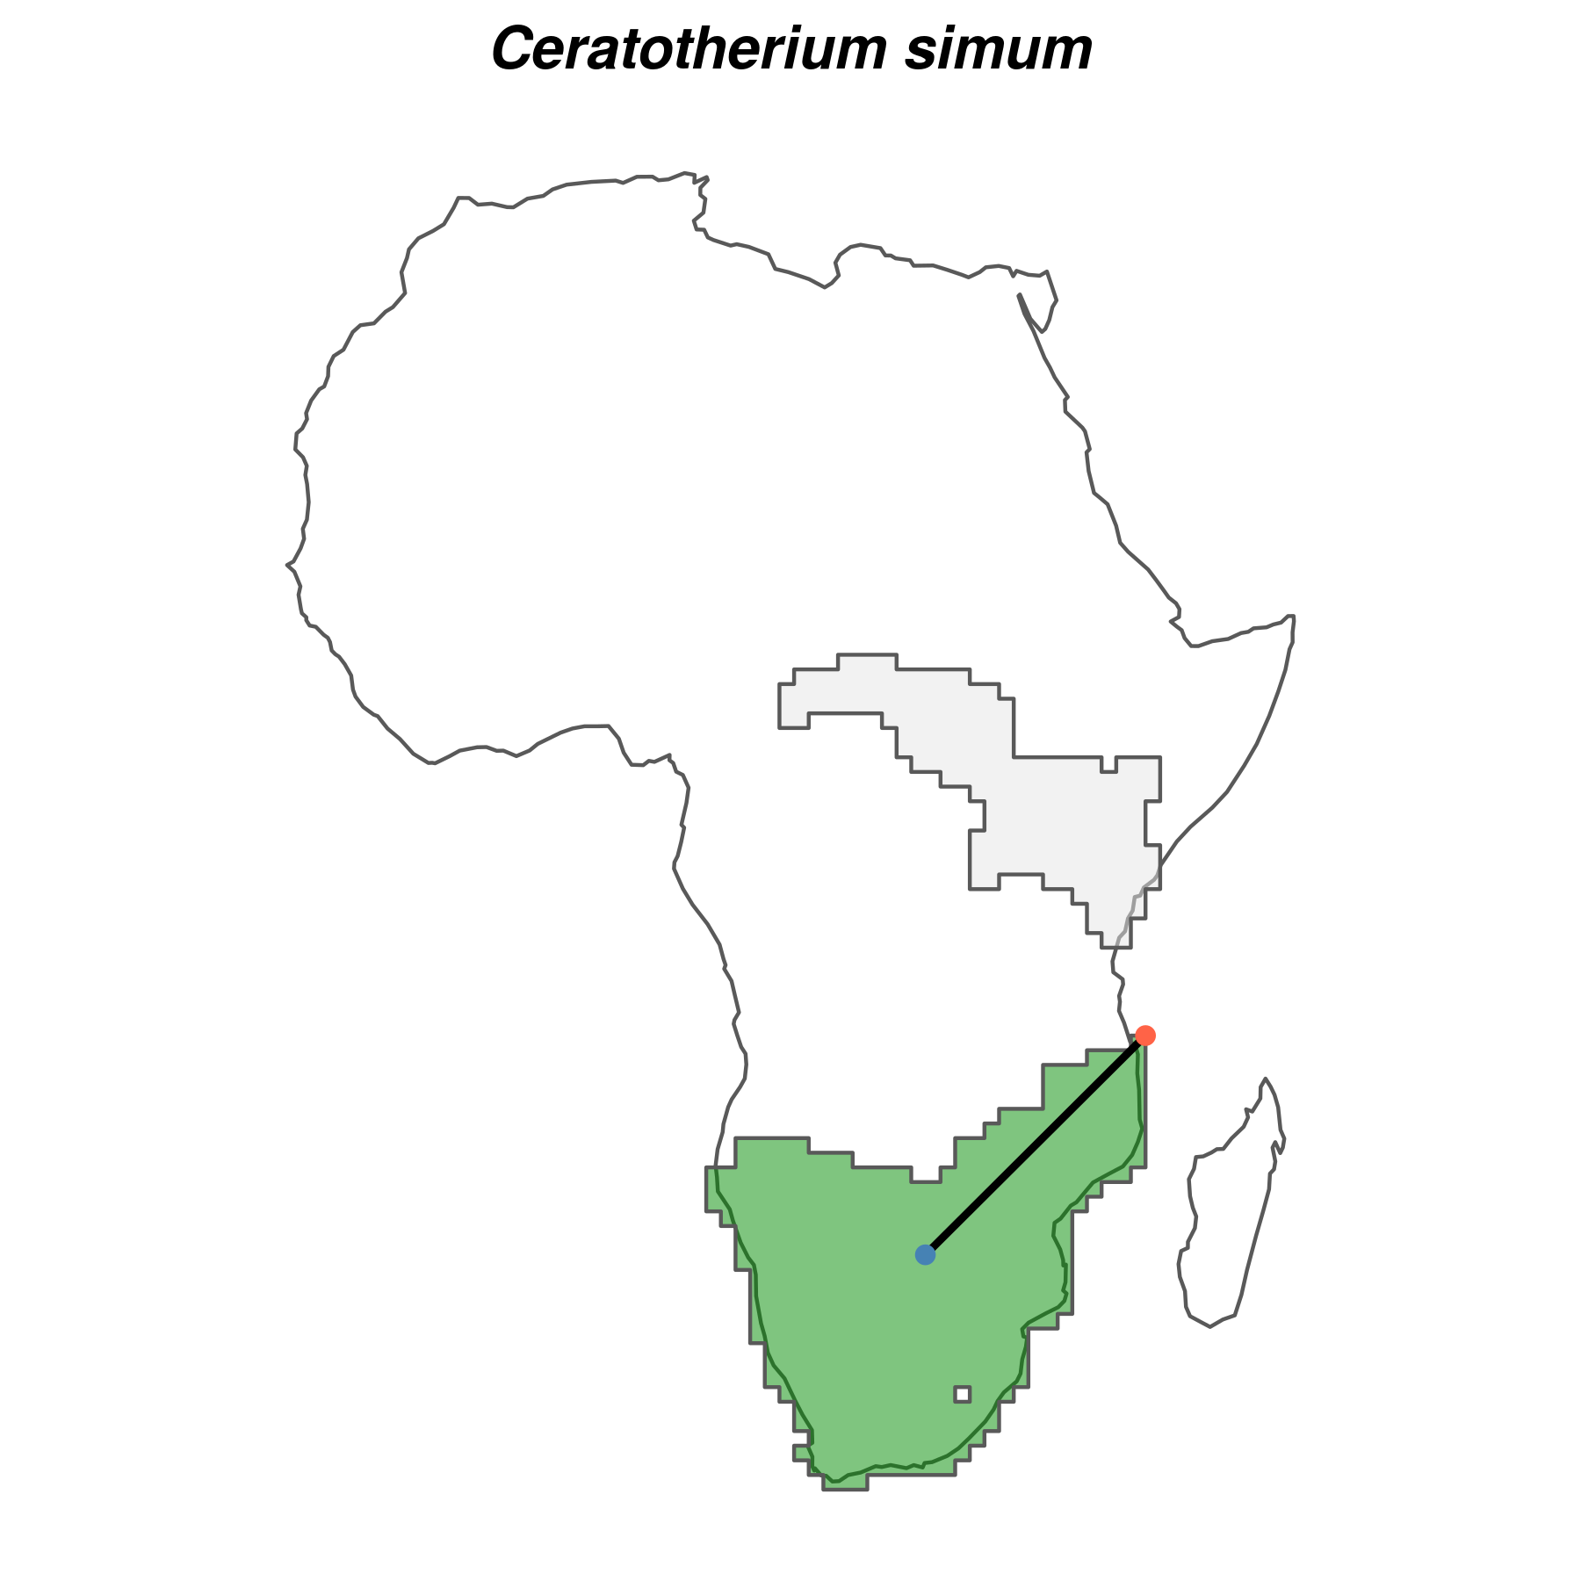Supplementary Figure 1: Example for the white rhinoceros (Ceratotherium simum) of species-specific buffer size used in the species distribution models. For each species, we calculated the background area buffer as the maximum distance (black line) from the centroid (blue point) to the edge (red point) of the largest continuous range (shown in green). The smallest continuous range is also shown (light grey).Buffer size was then used to delimit the area accessible to the species through dispersal, i.e. the area used to generate background locations. Ranges were the combined current and present-natural ranges from the PHYLACINE database (Faurby et al. 2018).

Supplementary Table 1: Summary of the evaluation statistics for the species distribution models for extant terrestrial mammals.

|  |  |  |  |  |
| --- | --- | --- | --- | --- |
| Evaluation statistic | Median | Median absolute deviation | Mean | Standard deviation |
| Continuous Boyce Index (CBI) | 0.93 | 0.08 | 0.87 | 0.15 |
| Area under the curve (AUC) of the receiver operating curve | 0.86 | 0.01 | 0.85 | 0.04 |
| Omission rate minimum training presence (ORMTP) | 0.02 | 0.03 | 0.07 | 0.15 |
| Proportion of known introduction ranges predicted* | 0.84 | 0.23 | 0.62 | 0.41 |

* Introduction ranges were obtained from Lundgren et al. (2018) and the IUCN Red List of Threatened Species (IUCN 2019).

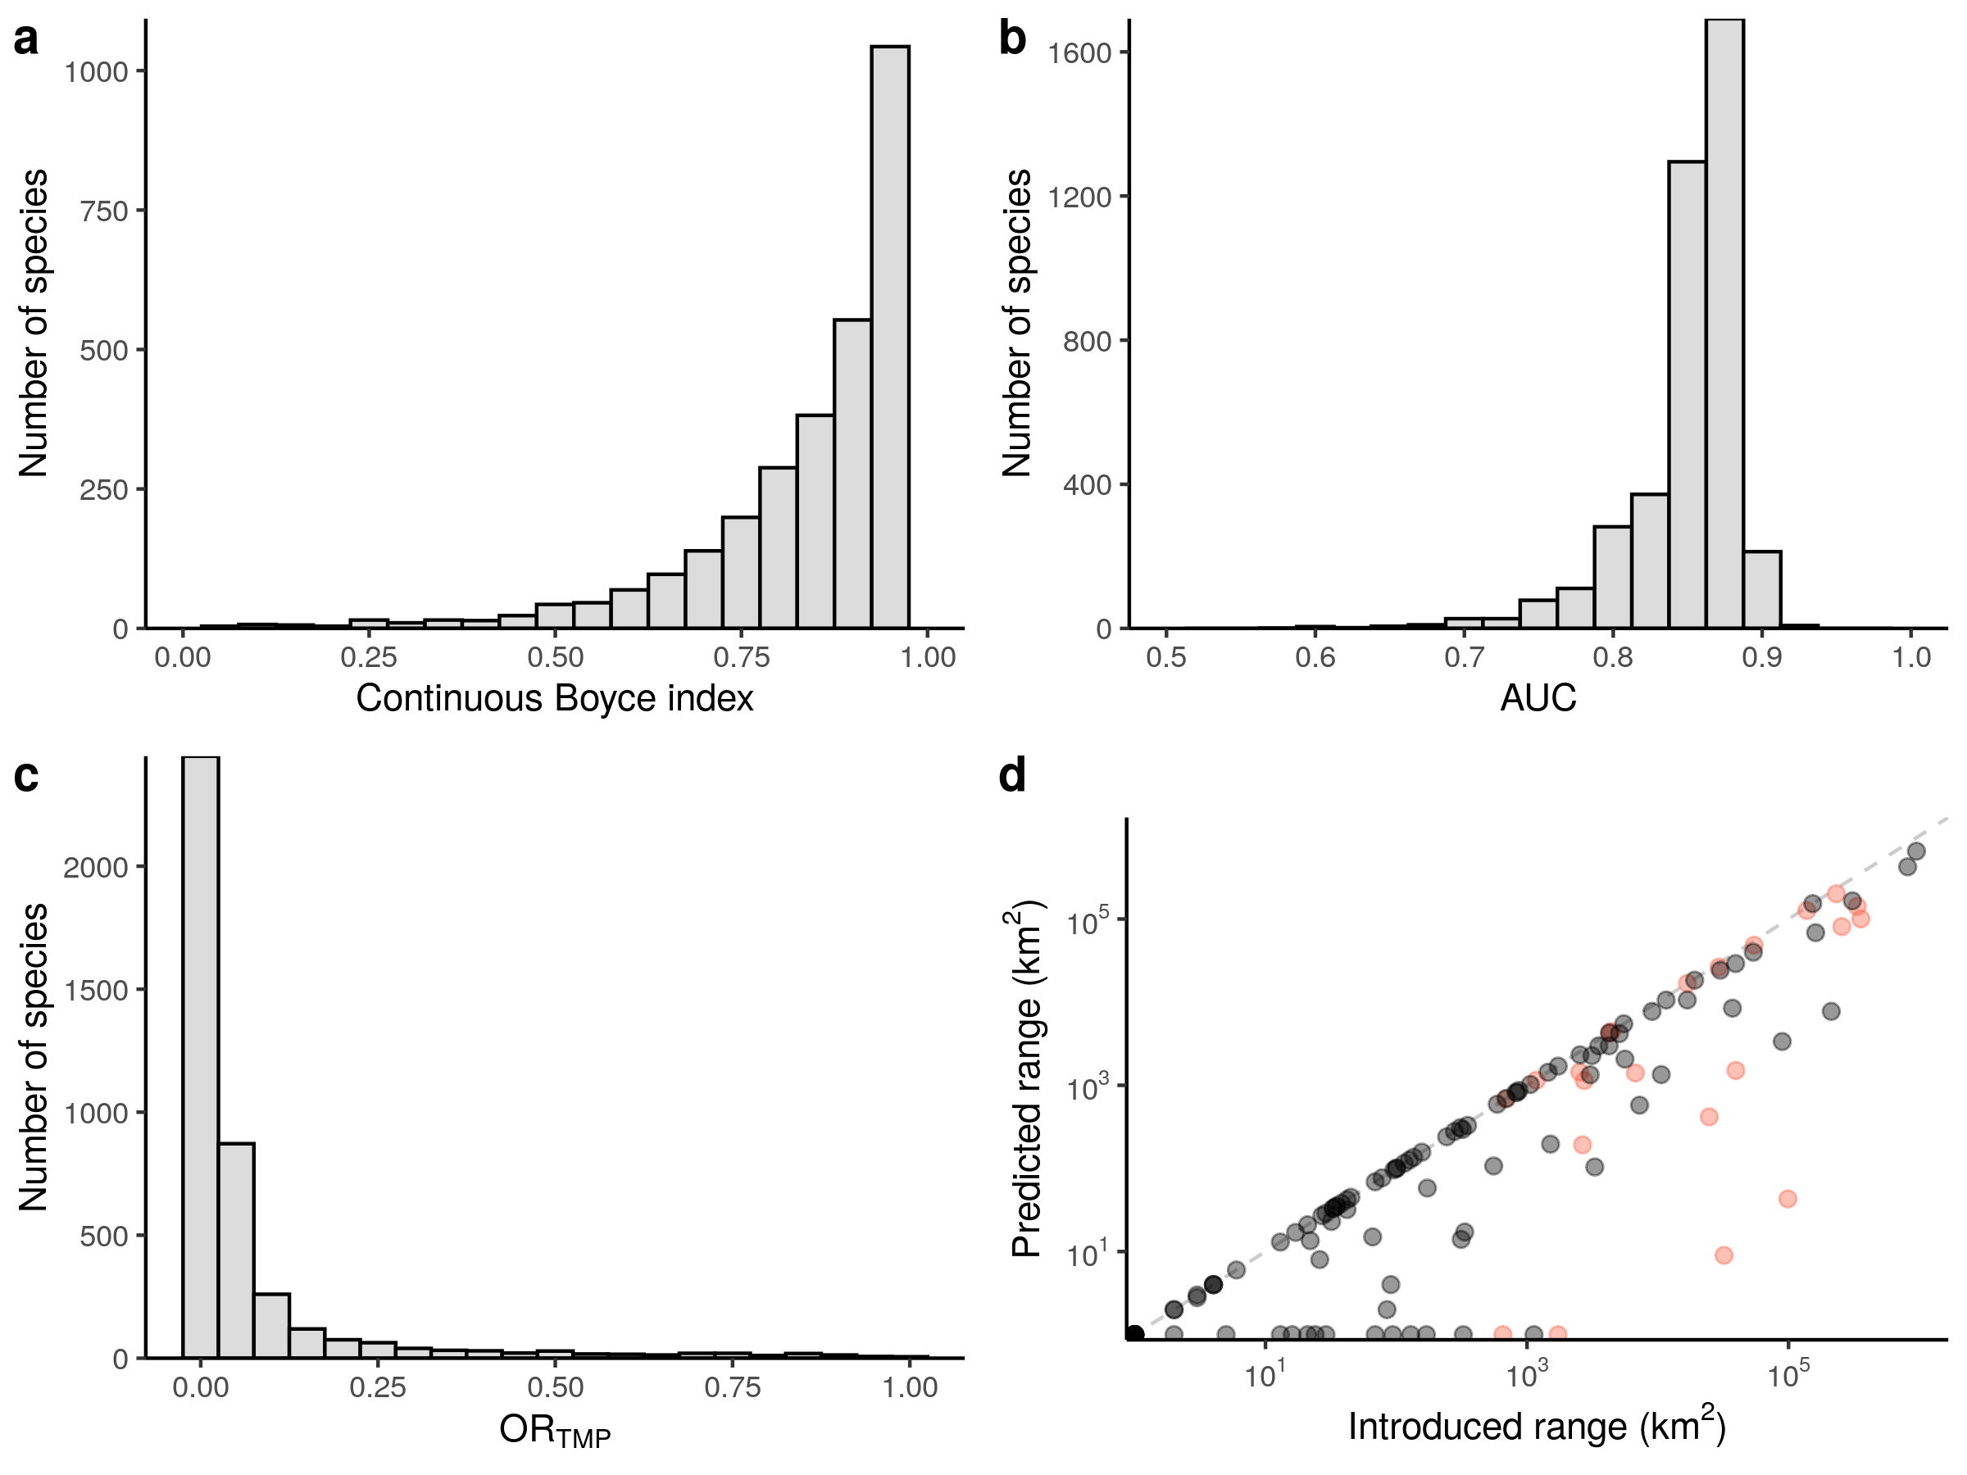

Supplementary Figure 2: Performance of maximum entropy (Maxent) species distribution models (SDMs). **a–c**, Histograms of the evaluation statistics for the Maxent SDMs. Predictive ability of SDMs is shown by both the Continuous Boyce Index (**a**) and by the Area Under the Curve (AUC) of the receiver operating curve (**b**). Model overfit is shown by the Omission Rate Minimum Training Presence (ORMTP;**c**). **d**, Scatterplot showing predictions of known introduction ranges of mammals using Maxent SDMs. Species with fully predicted known introduction range are on the plane bisector (dashed line). Introduced ranges were from Lundgren et al. (2018; red circles) and the IUCN Red List of Threatened Species (IUCN 2019; black circles).

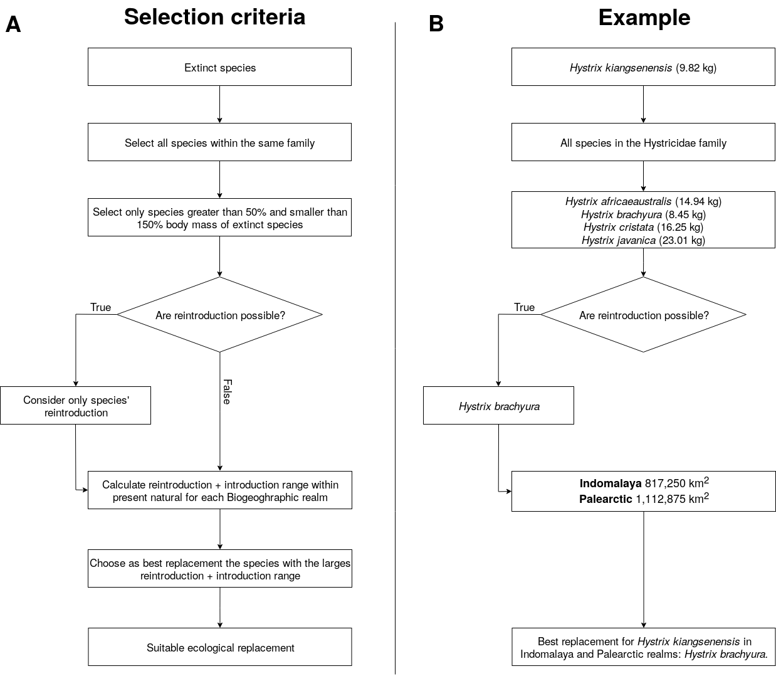

Supplementary Figure 3: Schematics showing selection of functional analogues to replace extinct species for the trophic rewilding scenario. We show for A) the selection criteria for replacement of extinct species with functional analogues, and B) a worked example of selecting a functional analogue for the extinct Hystrix kiangsenensis. Note that exceptions to the selection criteria are made for Probescians, Felidae and Ursidae as mentioned in the main text and Supplementary Material.

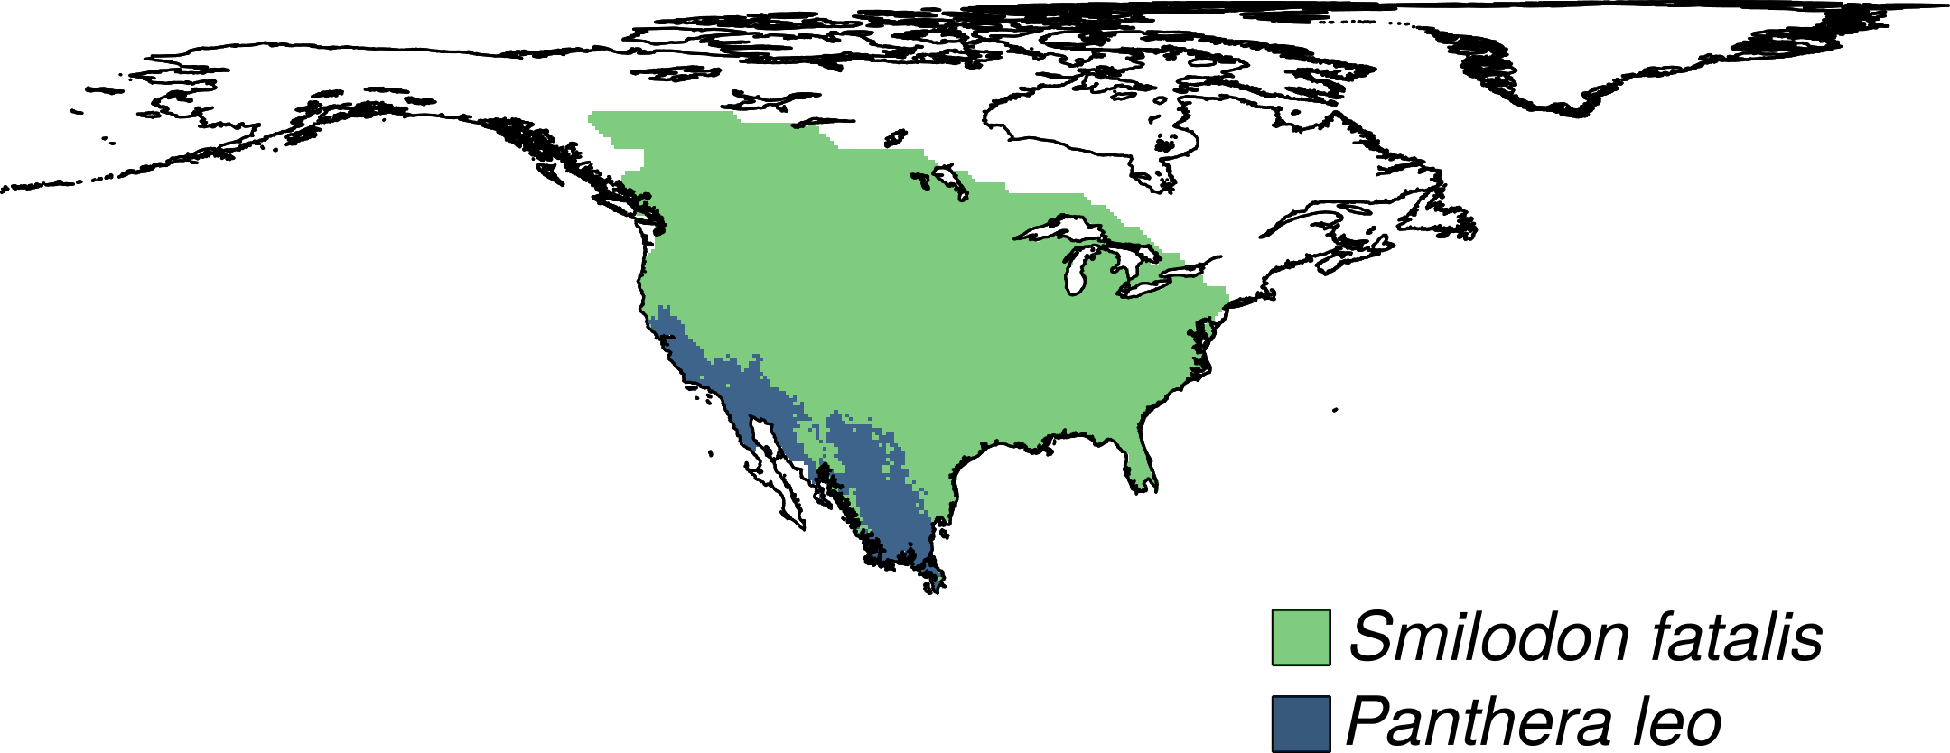

Supplementary Figure 4: Example of a functional analogue rewilding range for the extinct species Smilodon fatalis in the Nearctic realm. Present-natural ranges *S. Fatalis* (green shade) represent counter-factual ranges estimated for current climate without anthropogenic pressure through time and were from the PHYLACINE database (Faurby et al. 2018). The rewilding range of the functional analogue *Panthera leo* (blue shade) was obtained assessing its climatic suitability through maximum entropy species distribution models. In this example, P. leo rewilding range (blue area) is limited by the climatic suitability of species and covers only a small proportion of the present-natural distribution of S. fatalis.

Supplementary Table 2: List of the extinct species that were replaced by functional analogues in the focal biogeographic realm. List of terrestrial mammals extinct during the Late Pleistocene and their functional analogues for trophic rewilding in each biogeographic realm.

|  |  |  |
| --- | --- | --- |
| Extinct species | Functional analogues | Biogeographic realm |
| *Vombatus hacketti* | *Lasiorhinus latifrons* | Australasia |
| *Arctodus simus* | *Ursus arctos* | Nearctic |
| *Arctodus simus* | *Ursus arctos* | Neotropic |
| *Arctotherium wingei* | *Ursus americanus* | Neotropic |
| *Tremarctos floridanus* | *Ursus americanus* | Nearctic |
| *Tremarctos floridanus* | *Ursus americanus* | Neotropic |
| *Ursus spelaeus* | *Ursus arctos* | Palearctic |
| *Catagonus stenocephalus* | *Pecari tajacu* | Neotropic |
| *Muknalia minima* | *Pecari tajacu* | Nearctic |
| *Muknalia minima* | *Pecari tajacu* | Neotropic |
| *Tapirus augustus* | *Tapirus indicus* | Indomalaya |
| *Tapirus augustus* | *Tapirus indicus* | Palearctic |
| *Tapirus merriami* | *Tapirus bairdii* | Nearctic |
| *Tapirus rondoniensis* | *Tapirus terrestris* | Neotropic |
| *Tapirus veroensis* | *Tapirus bairdii* | Nearctic |
| *Tapirus veroensis* | *Tapirus bairdii* | Neotropic |
| *Kolpochoerus majus* | *Hylochoerus meinertzhageni* | Afrotropic |
| *Metridiochoerus compactus* | *Phacochoerus africanus* | Afrotropic |
| *Sus bucculentus* | *Sus scrofa* | Indomalaya |
| *Stegodon orientalis* | *Elephas maximus* | Indomalaya |
| *Stegodon orientalis* | *Elephas maximus* | Palearctic |
| *Stegodon trigonocephalus* | *Elephas maximus* | Indomalaya |
| *Elasmotherium sibiricum* | *Ceratotherium simum* | Palearctic |
| *Stephanorhinus kirchbergensis* | *Ceratotherium simum* | Indomalaya |
| *Stephanorhinus kirchbergensis* | *Ceratotherium simum* | Palearctic |
| *Petauroides ayamaruensis* | *Pseudochirulus canescens* | Australasia |
| *Petauroides ayamaruensis* | *Pseudochirulus schlegeli* | Australasia |
| *Bettongia anhydra* | *Bettongia lesueur* | Australasia |
| *Bettongia pusilla* | *Bettongia lesueur* | Australasia |
| *Bettongia pusilla* | *Bettongia penicillata* | Australasia |
| *Potorous platyops* | *Potorous gilbertii* | Australasia |
| *Perameles eremiana* | *Perameles bougainville* | Australasia |
| *Ochotona whartoni* | *Ochotona alpina* | Nearctic |
| *Neovison macrodon* | *Neovison vison* | Nearctic |
| *Conilurus albipes* | *Conilurus penicillatus* | Australasia |
| *Conilurus capricornensis* | *Conilurus penicillatus* | Australasia |
| *Notomys amplus* | *Notomys mitchellii* | Australasia |
| *Notomys longicaudatus* | *Notomys mitchellii* | Australasia |
| *Notomys macrotis* | *Notomys mitchellii* | Australasia |
| *Notomys mordax* | *Notomys alexis* | Australasia |
| *Notomys mordax* | *Notomys aquilo* | Australasia |
| *Notomys mordax* | *Notomys fuscus* | Australasia |
| *Notomys robustus* | *Notomys fuscus* | Australasia |
| *Pseudomys glaucus* | *Pseudomys novaehollandiae* | Australasia |
| *Pseudomys gouldii* | *Pseudomys desertor* | Australasia |
| *Brachyprotoma obtusata* | *Conepatus leuconotus* | Nearctic |
| *Manis paleojavanica* | *Smutsia gigantea* | Indomalaya |
| *Mammut americanum* | *Loxodonta africana* | Nearctic |
| *Mammut americanum* | *Loxodonta africana* | Neotropic |
| *Lagorchestes asomatus* | *Lagorchestes hirsutus* | Australasia |
| *Macropus greyi* | *Thylogale billardierii* | Australasia |
| *Metasthenurus newtonae* | *Macropus rufus* | Australasia |
| *Onychogalea lunata* | *Petrogale lateralis* | Australasia |
| *Procoptodon browneorum* | *Macropus giganteus* | Australasia |
| *Procoptodon gilli* | *Macropus rufus* | Australasia |
| *Protemnodon hopei* | *Macropus antilopinus* | Australasia |
| *Protemnodon hopei* | *Macropus giganteus* | Australasia |
| *Protemnodon hopei* | *Macropus rufus* | Australasia |
| *Protemnodon nombe* | *Macropus giganteus* | Australasia |
| *Protemnodon tumbuna* | *Macropus giganteus* | Australasia |
| *Simosthenurus maddocki* | *Macropus giganteus* | Australasia |
| *Sthenurus andersoni* | *Macropus rufus* | Australasia |
| *Thylogale christenseni* | *Dorcopsulus vanheurni* | Australasia |
| *Troposodon minor* | *Macropus giganteus* | Australasia |
| *Wallabia kitcheneri* | *Macropus fuliginosus* | Australasia |
| *Aztlanolagus agilis* | *Lepus californicus* | Nearctic |
| *Aztlanolagus agilis* | *Lepus californicus* | Neotropic |
| *Aztlanolagus agilis* | *Sylvilagus floridanus* | Neotropic |
| *Hystrix kiangsenensis* | *Hystrix brachyura* | Indomalaya |
| *Hystrix kiangsenensis* | *Hystrix brachyura* | Palearctic |
| *Hystrix refossa* | *Hystrix indica* | Indomalaya |
| *Hystrix refossa* | *Hystrix indica* | Palearctic |
| *Hexaprotodon sivalensis* | *Choeropsis liberiensis* | Indomalaya |
| *Cuvieronius hyodon* | *Elephas maximus* | Nearctic |
| *Cuvieronius hyodon* | *Loxodonta africana* | Neotropic |
| *Notiomastodon platensis* | *Elephas maximus* | Neotropic |
| *Homotherium latidens* | *Panthera tigris* | Palearctic |
| *Homotherium serum* | *Panthera onca* | Nearctic |
| *Homotherium serum* | *Panthera onca* | Neotropic |
| *Leopardus amnicola* | *Catopuma badia* | Nearctic |
| *Leopardus amnicola* | *Leopardus wiedii* | Neotropic |
| *Miracinonyx trumani* | *Puma concolor* | Nearctic |
| *Panthera atrox* | *Panthera tigris* | Nearctic |
| *Panthera atrox* | *Panthera leo* | Neotropic |
| *Panthera spelaea* | *Panthera tigris* | Nearctic |
| *Panthera spelaea* | *Panthera tigris* | Palearctic |
| *Smilodon fatalis* | *Panthera tigris* | Nearctic |
| *Smilodon fatalis* | *Panthera leo* | Neotropic |
| *Smilodon populator* | *Panthera leo* | Nearctic |
| *Smilodon populator* | *Panthera tigris* | Neotropic |
| *Equus francisci* | *Equus ferus* | Nearctic |
| *Equus francisci* | *Equus ferus* | Neotropic |
| *Equus hydruntinus* | *Equus ferus* | Palearctic |
| *Equus ovodovi* | *Equus ferus* | Palearctic |
| *Hippidion devillei* | *Equus ferus* | Neotropic |
| *Hippidion principale* | *Equus quagga* | Neotropic |
| *Elephas iolensis* | *Loxodonta africana* | Afrotropic |
| *Elephas iolensis* | *Loxodonta africana* | Palearctic |
| *Elephas namadicus* | *Elephas maximus* | Indomalaya |
| *Elephas namadicus* | *Elephas maximus* | Palearctic |
| *Elephas naumanii* | *Elephas maximus* | Indomalaya |
| *Elephas naumanii* | *Elephas maximus* | Palearctic |
| *Mammuthus columbi* | *Elephas maximus* | Nearctic |
| *Mammuthus columbi* | *Elephas maximus* | Neotropic |
| *Mammuthus primigenius* | *Elephas maximus* | Indomalaya |
| *Mammuthus primigenius* | *Elephas maximus* | Nearctic |
| *Mammuthus primigenius* | *Elephas maximus* | Palearctic |
| *Cryptonanus ignitus* | *Thylamys venustus* | Neotropic |
| *Dasypus bellus* | *Dasypus kappleri* | Nearctic |
| *Dasypus bellus* | *Dasypus kappleri* | Neotropic |
| *Lagostomus crassus* | *Lagostomus maximus* | Neotropic |
| *Agalmaceros blicki* | *Odocoileus virginianus* | Neotropic |
| *Cervalces scotti* | *Alces alces* | Nearctic |
| *Haploidoceros mediterraneus* | *Cervus elaphus* | Palearctic |
| *Megaloceros giganteus* | *Alces alces* | Palearctic |
| *Morenelaphus brachyceros* | *Ozotoceros bezoarticus* | Neotropic |
| *Navahoceros fricki* | *Odocoileus virginianus* | Nearctic |
| *Navahoceros fricki* | *Odocoileus virginianus* | Neotropic |
| *Paraceros fragilis* | *Ozotoceros bezoarticus* | Neotropic |
| *Rucervus schomburgki* | *Rucervus eldii* | Indomalaya |
| *Sangamona fugitiva* | *Cervus canadensis* | Nearctic |
| *Sinomegaceros ordosianus* | *Alces alces* | Palearctic |
| *Sinomegaceros yabei* | *Alces alces* | Indomalaya |
| *Sinomegaceros yabei* | *Alces alces* | Palearctic |
| *Neochoerus aesopi* | *Hydrochoerus hydrochaeris* | Nearctic |
| *Neochoerus aesopi* | *Hydrochoerus hydrochaeris* | Neotropic |
| *Canis dirus* | *Canis lupus* | Nearctic |
| *Canis dirus* | *Canis lupus* | Neotropic |
| *Dusicyon avus* | *Lycalopex griseus* | Neotropic |
| *Protocyon troglodytes* | *Chrysocyon brachyurus* | Neotropic |
| *Theriodictis tarijensis* | *Chrysocyon brachyurus* | Neotropic |
| *Camelops hesternus* | *Camelus ferus* | Nearctic |
| *Camelops hesternus* | *Camelus dromedarius* | Neotropic |
| *Hemiauchenia macrocephala* | *Lama guanicoe* | Nearctic |
| *Hemiauchenia macrocephala* | *Lama guanicoe* | Neotropic |
| *Hemiauchenia paradoxa* | *Camelus dromedarius* | Neotropic |
| *Palaeolama major* | *Camelus dromedarius* | Neotropic |
| *Palaeolama mirifica* | *Lama guanicoe* | Nearctic |
| *Palaeolama mirifica* | *Lama guanicoe* | Neotropic |
| *Palaeolama mirifica* | *Vicugna vicugna* | Neotropic |
| *Palaeolama weddeli* | *Camelus dromedarius* | Neotropic |
| *Antidorcas australis* | *Pelea capreolus* | Afrotropic |
| *Antidorcas bondi* | *Sylvicapra grimmia* | Afrotropic |
| *Bootherium bombifrons* | *Connochaetes taurinus* | Nearctic |
| *Bubalus palaeokerabau* | *Bos javanicus* | Indomalaya |
| *CapriniGen spA* | *Tragelaphus scriptus* | Afrotropic |
| *Damaliscus hypsodon* | *Tragelaphus scriptus* | Afrotropic |
| *Damaliscus niro* | *Alcelaphus buselaphus* | Afrotropic |
| *Euceratherium collinum* | *Bison bison* | Nearctic |
| *Euceratherium collinum* | *Bison bison* | Neotropic |
| *Gazella atlantica* | *Ammotragus lervia* | Palearctic |
| *Gazella bilkis* | *Capricornis crispus* | Afrotropic |
| *Gazella bilkis* | *Naemorhedus caudatus* | Afrotropic |
| *Gazella bilkis* | *Procapra gutturosa* | Afrotropic |
| *Gazella bilkis* | *Procapra przewalskii* | Afrotropic |
| *Gazella bilkis* | *Eudorcas albonotata* | Palearctic |
| *Gazella saudiya* | *Gazella gazella* | Afrotropic |
| *Gazella saudiya* | *Gazella gazella* | Palearctic |
| *Gazella tingitana* | *Gazella cuvieri* | Palearctic |
| *Hemitragus cedrensis* | *Capra pyrenaica* | Palearctic |
| *Hippotragus leucophaeus* | *Alcelaphus buselaphus* | Afrotropic |
| *Hippotragus leucophaeus* | *Damaliscus pygargus* | Afrotropic |
| *Megalotragus priscus* | *Alcelaphus buselaphus* | Afrotropic |
| *Megalovis guangxiensis* | *Pseudois nayaur* | Indomalaya |
| *Megalovis guangxiensis* | *Pseudois nayaur* | Palearctic |
| *Oreamnos harringtoni* | *Ovis canadensis* | Nearctic |
| *Oreamnos harringtoni* | *Ovis canadensis* | Neotropic |
| *Pelorovis antiquus* | *Bos primigenius* | Palearctic |
| *Rusingoryx atopocranion* | *Kobus ellipsiprymnus* | Afrotropic |
| *Sivacobus sankaliai* | *Capricornis thar* | Indomalaya |
| *Sivacobus sankaliai* | *Capricornis thar* | Palearctic |
| *Soergelia minor* | *Capra sibirica* | Palearctic |
| *Spirocerus kiakhtensis* | *Bos primigenius* | Palearctic |
| *Caipora bambuiorum* | *Brachyteles arachnoides* | Neotropic |
| *Protopithecus brasiliensis* | *Brachyteles arachnoides* | Neotropic |
| *Stockoceros conklingi* | *Antilocapra americana* | Nearctic |
| *Stockoceros conklingi* | *Antilocapra americana* | Neotropic |
| *Tetrameryx shuleri* | *Antilocapra americana* | Nearctic |
| *Tetrameryx shuleri* | *Antilocapra americana* | Neotropic |

Supplementary Table 3: Average proportions from the reconstructed food webs of the number of species per trophic level for current and rewilding scenario respect to the present-natural in protected areas ≥ 5,000 km2 with IUCN management status I-II and in random areas ≥ 5,000 km2.

|  |  |  |
| --- | --- | --- |
| **Trophic level** | **Current / present-natural** | **Rewilding / present-natural** |
| **Protected areas** | | |
| Megacarnivores (≥ 100 kg) | 0.29 | 0.53 |
| Megaherbivores (≥ 1,000 kg) | 0.17 | 0.31 |
| Large carnivores (21.5–99 kg) | 0.71 | 0.80 |
| Large herbivores (45–999 kg) | 0.44 | 0.61 |
| Small carnivores (< 21.5 kg) | 0.94 | 0.98 |
| Small herbivores (< 45 kg) | 0.97 | 0.98 |
| **Random areas** | | |
| Megacarnivores (≥ 100 kg) | 0.15 | 0.51 |
| Megaherbivores (≥ 1,000 kg) | 0.08 | 0.31 |
| Large carnivores (21.5–99 kg) | 0.51 | 0.92 |
| Large herbivores (45–999 kg) | 0.33 | 0.60 |
| Small carnivores (< 21.5 kg) | 0.92 | 0.98 |
| Small herbivores (< 45 kg) | 0.96 | 0.98 |

Supplementary Table 4: Average proportion from the reconstructed food webs of the number of predator-prey interactions between trophic levels for current and rewilding scenarios relative to the present-natural in protected areas ≥ 5,000 km2 with IUCN management status I-II and in random areas ≥ 5,000 km2.

|  |  |  |  |
| --- | --- | --- | --- |
| **Predator** | **Prey** | **Current / present-natural** | **Rewilding / present-natural** |
| **Protected areas** | | | |
| Megacarnivores | Large carnivores | 0.31 | 0.61 |
| Large herbivores | 0.17 | 0.33 |
| Small carnivores | 0.29 | 0.60 |
| Small herbivores | 0.28 | 0.55 |
| Large carnivores | Large herbivores | 0.42 | 0.50 |
| Small carnivores | 0.69 | 0.88 |
| Small herbivores | 0.78 | 0.89 |
| Small carnivores | Small herbivores | 0.95 | 0.99 |
| **Random areas** | | | |
| Megacarnivores | Large carnivores | 0.12 | 0.62 |
|  | Large herbivores | 0.08 | 0.38 |
|  | Small carnivores | 0.17 | 0.60 |
|  | Small herbivores | 0.16 | 0.58 |
| Large carnivores | Large herbivores | 0.29 | 0.55 |
|  | Small carnivores | 0.46 | 0.92 |
|  | Small herbivores | 0.57 | 0.92 |
| Small carnivores | Small herbivores | 0.89 | 0.98 |

# References

Elith, J. et al. A statistical explanation of maxent for ecologists. *Divers. Distrib.* **17**, 43–57 (2011).

Faurby, S. et al. PHYLACINE 1.2: The phylogenetic atlas of mammal macroecology. *Ecology* **99**, 2626–2626 (2018).

Fielding, A. H. & Bell, J. F. A review of methods for the assessment of prediction errors in conservation presence/absence models. *Environ. Conserv.* **24**, 38–49 (1997).

Guevara, L., Gerstner, B. E., Kass, J. M. & Anderson, R. P. Toward ecologically realistic predictions of species distributions: A cross-time example from tropical montane cloud forests. *Glob. Change Biol.* **24**, 1511–1522 (2018).

Hirzel, A. H., Le Lay, G., Helfer, V., Randin, C. & Guisan, A. Evaluating the ability of habitat suitability models to predict species presences. *Ecol. Model.* **199**, 142–152 (2006).

Hof, C. et al. Bioenergy cropland expansion may offset positive effects of climate change mitigation for global vertebrate diversity. *Proc. Nat. Acad. Sci.* **115**, 13294–13299 (2018).

IUCN 2019. The IUCN Red List of Threatened Species. Version 2019-3. http://www.iucnredlist.org/. Downloaded on 10 December 2019.

Liu, C., Newell, G. & White, M. On the selection of thresholds for predicting species occurrence with presence-only data. *Ecol. Evol.* **6**, 337–348 (2016).

Lundgren, E. J., Ramp, D., Ripple, W. J. & Wallach, A. D. Introduced megafauna are rewilding the Anthropocene. *Ecography* **41**, 857–866 (2018).

Merow, C., Smith, M. J., & Silander Jr, J. A. (2013). A practical guide to maxent for modeling species’ distributions: What it does, and why inputs and settings matter. *Ecography* **36**, 1058–1069.

Merow, C. et al. What do we gain from simplicity versus complexity in species distribution models? *Ecography* **37**, 1267–1281 (2014).

Phillips, S. J., Anderson, R. P., Dudík, M., Schapire, R. E. & Blair, M. E. Opening the black box: An open-source release of Maxent. *Ecography* **40**, 887–893 (2017).

Poo-Muñoz, D. A. et al. Galictis cuja (Mammalia): An update of current knowledge and geographic distribution. *Iheringia. Série Zoologia* **104**, 341–346 (2014).

Sandom, C. J. et al. Trophic rewilding presents regionally specific opportunities for mitigating climate change. *Philos. Trans. R. Soc. B: Biol. Sci.* **375**, 20190125 (2020).

Swets, J. A. Measuring the accuracy of diagnostic systems. *Science* **240**, 1285–1293 (1988).