Appendix for Rewiring food webs via trophic rewilding
Emilio Berti, Scott Jarvie, and Jens-Christian Svenning
Section for Ecoinformatics and Biodiversity, Department of Bioscience, Aarhus University, Ny Munkegade 114, DK-8000 Aarhus C, Denmark.\ Center for Biodiversity Dynamics in a Changing World (BIOCHANGE), Department of Bioscience, Aarhus University, Ny Munkegade 114, DK-8000 Aarhus C, Denmark.\ corresponding author: emilio.berti@bios.au.dk
Keywords: Food webs - Human-driven extinctions - Mammals - Megafauna - Rewilding - Trophic interactions.

Supporting information

Changes to the PHYLACINE database
We modified the body mass of two extinct species in the PHYLACINE database before modelling and analyses: body mass of the extinct species Sinomegaceros ordosianus was set equal to the mass of Sinomegaceros yabei and body mass of the extinct Dusicyon australis to Dusicyon avus.

Maxent species distribution models
Climatic suitability of terrestrial mammals was modelled using maximum entropy (Maxent) SDMs using the maxnet R-package based on inhomogeneous Poisson processes (Phillips, Anderson, Dudík, Schapire, & Blair, 2017). Maxent is a presence-background approach, in which environments occupied by a species are contrasted with the available environmental space (Elith et al., 2011; Merow, Smith, & Silander Jr, 2013). To predict distribution of mammals we used four bioclimatic variables from the Worldclim database at 2.5 arc-minute resolution (Fick & Hijmans, 2017): maximum temperature of the warmest month, minimum temperature of the coldest month, precipitation of wettest quarter, and precipitation of driest quarter. We reprojected these bioclimatic variables to a 5 km² resolution with a Behrmann equal-area projection using bilinear interpolation. To minimize potential issues with multi-collinearity, we ensured that the variance inflation factor among the climatic variables was below 4 (CITE).
We ran Maxent SDMs with the default settings, besides disabling threshold features to avoid locally overfitted response curves (Merow et al., 2013, 2014). We also increased the number of randomly sampled background records from the default setting of 10,000 to 100,000 to ensure greater representation of environmental variables available within background areas (Guevara, Gerstner, Kass, & Anderson, 2018). For the background area, we calculated species-specific buffers from combined current and present natural ranges (Faurby et al. 2018) to reflect the dispersal abilities of each species. Following previous studies (Hof et al., 2018; Poo-Muñoz et al., 2014), we calculated the buffer size as the maximum distance from the range centroid to the range edge of the largest continuous range (Hof et al., 2018; Poo-Muñoz et al., 2014); see figure S1 for an example. We only modelled species that had at least 10 presence locations, thus excluding 76 rare species with restricted geographic distribution. In total, we modeled 4,130 of the 4,206 living terrestrial mammals.

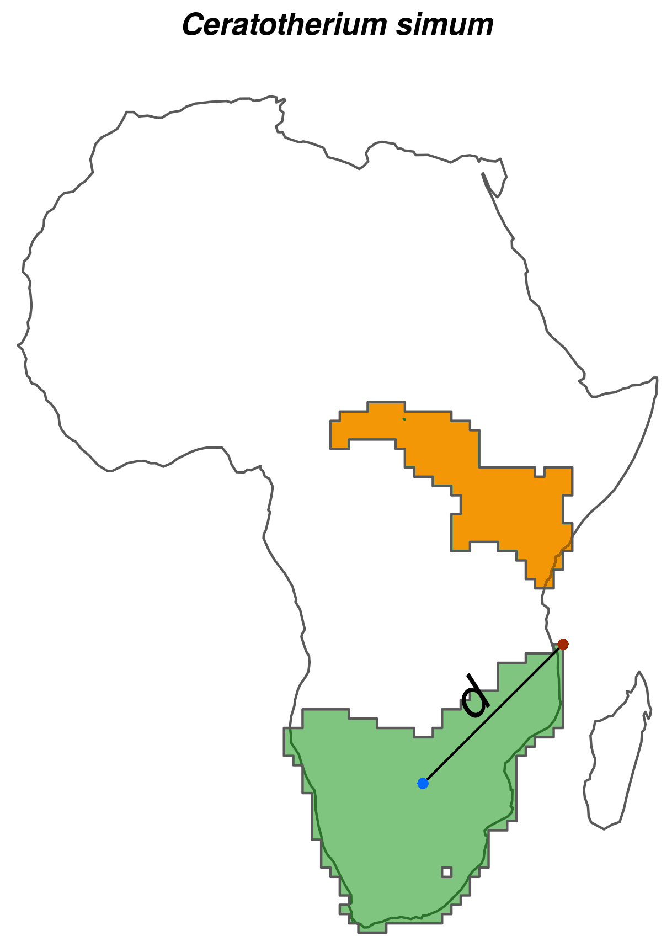

Figure S1: Schematic showing how species-specific background areas were calculated for maximum entropy (Maxent) species distribution models using the white rhinoceros (Ceratotherium simum) as an example. For each species, we calculated background area buffers as the maximum distance (d; black line) between the range centroid (blue point) and edge (red point) of the largest continuous range of the species (green shade). We calculated d for each species to reflect species-specific dispersal capabilities (Hof et al., 2018; Poo-Muñoz et al., 2014).
We assessed the predictive performance of Maxent models through five-fold cross validation using the average continuous Boyce index (CBI; Hirzel, Le Lay, Helfer, Randin, & Guisan (2006)), which indicates how much models discriminate against random expectation, and the average area under the Receiver Operating Curve (AUC; Swets (1988)), which indicates how well models differentiate between presences and pseudo-absences regardless of the degree of difference between them. Values of CBI range between -1 and 1, where values > 0 indicate the model's output is positively correlated with the true probability of presence and values < 0 indicate it is negatively correlated with the true probability of presence. AUC values range from <= 0.5 for models with discrimination no better than random to 1 for models with perfect discrimination between occupied and unoccupied places (Fielding & Bell, 1997). Model fit was inspected by five-fold cross validation of the average omission rate based on the minimum training presence value (ORMTP). The values of ORMTP range from 0 for models that are not overfit to 1 for models that are overfit. To convert continuous suitability predictions to binary layers indicating suitable/unsuitable habitat, we used as threshold the suitability value that maximised sensitivity and specificity (MSS) following Liu, Newell, & White (2016). We further assessed the performance of Maxent models by comparing projections of climatic suitability with 136 introduced range maps from Lundgren, Ramp, Ripple, & Wallach (2018) (n = 22 species) and the IUCN (IUCN (2016); n = 114 species). Introduced range maps were selected from Lundgren et al. (2018) over the IUCN (IUCN, 2016) for three species found in both datasets (Cervus elaphus, Ovibos moschatus, and Rangifer tarandus).
Evaluation statistics indicated, in general, very high to excellent quality of Maxent models. CBI index and AUC were on average very high (Table S1; figure S2) and ORMTP was in low, indicating that models were in general not overfitted. Also, much of the species' known introduction ranges were captured by Maxent models (figure S2): the median of the predicted introduction range was 0.84, with a median absolute deviation equal to 0.23.
Table S1: Evaluation statistics of the species distribution models (SDMs).
Evaluation statistic | Median | Median absolute deviation | Mean | Standard deviation
Continuous Boyce index (CBI) | 0.93 | 0.08 | 0.87 | 0.15
Area under the receiver operating curve(AUC) | 0.86 | 0.01 | 0.85 | 0.04

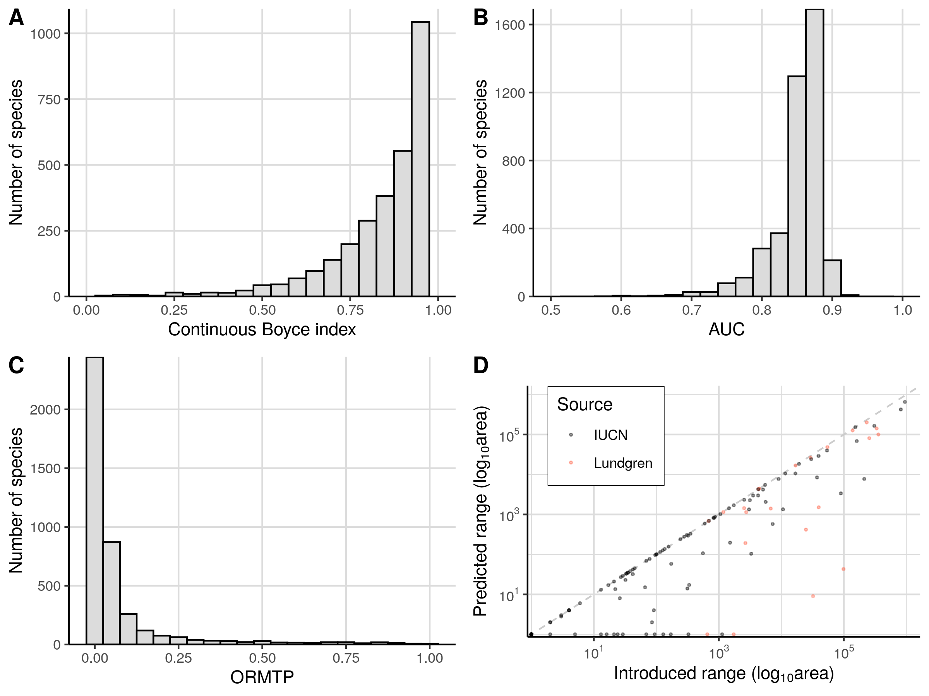
Figure S2: Evaluation statistics of Maxent species distribution models and comparison of predicted ranges to known introduced ranges. Predictive ability of the SDMs are shown by the Continuous Boyce index (A) and the area under the receiver operating curve (AUC, B). Model fit is shown by omission rate of minimum training points (ORMTP, C). Most of the range of introduced species was predicted by the Maxent SDMs (D). The introduced ranges were from IUCN introduction ranges (IUCN, 2016) and Lundgren et al. (2018).

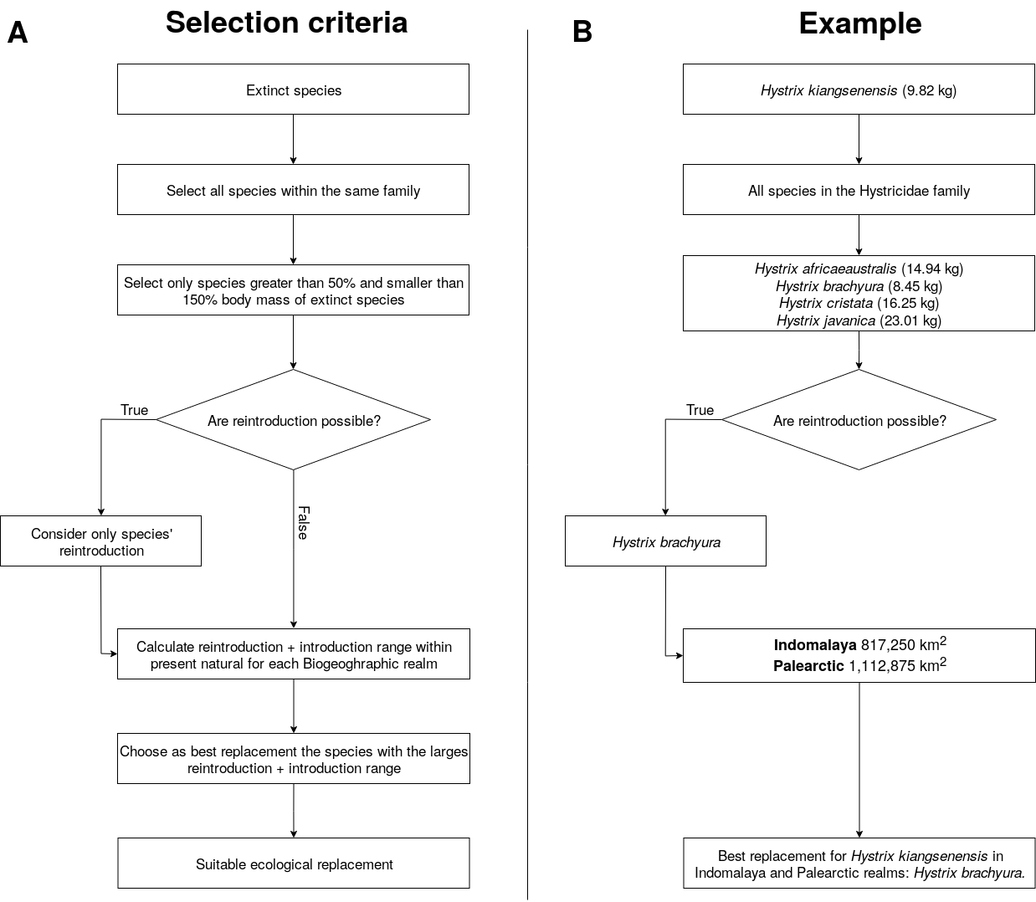
Figure S3: Schematics showing selection of functional analogues to replace extinct species for the trophic rewilding scenario. We show for a) the selection criteria for replacement of extinct species with functional analogues, and b) a worked example of the selection criteria directly alongside for the replacement of the extinct Hystrix kiangsenensis. Note that exceptions to the selection criteria are made for Probescians, Felidae and Ursidae as mentioned in the main text and Supplementary Material.

Table S1: List of extinct terrestrial mammals from the Late Pleistocene and the identified functional analogue to replace them in each biogeographic realm. We identified functional analogues following the selection criteria written in the main text and shown in Fig. S#. In total, 94 living species were identified that could be used as functional analogues for 127 of the 334 extinct terrestrial mammals.
Extinct species | Functional analogues | Biogeographic realm
Vombatus hacketti | Lasiorhinus latifrons | Australasia
Arctodus simus | Ursus arctos | Nearctic
Arctodus simus | Ursus arctos | Neotropic
Arctotherium wingei | Ursus americanus | Neotropic
Tremarctos floridanus | Ursus americanus | Nearctic
Tremarctos floridanus | Ursus americanus | Neotropic
Ursus spelaeus | Ursus arctos | Palearctic
Catagonus stenocephalus | Pecari tajacu | Neotropic
Muknalia minima | Pecari tajacu | Nearctic
Muknalia minima | Pecari tajacu | Neotropic
Tapirus augustus | Tapirus indicus | Indomalaya
Tapirus augustus | Tapirus indicus | Palearctic
Tapirus merriami | Tapirus bairdii | Nearctic
Tapirus rondoniensis | Tapirus terrestris | Neotropic
Tapirus veroensis | Tapirus bairdii | Nearctic
Tapirus veroensis | Tapirus bairdii | Neotropic
Kolpochoerus majus | Hylochoerus meinertzhageni | Afrotropic
Metridiochoerus compactus | Phacochoerus africanus | Afrotropic
Sus bucculentus | Sus scrofa | Indomalaya
Stegodon orientalis | Elephas maximus | Indomalaya
Stegodon orientalis | Elephas maximus | Palearctic
Stegodon trigonocephalus | Elephas maximus | Indomalaya
Elasmotherium sibiricum | Ceratotherium simum | Palearctic
Stephanorhinus kirchbergensis | Ceratotherium simum | Indomalaya
Stephanorhinus kirchbergensis | Ceratotherium simum | Palearctic
Petauroides ayamaruensis | Pseudochirulus canescens | Australasia
Petauroides ayamaruensis | Pseudochirulus schlegeli | Australasia
Bettongia anhydra | Bettongia lesueur | Australasia
Bettongia pusilla | Bettongia lesueur | Australasia
Bettongia pusilla | Bettongia penicillata | Australasia
Potorous platyops | Potorous gilbertii | Australasia
Perameles eremiana | Perameles bougainville | Australasia
Ochotona whartoni | Ochotona alpina | Nearctic
Neovison macrodon | Neovison vison | Nearctic
Conilurus albipes | Conilurus penicillatus | Australasia
Conilurus capricornensis | Conilurus penicillatus | Australasia
Notomys amplus | Notomys mitchellii | Australasia
Notomys longicaudatus | Notomys mitchellii | Australasia
Notomys macrotis | Notomys mitchellii | Australasia
Notomys mordax | Notomys alexis | Australasia
Notomys mordax | Notomys aquilo | Australasia
Notomys mordax | Notomys fuscus | Australasia
Notomys robustus | Notomys fuscus | Australasia
Pseudomys glaucus | Pseudomys novaehollandiae | Australasia
Pseudomys gouldii | Pseudomys desertor | Australasia
Brachyprotoma obtusata | Conepatus leuconotus | Nearctic
Manis paleojavanica | Smutsia gigantea | Indomalaya
Mammut americanum | Loxodonta africana | Nearctic
Mammut americanum | Loxodonta africana | Neotropic
Lagorchestes asomatus | Lagorchestes hirsutus | Australasia
Macropus greyi | Thylogale billardierii | Australasia
Metasthenurus newtonae | Macropus rufus | Australasia
Onychogalea lunata | Petrogale lateralis | Australasia
Procoptodon browneorum | Macropus giganteus | Australasia
Procoptodon gilli | Macropus rufus | Australasia
Protemnodon hopei | Macropus antilopinus | Australasia
Protemnodon hopei | Macropus giganteus | Australasia
Protemnodon hopei | Macropus rufus | Australasia
Protemnodon nombe | Macropus giganteus | Australasia
Protemnodon tumbuna | Macropus giganteus | Australasia
Simosthenurus maddocki | Macropus giganteus | Australasia
Sthenurus andersoni | Macropus rufus | Australasia
Thylogale christenseni | Dorcopsulus vanheurni | Australasia
Troposodon minor | Macropus giganteus | Australasia
Wallabia kitcheneri | Macropus fuliginosus | Australasia
Aztlanolagus agilis | Lepus californicus | Nearctic
Aztlanolagus agilis | Lepus californicus | Neotropic
Aztlanolagus agilis | Sylvilagus floridanus | Neotropic
Hystrix kiangsenensis | Hystrix brachyura | Indomalaya
Hystrix kiangsenensis | Hystrix brachyura | Palearctic
Hystrix refossa | Hystrix indica | Indomalaya
Hystrix refossa | Hystrix indica | Palearctic
Hexaprotodon sivalensis | Choeropsis liberiensis | Indomalaya
Cuvieronius hyodon | Elephas maximus | Nearctic
Cuvieronius hyodon | Loxodonta africana | Neotropic
Notiomastodon platensis | Elephas maximus | Neotropic
Homotherium latidens | Panthera tigris | Palearctic
Homotherium serum | Panthera onca | Nearctic
Homotherium serum | Panthera onca | Neotropic
Leopardus amnicola | Catopuma badia | Nearctic
Leopardus amnicola | Leopardus wiedii | Neotropic
Miracinonyx trumani | Puma concolor | Nearctic
Panthera atrox | Panthera tigris | Nearctic
Panthera atrox | Panthera leo | Neotropic
Panthera spelaea | Panthera tigris | Nearctic
Panthera spelaea | Panthera tigris | Palearctic
Smilodon fatalis | Panthera tigris | Nearctic
Smilodon fatalis | Panthera leo | Neotropic
Smilodon populator | Panthera leo | Nearctic
Smilodon populator | Panthera tigris | Neotropic
Equus francisci | Equus ferus | Nearctic
Equus francisci | Equus ferus | Neotropic
Equus hydruntinus | Equus ferus | Palearctic
Equus ovodovi | Equus ferus | Palearctic
Hippidion devillei | Equus ferus | Neotropic
Hippidion principale | Equus quagga | Neotropic
Elephas iolensis | Loxodonta africana | Afrotropic
Elephas iolensis | Loxodonta africana | Palearctic
Elephas namadicus | Elephas maximus | Indomalaya
Elephas namadicus | Elephas maximus | Palearctic
Elephas naumanii | Elephas maximus | Indomalaya
Elephas naumanii | Elephas maximus | Palearctic
Mammuthus columbi | Elephas maximus | Nearctic
Mammuthus columbi | Elephas maximus | Neotropic
Mammuthus primigenius | Elephas maximus | Indomalaya
Mammuthus primigenius | Elephas maximus | Nearctic
Mammuthus primigenius | Elephas maximus | Palearctic
Cryptonanus ignitus | Thylamys venustus | Neotropic
Dasypus bellus | Dasypus kappleri | Nearctic
Dasypus bellus | Dasypus kappleri | Neotropic
Lagostomus crassus | Lagostomus maximus | Neotropic
Agalmaceros blicki | Odocoileus virginianus | Neotropic
Cervalces scotti | Alces alces | Nearctic
Haploidoceros mediterraneus | Cervus elaphus | Palearctic
Megaloceros giganteus | Alces alces | Palearctic
Morenelaphus brachyceros | Ozotoceros bezoarticus | Neotropic
Navahoceros fricki | Odocoileus virginianus | Nearctic
Navahoceros fricki | Odocoileus virginianus | Neotropic
Paraceros fragilis | Ozotoceros bezoarticus | Neotropic
Rucervus schomburgki | Rucervus eldii | Indomalaya
Sangamona fugitiva | Cervus canadensis | Nearctic
Sinomegaceros ordosianus | Alces alces | Palearctic
Sinomegaceros yabei | Alces alces | Indomalaya
Sinomegaceros yabei | Alces alces | Palearctic
Neochoerus aesopi | Hydrochoerus hydrochaeris | Nearctic
Neochoerus aesopi | Hydrochoerus hydrochaeris | Neotropic
Canis dirus | Canis lupus | Nearctic
Canis dirus | Canis lupus | Neotropic
Dusicyon avus | Lycalopex griseus | Neotropic
Protocyon troglodytes | Chrysocyon brachyurus | Neotropic
Theriodictis tarijensis | Chrysocyon brachyurus | Neotropic
Camelops hesternus | Camelus ferus | Nearctic
Camelops hesternus | Camelus dromedarius | Neotropic
Hemiauchenia macrocephala | Lama guanicoe | Nearctic
Hemiauchenia macrocephala | Lama guanicoe | Neotropic
Hemiauchenia paradoxa | Camelus dromedarius | Neotropic
Palaeolama major | Camelus dromedarius | Neotropic
Palaeolama mirifica | Lama guanicoe | Nearctic
Palaeolama mirifica | Lama guanicoe | Neotropic
Palaeolama mirifica | Vicugna vicugna | Neotropic
Palaeolama weddeli | Camelus dromedarius | Neotropic
Antidorcas australis | Pelea capreolus | Afrotropic
Antidorcas bondi | Sylvicapra grimmia | Afrotropic
Bootherium bombifrons | Connochaetes taurinus | Nearctic
Bubalus palaeokerabau | Bos javanicus | Indomalaya
CapriniGen spA | Tragelaphus scriptus | Afrotropic
Damaliscus hypsodon | Tragelaphus scriptus | Afrotropic
Damaliscus niro | Alcelaphus buselaphus | Afrotropic
Euceratherium collinum | Bison bison | Nearctic
Euceratherium collinum | Bison bison | Neotropic
Gazella atlantica | Ammotragus lervia | Palearctic
Gazella bilkis | Capricornis crispus | Afrotropic
Gazella bilkis | Naemorhedus caudatus | Afrotropic
Gazella bilkis | Procapra gutturosa | Afrotropic
Gazella bilkis | Procapra przewalskii | Afrotropic
Gazella bilkis | Eudorcas albonotata | Palearctic
Gazella saudiya | Gazella gazella | Afrotropic
Gazella saudiya | Gazella gazella | Palearctic
Gazella tingitana | Gazella cuvieri | Palearctic
Hemitragus cedrensis | Capra pyrenaica | Palearctic
Hippotragus leucophaeus | Alcelaphus buselaphus | Afrotropic
Hippotragus leucophaeus | Damaliscus pygargus | Afrotropic
Megalotragus priscus | Alcelaphus buselaphus | Afrotropic
Megalovis guangxiensis | Pseudois nayaur | Indomalaya
Megalovis guangxiensis | Pseudois nayaur | Palearctic
Oreamnos harringtoni | Ovis canadensis | Nearctic
Oreamnos harringtoni | Ovis canadensis | Neotropic
Pelorovis antiquus | Bos primigenius | Palearctic
Rusingoryx atopocranion | Kobus ellipsiprymnus | Afrotropic
Sivacobus sankaliai | Capricornis thar | Indomalaya
Sivacobus sankaliai | Capricornis thar | Palearctic
Soergelia minor | Capra sibirica | Palearctic
Spirocerus kiakhtensis | Bos primigenius | Palearctic
Caipora bambuiorum | Brachyteles arachnoides | Neotropic
Protopithecus brasiliensis | Brachyteles arachnoides | Neotropic
Stockoceros conklingi | Antilocapra americana | Nearctic
Stockoceros conklingi | Antilocapra americana | Neotropic
Tetrameryx shuleri | Antilocapra americana | Nearctic
Tetrameryx shuleri | Antilocapra americana | Neotropic

References
Elith, J., Phillips, S. J., Hastie, T., Dudík, M., Chee, Y. E., & Yates, C. J. (2011). A statistical explanation of maxent for ecologists. Diversity and Distributions, 17(1), 43–57.
Faurby, S., Davis, M., Pedersen, R. Ø., Schowanek, S. D., Antonelli, A., & Svenning, J.-C. (2018). PHYLACINE 1.2: The phylogenetic atlas of mammal macroecology. Ecology, 99(11), 2626–2626. https://doi.org/10.1002/ecy.2443
Fielding, A. H., & Bell, J. F. (1997). A review of methods for the assessment of prediction errors in conservation presence/absence models. Environmental Conservation, 24(1), 38–49.
Guevara, L., Gerstner, B. E., Kass, J. M., & Anderson, R. P. (2018). Toward ecologically realistic predictions of species distributions: A cross-time example from tropical montane cloud forests. Global Change Biology, 24(4), 1511–1522.
Hirzel, A. H., Le Lay, G., Helfer, V., Randin, C., & Guisan, A. (2006). Evaluating the ability of habitat suitability models to predict species presences. Ecological Modelling, 199(2), 142–152.
Hof, C., Voskamp, A., Biber, M. F., Böhning-Gaese, K., Engelhardt, E. K., Niamir, A., … Hickler, T. (2018). Bioenergy cropland expansion may offset positive effects of climate change mitigation for global vertebrate diversity. Proceedings of the National Academy of Sciences, 115(52), 13294–13299.
IUCN. (2016). The iucn red list of threatened species, version 2016-3. International Union for Conservation of Nature; Natural Resources Cambridge.
Liu, C., Newell, G., & White, M. (2016). On the selection of thresholds for predicting species occurrence with presence-only data. Ecology and Evolution, 6(1), 337–348.
Lundgren, E. J., Ramp, D., Ripple, W. J., & Wallach, A. D. (2018). Introduced megafauna are rewilding the anthropocene. Ecography, 41(6), 857–866.
Merow, C., Smith, M. J., & Silander Jr, J. A. (2013). A practical guide to maxent for modeling species’ distributions: What it does, and why inputs and settings matter. Ecography, 36(10), 1058–1069.
Merow, C., Smith, M. J., Edwards Jr, T. C., Guisan, A., McMahon, S. M., Normand, S., … Elith, J. (2014). What do we gain from simplicity versus complexity in species distribution models? Ecography, 37(12), 1267–1281.
Phillips, S. J., Anderson, R. P., Dudík, M., Schapire, R. E., & Blair, M. E. (2017). Opening the black box: An open-source release of maxent. Ecography, 40(7), 887–893.
Poo-Muñoz, D. A., Escobar, L. E., Peterson, A. T., Astorga, F., Organ, J. F., & Medina-Vogel, G. (2014). Galictis cuja (mammalia): An update of current knowledge and geographic distribution. Iheringia. Série Zoologia, 104(3), 341–346.
Swets, J. A. (1988). Measuring the accuracy of diagnostic systems. Science, 240(4857), 1285–1293.

