Rewiring food webs via trophic rewilding

Emilio Berti^{1, 2, *}, Scott Jarvie^{1, 2}, & Jens-Christian Svenning^{1, 2}

¹Section for Ecoinformatics and Biodiversity, Department of Bioscience, Aarhus University, Ny Munkegade 114, DK-8000 Aarhus C, Denmark.
²Center for Biodiversity Dynamics in a Changing World (BIOCHANGE), Department of Bioscience, Aarhus University, Ny Munkegade 114, DK-8000 Aarhus C, Denmark.
*corresponding author: emilio.berti@bios.au.dk

Keywords:
- Food webs
- Defaunation
- Human-driven extinctions
- Mammals
- Megafauna
- Rewilding
- Trophic interactions.

Abstract
During the late-Quaternary, humans have caused mass extinctions of vertebrates, with a selective size-bias towards large mammals, causing losses of top-down trophic processes in ecosystems. Trophic rewilding, the (re)introduction of species or functional analogues to promote self-sustaining biodiverse ecosystems, has been proposed as a restoration strategy to reinstate ecosystems’ trophic complexity. Yet, the extent of restoration possible via trophic rewilding is poorly understood. Here, we combined current ranges of terrestrial mammals, present natural distributions (counter-factual estimates where human influence through time is considered negligible), and plausible rewilding ranges together with food web inference to investigate the effects of late-Quaternary extinctions on ecosystems’ trophic structure and potential recoveries through rewilding. Our results show that trophic complexity and top-down control in terrestrial ecosystems have been severely degraded by humans’ activities and that trophic rewilding can partly rewire food webs and restore a large proportion of lost predator-prey interactions, reinstating ecosystems’ trophic structure. Still, under the rewilding scenario examined, ecosystems remained depleted of higher trophic levels and of top-down trophic interactions with small to large differences compared to natural conditions. Overall, our findings highlight the potential of trophic rewilding to promote self-sustaining, biodiverse ecosystems and stress the need to approach rewilding with a more open-minded perspective.

Introduction
Humans have degraded ecosystems worldwide, removing from the environment species, their interactions, and the ecological processes associated with them (Ceballos et al., 2015; Dirzo et al., 2014; C. Sandom, Faurby, Sandel, & Svenning, 2014; Valiente-Banuet et al., 2015). Human-driven extirpations of mammals date back to the Late Pleistocene, with a large bodied size-selectivity likely causing extinctions of over half of megafauna genera (122 out of 234 genera ≥ 44 kg have gone extinct (Barnosky, 2008; Martin, 1984; C. Sandom et al., 2014; F. A. Smith, Smith, Lyons, & Payne, 2018)). As Late Pleistocene mammal extinctions acutely affected large body-sized species, interactions previously maintained by pre-human biodiverse megafauna assemblages have been removed from ecological networks, modifying ecosystem processes and functions (Faurby & Svenning, 2015; Gill, 2014; Malhi et al., 2016). For example, extirpations of apex predators have reduced control of prey densities and generated trophic cascades altering ecosystems structure and dynamics (Atkins et al., 2019; Estes et al., 2011; A. T. Ford et al., 2014; Ripple et al., 2014).
Trophic rewilding, the (re)introduction of large bodied species to restore lost ecological processes and promote self-sustaining biodiverse ecosystems (Svenning et al., 2016), has been proposed to re-establish lost ecological interactions (Perino et al., 2019). For example, reintroduction of wolves in the Yellowstone National Park have restored the landscape of fear and the top-down control effects promoted by large carnivores, re-establishing trophic cascades (Beschta & Ripple, 2016). Rewilding is however not universally accepted, with criticism on both its conceptual and ecological validity (Hayward et al., 2019; Nogués-Bravo, Simberloff, Rahbek, & Sanders, 2016). In fact, data on rewilding are scarce, limited in time, and geographically biased (Tanentzap & Smith, 2018), and community responses to rewilding can be contradictory and inconclusive, arising the issue of when and how to rewild (Alston et al., 2019). Despite evidence for the restoration potential of rewilding is increasing (Perino et al., 2019), there is still poor knowledge of the extent with which rewilding can rewire ecological networks with functionally similar interactions to pre-human conditions at global scale.
Macroecological and biogeographical approaches provide an appropriate framework to assess the potential of rewilding to rewire ecological networks at large scales and deep-time perspectives. These approaches can highlight similarities between extinct and extant species and suggest suitable ecological replacements for rewilding. Moreover, inference of biotic interactions and reconstruction of prehistoric ecological networks can be used to investigate the consequences of human-driven extinctions and extirpations of large mammals (Marjakangas et al., 2018; Pires et al., 2015; Yeakel et al., 2014). By combining a rewilding scenario supported by paleoecological data with macroecologically-grounded reconstructions of interaction networks it is possible to infer rewilding communities and interactions and examine the potential of rewilding to rewire ecological networks to pre-human conditions (M. M. Pires, 2017).
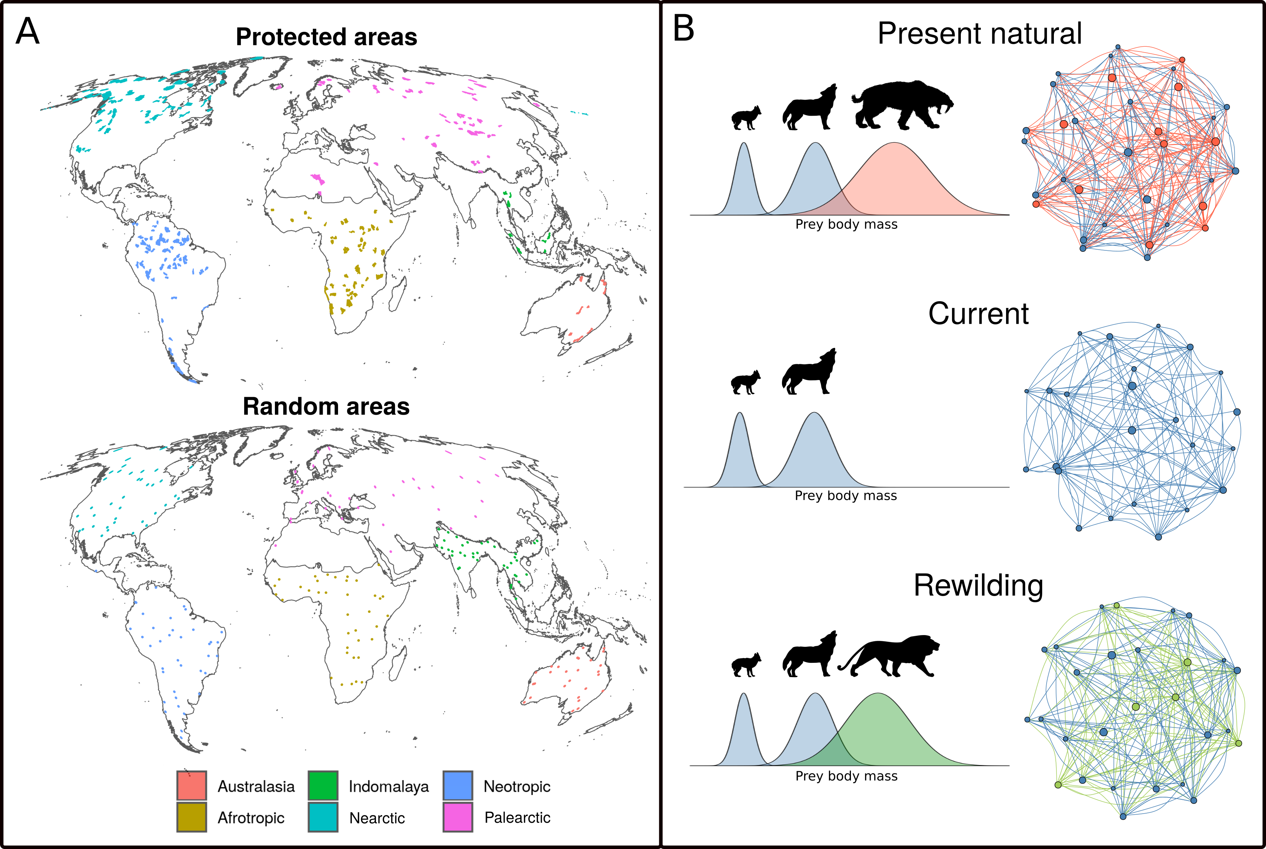
A) protected areas >= 5,000 km^2 (top) and random areas >= 5,000 km^2 (bottom) included in the study. Colours show different Ecozones. B) conceptual representation of the framework used. Dietary niches of species were derived using phylogenetic and trait-based approaches and food webs were inferred using species' diet and geographic distributions under the three scenarios examined. In the network representation of the food webs, species are nodes and predator-prey interactions are edges. Late Pleistocene human-driven extinctions have removed species and trophic interactions (red nodes and edges). Trophic rewilding aims to restore lost interactions by replacing extinct species with suitable ecological analogues (green nodes) that can rewire food webs establishing functionally analogue links (green edges).
In this study, we investigate the potential of rewilding to rewire terrestrial mammal food webs, ecological networks of 'who eats whom', to pre-human conditions in large (>=5,000 km^2) areas worldwide. In particular, we infer food webs under three scenarios: 1) present natural, i.e. a counter-factual scenario where mammals have not been affected by human activities through time (Faurby & Svenning, 2015; Faurby et al., 2018); 2) current conditions; and 3) a rewilding scenario where extant species can re-expand to present natural ranges and extinct species are replaced by closely related, similarly sized functional analogues that can tolerate similar climates. We then compare food webs under each scenario to investigate how much current food webs are impoverished of predator-prey intercations and whether rewilding can rewire food webs to pre-human states. Specifically, building on the terminology of Genes, Cid, Fernandez, & Pires (2017), we quantify: a) current debt, i.e. how many species and interactions have been lost because of past extinctions; b) rewilding credit, i.e. how many lost species and interactions can be reintroduced or replaced under the rewilding scenario; and c) rewilding deficit, i.e. how much past losses cannot be restored via rewilding. By comparing debt, credit, and deficit, we assess if rewilding credit can balance current debt.

Materials and methods
We quantified current extinction debt and rewilding credit and deficit in large (>= 5,000 km^2) protected areas (n = 209) with strict International Union for Conservation of Nature (IUCN) management category (Ia, Ib, and II). Rewilding is more feasible in large, strictly managed protected areas and human-wildlife coexistence less problematic. However, these large protected areas are concentrated in areas with low biodiversity (Daru et al., 2019); we therefore repeated the analyses using counter-factual areas >= 5,000 km^2 (n = 206) randomly scattered worldwide to investigate a global rewilding scenario without geographic biases. In summary, i) we ran correlative species distribution models (SDMs) to identify climatically suitable habitat for terrestrial mammals, ii) we then selected for each extinct species a closely related, similarly sized functional analogue, following conservative criteria, iii) we inferred food webs under present natural, current, and rewilding scenarios and iv) contrasted them to examine if rewilding can restore current defaunated food webs to pre-human conditions. We ran the analyses for protected and random areas separately; in the following sections we describe in details the methods used for protected areas, implying that the same was done for random areas where applicable.

Species distribution models
Correlative SDMs are projections in geographic space of species' environmental suitability niches reconstructed through correlation of species' presence with abiotic environmental predictors (Elith & Leathwick, 2009). To overcome biases introduced by anthropogenic pressures on where terrestrial mammals live, we used current and present natural range maps from the PHYLACINE database (Faurby et al., 2018). Following previous descriptions of PHYLACINE (Faurby & Svenning, 2015; Faurby et al., 2018), current ranges were generated from the IUCN range polygon maps for current, natural, and reintroduced ranges only (IUCN, 2016). Present natural ranges are estimates of where species could be today in the complete absence of influence of modern humans (Homo sapiens) through time (Faurby & Svenning, 2015) and can be viewed as pre-human(Homo sapiens) ranges adjusted for present-day climate. The present natural ranges combine knowledge of species' current IUCN range with historic distributions, fossil co-occurrence data, and range modifications caused by humans (Faurby & Svenning, 2015; Faurby et al., 2018). We generated presence locations within combined current and present natural range maps with a 20 km separation distance, excluding locations reported above the highest elevation for each species in the IUCN Red List or, if not stated, 4,000 meters, which is roughly the 95 percentile for upper elevations of mammals (IUCN, 2016). Elevation was determined for presence locations using the EarthEnv-DEM90 digital elevation model (Robinson, Regetz, & Guralnick, 2014). In total, we identified 4,206 extant terrestrial mammal species with range maps.
As environmental predictors for the correlative SDMs, we used four climatic variables from the Worldclim database (Fick & Hijmans, 2017): maximum temperature of the warmest month, minimum temperature of the coldest month, precipitation of wettest quarter, and precipitation of driest quarter. We selected these variables as they capture extreme conditions and, thus, likely represent factors limiting the distributions of terrestrial mammals. To model the climatic suitability of terrestrial mammals, we fitted maximum entropy (Maxent) models as implemented in the maxnet R-package (S. J. Phillips, Anderson, Dudík, Schapire, & Blair, 2017). Maxent is a presence-background approach, in which environments occupied by a species are contrasted with the available environmental space (Elith et al., 2011; Merow, Smith, & Silander Jr, 2013). For the background areas, we calculated species-specific buffers around the combined current and present natural ranges to reflect the dispersal abilities of each species, where the maximum distance from the range centroid to the range edge was used (Hof et al., 2018; Poo-Muñoz et al., 2014). Where a species had a disjunct range, the buffer area was calculated from the largest continuous range following Hof et al. (2018) (see electronic supplementary material, figure S1). We excluded 74 rare island endemics and 2 shrew species with small distribution ranges (Crocidura allex and Crocidura xantippe) as they had less than 10 presence points. In total, we modelled 4,130 of the 4,206 living terrestrial mammals. Predictive performance of Maxent models was assessed through five-fold cross validation and by comparing predicted suitable ranges with introduced range maps from IUCN (2016) and Lundgren, Ramp, Ripple, & Wallach (2018), which were not used to train Maxent models (Appendix).

Rewilding selection criteria
Following previous studies (Fig #; Berti et al. in prep; Jarvie et al. in prep), we searched for rewilding candidates that were phylogenetically close and functionally similar to globally extinct species and that could tolerate climatic conditions of their ranges. We always prioritised population restorations, i.e. reintroductions into present natural ranges, over introductions of functional analogues, as moving species’ outside their indigenous range is inherently riskier than reintroductions due to unforeseeable uncertainties and ecological risks (Fernández et al. 2017). For each globally extinct species, we selected as rewilding replacements the species from the same family that had similar size (within the 50% range of extinct species' body mass) and that had the largest climatically suitable range within the present natural of the extinct species. Because many proboscidean families went globally extinct, the two living extant elephants of the Proboscidea order (Elephas maximus and Loxodonta africana) were allowed to replaced other megaherbivores (>= 1,000 kg; Malhi et al. (2016)) within the Proboscidea order, as E. maximus and L. africana are frequently considered as ecological similar to extinct members of this group (J. Donlan, 2005; Janzen & Martin, 1982; Josh Donlan et al., 2006). Also, megacarnivores (>= 100 kg) within Felidae and Ursidae families were allowed to replace any other megacarnivore within the respective families, as they likely play similar ecological roles regulating the abundance and activity of large herbivores that are smaller than megaherbivores (Atkins et al., 2019; A. T. Ford et al., 2014; Laundré, Hernández, & Ripple, 2010; Ripple et al., 2014).
We assessed rewilding replacements separately for each Ecozone, bioregeographic realms characterized by separated evolutionary histories and patterns of extinctions (Malhi et al., 2016; Olson et al., 2001), as Ecozones delimit areas within which ecological and evolutionary processes operate most strongly (Olson & Dinerstein, 2002; Olson et al., 2001). Antarctic and Oceania Ecozones were excluded as they do not have living terrestrial mammals or suitable protected areas. To avoid negative impact of rewilding candidates' introduction into present natural ranges on similarly-sized -- i.e. within 50% of the body mass -- extant species in the same taxonomic group, we excluded introduction of rewilding candidates if rewilding ranges overlapped with reintroduction ranges of other species, as this poses serious issue for conservation for example species displacement through competition (Linnell & Strand, 2000). If there were more than one rewilding candidates, we selected as best replacement the species that had the largest climatically suitable range overlapping with the present natural range of the extinct species in the focal Ecozone. We did not select species for rewilding that violated any of the above criteria. See electronic supplement material, figure S# for a schematic representation of the selection criteria.

Reconstructing food webs
We reconstructed mammal assemblages within 209 large terrestrial protected areas (≥ 5,000 km²; figure 1), selected from the World Database of Protected Area (UNEP-WCMC & IUCN (2019), downloaded on June 2019). Following previous global studies (Jones et al., 2018; Runge et al., 2015), we excluded protected areas without detailed geographic information, proposed and designated sites not considered protected areas internationally, sites with an unknown status, UNESCO Biosphere Reserves, and marine-only sites as well as the marine portion of coastal sites. As large areas with limited human access are needed to establish self-sustaining population of large mammals (Chundawat, Sharma, Gogate, Malik, & Vanak, 2016; Woodroffe & Ginsberg, 1998), we kept only protected areas with strict IUCN management category (Ia, Ib, and II) and total surface ≥ 5,000 km² after dissolving adjacent areas together. To investigate the effects of human activities outside the current network of protected areas, which does not overlap with biodiversity hotspots (Daru et al., 2019), we reconstructed food webs also for counter-factual areas randomly distributed around the World (figure 1). For each area, we obtained mammal assemblages under present natural and current scenarios using present natural (including extinct species) and current range maps from the PHYLACINE database (Faurby et al., 2018). The rewilding assemblage was estimated from combined reintroduction (present natural including only extant species and current distributions) and rewilding ranges obtained using SDMs and selection of the best candidate replacements for extinct species.
Food webs were constructed for each area by combining phylogenetic inference with a trait-based approach. Phylogeny has been shown to be a good predictor of trophic interactions (Eklöf, Helmus, Moore, & Allesina, 2011), as species share more similar resources the closer they are related (Gray et al., 2015). We performed phylogenetic inference at the family level, a reasonable trade-off between accuracy of predictions and data availability (Gray et al., 2015). Each observed interaction between a prey and a predator was assigned to all species of the respective families. A trait-based approach was then used to remove interactions inferred using phylogeny that were not supported by macroecological evidence (Pomeranz, Thompson, Poisot, & Harding, 2019). This trait-based approach uses the relationship between the body mass of prey and predators, which structures trophic interactions in current and Pleistocene food webs (Owen-Smith & Mills, 2008; Segura, Farina, & Arim, 2016; Williams & Martinez, 2000). Following previous studies (Gravel, Poisot, Albouy, Velez, & Mouillot, 2013; Pomeranz et al., 2019), we used the 10% and 90% regression quantiles to obtain dietary niches of carnivores, i.e. the body mass range of their prey. The quantile regression was performed on data from the ECOWeB database (J. E. Cohen, 2010), the Global Biotic Interactions (GLOBI) database (Poelen, Simons, & Mungall, 2014), and two published savannah food webs (Baskerville et al., 2011; Visser, Freymann, & Olff, 2011).
After food webs were inferred, species were assigned to trophic levels defined by species' diet and body mass, reflecting the trophic and ecological role of species in food webs. We followed the trophic level definition as in Malhi et al. (2016). In particular, carnivores were divided into: i) megacarnivores ≥ 100 kg, which are generally apex predators and dominate food webs; ii) large carnivores 21.5 - 99 kg, which can predate on large prey and are subjected to top-down control from megacarnivores; and iii) small carnivores < 21.5 kg, which can predate only on smaller prey (Carbone, Mace, Roberts, & Macdonald, 1999). Herbivores were divided into: i) megaherbivores ≥ 1,000 kg, which are mostly free from predation; ii) large herbivores 45 - 999 kg, which are predated only by large carnivores and megacarnivores; and iii) small herbivores < 45 kg, which are predated and therefore controlled by all carnivores trophic levels.

Statistical analyses
For each food web under current, present natural, and rewilding scenarios, we calculated: 1) how many species were present at each trophic level, and 2) the number of predator-prey interactions connecting different trophic levels. In particular, we compared the number of species in each trophic level between present natural and current conditions to estimate current trophic richness debt and between current and rewilding scenarios to assess rewilding trophic richness credit. Similarly, we compared the number of trophic interactions across trophic levels between present natural and current and between current and rewilding scenarios to obtain the current interaction debt and the rewilding interaction credit. Moreover, we investigated the difference in the number of species per trophic level and the number of interactions between trophic level under present natural and rewilding scenarios to quantify the amount of current debts that cannot be balanced by rewilding credit. We called this difference "rewilding deficit".
To estimate significance and magnitude of differences among scenarios, we performed generalized linear mixed models (GLMMs). We selected the error distribution for the GLMMs based on the response data type and to remedy overdispersion (Zuur, Ieno, Walker, Saveliev, & Smith, 2009). We used a Poisson distribution to model the number of species at each trophic level with the fixed effects scenario, trophic level, and their interaction. A negative binomial distribution was used to model the predator-prey interactions across trophic levels with the fixed effects scenario, the trophic levels involved in the trophic link, and their interaction. For both GLMMs, we used the random effects 'protected area' and 'Ecozone' to account for non-comparable pseudo-replicates and different ecological histories of mammal assemblages in Ecozones (Olson et al., 2001). We assessed the significance among scenarios by performing multiple pair-wise contrasts with Bonferroni correction and estimated the magnitude of the differences using Cohen's d effect size (J. Cohen, 1988; Sawilowsky, 2009): d = (x_{i} – x_{j}) / s_{ij}, where x_{i} is the sample mean of scenario i, x_{j} the sample mean of scenario j, and s_{ij} the pooled standard deviation of samples i and j.
All data processing and analyses were performed in the R programming language version 3.6.1 (R Core Team, 2018) using packages tidyverse (Wickham, 2017), maxnet (S. Phillips, 2017), dismo (R. J. Hijmans, Phillips, Leathwick, & Elith, 2017), sf (Pebesma, 2018), raster (R. J. Hijmans, 2019), doParallel (Corporation & Weston, 2018), foreach (Microsoft & Weston, 2017), quantreg (Koenker, 2019), performance (Lüdecke, Makowski, & Waggoner, 2019), emmeans (Lenth, 2019), and estimate (Makowski & Lüdecke, 2019). All spatial analyses were conducted using the Behrmann cylindrical equal-area projection. Ecozones were derived using the World Wildlife Foundation shapefile (WWF, Olson & Dinerstein (2002)). Figures were made using packages ggplot2 (Wickham, 2016) with maps displayed in the Molleweide projection.

Results
The quality of the SDMs was on average very high to excellent and projected climatic suitability ranges captured much of the known introduction ranges of species obtained from Lundgren et al. (2018) and IUCN (2016) (electronic supplementary material, Table S1 and figure S2). Due to our conservative rewilding selection criteria, we found no replacements for the extinct families Archaeolemuridae, Chaeropodidae, Diprotodontidae, Macrauchenidae, Megaladapidae, Megatheriidae, Mylodontidae, Nesophontidae, Nothrotheridae, Palaeopropithecidae, Prolagidae, Proterotheriidae, Thylacinidae, Thylacoleonidae, and Toxodontidae. In total, we found 94 living species that can act as ecological replacements for 127 of the 334 extinct terrestrial mammals (electronic supplementary material, Table S3).
In large protected areas ≥ 5,000 km², we found a lower number of species in trophic levels under current conditions than in the present natural scenario except for small herbivores and small carnivores (Table 1, figure 1). The biggest decrease in numbers were for megacarnivores, megaherbivores, and large herbivores, where the magnitude of the difference was large (Cohen's d ≥ 0.80) or very large (d ≥ 1.20). The number of large carnivores under current conditions was lower than in the present natural, but the small effect size shows the decrease was less severe. Under the rewilding scenario, the number of megacarnivores, megaherbivores, and large herbivores significantly increased from current conditions, with small or medium effect sizes. For large carnivores however, the number of species did not increase significantly under rewilding. Importantly, rewilding did not restore the number of species for trophic levels affected by defaunation – megacarnivores, megaherbivores, large carnivores, and large herbivores – to present natural levels. The number of megacarnivores and megaherbivores trophic levels remained much smaller than the present natural even after species' (re)introduction, with respectively medium and large effect sizes of the difference.
In large random areas we observed similar but more pronounced patterns (figure 2). All trophic levels, except small herbivores and small carnivores, have been heavily depleted, with effect sizes equal or greater than in protected areas (Table 1). Under the conservative rewilding scenario trophic level richness was replenished from current conditions but not to present natural levels. Recovery was larger in magnitude compared to protected areas. Notably, rewilding deficit, i.e. the difference between rewilding and present natural trophic level richness, was comparable between random and protected areas (Table 1), showing a similar relative restoration potential of trophic rewilding. In general, the effect of Late Pleistocene extinctions and extirpation was higher in random areas than in protected areas. However, the restoration potential of rewilding was also higher in the random areas, and the number of species per trophic level was replenished to similar proportions in protected and random areas.

Trophic level | Present natural - Current | Current - Rewilding | Present natural - Rewilding
 | Protected areas
Megacarnivores (≥100 kg) | 1.24^{0.00}_{very large} | -0.60^{0.00}_{medium} | 0.64^{0.00}_{medium}
Megaherbivores (≥1,000 kg) | 1.79^{0.00}_{very large} | -0.61^{0.00}_{medium} | 1.18^{0.00}_{large}
Large carnivores (21.5 - 99 kg) | 0.35^{0.00}_{small} | -0.13^{0.06}_{very small} | 0.22^{0.00}_{small}
Large herbivores (45 - 999 kg) | 0.82^{0.00}_{large} | -0.33^{0.00}_{small} | 0.49^{0.00}_{small}
Small carnivores (< 21.5 kg) | 0.06^{0.01}_{very small} | -0.04^{0.19}_{very small} | 0.02^{0.79}_{very small}
Small herbivores (< 45 kg) | 0.03^{0.40}_{very small} | -0.01^{1.00}_{very small} | 0.02^{1.00}_{very small}
 | Random areas
Megacarnivores (≥100 kg) | 1.89^{0.00}_{very large} | -1.21^{0.00}_{very large} | 0.67^{0.00}_{medium}
Megaherbivores (≥1,000 kg) | 2.49^{0.00}_{huge} | -1.31^{0.00}_{very large} | 1.19^{0.00}_{large}
Large carnivores (21.5 - 99 kg) | 0.68^{0.00}_{medium} | -0.48^{0.00}_{small} | 0.20^{0.00}_{small}
Large herbivores (45 - 999 kg) | 1.10^{0.00}_{large} | -0.59^{0.00}_{medium} | 0.50^{0.00}_{medium}
Small carnivores (< 21.5 kg) | 0.09^{0.00}_{very small} | -0.07^{0.01}_{very small} | 0.02^{0.92}_{very small}
Small herbivores (< 45 kg) | 0.04^{0.06}_{very small} | -0.02^{0.57}_{very small} | 0.02^{0.91}_{very small}
Table 1: Differences between regression coefficients estimates of the number of species per trophic level among scenarios. Differences were obtained performing multiple pair-wise contrasts accounting for variation across Ecozones and food webs. Superscripts show the p-value of the contrasts adjusted with the Bonferroni correction and subscripts show the effect size of the change (Cohen's d (J. Cohen, 1988; Sawilowsky, 2009)).

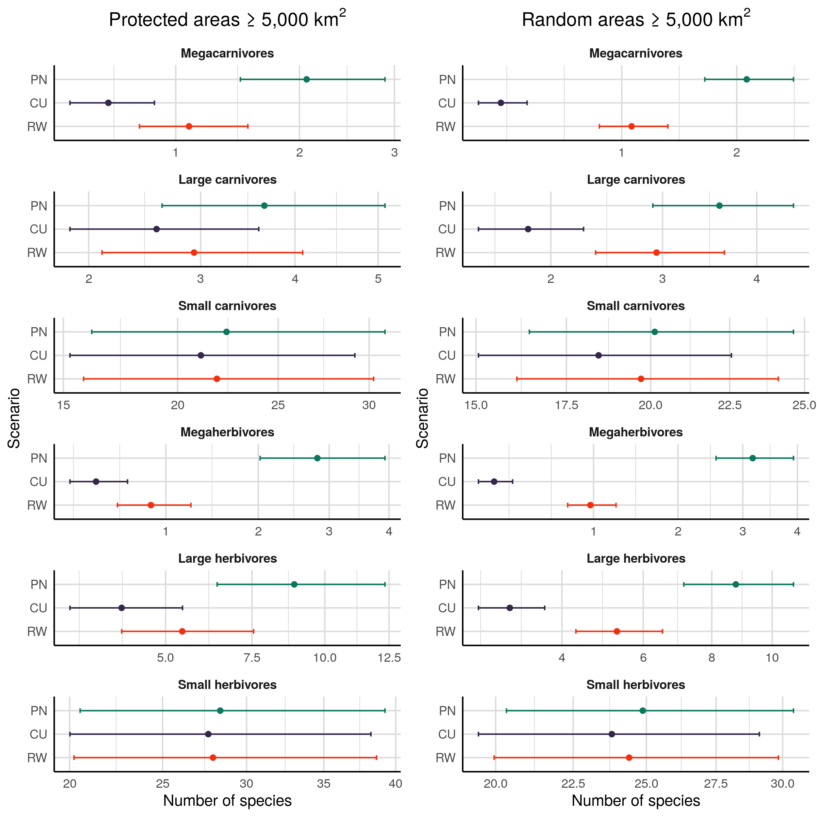
Number of species per trophic level in each scenarios for protected areas ≥ 5,000 km² (left) and for random areas ≥ 5,000 km² (right) under the three scenario examined. PN: present natural; CU: current; RW: rewilding. In all trophic levels except small herbivores, human-driven extinctions and extirpations have significantly reduced the number of species. A conservative rewilding approach can partly replenish the species pool through reintroduction and introduction of mammals as ecological replacements for globally extinct species, but the number of species in each trophic level cannot be fully restored to natural levels, as many extinct species do not have today functional analogues that are also phylogenetically closely related. Notably, rewilding has higher restoration potential outside protected areas, where the impact of human pressure on trophic level species richness has been particularly severe.
The number of interactions among trophic levels decreased between present natural and current conditions in both protected and random areas (Fig. 3). All interactions that involved megacarnivores as predators were severely reduced under current conditions compared to the present natural, with very large effect sizes (Table 2). Also, predator-prey interactions maintained by large carnivores decreased between present natural and current conditions, with a large decrease in the number of predator-prey interactions between large herbivores and large carnivores and small reductions in the number of interactions between small mammals and large carnivores. Notably, the number of interactions between trophic levels that have been affected increased under the rewilding scenario with small to large effect sizes, with the only exception being for large herbivore--large carnivores interactions, which did not increase significantly. Rewilding credit did not balanced current debt and trophic interactions were not completely restored to present natural levels. The number of large herbivores--large carnivores interactions and all trophic links involving megacarnivores were not replenished to present natural levels, with medium to large magnitudes of the difference (Table 2). As for trophic level richness, we found that pattern were qualitatively similar between protected and random areas, but that extinctions debt and rewilding credit were higher in random areas. Moreover, rewilding deficit was the comparable, showing that food webs were rewired to similar relative extent in protected and random areas.
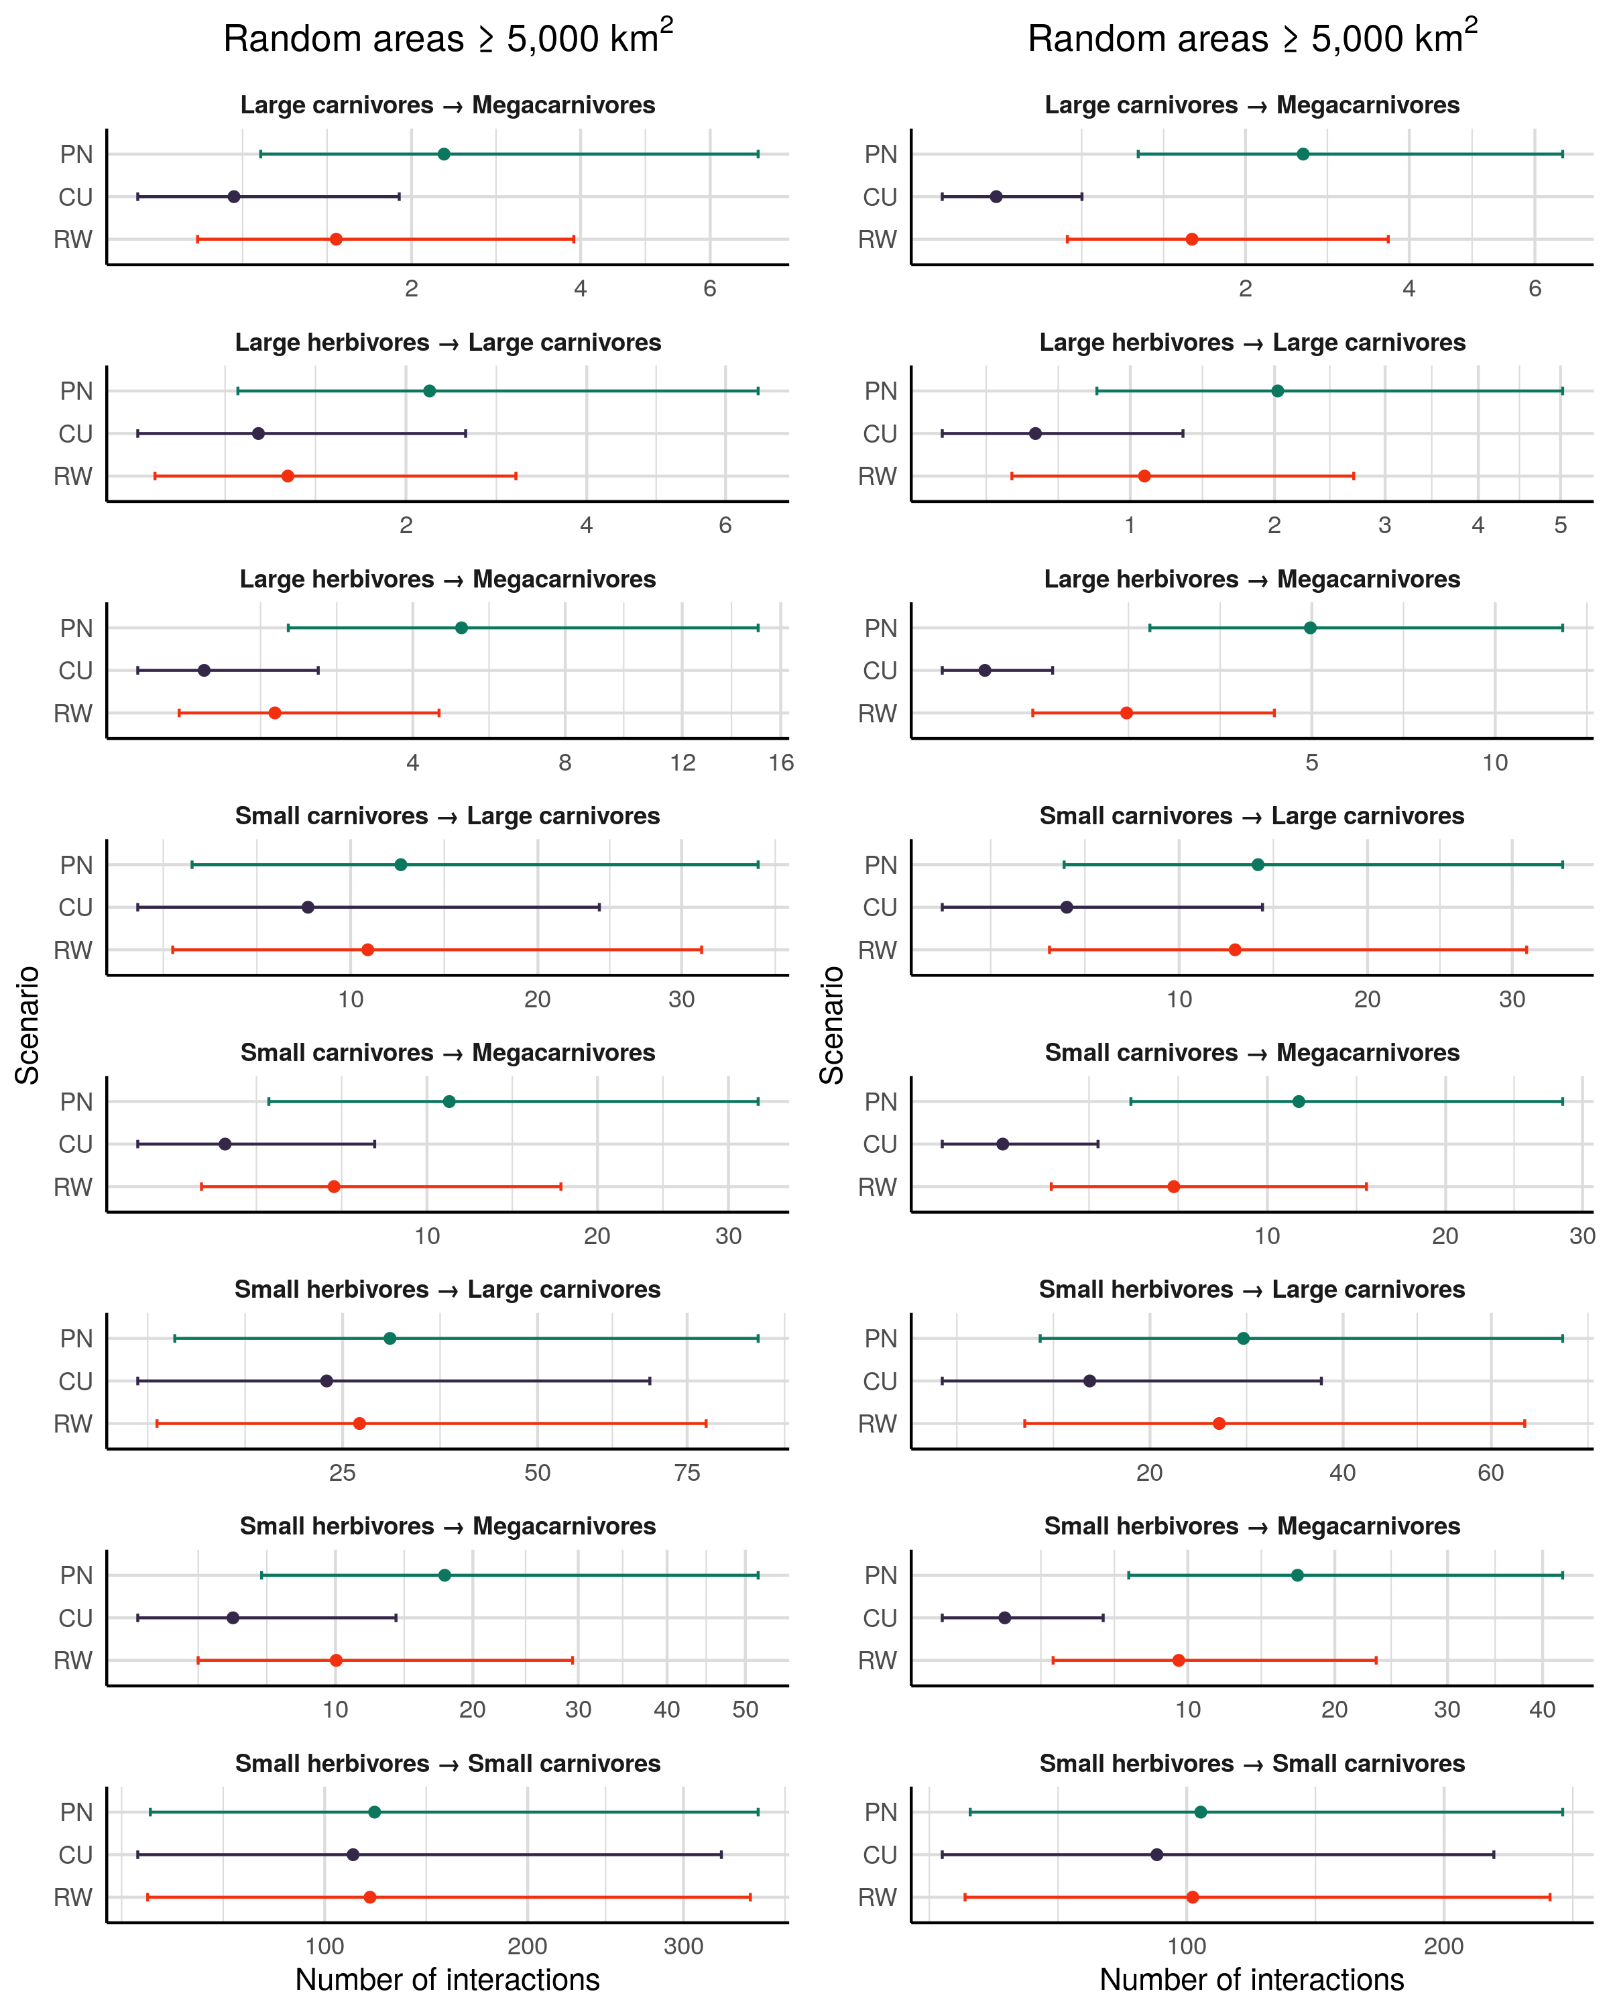
Number of predator-prey interactions across trophic levels under each scenarios for protected areas ≥ 5,000 km² (left) and for random areas ≥ 5,000 km² (right) under the three scenario examined. PN: present natural; CU: current; RW: rewilding. Top-down interactions promoted by megacarnivores (≥ 100 kg) and large carnivores (≥ 21.5 kg) have been largely removed following Late Pleistocene and late-Quaternary extinctions. Trophic rewilding can restore trophic structure by rewiring food webs with lost or functionally analogue predator-prey interactions. However, a full recovery to pre-human conditions cannot be achieved under the conservative rewilding strategy examined.
Prey | Predator | Present natural - Current | Current - Rewilding | Present natural - Rewilding
 |  | Protected areas
Large carnivores | Megacarnivores | 1.30^{0.00}_{very large} | -0.73^{0.00}_{medium} | 0.56^{0.00}_{medium}
Large herbivores | Megacarnivores | 1.92^{0.00}_{very large} | -0.74^{0.00}_{medium} | 1.19^{0.00}_{large}
Small carnivores | Megacarnivores | 1.45^{0.00}_{very large} | -0.84^{0.00}_{large} | 0.62^{0.00}_{medium}
Small herbivores | Megacarnivores | 1.31^{0.00}_{very large} | -0.74^{0.00}_{medium} | 0.57^{0.00}_{medium}
Large herbivores | Large carnivores | 0.93^{0.00}_{large} | -0.19^{0.17}_{very small} | 0.74^{0.00}_{medium}
Small carnivores | Large carnivores | 0.41^{0.00}_{small} | -0.27^{0.00}_{small} | 0.14^{0.07}_{very small}
Small herbivores | Large carnivores | 0.26^{0.00}_{small} | -0.14^{0.04}_{very small} | 0.12^{0.09}_{very small}
Small herbivores | Small carnivores | 0.08^{0.37}_{very small} | -0.06^{0.67}_{very small} | 0.02^{1.00}_{very small}
 |  | Random areas
Large carnivores | Megacarnivores | 2.26^{0.00}_{huge} | -1.70^{0.00}_{very large} | 0.56^{0.00}_{medium}
Large herbivores | Megacarnivores | 2.67^{0.00}_{huge} | -1.60^{0.00}_{very large} | 1.08^{0.00}_{large}
Small carnivores | Megacarnivores | 2.05^{0.00}_{huge} | -1.42^{0.00}_{very large} | 0.63^{0.00}_{medium}
Small herbivores | Megacarnivores | 1.99^{0.00}_{very large} | -1.40^{0.00}_{very large} | 0.59^{0.00}_{medium}
Large herbivores | Large carnivores | 1.34^{0.00}_{very large} | -0.72^{0.00}_{medium} | 0.63^{0.00}_{medium}
Small carnivores | Large carnivores | 0.89^{0.00}_{large} | -0.80^{0.00}_{large} | 0.09^{0.56}_{very small}
Small herbivores | Large carnivores | 0.64^{0.00}_{medium} | -0.55^{0.00}_{medium} | 0.09^{0.51}_{very small}
Small herbivores | Small carnivores | 0.14^{0.05}_{very small} | -0.12^{0.15}_{very small} | 0.03^{1.00}_{very small}
Table 2: Differences between regression coefficients estimates of the number of predator-prey interactions between trophic levels among scenarios. Differences were obtained performing multiple pair-wise contrasts accounting for variation across Ecozones and food webs. Superscripts show the p-value of the contrasts adjusted with the Bonferroni correction and subscripts show the effect size of the change (Cohen's d (J. Cohen, 1988; Sawilowsky, 2009)).

Discussion
In the Late Pleistocene, modern humans caused extinction and extirpation of many mammal species, especially of large body-sized megafauna (Martin, 1984; F. A. Smith et al., 2018). This defaunation degraded ecological networks by removing predator-prey interactions that control ecosystems' trophic structure (Malhi et al., 2016). A recently proposed approach to restore ecosystems and rewire ecological networks is trophic rewilding, the (re)introduction of species to promote biodiverse, self-sustaining ecosystems (Perino et al., 2019; Svenning et al., 2016). Small scale studies suggest that rewilding is an effective strategy for biodiversity conservation and ecosystem restoration, e.g. by maintaining semi-open landscapes and reinstating lost ecological interactions (Garrido et al., 2019; Genes et al., 2019; Riesch, Tonn, Meißner, Balkenhol, & Isselstein, 2019). Yet, the potential of rewilding to restore ecological networks to pre-human conditions at a global scale has not been investigated so far. Here, we fill this gap by taking a deep-time, large scale perspective on trophic rewilding. Overall, our results show that rewilding can rewire food webs, but that full restoration is not possible under a conservative rewilding scenario that minimises ecological risks and human-wildlife conflicts.
Our findings show that trophic levels of large body-size species were, not surprisingly, the most affected by human pressure. The number of megacarnivores and megaherbivores severely declined due to past extinctions, followed by large carnivores and large herbivores that had high but relatively smaller decreases in numbers. As a consequence of these species' losses, trophic interactions maintained by higher trophic levels were pruned away, the top-down control of higher to lower trophic levels decreased, and ecosystem trophic structure got degraded. Importantly, as trophic complexity is necessary for self-sustaining biodiverse ecosystems (Perino et al., 2019), this degradation of food webs complexity and community trophic structure likely jeopardises stability and resilience of ecosystems globally (Estes et al., 2011).
We found that trophic level richness and interactions debts due to past extinctions can, in part, be balanced by rewilding credit. Reintroduction of species into their present natural ranges together with replacement of globally extinct species with functional analogues increased the number of species in affected trophic levels with medium to large effect sizes, showing intermediate-high potential for recovery. The number of trophic interactions among depleted trophic levels also largely recovered, although not to pre-human conditions. Overall, our findings highlight the potential of rewilding to restore food webs to more self-sustaining, biodiverse states. Full restoration to pre-human conditions, however, cannot be achieved under the conservative rewilding scenario examined here, where replacement of extinct species was phylogenetically constrained.
Our results also show that extinction debt and rewilding credit are higher in random areas than in protected areas with strict IUCN management (Ia, Ib, and II). Although human land-use is concentrated in highly productive areas that potentially host higher biodiversity and species richness (Venter et al., 2018), the current network of protected areas poorly covers mammalian biodiversity hotspots (Daru et al., 2019). As a consequence, current extinction debt is lower in protected areas than random areas, where human pressure caused larger losses of species and interactions and degraded ecosystems more severely. Moreover, because random areas have higher potential species richness and trophic complexity than protected areas, rewilding credit and restoration potential are higher in the counter-factual random areas than in protected areas. This suggests trophic rewilding will rewire food webs most effectively outside the current network of protected areas. Importantly, rewilding deficit is comparable between protected and random areas, showing a similar relative potential of rewilding to restore trophic structure of ecosystems. Even if losses and recoveries are higher in random areas than in protected areas, the relative level of restoration that can be achieved via trophic rewilding are comparable. These results highlight the importance of rewilding strategies targeting also regions outside the protected area network, where (re)introductions of mammals will rewire food webs to pre-human conditions to larger extents and greatly restore ecosystems trophic structure.
Rewilding may increase human-wildlife conflicts in many areas, especially outside the network of protected areas, and society will play an important role in rewilding implementation and success (Perino et al., 2019). Rewilding may cause economic losses to some local stakeholders via predation on livestock or damages to crops and pastures. Moreover, people not directly damaged by wildlife can negatively perceive rewilding projects depending on how rewilding is implemented (Theunissen, 2019). Nevertheless, negative effects of rewilding can be mitigated by the adoption of compensation schemes by governmental agencies (Navarro & Pereira, 2015) and by aligning scientific, managers, and people's conception of nature with rewilding goals (Theunissen, 2019). In particular, identifying benefits and costs of wildlife in a socio-ecological framework can highlight possible actions to remedy unwanted outcomes of rewilding initiatives (Ceauşu, Graves, Killion, Svenning, & Carter, 2019). Also, the goals of traditional ecosystem conservation and restoration strategies and rewilding may not be so different as perceived (Van Meerbeek, Muys, Schowanek, & Svenning, 2019), and looking for a common ground and mutual understanding among scientific community, practitioners, and local communities will determine whether rewilding will be successful (R. M. Anderson et al., 2019).
In conclusion, our study shows that trophic complexity has been severely degraded worldwide and that a conservative rewilding strategy can partly, but not completely, restore trophic complexity in ecosystems. To rewire food webs to pre-human conditions, rewilding needs to be taken with a bolder approach. In particular, we simulated a conservative rewilding scenario with strict phylogenetic constraints; by focusing on species' functional traits rather than phylogenetic relationships, a larger number of extinct species can probably be replaced, raising the potential of rewilding to rewire food webs. Rewilding will probably be a controversial topic for long time and its implementation needs further improvements to secure the long-term restoration goals (Root-Bernstein, Gooden, & Boyes, 2018). This does not mean however that rewilding should be ostracised as a failing or unnecessary restoration strategy, but rather that policy makers, societal agencies, managers, and ecologists need to discuss and improve why and how rewilding is implemented. Importantly, new opportunities are opening to implement rewilding at large scales, as shown by comeback of wildlife in abandoned agricultural areas in Europe (Ceausu et al., 2015; Chapron et al., 2014); as human intervention at these large scales will unlikely be possible because of limited funding and resources, if and how rewilding is adopted will determine whether trophic complexity is restored or not in ecosystems. Overall, our findings show that a conservative rewilding strategy is a good starting point to restore ecosystems' trophic structure, but that rewilding cannot be so conservative and its restrictions need to be relaxed if the long-term goal is to achieve self-sustaining biodiverse ecosystems.

Acknowledgment
We thank the Carlsberg Foundation for economic support of this work through the Semper Ardens project MegaPast2Future (grant CF16-0005 to JCS). JCS also considers this work a contribution to his VILLUM Investigator project 'Biodiversity Dynamics in a Changing World', funded by VILLUM FONDEN (grant 16549).

Data accessibility
All data was open access. Predator-prey interactions were obtained from the ECOWeB and the GLOBI databases (J. E. Cohen, 2010; Poelen et al., 2014), from two published savanna food webs (Baskerville et al., 2011; Visser et al., 2011). Body mass and species present natural and current distribution ranges were obtained from the PHYLACINE 1.2 database (Faurby et al., 2018). We used climate data from the Worldclim 2.0 database (Fick & Hijmans, 2017) and Ecozone shapefile from the WWF (Olson & Dinerstein, 2002).

Author contribution
All authors developed the concept, designed the study, and contributed to the manuscript. EB conceived the idea, performed the analyses, and prepared the manuscript for submission.

Competing interests
The authors declare no competing interests.

References
Alston, J., Maitland, B., Brito, B., Esmaeili, S., Ford, A., Hays, B., … Goheen, J. (2019). Reciprocity in restoration ecology: When might large carnivore reintroduction restore ecosystems? Biological Conservation, 234, 82–89.
Anderson, R. M., Buitenwerf, R., Driessen, C., Genes, L., Lorimer, J., & Svenning, J.-C. (2019). Introducing rewilding to restoration to expand the conservation effort: A response to hayward et al. Biodiversity and Conservation, 28(13), 3691–3693.
Atkins, J. L., Long, R. A., Pansu, J., Daskin, J. H., Potter, A. B., Stalmans, M. E., … Pringle, R. M. (2019). Cascading impacts of large-carnivore extirpation in an african ecosystem. Science, eaau3561.
Barnosky, A. D. (2008). Megafauna biomass tradeoff as a driver of quaternary and future extinctions. Proceedings of the National Academy of Sciences, 105(Supplement 1), 11543–11548.
Baskerville, E. B., Dobson, A. P., Bedford, T., Allesina, S., Anderson, T. M., & Pascual, M. (2011). Spatial guilds in the serengeti food web revealed by a bayesian group model. PLoS Computational Biology, 7(12), e1002321.
Beschta, R. L., & Ripple, W. J. (2016). Riparian vegetation recovery in yellowstone: The first two decades after wolf reintroduction. Biological Conservation, 198, 93–103.
Carbone, C., Mace, G. M., Roberts, S. C., & Macdonald, D. W. (1999). Energetic constraints on the diet of terrestrial carnivores. Nature, 402(6759), 286.
Ceausu, S., Hofmann, M., Navarro, L. M., Carver, S., Verburg, P. H., & Pereira, H. M. (2015). Mapping opportunities and challenges for rewilding in europe. Conservation Biology, 29(4), 1017–1027.
Ceauşu, S., Graves, R. A., Killion, A. K., Svenning, J.-C., & Carter, N. H. (2019). Governing trade-offs in ecosystem services and disservices to achieve human–wildlife coexistence. Conservation Biology, 33(3), 543–553.
Ceballos, G., Ehrlich, P. R., Barnosky, A. D., García, A., Pringle, R. M., & Palmer, T. M. (2015). Accelerated modern human–induced species losses: Entering the sixth mass extinction. Science Advances, 1(5), e1400253.
Chapron, G., Kaczensky, P., Linnell, J. D., Arx, M. von, Huber, D., Andrén, H., … others. (2014). Recovery of large carnivores in europe’s modern human-dominated landscapes. Science, 346(6216), 1517–1519.
Chundawat, R. S., Sharma, K., Gogate, N., Malik, P. K., & Vanak, A. T. (2016). Size matters: Scale mismatch between space use patterns of tigers and protected area size in a tropical dry forest. Biological Conservation, 197, 146–153.
Cohen, J. (1988). Statistical power analysis for the behavioural sciences. Hillsdale, NJ: erlbaum.
Cohen, J. E. (2010). ECOWeB 1.1: Ecologists’ cooperative web bank.
Corporation, M., & Weston, S. (2018). DoParallel: Foreach parallel adaptor for the ’parallel’ package. Retrieved from https://CRAN.R-project.org/package=doParallel
Daru, B. H., Roux, P. C. le, Gopalraj, J., Park, D. S., Holt, B. G., & Greve, M. (2019). Spatial overlaps between the global protected areas network and terrestrial hotspots of evolutionary diversity. Global Ecology and Biogeography, 28(6), 757–766.
Dirzo, R., Young, H. S., Galetti, M., Ceballos, G., Isaac, N. J., & Collen, B. (2014). Defaunation in the anthropocene. Science, 345(6195), 401–406.
Donlan, J. (2005). Re-wilding north america. Nature, 436(7053), 913.
Eklöf, A., Helmus, M. R., Moore, M., & Allesina, S. (2011). Relevance of evolutionary history for food web structure. Proceedings of the Royal Society B: Biological Sciences, 279(1733), 1588–1596.
Elith, J., & Leathwick, J. R. (2009). Species distribution models: Ecological explanation and prediction across space and time. Annual Review of Ecology, Evolution, and Systematics, 40, 677–697.
Elith, J., Phillips, S. J., Hastie, T., Dudík, M., Chee, Y. E., & Yates, C. J. (2011). A statistical explanation of maxent for ecologists. Diversity and Distributions, 17(1), 43–57.
Estes, J. A., Terborgh, J., Brashares, J. S., Power, M. E., Berger, J., Bond, W. J., … others. (2011). Trophic downgrading of planet earth. Science, 333(6040), 301–306.
Faurby, S., & Svenning, J.-C. (2015). Historic and prehistoric human-driven extinctions have reshaped global mammal diversity patterns. Diversity and Distributions, 21(10), 1155–1166.
Faurby, S., Davis, M., Pedersen, R. Ø., Schowanek, S. D., Antonelli, A., & Svenning, J.-C. (2018). PHYLACINE 1.2: The phylogenetic atlas of mammal macroecology. Ecology, 99(11), 2626–2626. https://doi.org/10.1002/ecy.2443
Fick, S. E., & Hijmans, R. J. (2017). WorldClim 2: New 1-km spatial resolution climate surfaces for global land areas. International Journal of Climatology, 37(12), 4302–4315.
Ford, A. T., Goheen, J. R., Otieno, T. O., Bidner, L., Isbell, L. A., Palmer, T. M., … Pringle, R. M. (2014). Large carnivores make savanna tree communities less thorny. Science, 346(6207), 346–349.
Garrido, P., Mårell, A., Öckinger, E., Skarin, A., Jansson, A., & Thulin, C.-G. (2019). Experimental rewilding enhances grassland functional composition and pollinator habitat use. Journal of Applied Ecology, 56(4), 946–955.
Genes, L., Cid, B., Fernandez, F. A., & Pires, A. S. (2017). Credit of ecological interactions: A new conceptual framework to support conservation in a defaunated world. Ecology and Evolution, 7(6), 1892–1897.
Genes, L., Fernandez, F. A., Vaz-de-Mello, F. Z., Rosa, P. da, Fernandez, E., & Pires, A. S. (2019). Effects of howler monkey reintroduction on ecological interactions and processes. Conservation Biology, 33(1), 88–98.
Gill, J. L. (2014). Ecological impacts of the late quaternary megaherbivore extinctions. New Phytologist, 201(4), 1163–1169.
Gravel, D., Poisot, T., Albouy, C., Velez, L., & Mouillot, D. (2013). Inferring food web structure from predator–prey body size relationships. Methods in Ecology and Evolution, 4(11), 1083–1090.
Gray, C., Figueroa, D. H., Hudson, L. N., Ma, A., Perkins, D., & Woodward, G. (2015). Joining the dots: An automated method for constructing food webs from compendia of published interactions. Food Webs, 5, 11–20.
Hayward, M. W., Scanlon, R. J., Callen, A., Howell, L. G., Klop-Toker, K. L., Di Blanco, Y., … others. (2019). Reintroducing rewilding to restoration–Rejecting the search for novelty. Biological Conservation, 233, 255–259.
Hijmans, R. J. (2019). Raster: Geographic data analysis and modeling. Retrieved from https://CRAN.R-project.org/package=raster
Hijmans, R. J., Phillips, S., Leathwick, J., & Elith, J. (2017). Dismo: Species distribution modeling. Retrieved from https://CRAN.R-project.org/package=dismo
Hof, C., Voskamp, A., Biber, M. F., Böhning-Gaese, K., Engelhardt, E. K., Niamir, A., … Hickler, T. (2018). Bioenergy cropland expansion may offset positive effects of climate change mitigation for global vertebrate diversity. Proceedings of the National Academy of Sciences, 115(52), 13294–13299.
IUCN. (2016). The iucn red list of threatened species, version 2016-3. International Union for Conservation of Nature; Natural Resources Cambridge.
Janzen, D. H., & Martin, P. S. (1982). Neotropical anachronisms: The fruits the gomphotheres ate. Science, 215(4528), 19–27.
Jones, K. R., Venter, O., Fuller, R. A., Allan, J. R., Maxwell, S. L., Negret, P. J., & Watson, J. E. (2018). One-third of global protected land is under intense human pressure. Science, 360(6390), 788–791.
Josh Donlan, C., Berger, J., Bock, C. E., Bock, J. H., Burney, D. A., Estes, J. A., … others. (2006). Pleistocene rewilding: An optimistic agenda for twenty-first century conservation. The American Naturalist, 168(5), 660–681.
Koenker, R. (2019). Quantreg: Quantile regression. Retrieved from https://CRAN.R-project.org/package=quantreg
Laundré, J. W., Hernández, L., & Ripple, W. J. (2010). The landscape of fear: Ecological implications of being afraid. Open Ecology Journal, 3, 1–7.
Lenth, R. (2019). Emmeans: Estimated marginal means, aka least-squares means. Retrieved from https://CRAN.R-project.org/package=emmeans
Linnell, J. D., & Strand, O. (2000). Interference interactions, co-existence and conservation of mammalian carnivores. Diversity and Distributions, 6(4), 169–176.
Lundgren, E. J., Ramp, D., Ripple, W. J., & Wallach, A. D. (2018). Introduced megafauna are rewilding the anthropocene. Ecography, 41(6), 857–866.
Lüdecke, D., Makowski, D., & Waggoner, P. (2019). Performance: Assessment of regression models performance. Retrieved from https://CRAN.R-project.org/package=performance
Makowski, D., & Lüdecke, D. (2019). Estimate: Estimate effects, contrasts and means. Retrieved from https://github.com/easystats/estimate
Malhi, Y., Doughty, C. E., Galetti, M., Smith, F. A., Svenning, J.-C., & Terborgh, J. W. (2016). Megafauna and ecosystem function from the pleistocene to the anthropocene. Proceedings of the National Academy of Sciences, 113(4), 838–846.
Marjakangas, E.-L., Genes, L., Pires, M. M., Fernandez, F. A., Lima, R. A. de, Oliveira, A. A. de, … Galetti, M. (2018). Estimating interaction credit for trophic rewilding in tropical forests. Philosophical Transactions of the Royal Society B: Biological Sciences, 373(1761), 20170435.
Martin, P. S. (1984). Prehistoric overkill: The global model. Quaternary Extinctions: A Prehistoric Revolution, 354–403.
Merow, C., Smith, M. J., & Silander Jr, J. A. (2013). A practical guide to maxent for modeling species’ distributions: What it does, and why inputs and settings matter. Ecography, 36(10), 1058–1069.
Microsoft, & Weston, S. (2017). Foreach: Provides foreach looping construct for r. Retrieved from https://CRAN.R-project.org/package=foreach
Navarro, L. M., & Pereira, H. M. (2015). Rewilding abandoned landscapes in europe. In Rewilding european landscapes (pp. 3–23). Springer, Cham.
Nogués-Bravo, D., Simberloff, D., Rahbek, C., & Sanders, N. J. (2016). Rewilding is the new pandora’s box in conservation. Current Biology, 26(3), R87–R91.
Olson, D. M., & Dinerstein, E. (2002). The global 200: Priority ecoregions for global conservation. Annals of the Missouri Botanical Garden, 199–224.
Olson, D. M., Dinerstein, E., Wikramanayake, E. D., Burgess, N. D., Powell, G. V., Underwood, E. C., … others. (2001). Terrestrial ecoregions of the world: A new map of life on eartha new global map of terrestrial ecoregions provides an innovative tool for conserving biodiversity. BioScience, 51(11), 933–938.
Owen-Smith, N., & Mills, M. G. (2008). Predator–prey size relationships in an african large-mammal food web. Journal of Animal Ecology, 77(1), 173–183.
Pebesma, E. (2018). Simple Features for R: Standardized Support for Spatial Vector Data. The R Journal, 10(1), 439–446. https://doi.org/10.32614/RJ-2018-009
Perino, A., Pereira, H. M., Navarro, L. M., Fernández, N., Bullock, J. M., Ceaușu, S., … others. (2019). Rewilding complex ecosystems. Science, 364(6438), eaav5570.
Phillips, S. (2017). Maxnet: Fitting ’maxent’ species distribution models with ’glmnet’. Retrieved from https://CRAN.R-project.org/package=maxnet
Phillips, S. J., Anderson, R. P., Dudík, M., Schapire, R. E., & Blair, M. E. (2017). Opening the black box: An open-source release of maxent. Ecography, 40(7), 887–893.
Pires, M. M. (2017). Rewilding ecological communities and rewiring ecological networks. Perspectives in Ecology and Conservation, 15(4), 257–265.
Pires, M. M., Koch, P. L., Farina, R. A., Aguiar, M. A. de, Reis, S. F. dos, & Guimarães Jr, P. R. (2015). Pleistocene megafaunal interaction networks became more vulnerable after human arrival. Proceedings of the Royal Society B: Biological Sciences, 282(1814), 20151367.
Poelen, J. H., Simons, J. D., & Mungall, C. J. (2014). Global biotic interactions: An open infrastructure to share and analyze species-interaction datasets. Ecological Informatics, 24, 148–159.
Pomeranz, J. P., Thompson, R. M., Poisot, T., & Harding, J. S. (2019). Inferring predator–prey interactions in food webs. Methods in Ecology and Evolution, 10(3), 356–367.
Poo-Muñoz, D. A., Escobar, L. E., Peterson, A. T., Astorga, F., Organ, J. F., & Medina-Vogel, G. (2014). Galictis cuja (mammalia): An update of current knowledge and geographic distribution. Iheringia. Série Zoologia, 104(3), 341–346.
R Core Team. (2018). R: A language and environment for statistical computing. Retrieved from https://www.R-project.org/
Riesch, F., Tonn, B., Meißner, M., Balkenhol, N., & Isselstein, J. (2019). Grazing by wild red deer: Management options for the conservation of semi-natural open habitats. Journal of Applied Ecology.
Ripple, W. J., Estes, J. A., Beschta, R. L., Wilmers, C. C., Ritchie, E. G., Hebblewhite, M., … others. (2014). Status and ecological effects of the world’s largest carnivores. Science, 343(6167), 1241484.
Robinson, N., Regetz, J., & Guralnick, R. P. (2014). EarthEnv-dem90: A nearly-global, void-free, multi-scale smoothed, 90m digital elevation model from fused aster and srtm data. ISPRS Journal of Photogrammetry and Remote Sensing, 87, 57–67.
Root-Bernstein, M., Gooden, J., & Boyes, A. (2018). Rewilding in practice: Projects and policy. Geoforum, 97, 292–304.
Runge, C. A., Watson, J. E., Butchart, S. H., Hanson, J. O., Possingham, H. P., & Fuller, R. A. (2015). Protected areas and global conservation of migratory birds. Science, 350(6265), 1255–1258.
Sandom, C., Faurby, S., Sandel, B., & Svenning, J.-C. (2014). Global late quaternary megafauna extinctions linked to humans, not climate change. Proceedings of the Royal Society B: Biological Sciences, 281(1787), 20133254.
Sawilowsky, S. S. (2009). New effect size rules of thumb. Journal of Modern Applied Statistical Methods, 8(2), 597–599.
Segura, A. M., Farina, R. A., & Arim, M. (2016). Exceptional body sizes but typical trophic structure in a pleistocene food web. Biology Letters, 12(5), 20160228.
Smith, F. A., Smith, R. E. E., Lyons, S. K., & Payne, J. L. (2018). Body size downgrading of mammals over the late quaternary. Science, 360(6386), 310–313.
Svenning, J.-C., Pedersen, P. B., Donlan, C. J., Ejrnæs, R., Faurby, S., Galetti, M., … others. (2016). Science for a wilder anthropocene: Synthesis and future directions for trophic rewilding research. Proceedings of the National Academy of Sciences, 113(4), 898–906.
Tanentzap, A. J., & Smith, B. R. (2018). Unintentional rewilding: Lessons for trophic rewilding from other forms of species introductions. Philosophical Transactions of the Royal Society B: Biological Sciences, 373(1761), 20170445.
Theunissen, B. (2019). The oostvaardersplassen fiasco. Isis, 110(2), 341–345.
UNEP-WCMC, & IUCN. (2019). Protected planet: The world database on protected areas (wdpa). Retrieved from www.protectedplanet.net
Valiente-Banuet, A., Aizen, M. A., Alcántara, J. M., Arroyo, J., Cocucci, A., Galetti, M., … others. (2015). Beyond species loss: The extinction of ecological interactions in a changing world. Functional Ecology, 29(3), 299–307.
Van Meerbeek, K., Muys, B., Schowanek, S. D., & Svenning, J.-C. (2019). Reconciling conflicting paradigms of biodiversity conservation: Human intervention and rewilding. BioScience.
Venter, O., Magrach, A., Outram, N., Klein, C. J., Possingham, H. P., Di Marco, M., & Watson, J. E. (2018). Bias in protected-area location and its effects on long-term aspirations of biodiversity conventions. Conservation Biology, 32(1), 127–134.
Visser, S. N. de, Freymann, B. P., & Olff, H. (2011). The serengeti food web: Empirical quantification and analysis of topological changes under increasing human impact. Journal of Animal Ecology, 80(2), 484–494.
Wickham, H. (2016). Ggplot2: Elegant graphics for data analysis. Retrieved from https://ggplot2.tidyverse.org
Wickham, H. (2017). The tidyverse. R Package Ver. 1.1. 1.
Williams, R. J., & Martinez, N. D. (2000). Simple rules yield complex food webs. Nature, 404(6774), 180.
Woodroffe, R., & Ginsberg, J. R. (1998). Edge effects and the extinction of populations inside protected areas. Science, 280(5372), 2126–2128.
Yeakel, J. D., Pires, M. M., Rudolf, L., Dominy, N. J., Koch, P. L., Guimarães, P. R., & Gross, T. (2014). Collapse of an ecological network in ancient egypt. Proceedings of the National Academy of Sciences, 111(40), 14472–14477.
Zuur, A., Ieno, E. N., Walker, N., Saveliev, A. A., & Smith, G. M. (2009). Mixed effects models and extensions in ecology with r. Springer Science & Business Media.

