Appendix for Rewiring food webs through trophic rewilding

Supporting information

Changes to the PHYLACINE database
We modified the body mass of two extinct species in the PHYLACINE database before modelling and analyses: body mass of the extinct species Sinomegaceros ordosianus was set equal to the mass of Sinomegaceros yabei and body mass of the extinct Dusicyon australis to Dusicyon avus. Moreover, the cow (Bos primigenius) and the dromedary (Camelus dromedarius), two species considered to be extinct as wilf populations by the IUCN (IUCN 2019), were included in the analyses, as they are often considered to be sufficiently similar to their ancestral forms (Sandom et al. 2020).

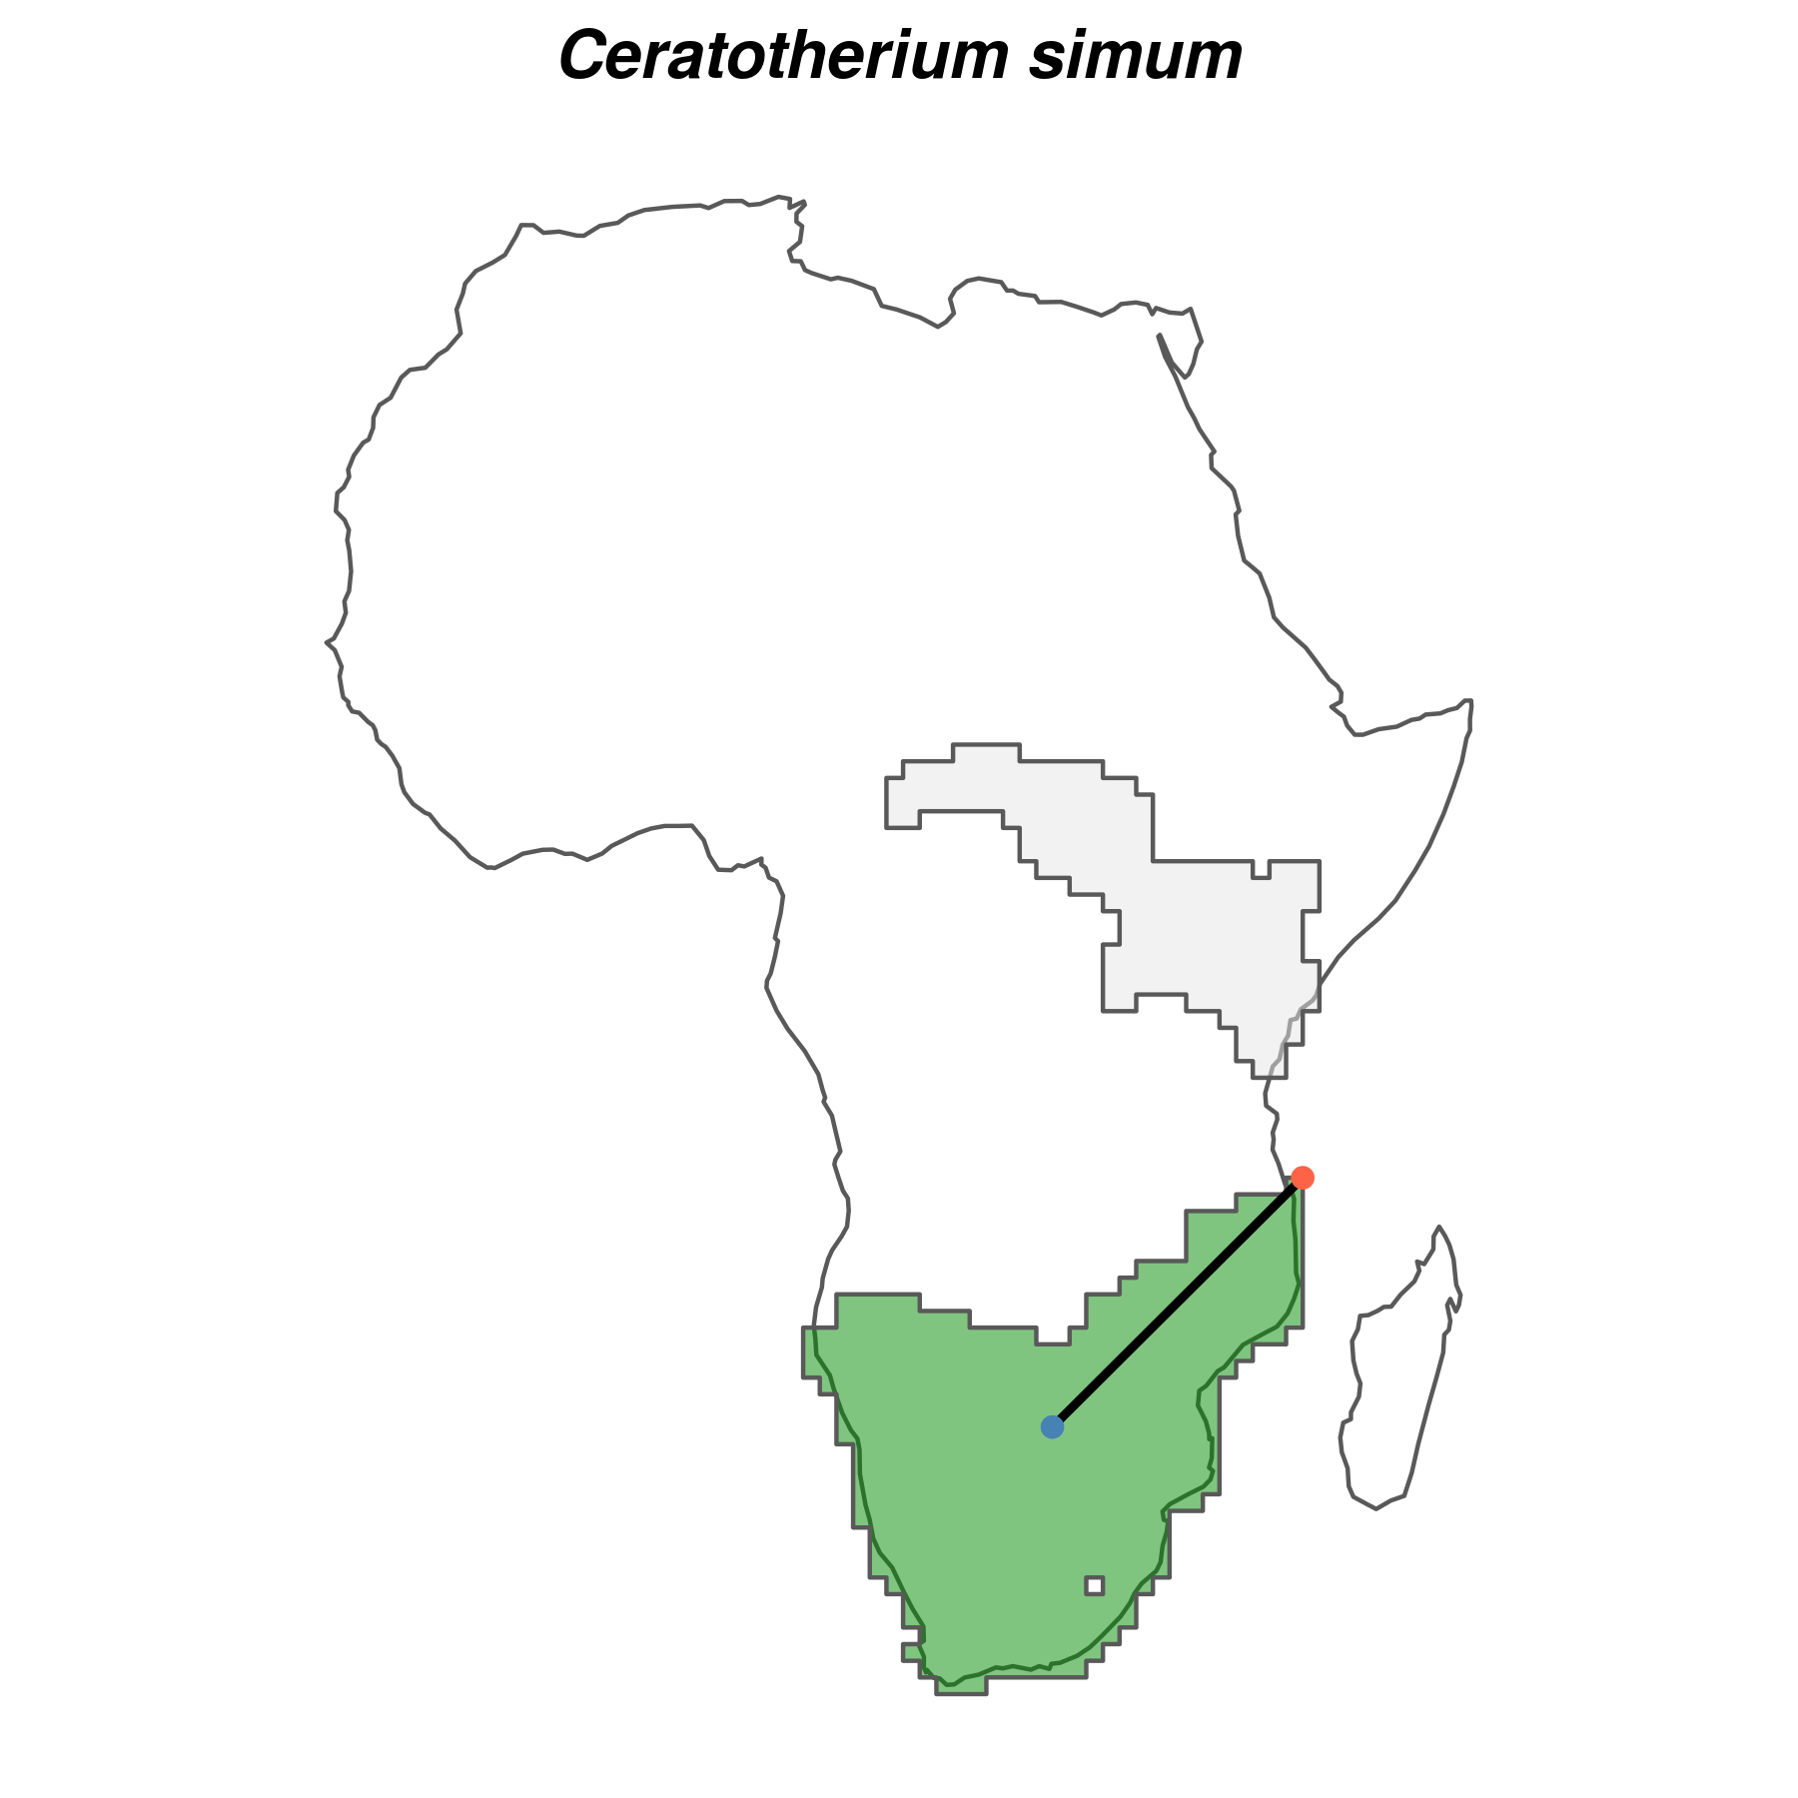
Supplementary Figure 1: Example for the white rhinoceros (Ceratotherium simum) of species-specific buffer size used in the species distribution models. For each species, we calculated the background area buffer as the maximum distance (black line) from the centroid (blue point) to the edge (red point) of the largest continuous range (shown in green). The smallest continuous range is also shown (light grey).Buffer size was then used to delimit the area accessible to the species through dispersal, i.e. the area used to generate background locations. Ranges were the combined current and present-natural ranges from the PHYLACINE database (Faurby et al. 2018).
Supplementary Table 1: Summary of the evaluation statistics of the species distribution models for extant terrestrial mammals.
Evaluation statistic | Median | Median absolute deviation | Mean | Standard deviation
Continuous Boyce Index (CBI) | 0.93 | 0.08 | 0.87 | 0.15
Area under the curve (AUC) of the receiver operating curve | 0.86 | 0.01 | 0.85 | 0.04
Omission rate minimum training presence (OR_{MTP}) | 0.02 | 0.03 | 0.07 | 0.15
Proportion of known introduction ranges predicted* | 0.84 | 0.23 | 0.62 | 0.41
* Introduction ranges were obtained from Lundgren et al. (2018) and the IUCN Red List of Threatened Species (IUCN 2019).

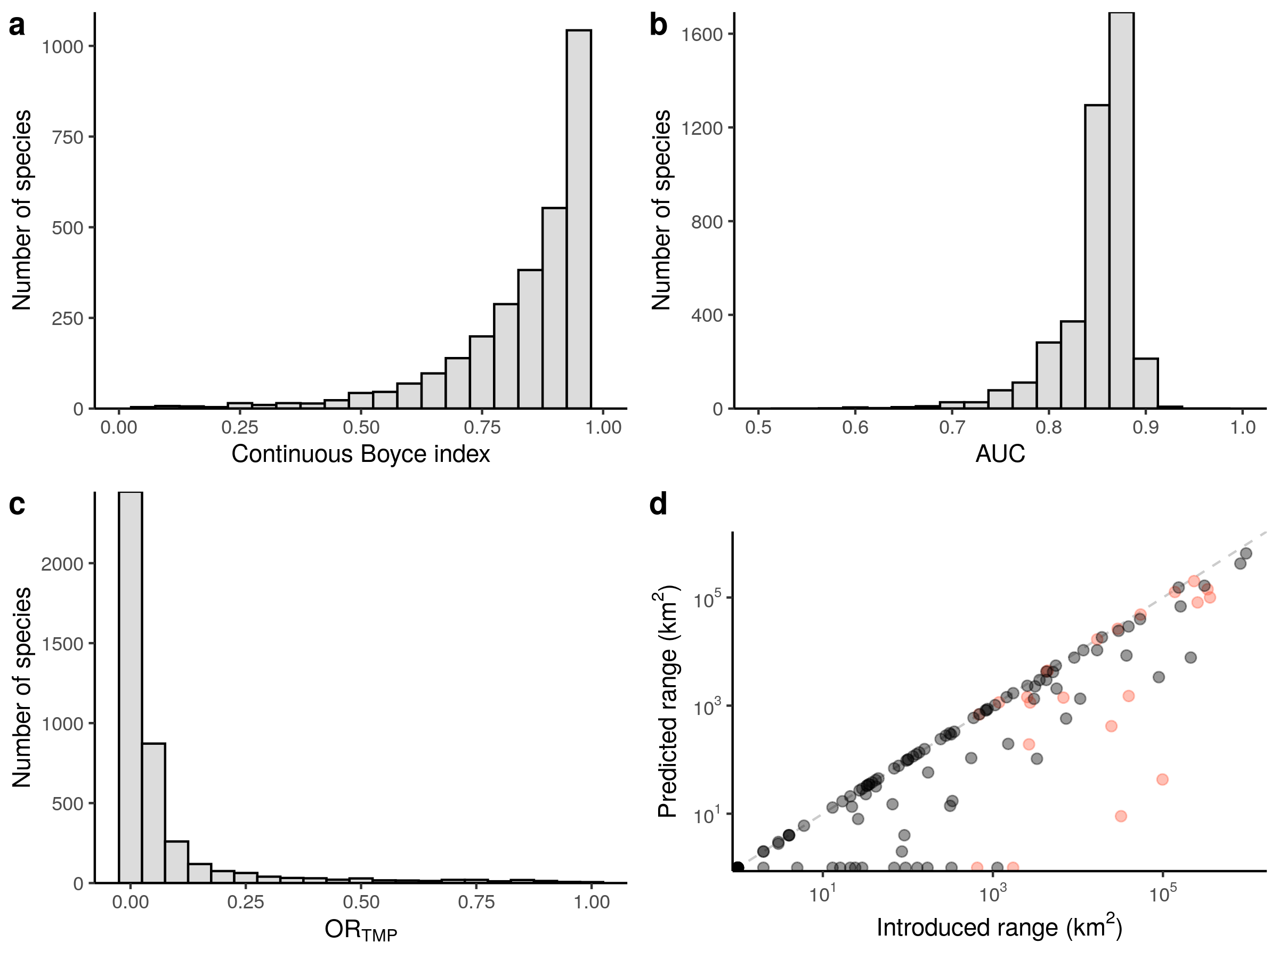
Supplementary Figure 2: Performance of maximum entropy (Maxent) species distribution models (SDMs). a–c, Histograms of the evaluation statistics for the Maxent SDMs. Predictive ability of SDMs is shown by both the Continuous Boyce Index (a) and by the Area Under the Curve (AUC) of the receiver operating curve (b). Model overfit is shown by the Omission Rate Minimum Training Presence (OR_{MTP}; c). d, Scatterplot showing predictions of known introduction ranges of mammals using Maxent SDMs. Species with fully predicted known introduction range are on the plane bisector (dashed line). Introduced ranges were from Lundgren et al. (2018; red circles) and the IUCN Red List of Threatened Species (IUCN 2019; black circles).

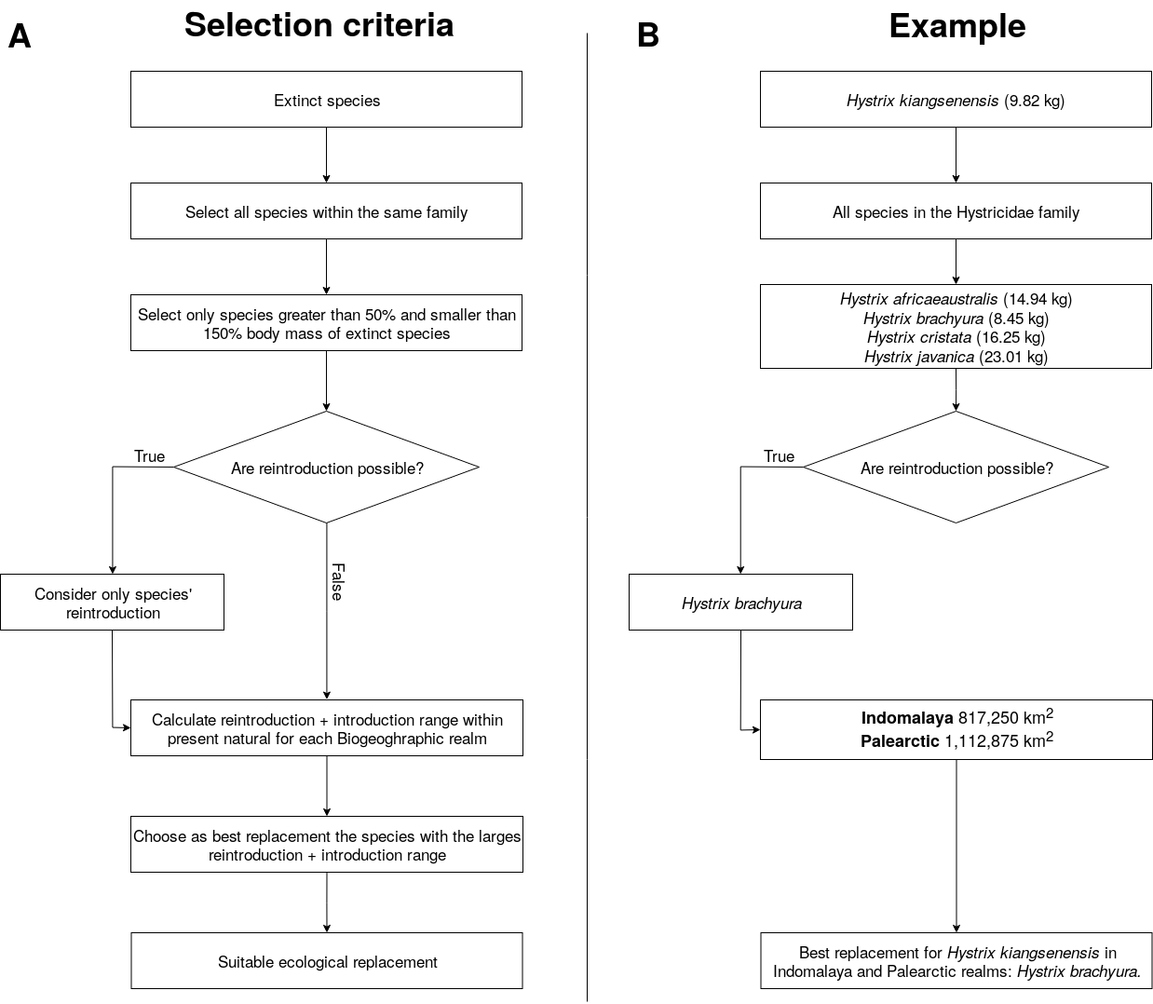
Supplementary Figure 3: Schematics showing selection of functional analogues to replace extinct species for the trophic rewilding scenario. We show for A) the selection criteria for replacement of extinct species with functional analogues, and B) a worked example of selecting a functional analogue for the extinct Hystrix kiangsenensis. Note that exceptions to the selection criteria are made for Probescians, Felidae and Ursidae as mentioned in the main text and Supplementary Material.

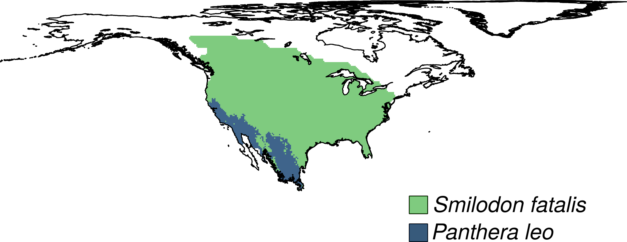
Supplementary Figure 4: Example of a functional analogue rewilding range for the extinct species Smilodon fatalis in the Nearctic realm. Present-natural ranges S. Fatalis (green shade) represent counter-factual ranges estimated for current climate without anthropogenic pressure through time and were from the PHYLACINE database (Faurby et al. 2018). The rewilding range of the functional analogue Panthera leo (blue shade) was obtained assessing its climatic suitability through maximum entropy species distribution models. In this example, P. leo rewilding range (blue area) is limited by the climatic suitability of species and covers only a small proportion of the present-natural distribution of S. fatalis.
Supplementary Table 2: List of the extinct species that were replaced by functional analogues in the focal biogeographic realm. List of terrestrial mammals extinct during the Late Pleistocene and their functional analogues for trophic rewilding in each biogeographic realm.
Extinct species | Functional analogues | Biogeographic realm
Vombatus hacketti | Lasiorhinus latifrons | Australasia
Arctodus simus | Ursus arctos | Nearctic
Arctodus simus | Ursus arctos | Neotropic
Arctotherium wingei | Ursus americanus | Neotropic
Tremarctos floridanus | Ursus americanus | Nearctic
Tremarctos floridanus | Ursus americanus | Neotropic
Ursus spelaeus | Ursus arctos | Palearctic
Catagonus stenocephalus | Pecari tajacu | Neotropic
Muknalia minima | Pecari tajacu | Nearctic
Muknalia minima | Pecari tajacu | Neotropic
Tapirus augustus | Tapirus indicus | Indomalaya
Tapirus augustus | Tapirus indicus | Palearctic
Tapirus merriami | Tapirus bairdii | Nearctic
Tapirus rondoniensis | Tapirus terrestris | Neotropic
Tapirus veroensis | Tapirus bairdii | Nearctic
Tapirus veroensis | Tapirus bairdii | Neotropic
Kolpochoerus majus | Hylochoerus meinertzhageni | Afrotropic
Metridiochoerus compactus | Phacochoerus africanus | Afrotropic
Sus bucculentus | Sus scrofa | Indomalaya
Stegodon orientalis | Elephas maximus | Indomalaya
Stegodon orientalis | Elephas maximus | Palearctic
Stegodon trigonocephalus | Elephas maximus | Indomalaya
Elasmotherium sibiricum | Ceratotherium simum | Palearctic
Stephanorhinus kirchbergensis | Ceratotherium simum | Indomalaya
Stephanorhinus kirchbergensis | Ceratotherium simum | Palearctic
Petauroides ayamaruensis | Pseudochirulus canescens | Australasia
Petauroides ayamaruensis | Pseudochirulus schlegeli | Australasia
Bettongia anhydra | Bettongia lesueur | Australasia
Bettongia pusilla | Bettongia lesueur | Australasia
Bettongia pusilla | Bettongia penicillata | Australasia
Potorous platyops | Potorous gilbertii | Australasia
Perameles eremiana | Perameles bougainville | Australasia
Ochotona whartoni | Ochotona alpina | Nearctic
Neovison macrodon | Neovison vison | Nearctic
Conilurus albipes | Conilurus penicillatus | Australasia
Conilurus capricornensis | Conilurus penicillatus | Australasia
Notomys amplus | Notomys mitchellii | Australasia
Notomys longicaudatus | Notomys mitchellii | Australasia
Notomys macrotis | Notomys mitchellii | Australasia
Notomys mordax | Notomys alexis | Australasia
Notomys mordax | Notomys aquilo | Australasia
Notomys mordax | Notomys fuscus | Australasia
Notomys robustus | Notomys fuscus | Australasia
Pseudomys glaucus | Pseudomys novaehollandiae | Australasia
Pseudomys gouldii | Pseudomys desertor | Australasia
Brachyprotoma obtusata | Conepatus leuconotus | Nearctic
Manis paleojavanica | Smutsia gigantea | Indomalaya
Mammut americanum | Loxodonta africana | Nearctic
Mammut americanum | Loxodonta africana | Neotropic
Lagorchestes asomatus | Lagorchestes hirsutus | Australasia
Macropus greyi | Thylogale billardierii | Australasia
Metasthenurus newtonae | Macropus rufus | Australasia
Onychogalea lunata | Petrogale lateralis | Australasia
Procoptodon browneorum | Macropus giganteus | Australasia
Procoptodon gilli | Macropus rufus | Australasia
Protemnodon hopei | Macropus antilopinus | Australasia
Protemnodon hopei | Macropus giganteus | Australasia
Protemnodon hopei | Macropus rufus | Australasia
Protemnodon nombe | Macropus giganteus | Australasia
Protemnodon tumbuna | Macropus giganteus | Australasia
Simosthenurus maddocki | Macropus giganteus | Australasia
Sthenurus andersoni | Macropus rufus | Australasia
Thylogale christenseni | Dorcopsulus vanheurni | Australasia
Troposodon minor | Macropus giganteus | Australasia
Wallabia kitcheneri | Macropus fuliginosus | Australasia
Aztlanolagus agilis | Lepus californicus | Nearctic
Aztlanolagus agilis | Lepus californicus | Neotropic
Aztlanolagus agilis | Sylvilagus floridanus | Neotropic
Hystrix kiangsenensis | Hystrix brachyura | Indomalaya
Hystrix kiangsenensis | Hystrix brachyura | Palearctic
Hystrix refossa | Hystrix indica | Indomalaya
Hystrix refossa | Hystrix indica | Palearctic
Hexaprotodon sivalensis | Choeropsis liberiensis | Indomalaya
Cuvieronius hyodon | Elephas maximus | Nearctic
Cuvieronius hyodon | Loxodonta africana | Neotropic
Notiomastodon platensis | Elephas maximus | Neotropic
Homotherium latidens | Panthera tigris | Palearctic
Homotherium serum | Panthera onca | Nearctic
Homotherium serum | Panthera onca | Neotropic
Leopardus amnicola | Catopuma badia | Nearctic
Leopardus amnicola | Leopardus wiedii | Neotropic
Miracinonyx trumani | Puma concolor | Nearctic
Panthera atrox | Panthera tigris | Nearctic
Panthera atrox | Panthera leo | Neotropic
Panthera spelaea | Panthera tigris | Nearctic
Panthera spelaea | Panthera tigris | Palearctic
Smilodon fatalis | Panthera tigris | Nearctic
Smilodon fatalis | Panthera leo | Neotropic
Smilodon populator | Panthera leo | Nearctic
Smilodon populator | Panthera tigris | Neotropic
Equus francisci | Equus ferus | Nearctic
Equus francisci | Equus ferus | Neotropic
Equus hydruntinus | Equus ferus | Palearctic
Equus ovodovi | Equus ferus | Palearctic
Hippidion devillei | Equus ferus | Neotropic
Hippidion principale | Equus quagga | Neotropic
Elephas iolensis | Loxodonta africana | Afrotropic
Elephas iolensis | Loxodonta africana | Palearctic
Elephas namadicus | Elephas maximus | Indomalaya
Elephas namadicus | Elephas maximus | Palearctic
Elephas naumanii | Elephas maximus | Indomalaya
Elephas naumanii | Elephas maximus | Palearctic
Mammuthus columbi | Elephas maximus | Nearctic
Mammuthus columbi | Elephas maximus | Neotropic
Mammuthus primigenius | Elephas maximus | Indomalaya
Mammuthus primigenius | Elephas maximus | Nearctic
Mammuthus primigenius | Elephas maximus | Palearctic
Cryptonanus ignitus | Thylamys venustus | Neotropic
Dasypus bellus | Dasypus kappleri | Nearctic
Dasypus bellus | Dasypus kappleri | Neotropic
Lagostomus crassus | Lagostomus maximus | Neotropic
Agalmaceros blicki | Odocoileus virginianus | Neotropic
Cervalces scotti | Alces alces | Nearctic
Haploidoceros mediterraneus | Cervus elaphus | Palearctic
Megaloceros giganteus | Alces alces | Palearctic
Morenelaphus brachyceros | Ozotoceros bezoarticus | Neotropic
Navahoceros fricki | Odocoileus virginianus | Nearctic
Navahoceros fricki | Odocoileus virginianus | Neotropic
Paraceros fragilis | Ozotoceros bezoarticus | Neotropic
Rucervus schomburgki | Rucervus eldii | Indomalaya
Sangamona fugitiva | Cervus canadensis | Nearctic
Sinomegaceros ordosianus | Alces alces | Palearctic
Sinomegaceros yabei | Alces alces | Indomalaya
Sinomegaceros yabei | Alces alces | Palearctic
Neochoerus aesopi | Hydrochoerus hydrochaeris | Nearctic
Neochoerus aesopi | Hydrochoerus hydrochaeris | Neotropic
Canis dirus | Canis lupus | Nearctic
Canis dirus | Canis lupus | Neotropic
Dusicyon avus | Lycalopex griseus | Neotropic
Protocyon troglodytes | Chrysocyon brachyurus | Neotropic
Theriodictis tarijensis | Chrysocyon brachyurus | Neotropic
Camelops hesternus | Camelus ferus | Nearctic
Camelops hesternus | Camelus dromedarius | Neotropic
Hemiauchenia macrocephala | Lama guanicoe | Nearctic
Hemiauchenia macrocephala | Lama guanicoe | Neotropic
Hemiauchenia paradoxa | Camelus dromedarius | Neotropic
Palaeolama major | Camelus dromedarius | Neotropic
Palaeolama mirifica | Lama guanicoe | Nearctic
Palaeolama mirifica | Lama guanicoe | Neotropic
Palaeolama mirifica | Vicugna vicugna | Neotropic
Palaeolama weddeli | Camelus dromedarius | Neotropic
Antidorcas australis | Pelea capreolus | Afrotropic
Antidorcas bondi | Sylvicapra grimmia | Afrotropic
Bootherium bombifrons | Connochaetes taurinus | Nearctic
Bubalus palaeokerabau | Bos javanicus | Indomalaya
CapriniGen spA | Tragelaphus scriptus | Afrotropic
Damaliscus hypsodon | Tragelaphus scriptus | Afrotropic
Damaliscus niro | Alcelaphus buselaphus | Afrotropic
Euceratherium collinum | Bison bison | Nearctic
Euceratherium collinum | Bison bison | Neotropic
Gazella atlantica | Ammotragus lervia | Palearctic
Gazella bilkis | Capricornis crispus | Afrotropic
Gazella bilkis | Naemorhedus caudatus | Afrotropic
Gazella bilkis | Procapra gutturosa | Afrotropic
Gazella bilkis | Procapra przewalskii | Afrotropic
Gazella bilkis | Eudorcas albonotata | Palearctic
Gazella saudiya | Gazella gazella | Afrotropic
Gazella saudiya | Gazella gazella | Palearctic
Gazella tingitana | Gazella cuvieri | Palearctic
Hemitragus cedrensis | Capra pyrenaica | Palearctic
Hippotragus leucophaeus | Alcelaphus buselaphus | Afrotropic
Hippotragus leucophaeus | Damaliscus pygargus | Afrotropic
Megalotragus priscus | Alcelaphus buselaphus | Afrotropic
Megalovis guangxiensis | Pseudois nayaur | Indomalaya
Megalovis guangxiensis | Pseudois nayaur | Palearctic
Oreamnos harringtoni | Ovis canadensis | Nearctic
Oreamnos harringtoni | Ovis canadensis | Neotropic
Pelorovis antiquus | Bos primigenius | Palearctic
Rusingoryx atopocranion | Kobus ellipsiprymnus | Afrotropic
Sivacobus sankaliai | Capricornis thar | Indomalaya
Sivacobus sankaliai | Capricornis thar | Palearctic
Soergelia minor | Capra sibirica | Palearctic
Spirocerus kiakhtensis | Bos primigenius | Palearctic
Caipora bambuiorum | Brachyteles arachnoides | Neotropic
Protopithecus brasiliensis | Brachyteles arachnoides | Neotropic
Stockoceros conklingi | Antilocapra americana | Nearctic
Stockoceros conklingi | Antilocapra americana | Neotropic
Tetrameryx shuleri | Antilocapra americana | Nearctic
Tetrameryx shuleri | Antilocapra americana | Neotropic

Supplementary Table 3: Average proportions from the reconstructed food webs of the number of species per trophic level for current and rewilding scenario respect to the present-natural in protected areas ≥ 5,000 km² with IUCN management status I-II and in random areas ≥ 5,000 km².
Trophic level | Current / present-natural | Rewilding / present-natural
Protected areas
Megacarnivores (≥ 100 kg) | 0.29 | 0.53
Megaherbivores (≥ 1,000 kg) | 0.17 | 0.31
Large carnivores (21.5–99 kg) | 0.71 | 0.80
Large herbivores (45–999 kg) | 0.44 | 0.61
Small carnivores (< 21.5 kg) | 0.94 | 0.98
Small herbivores (< 45 kg) | 0.97 | 0.98
Random areas
Megacarnivores (≥ 100 kg) | 0.15 | 0.51
Megaherbivores (≥ 1,000 kg) | 0.08 | 0.31
Large carnivores (21.5–99 kg) | 0.51 | 0.92
Large herbivores (45–999 kg) | 0.33 | 0.60
Small carnivores (< 21.5 kg) | 0.92 | 0.98
Small herbivores (< 45 kg) | 0.96 | 0.98

Supplementary Table 4: Average proportion from the reconstructed food webs of the number of predator-prey interactions between trophic levels for current and rewilding scenarios relative to the present-natural in protected areas ≥ 5,000 km² with IUCN management status I-II and in random areas ≥ 5,000 km².

Predator | Prey | Current / present-natural | Rewilding / present-natural
Protected areas
Megacarnivores | Large carnivores | 0.31 | 0.61
Megacarnivores | Large herbivores | 0.17 | 0.33
Megacarnivores | Small carnivores | 0.29 | 0.60
Megacarnivores | Small herbivores | 0.28 | 0.55
Large carnivores | Large herbivores | 0.42 | 0.50
Large carnivores | Small carnivores | 0.69 | 0.88
Large carnivores | Small herbivores | 0.78 | 0.89
Small carnivores | Small herbivores | 0.95 | 0.99
Random areas
Megacarnivores | Large carnivores | 0.12 | 0.62
 | Large herbivores | 0.08 | 0.38
 | Small carnivores | 0.17 | 0.60
 | Small herbivores | 0.16 | 0.58
Large carnivores | Large herbivores | 0.29 | 0.55
 | Small carnivores | 0.46 | 0.92
 | Small herbivores | 0.57 | 0.92
Small carnivores | Small herbivores | 0.89 | 0.98

References
Elith, J. et al. A statistical explanation of maxent for ecologists. Divers. Distrib. 17, 43–57 (2011).
Faurby, S. et al. PHYLACINE 1.2: The phylogenetic atlas of mammal macroecology. Ecology 99, 2626–2626 (2018).
Fielding, A. H. & Bell, J. F. A review of methods for the assessment of prediction errors in conservation presence/absence models. Environ. Conserv. 24, 38–49 (1997).
Guevara, L., Gerstner, B. E., Kass, J. M. & Anderson, R. P. Toward ecologically realistic predictions of species distributions: A cross-time example from tropical montane cloud forests. Glob. Change Biol. 24, 1511–1522 (2018).
Hirzel, A. H., Le Lay, G., Helfer, V., Randin, C. & Guisan, A. Evaluating the ability of habitat suitability models to predict species presences. Ecol. Model. 199, 142–152 (2006).
Hof, C. et al. Bioenergy cropland expansion may offset positive effects of climate change mitigation for global vertebrate diversity. Proc. Nat. Acad. Sci. 115, 13294–13299 (2018).
IUCN 2019. The IUCN Red List of Threatened Species. Version 2019-3. http://www.iucnredlist.org/. Downloaded on 10 December 2019.
Liu, C., Newell, G. & White, M. On the selection of thresholds for predicting species occurrence with presence-only data. Ecol. Evol. 6, 337–348 (2016).
Lundgren, E. J., Ramp, D., Ripple, W. J. & Wallach, A. D. Introduced megafauna are rewilding the Anthropocene. Ecography 41, 857–866 (2018).
Merow, C., Smith, M. J., & Silander Jr, J. A. (2013). A practical guide to maxent for modeling species’ distributions: What it does, and why inputs and settings matter. Ecography 36, 1058–1069.
Merow, C. et al. What do we gain from simplicity versus complexity in species distribution models? Ecography 37, 1267–1281 (2014).
Phillips, S. J., Anderson, R. P., Dudík, M., Schapire, R. E. & Blair, M. E. Opening the black box: An open-source release of Maxent. Ecography 40, 887–893 (2017).
Poo-Muñoz, D. A. et al. Galictis cuja (Mammalia): An update of current knowledge and geographic distribution. Iheringia. Série Zoologia 104, 341–346 (2014).
Sandom, C. J. et al. Trophic rewilding presents regionally specific opportunities for mitigating climate change. Philos. Trans. R. Soc. B: Biol. Sci. 375, 20190125 (2020).
Swets, J. A. Measuring the accuracy of diagnostic systems. Science 240, 1285–1293 (1988).

