Globally downgraded food webs in protected areas can be partially rewired through trophic rewilding
Emilio Berti ^{*, 1, 2}, Scott Jarvie^{1, 2}, Jens-Christian Svenning^{1, 2}
1 – Center for Biodiversity Dynamics in a Changing World (BIOCHANGE), Department of Biology, Aarhus University, Ny Munkegade 114, DK-8000 Aarhus C, Denmark
2 – Section for Ecoinformatics and Biodiversity, Department of Biology, Aarhus University, Ny Munkegade 114, DK-8000 Aarhus C, Denmark
* – Corresponding author: emilio.berti@bio.au.dk

Introduction
Protected areas are a key instrument for biodiversity conservation, but generally harbour impoverished faunas and downgraded food webs due to the human-linked prehistoric and historic megafauna extinctions. This trophic downgrading, which often challenges ecosystems functionality and community stability, may be remedied through trophic rewilding, an ecological restoration strategy that uses species (re)introductions to restore top-down trophic interactions. However, the extent to which extant species can rewire food webs to pre-extinction levels is poorly understood. Using current and estimated natural ranges of all extant and extinct late-Quaternary mammals, we modelled climatic suitability to identify species for reintroductions and introductions as functional analogues to replace closely-related, similarly-sized extinct species. We then inferred food webs in large protected areas (PAs) and assessed the consequences of past losses for trophic complexity and the recoveries opportunities through rewilding. Our results show that species richness of the upper trophic levels has declined following late-Quaternary extinctions and that the number of trophic interactions decreased in PAs on average by 49%. Importantly, we found that trophic rewilding could partially restore trophic level richness and rewire 18% of the lost interactions through reintroductions jointly with introductions of functional analogues. Overall, our findings support trophic rewilding as an opportunity to rewire food webs in PAs globally and reinstate lost trophic interactions in degraded ecosystems.
During the last 50,000 years, large-bodied animals (megafauna) have been removed from ecosystems around the world in a size-selective extinction event unique for the last 66 million years ¹⁠ (Smith et al. 2018) and strongly linked to the global expansion of modern humans ²⁠ (Sandom et al. 2014)(Homo sapiens). These size-biased losses have continued through the Holocene ^{3,4}⁠ (Crees et al. 2014, Teng et al. 2020) and into the present in many areas (Dirzo et al. 2011) ⁵⁠, leading to widespread trophic downgrading of ecosystems (Estes et al. 2011, Mendoza et al. 2019) ^{6,7}⁠. The downsizing of faunas and simplification of food webs have a wide range of ecosystem consequences such as reduced regulatory effects of top-down control and decreased resilience of ecosystems (Estes et al. 2011, Gill 2014) ^{6,8}⁠. Protected areas (PAs) are a cornerstone for nature conservation. With almost 15% of the terrestrial surface covered ⁹⁠ (UNEP-WCMC 2018), PAs protect habitats and species from increasing anthropogenic pressure, buffering them from threatening processes (Gaston et al. 2008) ¹⁰⁠. Nevertheless, prehistoric and historic faunal downsizing also affect PAs, potentially reducing their capacity for maintaining biodiversity as well as altering their ecological functioning.
Trophic rewilding is a novel restoration strategy that advocates the (re)introduction of large-bodied species to restore trophic top-down interactions and associated tropic cascades and to promote self-sustaining biodiverse ecosystems (Svenning et al 2016) ¹¹⁠. For example, the reintroduction of wolves into Yellowstone National Park in the mid-1990s reinstated various direct and indirect top-down effects, as mediated by both large herbivores and mesopredators (Ripple et al. 2014a, Ripple et al. 2014b) ^{12,13}⁠. Empirical data from rewilding projects is, however, scarce and geographically biased (Tanantzap et al. 2018) ¹⁴⁠, with scientific literature on rewilding dominated by essays, perspectives and opinion papers (Svenning et al. 2016) ¹¹⁠. Despite increasing evidence for the restoration potential of rewilding from local studies (Perino et al. 2019) ¹⁵⁠, there is still limited knowledge of the opportunities to rewire ecological networks at a global scale through rewilding.
In this study, we investigate the opportunities to rewire terrestrial mammal food webs through rewilding in both large (≥ 5,000 km²) PAs with strict International Union for Conservation of Nature (IUCN) category I-II and, for comparison, geographically-unbiased random areas (Fig. 1). We include the latter partly to address the non-random geographic location of PAs and to represent that there may also be opportunities for trophic rewilding outside large PAs (e.g., Pedersen et al. 2020) ¹⁶⁠ . To assess the consequences of past extinctions and restoration opportunities, we infer food webs under three scenarios: 1) no-extinction, where extinct mammals are considered alive and extinct and extant mammals occupy their present-natural ranges, estimates of their natural distribution for today’s climate given the absence of anthropogenic pressure through time (Faurby et al. 2015, Faurby et al. 2018) ^{17,18}⁠; 2) current, where extinct mammals are excluded and extant mammals have current geographic distribution, except for introduced ranges; and 3) rewilding, where extant species are reintroduced to present-natural ranges and extinct species are replaced, to the extent possible, by closely-related, similarly-sized functional analogues that have overlapping climatic requirements, as evaluated through species distribution models (SDMs).

Results and discussion

Late-Quaternary losses of species and trophic interactions in PAs
PAs are globally strongly affected by past size-biased defaunation, with the number of species per trophic levels significantly lower at present than in the no-extinction scenario, except for small herbivores and small carnivores (Fig. 1). The relative reductions are especially strong for megacarnivores (≥ 100 kg), megaherbivores (≥ 1,000 kg), and large herbivores (45-999 kg), while large carnivores (21.5-99 kg) are also, but less strongly affected (Fig. 2). Overall, the numbers of species within the PAs are reduced on average by 41% across all trophic levels relative to the no-extinction baseline. In line with previous evidence (Smith et al. 2018, Sandom et al. 2014, Ripple et al. 2014b) ^{1,2,13}⁠, we found that much of these decreases are explained by megafaunal losses, particularly of megacarnivores and megaherbivores, with average declines up to 83% (Supplementary Table 1).
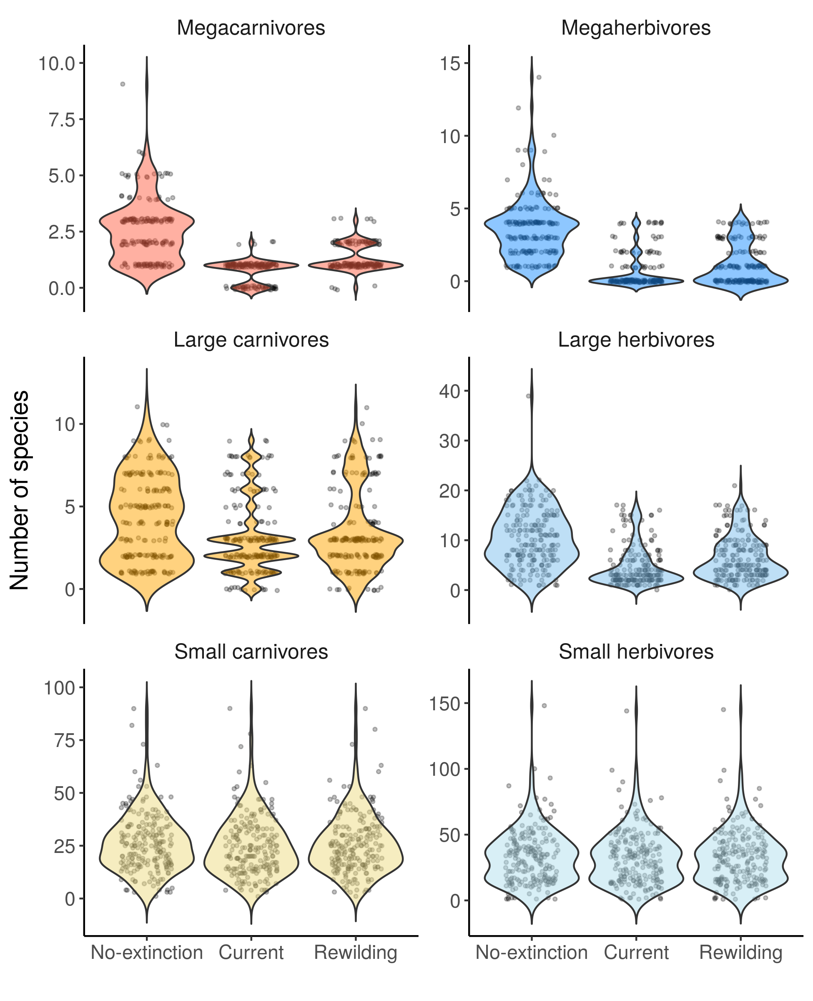

Fig. 1. Number of species per trophic levels in PAs under the three scenarios examined. Individual data points represents single food webs, while violin plots show their overall distribution. For definition of trophic levels see Fig. 2.
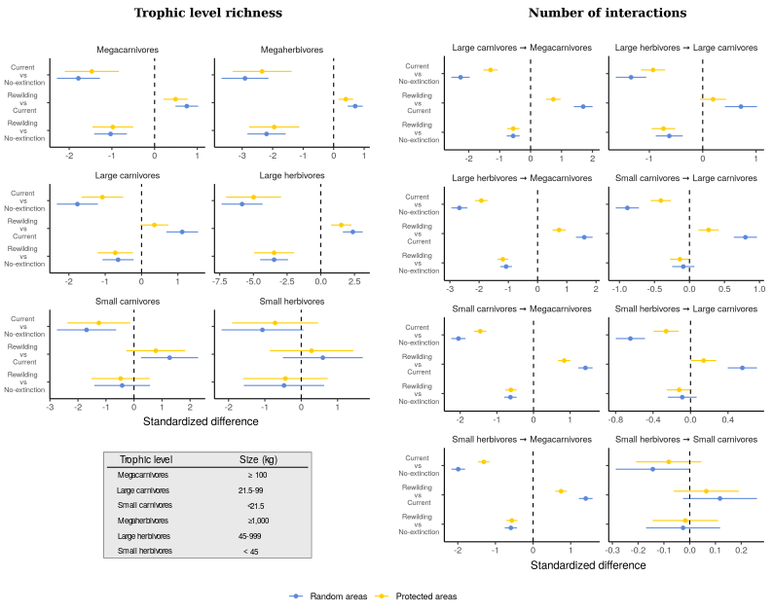
Fig. 2. Standardized differences of the contrasts among scenarios for trophic level richness and number of interactions from generalized linear mixed model. Standardized differences are an effect size measure that show the ecological importance of the change among the scenarios. Horizontal bars show the 95% confidence interval of the difference among contrasts. Differences that are not significant (P ≥ 0.01, after Bonferroni correction) have confidence intervals crossing the dashed vertical lines.
Reflecting the strong past size-biased defaunation, the number of interactions among trophic levels in PAs mammal communities is much reduced under current scenario relative to the no-extinction scenario (Fig. 1). Notably, all interactions involving megacarnivores are strongly reduced, with the link between large carnivores and large herbivores also strongly reduced, and a smaller reduction in link from large carnivores to small carnivores. In our reconstructed food webs, megaherbivores were found to be always free from predation, which is in line with previous evidence of megaherbivores being not controlled by predators ^{19,20}⁠ (Hopcraft et al. 2010), Consequently, the severe reductions of megaherbivores’ richness is not modelled to affect the trophic networks considered here. These findings indicate that food webs have been simplified by Late Pleistocene extinctions, with an average loss of interactions between all trophic levels of 49% in PAs. Such declines are mainly due to losses of top-down interactions by megacarnivores, with average declines as high as 83% (Supplementary Table 2).
The severe losses of megafauna richness and associated trophic processes show that food webs have been degraded due to late-Quaternary extinctions and suggest top-down control effects have been severely reduced in PAs worldwide. These findings corroborate evidence from previous studies that found top-down trophic processes and trophic complexity to be severely reduced following late-Quaternary extinctions ^{7,13}⁠ (Ripple et al. 2014b, Mendoza et al. 2019). Importantly, declines of trophic complexity and associated trophic processes have negative consequences on community dynamics and ecosystem functioning ^{6⁠} (Estes et al. 2011). For instance, extinction of megacarnivores, which are keystone species regulating densities and behaviour of their prey (Ripple et al. 2014b, Atkins et al. 2019) ^{13,21}⁠, cause losses of top-down control with cascading effects that altered ecosystems (Estes et al. 2011, Ripple et al. 2014a) ^{6,12}⁠. Moreover, losses of megaherbivores, which are not controlled by predation ^{19,20}⁠, have strong effects on vegetation structure, alter ecological processes such as nutrient flow, and cause homogenization of plant communities (Cromsigt et al. 2014, Bakker et al. 2016, Le Roux et al. 2018) ^{22–24}⁠.

Rewiring food webs in PAs through trophic rewilding
We found 94 living species can act as functional analogues to replace 127 of the 334 terrestrial mammals that went extinct during the late-Quaternary (Supplementary Table 3). To ensure introduced functional analogues had comparable roles in food webs to extinct species ²⁵⁠ (Donlan et al. 2006) ^{26,27}⁠ (Eklöf et al. 2012, Gravel et al. 2013), we selected closely-related, similarly-sized extant species with overlapping climatic requirements, evaluated through species distribution models. Extinct species for which all closely-related, similarly-sized species also went extinct were not replaced (e.g., the thylacine, Thylacinus cynocephalus). Consequently, complete replacement of extinct species with functional analogues was not possible under these constraints of the rewilding scenario examined here (Supplementary Fig. 1).
Trophic rewilding, as modelled here, would lead to important mammal recoveries in PAs, with the strongest effects for megacarnivores and megaherbivores, intermediate effects for large herbivores, and limited effects on large carnivores, small carnivores, and small herbivores (Fig. 1). Specifically, we found that rewilding would restore the number of species in all trophic levels by 11% relative to the no-extinction levels, with recoveries for megafauna being higher: megacarnivores richness increased by 24% and megaherbivores richness by 14% (Supplementary Table 1). These results suggest that the recoveries of megaherbivores’ and large herbivores’ richness should be able to partly reinstate long-tern natural levels of herbivory and predation and associated levels of top-down control on vegetation, facilitating heterogeneous landscapes with high levels of biodiversity ²⁸⁠.
We found that trophic rewilding would partially, but not completely restore food webs to the no-extinction scenario. Despite food webs not being completely restored to no-extinction conditions, partly due to the conservative criteria of our rewilding scenario, predator-prey interactions and trophic complexity would recover substantially. In particular, the relative increase in interactions would be strongest for megacarnivore-large herbivores and megacarnivore-small carnivore interactions, medium for megacarnivore-large carnivore and megacarnivore-small herbivore interactions, and small, but still significant for large carnivore-small carnivore interactions (Table 2). In our rewilding scenario, on average 18% of the lost trophic interactions in PAs would be restored, with recoveries largely concentrated in interactions involving megafauna. For instance, megacarnivore trophic interactions would increase on average by 26% (Supplementary Table 2).
These results indicate that rewilding has a high potential to rewire food webs in PAs worldwide. In particular, our findings show that predation top-down control, weakened worldwide by human activities ^{6,13}⁠ (Estes et al. 2011, Ripple et al 2014b), can be partly restored towards no-extinction levels. Such recoveries would reinstate top-down control on prey densities, likely promoting trophic cascades and increasing the resilience and biodiversity of ecosystems ^{21,29}⁠ (Atkins et al. 2019, Tylianakis et al 2010). Moreover, recoveries of large herbivore and megaherbivore richness suggest that trophic processes promoted by these trophic levels can also be partly restored to no-extinction levels, increasing the exchange of nutrients and energy among habitat patches and creating biodiverse heterogeneous habitats ^{22,24,30}⁠ (Cromsigt et al. 2014, Bakker et al. 2016, Le Roux et al. 2018). Overall, we found strong support for the high potential of trophic rewilding to reinstate trophic complexity and promote biodiverse self-sustaining ecosystems in PAs globally (as argued in Svenning et al. 2016 and Perino et al. 2019).

Rewilding food webs outside current large protected areas
When we considered random areas, irrespective of current land use, we still observed similar patterns as for the PAs, but with stronger effect sizes for both past losses and possible recoveries through rewilding (Fig. 1 and Supplementary Tables 1 and 2). This shows that our analyses were not influenced by geographic biases of the current network of PAs, which are located in areas with low human pressure and that poorly cover biodiversity hotspots of mammals ^{31,32}⁠ (Joppa et al. 2009, Daru et al. 2019). Moreover, these results suggest that there is strong scope for trophic rewilding not only in PAs, but more generally worldwide, given favourable societal conditions. In these areas, rewilding would thus rewire food webs and restore trophic complexity, also in areas that are currently non-protected, if human-wildlife coexistence can be achieved.
Here, we used a theoretical approach to investigate how late-Quaternary extinctions altered food webs and how rewilding can restore them. However, human-wildlife coexistence is the necessary starting point for rewilding ¹⁵⁠ (Perino et al. 2019). Success of rewilding depends on complex socio-ecological factors, particularly on the support from local communities ³³⁠ (Ceausu et al. 2019). For instance, rewilding can cause conflicts with local stakeholder, e.g., due to livestock predation or damages to crops and pastures ³⁴⁠ (Pereira et al., p. 72–74). People not directly damaged by wildlife can also negatively perceive rewilding projects depending on how they are implemented ³⁵⁠ (Theunissen 2019). Human-wildlife conflicts can, however, be resolved by identifying benefits and costs of wildlife ³³⁠ (Ceausu et al. 2019), by adopting compensation schemes for damages caused by wildlife ³⁶⁠ (Ravenelle et al. 2017), and by implementation adapted to the socio-ecological setting ¹⁶⁠ (Pedersen et al. 2020).
Importantly, our results from PAs ≥ 5,000 km² with strict IUCN management category I-II, where anthropogenic activities are more strictly controlled and human pressure is generally low ³⁷⁠ (Supplementary Information, Supplementary Fig. 2), are representative of regions where human-wildlife coexistence is more likely to be achieved. These would seem an obvious focal point for rewilding efforts, as our results show that these areas harbour downgraded food webs relative to the long-term natural situation, likely affected their functionality for biodiversity conservation. However, our findings also show that areas outside the large PAs have similar recovery opportunities if societal conditions would allow. Approaches to facilitating human-wildlife coexistence would allow rewilding to rewire food webs, reinstating lost trophic processes and promoting self-sustaining biodiverse ecosystems in natural and semi-natural areas in such areas, albeit often at reduced levels (Svenning et al. 2016).

Discussion
Trophic rewilding is a novel approach proposed to restore species and their ecological functions in degraded ecosystems and to promote self-sustaining biodiverse ecosystems ¹¹⁠ (Svenning et al. 2016). Our analyses reveal that late-Quaternary extinctions have severely degraded food webs worldwide by removing higher trophic levels and their predator-prey interactions. Consequently, top-down control processes have been reduced ^{13,21}⁠ (Ripple et al. 2014b, Atkins 2019), causing cascading effects that negatively affect composition and dynamics of communities ^{6,12,24,30}⁠ (Estes et al. 2011, Ripple et al. 2014a, Le Roux et al. 2018, Bakker et al. 2016). Importantly, we found that trophic rewilding has the potential to partially reverse such losses in a scenario where ecological risks are minimised and human-wildlife coexistence partially facilitated. Overall, our findings suggest high restoration opportunities for food webs and trophic complexity through trophic rewilding in PAs and, more generally, globally where favourable societal conditions can be met. This would rewire food webs and increase trophic complexity of terrestrial communities, reinstating trophic processes and top-down control and promoting self-sustaining biodiverse ecosystems ^{11,15}⁠ (Svenning et al. 2016, Perino et al. 2019).
In some areas, species are already re-expanding to their natural ranges and passive rewilding has already started. In Europe, for instance, land abandonment has increased in recent decades ³⁸⁠ (Verburg and Overmars 2009), promoting wildlife’s comeback ^{38,39}⁠ (Chapron et al. 2014, Ceausu et al. 2015). Traditional conservation and restoration approaches, which require large amount of resources and are limited to relatively small spatial scales, are unlikely to be effective measures to protect and restore ecosystems at broad geographic scales ³⁴⁠ (Pereira and Navarro 2015). In such cases our results show that rewilding, proposed as an alternative or complementary strategy to more traditional conservation and restoration strategies ¹⁵⁠ (Perino et al. 2019), can be a viable restoration strategy to boost trophic complexity and top-down trophic processes where wildlife is already re-expanding into abandoned landscapes.
Our findings support trophic rewilding as a promising, novel restoration strategy to re-establish in defaunated ecosystems important ecological functions, such as top-down control and trophic complexity ^{12,15}⁠ (Perino et al. 2019, Ripple et al. 2014a). Measures to facilitate human-wildlife coexistence and mitigate negative impacts of wildlife for local communities are needed to promote rewilding with realistic goals ^{16,33}⁠ (Ceausu et al. 2019, Pedersen et al. 2020). In some areas, such as large PAs I-II and abandoned landscapes where wildlife is making a comeback, active or passive trophic rewilding has particularly high potential to restore trophic complexity⁠ (Ripple et al. 2015B, Perino et al. 2019). Moreover, trophic rewilding with realistic goals and pragmatic implementation is also much more broadly feasible, if measures to facilitate human-wildlife coexistence and mitigate negative impacts of wildlife for local communities are successfully implemented. ^{22,36}⁠ (Ceausu et al. 2019, Pedersen et al. 2020). In conclusion, our study shows that, in our time of widespread biodiversity changes and trophic downgrading ^{6,7}⁠ (Estes et al. 2011, Mendoza et al. 2019), trophic rewilding is a much needed approach to restore degraded ecosystems to self-sustaining biodiverse states ^{11,15}⁠ (Svenning et al. 2016, Perino et al. 2019).

Methods

Overview
Our methodology follows four distinct steps: 1) we ran correlative species distribution models (SDMs) for extant terrestrial mammals to estimate their climatically suitable habitats; 2) we modelled reintroductions of extant terrestrial mammals and identified extant mammals that can replace closely-related, similarly-sized extinct species in climatically suitable habitats; 3) we reconstructed food webs within large protected areas (PAs) and random areas for a no-extinction, a current, and a rewilding scenario; and 4) we contrasted the food webs among these three scenarios and investigated whether rewilding can rewire current food webs to present-natural conditions. These four steps are explained in more detail below.

Species distribution models
Correlative SDMs are currently the main tools used to derive spatially explicit predictions of environmental suitability for species ⁴⁰⁠ (Elith and Leathwick 2009). They typically achieve this through identification of statistical relationships between species observations and environmental descriptors ⁴¹⁠ (Guisan and Thuiller 2005). Following previous studies ^{42,43}⁠ (Jarvie and Svenning 2018, Monsarrat et al. 2019), we used current and present-natural range maps from the PHYLACINE database ⁴⁴⁠ (Faurby et al. 2018) to overcome biases when running SDMs due to anthropogenic range contraction of species ⁴⁵⁠ (Faurby and Araújo 2018). Current ranges were generated from the IUCN range maps for current, natural, and reintroduced ranges only ⁴⁶⁠ (IUCN 2019). Present-natural ranges are estimates of where species would be found today given the absence of anthropogenic influence through time ⁴⁷⁠ (Faurby and Svenning 2015). Present-natural ranges were derived combining current ranges with known historic distributions of species, fossil co-occurrence with closely-associated species, and known range modifications caused by humans ⁴⁷⁠ (Faurby and Svenning 2015). We generated presence locations for extant terrestrial mammals within combined current and present-natural range maps with a 20 km separation distance, excluding locations reported above the highest elevation for each species in the IUCN Red List or, if not stated, 4,000 meters, which is roughly the 95 percentile for upper elevations of mammals ⁴⁶⁠ (IUCN 2019). Elevation was determined for presence locations using the EarthEnv-DEM90 digital elevation model ⁴⁸⁠ (Robinson et al. 2014). We did not model species with less than 10 presence locations, thus excluding 76 species with restricted ranges. In total, we modelled 4,130 of the 4,206 living terrestrial mammals.
As environmental predictors for the SDMs, we used four bioclimatic variables from the WorldClim v2 database ⁴⁹⁠ (Fick and Hijmans 2017): maximum temperature of the warmest month, minimum temperature of the coldest month, precipitation of wettest quarter, and precipitation of driest quarter. We selected these variables as they capture extreme conditions and, thus, likely represent factors limiting the species distributions ⁵⁰⁠ (Guisan et al. 2017). The four variables were downloaded at 2.5 arc-minute resolution and reprojected to a 5 km resolution using bilinear interpolation with a Behrmann equal-area projection. To minimize potential issues with multi-collinearity, we ensured that the variance inflation factor among the climatic variables was below 4 ⁵¹⁠ (O’Brien 2007).
To model the climatic suitability of terrestrial mammals, we fitted maximum entropy (Maxent) models as implemented in the R package ‘maxnet’ ⁵²⁠ (Phillips et al. 2017). Maxent is a presence-background approach, in which environments occupied by a species are contrasted with the available environmental space ^{53,54}⁠ (Elith et al. 2011, Merow et al. 2013). Maxent models were fitted with the default settings, besides disabling threshold features to avoid locally overfitted response curves ⁵⁴⁠ (Merow et al. 2013) and increasing the number of randomly sampled background records from 10,000 up to a maximum of 100,000 to ensure greater representation of environmental space ⁵⁵⁠ (Guevara et al. 2018). For the background area, we calculated species-specific buffers from combined current and present natural ranges to reflect the dispersal abilities of each species ⁵⁶⁠ (Barve et al. 2011). Following previous studies ^{57,58}⁠ (Poo-Muñoz et al. 2014, Hof et al. 2018), we calculated the buffer size as the maximum distance from the centroid to the edge of the largest continuous range (see Supplementary Fig. 3 for an example).
We assessed the predictive performance of Maxent SDMs through five-fold cross validation using the average Continuous Boyce Index (CBI) ⁵⁹⁠ (Hirzel et al. 2006), which indicates how much models discriminate against random expectation, and the average Area Under the Curve (AUC) of the Receiver Operating Characteristic curve ⁶⁰⁠ (Swets 1988), which indicates how well models differentiate between presences and pseudo-absences regardless of the degree of difference between them. Values of CBI range between -1 and 1, where values > 0 indicate the model's output is positively correlated with the true probability of presence. AUC values range from 0 to 1, where AUC ≤ 0.5 indicate models with discrimination no better or worse than random and AUC = 1 indicate models with perfect discrimination ⁶¹⁠ (Fielding and Bell 1997). Model overfit was inspected through five-fold cross validation of the average omission rate based on the minimum training presence value (OR_{MTP}) ⁶²⁠ (Radosavljevic and Anderson 2014). The values of OR_{MTP} range from 0 for models that are not overfit to 1 for models that are overfit. To convert continuous suitability predictions to binary layers indicating suitable/unsuitable habitat, we used as threshold the suitability value that maximised sensitivity and specificity, which is more reliable than other threshold metrics when only presence data are available ⁶³⁠ (Liu et al. 2016). We also assessed the performance of SDMs by comparing our projected binary suitability maps with known introduced ranges of 136 species obtained from ⁶⁴⁠ Lundgren et al. (2018; n = 22 species) and the IUCN ⁴⁶⁠ (IUCN 2019; n = 114 species). The introduced ranges were not used to generate presence records to train the SDMs and were thus an independent validation source. For three species found in both datasets (Cervus elaphus, Ovibos moschatus, and Rangifer tarandus), we assessed performance of SDMs using only the ranges from ⁶⁴⁠ Lundgren et al. (2018).
Predictive performance of the SDMs was on average very high to excellent (mean CBI = 0.87; mean AUC = 0.85), while model overfitting was generally low (mean OR_{MTP} = 0.07; Supplementary Table 5). The SDMs predicted on average 62% of the introduced ranges from Lungren et al. (2018) and IUCN (2019), which were independent validation sources (Supplementary Fig. 4). Overall, these results indicate that SDMs give reliable projections of climatically suitable habitats for terrestrial mammals.

Selecting rewilding candidates
To select rewilding candidates, two steps were followed: i) we modelled reintroductions of extant terrestrial mammals into their present-natural ranges; ii) we modelled introductions of extant mammals that can be used as functional analogues to replace closely-related, similarly-sized extinct species in climatically suitable habitats (Lundgren et al. 2020). When more than one functional analogue was available for an extinct species, only one species was selected to replace an extinct species in a focal biogeographic realm, as biogeographic realms describe broad geographic regions with cohesive ecological and evolutionary history ^{65,66}⁠ (Olson et al. 2001, Olson and Dinerstein 2002). We excluded from analyses the two biogeographic realms Antarctica, as no terrestrial mammal lives there, and Oceania, where there is no terrestrial protected areas ≥ 5,000 km² with strictly managed IUCN category (Fig. 1). Importantly, as moving species outside their indigenous range is inherently riskier than reintroduction due to unforeseeable uncertainties and ecological risks ⁶⁷⁠ (Fernández et al. 2017), reintroductions of species as functional analogues were always prioritised over introductions of non-native species.
To make sure functional analogues had similar role in ecosystems to extinct species, functional analogues were selected from the same family of the extinct species and had similar body size, i.e., within 50% of the body mass range of the extinct species. We made two exceptions to this: 1) extinct megaherbivore ≥ 1,000 kg (Malhi et al., 2016) from the Proboscidea order were allowed to be replaced by the two extant elephants (Elephas maximus and Loxodonta africana). The rationale being that extant elephants are often considered as functional analogues of extinct megaherbivore proboscidean in many areas of the globe ^{11,25,68}⁠ (Donlan 2005, Donlan et al. 2006, Svenning 2007), due to their general phenotypic similarity (large body size, tusks, trunk) and because they promote similar key ecosystem processes, e.g., nutrient cycles and vegetation clearing ^{25,69}⁠ (Janzen and Martin 1982, Donlan et al. 2006). 2) Extinct megacarnivores (≥ 100 kg ⁷⁰⁠ ) (Malhi et al. 2016) from the families Felidae and Ursidae were allowed to be replaced by extant megacarnivores from the respective families, without further restrictions on body size. This was because Felidae and Ursidae megacarnivores play an integral part of a complete animal community, influencing ecosystems by regulating the abundance and activity of large herbivores that are smaller than megaherbivores ¹⁹⁠ (Hopcraft et al. 2010), either through direct predation or by behavioural changes induced by generation and shaping of “landscapes of fear” ²¹⁠ (Atkins et al. 2019).
When more than one functional analogue was a possible candidate to replace one extinct species in one biogeographic realm, we selected as functional analogue for rewilding the species that had the largest climatically suitable range overlapping with the present-natural range of the extinct species in the focal biogeographic realm. Importantly, we did not consider introductions of functional analogues when these had overlapping rewilding ranges with present-natural ranges of similarly-sized – i.e., within 50% of the body mass – extant species that could be reintroduced. This was to prevent potential issues due to competition between functionally similar species ⁷¹⁠ (Linnell and Strand 2000) and to avoid negative impacts on reintroductions from introducing non-native species. Extinct species for which we did not find any functional analogue that met the above conditions were not replaced. See Supplementary Fig. 5 for a schematic representation of how functional analogues were selected and Supplementary Fig. 6 for an example of functional analogue introduction range.

Reconstructing food webs
To investigate the potential of rewilding to rewire terrestrial mammal food webs, we reconstructed food webs in large PAs and geographically-unbiased random areas at a global scale. We selected PAs with strict IUCN management category I (strict nature reserves and wilderness areas) and II (national parks) as they represent sites where trophic rewilding is likely more feasible today, being geographically isolated and with generally less human pressure ³⁷⁠ (Jones et al. 2018) (Supplementary Fig. 2). We considered only large PAs ≥ 5,000 km², as this size should assure viable and biodiverse communities of megafauna, which require large areas for sustaining populations ^{72–74}⁠ (Woodroffe and Ginsberg 1998, Cantú-Salazar and Gaston 2010, Ripple et al. 2015). The ≥ 5,000 km² area is a pragmatic trade-off between possibly over-optimistic cut-offs, e.g., 100 km² ⁷⁴⁠ (Ripple et al. 2015), and overly-conservative thresholds, e.g., 25,000 km² ⁷³⁠ (Cantú-Salazar and Gaston 2010). We obtained PAs geometries from the World Database of Protected Area (WDPA) ⁹⁠ (UNEP-WCMC & IUCN 2019, downloaded June 2019). Following previous studies ⁷⁵⁠ (Runge et al. 2015), we excluded PAs without detailed geographic information, with unknown management status, UNESCO Biosphere Reserves, marine-only sites as well as the marine portion of coastal sites, and areas not considered protected internationally. After dissolvingadjacent geometries, assigning overlapping areas to the strictest IUCN category following WDPA best practice guidelines (https://www.protectedplanet.net/c/calculating-protected-area-coverage), we excluded areas with extent < 5,000 km². In total, we found 209 protected areas that met our requirements (Fig. 4).
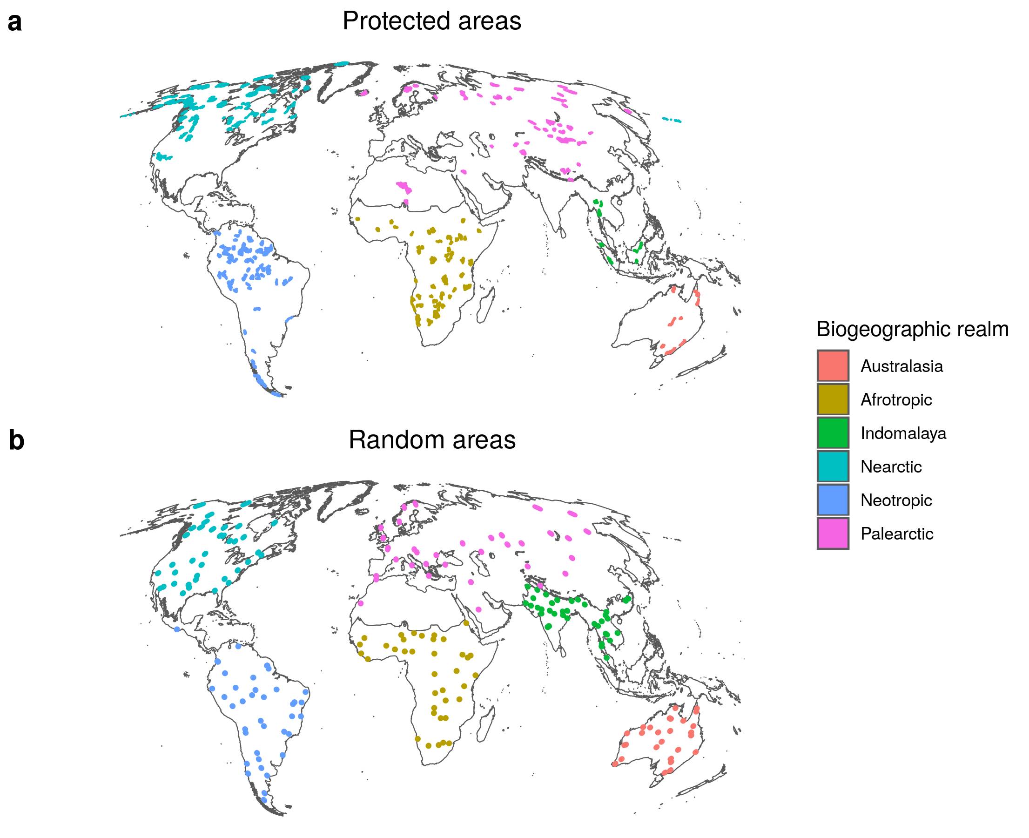
Fig. 4: Large protected and random areas ≥ 5,000 km² for trophic rewilding in each biogeographic realm (colours). a, Protected areas (PAs) with strict IUCN management category I-II. These PAs have generally low human pressure and represent areas where human-wildlife coexistence and rewilding are more likely to be achieved. b, Areas ≥ 5,000 km² generated at random for each biogeographic realm, displayed larger than their real extent for easier visualization. Random areas represent areas without the geographic biases of PAs and where there may also be opportunities for trophic rewilding if societal conditions allow.
We complemented the results from PAs, which may partly be affected by geographic and size biases (Fig. 4, Supplementary Fig. 7), by replicating our analyses using geographically random areas comparable in number and size with the PAs. Notably, PAs ≥ 5,000 km² with strict IUCN management categories are unevenly distributed on the continents and poorly overlap with current mammal biodiversity hotspots ^{31,32}⁠ (Joppa and Pfaff 2009, Daru et al. 2019). Moreover, as trophic rewilding may also be feasible outside large PAs if societal conditions allow (e.g., ¹⁶⁠ Pedersen et al. 2020), we could estimate such restoration opportunities by including random areas in our analyses. We thus replicated our analyses in 206 randomly generated areas of 40 km radius (area ~5,026 km²) that were evenly distributed among biogeographic realms (Fig. 4). These random areas did not have the geographic or size biases of PAs and, in addition, were representative of the ecological effect of rewilding also outiside the current network of PAs, where rewilding may be feasible given favourable societal conditions ¹⁶⁠ (Pedersen et al. 2020).
We reconstructed predator-prey communities for the three scenarios combining the current and present-natural ranges maps from the PHYLACINE database ⁴⁴⁠ (Faurby et al. 2018) and the binary climatic suitability maps for the selected rewilding candidates. For the no-extinction scenario, both extant and extinct species were considered to be alive and occupying their present-natural ranges; for the current scenario, we excluded extinct species and considered extant species to occupy their current ranges; for the rewilding scenario, we considered extant species to occupy their combined current and present-natural ranges, with species selected as functional analogues also occupying their introduction ranges to replace globally extinct species. The introduction ranges were always constrained to areas where extant species were found to be climatically suitable (see Supplementary Fig. 6 for an example).
Food webs were inferred for each PA and random area by combining a phylogenetic and a trait-based approach ⁷⁶⁠ (Pomeranz et al. 2019). Phylogeny has been shown to be a good predictor of trophic interactions ²⁶⁠ (Eklöf et al. 2012), as closely related species share similar resources ⁷⁷⁠ (Gray et al. 2015). We performed phylogenetic inference at the family level, a reasonable trade-off between accuracy of predictions and data availability ⁷⁷⁠ (Gray et al. 2015). Hence, we assigned each known interaction between a prey and a predator to all species of the respective families. We then used a trait-based approach to remove interactions inferred using phylogeny that were not supported by macroecological evidence ⁷⁶⁠ (Pomeranz et al. 2019). This trait-based approach uses the relationship between the body mass of prey and predators, which structures trophic interactions in food webs ^{82–84}⁠ (Williams and Martinez 2000, Owen-Smith and Mills 2008, Segura et al. 2016). Following previous studies ^{27,76}⁠ (Gravel et al. 2013, Pomeranz et al. 2019), we obtained dietary niches of carnivores, i.e., the body mass range of their prey, as the range within the 10% and the 90% regression quantiles. Phylogenetically inferred predator-prey interactions that felt outside the dietary niches were removed from the food webs. Data of predator-prey interactions was obtained from the ECOWeB database ⁷⁸⁠ (Cohen 2010), the Global Biotic Interactions database (GLOBI) ⁷⁹⁠ (Poelen et al. 2014), and two published food webs ^{80,81}⁠ (Baskerville et al. 2011, De Visser et al. 2011).
After food webs were inferred, we assigned species to trophic levels according to their diet and body mass, reflecting the trophic and ecological role of mammals in terrestrial ecosystems ^{19,70,85}⁠ (Malhi et al. 2016, Hopcraft et al. 2010, Carbone et al. 1999). We divided carnivores into three trophic levels: 1) megacarnivores ≥ 100 kg, which are generally apex predators that dominate food webs ¹³⁠ (Ripple et al. 2014b); 2) large carnivores 21.5-99 kg, which predate on large prey, but are subjected to top-down control from megacarnivores; and iii) small carnivores < 21.5 kg, which can predate only on smaller prey ⁸⁵⁠ (Carbone et al. 1999). We also divided herbivores into three trophic levels: 1) megaherbivores ≥ 1,000 kg, which are mostly free from predation ¹⁹⁠ (Hopcraft et al. 2010); ii) large herbivores 45–999 kg, which are predated only by large carnivores and megacarnivores; and iii) small herbivores < 45 kg, which are predated by all carnivore trophic levels ¹⁹⁠ (Hopcraft et al. 2010).

Statistical analyses
For the three food web scenarios, we calculated for each PA and random area the number of species present in each trophic level and the number of predator-prey interactions among trophic levels. We then fitted generalised linear mixed models (GLMMs) using food webs as (pseudo)replicate sample units and compared the changes across scenarios. Specifically, we estimated: 1) the differences between current and no-extinction scenarios, i.e., the losses due to late-Quaternary extinctions; 2) the differences between rewilding and current scenario, i.e., the restoration opportunities through rewilding; and 3) the differences between rewilding and no-extinction scenarios, i.e., the losses due to extinctions that cannot be recovered through rewilding. We selected the error distribution for the GLMMs based on the response data type and to remedy overdispersion. We used a Poisson distribution to model the number of species in each trophic level with the fixed effects scenario, trophic level, and their interaction. A negative binomial distribution was used to model the predator-prey interactions across trophic levels with the fixed effects scenario, trophic levels involved in the link, and their interaction. For both GLMMs, we used the random effects food web ID and biogeographic realm as random intercepts. Because preliminary analyses including protected and random areas as categorical predictors in the GLMMs showed random areas had in general lower numbers of species and interactions than protected areas (P < 0.05), we analysed protected and random areas separately. We checked model assumptions were met for GLMMs through inspection of the residuals. We assessed goodness-of-fit of GLMMs by calculating the marginal R², the proportion of variance in the data explained by only the fixed effects, and the conditional R², the proportion of variance in the data explained by both fixed and random effects ⁸⁶⁠ (Nakagawa & Schielzeth 2013). In general, GLMMs had in generalvery good fit, explaining on average 67% of the variance in the data when only fixed effects were considered and 95% of the variance when also the random effects were included.
We assessed significance among scenarios by performing pair-wise contrasts with Bonferroni correction, with overall significance level set at α = 0.05. To assess if significant results were also ecologically meaningful, we used the Cohen’s d effect size, which quantifies the standardized difference between model estimates ⁸⁷⁠ (Cohen 1988). Following ⁸⁷⁠ Cohen (1988) and ⁸⁸⁠ Sawilowsky (2009), we interpreted effect sizes as: very small (d = 0.00-0.19), small (d = 0.20-0.49), medium effect (d = 0.50-0.79), large (d = 0.80-1.19), very large (d = 1.20-1.99), and huge (d ≥ 2.00).
Data processing and analyses were performed in the R programming language v. 3.6.1 ^{89⁠} (R Core Team, 2018). We ran Maxent SDMs using the package ‘maxnet’ ⁵²⁠ (Phillips et al. 2017). All spatial analyses were conducted using the Behrmann cylindrical equal-area projection, with maps displayed in the Molleweide projection.

Data accessibility
All data used was open access: predator-prey interactions were obtained from ^{78–81}⁠ Baskerville et al. (2011), Visser et al. (2011), and the ECOWeB and GLOBI databases (J. E. Cohen, 2010; Poelen et al., 2014); body mass and current and present-natural ranges were from PHYLACINE 1.2 ⁴⁴⁠ (Faurby et al., 2018); climate data was from the WorldClim 2.0 database ⁴⁹⁠ (Fick & Hijmans, 2017); elevation data was from the EarthEnv-DEM90 digital elevation model ⁴⁸⁠ (Robinson et al., 2014); protected areas data was from the World Database of Protected Area (WDPA) ⁹⁠ (UNEP-WCMC & IUCN 2019, downloaded June 2019); the biogeographic realms shapefile was from ⁶⁵⁠ Olson et al. (2001).

Competing interests
We have no competing interests.

References
1. Smith, F. A., Smith, R. E. E., Lyons, S. K. & Payne, J. L. Body size downgrading ofmammals over the late Quaternary. 313, 310–313 (2018).
2. Sandom, C., Faurby, S., Sandel, B. & Svenning, J.-C. Global late Quaternary megafauna extinctions linked to humans, not climate change. Proc. R. Soc. B Biol. Sci. 281, 20133254–20133254 (2014).
3. Crees, J. J., Carbone, C., Sommer, R. S., Benecke, N. & Turvey, S. T. Millennial-scale faunal record reveals differential resilience of European large mammals to human impacts across the Holocene. Proc. R. Soc. B Biol. Sci. 283, (2016).
4. Teng, S. N., Xu, C., Teng, L. & Svenning, J. C. Long-term effects of cultural filtering on megafauna species distributions across China. Proc. Natl. Acad. Sci. U. S. A. 117, 486–493 (2020).
5. Dirzo, R. et al. Defaunation in the Anthropocene. Science. 345, 401–406 (2014).
6. Estes, J. A. et al. Trophic downgrading of planet Earth. Science. 333, 301–306 (2011).
7. Mendoza, M. & Araújo, M. B. Climate shapes mammal community trophic structures and humans simplify them. Nat. Commun. 10, (2019).
8. Gill, J. L. Ecological impacts of the late Quaternary megaherbivore extinctions. New Phytol. 201, 1163–1169 (2014).
9. UNEP-WCMC. NGS Protected Planet Report. (2018).
10. Gaston, K. J., Jackson, S. F., Cantú-Salazar, L. & Cruz-Piñón, G. The Ecological Performance of Protected Areas. Annu. Rev. Ecol. Evol. Syst. 39, 93–113 (2008).
11. Svenning, J.-C. et al. Science for a wilder Anthropocene: Synthesis and future directions for trophic rewilding research. Proc. Natl. Acad. Sci. 113, 898–906 (2016).
12. Ripple, W. J., Beschta, R. L., Fortin, J. K. & Robbins, C. T. Trophic cascades from wolves to grizzly bears in Yellowstone. J. Anim. Ecol. 83, 223–233 (2014).
13. Ripple, W. J. et al. Status and ecological effects of the world’s largest carnivores. Science. 343, 1241484 (2014).
14. Tanentzap, A. J. & Smith, B. R. Unintentional rewilding: Lessons for trophic rewilding from other forms of species introductions. Philos. Trans. R. Soc. B Biol. Sci. 373, (2018).
15. Bakker, E. S. & Svenning, J.-C. Trophic rewilding: impact on ecosystems under global change. (2018).
16. Perino, A. et al. Rewilding complex ecosystems. Science. 364, eaav5570 (2019).
17. Zhang, L., Takahashi, D., Hartvig, M. & Andersen, K. H. Food-web dynamics under climate change. Proc. R. Soc. B 284, 20171772 (2017).
18. Pires, M. M. Rewilding ecological communities and rewiring ecological networks. Perspect. Ecol. Conserv. 15, 257–265 (2017).
19. Marjakangas, E. L. et al. Estimating interaction credit for trophic rewilding in tropical forests. Philos. Trans. R. Soc. B Biol. Sci. 373, (2018).
20. Yeakel, J. D. et al. Collapse of an ecological network in Ancient Egypt. Proc. Natl. Acad. Sci. U. S. A. 111, 14475–14477 (2014).
21. Pires, M. M. et al. Pleistocene megafaunal interaction networks became more vulnerable after human arrival. Proc. R. Soc. B Biol. Sci. 282, (2015).
22. Pedersen, P. B. M., Ejrnæs, R., Sandel, B. & Svenning, J. C. Trophic Rewilding Advancement in Anthropogenically Impacted Landscapes (TRAAIL): A framework to link conventional conservation management and rewilding. Ambio 49, 231–244 (2020).
23. Faurby, S. & Svenning, J. C. Historic and prehistoric human-driven extinctions have reshaped global mammal diversity patterns. Divers. Distrib. 21, 1155–1166 (2015).
24. Faurby, S. et al. PHYLACINE 1.2: The Phylogenetic Atlas of Mammal Macroecology. Ecology 99, 2626 (2018).
25. Hopcraft, J. G. C., Olff, H. & Sinclair, A. R. E. Herbivores, resources and risks: alternating regulation along primary environmental gradients in savannas. Trends Ecol. Evol. 25, 119–128 (2010).
26. Atkins, J. L. et al. Cascading impacts of large-carnivore extirpation in an African ecosystem. Science. 364, 173–177 (2019).
27. Bakker, E. S. et al. Combining paleo-data and modern exclosure experiments to assess the impact of megafauna extinctions on woody vegetation. Proc. Natl. Acad. Sci. 113, 847–855 (2016).
28. le Roux, E., Kerley, G. I. H. & Cromsigt, J. P. G. M. Megaherbivores Modify Trophic Cascades Triggered by Fear of Predation in an African Savanna Ecosystem. Curr. Biol. 28, 2493-2499.e3 (2018).
29. Cromsigt, J. P. G. M. & te Beest, M. Restoration of a megaherbivore: Landscape-level impacts of white rhinoceros in Kruger National Park, South Africa. J. Ecol. 102, 566–575 (2014).
30. Tylianakis, J. M., Laliberté, E., Nielsen, A. & Bascompte, J. Conservation of species interaction networks. Biol. Conserv. 143, 2270–2279 (2010).
31. Joppa, L. N. & Pfaff, A. High and far: Biases in the location of protected areas. PLoS One 4, 1–6 (2009).
32. Daru, B. H. et al. Spatial overlaps between the global protected areas network and terrestrial hotspots of evolutionary diversity. Glob. Ecol. Biogeogr. 28, 757–766 (2019).
33. Ceauşu, S., Graves, R. A., Killion, A. K., Svenning, J. C. & Carter, N. H. Governing trade-offs in ecosystem services and disservices to achieve human–wildlife coexistence. Conserv. Biol. 33, 543–553 (2019).
34. Pereira, H. M. & Navarro, L. M. Rewilding European Landscapes. Rewilding European Landscapes (2015). doi:10.1007/978-3-319-12039-3_7.
35. Theunissen, B. The oostvaardersplassen fiasco. Isis 110, 341–345 (2019).
36. Ravenelle, J. & Nyhus, P. J. Global patterns and trends in human–wildlife conflict compensation. Conserv. Biol. 31, 1247–1256 (2017).
37. Jones, K. R. et al. One-third of global protected land is under intense human pressure. Science. 360, 788–791 (2018).
38. Ceausu, S. et al. Mapping opportunities and challenges for rewilding in Europe. Conserv. Biol. 29, 1017–1027 (2015).
39. Chapron, G. et al. Recovery of large carnivores in {E}urope’s modern human-dominated landscapes. Science. 346, 1517–1519 (2014).
40. Elith, J. & Leathwick, J. R. Species distribution models: ecological explanation and prediction across space and time. Annu. Rev. Ecol. Evol. Syst. 40, (2009).
41. Guisan, A. & Thuiller, W. Predicting species distribution: Offering more than simple habitat models. Ecol. Lett. 8, 993–1009 (2005).
42. Jarvie, S. & Svenning, J. C. Using species distribution modelling to determine opportunities for trophic rewilding under future scenarios of climate change. Philos. Trans. R. Soc. B Biol. Sci. 373, (2018).
43. Monsarrat, S., Jarvie, S. & Svenning, J. C. Anthropocene refugia: Integrating history and predictive modelling to assess the space available for biodiversity in a human-dominated world. Philos. Trans. R. Soc. B Biol. Sci. 374, (2019).
44. Faurby, S. et al. PHYLACINE 1.2: The Phylogenetic Atlas of Mammal Macroecology. Ecology (2018).
45. Faurby, S. & Araújo, M. B. Anthropogenic range contractions bias species climate change forecasts. Nat. Clim. Chang. 8, 252–256 (2018).
46. IUCN. The IUCN Red List of Threatened Species. Version 2019-3. http://www.iucnredlist.org/ (2019).
47. Faurby, S. & Svenning, J.-C. Historic and prehistoric human-driven extinctions have reshaped global mammal diversity patterns. Divers. Distrib. 21, 1155–1166 (2015).
48. Robinson, N., Regetz, J. & Guralnick, R. P. EarthEnv-DEM90: A nearly-global, void-free, multi-scale smoothed, 90m digital elevation model from fused ASTER and SRTM data. ISPRS J. Photogramm. Remote Sens. 87, 57–67 (2014).
49. Fick, S. E. & Hijmans, R. J. WorldClim 2: new 1-km spatial resolution climate surfaces for global land areas. Int. J. Climatol. 37, 4302–4315 (2017).
50. Guisan, A., Thuiller, W. & Zimmermann, N. E. Habitat suitability and distribution models: with applications in R. (Cambridge University Press, 2017).
51. O’Brien, R. M. A caution regarding rules of thumb for variance inflation factors. Qual. Quant. 41, 673–690 (2007).
52. Phillips, S. J., Anderson, R. P., Dudík, M., Schapire, R. E. & Blair, M. E. Opening the black box: an open-source release of Maxent. Ecography (Cop.). 40, 887–893 (2017).
53. Elith, J. et al. A statistical explanation of MaxEnt for ecologists. Divers. Distrib. 17, 43–57 (2011).
54. Merow, C., Smith, M. J. & Silander, J. A. A practical guide to MaxEnt for modeling species’ distributions: What it does, and why inputs and settings matter. Ecography (Cop.). 36, 1058–1069 (2013).
55. Guevara, L., Gerstner, B. E., Kass, J. M. & Anderson, R. P. Toward ecologically realistic predictions of species distributions: A cross-time example from tropical montane cloud forests. Glob. Chang. Biol. 24, 1511–1522 (2018).
56. Barve, N. et al. The crucial role of the accessible area in ecological niche modeling and species distribution modeling. Ecol. Modell. 222, 1810–1819 (2011).
57. Poo-Muñoz, D. A. et al. Galictis cuja (Mammalia): Actualización sobre su conocimiento y distribución geográfica. Iheringia - Ser. Zool. 104, 341–346 (2014).
58. Hof, C. et al. Bioenergy cropland expansion may offset positive effects of climate change mitigation for global vertebrate diversity. Proc. Natl. Acad. Sci. U. S. A. 115, 13294–13299 (2018).
59. Hirzel, A. H., Le Lay, G., Helfer, V., Randin, C. & Guisan, A. Evaluating the ability of habitat suitability models to predict species presences. Ecol. Modell. 199, 142–152 (2006).
60. Swets, J. A. Measuring the Accuracy of Diagnostic Systems Linked references are available on JSTOR for this article : Measuring the Accuracy of Diagnostic Systems. Science. 240, 1285–1293 (1988).
61. Fielding, A. H. & Bell, J. F. A review of methods for the assessment of prediction errors in conservation presence/absence models. Environ. Conserv. 24, 38–49 (1997).
62. Radosavljevic, A. & Anderson, R. P. Making better Maxent models of species distributions: complexity, overfitting and evaluation. J. Biogeogr. 41, 629–643 (2014).
63. Liu, C., Newell, G. & White, M. On the selection of thresholds for predicting species occurrence with presence-only data. Ecol. Evol. 6, 337–348 (2016).
64. Lundgren, E. J., Ramp, D., Ripple, W. J. & Wallach, A. D. Introduced megafauna are rewilding the Anthropocene. Ecography (Cop.). 41, 857–866 (2018).
65. Olson, D. M. et al. Terrestrial Ecoregions of the World: A New Map of Life on Earth. Bioscience 51, 933 (2001).
66. Olson, D. M. & Dinerstein, E. The Global 200 : Priority Ecoregions for Global Conservation. 89, 199–224 (2002).
67. Fernandez, F. A. S. et al. Rewilding the Atlantic Forest: Restoring the fauna and ecological interactions of a protected area. Perspect. Ecol. Conserv. 15, 308–314 (2017).
68. Donlan, J. Re-wilding North America. 436, (2005).
69. Donlan, C. J. et al. Pleistocene rewilding: An optimistic agenda for twenty-first century conservation. Am. Nat. 168, 660–681 (2006).
70. Janzen, D. H. & Martin, P. S. Neotropical anachronisms: The fruits the gomphotheres ate. Science. 215, 19–27 (1982).
71. Malhi, Y. et al. Megafauna and ecosystem function from the Pleistocene to the Anthropocene. Proc. Natl. Acad. Sci. 113, 838–846 (2016).
72. Linnell, J. D. C. & Strand, O. Interference interactions, co-existence and conservation of mammalian carnivores. Divers. Distrib. 6, 169–176 (2000).
73. Woodroffe, R. & Ginsberg, J. R. Edge effects and the extinction of populations inside protected areas. Science. 280, 2126–2128 (1998).
74. Cantú-Salazar, L. & Gaston, K. J. Very Large Protected Areas and Their Contribution to Terrestrial Biological Conservation. Bioscience 60, 808–818 (2010).
75. Ripple, W. J. et al. Collapse of the world’s largest herbivores. Sci. Adv. 1, (2015).
76. Runge, C. A. et al. Protected areas and global conservation of migratory birds. Science. 350, 1255–1258 (2015).
77. Pomeranz, J. P. F., Thompson, R. M., Poisot, T. & Harding, J. S. Inferring predator–prey interactions in food webs. Methods Ecol. Evol. 10, 356–367 (2019).
78. Eklöf, A., Helmus, M. R., Moore, M. & Allesina, S. Relevance of evolutionary history for food web structure. Proc. R. Soc. B Biol. Sci. 279, 1588–1596 (2012).
79. Gray, C. et al. Joining the dots: An automated method for constructing food webs from compendia of published interactions. Food Webs 5, 11–20 (2015).
80. Cohen, J. E. Ecologists’ Co-Operative Web Bank. Version 1.1. Machine-readable database of food webs. (2010).
81. Poelen, J. H., Simons, J. D. & Mungall, C. J. Global biotic interactions: An open infrastructure to share and analyze species-interaction datasets. Ecol. Inform. 24, 148–159 (2014).
82. Baskerville, E. B. et al. Spatial guilds in the serengeti food web revealed by a bayesian group model. PLoS Comput. Biol. 7, (2011).
83. De Visser, S. N., Freymann, B. P. & Olff, H. The Serengeti food web: Empirical quantification and analysis of topological changes under increasing human impact. J. Anim. Ecol. 80, 484–494 (2011).
84. Williams, R. J. & Martinez, N. D. Simple rules yield complex food webs. Nature 404, 180–183 (2000).
85. Owen-Smith, N. & Mills, M. G. L. Predator-prey size relationships in an African large-mammal food web. J. Anim. Ecol. 77, 173–183 (2008).
86. Segura, A. M., Fariña, R. A. & Arim, M. Exceptional body sizes but typical trophic structure in a Pleistocene food web. Biol. Lett. 12, 10–13 (2016).
87. Gravel, D., Poisot, T., Albouy, C., Velez, L. & Mouillot, D. Inferring food web structure from predator-prey body size relationships. Methods Ecol. Evol. 4, 1083–1090 (2013).
88. Carbone, C., Mace, G. M., Roberts, S. C. & Macdonald, D. W. Energetic constraints on the diet of terrestrial carnivores. Nature 402, 286–288 (1999).
89. Nakagawa, S. & Schielzeth, H. A general and simple method for obtaining R2 from generalized linear mixed-effects models. Methods Ecol. Evol. 4, 133–142 (2013).
90. Cohen, J. Statistical power analysis for the behavioral sciences. (Academic press, 2013).
91. Sawilowsky, S. S. New effect size rules of thumb. J. Mod. Appl. Stat. Methods 8, 597–599 (2009).
92. R Core Team. R: A Language and Environment for Statistical Computing. (2018).

Fig. 1: Map of large protected and random areas ≥ 5,000 km² for trophic rewilding in each biogeographic realm (colours). a, Protected areas (PAs) with strict IUCN management category I–II. These PAs have generally low human pressure and represent areas where human-wildlife coexistence and rewilding are more likely to be achieved. b, Areas ≥ 5,000 km² generated at random for each biogeographic realm, displayed larger than their real extent for easier visualization. Random areas represent areas without the geographic biases of PAs and where there may also be opportunities for trophic rewilding if societal conditions allow.

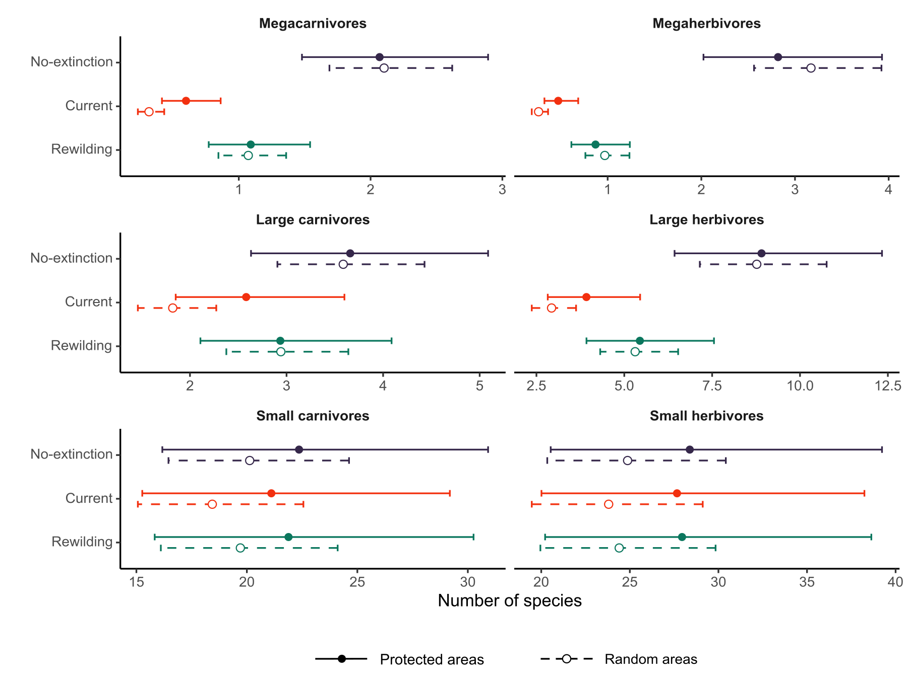
Figure 2: Estimates of the number of species per trophic level. The estimates were obtained from generalized linear mixed models (GLMMs) for the three scenarios: no-extinction (blue), current (red), and rewilding (green). Circles show the estimates of the number of species and lines the 95% confidence intervals for protected areas (closed circle and solid lines) and for random areas (open circle and dashed lines). GLMMs accounted for the variability across food web sites and biogeographic realms as random intercepts. Trophic levels were defined following ⁷⁰⁠ Malhi et al. (2016) as: megacarnivores (≥ 100 kg), large carnivores (21.5–99 kg), small carnivores (< 21.5 kg), megaherbivores (≥ 1,000 kg), large herbivores (45–999 kg), and small herbivores (< 45 kg).

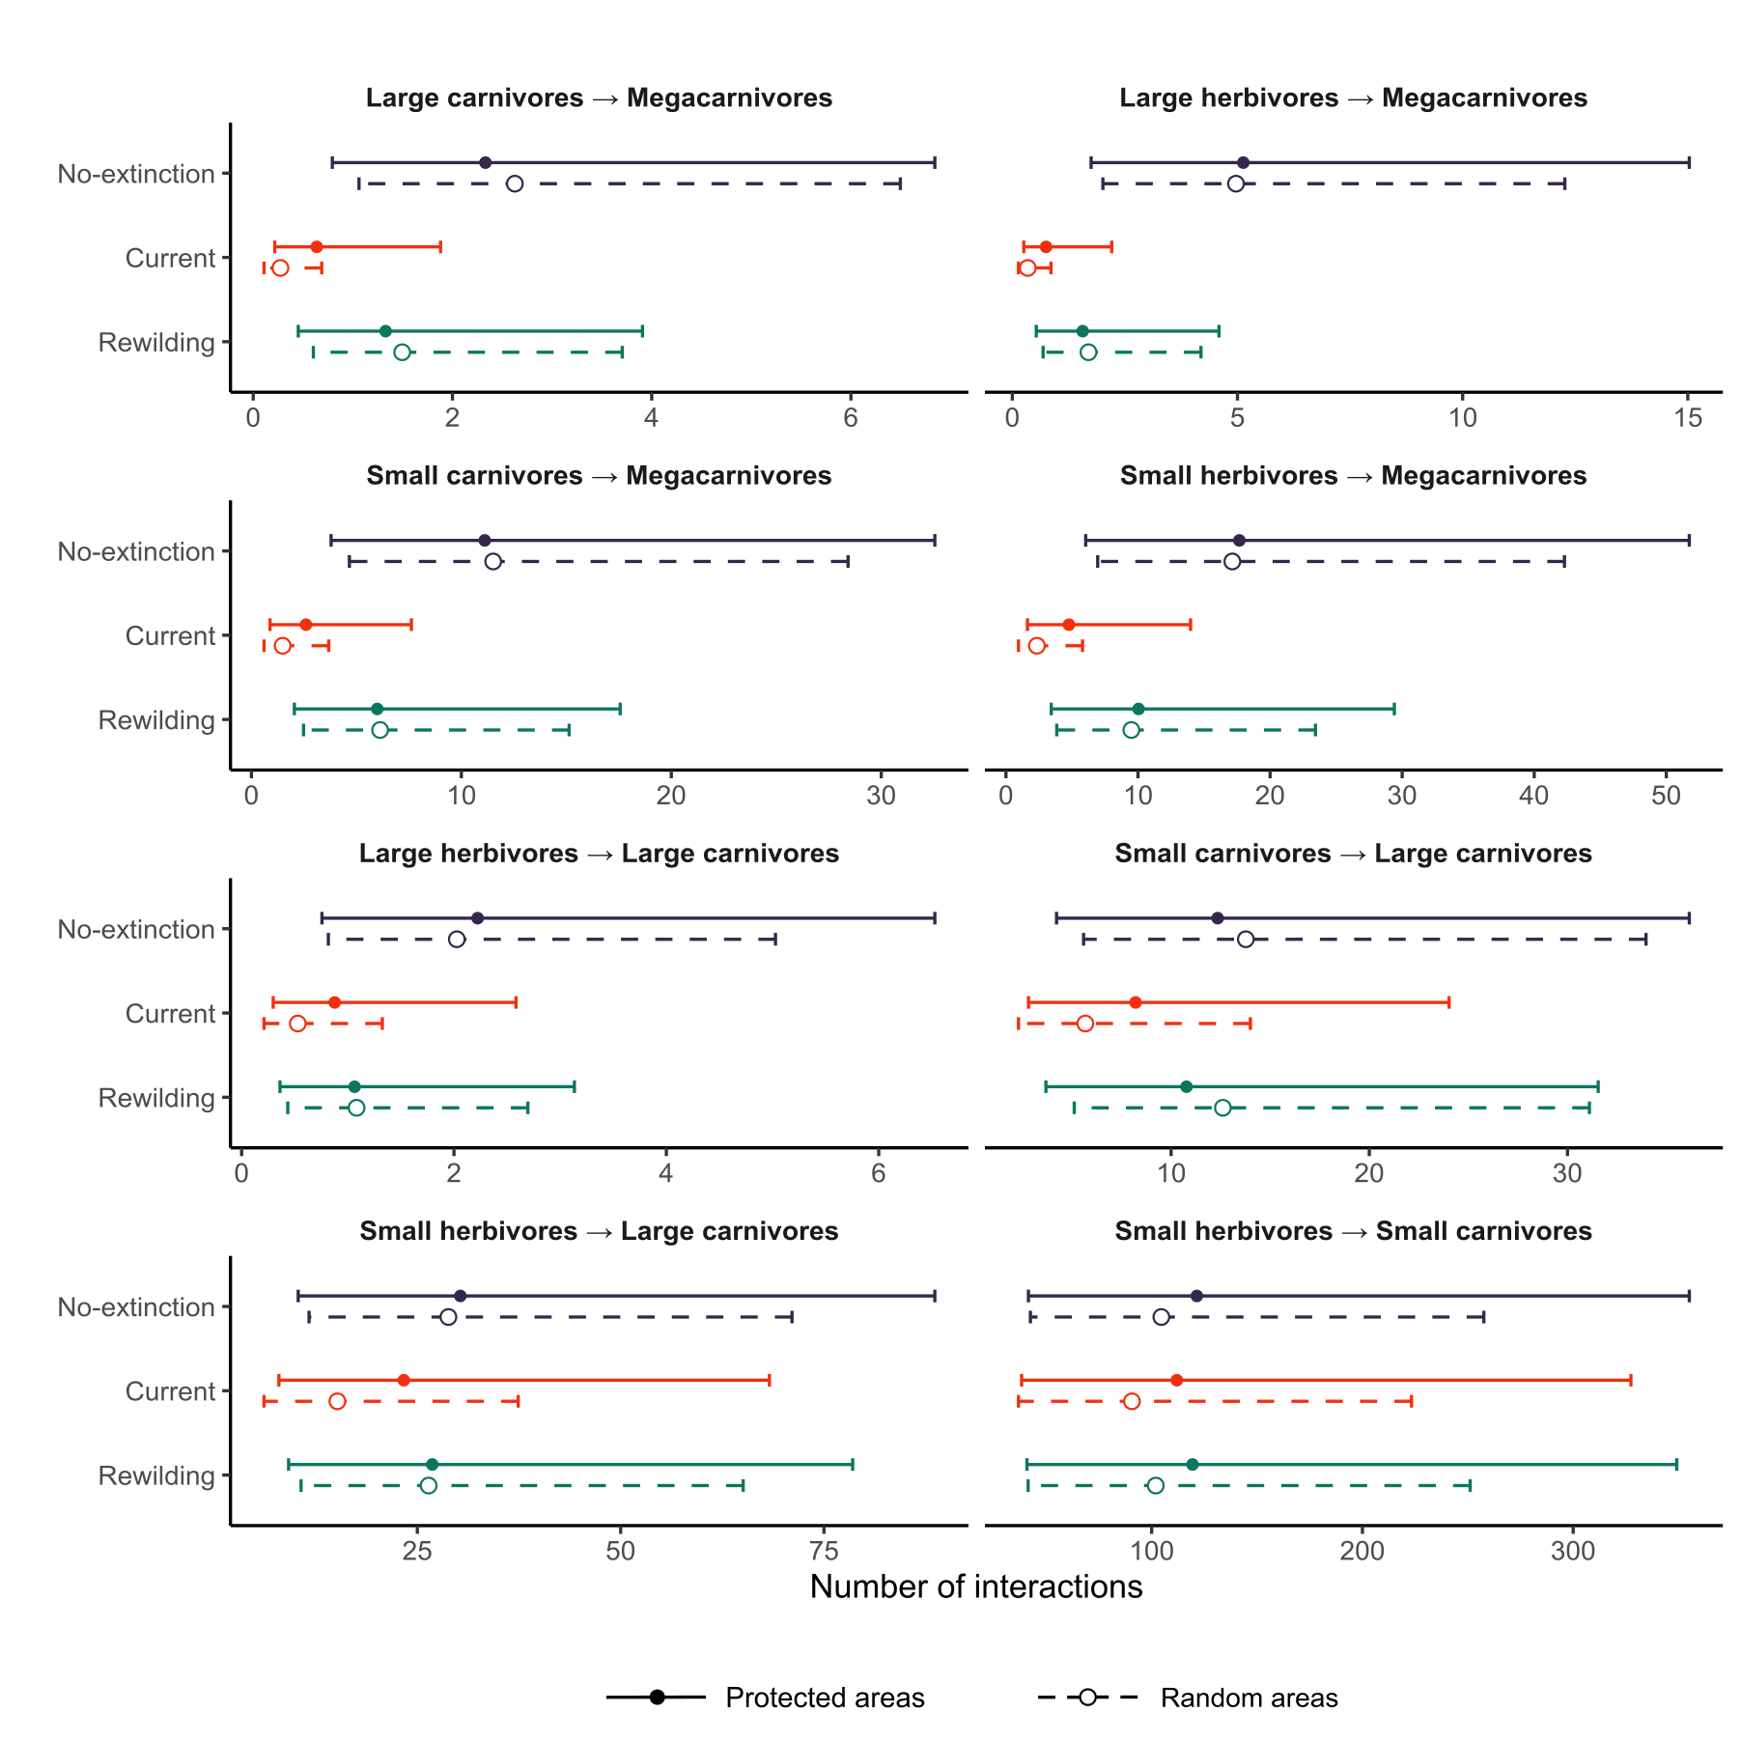
Figure 3: Estimates of the number of interactions among trophic levels. The estimates were obtained from generalized linear mixed models (GLMMs) for the three scenarios: no-extinction (blue), current (red), and rewilding (green). Circles show the estimates of the number of interactions among trophic levels and lines the 95% confidence intervals for protected areas (closed circle and solid lines) and for random areas (open circle and dashed lines). GLMMs accounted for the variability across food web sites and biogeographic realms as random intercepts. For the definitions of trophic levels see the caption of Fig. 1. Megaherbivores were found to be free from predation in all food webs.
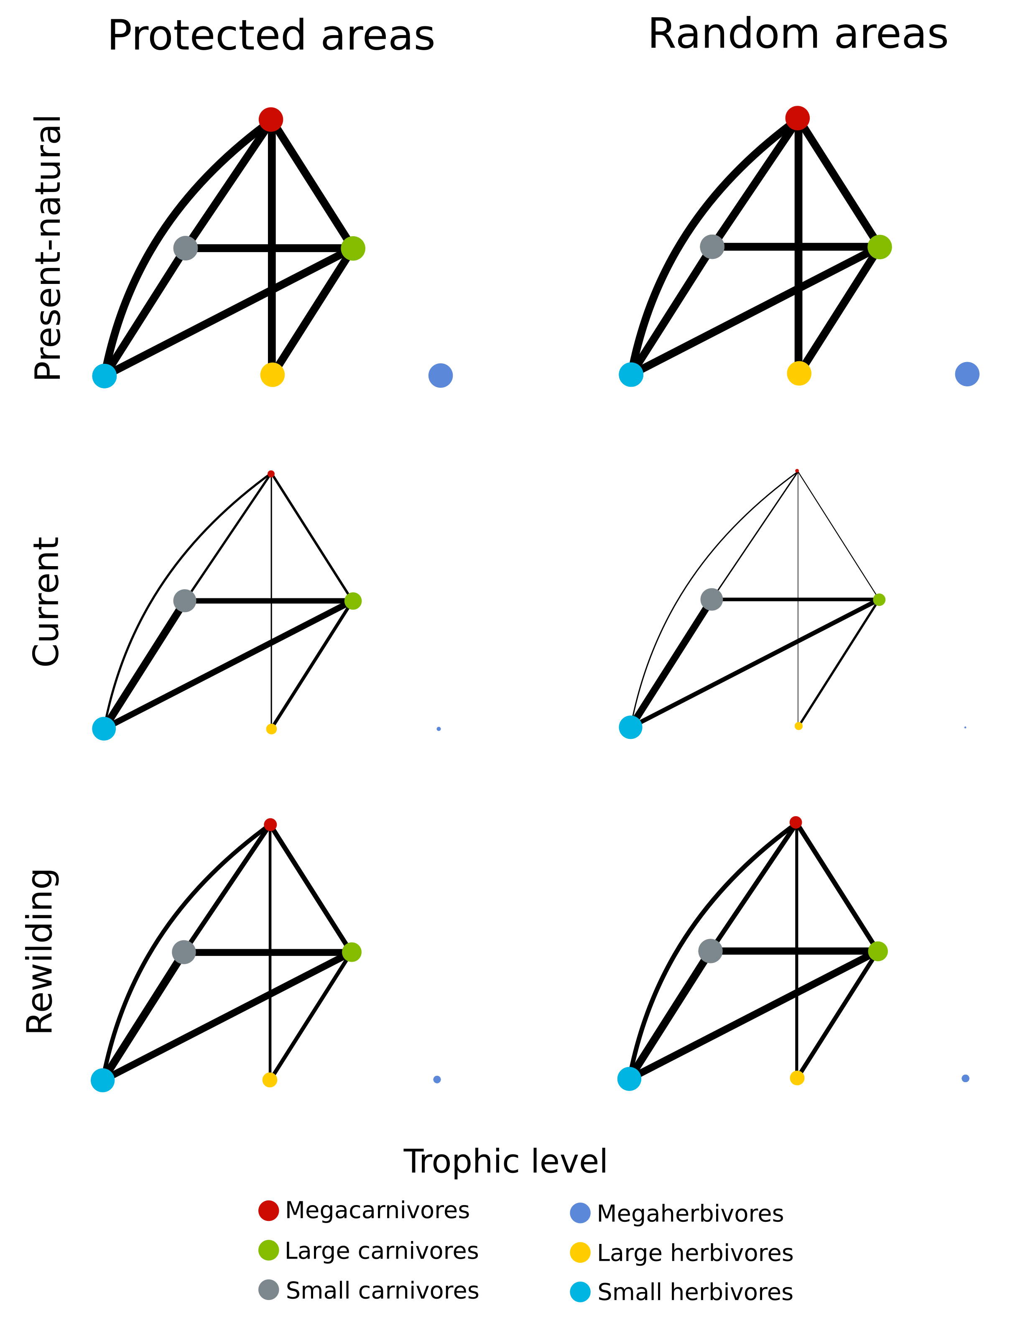
Figure 4: Network representation of the mean estimates from GLMMs for the food webs in the three scenarios. Circles are trophic levels and lines the predator-prey interactions. Circles and lines are normalised for the present-natural values, our reference baseline. Circle colours show the trophic levels.

1. Smith, F. A., Smith, R. E. E., Lyons, S. K. & Payne, J. L. Body size downgrading ofmammals over the late Quaternary. 313, 310–313 (2018).
2. Sandom, C., Faurby, S., Sandel, B. & Svenning, J.-C. Global late Quaternary megafauna extinctions linked to humans, not climate change. Proc. R. Soc. B Biol. Sci. 281, 20133254–20133254 (2014).
3. Crees, J. J., Carbone, C., Sommer, R. S., Benecke, N. & Turvey, S. T. Millennial-scale faunal record reveals differential resilience of European large mammals to human impacts across the Holocene. Proc. R. Soc. B Biol. Sci. 283, (2016).
4. Teng, S. N., Xu, C., Teng, L. & Svenning, J. C. Long-term effects of cultural filtering on megafauna species distributions across China. Proc. Natl. Acad. Sci. U. S. A. 117, 486–493 (2020).
5. Dirzo, R. et al. Defaunation in the Anthropocene. Science (80-. ). 345, 401–406 (2014).
6. Estes, J. A. et al. Trophic downgrading of planet Earth. Science (80-. ). 333, 301–306 (2011).
7. Mendoza, M. & Araújo, M. B. Climate shapes mammal community trophic structures and humans simplify them. Nat. Commun. 10, (2019).
8. Gill, J. L. Ecological impacts of the late Quaternary megaherbivore extinctions. New Phytol. 201, 1163–1169 (2014).
9. UNEP-WCMC. NGS Protected Planet Report. (2018).
10. Gaston, K. J., Jackson, S. F., Cantú-Salazar, L. & Cruz-Piñón, G. The Ecological Performance of Protected Areas. Annu. Rev. Ecol. Evol. Syst. 39, 93–113 (2008).
11. Svenning, J.-C. et al. Science for a wilder Anthropocene: Synthesis and future directions for trophic rewilding research. Proc. Natl. Acad. Sci. 113, 898–906 (2016).
12. Ripple, W. J., Beschta, R. L., Fortin, J. K. & Robbins, C. T. Trophic cascades from wolves to grizzly bears in Yellowstone. J. Anim. Ecol. 83, 223–233 (2014).
13. Ripple, W. J. et al. Status and ecological effects of the world’s largest carnivores. Science (80-. ). 343, 1241484 (2014).
14. Tanentzap, A. J. & Smith, B. R. Unintentional rewilding: Lessons for trophic rewilding from other forms of species introductions. Philos. Trans. R. Soc. B Biol. Sci. 373, (2018).
15. Perino, A. et al. Rewilding complex ecosystems. Science (80-. ). 364, eaav5570 (2019).
16. Pedersen, P. B. M., Ejrnæs, R., Sandel, B. & Svenning, J. C. Trophic Rewilding Advancement in Anthropogenically Impacted Landscapes (TRAAIL): A framework to link conventional conservation management and rewilding. Ambio 49, 231–244 (2020).
17. Faurby, S. & Svenning, J. C. Historic and prehistoric human-driven extinctions have reshaped global mammal diversity patterns. Divers. Distrib. 21, 1155–1166 (2015).
18. Faurby, S. et al. PHYLACINE 1.2: The Phylogenetic Atlas of Mammal Macroecology. Ecology 99, 2626 (2018).
19. Hopcraft, J. G. C., Olff, H. & Sinclair, A. R. E. Herbivores, resources and risks: alternating regulation along primary environmental gradients in savannas. Trends Ecol. Evol. 25, 119–128 (2010).
20. Owen-Smith, R. N. Megaherbivores: the influence of very large body size on ecology. (Cambridge University Press, 1998).
21. Atkins, J. L. et al. Cascading impacts of large-carnivore extirpation in an African ecosystem. Science (80-. ). 364, 173–177 (2019).
22. Cromsigt, J. P. G. M. & te Beest, M. Restoration of a megaherbivore: Landscape-level impacts of white rhinoceros in Kruger National Park, South Africa. J. Ecol. 102, 566–575 (2014).
23. Bakker, E. S. et al. Combining paleo-data and modern exclosure experiments to assess the impact of megafauna extinctions on woody vegetation. Proc. Natl. Acad. Sci. U. S. A. 113, 847–855 (2016).
24. le Roux, E., Kerley, G. I. H. & Cromsigt, J. P. G. M. Megaherbivores Modify Trophic Cascades Triggered by Fear of Predation in an African Savanna Ecosystem. Curr. Biol. 28, 2493-2499.e3 (2018).
25. Donlan, C. J. et al. Pleistocene rewilding: An optimistic agenda for twenty-first century conservation. Am. Nat. 168, 660–681 (2006).
26. Eklöf, A., Helmus, M. R., Moore, M. & Allesina, S. Relevance of evolutionary history for food web structure. Proc. R. Soc. B Biol. Sci. 279, 1588–1596 (2012).
27. Gravel, D., Poisot, T., Albouy, C., Velez, L. & Mouillot, D. Inferring food web structure from predator-prey body size relationships. Methods Ecol. Evol. 4, 1083–1090 (2013).
28. Svenning, J.-C., Munk, M. & Schweiger, A. Trophic rewilding: ecological restoration of top-down trophic interactions to promote self-regulating biodiverse ecosystems. Rewilding. in Rewilding (eds. Pettorelli, N., Durant, S. M. & du Toit, J. T.) 73–98 (2019).
29. Tylianakis, J. M., Laliberté, E., Nielsen, A. & Bascompte, J. Conservation of species interaction networks. Biol. Conserv. 143, 2270–2279 (2010).
30. Bakker, E. S. et al. Combining paleo-data and modern exclosure experiments to assess the impact of megafauna extinctions on woody vegetation. Proc. Natl. Acad. Sci. 113, 847–855 (2016).
31. Joppa, L. N. & Pfaff, A. High and far: Biases in the location of protected areas. PLoS One 4, 1–6 (2009).
32. Daru, B. H. et al. Spatial overlaps between the global protected areas network and terrestrial hotspots of evolutionary diversity. Glob. Ecol. Biogeogr. 28, 757–766 (2019).
33. Ceauşu, S., Graves, R. A., Killion, A. K., Svenning, J. C. & Carter, N. H. Governing trade-offs in ecosystem services and disservices to achieve human–wildlife coexistence. Conserv. Biol. 33, 543–553 (2019).
34. Pereira, H. M. & Navarro, L. M. Rewilding European Landscapes. Rewilding European Landscapes (2015). doi:10.1007/978-3-319-12039-3_7.
35. Theunissen, B. The oostvaardersplassen fiasco. Isis 110, 341–345 (2019).
36. Ravenelle, J. & Nyhus, P. J. Global patterns and trends in human–wildlife conflict compensation. Conserv. Biol. 31, 1247–1256 (2017).
37. Jones, K. R. et al. One-third of global protected land is under intense human pressure. Science (80-. ). 360, 788–791 (2018).
38. Ceausu, S. et al. Mapping opportunities and challenges for rewilding in Europe. Conserv. Biol. 29, 1017–1027 (2015).
39. Chapron, G. et al. Recovery of large carnivores in {E}urope’s modern human-dominated landscapes. Science (80-. ). 346, 1517–1519 (2014).
40. Elith, J. & Leathwick, J. R. Species distribution models: ecological explanation and prediction across space and time. Annu. Rev. Ecol. Evol. Syst. 40, (2009).
41. Guisan, A. & Thuiller, W. Predicting species distribution: Offering more than simple habitat models. Ecol. Lett. 8, 993–1009 (2005).
42. Jarvie, S. & Svenning, J. C. Using species distribution modelling to determine opportunities for trophic rewilding under future scenarios of climate change. Philos. Trans. R. Soc. B Biol. Sci. 373, (2018).
43. Monsarrat, S., Jarvie, S. & Svenning, J. C. Anthropocene refugia: Integrating history and predictive modelling to assess the space available for biodiversity in a human-dominated world. Philos. Trans. R. Soc. B Biol. Sci. 374, (2019).
44. Faurby, S. et al. PHYLACINE 1.2: The Phylogenetic Atlas of Mammal Macroecology. Ecology (2018).
45. Faurby, S. & Araújo, M. B. Anthropogenic range contractions bias species climate change forecasts. Nat. Clim. Chang. 8, 252–256 (2018).
46. IUCN. The IUCN Red List of Threatened Species. Version 2019-3. http://www.iucnredlist.org/ (2019).
47. Faurby, S. & Svenning, J.-C. Historic and prehistoric human-driven extinctions have reshaped global mammal diversity patterns. Divers. Distrib. 21, 1155–1166 (2015).
48. Robinson, N., Regetz, J. & Guralnick, R. P. EarthEnv-DEM90: A nearly-global, void-free, multi-scale smoothed, 90m digital elevation model from fused ASTER and SRTM data. ISPRS J. Photogramm. Remote Sens. 87, 57–67 (2014).
49. Fick, S. E. & Hijmans, R. J. WorldClim 2: new 1-km spatial resolution climate surfaces for global land areas. Int. J. Climatol. 37, 4302–4315 (2017).
50. Guisan, A., Thuiller, W. & Zimmermann, N. E. Habitat suitability and distribution models: with applications in R. (Cambridge University Press, 2017).
51. O’Brien, R. M. A caution regarding rules of thumb for variance inflation factors. Qual. Quant. 41, 673–690 (2007).
52. Phillips, S. J., Anderson, R. P., Dudík, M., Schapire, R. E. & Blair, M. E. Opening the black box: an open-source release of Maxent. Ecography (Cop.). 40, 887–893 (2017).
53. Elith, J. et al. A statistical explanation of MaxEnt for ecologists. Divers. Distrib. 17, 43–57 (2011).
54. Merow, C., Smith, M. J. & Silander, J. A. A practical guide to MaxEnt for modeling species’ distributions: What it does, and why inputs and settings matter. Ecography (Cop.). 36, 1058–1069 (2013).
55. Guevara, L., Gerstner, B. E., Kass, J. M. & Anderson, R. P. Toward ecologically realistic predictions of species distributions: A cross-time example from tropical montane cloud forests. Glob. Chang. Biol. 24, 1511–1522 (2018).
56. Barve, N. et al. The crucial role of the accessible area in ecological niche modeling and species distribution modeling. Ecol. Modell. 222, 1810–1819 (2011).
57. Poo-Muñoz, D. A. et al. Galictis cuja (Mammalia): Actualización sobre su conocimiento y distribución geográfica. Iheringia - Ser. Zool. 104, 341–346 (2014).
58. Hof, C. et al. Bioenergy cropland expansion may offset positive effects of climate change mitigation for global vertebrate diversity. Proc. Natl. Acad. Sci. U. S. A. 115, 13294–13299 (2018).
59. Hirzel, A. H., Le Lay, G., Helfer, V., Randin, C. & Guisan, A. Evaluating the ability of habitat suitability models to predict species presences. Ecol. Modell. 199, 142–152 (2006).
60. Swets, J. A. Measuring the Accuracy of Diagnostic Systems Linked references are available on JSTOR for this article : Measuring the Accuracy of Diagnostic Systems. Science (80-. ). 240, 1285–1293 (1988).
61. Fielding, A. H. & Bell, J. F. A review of methods for the assessment of prediction errors in conservation presence/absence models. Environ. Conserv. 24, 38–49 (1997).
62. Radosavljevic, A. & Anderson, R. P. Making better Maxent models of species distributions: complexity, overfitting and evaluation. J. Biogeogr. 41, 629–643 (2014).
63. Liu, C., Newell, G. & White, M. On the selection of thresholds for predicting species occurrence with presence-only data. Ecol. Evol. 6, 337–348 (2016).
64. Lundgren, E. J., Ramp, D., Ripple, W. J. & Wallach, A. D. Introduced megafauna are rewilding the Anthropocene. Ecography (Cop.). 41, 857–866 (2018).
65. Olson, D. M. et al. Terrestrial Ecoregions of the World: A New Map of Life on Earth. Bioscience 51, 933 (2001).
66. Olson, D. M. & Dinerstein, E. The Global 200 : Priority Ecoregions for Global Conservation. 89, 199–224 (2002).
67. Fernandez, F. A. S. et al. Rewilding the Atlantic Forest: Restoring the fauna and ecological interactions of a protected area. Perspect. Ecol. Conserv. 15, 308–314 (2017).
68. Donlan, J. Re-wilding North America. 436, (2005).
69. Janzen, D. H. & Martin, P. S. Neotropical anachronisms: The fruits the gomphotheres ate. Science (80-. ). 215, 19–27 (1982).
70. Malhi, Y. et al. Megafauna and ecosystem function from the Pleistocene to the Anthropocene. Proc. Natl. Acad. Sci. 113, 838–846 (2016).
71. Linnell, J. D. C. & Strand, O. Interference interactions, co-existence and conservation of mammalian carnivores. Divers. Distrib. 6, 169–176 (2000).
72. Woodroffe, R. & Ginsberg, J. R. Edge effects and the extinction of populations inside protected areas. Science (80-. ). 280, 2126–2128 (1998).
73. Cantú-Salazar, L. & Gaston, K. J. Very Large Protected Areas and Their Contribution to Terrestrial Biological Conservation. Bioscience 60, 808–818 (2010).
74. Ripple, W. J. et al. Collapse of the world’s largest herbivores. Sci. Adv. 1, (2015).
75. Runge, C. A. et al. Protected areas and global conservation of migratory birds. Science (80-. ). 350, 1255–1258 (2015).
76. Pomeranz, J. P. F., Thompson, R. M., Poisot, T. & Harding, J. S. Inferring predator–prey interactions in food webs. Methods Ecol. Evol. 10, 356–367 (2019).
77. Gray, C. et al. Joining the dots: An automated method for constructing food webs from compendia of published interactions. Food Webs 5, 11–20 (2015).
78. Cohen, J. E. Ecologists’ Co-Operative Web Bank. Version 1.1. Machine-readable database of food webs. (2010).
79. Poelen, J. H., Simons, J. D. & Mungall, C. J. Global biotic interactions: An open infrastructure to share and analyze species-interaction datasets. Ecol. Inform. 24, 148–159 (2014).
80. Baskerville, E. B. et al. Spatial guilds in the serengeti food web revealed by a bayesian group model. PLoS Comput. Biol. 7, (2011).
81. De Visser, S. N., Freymann, B. P. & Olff, H. The Serengeti food web: Empirical quantification and analysis of topological changes under increasing human impact. J. Anim. Ecol. 80, 484–494 (2011).
82. Williams, R. J. & Martinez, N. D. Simple rules yield complex food webs. Nature 404, 180–183 (2000).
83. Owen-Smith, N. & Mills, M. G. L. Predator-prey size relationships in an African large-mammal food web. J. Anim. Ecol. 77, 173–183 (2008).
84. Segura, A. M., Fariña, R. A. & Arim, M. Exceptional body sizes but typical trophic structure in a Pleistocene food web. Biol. Lett. 12, 10–13 (2016).
85. Carbone, C., Mace, G. M., Roberts, S. C. & Macdonald, D. W. Energetic constraints on the diet of terrestrial carnivores. Nature 402, 286–288 (1999).
86. Nakagawa, S. & Schielzeth, H. A general and simple method for obtaining R2 from generalized linear mixed-effects models. Methods Ecol. Evol. 4, 133–142 (2013).
87. Cohen, J. Statistical power analysis for the behavioral sciences. (Academic press, 2013).
88. Sawilowsky, S. S. New effect size rules of thumb. J. Mod. Appl. Stat. Methods 8, 597–599 (2009).
89. R Core Team. R: A Language and Environment for Statistical Computing. (2018).

