Globally downgraded food webs in protected areas can be partially rewired through trophic rewilding

Supporting information

Changes to the PHYLACINE database
In the PHYLACINE 1.2 database, the two extinct species Sinomegaceros ordosianus and Dusicyon australis had inaccurate body mass information. We thus modified their body mass before modelling and analyses. Specifically, body mass of S. ordosianus was set equal to the mass of S. yabei and body mass of D. australis to D. avus. Moreover, the cow (Bos primigenius) and the dromedary (Camelus dromedarius), two species considered to be extinct as wild populations by the IUCN ¹⁠, were included in the analyses as extant species. This was because B. primigenius and C. dromedarius are often considered to be sufficiently similar to their ancestral forms, e.g. ²⁠ (Sandom et al. 2020).
Supplementary Table 1: Average proportions from the reconstructed food webs of the number of species per trophic level. Proportions show the relative number of species under current and rewilding scenarios respect to the no-extinction scenario for large protected areas ≥ 5000 km² with IUCN management category I-II and for areas ≥ 5000 km² randomly distributed in each biogeographic realm.
Trophic level | Current / no-extinction | Rewilding / no-extinction
Protected areas
Megacarnivores (≥ 100 kg) | 0.29 | 0.53
Megaherbivores (≥ 1,000 kg) | 0.17 | 0.31
Large carnivores (21.5–99 kg) | 0.71 | 0.80
Large herbivores (45–999 kg) | 0.44 | 0.61
Small carnivores (< 21.5 kg) | 0.94 | 0.98
Small herbivores (< 45 kg) | 0.97 | 0.98
Random areas
Megacarnivores (≥ 100 kg) | 0.15 | 0.51
Megaherbivores (≥ 1,000 kg) | 0.08 | 0.31
Large carnivores (21.5–99 kg) | 0.51 | 0.92
Large herbivores (45–999 kg) | 0.33 | 0.60
Small carnivores (< 21.5 kg) | 0.92 | 0.98
Small herbivores (< 45 kg) | 0.96 | 0.98

Supplementary Table 2: Average proportions from the reconstructed food webs of the number of interactions among trophic levels. Proportions show the relative number of predator-prey interactions under current and rewilding scenarios respect to the no-extinction scenario for large protected areas ≥ 5000 km² with IUCN management category I-II and for areas ≥ 5000 km² randomly distributed in each biogeographic realm.
Predator | Prey | Current / present-natural | Rewilding / present-natural
Protected areas
Megacarnivores | Large carnivores | 0.31 | 0.61
Megacarnivores | Large herbivores | 0.17 | 0.33
Megacarnivores | Small carnivores | 0.29 | 0.60
Megacarnivores | Small herbivores | 0.28 | 0.55
Large carnivores | Large herbivores | 0.42 | 0.50
Large carnivores | Small carnivores | 0.69 | 0.88
Large carnivores | Small herbivores | 0.78 | 0.89
Small carnivores | Small herbivores | 0.95 | 0.99
Random areas
Megacarnivores | Large carnivores | 0.12 | 0.62
 | Large herbivores | 0.08 | 0.38
 | Small carnivores | 0.17 | 0.60
 | Small herbivores | 0.16 | 0.58
Large carnivores | Large herbivores | 0.29 | 0.55
 | Small carnivores | 0.46 | 0.92
 | Small herbivores | 0.57 | 0.92
Small carnivores | Small herbivores | 0.89 | 0.98

Supplementary Table 3: List of the extinct species that were replaced by functional analogues under the rewilding scenario for the focal biogeographic realm.
Extinct species | Functional analogues | Biogeographic realm
Agalmaceros blicki | Odocoileus virginianus | Neotropic
Antidorcas australis | Pelea capreolus | Afrotropic
Antidorcas bondi | Sylvicapra grimmia | Afrotropic
Arctodus simus | Ursus arctos | Nearctic
Arctodus simus | Ursus arctos | Neotropic
Arctotherium wingei | Ursus americanus | Neotropic
Aztlanolagus agilis | Lepus californicus | Nearctic
Aztlanolagus agilis | Lepus californicus | Neotropic
Aztlanolagus agilis | Sylvilagus floridanus | Neotropic
Bettongia anhydra | Bettongia lesueur | Australasia
Bettongia pusilla | Bettongia lesueur | Australasia
Bettongia pusilla | Bettongia penicillata | Australasia
Bootherium bombifrons | Connochaetes taurinus | Nearctic
Brachyprotoma obtusata | Conepatus leuconotus | Nearctic
Bubalus palaeokerabau | Bos javanicus | Indomalaya
Caipora bambuiorum | Brachyteles arachnoides | Neotropic
Camelops hesternus | Camelus ferus | Nearctic
Camelops hesternus | Camelus dromedarius | Neotropic
Canis dirus | Canis lupus | Nearctic
Canis dirus | Canis lupus | Neotropic
CapriniGen spA | Tragelaphus scriptus | Afrotropic
Catagonus stenocephalus | Pecari tajacu | Neotropic
Cervalces scotti | Alces alces | Nearctic
Conilurus albipes | Conilurus penicillatus | Australasia
Conilurus capricornensis | Conilurus penicillatus | Australasia
Cryptonanus ignitus | Thylamys venustus | Neotropic
Cuvieronius hyodon | Elephas maximus | Nearctic
Cuvieronius hyodon | Loxodonta africana | Neotropic
Damaliscus hypsodon | Tragelaphus scriptus | Afrotropic
Damaliscus niro | Alcelaphus buselaphus | Afrotropic
Dasypus bellus | Dasypus kappleri | Nearctic
Dasypus bellus | Dasypus kappleri | Neotropic
Dusicyon avus | Lycalopex griseus | Neotropic
Elasmotherium sibiricum | Ceratotherium simum | Palearctic
Elephas iolensis | Loxodonta africana | Afrotropic
Elephas iolensis | Loxodonta africana | Palearctic
Elephas namadicus | Elephas maximus | Indomalaya
Elephas namadicus | Elephas maximus | Palearctic
Elephas naumanii | Elephas maximus | Indomalaya
Elephas naumanii | Elephas maximus | Palearctic
Equus francisci | Equus ferus | Nearctic
Equus francisci | Equus ferus | Neotropic
Equus hydruntinus | Equus ferus | Palearctic
Equus ovodovi | Equus ferus | Palearctic
Euceratherium collinum | Bison bison | Nearctic
Euceratherium collinum | Bison bison | Neotropic
Gazella atlantica | Ammotragus lervia | Palearctic
Gazella bilkis | Capricornis crispus | Afrotropic
Gazella bilkis | Naemorhedus caudatus | Afrotropic
Gazella bilkis | Procapra gutturosa | Afrotropic
Gazella bilkis | Procapra przewalskii | Afrotropic
Gazella bilkis | Eudorcas albonotata | Palearctic
Gazella saudiya | Gazella gazella | Afrotropic
Gazella saudiya | Gazella gazella | Palearctic
Gazella tingitana | Gazella cuvieri | Palearctic
Haploidoceros mediterraneus | Cervus elaphus | Palearctic
Hemiauchenia macrocephala | Lama guanicoe | Nearctic
Hemiauchenia macrocephala | Lama guanicoe | Neotropic
Hemiauchenia paradoxa | Camelus dromedarius | Neotropic
Hemitragus cedrensis | Capra pyrenaica | Palearctic
Hexaprotodon sivalensis | Choeropsis liberiensis | Indomalaya
Hippidion devillei | Equus ferus | Neotropic
Hippidion principale | Equus quagga | Neotropic
Hippotragus leucophaeus | Alcelaphus buselaphus | Afrotropic
Hippotragus leucophaeus | Damaliscus pygargus | Afrotropic
Homotherium latidens | Panthera tigris | Palearctic
Homotherium serum | Panthera onca | Nearctic
Homotherium serum | Panthera onca | Neotropic
Hystrix kiangsenensis | Hystrix brachyura | Indomalaya
Hystrix kiangsenensis | Hystrix brachyura | Palearctic
Hystrix refossa | Hystrix indica | Indomalaya
Hystrix refossa | Hystrix indica | Palearctic
Kolpochoerus majus | Hylochoerus meinertzhageni | Afrotropic
Lagorchestes asomatus | Lagorchestes hirsutus | Australasia
Lagostomus crassus | Lagostomus maximus | Neotropic
Leopardus amnicola | Catopuma badia | Nearctic
Leopardus amnicola | Leopardus wiedii | Neotropic
Macropus greyi | Thylogale billardierii | Australasia
Mammut americanum | Loxodonta africana | Nearctic
Mammut americanum | Loxodonta africana | Neotropic
Mammuthus columbi | Elephas maximus | Nearctic
Mammuthus columbi | Elephas maximus | Neotropic
Mammuthus primigenius | Elephas maximus | Indomalaya
Mammuthus primigenius | Elephas maximus | Nearctic
Mammuthus primigenius | Elephas maximus | Palearctic
Manis paleojavanica | Smutsia gigantea | Indomalaya
Megaloceros giganteus | Alces alces | Palearctic
Megalotragus priscus | Alcelaphus buselaphus | Afrotropic
Megalovis guangxiensis | Pseudois nayaur | Indomalaya
Megalovis guangxiensis | Pseudois nayaur | Palearctic
Metasthenurus newtonae | Macropus rufus | Australasia
Metridiochoerus compactus | Phacochoerus africanus | Afrotropic
Miracinonyx trumani | Puma concolor | Nearctic
Morenelaphus brachyceros | Ozotoceros bezoarticus | Neotropic
Muknalia minima | Pecari tajacu | Nearctic
Muknalia minima | Pecari tajacu | Neotropic
Navahoceros fricki | Odocoileus virginianus | Nearctic
Navahoceros fricki | Odocoileus virginianus | Neotropic
Neochoerus aesopi | Hydrochoerus hydrochaeris | Nearctic
Neochoerus aesopi | Hydrochoerus hydrochaeris | Neotropic
Neovison macrodon | Neovison vison | Nearctic
Notiomastodon platensis | Elephas maximus | Neotropic
Notomys amplus | Notomys mitchellii | Australasia
Notomys longicaudatus | Notomys mitchellii | Australasia
Notomys macrotis | Notomys mitchellii | Australasia
Notomys mordax | Notomys alexis | Australasia
Notomys mordax | Notomys aquilo | Australasia
Notomys mordax | Notomys fuscus | Australasia
Notomys robustus | Notomys fuscus | Australasia
Ochotona whartoni | Ochotona alpina | Nearctic
Onychogalea lunata | Petrogale lateralis | Australasia
Oreamnos harringtoni | Ovis canadensis | Nearctic
Oreamnos harringtoni | Ovis canadensis | Neotropic
Palaeolama major | Camelus dromedarius | Neotropic
Palaeolama mirifica | Lama guanicoe | Nearctic
Palaeolama mirifica | Lama guanicoe | Neotropic
Palaeolama mirifica | Vicugna vicugna | Neotropic
Palaeolama weddeli | Camelus dromedarius | Neotropic
Panthera atrox | Panthera tigris | Nearctic
Panthera atrox | Panthera leo | Neotropic
Panthera spelaea | Panthera tigris | Nearctic
Panthera spelaea | Panthera tigris | Palearctic
Paraceros fragilis | Ozotoceros bezoarticus | Neotropic
Pelorovis antiquus | Bos primigenius | Palearctic
Perameles eremiana | Perameles bougainville | Australasia
Petauroides ayamaruensis | Pseudochirulus canescens | Australasia
Petauroides ayamaruensis | Pseudochirulus schlegeli | Australasia
Potorous platyops | Potorous gilbertii | Australasia
Procoptodon browneorum | Macropus giganteus | Australasia
Procoptodon gilli | Macropus rufus | Australasia
Protemnodon hopei | Macropus antilopinus | Australasia
Protemnodon hopei | Macropus giganteus | Australasia
Protemnodon hopei | Macropus rufus | Australasia
Protemnodon nombe | Macropus giganteus | Australasia
Protemnodon tumbuna | Macropus giganteus | Australasia
Protocyon troglodytes | Chrysocyon brachyurus | Neotropic
Protopithecus brasiliensis | Brachyteles arachnoides | Neotropic
Pseudomys glaucus | Pseudomys novaehollandiae | Australasia
Pseudomys gouldii | Pseudomys desertor | Australasia
Rucervus schomburgki | Rucervus eldii | Indomalaya
Rusingoryx atopocranion | Kobus ellipsiprymnus | Afrotropic
Sangamona fugitiva | Cervus canadensis | Nearctic
Simosthenurus maddocki | Macropus giganteus | Australasia
Sinomegaceros ordosianus | Alces alces | Palearctic
Sinomegaceros yabei | Alces alces | Indomalaya
Sinomegaceros yabei | Alces alces | Palearctic
Sivacobus sankaliai | Capricornis thar | Indomalaya
Sivacobus sankaliai | Capricornis thar | Palearctic
Smilodon fatalis | Panthera tigris | Nearctic
Smilodon fatalis | Panthera leo | Neotropic
Smilodon populator | Panthera leo | Nearctic
Smilodon populator | Panthera tigris | Neotropic
Soergelia minor | Capra sibirica | Palearctic
Spirocerus kiakhtensis | Bos primigenius | Palearctic
Stegodon orientalis | Elephas maximus | Indomalaya
Stegodon orientalis | Elephas maximus | Palearctic
Stegodon trigonocephalus | Elephas maximus | Indomalaya
Stephanorhinus kirchbergensis | Ceratotherium simum | Indomalaya
Stephanorhinus kirchbergensis | Ceratotherium simum | Palearctic
Sthenurus andersoni | Macropus rufus | Australasia
Stockoceros conklingi | Antilocapra americana | Nearctic
Stockoceros conklingi | Antilocapra americana | Neotropic
Sus bucculentus | Sus scrofa | Indomalaya
Tapirus augustus | Tapirus indicus | Indomalaya
Tapirus augustus | Tapirus indicus | Palearctic
Tapirus merriami | Tapirus bairdii | Nearctic
Tapirus rondoniensis | Tapirus terrestris | Neotropic
Tapirus veroensis | Tapirus bairdii | Nearctic
Tapirus veroensis | Tapirus bairdii | Neotropic
Tetrameryx shuleri | Antilocapra americana | Nearctic
Tetrameryx shuleri | Antilocapra americana | Neotropic
Theriodictis tarijensis | Chrysocyon brachyurus | Neotropic
Thylogale christenseni | Dorcopsulus vanheurni | Australasia
Tremarctos floridanus | Ursus americanus | Nearctic
Tremarctos floridanus | Ursus americanus | Neotropic
Troposodon minor | Macropus giganteus | Australasia
Ursus spelaeus | Ursus arctos | Palearctic
Vombatus hacketti | Lasiorhinus latifrons | Australasia
Wallabia kitcheneri | Macropus fuliginosus | Australasia

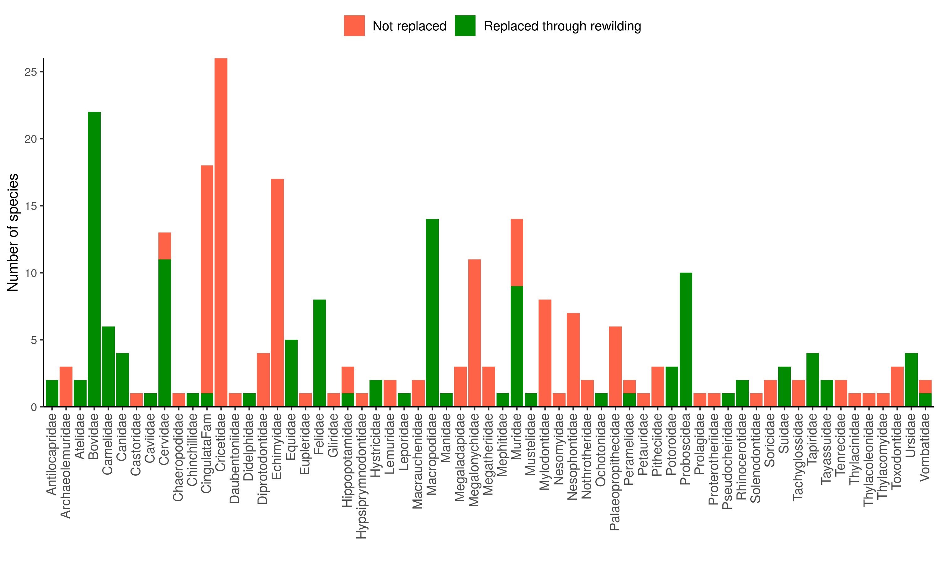
Supplementary Figure 1: Number of extinct species that could not be replaced (red) and that could be replaced through rewilding (green) divided in closely-related groups (families except for order Proboscidea). Species were replaced by functional analogue extant species that were phylogenetically closely-related and with similar body size. Functional analogues were selected from extinct species’ families except for proboscideans, which were grouped together in the Proboscidea order, displayed here as a closely-related group.

Supplementary Table 4. Standardized differences of the contrasts among scenarios for torphic level richness from generalized linear mixed model (GLMM). Standardized differences are an effect size measure (Cohen’s d) that show the ecological importance of the change among the scenarios. P are the statistical significances of the contrast adjusted with Bonferroni correction to have an overall significance level α = 0.05 (P < 0.01 show significant differences). Effect sizes indicate the magnitude of the change and illustrate the ecological importance of the standardized differences. GLMMs accounted for the variability across food web sites and biogeographic realms as random intercepts.
Trophic level | No-extinction–current |  |  | Rewilding–current |  |  | No-extinction–rewilding
 | Cohen’s d | P | Effect size | Cohen’s d | P | Effect size | Cohen’s d | P | Effect size
Protected areas
Megacarnivores (≥ 100 kg) | 1.24 | < 0.01 | very large | 0.60 | < 0.01 | medium | 0.64 | < 0.01 | medium
Megaherbivores (≥ 1,000 kg) | 1.79 | < 0.01 | very large | 0.61 | < 0.01 | medium | 1.18 | < 0.01 | large
Large carnivores (21.5–99 kg) | 0.35 | < 0.01 | small | 0.13 | 0.06 | very small | 0.22 | < 0.01 | small
Large herbivores (45–999 kg) | 0.82 | < 0.01 | large | 0.33 | < 0.01 | small | 0.49 | < 0.01 | small
Small carnivores (< 21.5 kg) | 0.06 | 0.01 | very small | 0.04 | 0.19 | very small | 0.02 | 0.79 | very small
Small herbivores (< 45 kg) | 0.03 | 0.40 | very small | 0.01 | 1.00 | very small | 0.02 | < 0.01 | very small
Random areas
Megacarnivores (≥ 100 kg) | 1.89 | <0.01 | very large | 1.21 | <0.01 | very large | 0.67 | <0.01 | medium
Megaherbivores (≥ 1,000 kg) | 2.49 | <0.01 | huge | 1.31 | <0.01 | very large | 1.19 | <0.01 | large
Large carnivores (21.5–99 kg) | 0.68 | <0.01 | medium | 0.48 | <0.01 | small | 0.20 | <0.01 | small
Large herbivores (45–999 kg) | 1.10 | <0.01 | large | 0.59 | <0.01 | medium | 0.50 | <0.01 | medium
Small carnivores (< 21.5 kg) | 0.09 | <0.01 | very small | 0.07 | 0.01 | very small | 0.02 | 0.92 | very small
Small herbivores (< 45 kg) | 0.04 | 0.06 | very small | 0.02 | 0.57 | very small | 0.02 | 0.91 | very small
Supplementary Table 5. Estimates of the number of interactions between trophic levels. Cohen’s d are standardized differences between model estimates for the number of interactions between trophic levels from generalized linear mixed models (GLMMs) among the scenarios: no-extinction, current, and rewilding. P are the statistical significances of the contrast adjusted with Bonferroni correction to have an overall significance level α = 0.05 (P < 0.01 show significant differences). Effect sizes show the magnitude of the change and illustrate the ecological importance of the standardized differences. GLMMs accounted for the variability across food web sites and biogeographic realms as random intercepts. For the definitions of trophic levels see caption of Fig. 2.
Predator | Prey | No-extinction–current |  |  | Rewilding–current |  |  | No-extinction–rewilding
 |  | Cohen’s d | P | Effect size | Cohen’s d | P | Effect size | Cohen’s d | P | Effect size
Protected areas
Megacarnivores | large carnivores | 1.30 | < 0.01 | very large | 0.73 | < 0.01 | medium | 0.56 | < 0.01 | medium
Megacarnivores | large herbivores | 1.92 | < 0.01 | very large | 0.74 | < 0.01 | medium | 1.19 | < 0.01 | large
Megacarnivores | small carnivores | 1.45 | < 0.01 | very large | 0.84 | < 0.01 | large | 0.62 | < 0.01 | medium
Megacarnivores | small herbivores | 1.31 | < 0.01 | very large | 0.74 | < 0.01 | medium | 0.57 | < 0.01 | medium
Large carnivores | large herbivores | 0.93 | < 0.01 | large | 0.19 | < 0.01 | very small | 0.74 | < 0.01 | medium
Large carnivores | small carnivores | 0.41 | < 0.01 | small | 0.27 | < 0.01 | small | 0.14 | 0.07 | very small
Large carnivores | small herbivores | 0.26 | < 0.01 | small | 0.14 | 0.04 | very small | 0.14 | 0.07 | very small
Small carnivores | small herbivores | 0.08 | 0.37 | very small | 0.06 | 0.67 | very small | 0.02 | 1.00 | very small
Random areas
Megacarnivores | large carnivores | 2.26 | < 0.01 | huge | 1.70 | < 0.01 | very large | 0.56 | < 0.01 | medium
Megacarnivores | large herbivores | 2.67 | < 0.01 | huge | 1.60 | < 0.01 | very large | 1.08 | < 0.01 | large
Megacarnivores | small carnivores | 2.05 | < 0.01 | huge | 1.42 | < 0.01 | very large | 0.63 | < 0.01 | medium
Megacarnivores | small herbivores | 1.99 | < 0.01 | very large | 1.40 | < 0.01 | very large | 0.59 | < 0.01 | medium
Large carnivores | large herbivores | 1.34 | < 0.01 | very large | 0.72 | < 0.01 | medium | 0.63 | < 0.01 | medium
Large carnivores | small carnivores | 0.89 | < 0.01 | large | 0.80 | < 0.01 | large | 0.09 | 0.56 | very small
Large carnivores | small herbivores | 0.64 | < 0.01 | medium | 0.55 | < 0.01 | medium | 0.09 | 0.51 | very small
Small carnivores | small herbivores | 0.14 | 0.05 | very small | 0.12 | 0.15 | very small | 0.03 | 1.00 | very small

Human pressure in protected areas
We examined the level of human pressure in large protected areas (PAs) ≥ 5,000 km² with strict IUCN management status I-II to investigate possible negative consequences of rewilding for human-wildlife coexistence. We downloaded the Human Footprint (HF) v.3 raster, representing the cumulative pressure of anthropogenic activities, such as urban areas and agricultural land, worldwide at 1 km² resolution³⁠. HF values range from 0 for areas with very low human pressure to 50 for areas under very high anthropogenic disturbance. We re-projected the HF layer to a 5 km² resolution using bilinear interpolation with a Behrmann equal-area projection, as this was used for all other analyses. We then extracted the values of HF within PAs ≥ 5,000 km² with strict IUCN management status I-II and compared them with cells not covered by PAs using the non-parametric Wilcoxon rank-sum test.
We found that HF was significantly lower within large PAs I-II than outside (P < 0.05). In particular, cells within PAs had an average HF = 1.66, whereas cells outside PAs had an average HF = 5.95. Moreover, half of the cells within PAs had HF = 0, i.e., they have very low anthropogenic disturbances, while only 23% of the cells outside PAs had HF = 0. These results show that human pressure is significantly lower within the PAs chosen for simulating the rewilding scenario (Supplementary Figure 5) and suggest human-wildlife coexistence can be more easily achievable within PAs ≥ 5000 km² I-II than in other regions globally.
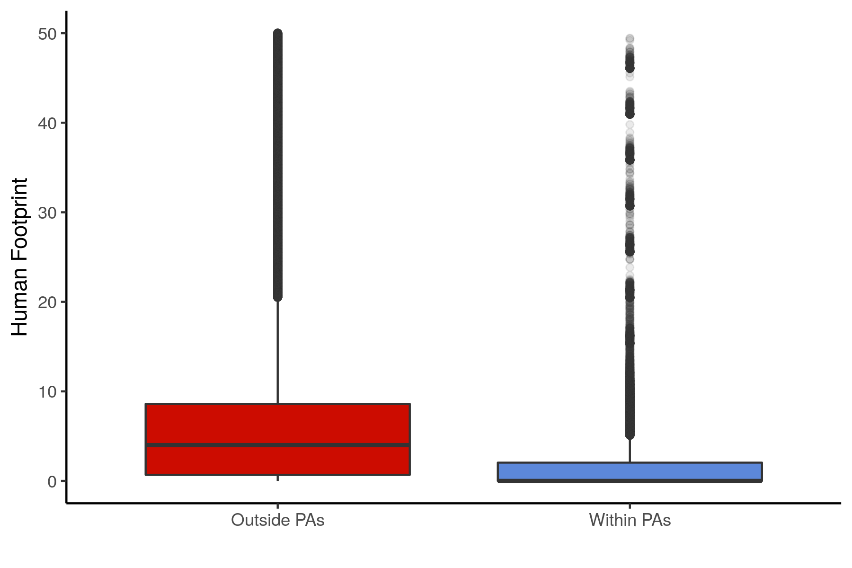

Supplementary Figure 2: Human Footprint (HF) outside and within protected areas (PAs). The boxplots show values of HF for cells outside and within large protected areas (PAs) ≥ 5,000 km² with strict IUCN management status I-II. HF was significantly lower (P < 0.05) within than outsides PAs.

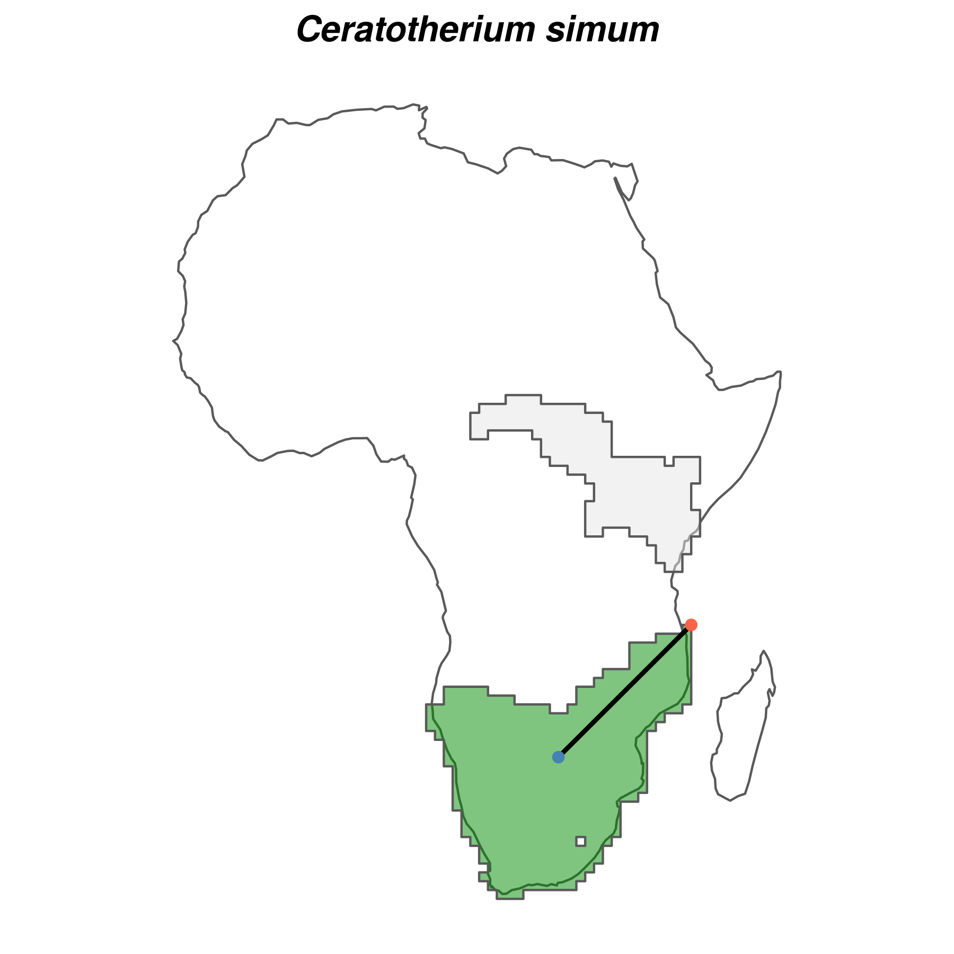
Supplementary Figure 3: Example of species-specific background buffer for maximum entropy (Maxent) models for the white rhinoceros (Ceratotherium simum). For each species, we calculated the background buffer as the maximum distance (black line) from the centroid (blue point) to the edge (red point) of the largest continuous range (shown in green). The smallest continuous range is also shown (light grey). Buffer size was then used to delimit the area accessible to the species through dispersal, i.e. the area used to generate background locations. Ranges were the combined current and present-natural ranges from the PHYLACINE database ⁴⁠ (Faurby et al. 2018).
Supplementary Table 5: Summary of the evaluation statistics for the species distribution models. Continuous Boyce Index (CBI) indicates how much models discriminate against random expectation and the average Area Under the Curve (AUC) of the Receiver Operating Clot show indicates how well models differentiate between presences and pseudo-absences. Low omission rates based on the minimum training presence value (OR_{MTP}) indicate models were not overfit. Introduction ranges were from ^{1,5⁠} .
Evaluation statistic | Median | Median absolute deviation | Mean | Standard deviation
Continuous Boyce Index (CBI) | 0.93 | 0.08 | 0.87 | 0.15
Area under the curve (AUC) of the receiver operating curve | 0.86 | 0.01 | 0.85 | 0.04
Omission rate minimum training presence (OR_{MTP}) | 0.02 | 0.03 | 0.07 | 0.15
Proportion of known introduction ranges predicted* | 0.84 | 0.23 | 0.62 | 0.41

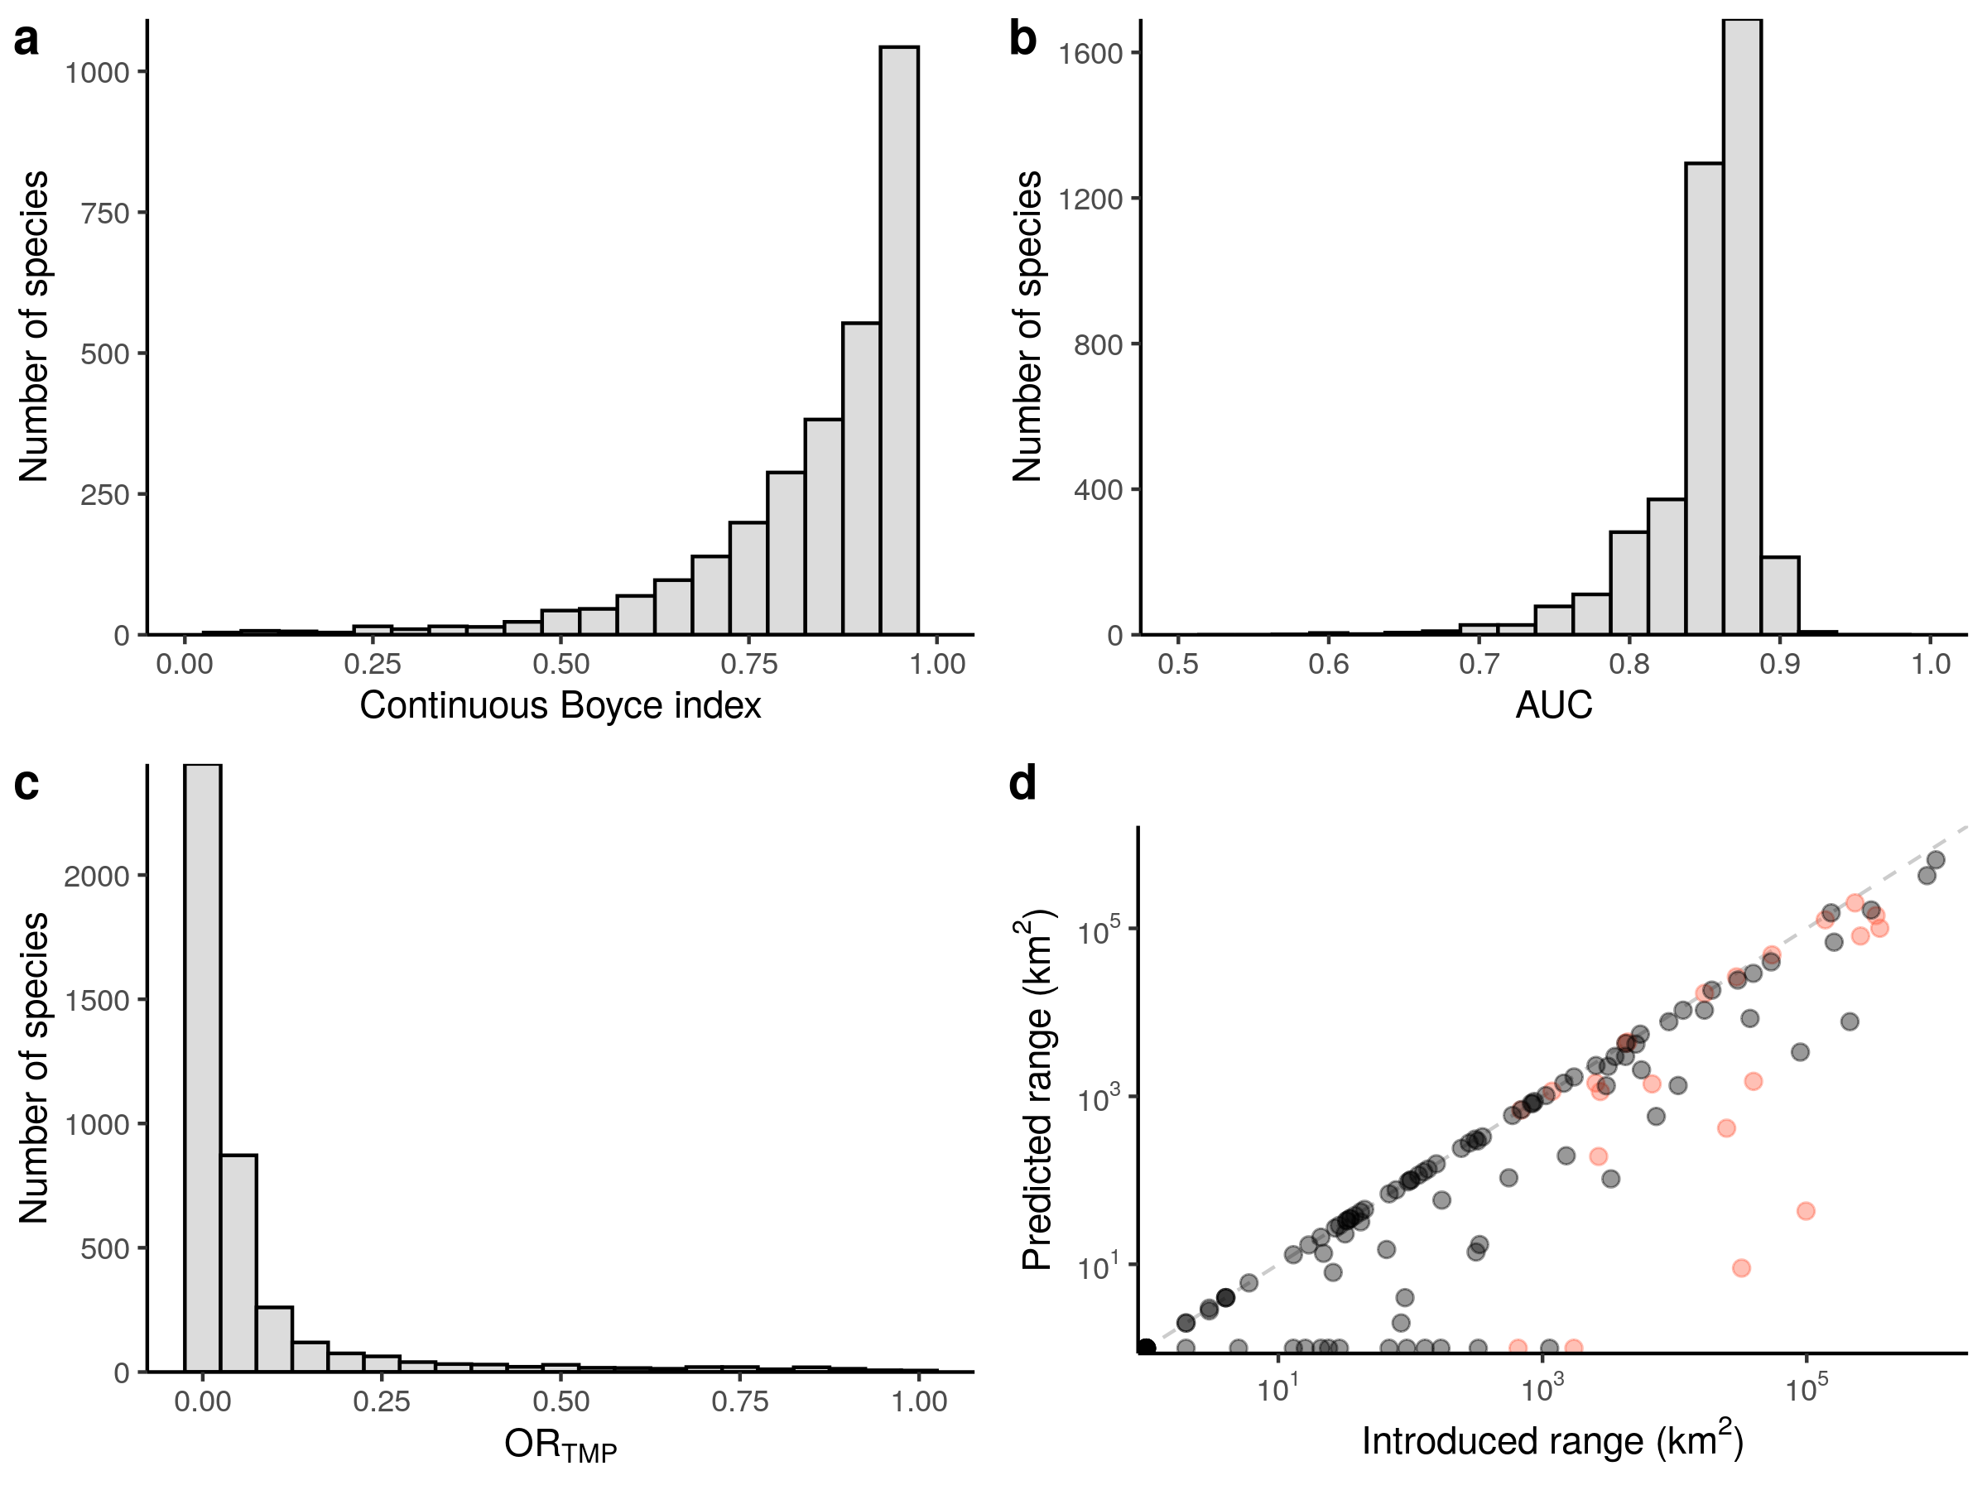
Supplementary Figure 4: Performance of maximum entropy (Maxent) species distribution models (SDMs). a–c, Histograms of the evaluation statistics for the Maxent SDMs. Predictive ability of SDMs is shown by both the Continuous Boyce Index (a) and by the Area Under the Curve (AUC) of the receiver operating curve (b). Model tendency to overfit is shown by the Omission Rate Minimum Training Presence (OR_{MTP}; c). d, Scatterplot showing predictions of known introduction ranges of mammals using Maxent SDMs. Species for which Maxent SDMs predicted the entire extinct of known introduction range are on the 1:1 line (dashed line). Introduced ranges were from ^{5⁠} Lundgren et al. (2018; red circles) and ¹⁠ the IUCN Red List of Threatened Species (IUCN 2019; black circles).

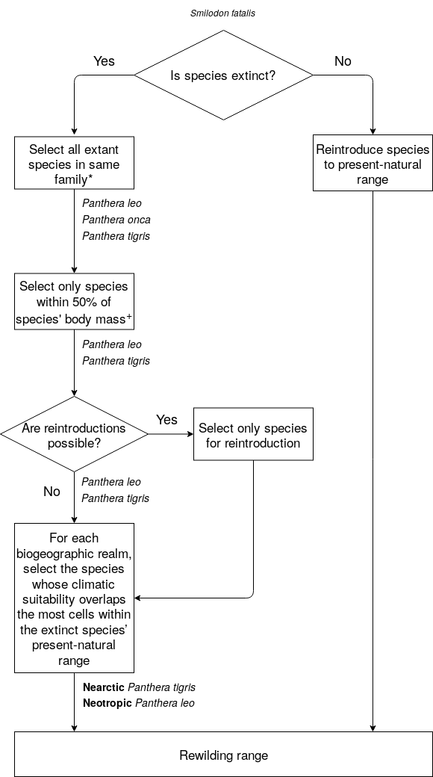
Supplementary Figure 5: Schematics showing selection of functional analogues to replace extinct species for the trophic rewilding scenario. An example is shown for the extinct species Smilodon fatalis. Functional analogues were selected from extant species that were phylogenetically closely-related, with similar body size to extinct species, and with overlapping areas of climatic suitability. Species were considered closely-related if they were from the same family, with the exception of Proboscidean species (* in figure), which were considered all closely-related within the Proboscidea order, as they share common morphological characteristic and similar functional roles ⁶⁠ . Functional analogues were considered to have similar body size to extinct species when they had body size between 50% – 150% body size of extinct species. Few exceptions (⁺ in figure) were made: megaherbivores (≥ 1,000 kg) Proboscideans were allowed to be replaced by any extant megaherbivore from this order; megacarnivores (≥ 100 kg) for the Felidae and Ursidae families were allowed to be replaced by any extant megacarnivore from their respective families. More details can be found in the main text.

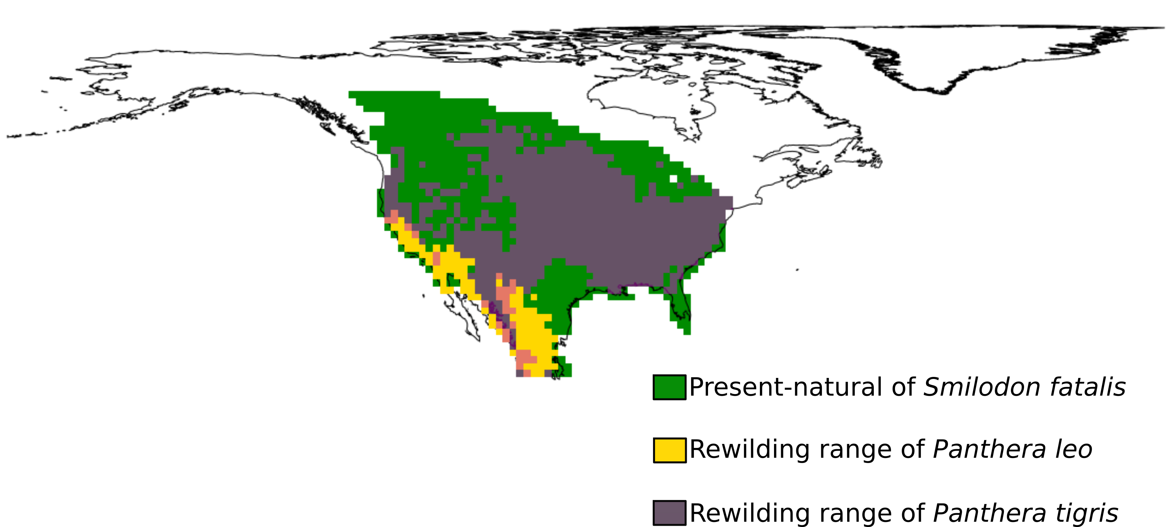
Supplementary Figure 6: Example of a functional analogue rewilding range for the extinct species Smilodon fatalis in the Nearctic realm. The present-natural range of S. Fatalis (green shade) represents a counter-factual range for today’s climate without anthropogenic pressure through time ⁴⁠ (Faurby et al. 2018). The introduction ranges of the functional analogues Panthera leo (yellow shade) and Panthera tigris (purple shade) were obtained assessing their climatic suitability through maximum entropy species distribution models and clipped to the present-natural of S. fatalis. In this example, P. tigris is selected as functional analogue for rewilding in the Nearctic due to the larger introduction area within the present-natural of S. fatalis in this biogeographic realm.

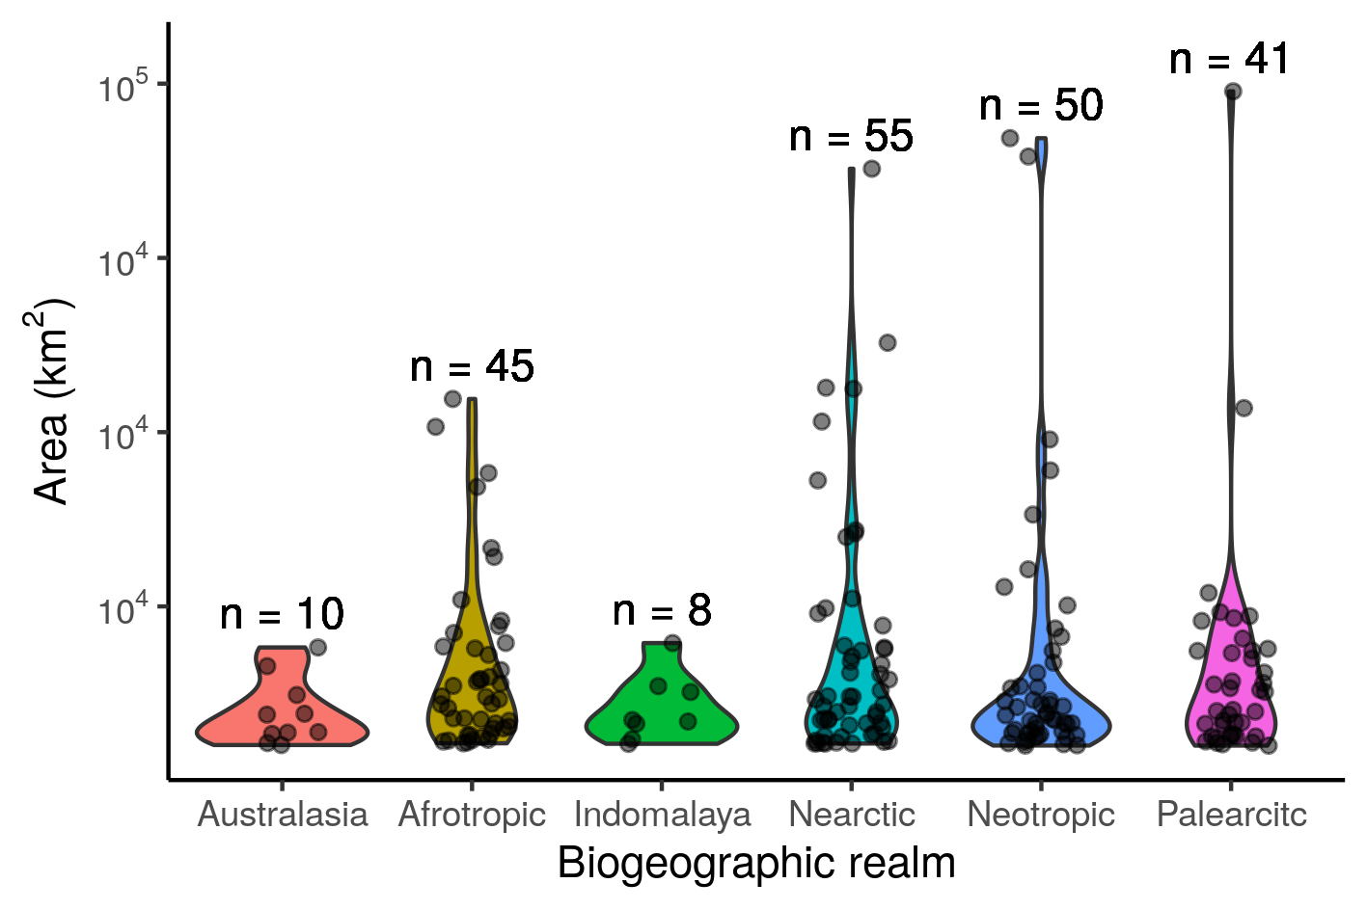

Supplementary Figure 7: Size of protected areas (PAs) ≥ 5,000 km² in the six biogeographic realms. Violin plots show the distribution of the PAs size in each biogeographic realm and the points the individual PAs. Superscripts (n) indicate the number of PAs ≥ 5,000 km² in each realm.

References

1. IUCN. The IUCN Red List of Threatened Species, Version 2019-3. (2019).
2. Sandom, C. J. et al. Trophic rewilding presents regionally specific opportunities for mitigating climate change. Philos. Trans. R. Soc. B Biol. Sci. 375, 1–8 (2020).
3. Venter, O. et al. Global terrestrial Human Footprint maps for 1993 and 2009. Sci. Data 3, 1–10 (2016).
4. Faurby, S., Davis, M., Pedersen Rasmus Øand Schowanek, S. D., Antonelli, A. & Svenning, J.-C. PHYLACINE 1.2: The phylogenetic atlas of mammal macroecology. Ecology 99, 2626 (2018).
5. Lundgren, E. J., Ramp, D., Ripple, W. J. & Wallach, A. D. Introduced megafauna are rewilding the Anthropocene. Ecography (Cop.). 41, 857–866 (2018).
6. Donlan, C. J. et al. Pleistocene rewilding: An optimistic agenda for twenty-first century conservation. Am. Nat. 168, 660–681 (2006).

