% Copyright (c) 2017 Emilio Cabrera <emilio1625@gmail.com>

%

% GNU GENERAL PUBLIC LICENSE

% Version 3, 29 June 2007

%

% This program is free software: you can redistribute it and/or modify

% it under the terms of the GNU General Public License as published by

% the Free Software Foundation, either version 3 of the License, or

% (at your option) any later version.

%

% This program is distributed in the hope that it will be useful,

% but WITHOUT ANY WARRANTY; without even the implied warranty of

% MERCHANTABILITY or FITNESS FOR A PARTICULAR PURPOSE. See the

% GNU General Public License for more details.

%

% You should have received a copy of the GNU General Public License

% along with this program. If not, see <http://www.gnu.org/licenses/>.

% Preparamos el area de trabajo

clear all;

pkg load signal;

% Características de la señal

global amp = 1; % amplitud de la señal

global tmp = amp / 2; % temporal

global tau = 0.01; % tiempo en alta por periodo

global T = 0.02; % periodo de la señal en segundos

global duty = tau / T; % ciclo de trabajo de 0 a 1

global f = 1 / T; % frecuencia de// la señal

global w = 2 * pi * f; % velocidad angular de la señal

global t = 0 : T / 200 : 3 * T; % vector de tiempo

global x = tmp + tmp * square(w * t, duty); % señal

% coeficiente de la serie trigonometrica

function x = a_(n)

global amp; global duty;

x = (amp / (pi * n)) * sin(2 * pi * n * duty);

endfunction

function x = b_(n)

global amp; global duty;

x = (amp / (pi * n)) * (1 - cos(2 * pi * n * duty));

endfunction

% coeficientes de la serie simplificada

function [A O] = coef(i)

for n = 1:i

a = a_(n);

b = b_(n);

A(n) = sqrt(a^2 + b^2);

O(n) = atan2(b, a);

endfor

endfunction

% grafica la señal reconstruida

function plot_rsignal(n)

global amp; global t; global w; global duty;

[An On] = coef(n);

% creamos un vector vacio del tamaño del vector de tiempo

% y sumamos la componente de directa

x = 0 .* t .+ duty;

for i = 1 : n

x = x + An(i) * cos(w * i * t .- On(i));

endfor

plot(t, x); axis([0 t(length(t)) -0.5 * amp amp * 1.5]);

title('Señal reconstruida'); xlabel('tiempo [ms]'); ylabel('x(t)');

endfunction

%grafica los coeficientes

function plot_coef(n, s)

global amp; global f;

[An On] = coef(n);

nv = 1 : n;

if (s == 0)

stem(f * nv, On); axis([0 f * n]);

title('Fase de la serie'); xlabel('frecuencia [Hz]'); ylabel('Øn');

else

stem(f * nv, An); axis([0 f * n]);

title('Armónicos de la señal'); xlabel('frecuencia [Hz]'); ylabel('An');

endif

endfunction

Señal 1

∆ = 10 [us] T = 20 [us]

|  |  |  |
| --- | --- | --- |
| # de armónico | Magnitud | Fase |
|  | 2.3590e-01 | -2.46740 |
|  | 1.4444e-17 | -4.93480 |
|  | 7.8632e-02 | -2.46740 |
|  | 1.4444e-17 | -4.93480 |
|  | 4.7179e-02 | -2.46740 |
|  | 1.4444e-17 | -4.93480 |
|  | 3.3699e-02 | -2.46740 |
|  | 1.4444e-17 | -4.93480 |
|  | 2.6211e-02 | -2.46740 |
|  | 1.4444e-17 | -4.93480 |
|  | 2.1445e-02 | -2.46740 |
|  | 1.4444e-17 | -4.93480 |
|  | 1.8146e-02 | -2.46740 |
|  | 1.4444e-17 | -4.93480 |
|  | 1.5726e-02 | -2.46740 |
|  | 1.4444e-17 | -4.93480 |
|  | 1.3876e-02 | -2.46740 |
|  | 1.4444e-17 | -4.93480 |
|  | 1.2416e-02 | -2.46740 |
|  | 1.4444e-17 | -4.93480 |
|  | 1.1233e-02 | -2.46740 |
|  | 5.2538e-17 | -4.93480 |
|  | 1.0256e-02 | -2.46740 |
|  | 1.4444e-17 | -4.93480 |
|  | 9.4358e-03 | -2.46740 |
|  | 1.7789e-17 | -0.00000 |
|  | 8.7369e-03 | -2.46740 |
|  | 1.4444e-17 | -4.93480 |
|  | 8.1343e-03 | -2.46740 |
|  | 4.2380e-17 | -4.93480 |
|  | 7.6095e-03 | -2.46740 |
|  | 1.4444e-17 | -4.93480 |
|  | 7.1483e-03 | -2.46740 |
|  | 1.0205e-17 | -0.00000 |
|  | 6.7399e-03 | -2.46740 |
|  | 1.4444e-17 | -4.93480 |
|  | 6.3756e-03 | -2.46740 |
|  | 3.6499e-17 | -4.93480 |
|  | 6.0486e-03 | -2.46740 |
|  | 1.4444e-17 | -4.93480 |
|  | 5.7535e-03 | -2.46740 |
|  | 5.5096e-18 | -0.00000 |
|  | 5.4859e-03 | -2.46740 |
|  | 5.2538e-17 | -4.93480 |
|  | 5.2421e-03 | -2.46740 |
| # de armónico | Magnitud | Fase |
|  | 3.2663e-17 | -4.93480 |
|  | 5.0191e-03 | -2.46740 |
|  | 1.4444e-17 | -4.93480 |
|  | 4.8142e-03 | -2.46740 |
|  | 2.3169e-18 | -0.00000 |
|  | 4.6254e-03 | -2.46740 |
|  | 1.7789e-17 | -0.00000 |
|  | 4.4509e-03 | -2.46740 |
|  | 2.9964e-17 | -4.93480 |
|  | 4.2890e-03 | -2.46740 |
|  | 1.4444e-17 | -4.93480 |
|  | 4.1385e-03 | -2.46740 |
|  | 5.0350e-21 | -0.00000 |
|  | 3.9982e-03 | -2.46740 |
|  | 4.2380e-17 | -4.93480 |
|  | 3.8671e-03 | -2.46740 |
|  | 2.7962e-17 | -4.93480 |
|  | 3.7444e-03 | -2.46740 |
|  | 1.4444e-17 | -4.93480 |
|  | 3.6292e-03 | -2.46740 |
|  | 1.7464e-18 | -4.93480 |
|  | 3.5208e-03 | -2.46740 |
|  | 1.0205e-17 | -0.00000 |
|  | 3.4188e-03 | -2.46740 |
|  | 2.6417e-17 | -4.93480 |
|  | 3.3225e-03 | -2.46740 |
|  | 1.4444e-17 | -4.93480 |
|  | 3.2314e-03 | -2.46740 |
|  | 3.1192e-18 | -4.93480 |
|  | 3.1453e-03 | -2.46740 |
|  | 3.6499e-17 | -4.93480 |
|  | 3.0636e-03 | -2.46740 |
|  | 2.5189e-17 | -4.93480 |
|  | 2.9860e-03 | -2.46740 |
|  | 1.4444e-17 | -4.93480 |
|  | 2.9123e-03 | -2.46740 |
|  | 4.5105e-17 | -4.93480 |
|  | 2.8421e-03 | -2.46740 |
|  | 5.5096e-18 | -0.00000 |
|  | 2.7752e-03 | -2.46740 |
|  | 2.4189e-17 | -4.93480 |
|  | 2.7114e-03 | -2.46740 |
|  | 5.2538e-17 | -4.93480 |
|  | 2.6505e-03 | -2.46740 |
|  | 5.1326e-18 | -4.93480 |
| # de armónico | Magnitud | Fase |
|  | 2.5923e-03 | -2.46740 |
|  | 3.2663e-17 | -4.93480 |
|  | 2.5365e-03 | -2.46740 |
|  | 1.2302e-17 | -0.00000 |
|  | 2.4831e-03 | -2.46740 |
| # de armónico | Magnitud | Fase |
|  | 1.4444e-17 | -4.93480 |
|  | 2.4319e-03 | -2.46740 |
|  | 4.0100e-17 | -4.93480 |
|  | 2.3828e-03 | -2.46740 |
|  | 2.3169e-18 | -0.00000 |

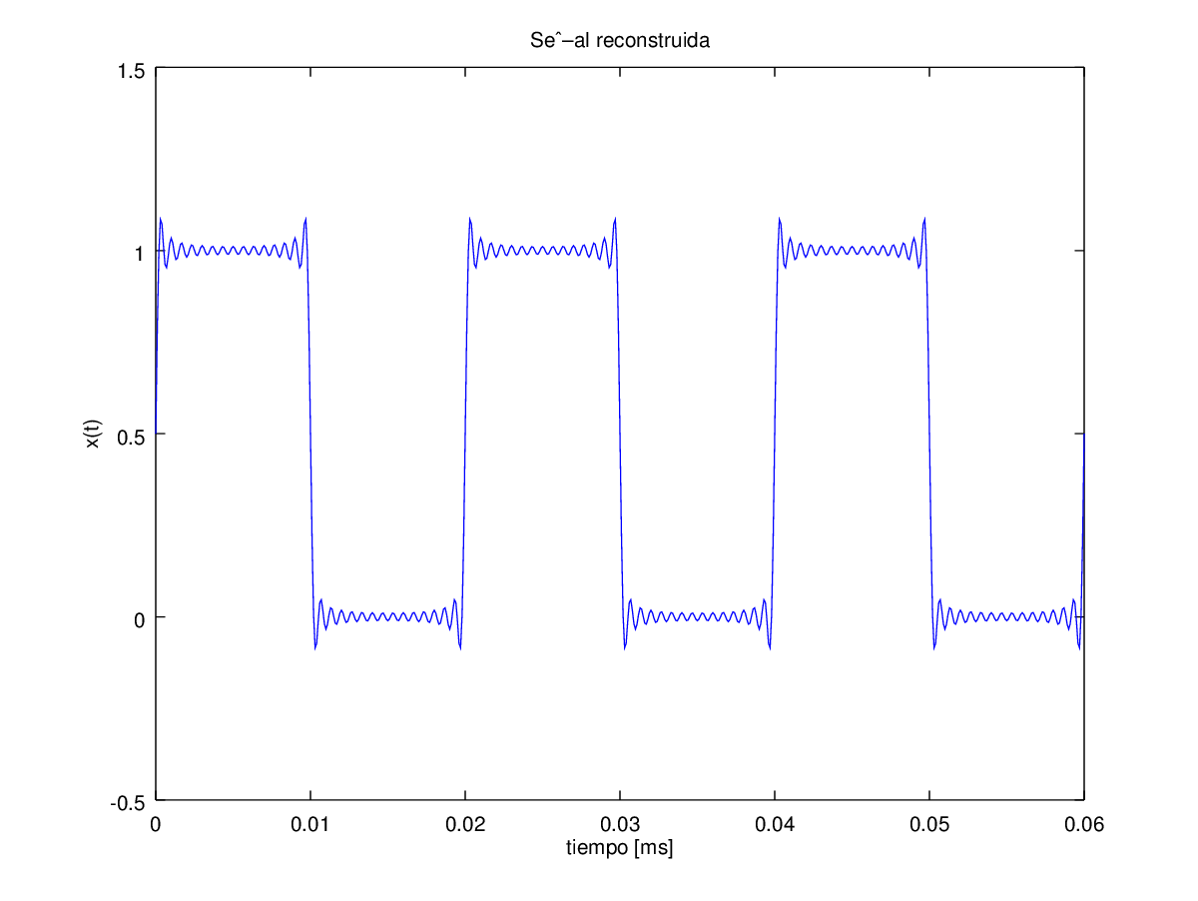

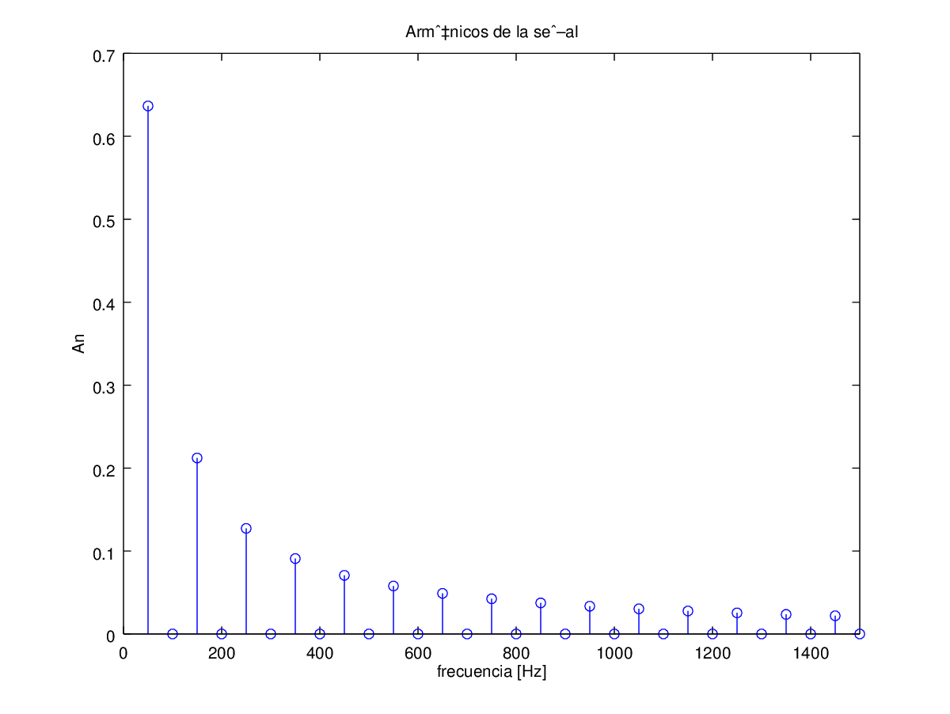

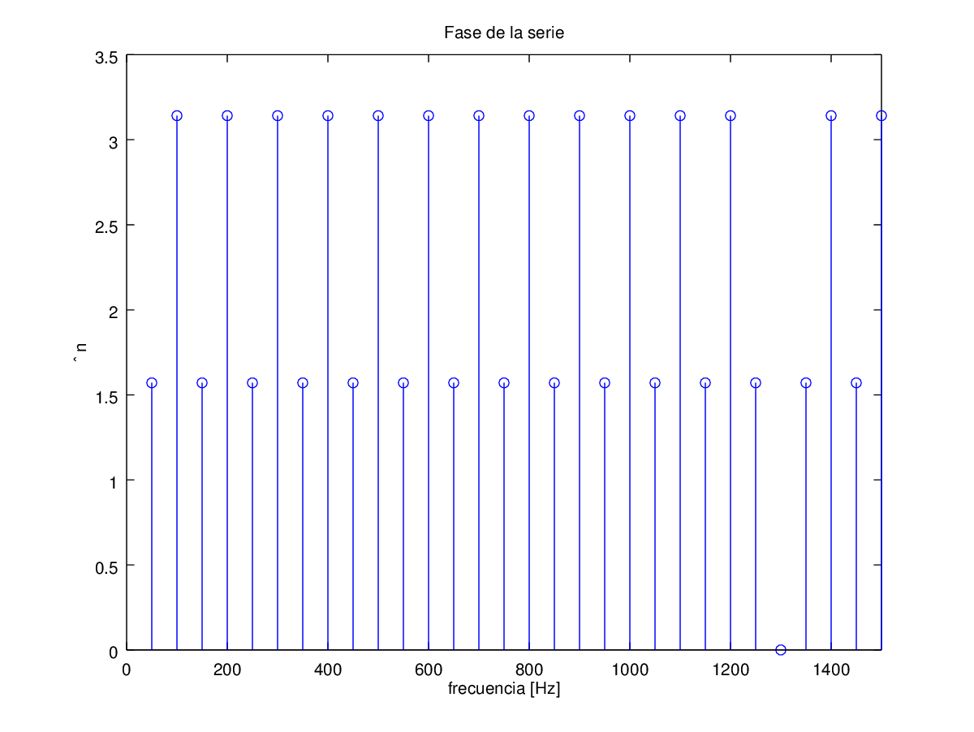

|  |  |  |
| --- | --- | --- |
| # de armónico | Magnitud | Fase |
|  | 6.3662e-001 | 1.57080 |
|  | 3.8980e-017 | 3.14159 |
|  | 2.1221e-001 | 1.57080 |
|  | 3.8980e-017 | 3.14159 |
|  | 1.2732e-001 | 1.57080 |
|  | 3.8980e-017 | 3.14159 |
|  | 9.0946e-002 | 1.57080 |
|  | 3.8980e-017 | 3.14159 |
|  | 7.0736e-002 | 1.57080 |
|  | 3.8980e-017 | 3.14159 |
|  | 5.7875e-002 | 1.57080 |
|  | 3.8980e-017 | 3.14159 |
|  | 4.8971e-002 | 1.57080 |
|  | 3.8980e-017 | 3.14159 |
|  | 4.2441e-002 | 1.57080 |

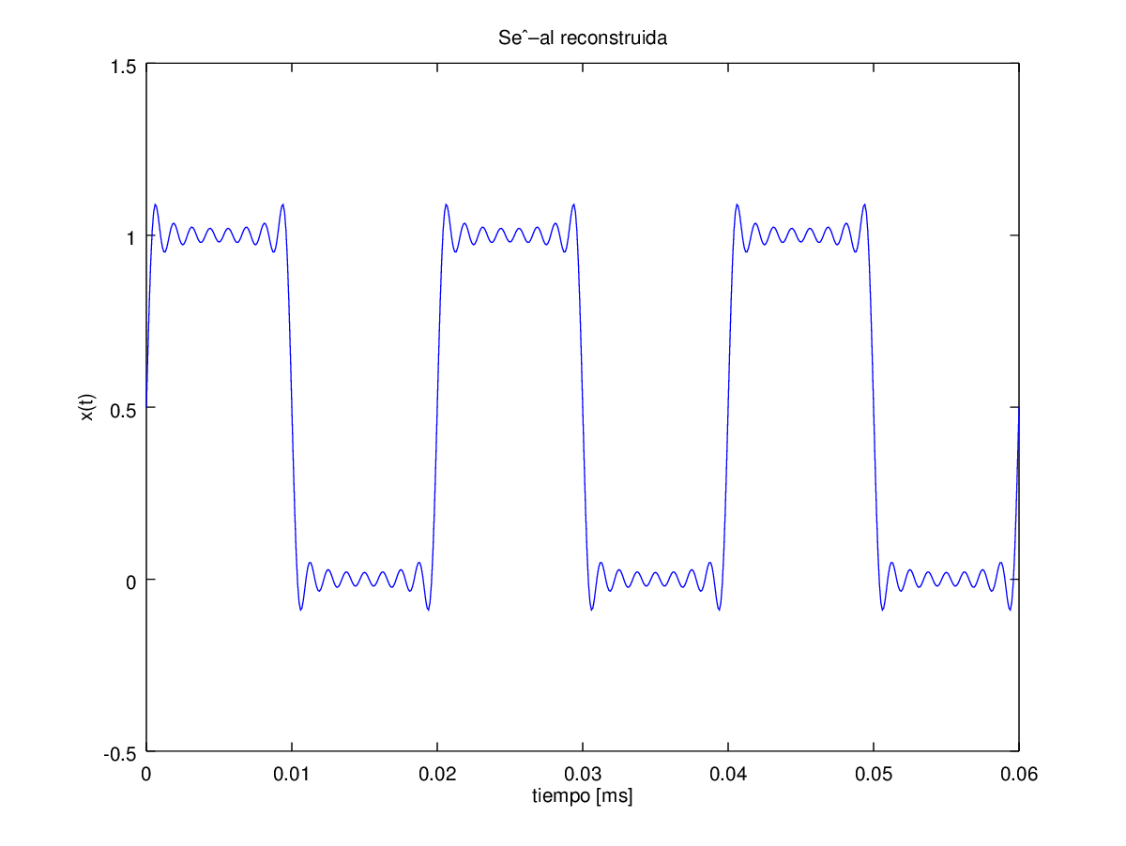

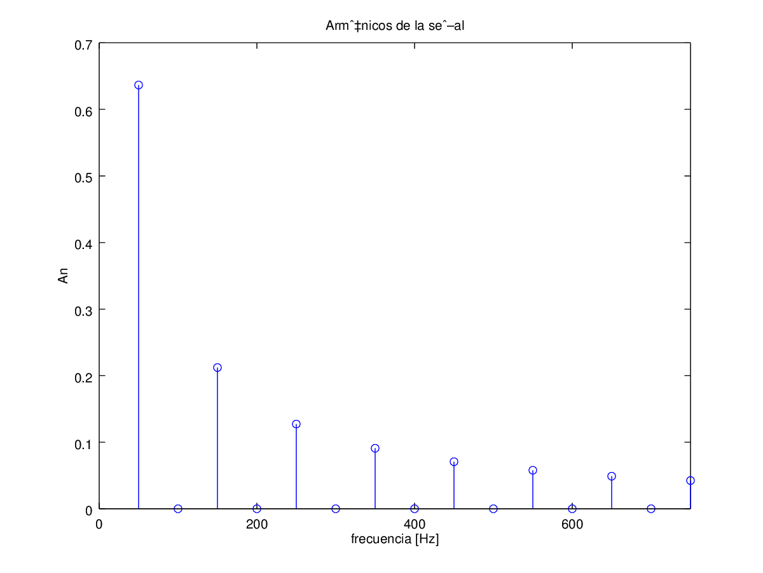

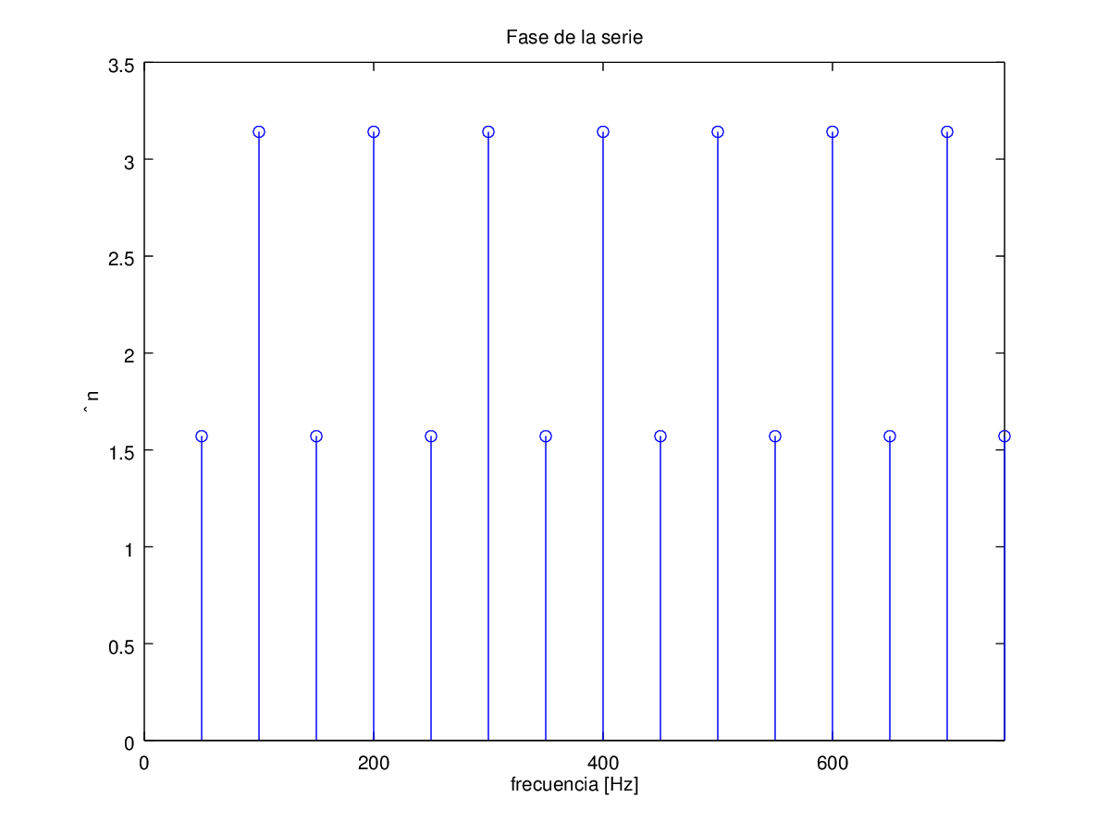

|  |  |  |
| --- | --- | --- |
| # de armónico | Magnitud | Fase |
|  | 6.3662e-001 | 1.57080 |
|  | 3.8980e-017 | 3.14159 |
|  | 2.1221e-001 | 1.57080 |
|  | 3.8980e-017 | 3.14159 |
|  | 1.2732e-001 | 1.57080 |

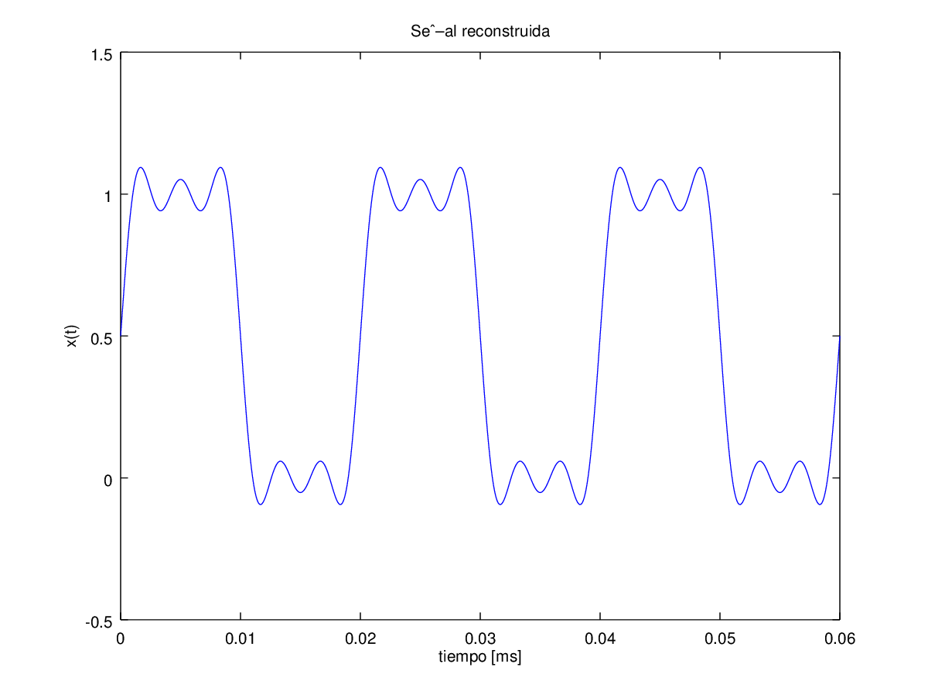

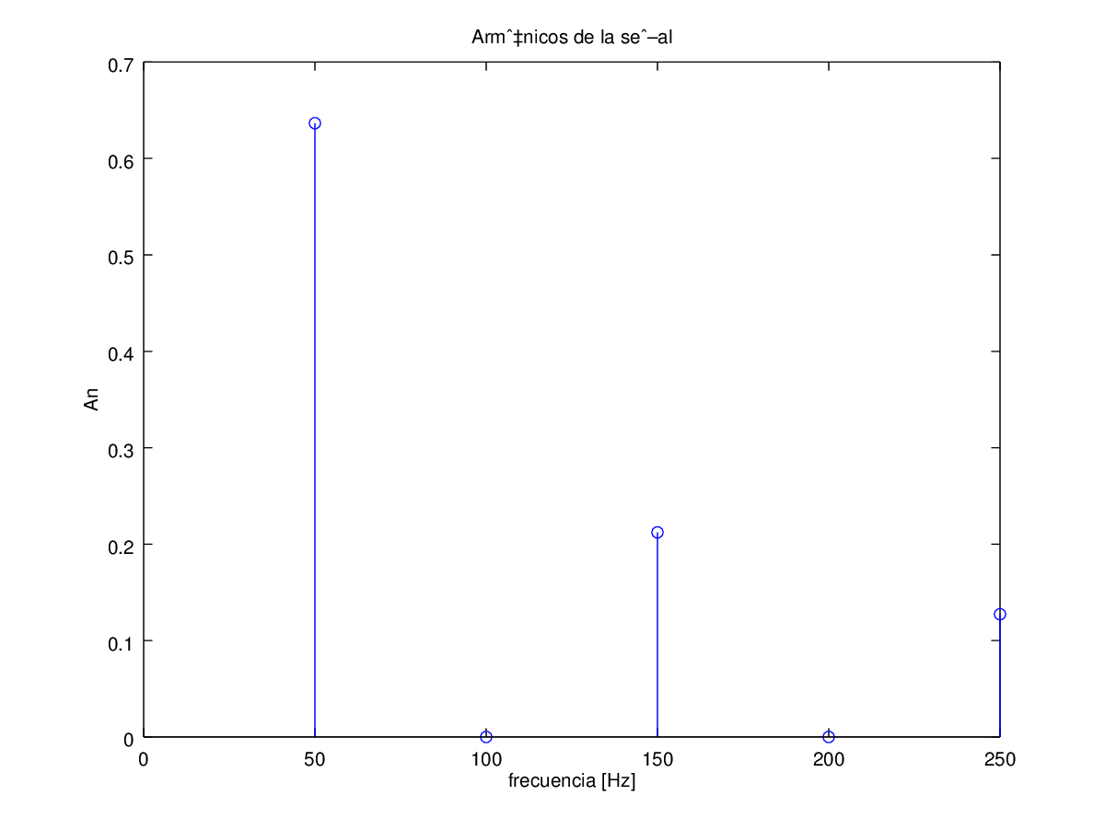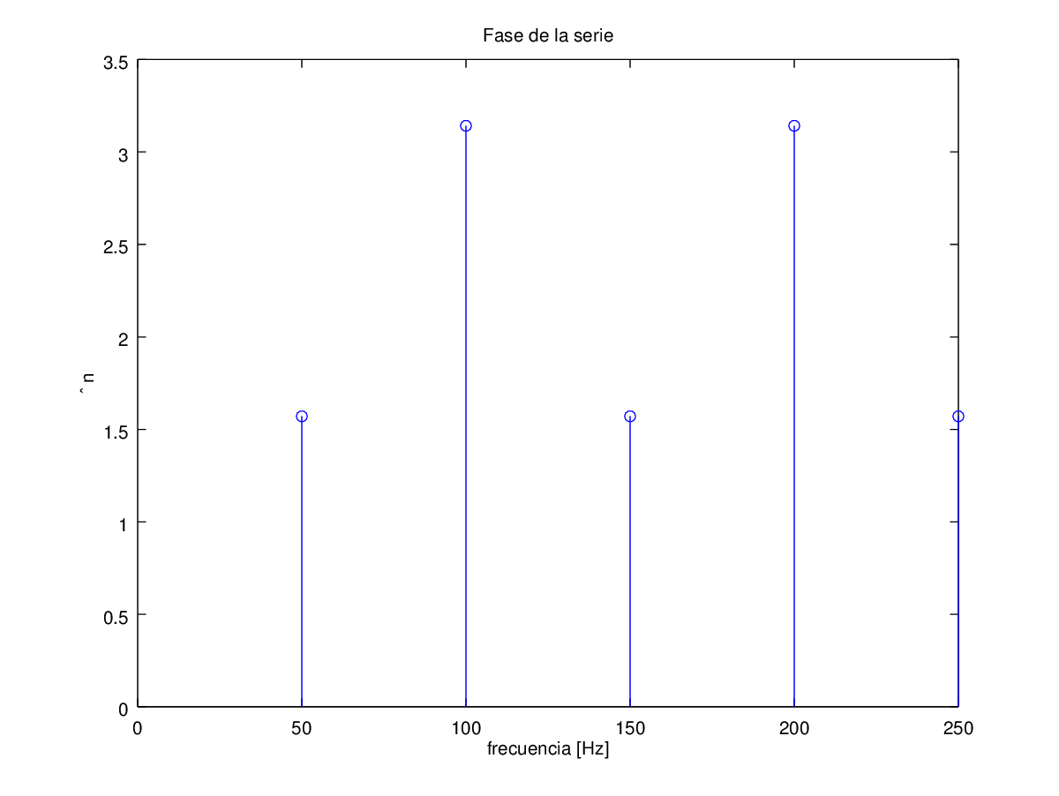

Señal 2

∆ = 1 [ms]

T = 2 [ms]

|  |  |  |
| --- | --- | --- |
| # de armónico | Magnitud | Fase |
|  | 6.3662e-001 | 1.57080 |
|  | 3.8980e-017 | 3.14159 |
|  | 2.1221e-001 | 1.57080 |
|  | 3.8980e-017 | 3.14159 |
|  | 1.2732e-001 | 1.57080 |
|  | 3.8980e-017 | 3.14159 |
|  | 9.0946e-002 | 1.57080 |
|  | 3.8980e-017 | 3.14159 |
|  | 7.0736e-002 | 1.57080 |
|  | 3.8980e-017 | 3.14159 |
|  | 5.7875e-002 | 1.57080 |
|  | 3.8980e-017 | 3.14159 |
|  | 4.8971e-002 | 1.57080 |
|  | 3.8980e-017 | 3.14159 |
|  | 4.2441e-002 | 1.57080 |
| # de armónico | Magnitud | Fase |
|  | 3.8980e-017 | 3.14159 |
|  | 3.7448e-002 | 1.57080 |
|  | 3.8980e-017 | 3.14159 |
|  | 3.3506e-002 | 1.57080 |
|  | 3.8980e-017 | 3.14159 |
|  | 3.0315e-002 | 1.57080 |
|  | 1.4179e-016 | 3.14159 |
|  | 2.7679e-002 | 1.57080 |
|  | 3.8980e-017 | 3.14159 |
|  | 2.5465e-002 | 1.57080 |
|  | 4.8009e-017 | 0.00000 |
|  | 2.3579e-002 | 1.57080 |
|  | 3.8980e-017 | 3.14159 |
|  | 2.1952e-002 | 1.57080 |
|  | 1.1437e-016 | 3.14159 |

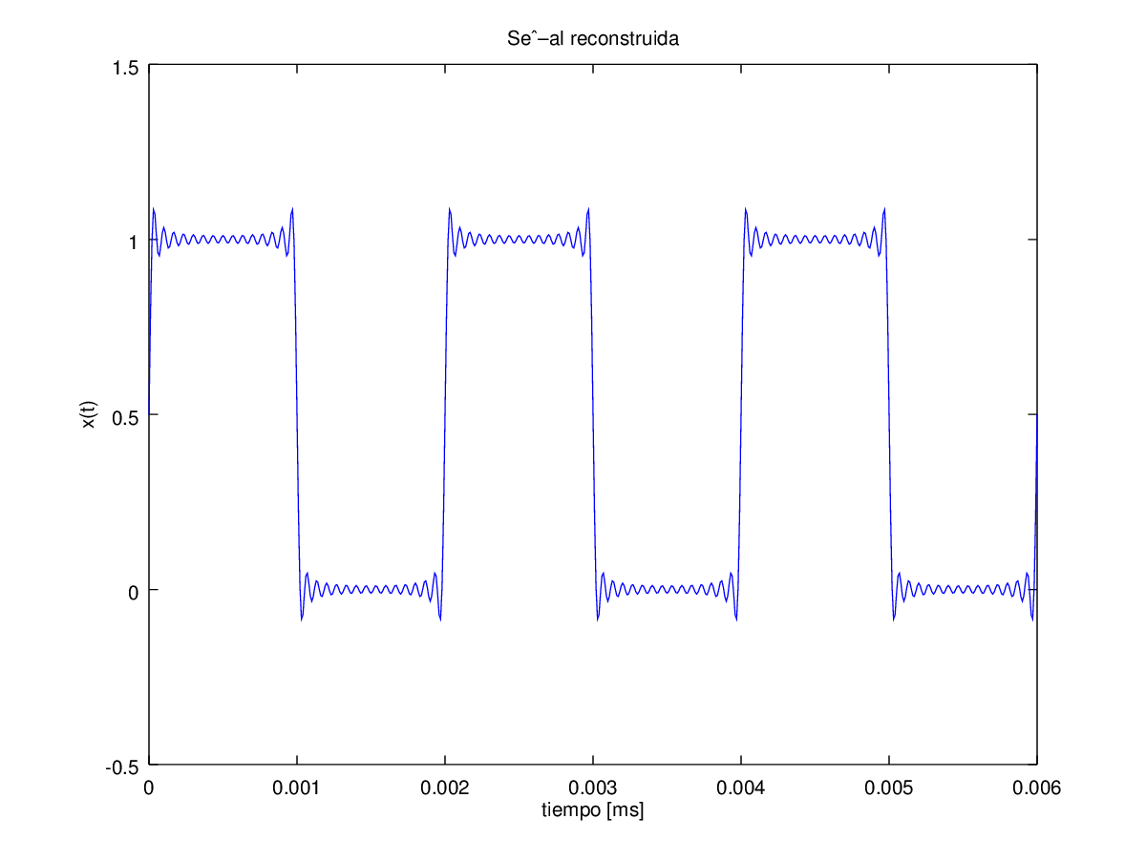

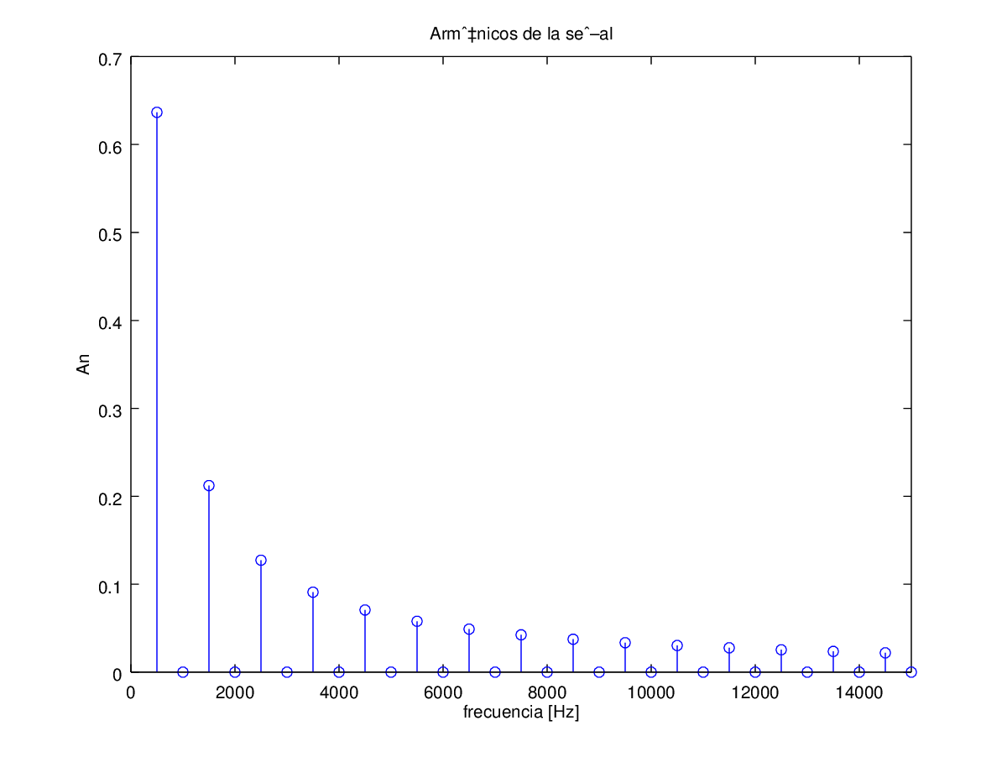

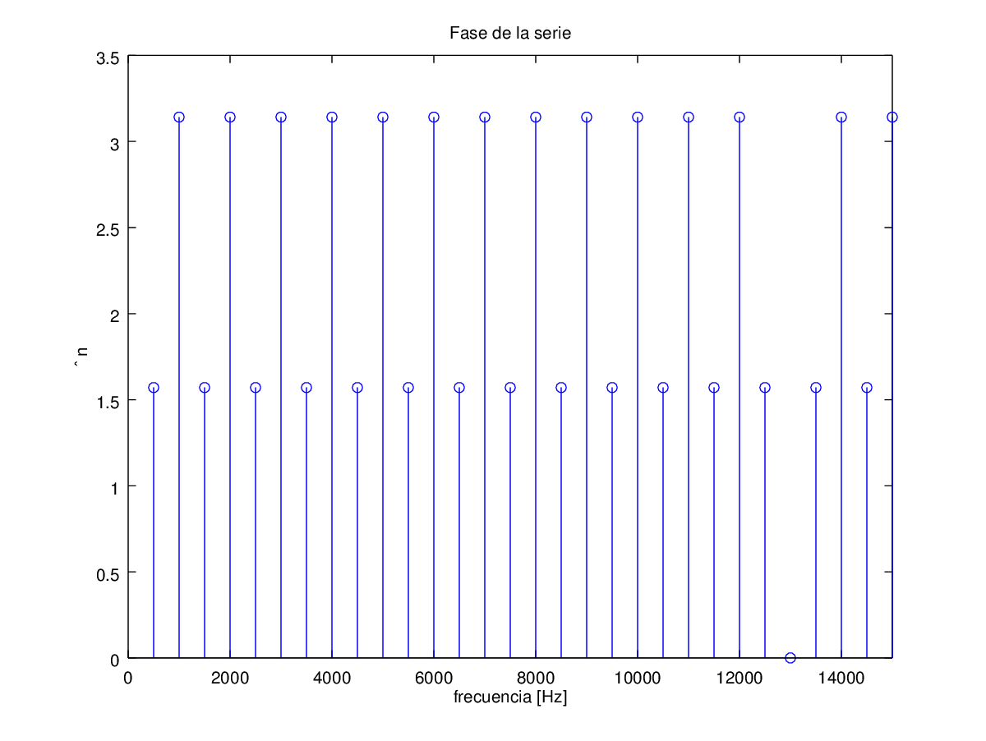

|  |  |  |
| --- | --- | --- |
| # de armónico | Magnitud | Fase |
|  | 6.3662e-001 | 1.57080 |
|  | 3.8980e-017 | 3.14159 |
|  | 2.1221e-001 | 1.57080 |
|  | 3.8980e-017 | 3.14159 |
|  | 1.2732e-001 | 1.57080 |
|  | 3.8980e-017 | 3.14159 |
|  | 9.0946e-002 | 1.57080 |
|  | 3.8980e-017 | 3.14159 |
|  | 7.0736e-002 | 1.57080 |
|  | 3.8980e-017 | 3.14159 |
|  | 5.7875e-002 | 1.57080 |
|  | 3.8980e-017 | 3.14159 |
|  | 4.8971e-002 | 1.57080 |
|  | 3.8980e-017 | 3.14159 |
|  | 4.2441e-002 | 1.57080 |

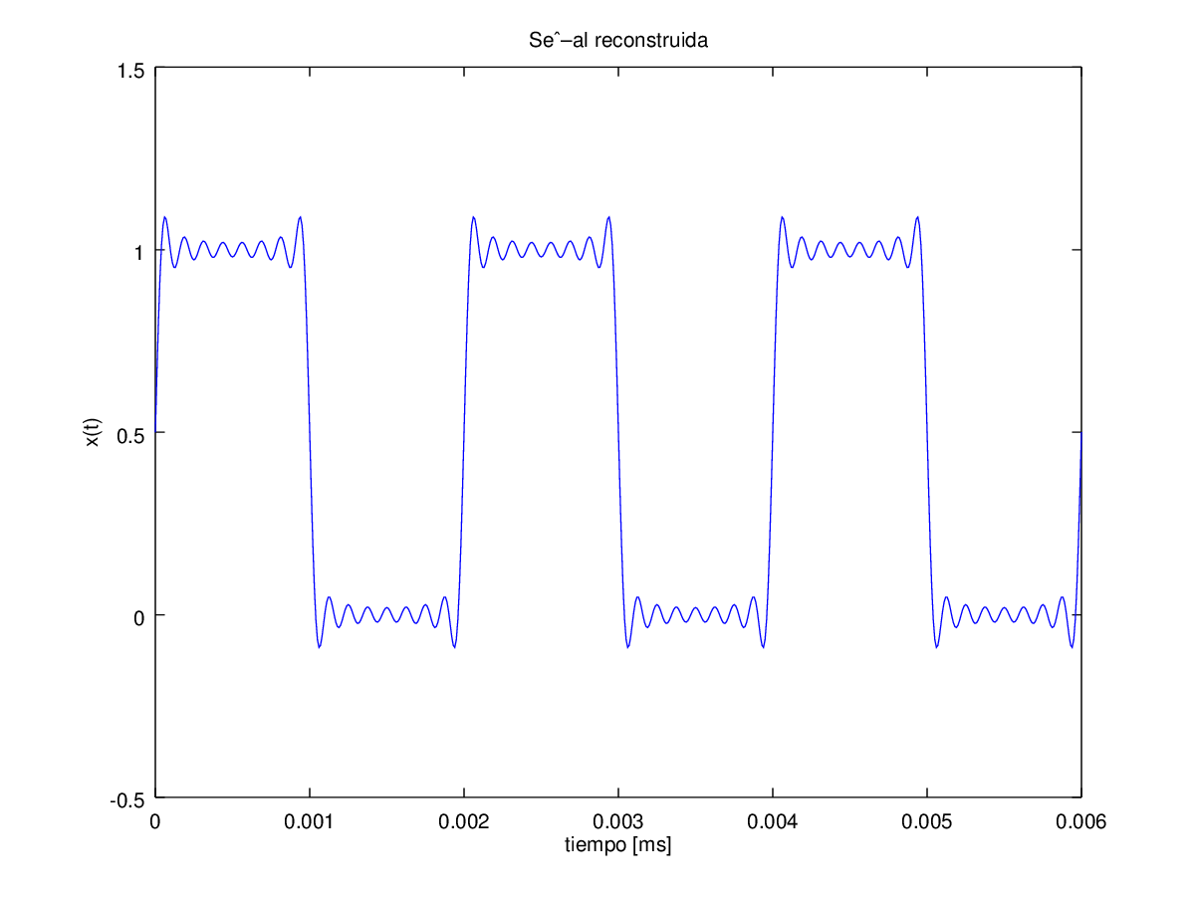

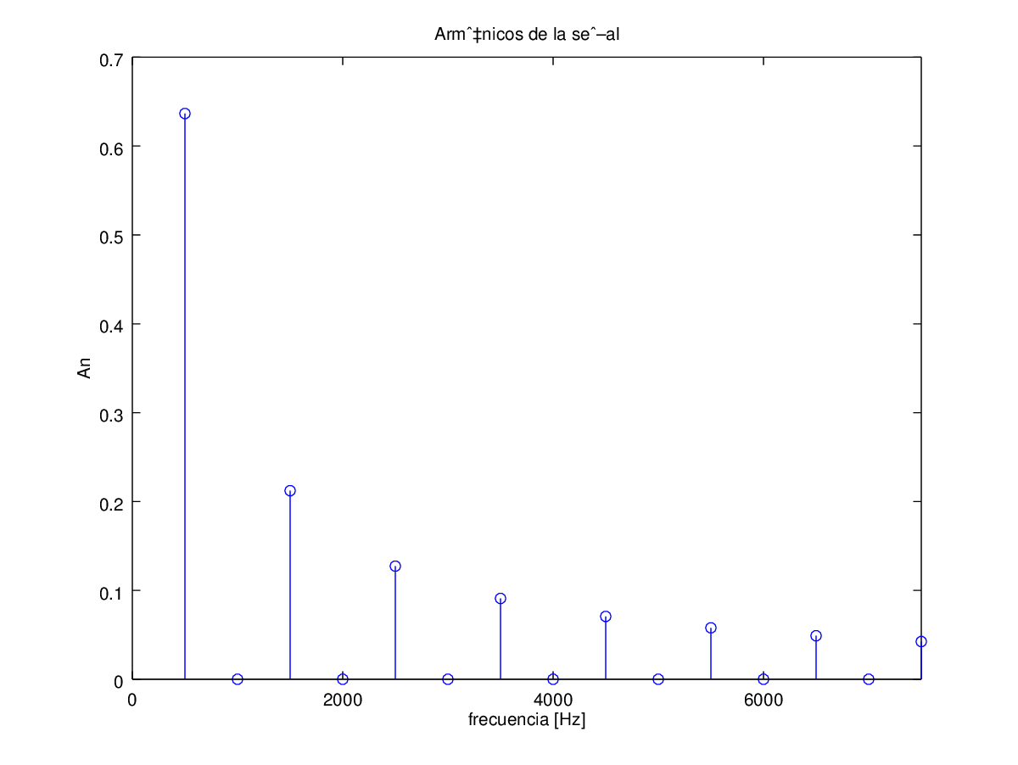

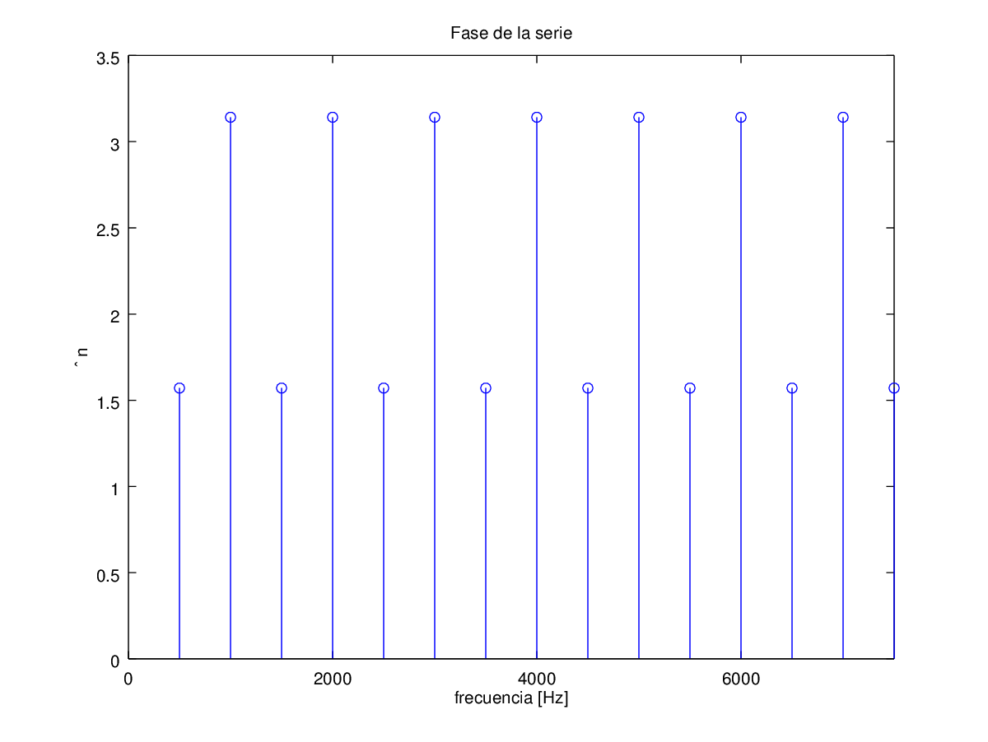

|  |  |  |
| --- | --- | --- |
| # de armónico | Magnitud | Fase |
|  | 6.3662e-001 | 1.57080 |
|  | 3.8980e-017 | 3.14159 |
|  | 2.1221e-001 | 1.57080 |
|  | 3.8980e-017 | 3.14159 |
|  | 1.2732e-001 | 1.57080 |

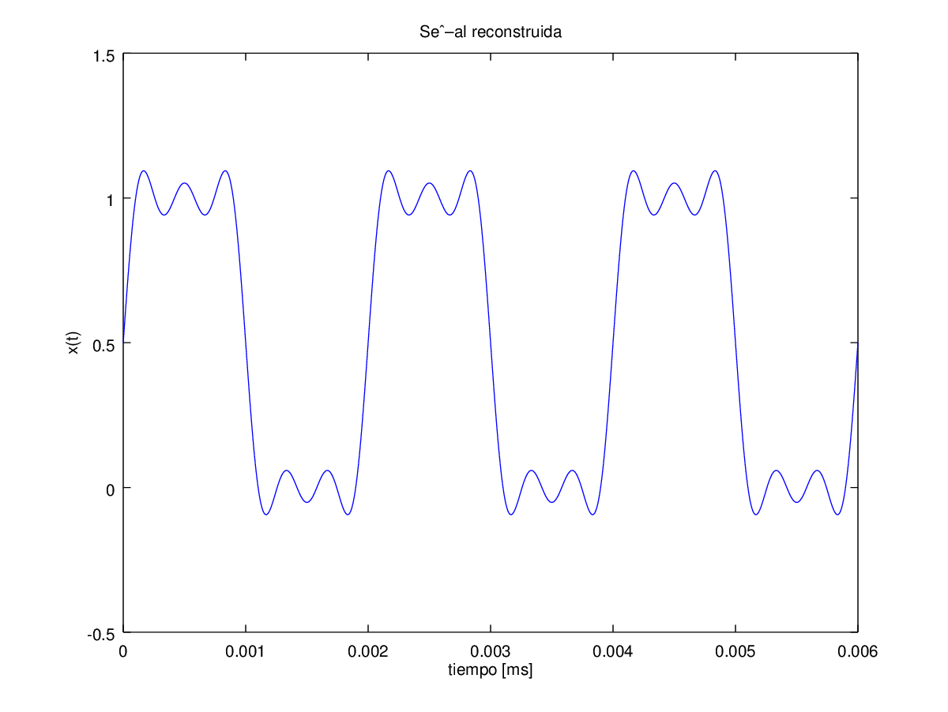

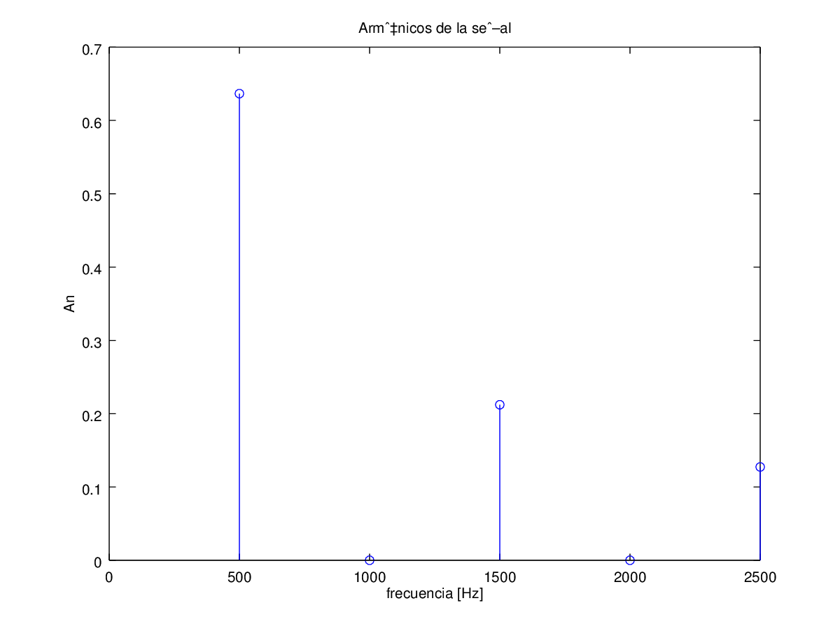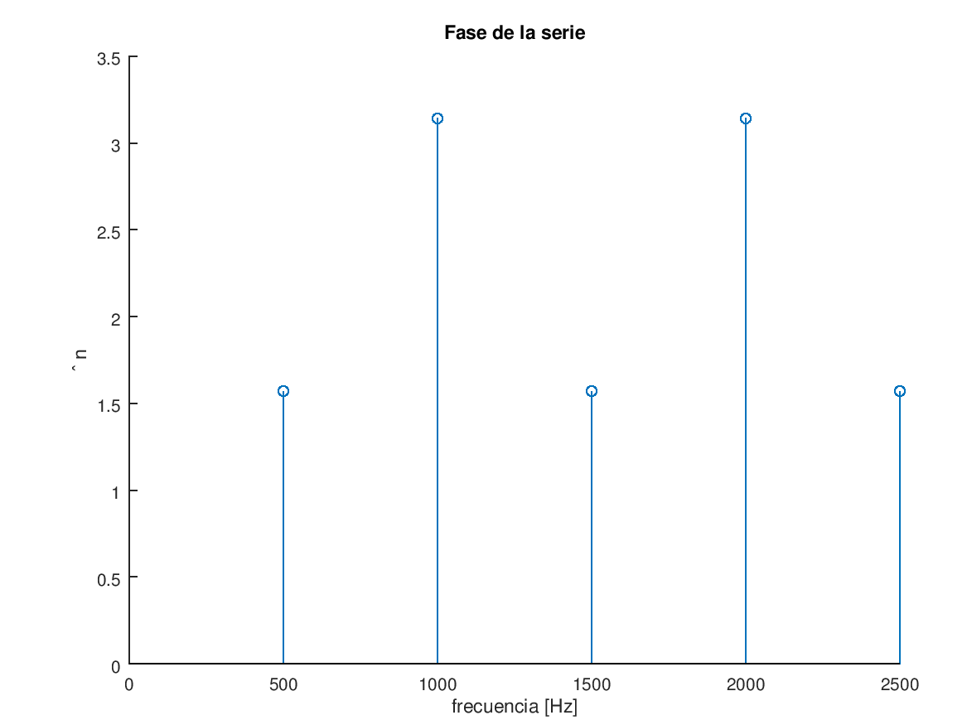

Señal 3

∆ = 0.1 [ms]

T = 0.2 [ms]

|  |  |  |
| --- | --- | --- |
| # de armónico | Magnitud | Fase |
|  | 6.3662e-001 | 1.57080 |
|  | 3.8980e-017 | 3.14159 |
|  | 2.1221e-001 | 1.57080 |
|  | 3.8980e-017 | 3.14159 |
|  | 1.2732e-001 | 1.57080 |
|  | 3.8980e-017 | 3.14159 |
|  | 9.0946e-002 | 1.57080 |
|  | 3.8980e-017 | 3.14159 |
|  | 7.0736e-002 | 1.57080 |
|  | 3.8980e-017 | 3.14159 |
|  | 5.7875e-002 | 1.57080 |
|  | 3.8980e-017 | 3.14159 |
|  | 4.8971e-002 | 1.57080 |
|  | 3.8980e-017 | 3.14159 |
|  | 4.2441e-002 | 1.57080 |
| # de armónico | Magnitud | Fase |
|  | 3.8980e-017 | 3.14159 |
|  | 3.7448e-002 | 1.57080 |
|  | 3.8980e-017 | 3.14159 |
|  | 3.3506e-002 | 1.57080 |
|  | 3.8980e-017 | 3.14159 |
|  | 3.0315e-002 | 1.57080 |
|  | 1.4179e-016 | 3.14159 |
|  | 2.7679e-002 | 1.57080 |
|  | 3.8980e-017 | 3.14159 |
|  | 2.5465e-002 | 1.57080 |
|  | 4.8009e-017 | 0.00000 |
|  | 2.3579e-002 | 1.57080 |
|  | 3.8980e-017 | 3.14159 |
|  | 2.1952e-002 | 1.57080 |
|  | 1.1437e-016 | 3.14159 |

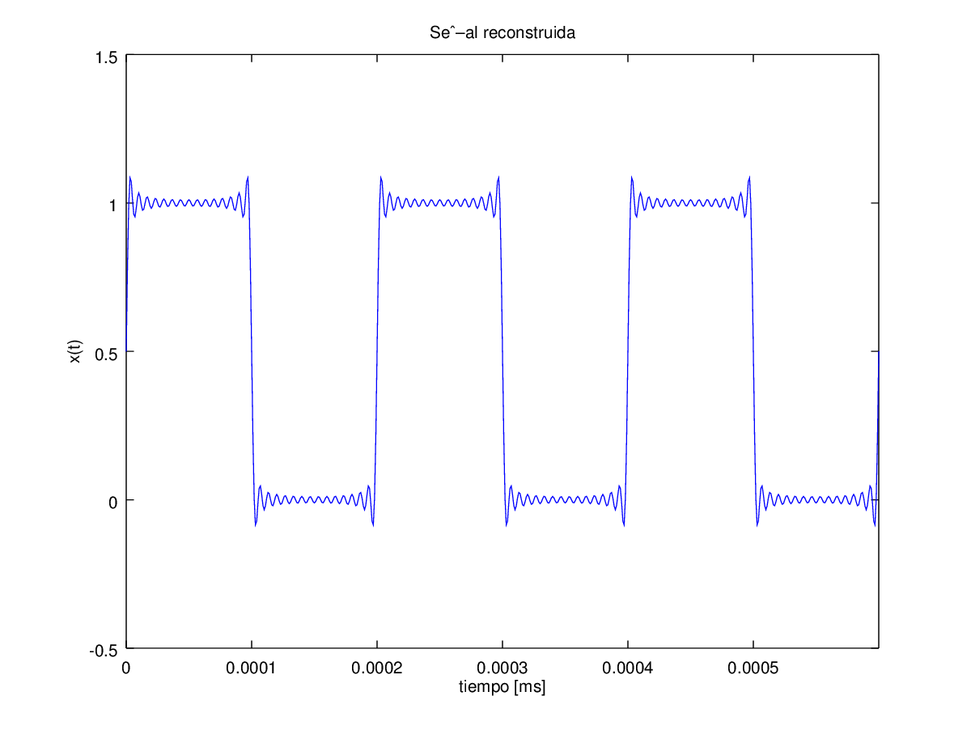

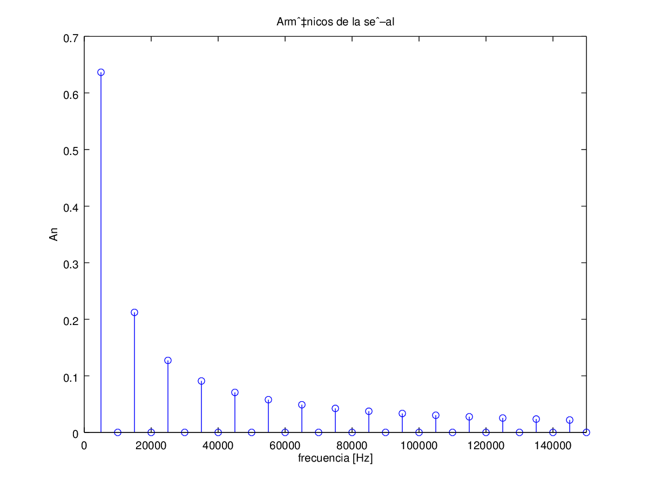

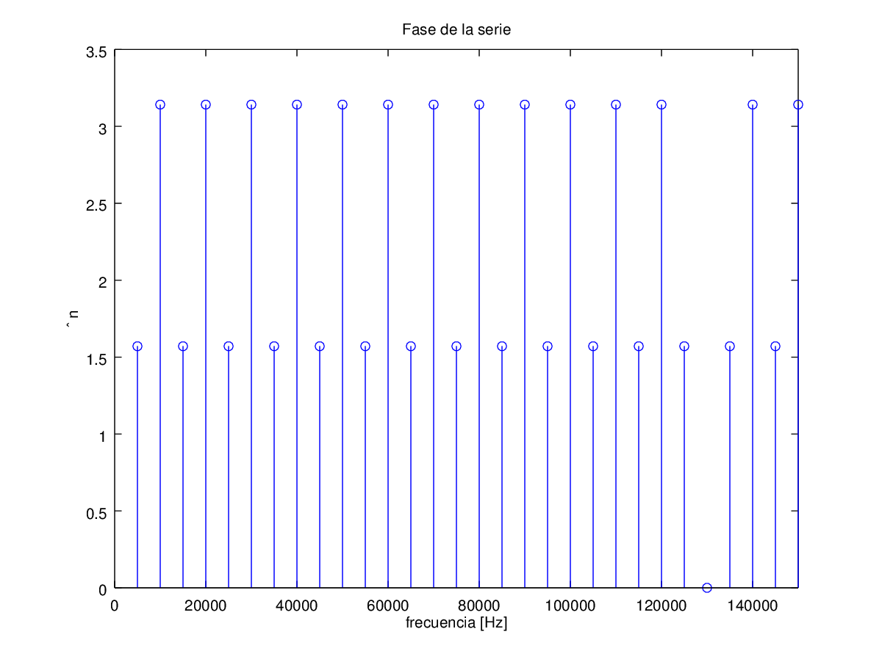

|  |  |  |
| --- | --- | --- |
| # de armónico | Magnitud | Fase |
|  | 6.3662e-001 | 1.57080 |
|  | 3.8980e-017 | 3.14159 |
|  | 2.1221e-001 | 1.57080 |
|  | 3.8980e-017 | 3.14159 |
|  | 1.2732e-001 | 1.57080 |
|  | 3.8980e-017 | 3.14159 |
|  | 9.0946e-002 | 1.57080 |
|  | 3.8980e-017 | 3.14159 |
|  | 7.0736e-002 | 1.57080 |
|  | 3.8980e-017 | 3.14159 |
|  | 5.7875e-002 | 1.57080 |
|  | 3.8980e-017 | 3.14159 |
|  | 4.8971e-002 | 1.57080 |
|  | 3.8980e-017 | 3.14159 |
|  | 4.2441e-002 | 1.57080 |

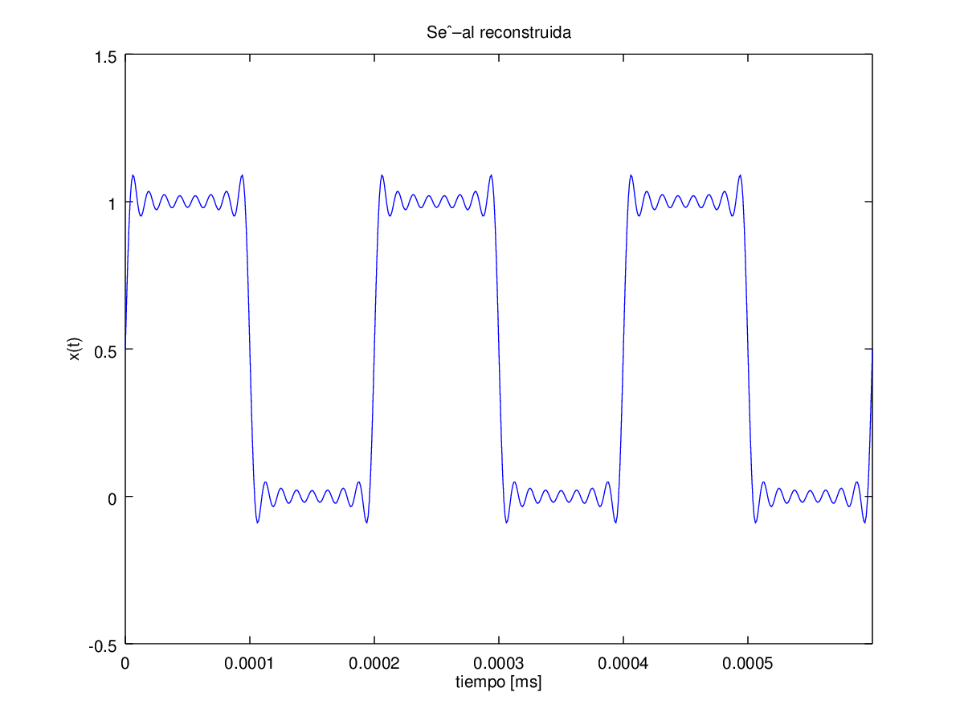

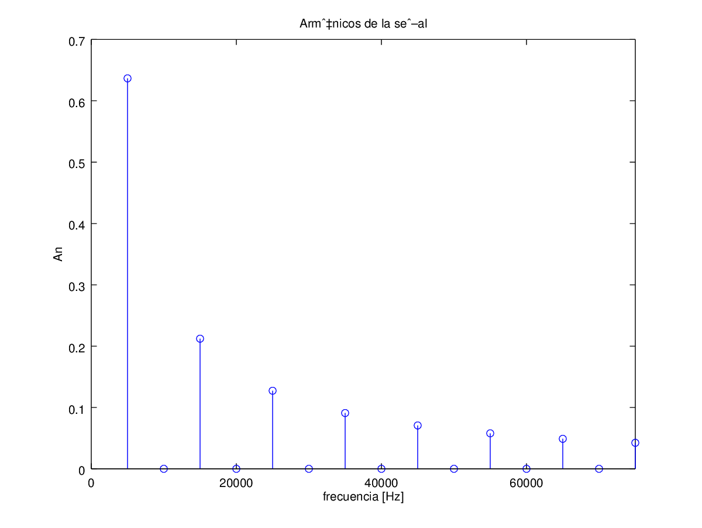

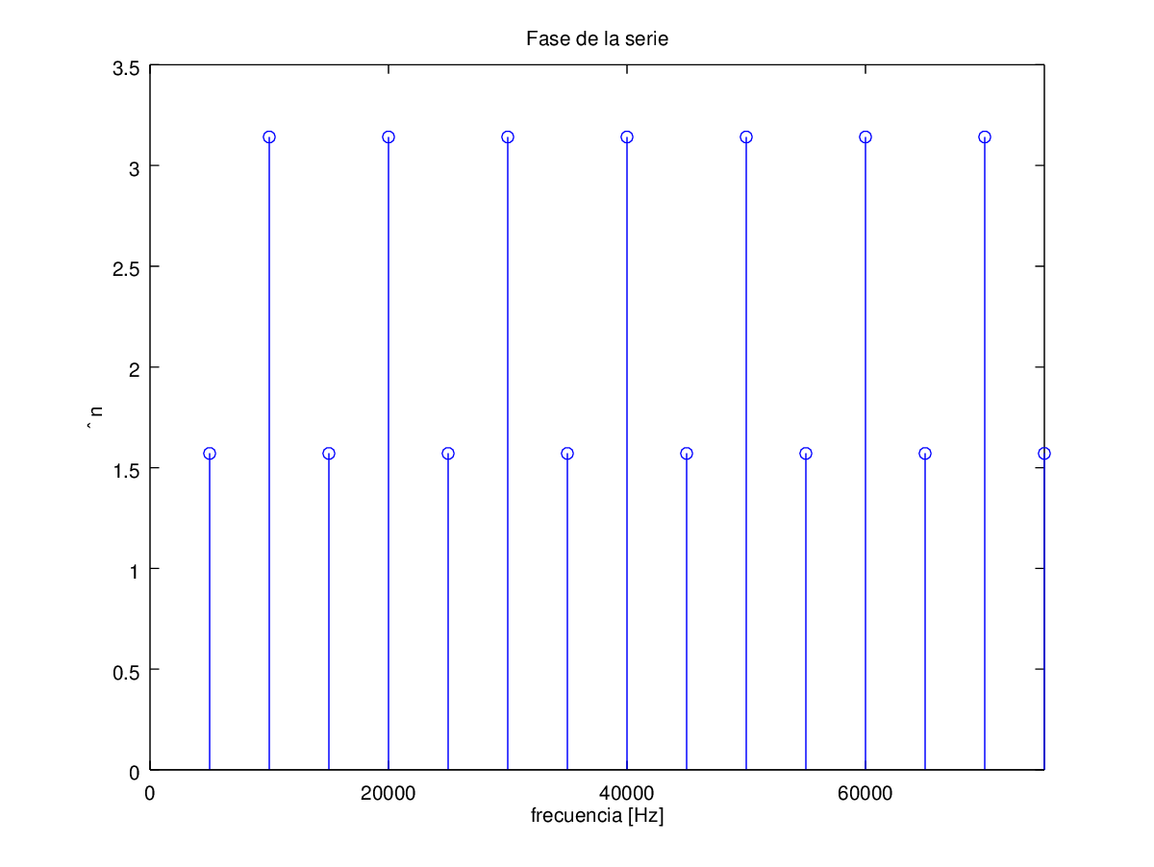

|  |  |  |
| --- | --- | --- |
| # de armónico | Magnitud | Fase |
|  | 6.3662e-001 | 1.57080 |
|  | 3.8980e-017 | 3.14159 |
|  | 2.1221e-001 | 1.57080 |
|  | 3.8980e-017 | 3.14159 |
|  | 1.2732e-001 | 1.57080 |

