|  |  |  |  |  |
| --- | --- | --- | --- | --- |
| Dispositivo | Interface | Dirección IP | Mascara de | SR OBS: |
| PC01 |  | 21.0.0.2 | 255.0.0.0 | PE: 21.0.0.1 |
|  |  |  |  |  |
| PC02 |  | 192.168.2.3 | 255.255.255.240 | PE: 192.168.2.1 |
|  |  |  |  |  |
| A | Serial 0/0/0 | 10.0.0.2 | 255.0.0.0 | DTE |
|  | Serial 0/0/1 | 17.1.0.1 | 255.0.0.0 | DTE |
|  | FastEthernet 0/0 | 21.0.0.1 | 255.0.0.0 | * |
| B | Serial 0/0/0 | 10.0.0.3 | 255.0.0.0 | DTE |
|  | Serial 0/0/1 | 170.56.3.1 | 255.255.0.0 | DCE |
| C | Serial 0/0/0 | 17.1.0.2 | 255.0.0.0 | DTE |
|  | Serial 0/0/1 | 203.3.3.1 | 255.255.255.0 | DTE |
|  | Serial 0/1/0 | 200.1.1.1 | 255.255.255.0 | DCE |
|  |  |  |  |  |
| D | Serial 0/0/0 | 170.56.3.1 | 255.255.0.0 | DCE |
|  | Serial 0/0/1 | 202.2.2.2 |  | DTE |
|  | Serial 0/1/0 | 200.1.1.2 |  | DCE |
|  |  |  |  |  |
| E | Serial 0/0/0 | 203.3.3.2 | 255.255.255.0 | DTE |
|  | Serial 0/0/1 | 202.2.2.1 | 255.255.0.0 | DTE |
|  | Serial 0/1/0 | 160.0.0.1 |  | DCE |
| F | FastEthernet 0/0 | 192.168.2.1 | 255.255.255.240 | * |
|  | Serial 0/0/0 | 160.0.0.2 | 255.255.0.0 | DCE |
|  |  |  |  |  |

**Usando el comando ‘bandwidth <numero de kbps>’ modificamos el ancho de banda de cada enlace a:**

Enlace Ancho de banda

A-B 56 kbps

B-D 64 kbps

A-C 256 kbps

C-E 256 kbps

D-E 128 kbps

E-F 256 kbps

C-D Valores por defecto – 1544 kbps

Para obtener el costo de cada uno de los enlaces utilizamos el comando “show ip ospf interface” **desde cada Router**

Ejemplo desde el Router D ***SE VE EN NEGRITA EL COSTE***

D>enab

D>enable

Password:

D#show ip ospf int

D#show ip ospf interface

Serial0/0/1 is up, line protocol is up

Internet address is 202.2.2.2/24, Area 0

**Process ID 1, Router ID 202.2.2.2, Network Type POINT-TO-POINT, Cost: 781**

Transmit Delay is 1 sec, State POINT-TO-POINT,

Timer intervals configured, Hello 10, Dead 40, Wait 40, Retransmit 5

Hello due in 00:00:06

Index 1/1, flood queue length 0

Next 0x0(0)/0x0(0)

Last flood scan length is 1, maximum is 1

Last flood scan time is 0 msec, maximum is 0 msec

Neighbor Count is 1 , Adjacent neighbor count is 1

Adjacent with neighbor 203.3.3.2

Suppress hello for 0 neighbor(s)

Serial0/0/0 is up, line protocol is up

Internet address is 170.56.3.2/16, Area 0

**Process ID 1, Router ID 202.2.2.2, Network Type POINT-TO-POINT, Cost: 1562**

Transmit Delay is 1 sec, State POINT-TO-POINT,

Timer intervals configured, Hello 10, Dead 40, Wait 40, Retransmit 5

Hello due in 00:00:01

Index 2/2, flood queue length 0

Next 0x0(0)/0x0(0)

Last flood scan length is 1, maximum is 1

Last flood scan time is 0 msec, maximum is 0 msec

Neighbor Count is 1 , Adjacent neighbor count is 1

Adjacent with neighbor 170.56.3.1

Suppress hello for 0 neighbor(s)

Serial0/1/0 is up, line protocol is up

Internet address is 200.1.1.2/24, Area 0

**Process ID 1, Router ID 202.2.2.2, Network Type POINT-TO-POINT, Cost: 64**

Transmit Delay is 1 sec, State POINT-TO-POINT,

Timer intervals configured, Hello 10, Dead 40, Wait 40, Retransmit 5

Hello due in 00:00:02

Index 3/3, flood queue length 0

Next 0x0(0)/0x0(0)

Last flood scan length is 1, maximum is 1

Last flood scan time is 0 msec, maximum is 0 msec

Neighbor Count is 1 , Adjacent neighbor count is 1

Adjacent with neighbor 203.3.3.1

Suppress hello for 0 neighbor(s)

**Así desde cada Router obtenemos la siguiente tabla para los costes:**

Enlace Costo

A-B 1785

B-D 1562

A-C 390

C-E 390

D-E 781

C-D 64

E-F *

**“Predecir”, cuál será la ruta que tomará un paquete desde la PC01 hasta la PC02**

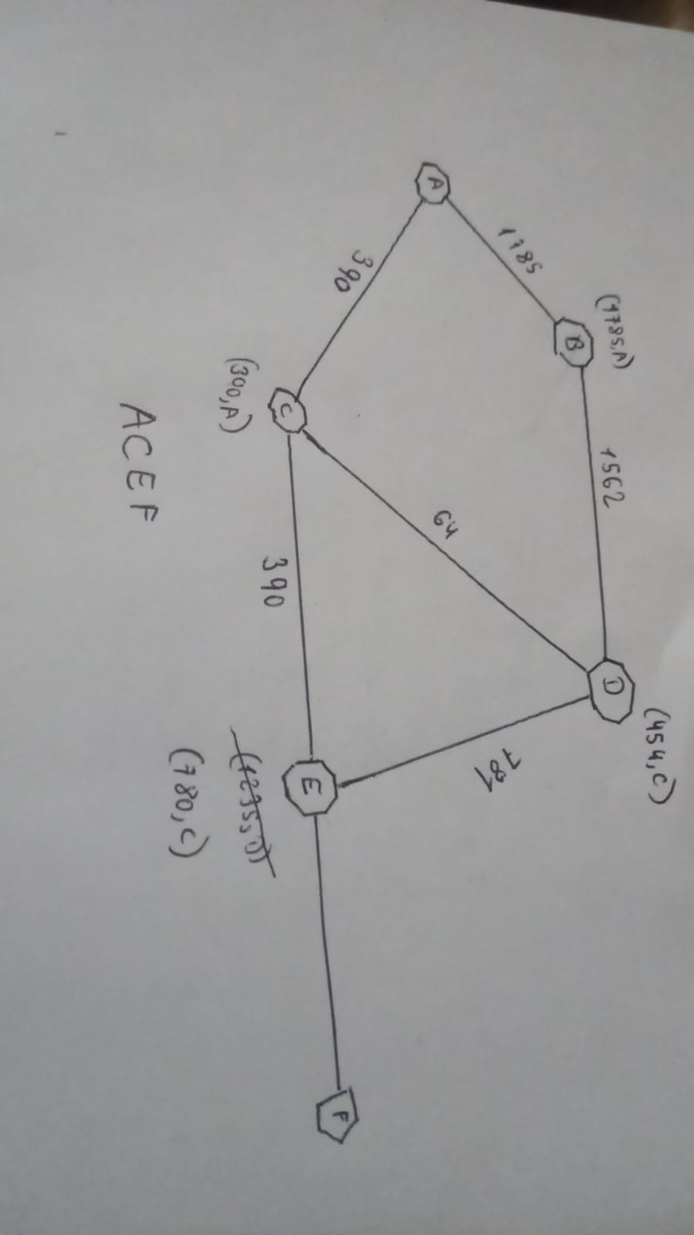

**Comprobar la predicción, utilizando el comando tracert desde la línea de comandos del sistema operativo de la PC01**

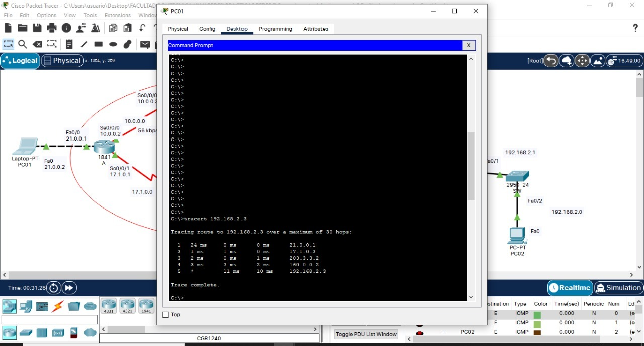

**\*Bajar administrativamente la interface serial del router C que conecta con el router Predecir”, cuál será la nueva ruta entre PC01y PC02**

**Primero ejecutamos lo siguiente en el Router C**

C>ENA

C>ENAble

Password:

C#

C#configure terminal

Enter configuration commands, one per line. End with CNTL/Z.

C(config)#interface Serial0/0/1

C(config-if)#shut

C(config-if)#shutdown

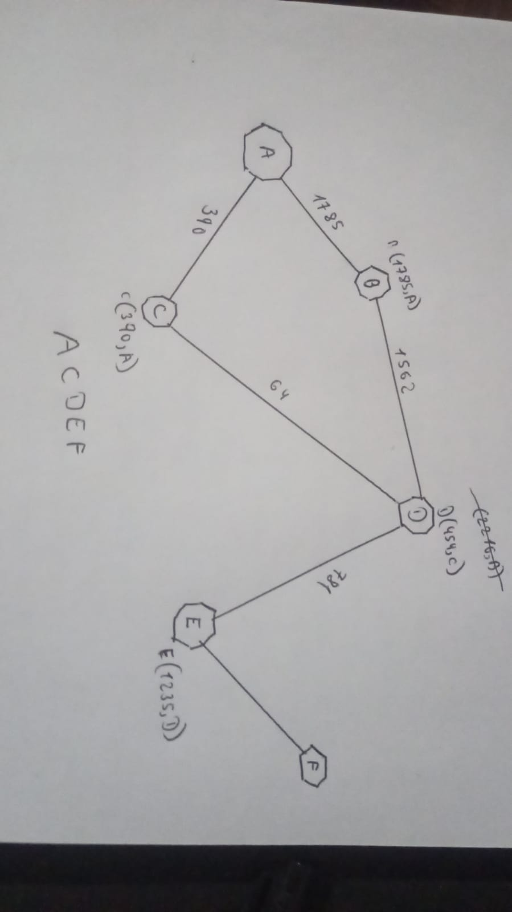

**Comprobar utilizando el comando tracert desde la PC01**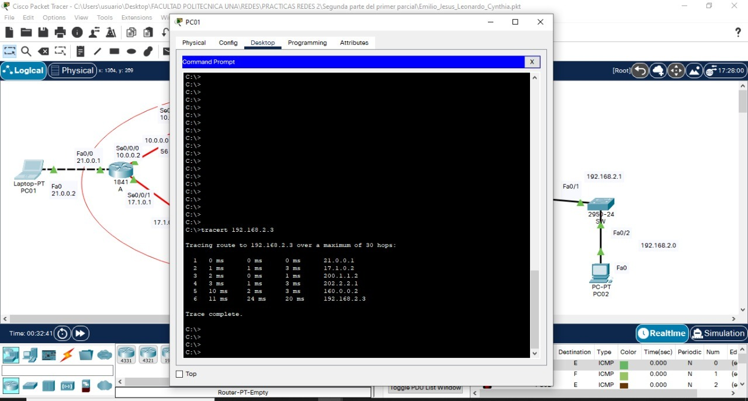

**Integrantes del grupo para la parte práctica del Primer examen parcial:**

Emilio Matias Saldivar Caputo

Cynthia Gabriela Díaz Franco

Leonardo Andres Ramos

Jesús Fernando Fernández Martínez