**Sofa Shop Information System - User Guide**

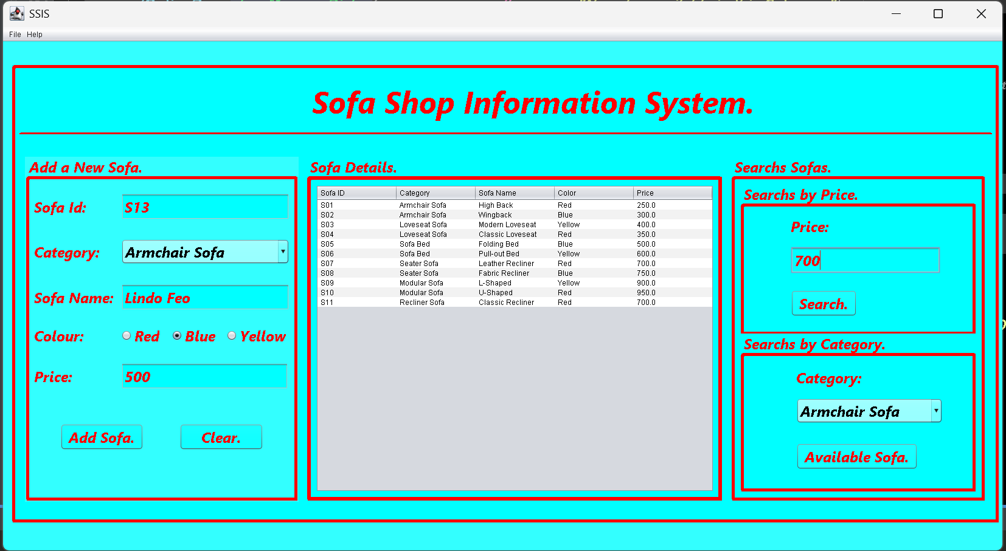**System Main GUI Image.**

**1. Adding a New Sofa:**

* 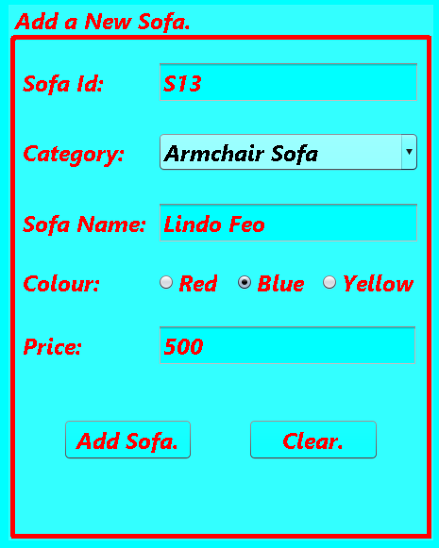Enter the details (ID, Category, Name, Color, Price).
* Click 'Add Sofa' to store it in the table.

**2. Show all details of sofas in the database.**

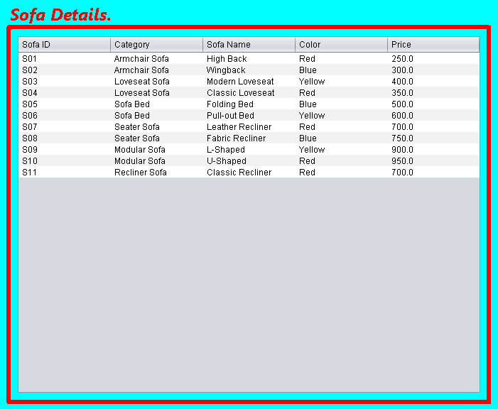

**3. Searching for a Sofa by Price:**

* Enter the price in the search field.

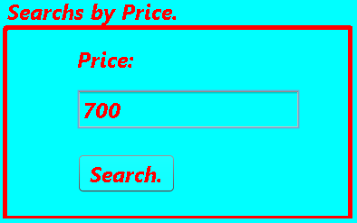

* Click 'Search' to find a matching sofa.
* If multiple sofas have the same price, only the first one will be displayed.

**4. Checking Sofa Availability by Category:**

* Select a category from the dropdown list.

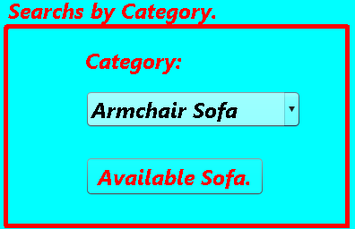

* Click 'Available Sofa' to see how many sofas are in stock.

**5. Opening a Saved File:**

- Go to 'File' > 'Open File' to load an existing sofa list from a file.

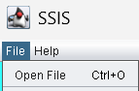

**6. Exiting the Program:**

- Click 'File' > 'Exit' to close the application.

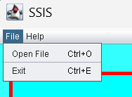

**7. Troubleshooting:**

* If the program does not open, ensure Java is installed.
* If the table does not update, try restarting the application.
* For any errors, contact support at support@emiliobarrerasepulveda@gmail.com.