Lunero — Comprehensive Requirements Document
Tagline: "A calmer way to budget."

0. Brand & Visual Direction
Lunero is a calm, nature-inspired personal budgeting app with an editorial, minimal aesthetic (non-banking look). The brand emphasizes warm neutrals, soft accents, generous whitespace, and clear hierarchy. Overspend states use a soft red. Typography pairs a modern grotesk (e.g., Söhne/Inter) with Plus Jakarta Sans.

1. Product Vision & Goals
Help users plan and stay within their budget with effortless manual capture, period-based budgeting (FlowSheets), and clear weekly/monthly/yearly trends, supported by an integrated AI budgeting coach. Provide the same UI and features across mobile (iOS/Android) and web with seamless sync via user accounts.

2. Scope & Out of Scope
In scope (MVP):
- Cross-platform app (iOS, Android, Web) with consistent UI and functionality.
- Manual capture of Income, Expenses, and Savings entries.
- Period-based budgets called FlowSheets (weekly, monthly, custom), with auto-reset and archive.
- AI budgeting coach integrated into capture and review flows.
- Trend views: weekly, monthly, yearly.
- Custom categories with sensible defaults.
- Accounts and authentication, with optional social sign-in.
Out of scope (MVP):
- Live bank integrations and automatic transaction import.
- Advanced investment portfolio tracking beyond Savings/Investments allocations.

3. Definitions & Naming
FlowSheet: The active budget for a chosen period. At period end, it closes and moves to Past FlowSheets; a new one is created and reset.
Available Balance: Total Income − (Total Expenses + Total Savings) in the active FlowSheet.

4. User Accounts & Authentication
- Account Creation: Email + password; profile management; secure password reset.
- Sign-In Options Email/password Google, Apple.
- Data Sync: Automatic sync of user data (entries, categories, settings) across devices once authenticated.

5. Budget Model: FlowSheets
Users plan and capture within a FlowSheet for the chosen period. At the end of the period, the FlowSheet is archived with the user able to re-edit past Flowsheets; a fresh FlowSheet is created.
- 5.1 Period Configuration
- Supported periods: weekly, monthly, custom (e.g., bi-weekly).
- Configurable start (week start; month aligns to calendar by default).
- Calender month by default
- Auto-reset: On period end, archive current FlowSheet; create a new blank one.
- 5.2 Pre-Population from History
- On new period, suggest recurring items detected from history (salary, bond, loans, insurance, subscriptions).
- Users can mark entries as recurring with cadence (weekly, monthly, custom).
- 5.3 Balancing Logic & Overspend Indicators
- Available Balance updates immediately as entries are added/edited.
- If Available Balance < 0, show a red progress bar and highlight negative balance.

6. Categories: Defaults & Management
Default categories ship with Lunero. Users can create/rename/delete categories and place each under Income, Expense, or Savings.
- 6.1 Income (defaults)
- Salary
- Freelance work
- Donations
- 6.2 Expenses (defaults)
- Bond
- Levies
- Water
- Wifi
- Car finance
- Car insurance
- Life insurance
- Retirement Annuity/Pension
- Tithe/Donations
- Electricity
- Subscription services
- Cellphone bill
- Petrol
- Food
- Cleaning supplies
- Bank fees
- Miscellaneous
- Gym
- Social
- Credit card repayments
- Studies
- Business overheads
- 6.3 Savings (defaults)
- Emergency savings
- General savings
- Investments
- 6.4 Category Management
- Users can create custom categories and assign them to Income, Expense, or Savings.
- Each category should have an icon and color
Category | Color Name | Hex Code | Meaning / Intent
Income | Olive Gray | #6B6F69 | Calm positive inflow
Expenses | Clay Red | #C86D5A | Warm attentive outflow
Savings | Warm Earth / Sand | #C4A484 | Steady, future-focused

7. Capture & Transaction Flows
- Quick Add: Add Income, Expense, or Savings with amount, date, category, optional note.
- Editing: Edit/delete entries in the active FlowSheet; past FlowSheets are read-only by default.
- Recurring Entries: Mark any entry as recurring with cadence.
- Search & Filters: Filter by type, category, date, amount range.

8. Trend & Summary Views
- Weekly Trends: totals for income, expenses, savings; week-over-week change indicators.
- Monthly Trends: income vs expenses with category breakdowns and net balance.
- Yearly Overview: cumulative view of income, expenses, savings; highlight surplus/deficit months.
- Past FlowSheets: archive with summary cards and drill-down.

9. AI Budgeting Coach
- Suggest likely items during capture based on history (salary, bond, insurance, subscriptions).
- Proactive alerts when spending trends toward overspend.
- Natural-language queries (e.g., "What did I spend on groceries last month?").
- Coaching tips to improve savings habits and balance across periods.

10. UX & Visual Design Principles
- Sleek, minimal, editorial aesthetic with warm neutrals; not a banking app look.
- Consistent design language across mobile and web; component parity and behavior.
- Clear deficit indicators (e.g., red bar, negative badge) when exceeding income.
- Accessibility: aim for WCAG AA contrast and keyboard/screen-reader support on web.

11. Non-Functional Requirements
- Performance: dashboard loads ~2s on typical 4G; API median <200ms for key endpoints.
- Reliability: 99.5% monthly uptime target for MVP; graceful offline handling with queued sync.
- Security: HTTPS, password hashing (bcrypt/argon2); role-based access; basic audit logs.
- Privacy: data minimization; export and account deletion capabilities.
- Localization-ready for currency, dates, numbers.

13. Acceptance Criteria (Samples)
- Adding a $100 Expense in the active FlowSheet decreases Available Balance by $100 immediately.
- When Available Balance < 0, the progress bar turns red and the balance shows a negative sign.
- On the first day of a new month (monthly setting), the previous FlowSheet is archived and moves to Past FlowSheets; a new blank FlowSheet is created.
- New FlowSheet creation generates suggestions for recurring items (e.g., salary, bond, insurance) based on the prior two periods; user can accept or dismiss each.
- Users can add a custom category (income/expense/savings) and it appears immediately in the category picker.

14. Open Questions & Assumptions
- Rollover: Should unspent balance roll into next period as Income/Savings/none? – No rollover. This is not a banking app
- Currency: Single currency per account vs multi-currency entries?
- User will select a default currency initially but can add items of a different currency and conversion must be done in the backend to align remaining budget amounts
- Dark mode at launch

15. Calendar View & Daily Summaries
Lunero must include a Calendar View that allows users to see their income, expenses, and savings activity distributed across days within a chosen period.

Key Requirements

15.1 Calendar Display
- A clean, minimal monthly calendar grid must be available within each FlowSheet period.
- Each day must show:
  - Income total for that day
  - Expense total for that day
  - Savings total for that day
- Totals should use category colors:
  - Income → Olive Green (#6B6F69)
  - Expenses → Clay Red (#C86D5A)
  - Savings → Warm Earth (#C4A484)

15.2 Interaction Requirements
- Tapping/clicking a day should open a Daily Breakdown Panel showing:
  - All entries captured that day
  - Category, amount, notes, and type (Income/Expense/Savings)
  - A subtotal per type
- Users must be able to add transactions directly from a specific day using a “+ Add” button inside the Daily Breakdown Panel.

15.3 FlowSheet Integration
- The calendar reflects only entries from the active FlowSheet.
- Navigating to past FlowSheets shows the calendar for that given flowsheets.
- Future days in the current period should appear visually neutral/unpopulated.

15.4 Visual Indicators
- Days with no activity remain minimalist and blank (“empty state”).
- Days with activity show:
  - A small dot or underline in the corresponding category colors, or
  - A tiny three-segment bar (Income / Expense / Savings) to indicate distribution.
- High-activity days can include a subtle highlight behind the date.

15.5 Weekly & Monthly Sync
- Weekly Trends must pull directly from these daily sums.
- Monthly totals must be computed as the sum of all days in the calendar.

15.6 UX Guidance
- The calendar must match Lunero’s editorial aesthetic:
  - Light ivory background
  - Soft grey dividers
  - Thin minimalist date text
  - Rounded selection highlight for the active day
- Overspend days should not be highlighted on the calendar (only shown in FlowSheet balance), to avoid stress-inducing interactions.

Brand Overview
Lunero is a calm, modern, nature-inspired financial wellness app. Tagline: "A calmer way to budget."

Mood Board Summary
The Lunero mood board evokes natural clarity and calm through earthy colors, warm neutrals, soft typography, and an elegant flowing logo mark. Visual style emphasizes minimalism, editorial layout, and a non-banking aesthetic.

Requirements (Updated)
All previous requirements from FinFlow have been updated to reflect the Lunero brand name, tagline, and design direction. The application must adopt the natural, minimal, editorial aesthetic represented in the Lunero mood board.

Visual Mood Board & Brand Elements
The following board illustrates Lunero's brand direction: natural clarity, warm neutrals, editorial typography, and an elegant flowing emblem. The tagline and logo are included for reference.
Logo & Tagline: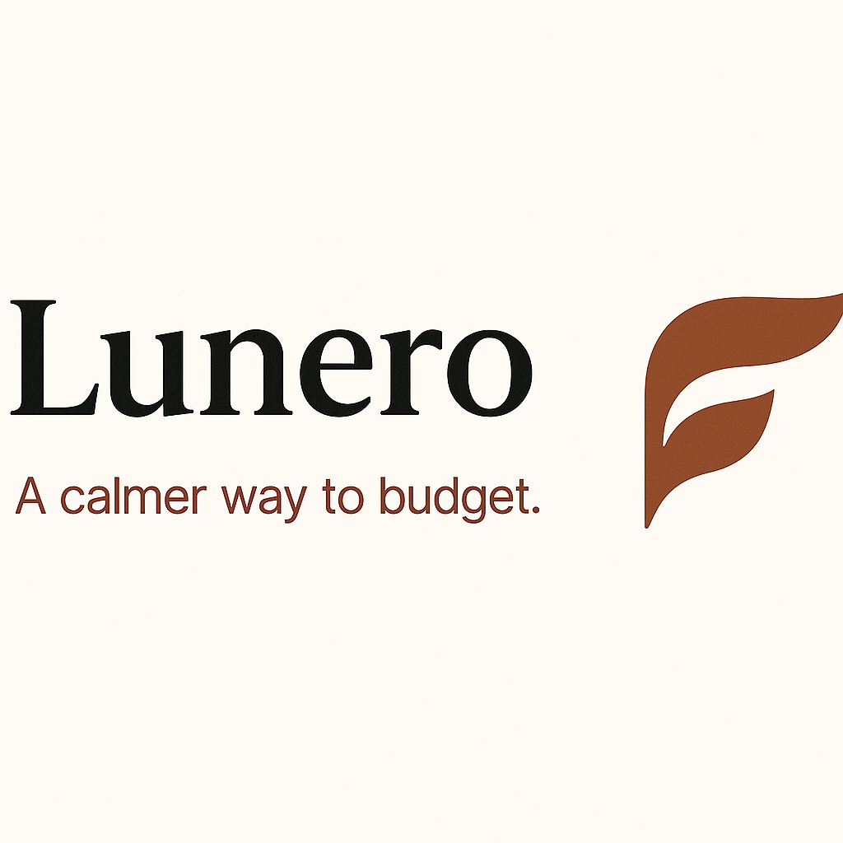

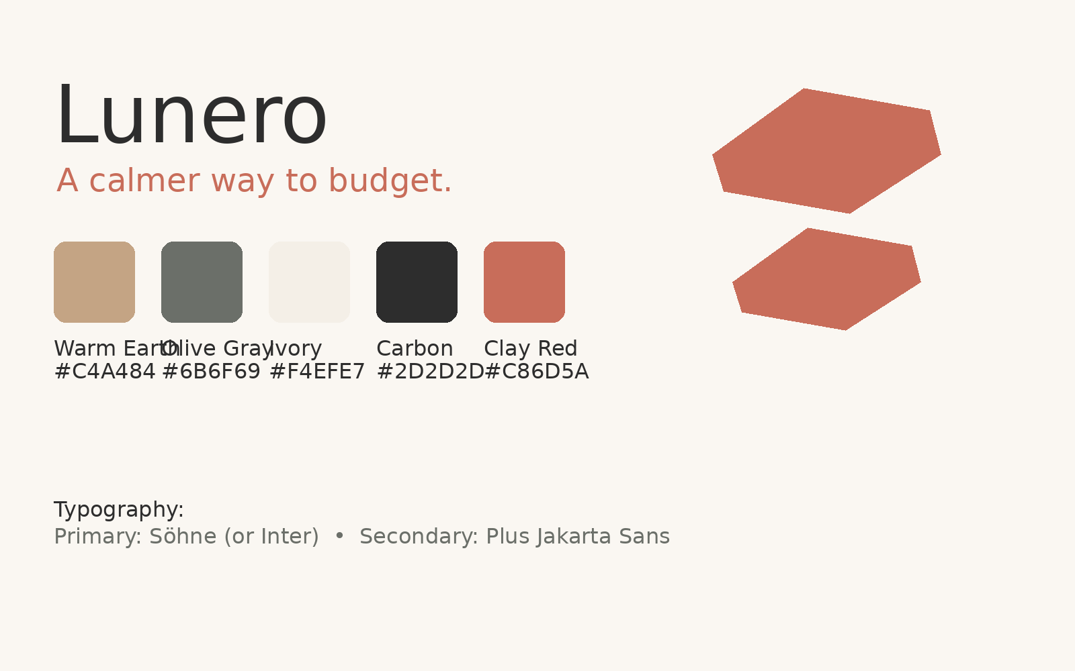
Tagline: "A calmer way to budget."

